Supplementary Information
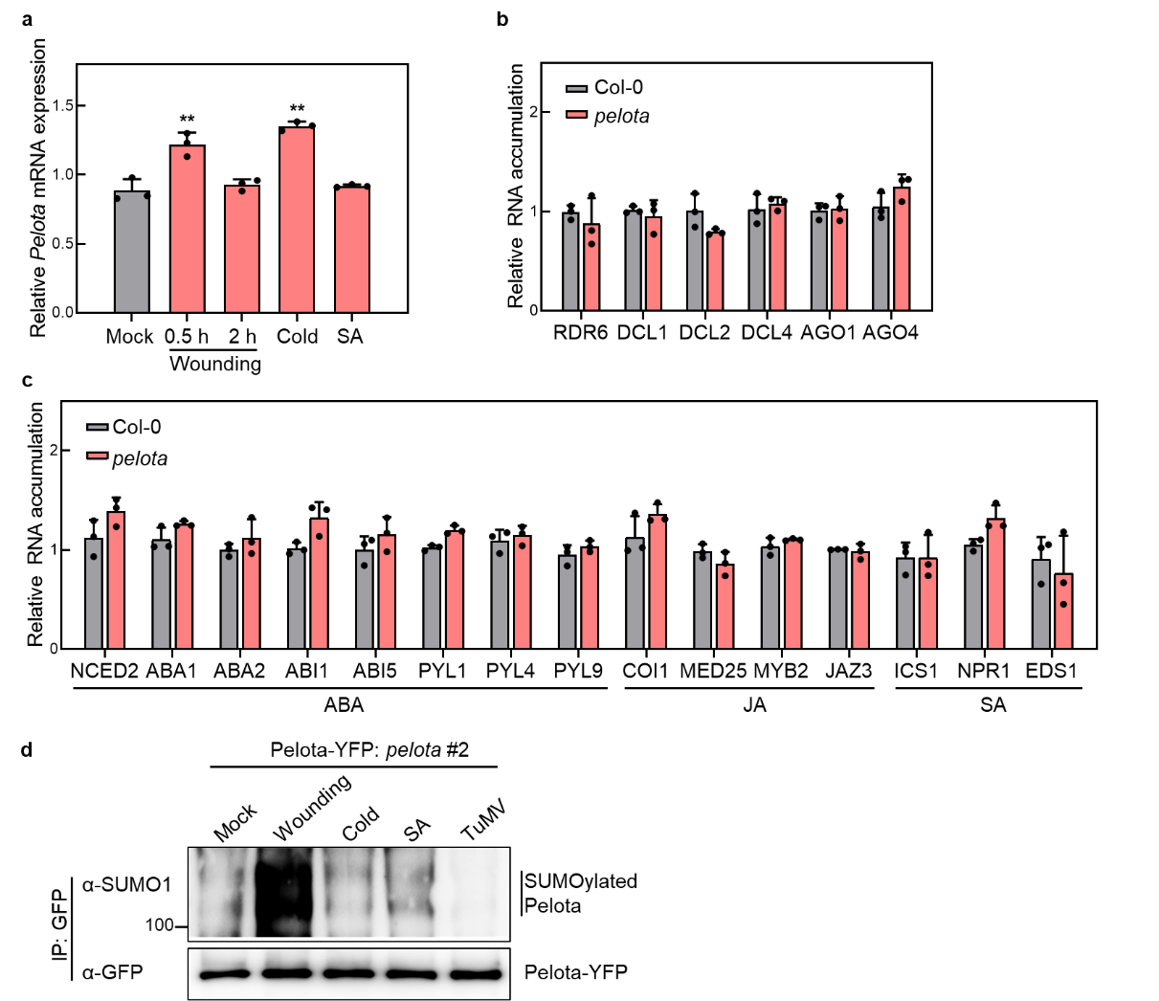
Supplementary Fig. 1 Analysis of Pelota relevant transcriptional pattern. a, qRT-PCR analysis of the Pelota expression level in Arabidopsis plants under wounding, cold, and SA treatments. b, Expression patterns of RNA silencing related genes in pelota compared to WT. c, Expression patterns of ABA, JA, SA phytohormone-related genes in pelota compared to WT. d, In vivo SUMOylation of Pelota. Pelota: pelota (35S: Pelota-YFP/pelota #2) Arabidopsis plants were subjected to treatments in Supplementary Fig. 1a and TuMV infection at 14 dpi. SUMOylated Pelota was detected with anti-SUMO1 antibody.

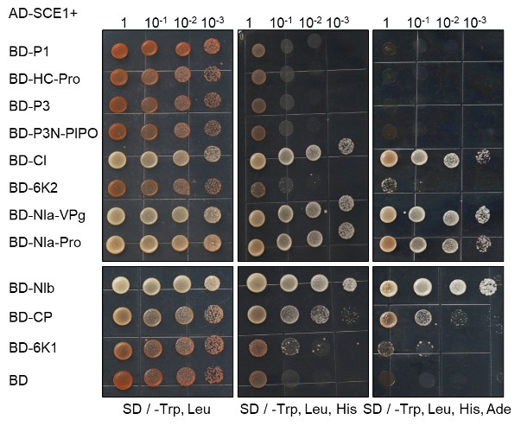

Supplementary Fig. 2 SCE1 interacts with several TuMV-encoded viral proteins in yeast cells. Y2H Gold yeast cells harboring the indicated plasmids were co-expressed, subjected to 10-fold serial dilutions and plated on synthetic dextrose (SD)/-Trp, -Leu, -His, -Ade plates at 30 °C and photographed after 3 days. Yeast cells co-expressing AD-SCE1 and BD were used as a negative control.

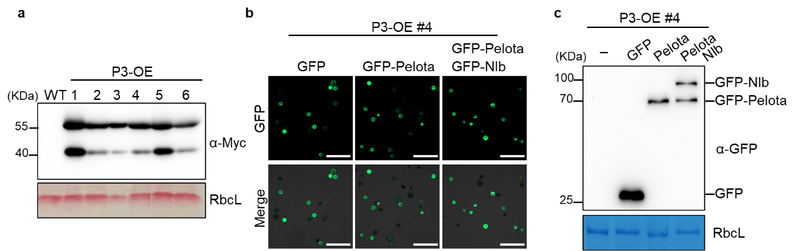
Supplementary Fig. 3 Validation of P3 transgenic plants and protoplast transformation experiments. a, WB analysis showing the expression of TuMV-P3 in TuMV-P3 transgenic Arabidopsis lines. b,c, Protein expression in TuMV-P3 transgenic Arabidopsis protoplasts transforming GFP, GFP-Pelota or GFP-Pelota and GFP-NIb were confirmed by confocal microscopy and WB assays. Scale bars correspond to 200 μm. CBB-staining of RbcL was a loading control.

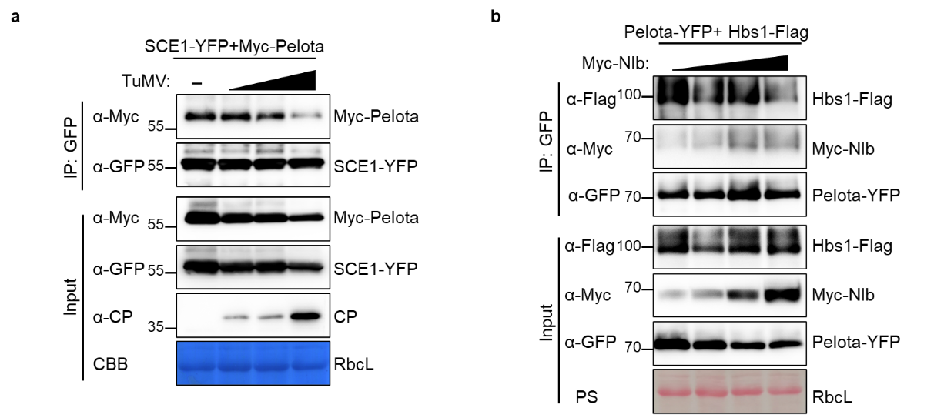
Supplementary Fig. 4 TuMV disrupt the Pelota-SCE1 interaction, and NIb disrupts the Pelota-Hbs1 interaction. a, Competitive Co-IP assays in vivo of SCE1-YFP and Myc-Pelota co-expressed with increasing amounts of TuMV in N. benthamiana leaves. Proteins were immunoprecipitated with anti-GFP beads. Immunoprecipitated and input proteins were then analyzed with anti-Myc and anti-GFP antibodies. CBB-staining of RbcL was a loading control. b, Competitive Co-IP assays in vivo. Pelota-YFP and Hbs1-Flag were co-expressed along with increasing amounts of NIb in N. benthamiana leaves. Proteins were immunoprecipitated with anti-GFP beads. Immunoprecipitated and input proteins were then analyzed with anti-Flag, anti-Myc, or anti-GFP antibodies. Ponceau S (PS)-staining of RbcL was a loading control.
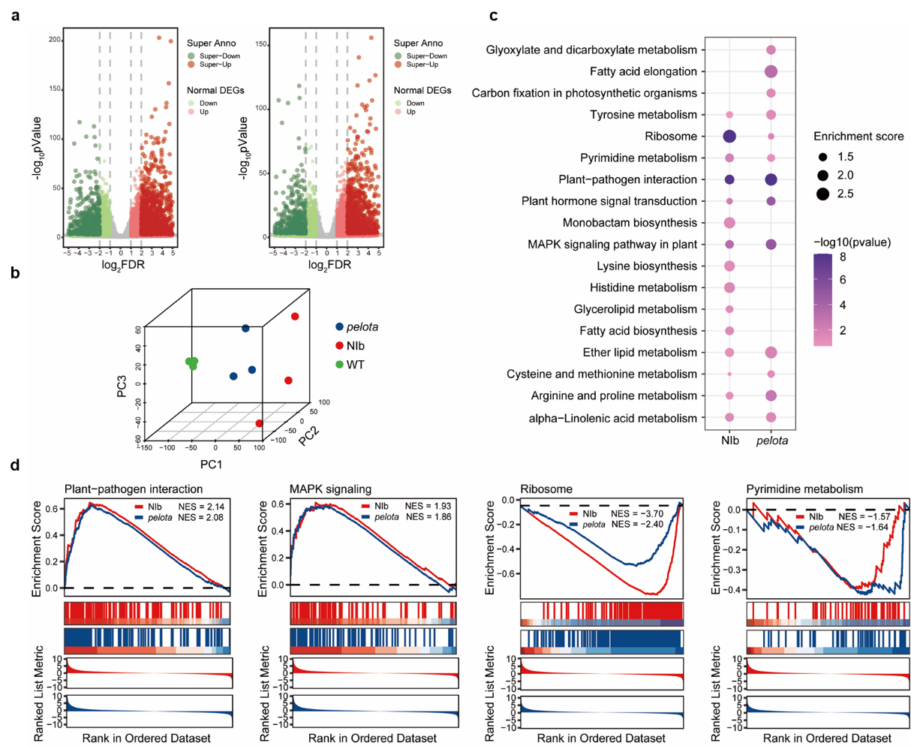
Supplementary Fig. 5 The expression of NIb can substitute for the impact of Pelota deficiency. a, The volcano plot shows the overall change of genes in NIb and pelota compared with the WT control. Specifically, genes with absolute log₂ (Fold change) > 1 and adjusted p-value < 0.05 are classified as usual differentially expressed genes. Moreover, genes surpass the criteria of absolute log₂ (Fold change) > 2 and adjusted p-value < 0.001 are denoted as super differentially expressed genes. b, The 3D PCA plot plot illustrates the general transcriptome characteristics of the samples. The percentages of the total variation explained by the 1st, 2nd, and 3rd principal components are indicated on the x-, y-, and z-axis, respectively. c, The bubble plot illustrates the results of NIb transgenic and pelota samples KEGG pathway enrichment analysis. Each bubble represents a KEGG pathway, with bubble size proportional to the enrichment ratio compared to background genes. The color intensity of each bubble reflects the statistical significance of enrichment, typically represented by the -log₁₀ transformed p-value. d, Gene set enrichment analysis (GSEA) was performed on the NIb transgenic and pelota groups.

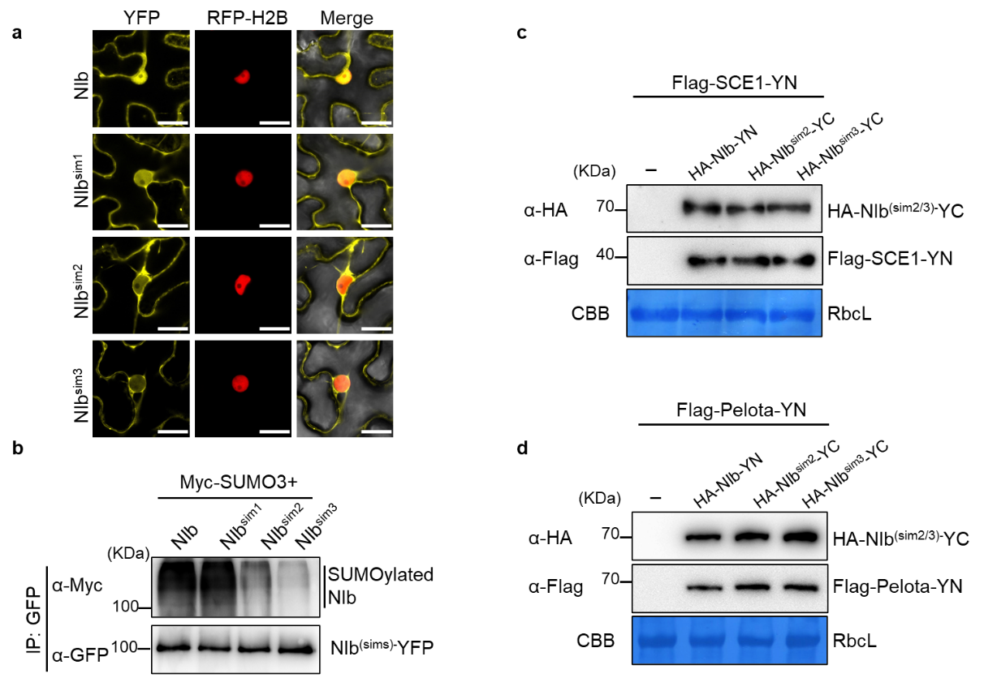
Supplementary Fig. 6 Subcellular localization, SUMOylation of the NIb^{sim} mutants and immunoblotting analysis confirming protein expression in Fig. 5. a, Subcellular localization of NIb and its sim mutants in N. benthamiana leaves. Scale bars correspond to 20 μm. b, In vivo SUMOylation assay. NIb-YFP or NIb^{sim}-YFP mutants were co-expressed with Myc-SUMO3 in N. benthamiana leaves. The proteins were immunoprecipitated with anti-GFP beads and analyzed with anti-Myc and anti-GFP antibodies. c,d, Immunoblotting detection of protein expression from the BiFC vectors in Fig. 5b. CBB-staining of RbcL was a loading control.

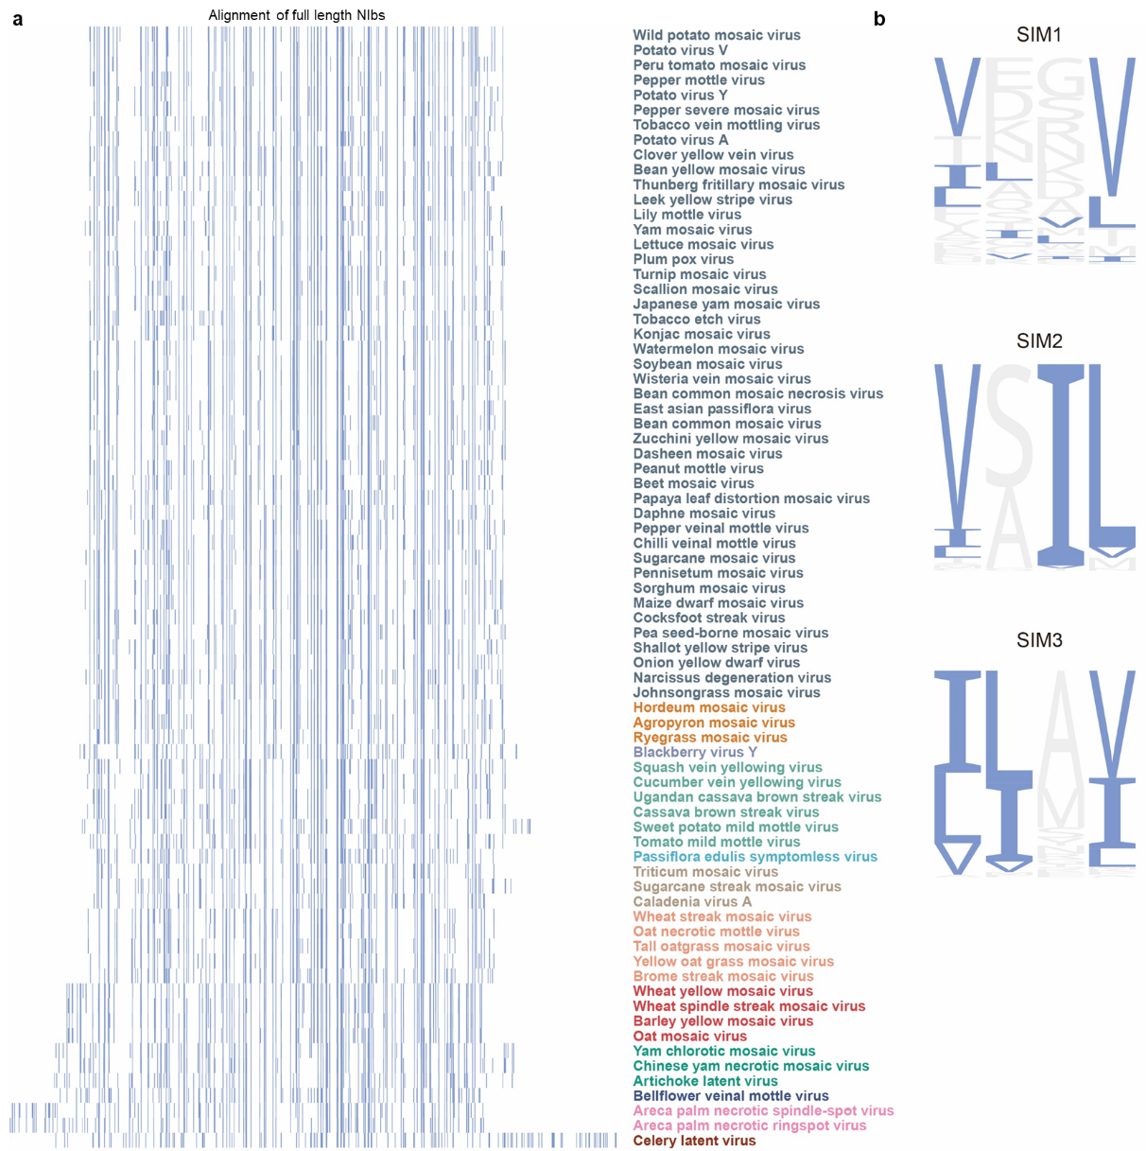
Supplementary Fig. 7 The conservation analysis SIM motif characteristics in the NIb sequences of the selected Potyvirids. a, Alignment of the NIb sequences from 12 potyvirid genera. b, Enrichment analysis of the SIM motifs in the NIb sequences of selected potyvirids.
Supplemental Table 1: Primers used in this study
Names | Primers Sequence (5'-3')
Pelota | GGGGACAAGTTTGTACAAAAAAGCAGGCTTCATGAAGATCGTTCGCAGGG
Pelota | GGGGACCACTTTGTACAAGAAAGCTGGGTCCATCTCAATGTCTTCGAG
Hbs1 | GGGGACAAGTTTGTACAAAAAAGCAGGCTTCATGCCTCGTAAAGGATTA
Hbs1 | GGGGACCACTTTGTACAAGAAAGCTGGGTCTGAGTCTTGGATAATCC
GST-Pelota | GGGGCCCCTGGGATCCATGAAGATCGTTCGCA
GST-Pelota | GTCGACCCGGGAATTCCATCTCAATGTCTTC
YFP-qPCR | ATCATGGCCGACAAGCAGAA
YFP-qPCR | TCTCGTTGGGGTCTTTGCTC
TuMV-CP-qPCR | TGGCTGATTACGAACTGACG
TuMV-CP-qPCR | CTGCCTAAATGTGGGTTTGG
AtActin2-qPCR | CACCACAACAGCAGAGCGGGA
AtActin2-qPCR | TCCCACAAACGAGGGCTGGA
NbActin-qPCR | AAAGACCAGCTCATCCGTGGAGAA
NbActin-qPCR | TGTGGTTTCATGAATGCCAGCAGC
His-NIb | CGAGGGATCCGAATTCATGACCCAGCAGAATCG
His-NIb | CGACAAGCTTGAATTCCTGGTGATAAACACAA
TuMV-NIb-sim1 | TTTGAAAAGACAGCTGAAATAGCCGTATCAGATCTGCG
TuMV-NIb-sim1 | CGCAGATCTGATACGGCTATTTCAGCTGTCTTTTCAAA
TuMV-NIb-sim2 | GAGCCAGAGCGAATAGCATCGGCTCTAGAATGGGATCG
TuMV-NIb-sim2 | CGATCCCATTCTAGAGCCGATGCTATTCGCTCTGGCTC
TuMV-NIb-sim3 | AACGGAGATGATTTACTGGCAAGCGCACACCCAGAG
TuMV-NIb-sim3 | CTCTGGGTGTGCGCTTGCCAGTAAATCATCTCCGTT
AN-NIb-sim2 | AAGATGAGAGAGCAATTGCAGCCCTTCAATGGAAAAG
AN-NIb-sim2 | CTTTTCCATTGAAGGGCTGCAATTGCTCTCTCATCTT
AN-NIb-sim3 | TGGATAATACCGCCATAGCAATGGTGTCTTTTGTTTAT
AN-NIb-sim3 | ATAAACAAAAGACACCATTGCTATGGCGGTATTATCCA
PV-NIb-sim2 | GAAGAGGAACGTGCTGTTTCAGCCTTAGAGTGGGACC
PV-NIb-sim2 | GGTCCCACTCTAAGGCTGAAACAGCACGTTCCTCTTC
PV-NIb-sim3 | ATGGAGATGACGCCATAGCGGCTGTCAGACATGAGGA
PV-NIb-sim3 | TCCTCATGTCTGACAGCCGCTATGGCGTCATCTCCAT
MBP-SCE1 | GGAAGGATTTCAGAATTCATGGCTAGTGGAATC
MBP-SCE1 | TCTAGAGGATCCGAATTC GACAAGAGCAGGATAC

