Supplementary Figures:
Potassium silicate efficacy for improving the strawberry agronomic traits and gray mold fungal resistance
Rosalyn D. Battle, Amaranatha R. Vennapusa, Venkata H. Limmada, Michael Moore, Sathya Elavarthi, Kalpalatha Melmaiee*
¹Department of Agriculture and Natural Resources, Delaware State University, Dover, DE 19901, USA
²Optical Science Center for Applied Research (OSCAR), Delaware State University, Dover, DE 19901, USA
Correspondence
Kalpalatha Melmaiee
kmelmaiee@desu.edu
†, authors equally contributed to the work

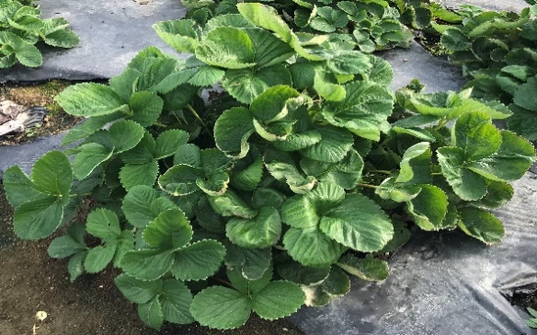
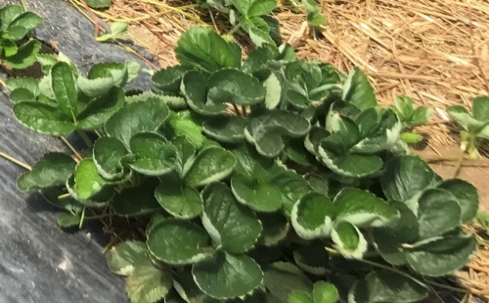
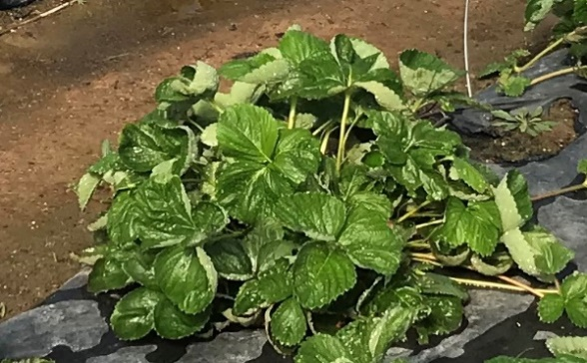
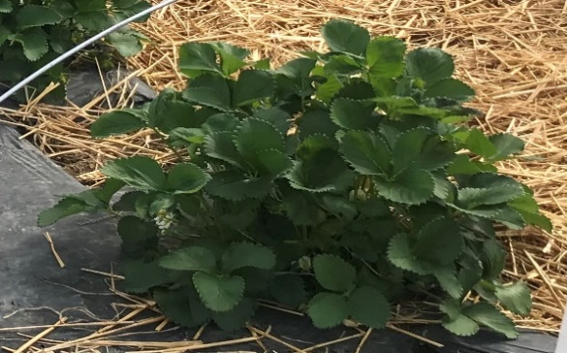
3 mL
4 mL
2 mL
0 mL
A)

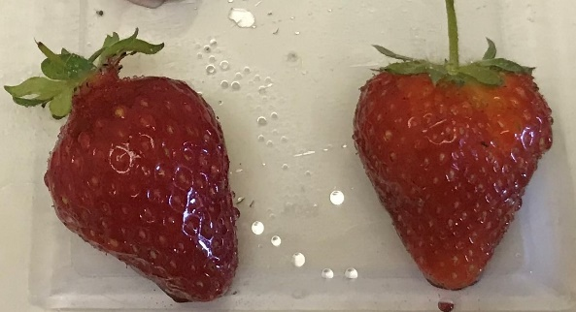
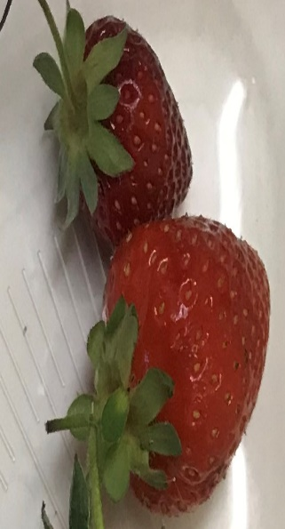
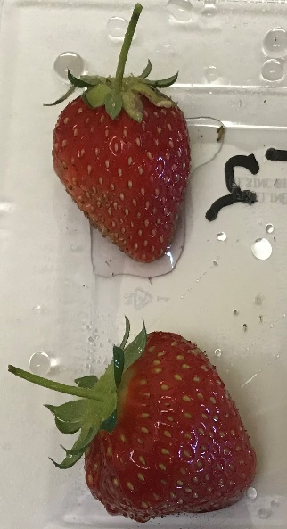
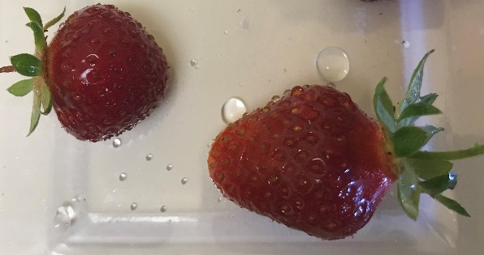
0 mL
2 mL
3 mL
4 mL
B)

Supply Fig.1 Effect of Potassium silicate treatment on morphophysiological traits in strawberry plants. A) Plant canopy variation upon different concentrations of Si treatments (0, 2, 3, and 4 mL/ gallon) on strawberry plants. B) Fruit size upon different concentrations of Si treatments (0, 2, 3, and 4 mL/ gallon)

