Supplementary

Data

Colonoscopy Examples

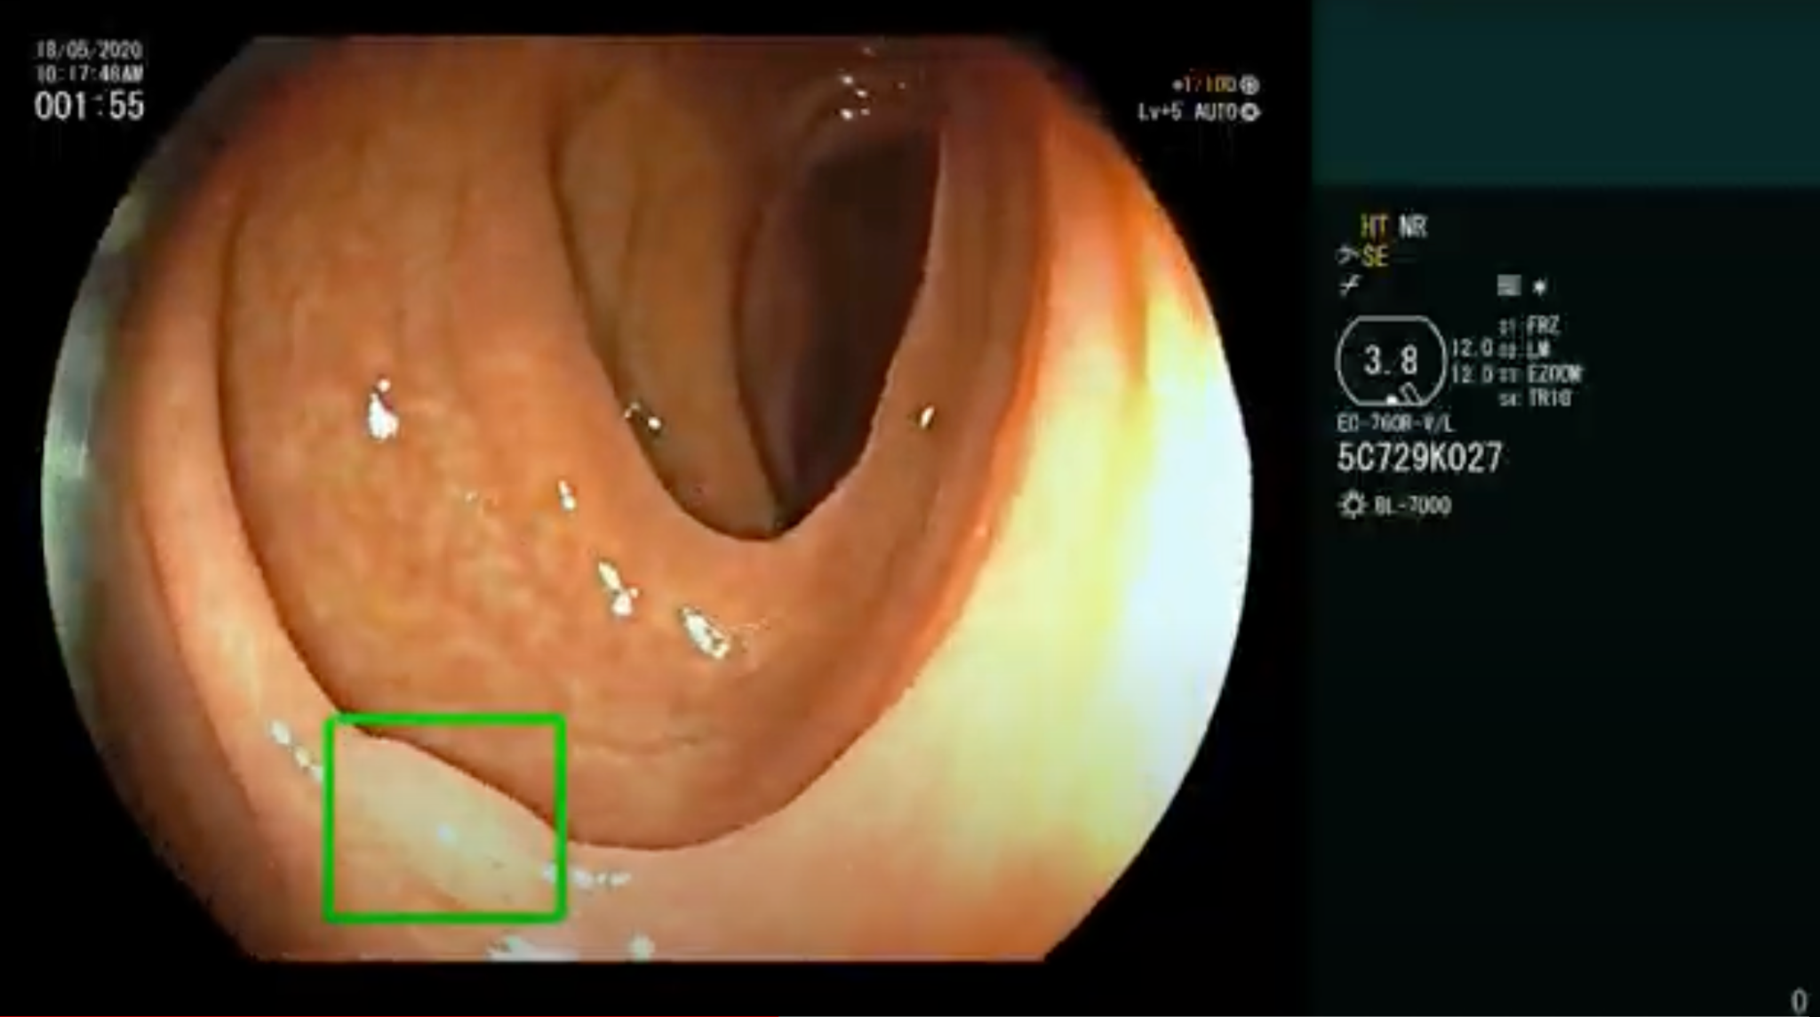
Example video 1. See attached file.

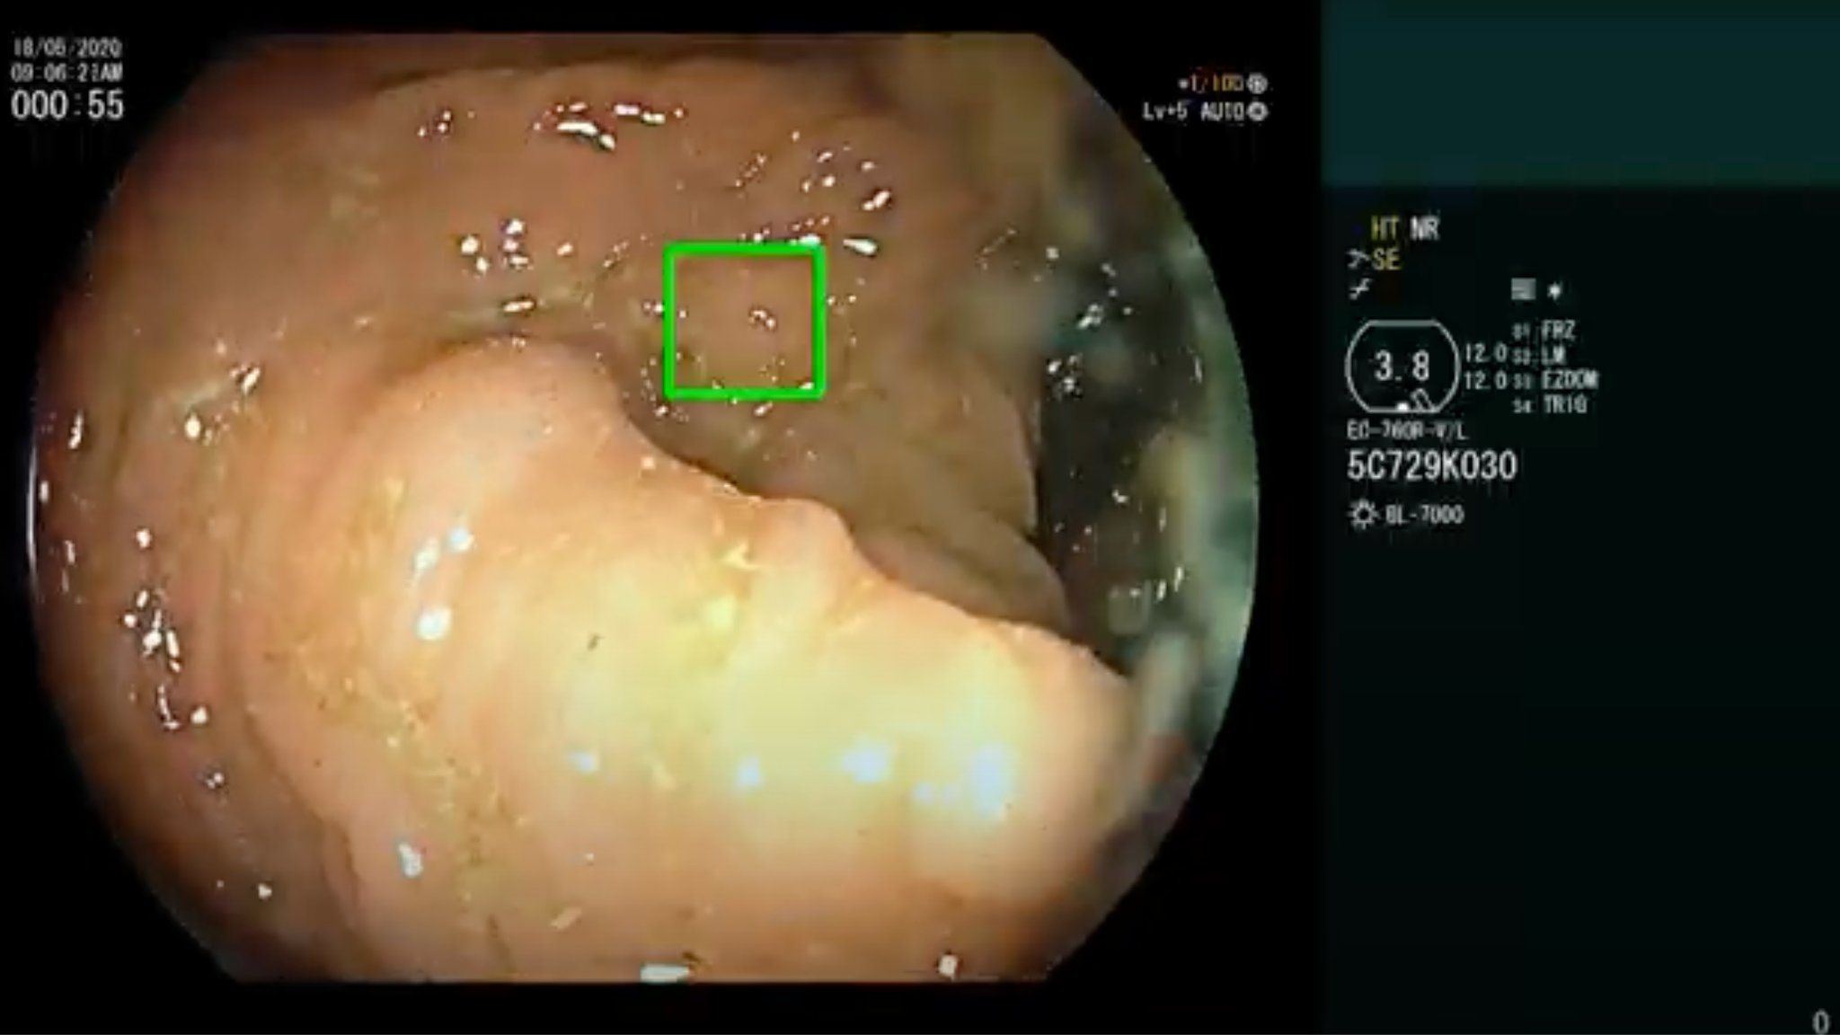
Example video 2. See attached file.
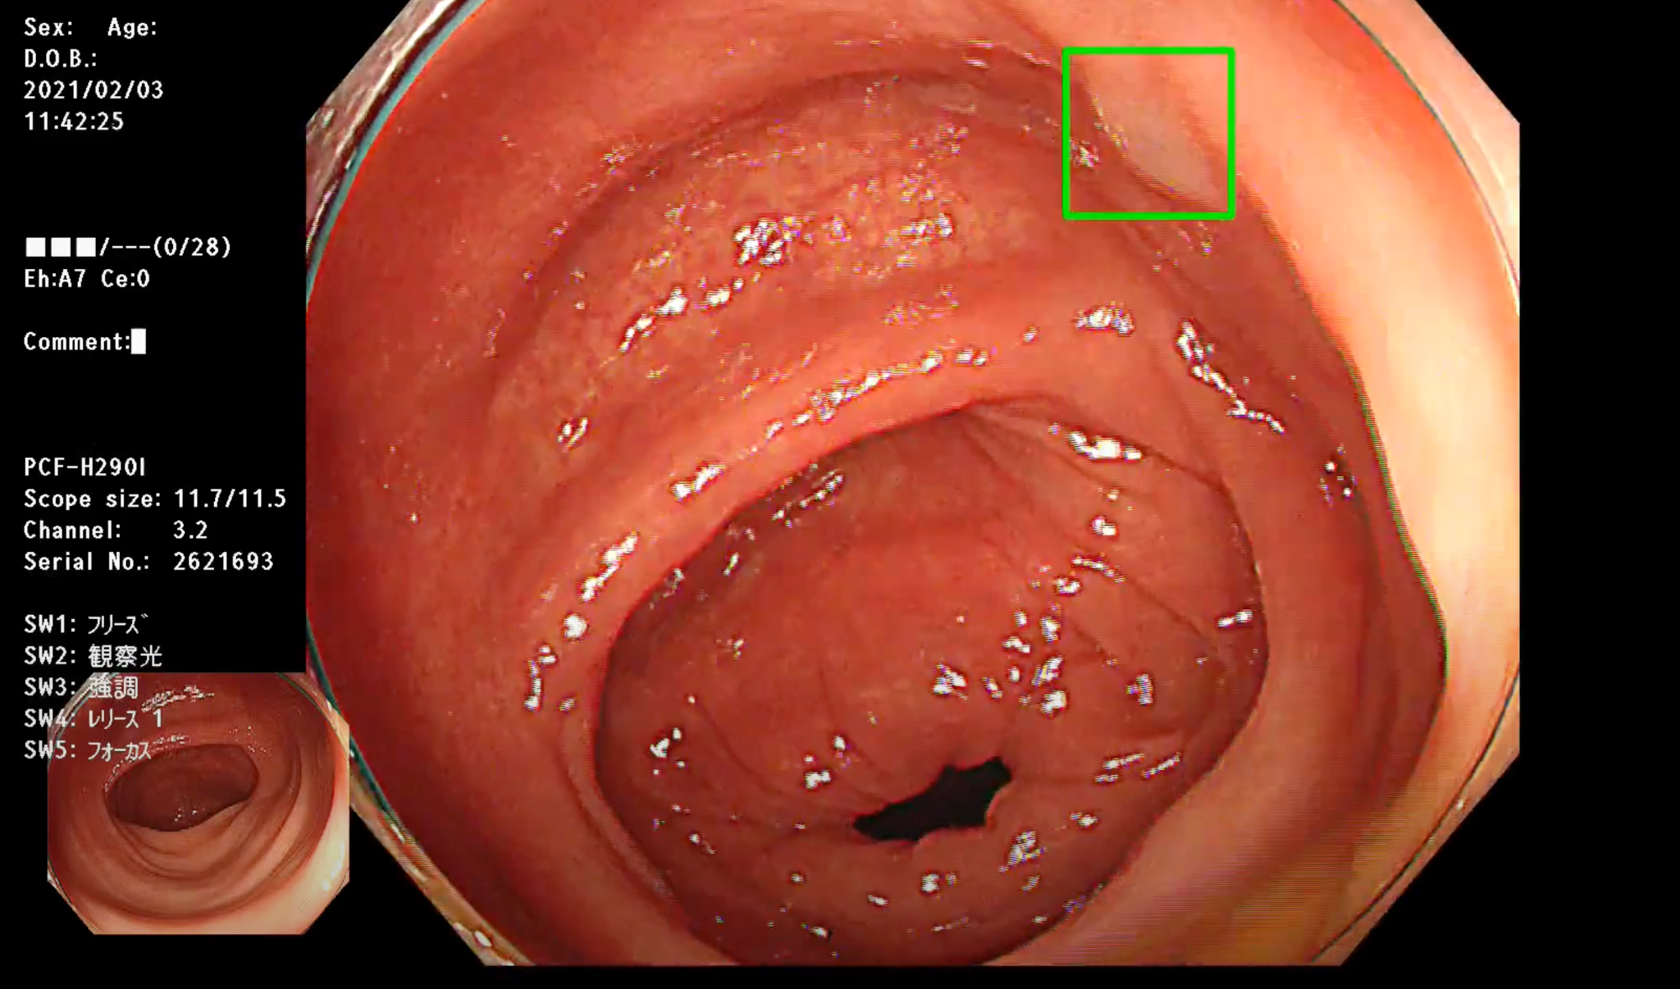
Example video 3. See attached file.

CE Example Video:
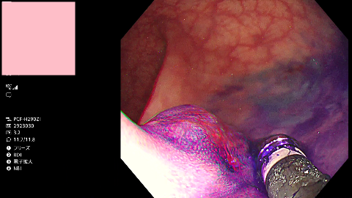
Example video 4. See attached file.

Descriptives
The following endoscope models were used to acquire the colonoscopy videos in Israel and Japan: CF-H180AL, CF-HQ190L, and PCF-Q180AL (Olympus, Tokyo, Japan); EC-760R-V/L, EG-760R, and EC-530LP (Fujifilm, Tokyo, Japan); and EC-3890LK (Pentax, Tokyo, Japan).

There are a number of differences between the colonoscopy videos collected from our Israeli and Japanese sites. The Japanese colonoscopy videos are longer (13 minutes as compared to 22 minutes, on average). There are more polyps per procedure in the Japanese colonoscopy videos (0.7 in Israel as compared to 2.0 in Japan). In addition, NBI and CE are very commonly used in Japanese colonoscopies. 9% of the data in Japan were viewed with NBI (11 hours total) as compared with 0% in Israel. 3% of the data from Japan were viewed with CE (3.8 hours total) as compared to 0% in Israel. For a summary of these differences, see Table 1.

 | Israel train | Israel validation | Japan validation
Videos | 3611 | 1393 | 354
Hours | 796 | 310 | 128
Average video length (minutes) | 13 | 13 | 22
Frames (million) | 86 | 33 | 14
Unique polyps | 2230 | 956 | 721
Polyps per procedure | 0.6 | 0.7 | 2.0
NBI (hours) | 0 | 0 | 11
Polyp seen in NBI (hours) | 0 | 0 | 4
Chromoendoscopy (estimated, hours) | 0 | 0 | 3.8
Polyps seen in chromoendoscopy (hours) | 0 | 0 | 0.8
Nationality of patients | Israel-only | Israel-only | Japan-only
Table S1: Data descriptives between Israeli training, Israeli validation, and Japanese datasets. We highlight in red the clinically meaningful differences between the datasets.

NBI and CE use in Japanese videos were substantial, both in terms of fraction of videos with them and amount of time lesions were viewed using one of these two techniques. Furthermore, NBI was used much more commonly than CE. Of the 353 Japanese videos, 126 had NBI on for at least 5% of the video, and 16 videos had NBI on for at least 20%. 19 videos had CE for at least 5% of the video, and 4 videos had CE for at least 20%.

Data storage and preprocessing
Data was stored privately on the Google Cloud Platform. The entire video is stored on disk, but during inference we exclude the HUD and filter frames that are outside the body [1].

Data Annotation
A schematic of our colonoscopy annotation pipeline is shown in Supplementary Figure S1. The process and figure come from [2].

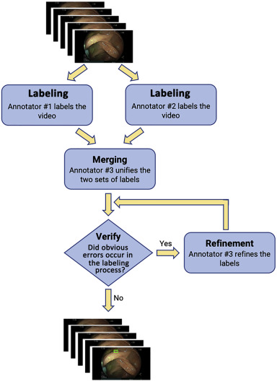
Figure S1: Schematic diagram of annotation procedure. Figure taken from [2]

All the Japanese colonoscopy videos (354 videos, 128 hours) and a random subset of the Israeli colonoscopy videos (5004 videos, 1106 hours) were annotated with polyp locations. The video annotation procedure is identical to [2] (section "Annotation procedure"). To summarize, each video was annotated by board-certified gastroenterologists from Israel and India, drawn from a pool of 20. Each video was labeled by two independent offline gastroenterologists who were not authors of the study. In cases where the two gastroenterologists disagreed, a third, more senior physician made a final decision based on the first two reads. All physicians used a specialized labeling tool to identify polyp bounding boxes. These annotations provide the ground truth for polyp locations. Two physician annotators were independently given the task of identifying the frames with polyps and drawing bounding boxes around them. A third physician annotator verified the accuracy of the annotations, reconciled differences if they existed, and refined the accuracy of the bounding box labels in space and time.

Differences in Japanese data: narrow-band imaging (NBI) and chromoendoscopy (CE)
To identify NBI, we extracted text in the HUD indicating whether NBI had been turned on. This method is completely accurate. To identify CE frames, we identified a range of pixel values that were present during CE and absent in a normal, or “white-light” (WL), Japanese colonoscopy. We detected the presence or absence of pixels in this range, and considered a frame to "have chromoendoscopy" if a sufficient fraction of pixels were in this range. This heuristic approach was validated against manual inspection in 100 randomly selected cases by one of the authors.

CADe Architecture and Training

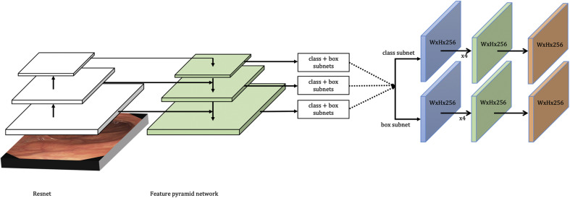
Figure S2: A schematic diagram of the neural network architecture (RetinaNet). Architecture and diagram come from [3].

The detector is a RetinaNet using standard stochastic gradient descent type techniques for minimizing detection loss, with the same procedure and parameters as [2]. We summarize the approach here for convenience.
RetinaNet object detection is a single-shot detector. A large set of candidate object locations, referred to as “anchor boxes,” is sampled across the image (at about 100,000 locations). This set densely covers a grid of spatial positions, with 3 scales and 3 aspect ratios for each position. Features are extracted using a Resnet50v1. This network is applied directly to the image to extract features. The features from each feature pyramid network level are then further fed into 2 subnetworks. First, the classification subnet predicts the probability of object presence at each spatial position for each of the A = 9 anchors per position and K object classes. The subnet is a fully convolutional network that applies four 3 × 3 convolutional layers, each with C = 256 filters and each followed by rectified linear activation function (ReLU) activations, followed by a 3 × 3 convolutional layer with KA filters. Second, the box regression subnet is a fully convolutional network that predicts an offset from each anchor box to a nearby ground-truth object.
Positive frames (ie, frames that contain polyps) are generated as the entire set of video frames annotated as polyps by the annotators as previously described. There are a total of 204,687 positive frames. Negative frames can be any frames that do not contain polyps; because of the large size of the train set, this can be up to 80 million frames. We do not do any explicit class balancing, as the Focal loss [3] is designed to and is empirically capable of handling the large class imbalance present in most object detection tasks.
The parameters for the Median Filtering algorithm were determined by the overall performance on a hold out validation set of videos. No domain adaptation was performed to adapt the network from train to validation. The network, trained as described above, was applied as is to the validation and test sets.

Data from two hospitals were used to train the polyp detector, and data from the third was used for evaluation.

Modifications to detector pipeline
While our study didn't change the CADe polyp detector neural network or filter, there were two important adjustments made to the video preprocessing between Israel and Japan. First, the HUD of the endoscopes used in the Japanese colonoscopies were different than any seen in the Israeli data, so the region-of-interest (ROI) on which the detector was run on was adjusted. Second, an inside-outside model [1] was used to detect which parts of the video were taken from inside the body, and which were outside. We used the inside-outside model to automatically remove the outside-of-the-body sections of the videos.

The model was trained from scratch on data from Israel using standard stochastic gradient descent type techniques for minimizing detection loss, using the same procedure and parameters as [2].

Supplementary Results

NBI and CE distances without labels

 | Embedding
Comparison | MSN | SimCLR | Imagenet | Deep Image Prior
Israel vs  Japan WL | 1323.8  (1318.9, 1328.9) | 16.4  (16.3, 16.6) | 29615.3  (29028.7, 30148.7) | 8.8  (8.7, 8.8)
Israel vs  Japan NBI | 1677.2  (1671.1, 1683.6) | 22.8  (22.6, 22.9) | 60325.2  (59500.8, 61100.0) | 12.8  (12.7, 12.9)
Israel vs  Japan CE | 1898.3  (1892.8, 1903.5) | 40.5  (40.3, 40.7) | 48268.0  (47702.4, 48843.1) | 29.2  (29.1, 29.4)
Japan WL vs Japan NBI | 707.0  (696.5, 717.1) | 25.3  (25.0, 25.6) | 14612.6  (14049.3, 15194.9) | 16.9  (16.7, 17.1)
Japan WL vs Japan CE | 618.2  (609.1, 627.3) | 24.3  (23.9, 24.6) | 20821.9  (20282.7, 21290.5) | 30.6  (30.3, 30.9)
Japan NBI vs Japan CE | 985.0  (971.1, 999.1) | 41.1  (40.5, 41.7) | 28837.8  (27742.5, 29828.2) | 32.0  (31.6, 32.4)
Supplementary Table S2: Frechet distance on MSN embeddings 95% confidence intervals, bootstrapped. 1000 bootstrapping resamples.

Note that by using 95% CI Frechet distances alone (unsupervised), MSN can distinguish all six groups above. SimCLR cannot distinguish Japan NBI and Japan CE, but can distinguish between the others.

Supervised prediction of labels

 | MSN | SimCLR | Inception | Deep Image Prior
Japan WL vs. Israel | 0.99  (0.99, 0.99) | 0.98  (0.97, 0.98) | 0.95  (0.94, 0.96) | 0.95  (0.94, 0.96)
Supplementary Table S3: Supervised prediction task of prediction of Japan vs. Israel using MSN and other embedding spaces. As expected by the significant unsupervised separability, it is easy for an SVM to achieve high performance on this task.

t-SNE Inspection of Detector Performances
We perform t-SNE on MSN embeddings, and label each point with its CADe Polyp detector prediction performance to create a heatmap. (Supplementary Figure S4). While, to the eye, this shows some amount of spatial clustering by detection performance, there are no obvious qualitative patterns. This motivates the supervised approaches applied in the main text.

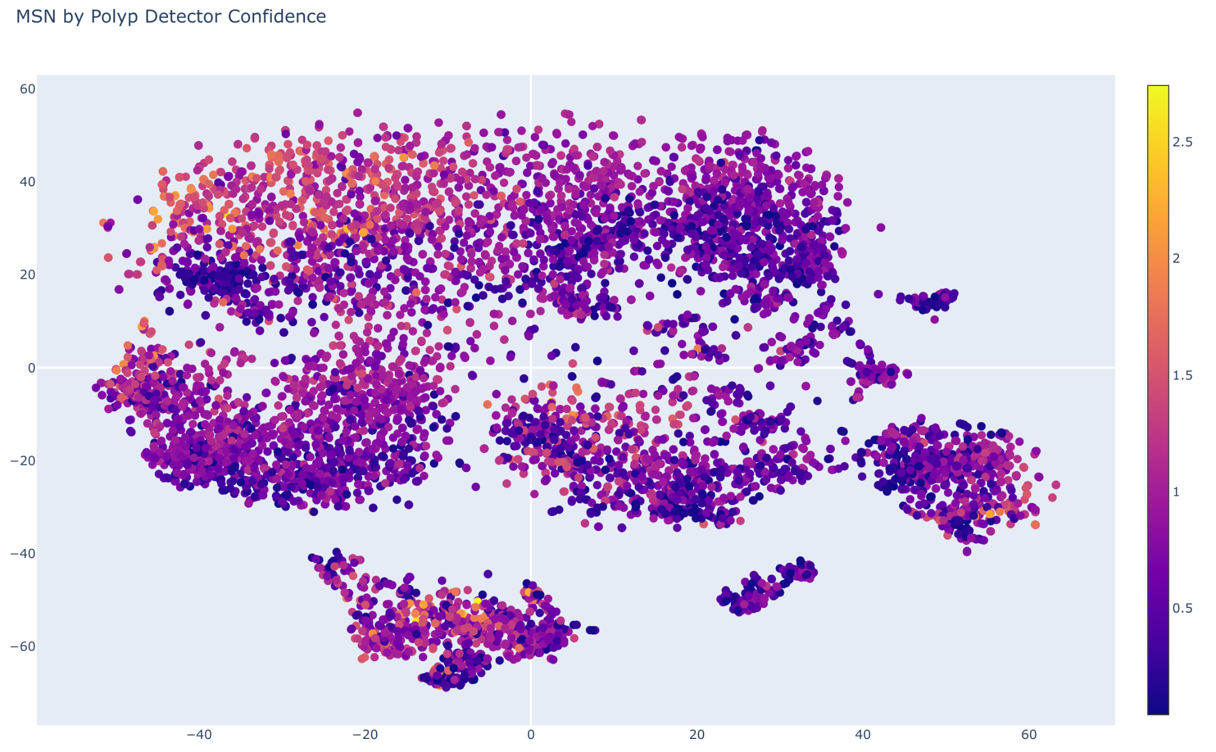
Supplementary Figure S4: All Japanese and Israeli points displayed in a t-SNE plot of MSN space (MSN). The points are colored by the confidence of the detector in its prediction of a polyp. We can see that low-confidence points may qualitatively cluster in a handful of distinct areas, but there is no obvious separating surface.

t-SNE Inspection of Other Embedding Spaces
In addition to SimCLR, we repeat our analysis on two off-the-shelf embedding spaces, Inception v3, and a Deep Image Prior.As mentioned in prior sections, SimCLR is trained on colonoscopy data. Inception is trained on ImageNet, and Deep Image Prior is untrained.

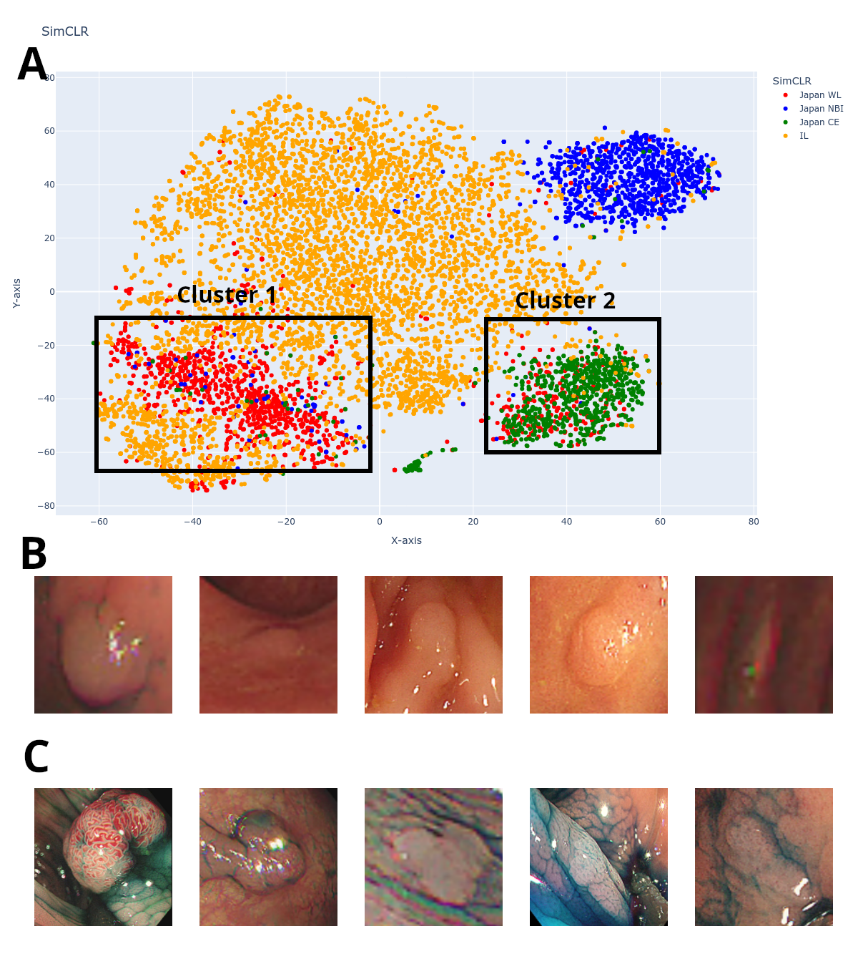
Supplementary Figure S5: Similar to the main text’s Figure 3, but using SimCLR as embeddings instead of MSN. We can still see anomalous mislabellings of CE points in the space provided by SimCLR.

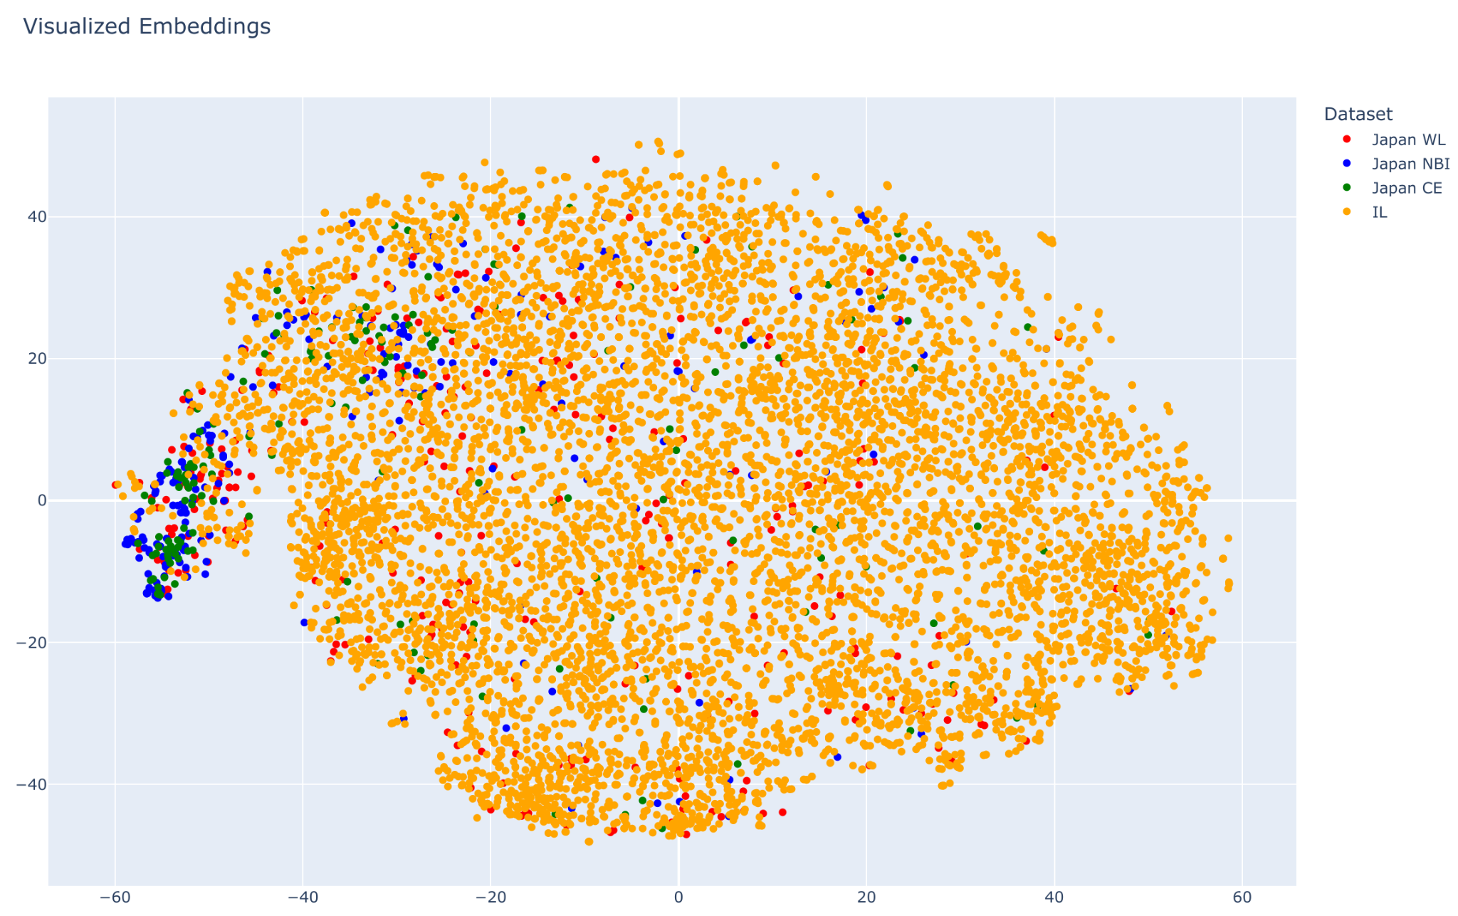
Supplementary Figure 6: A t-SNE of Inception embeddings with NBI, Japanese WL, CE, and Israeli frames labeled. It can be seen that there is some structure to the space, though different labels are not as well-separated as for MSN or SimCLR.

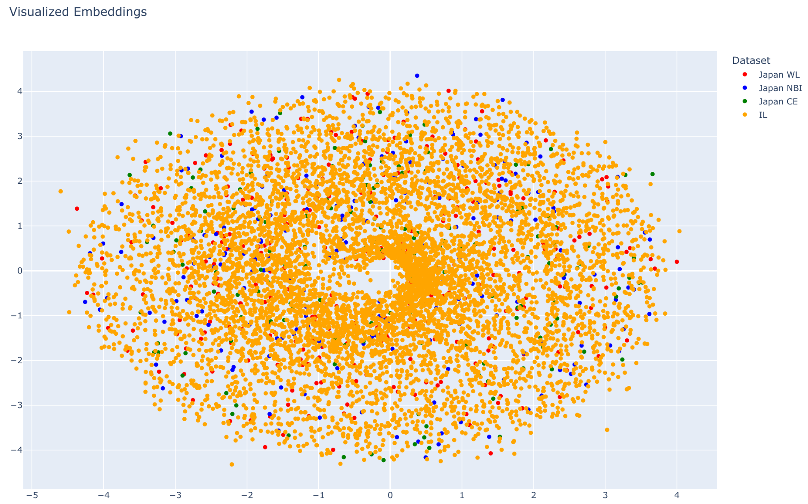
Supplementary Figure 7: A t-SNE of Deep Image Prior embeddings with NBI, Japanese WL, CE, and Israeli frames labeled. It can be seen that there is little structure to the space, with a projection mapping to a ball-like statistical distribution, and points with different semantic labels distributed evenly throughout the space.

Acknowledgements
We would like to thank the following individuals: Anil Patwardhan, for their insightful and incredibly helpful feedback on our manuscript; Mira Fruchter, for her help organizing the data collection efforts; Karen Ouk, for her organizational support on this project; Daniel Freedman, Jonathan Huang, & Vighnesh Birodkar, for their technical assistance; and Verily Life Sciences, for funding this work.

References
- Kelner O, Weinstein O, Rivlin E, Goldenberg R. Semantic Parsing of Colonoscopy Videos with Multi-Label Temporal Networks. IEEE/CVF International Conference on Computer Vision Workshops (ICCVW) 2023;2591-2598.
- Livovsky DM, Veikherman D, Golany T, et al, Detection of elusive polyps using a large-scale artificial intelligence system (with videos), Gastrointestinal Endoscopy 2021;94(6)1099-1109.e10. DOI: 10.1016/j.gie.2021.06.021.
- Lin TY, Goyal P, Girshick R, He K, Dollár P. Focal Loss for Dense Object Detection. IEEE Transactions on Pattern Analysis and Machine Intelligence 2020;42(2):318-327. DOI: 10.1109/TPAMI.2018.2858826.

