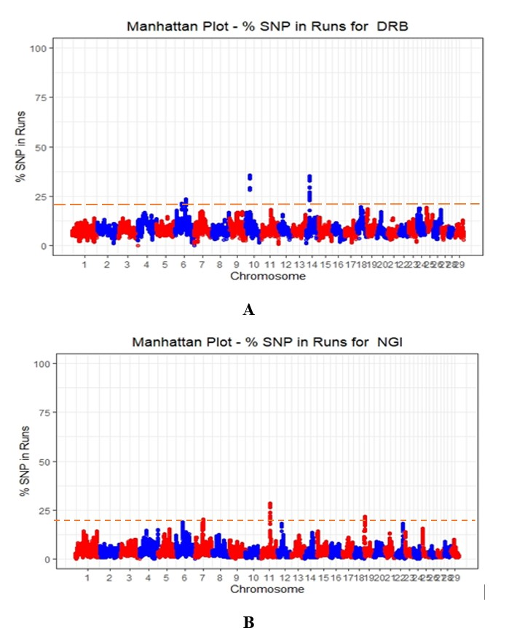
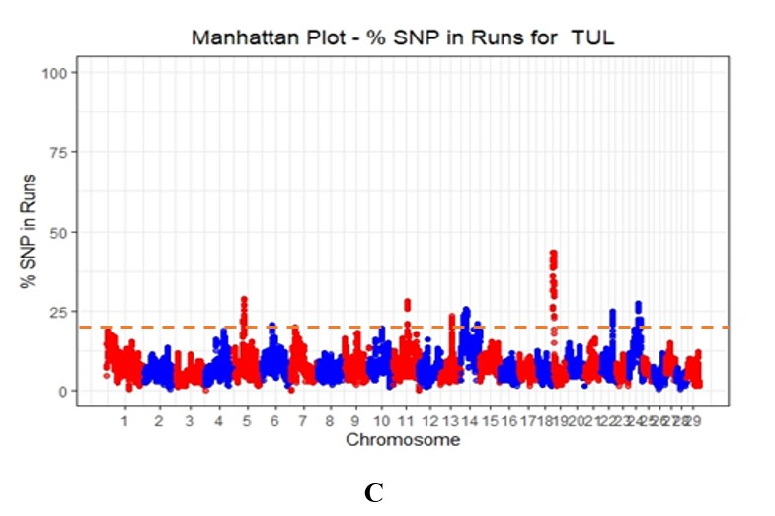
Supplementary Figure 1A, B and C. Manhattan plots for ROH islands distribution across the autosomes in Drakensberger, Nguni, and Tuli Populations. The dotted line represents a threshold of 20% in DRB, NGI, and TUL respectively.
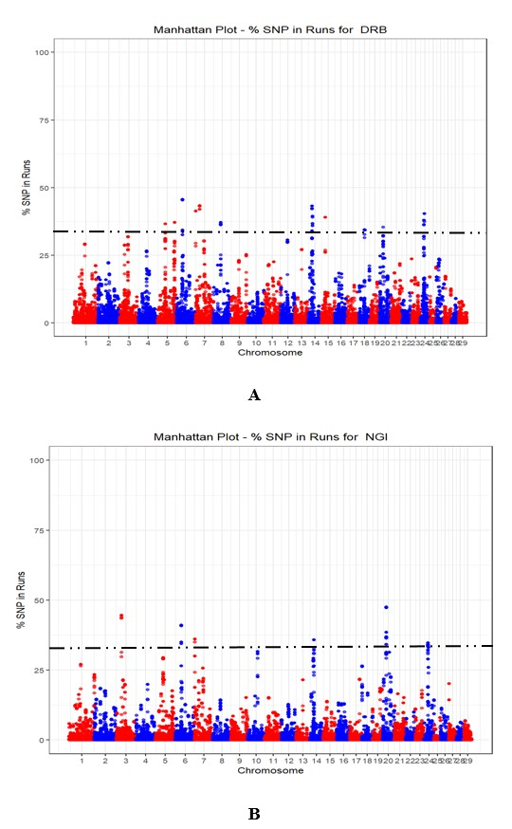
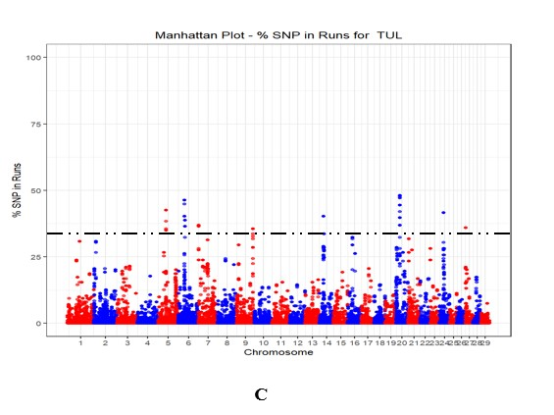
Supplementary Figure 2 A, B, and C Manhattan plots for ROHet islands distribution across the autosomes in Drakensberger, Nguni, and Tuli Populations. The dotted line represents a threshold of 30% in DRB, NGI, and TUL respectively.
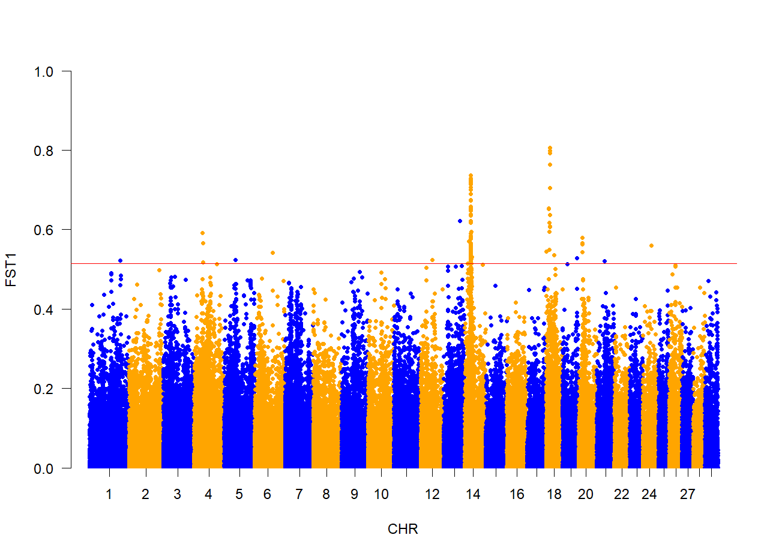
A) DRB vs NGI
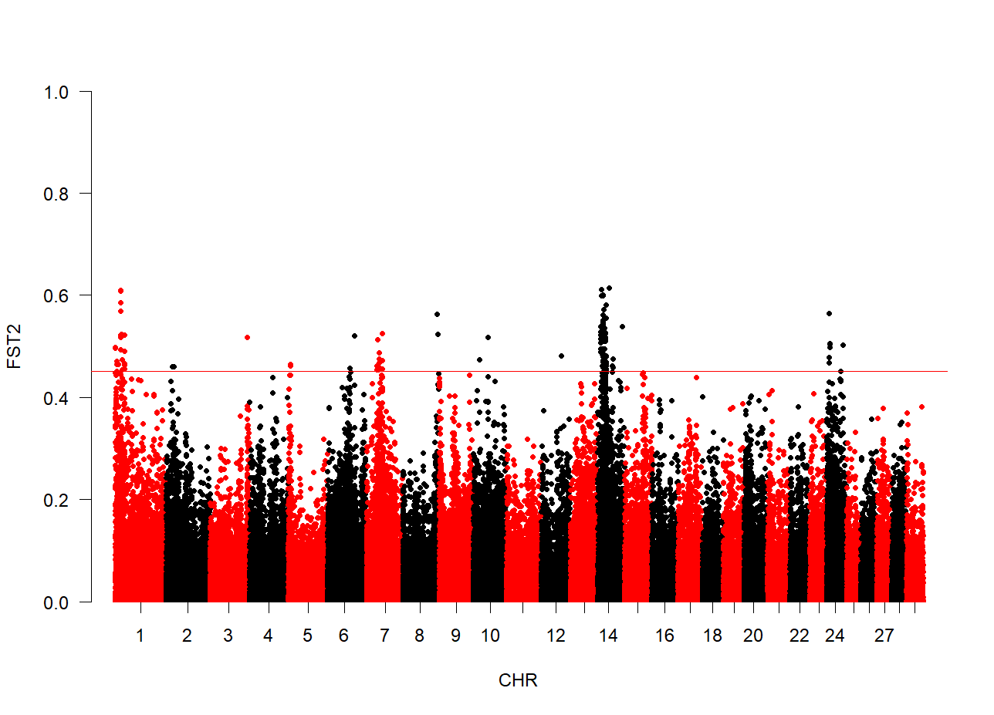
B) NGI vs TUL
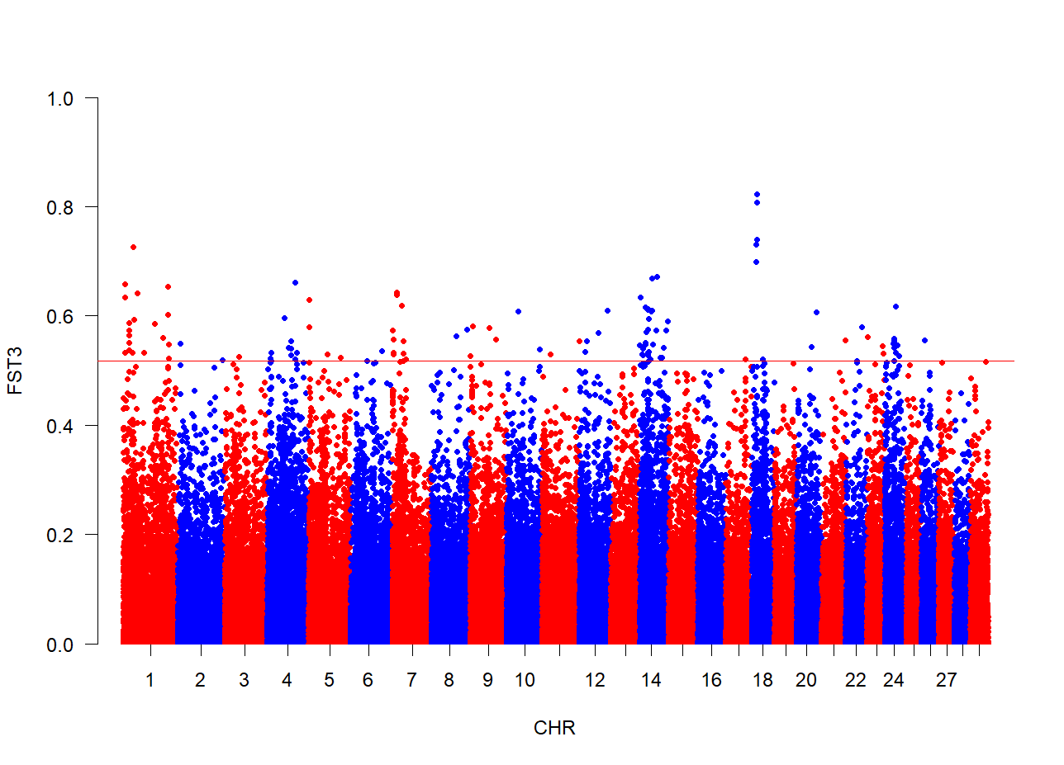
C) DRB vs NGI
Supplementary Figure 3 A, B and C: Manhattan plots for the distribution of top 0.1 FST values within the autosomes for three breed combinations: A) DRB vs NGI, B) NGI vs TUL, and C) DRB vs TUL

