Supplemental Figure 1. VCP identified by proximity labeling from tau aggregation. (A) Western blot probed for biotin using streptavidin-HRP showed the earliest reconstitution of P301S tau-sAPEX2 activity at 5h.

Supplemental Figure 2. Reduction of VCP inhibits tau seeding. (A) Western blot showing KD of VCP compared to scrambled (Scr) control siRNA-treated cells. (B) Images representing tau-clover signal as observed under YFP channel (20x magnification). VCP KD cells are brighter but fewer in number due to reduced cell proliferation. (C) Flow plots depicting a shift in dual positive biosensor population in quadrant 2 (Q2) for the VCP KD cell line, highlighting the increase in fluorescence levels of the biosensors as observed under the microscope. The population size, however, is reduced, indicating reduced cell proliferation. (D) Flow plots showing no background spontaneous seeding (FRET+ values) in the VCP KD cells in the absence of exogenous tau fibrils, despite the increased basal fluorescence.

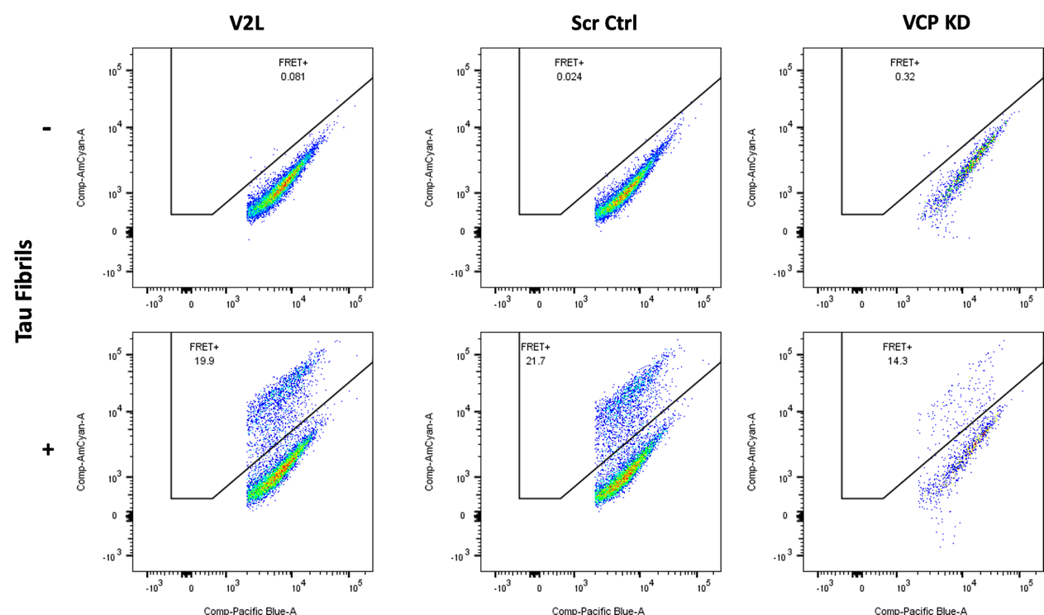
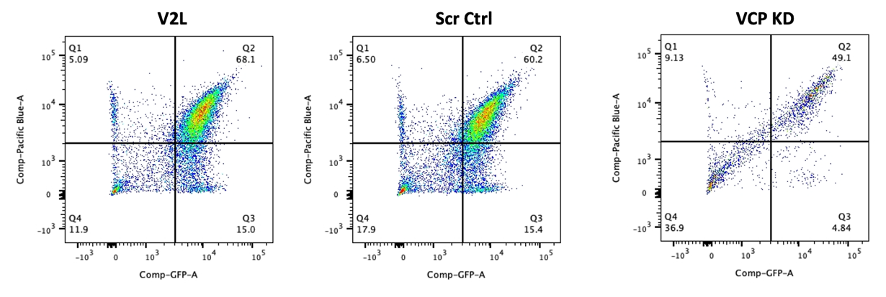
Supplemental Figure 3. ML-240 increases tau aggregation kinetics.
(A) ML-240 increased the kinetics of tau seeding with FRET signal detectable by 8 h.

Supplemental Figure 4. ML-240 induces Gal3 puncta formation. U2OS cells overexpressing galectin-3-mRuby3 were treated with different compounds for 5h prior to media replacement. (A) ML-240 (3μM) and LLOMe (1mM) induced Gal3 puncta, while NMS-873 (3μM) did not. Co-treatment of ML-240 and NMS-873 also induced Gal3 puncta. Representative images of n=3 independent experiments taken before media replacement (5h of compound alone incubation). Scale bar = 100μm.

Supplemental Figure 5. VCP inhibition impacts tau seeding early in the process. (A) ML-240 increased, and NMS-873 decreased tau aggregation only <8h of seed exposure, represented by the tau-clover images at the indicated time points, taken on the YFP channel at 20x magnification.

Supplemental Figure 6. Acute VCP inhibition impacts tau seeding in human neurons. (A) Differentiated iPSC human neurons were transduced with tau RD(P301S)-clover/ruby lentivirus for 48h followed by seeding in the presence or absence of VCP inhibitors. Neurons were co-treated were tau fibrils and inhibitors for 4h prior to media replacement. FRET signal was measured at 48h. (B) Acute exposure with ML-240 (1μM) enhanced seeded tau aggregation whereas (C) NMS-873 (100nM) reduced tau aggregation. Error bars represent S.D. Representative data for n=3 independent experiments. Each dot represents an image taken per condition, with 4 different points captured per well, for a total of 5 wells per condition.
P values: **** < 0.0001, ** 0.0017; Paired t-test with a 95% confidence interval.

Supplemental Figure 7. ML-240 enhances seeding by recombinant α-synuclein.
α-syn(A53T)-CFP/YFP biosensors were seeded with recombinant synuclein fibrils. (A) ML-240 increased α-synuclein seeding. Error bars represent S.D. Representative data for n=3 independent experiments. No seeding was observed in the absence of compound. P value, **** <0.0001; One-Way ANOVA with a 95% confidence interval.
(B) Representative fluorescence microscopy images for effects of ML-240 on α-synuclein seeding (20x magnification).

Supplemental Figure 8. VCP cofactors differentially regulate tau seeding. (A) Graphs representing the % FRET+ signal for cofactors (KO and KD) that did not affect tau seeding. (B) KO of UBXN6 increased tau seeding but the effect was most pronounced at higher tau concentrations. Error bars represent S.D. Graph representative of n=3 independent experiments. (C) KO of FAF2 caused spontaneous aggregation as observed by tau-clover puncta in the YFP channel. (D) Flow plots depict spontaneous aggregation in the FAF2 KO cells in the absence of exogenously added tau seeds as recorded by FRET signal. (E) Western blots indicate absence of FAF2, ATXN3, NSFL1C, and UBE4B in respective knockout cells lines. Non-targeting guide (NTG) was used as a negative control. (F) Representative images showing increased basal fluorescence in NPLOC4 KD biosensors. (G) Flow plots depict a shift in dual positive biosensor population in quadrant 2 (Q2) for the NPLOC4 KD cell line indicating the increase in fluorescence levels of the biosensors as also observed under the microscope. (H) Flow plots indicate no background spontaneous aggregation in the NPLOC4 KD cells in the absence of exogenous tau fibrils, despite the increase in basal fluorescence. (I) Western blots indicate reduced protein levels of the cofactors in their respective KD cell lines. Scrambled siRNA (Scr) treated cell line was a negative control.

