Derivation and Validation of Generalized Sepsis-induced Acute Respiratory Failure Phenotypes Among Critically Ill Patients: A Retrospective Study

Tilendra Choudhary (PhD), Pulakesh Upadhyaya (PhD), Carolyn M. Davis (MD), Philip Yang (MD, MSc), Simon Tallowin (BMBS, MSc), Felipe A. Lisboa (MD), Seth A. Schobel (PhD), Craig M. Coopersmith (MD), Eric A. Elster (MD), Timothy G. Buchman (MD), Christopher J. Dente (MD), Rishikesan Kamaleswaran (PhD)

Online Data Supplement Information

Supplemental Table E1. Summary of electronic medical record (EMR)-based clinical variables or features (f1-f50) used in our study. ………………………………………………………………………………………………. Page 3
Supplemental Figure E1. Radar diagrams showing distribution variations of normalized clinical features (f1-f50) by their average values across different phenotypes of the derivation and validation data. Meanings of feature labels (f1-f50) are exactly same as listed in Table E1. ……………………………………………………………………. Page 4
Supplemental Figure E2. Radar diagrams showing variability in demographic variables (age, sex, race, ethnicity) and mortality outcomes (in %) across different phenotypes of the derivation and validation data. …………..... Page 5
Supplemental Figure E3. Shapley Additive exPlanations (SHAP) beeswarm plots highlighting the dominant features to characterize each of the four clusters as phenotypes. It presents SHAP plots for (a) phenotype A, (b) phenotype B, (c) phenotype C, and (d) phenotype D. ………………………………………………………………………… Page 6
Supplemental Figure E4. Performance of ML classifiers built on the derivation data for predicting multiclass phenotypes showing ROC curves and area under the ROC curves (AUC). Logistic regression outperforms others. …………………………………………………………………………………………………………………... Page 7
Supplemental Figure E5. Performance of best performing model logistic regression for phenotype prediction in terms of (a) normalized confusion matrix, and (b) classification metrics. …………………………………..………... Page 7
Supplemental Table E2. Summary of patient characteristics of the validation cohort (Emory SICU) and its phenotypes. …………………………………………………………………………………………………...… Page 8
Supplemental Table E3. Summary of patient characteristics of the validation cohort (Grady SICU) and its phenotypes. …………...………………………………………………………………………………………… Page 9
Supplemental Figure E6. UMAP representation of the derivation data showing distribution of patient encounters from 2020-21 (COVID-19 years; orange colored) is same as patients from other study years (blue colored). .. Page 10
Supplemental Table E4. Maximum individual SOFA per phenotype in 24-hour pre-intubation region for Emory MICU data. …………………………………………………………………………………………………….. Page 11
Supplemental Table E5. Maximum individual SOFA per phenotype in 24-hour pre-intubation region for Grady MICU data. ……………………………………………………………………………………………………. Page 12
Supplemental Table E6. Maximum individual SOFA per phenotype in 24-hour pre-intubation region for Emory SICU data. ………………………………………………….…………………………………………………. Page 13
Supplemental Table E7. Maximum individual SOFA per phenotype in 24-hour pre-intubation region for Grady SICU data. ………………………………………..…………………….……………………………………………. Page 14

Supplemental Table E1. Summary of electronic medical record (EMR)-based clinical variables or features (f1-f50) used in our study.
List of routine clinical variables selected in the study: variable names and their meanings
f1 - temperature: Body temperature (ºC)  f2 - sbp_cuff: Cuff-based systolic blood pressure (mmHg)  f3 - dbp_cuff: Cuff-based diastolic blood pressure (mmHg)  f4 - pulse: Pulse rate (beats per minute)  f5 - unassisted_resp_rate: Respiratory rate (breaths/min.)  f6 - spo2: Blood saturated oxygen concentration, SpO₂ level (%)  f7 - end_tidal_co2: End-tidal CO₂ (mmHg)  f8 - o2_flow_rate: (L/minute)  f9 - bicarb_(hco3): (mmol/L)  f10 - blood_urea_nitrogen_(bun): (mg/dL)  f11 - calcium (mg/dL)  f12 - calcium_ionized (mg/dL)  f13 - chloride (mEq/L)  f14 - creatinine: (mg/dL)  f15 - glucose (mmol/L)  f16 - magnesium (mg/dL)  f17 - osmolarity (mOsm/kg)  f18 - phosphorus (mg/dL)  f19 - potassium (mEq/L)  f20 - sodium (mEq/L)  f21 - hemoglobin: (g/dL)  f22 - met_hgb: (g/dL)  f23 - platelets: (×10⁹/L)  f24 - white_blood_cell_count: (×10⁹/L)  f25 - carboxy_hgb (%) | f26 - alanine_aminotransferase_(alt) (U/L)  f27 - albumin: (g/L)  f28 - alkaline_phosphatase (IU/L)  f29 - ammonia: (µg/dL)  f30 - bilirubin_direct: (mg/dL)  f31 - bilirubin_total: (mg/dL)  f32 - fibrinogen: (mg/dL)  f33 - inr: International Normalized Ratio  f34 - lactate_dehydrogenase: (IU/L)  f35 - lactic_acid: (mmol/L)  f36 - partial_prothrombin_time_(ptt): (s)  f37 - protein: (g/dL)  f38 - lipase: (U/L)  f39 - b-type_natriuretic_peptide_(bnp): B-type natriuretic peptide (pg/ml)  f40 - troponin: (ng/mL)  f41 - fio2: Fraction of inspired oxygen (range: 0-1)  f42 - partial_pressure_of_carbon_dioxide_(paco2):  PaCO₂ (mmHg)  f43 - partial_pressure_of_oxygen_(pao2): PaO₂ (mmHg)  f44 - ph  f45 - saturation_of_oxygen_(sao2) (%)  f46 - d_dimer: (ng/mL)  f47 - hemoglobin_a1c (%)  f48 - best_map: Mean arterial pressure (mmHg)  f49 - pf_sp: SpO2/FiO2 ratio  f50 - pf_pa: PaO2/FiO2 ratio (mmHg)

Supplemental Figure E1.

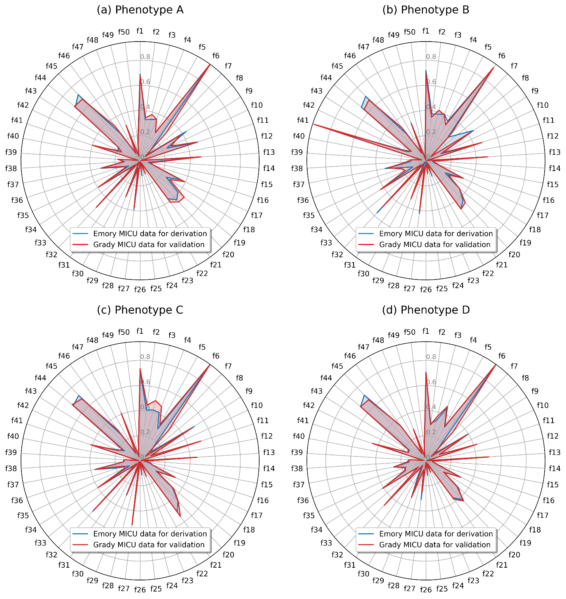

Supplemental Figure E2.
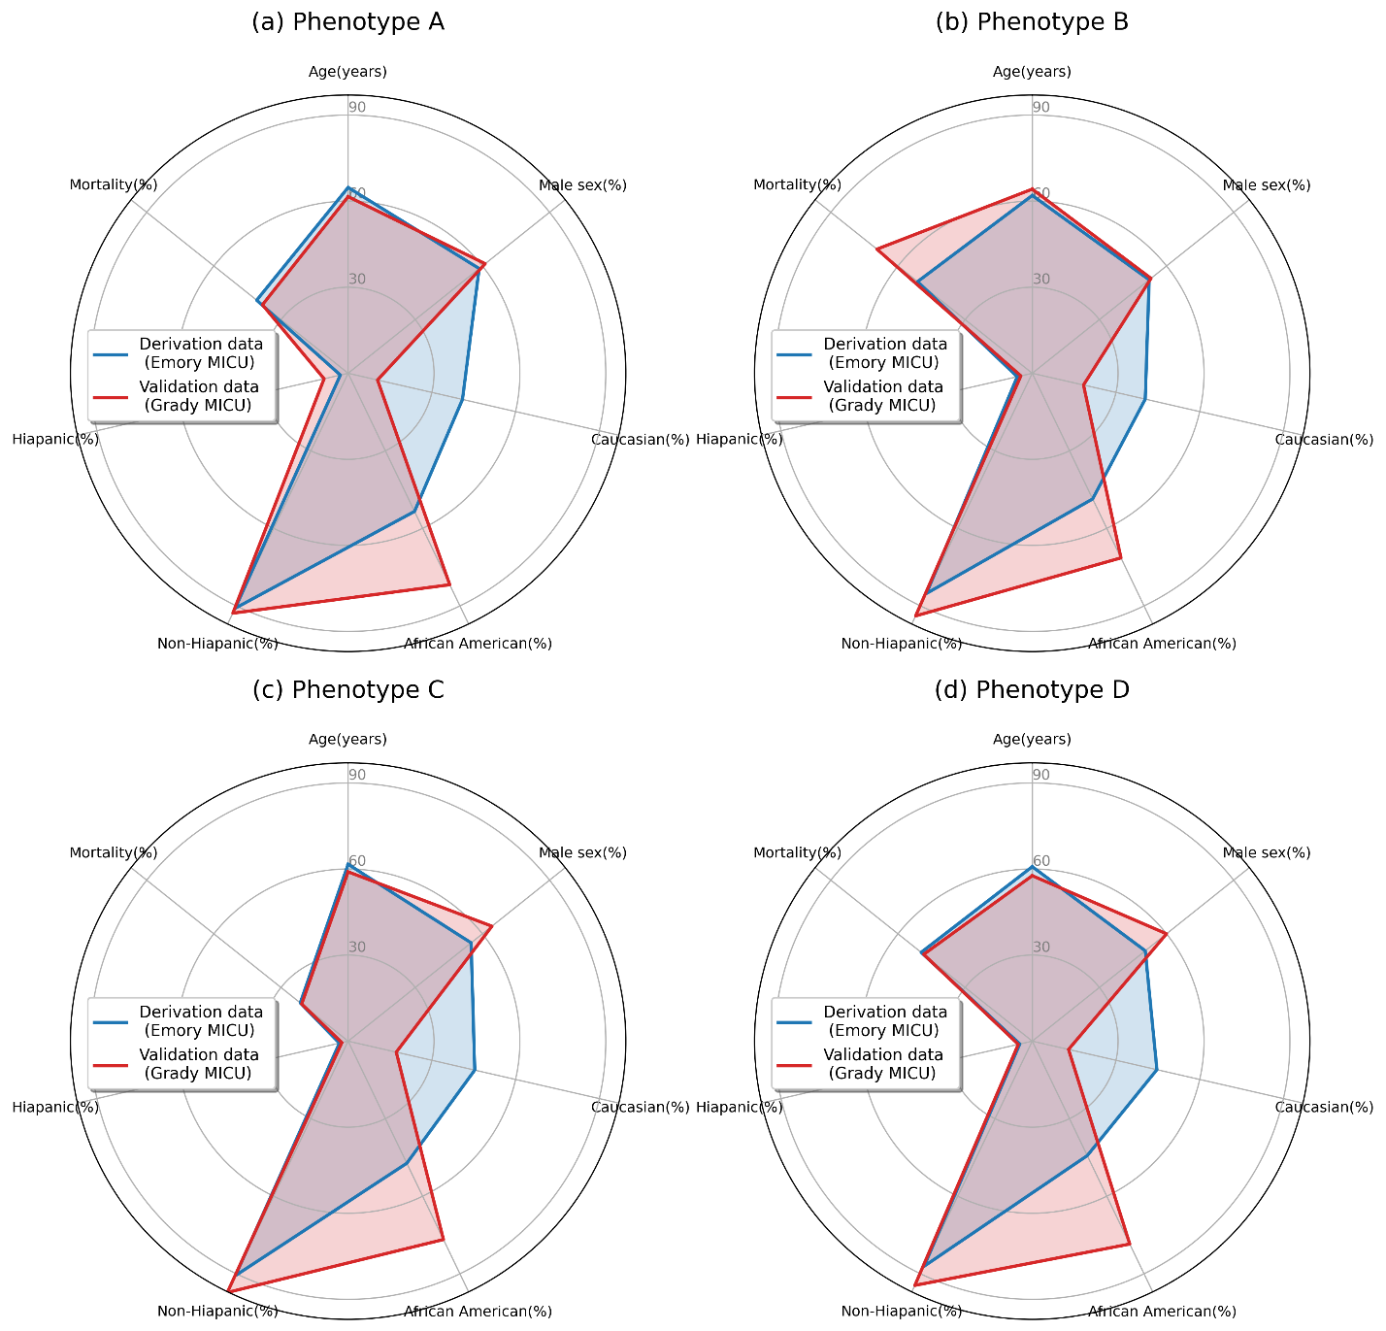

Supplemental Figure E3.
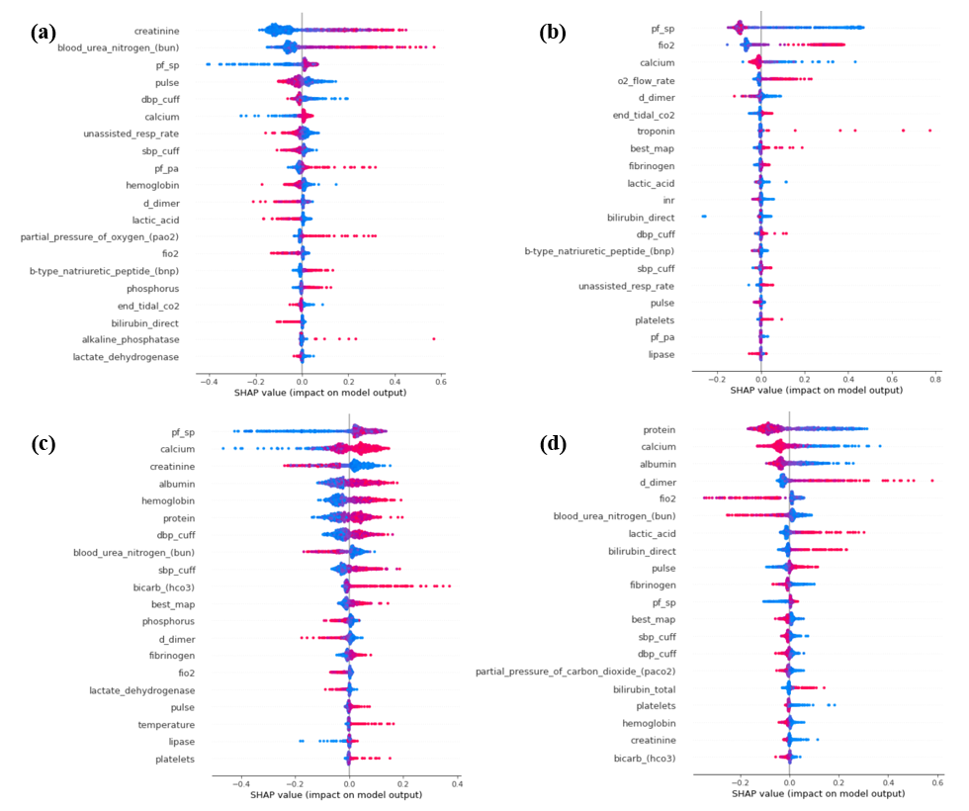

Supplemental Figure E4.
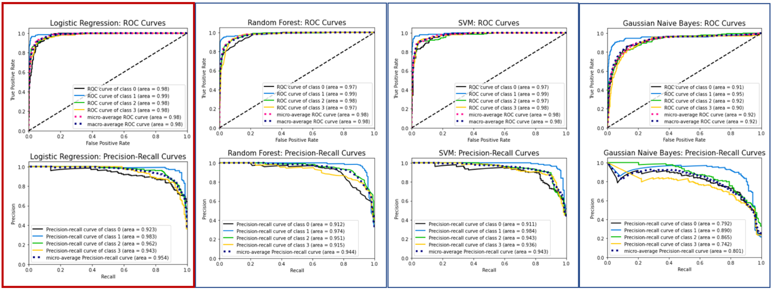

Supplemental Figure E5.
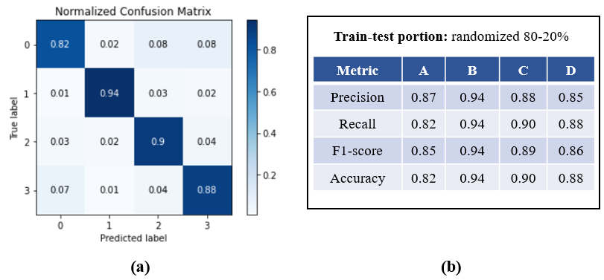

Supplemental Table E2:

Parameters | Whole cohort | A | B | C | D | p-value
count (%) | 1128 (100) | 818 (72.5) | 39 (3.5) | 259 (23) | 12 (1.1) | -
Mortality* | 255, 22.93% | 196, 24.32% | 13, 33.33% | 42, 16.22% | 4, 33.33% | -
Age, mean(std) | 60.4 (14.6) | 61.1 (14.1) | 59.5 (16.9) | 58.8 (15.4) | 49.3 (18.2) | 0.008
Males, count (%) | 661 (58.6) | 477 (58.3) | 18 (46.2) | 161 (62.2) | 5 (41.7) | -
Race: African American or Black, count (%) | 465 (41.2) | 333 (40.7) | 17 (43.6) | 111 (42.9) | 4 (33.3) | 0.948
Race: Caucasian or White, count (%) | 560 (49.6) | 407 (49.8) | 20 (51.3) | 126 (48.6) | 7 (58.3) | 0.948
Ethnicity: Hispanic, count (%) | 34 (3.0) | 22 (2.7) | 2 (5.1) | 10 (3.9) | 0 (0) | 0.848
Ethnicity: Non-Hispanic, count (%) | 1011 (89.6) | 739 (90.3) | 34 (87.2) | 227 (87.6) | 11 (91.7) | 0.848
P/F ratio, m(IQR) | 262.5 [183.5,344.0] | 280.0 [202.5,362.5] | 109.3 [74.1,143.0] | 225.0 [172.4,299.2] | 260.7 [190.0,305.6] | <0.001
S/F ratio, m(IQR) | 247.5 [211.1,316.7] | 250.0 [232.5,322.6] | 98.5 [94.9,121.6] | 245.0 [198.9,283.5] | 243.8 [211.3,264.3] | <0.001
FiO₂, m(IQR) | 0.4 [0.3,0.5] | 0.4 [0.3,0.4] | 1.0 [0.8,1.0] | 0.4 [0.3,0.5] | 0.4 [0.4,0.5] | <0.001
PaO₂, m(IQR) | 102.0 [84.0,130.0] | 106.0 [87.0,135.0] | 74.0 [67.5,91.5] | 93.0 [80.0,116.2] | 106.0 [90.0,122.5] | <0.001
PaCO₂, m(IQR) | 38.0 [34.0,43.0] | 38.0 [34.0,42.0] | 36.0 [32.0,44.0] | 39.9 [36.0,46.0] | 33.0 [24.0,39.5] | <0.001
MAP, m(IQR) | 83.5 [78.0,91.0] | 82.0 [77.0,89.0] | 88.5 [77.6,95.3] | 88.2 [83.0,97.0] | 76.8 [75.4,80.1] | <0.001
Creatinine, m(IQR) | 1.2 [0.8,2.2] | 1.4 [0.9,2.7] | 1.2 [0.8,1.7] | 0.9 [0.7,1.3] | 1.5 [1.0,2.3] | <0.001
Bilirubin total, m(IQR) | 0.7 [0.5,1.3] | 0.8 [0.5,1.5] | 0.7 [0.5,1.3] | 0.6 [0.5,0.9] | 1.1 [0.7,3.9] | 0.001
Albumin, m(IQR) | 2.8 [2.4,3.3] | 2.7 [2.3,3.2] | 2.8 [2.5,3.3] | 3.4 [2.8,3.8] | 2.2 [1.9,2.7] | <0.001
Lactic acid, m(IQR) | 1.5 [1.2,2.0] | 1.5 [1.2,2.0] | 1.9 [1.3,2.4] | 1.5 [1.2,1.8] | 1.9 [1.7,4.2] | 0.005
D-dimer, m(IQR) | 3652.0 [1496.8,8418.5] | 4143.0 [1687.0,9999.0] | 2160.5 [1563.0,5248.8] | 2396.8 [1101.8,5710.0] | 7475.0 [2723.5,11287.5] | 0.026
Platelets, m(IQR) | 210.5 [139.8,288.0] | 202.0 [130.0,285.1] | 197.0 [148.0,240.0] | 234.0 [176.0,303.5] | 96.5 [46.8,186.2] | <0.001
Hemoglobin, m(IQR) | 9.4 [8.2,11.1] | 8.8 [8.0,10.2] | 10.4 [8.8,12.0] | 11.8 [10.2,13.5] | 8.9 [8.4,9.5] | <0.001
BNP, m(IQR) | 328.0 [110.5,831.0] | 444.0 [147.6,998.2] | 250.5 [80.8,479.5] | 126.0 [42.0,432.0] | 440.5 [195.2,1190.5] | <0.001
BUN, m(IQR) | 25.0 [16.0,40.0] | 29.0 [19.0,47.0] | 29.0 [19.5,44.5] | 17.0 [12.0,23.9] | 14.5 [10.5,27.2] | <0.001
SOFA max total, m(IQR) | 7.0 [4.0,9.0] | 7.0 [5.0,9.0] | 7.0 [5.0,9.0] | 5.0 [4.0,8.0] | 11.0 [8.0,12.0] | <0.001
GCS total score, m(IQR) | 15.0 [13.0,15.0] | 15.0 [13.0,15.0] | 15.0 [11.0,15.0] | 15.0 [13.0,15.0] | 14.5 [11.5,15.0] | 0.783
PEEP, m(IQR) | 6.0 [6.0,8.0] | 6.0 [6.0,8.0] | 10.0 [8.0,12.0] | 6.0 [6.0,10.0] | 7.0 [5.8,8.5] | <0.001
For clinical variables, this table lists the medians and interquartile ranges (IQR: Q1-Q2) for each phenotype as well as for the whole cohort. The p-value is also provided for each variable to indicate the statistical significance of the differences among the phenotypes. For evaluating statistical significance, Kruskal-Wallis test was performed for continuous variables and Chi-squared test was used for categorical variables. *Mortality was computed with respect to patients (not encounters). Abbreviations used — count: total encounters, mean: average, std: standard deviation, m: median, IQR: interquartile range, PaO₂: partial pressure of oxygen, SpO₂: peripheral oxygen saturation level, FiO₂: fraction of inspired oxygen, P/F: PaO₂/FiO₂ ratio, S/F: SpO₂/FiO₂ ratio, PaCO₂: partial pressure of carbon dioxide in arterial blood, MAP: mean arterial blood pressure, Resp.: respiration, BNP: B-type natriuretic peptide, BUN: blood urea nitrogen, SOFA: sequential organ failure assessment, GCS: Glasgow coma scale. Measurement units — P/F ratio, PaO2, PaCO2, and MAP: mmHg; S/F ratio and FiO₂: unitless; creatinine and bilirubin total: mg/dL; albumin: g/L; lactic acid: mmol/L; D-dimer: ng/mL; platelets: ×10³/µL; hemoglobin: g/dL; BNP: pg/mL; BUN: mg/dL.

Supplemental Table E3:

Parameters | Whole cohort | A | B | C | D | p-value
count (%) | 466 (100) | 133 (28.5) | 5 (1.1) | 264 (56.7) | 64 (13.7) | -
Mortality* | 91, 19.57% | 32, 24.06% | 4, 80% | 32, 12.12% | 23, 35.94% | -
Age, mean(std) | 56.0 (16.4) | 60.2 (15.4) | 61.6 (6.2) | 53.9 (16.1) | 55.4 (18.5) | 0.003
Males, count (%) | 284 (60.9) | 74 (55.6) | 1 (20.0) | 175 (66.3) | 34 (53.1) | -
Race: African American or Black, count (%) | 354 (76.0) | 106 (79.7) | 5 (100.0) | 194 (73.5) | 49 (76.6) | 0.497
Race: Caucasian or White, count (%) | 77 (16.5) | 16 (12.0) | 0 (0) | 49 (18.6) | 12 (18.8) | 0.497
Ethnicity: Hispanic, count (%) | 20 (4.3) | 4 (3.0) | 0 (0) | 12 (4.5) | 4 (6.2) | 0.928
Ethnicity: Non-Hispanic, count (%) | 443 (95.1) | 128 (96.2) | 5 (100.0) | 250 (94.7) | 60 (93.8) | 0.928
P/F ratio, m(IQR) | 305.0 [245.0,365.0] | 334.3 [290.5,382.0] | 94.3 [85.5,202.0] | 292.5 [236.3,357.5] | 284.2 [251.4,333.8] | <0.001
S/F ratio, m(IQR) | 250.0 [242.5,250.0] | 250.0 [245.9,267.3] | 100.8 [100.0,104.4] | 250.0 [242.5,250.0] | 249.5 [235.1,250.0] | <0.001
FiO₂, m(IQR) | 0.4 [0.4,0.4] | 0.4 [0.4,0.4] | 0.9 [0.9,1.0] | 0.4 [0.4,0.4] | 0.4 [0.4,0.4] | <0.001
PaO₂, m(IQR) | 121.0 [99.0,144.0] | 137.0 [114.0,151.0] | 79.0 [76.0,100.0] | 114.0 [96.5,141.0] | 111.5 [99.8,127.5] | <0.001
PaCO₂, m(IQR) | 37.0 [33.0,41.0] | 36.0 [31.0,40.0] | 43.0 [35.0,50.0] | 38.0 [34.0,41.0] | 36.5 [30.8,40.0] | 0.008
MAP, m(IQR) | 89.0 [82.0,95.5] | 84.8 [77.0,91.0] | 78.0 [77.5,80.0] | 93.0 [87.0,98.0] | 81.0 [76.0,86.6] | <0.001
Creatinine, m(IQR) | 1.2 [0.8,2.0] | 2.6 [1.5,5.4] | 1.1 [1.1,1.5] | 1.0 [0.8,1.4] | 1.1 [0.9,1.7] | <0.001
Bilirubin total, m(IQR) | 0.7 [0.5,1.3] | 0.6 [0.4,1.2] | 0.8 [0.4,1.4] | 0.7 [0.5,1.2] | 1.1 [0.6,2.3] | 0.001
Albumin, m(IQR) | 3.0 [2.4,3.4] | 2.7 [2.3,3.1] | 3.0 [2.6,3.2] | 3.3 [2.8,3.7] | 2.1 [1.9,2.5] | <0.001
Lactic acid, m(IQR) | 2.2 [1.7,3.4] | 2.2 [1.6,3.2] | 5.4 [4.4,6.1] | 2.1 [1.6,3.2] | 2.6 [2.0,4.0] | <0.001
D-dimer, m(IQR) | 6261.0 [2355.0,13674.0] | 6430.0 [2471.1,12292.2] | 3688.0 [3688.0,3688.0] | 5251.5 [1961.8,20407.0] | 6555.5 [3303.0,14402.1] | 0.812
Platelets, m(IQR) | 216.5 [147.0,311.0] | 208.0 [146.0,301.0] | 250.0 [200.0,302.0] | 234.0 [160.8,320.0] | 163.0 [104.2,299.2] | 0.012
Hemoglobin, m(IQR) | 10.6 [8.8,12.7] | 9.1 [7.8,10.9] | 10.0 [7.5,10.6] | 11.8 [9.8,13.6] | 9.2 [8.4,10.5] | <0.001
BNP, m(IQR) | 209.0 [78.5,589.0] | 334.0 [129.5,1457.8] | 812.0 [477.8,1881.0] | 165.5 [54.0,366.0] | 173.0 [89.0,384.5] | <0.001
BUN, m(IQR) | 22.0 [14.0,38.0] | 47.0 [29.0,71.0] | 31.0 [17.0,38.0] | 17.0 [12.0,23.0] | 22.2 [16.0,31.0] | <0.001
SOFA max total, m(IQR) | 5.0 [3.0,8.0] | 6.0 [4.0,9.0] | 7.0 [5.0,8.0] | 4.0 [3.0,6.0] | 6.0 [4.0,9.0] | <0.001
GCS total score, m(IQR) | 15.0 [13.0,15.0] | 15.0 [13.0,15.0] | 15.0 [15.0,15.0] | 15.0 [12.5,15.0] | 15.0 [14.0,15.0] | 0.543
PEEP, m(IQR) | 8.0 [5.0,8.0] | 8.0 [5.0,8.0] | 8.0 [8.0,8.0] | 8.0 [5.0,8.0] | 8.0 [5.0,8.0] | 0.34
For clinical variables, this table lists the medians and interquartile ranges (IQR: Q1-Q2) for each phenotype as well as for the whole cohort. The p-value is also provided for each variable to indicate the statistical significance of the differences among the phenotypes. For evaluating statistical significance, Kruskal-Wallis test was performed for continuous variables and Chi-squared test was used for categorical variables. *Mortality was computed with respect to patients (not encounters). Abbreviations used — count: total encounters, mean: average, std: standard deviation, m: median, IQR: interquartile range, PaO₂: partial pressure of oxygen, SpO₂: peripheral oxygen saturation level, FiO₂: fraction of inspired oxygen, P/F: PaO₂/FiO₂ ratio, S/F: SpO₂/FiO₂ ratio, PaCO₂: partial pressure of carbon dioxide in arterial blood, MAP: mean arterial blood pressure, Resp.: respiration, BNP: B-type natriuretic peptide, BUN: blood urea nitrogen, SOFA: sequential organ failure assessment, GCS: Glasgow coma scale. Measurement units — P/F ratio, PaO2, PaCO2, and MAP: mmHg; S/F ratio and FiO₂: unitless; creatinine and bilirubin total: mg/dL; albumin: g/L; lactic acid: mmol/L; D-dimer: ng/mL; platelets: ×10³/µL; hemoglobin: g/dL; BNP: pg/mL; BUN: mg/dL.

Supplemental Figure E6.
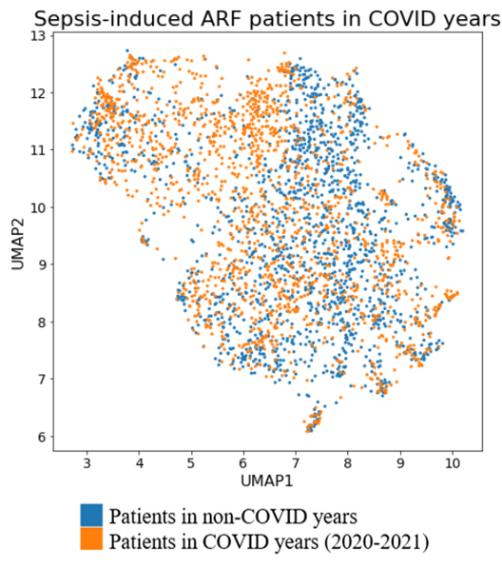

Supplemental Table E4:
Individual SOFA for Emory MICU | SOFA value | Whole cohort | A | B | C | D | p-value
n | - | 3349 | 845 | 692 | 993 | 819 | -
SOFA max coagulopathy, n (%) | 0 | 1772 (59.1) | 432 (58.1) | 438 (70.4) | 637 (72.1) | 265 (35.4) | <0.001
SOFA max coagulopathy, n (%) | 1 | 513 (17.1) | 141 (19.0) | 102 (16.4) | 146 (16.5) | 124 (16.6) | <0.001
SOFA max coagulopathy, n (%) | 2 | 345 (11.5) | 91 (12.2) | 46 (7.4) | 59 (6.7) | 149 (19.9) | <0.001
SOFA max coagulopathy, n (%) | 3 | 225 (7.5) | 59 (7.9) | 17 (2.7) | 24 (2.7) | 125 (16.7) | <0.001
SOFA max coagulopathy, n (%) | 4 | 142 (4.7) | 20 (2.7) | 19 (3.1) | 18 (2.0) | 85 (11.4) | <0.001
SOFA max renal, n (%) | 0 | 1115 (34.7) | 79 (9.7) | 282 (43.1) | 483 (50.6) | 271 (34.5) | <0.001
SOFA max renal, n (%) | 1 | 757 (23.6) | 115 (14.1) | 163 (24.9) | 282 (29.6) | 197 (25.1) | <0.001
SOFA max renal, n (%) | 2 | 609 (19.0) | 191 (23.3) | 112 (17.1) | 127 (13.3) | 179 (22.8) | <0.001
SOFA max renal, n (%) | 3 | 296 (9.2) | 139 (17.0) | 39 (6.0) | 39 (4.1) | 79 (10.1) | <0.001
SOFA max renal, n (%) | 4 | 435 (13.5) | 294 (35.9) | 58 (8.9) | 23 (2.4) | 60 (7.6) | <0.001
SOFA max hepatic, n (%) | 0 | 1563 (65.0) | 368 (64.7) | 395 (76.7) | 527 (75.3) | 273 (44.0) | <0.001
SOFA max hepatic, n (%) | 1 | 332 (13.8) | 86 (15.1) | 68 (13.2) | 95 (13.6) | 83 (13.4) | <0.001
SOFA max hepatic, n (%) | 2 | 318 (13.2) | 88 (15.5) | 38 (7.4) | 62 (8.9) | 130 (20.9) | <0.001
SOFA max hepatic, n (%) | 3 | 95 (4.0) | 22 (3.9) | 10 (1.9) | 10 (1.4) | 53 (8.5) | <0.001
SOFA max hepatic, n (%) | 4 | 97 (4.0) | 5 (0.9) | 4 (0.8) | 6 (0.9) | 82 (13.2) | <0.001
SOFA max neuro, n (%) | 0 | 949 (36.4) | 195 (29.8) | 288 (51.4) | 255 (35.3) | 211 (31.6) | <0.001
SOFA max neuro, n (%) | 1 | 564 (21.7) | 157 (24.0) | 107 (19.1) | 146 (20.2) | 154 (23.1) | <0.001
SOFA max neuro, n (%) | 2 | 438 (16.8) | 130 (19.9) | 58 (10.4) | 135 (18.7) | 115 (17.2) | <0.001
SOFA max neuro, n (%) | 3 | 436 (16.7) | 111 (17.0) | 70 (12.5) | 130 (18.0) | 125 (18.7) | <0.001
SOFA max neuro, n (%) | 4 | 217 (8.3) | 61 (9.3) | 37 (6.6) | 57 (7.9) | 62 (9.3) | <0.001
SOFA max cardio, n (%) | 0 | 1178 (36.3) | 241 (29.2) | 281 (41.4) | 497 (53.0) | 159 (19.7) | <0.001
SOFA max cardio, n (%) | 1 | 607 (18.7) | 188 (22.8) | 118 (17.4) | 144 (15.4) | 157 (19.4) | <0.001
SOFA max cardio, n (%) | 2 | 42 (1.3) | 14 (1.7) | 3 (0.4) | 15 (1.6) | 10 (1.2) | <0.001
SOFA max cardio, n (%) | 3 | 387 (11.9) | 85 (10.3) | 111 (16.4) | 102 (10.9) | 89 (11.0) | <0.001
SOFA max cardio, n (%) | 4 | 1035 (31.9) | 297 (36.0) | 165 (24.3) | 179 (19.1) | 394 (48.7) | <0.001
SOFA max respiratory, n (%) | 0 | 100 (4.6) | 47 (9.6) | 8 (1.6) | 20 (3.2) | 25 (4.4) | <0.001
SOFA max respiratory, n (%) | 1 | 150 (7.0) | 53 (10.8) | 9 (1.9) | 44 (7.1) | 44 (7.8) | <0.001
SOFA max respiratory, n (%) | 2 | 307 (14.2) | 72 (14.7) | 31 (6.4) | 99 (16.0) | 105 (18.7) | <0.001
SOFA max respiratory, n (%) | 3 | 672 (31.2) | 158 (32.2) | 98 (20.2) | 218 (35.2) | 198 (35.2) | <0.001
SOFA max respiratory, n (%) | 4 | 928 (43.0) | 161 (32.8) | 339 (69.9) | 238 (38.4) | 190 (33.8) | <0.001

Supplemental Table E5:
Individual SOFA Grady MICU | SOFA value | Whole cohort | A | B | C | D | p-value
n | - | 867 | 214 | 49 | 404 | 200 | -
SOFA max coagulopathy, n (%) | 0 | 516 (61.2) | 124 (58.8) | 18 (39.1) | 278 (71.3) | 96 (49.0) | <0.001
SOFA max coagulopathy, n (%) | 1 | 145 (17.2) | 40 (19.0) | 14 (30.4) | 67 (17.2) | 24 (12.2) | <0.001
SOFA max coagulopathy, n (%) | 2 | 117 (13.9) | 23 (10.9) | 9 (19.6) | 38 (9.7) | 47 (24.0) | <0.001
SOFA max coagulopathy, n (%) | 3 | 48 (5.7) | 20 (9.5) | 4 (8.7) | 5 (1.3) | 19 (9.7) | <0.001
SOFA max coagulopathy, n (%) | 4 | 17 (2.0) | 4 (1.9) | 1 (2.2) | 2 (0.5) | 10 (5.1) | <0.001
SOFA max renal, n (%) | 0 | 296 (34.4) | 21 (9.9) | 11 (22.9) | 199 (49.5) | 65 (32.8) | <0.001
SOFA max renal, n (%) | 1 | 215 (25.0) | 34 (16.0) | 14 (29.2) | 114 (28.4) | 53 (26.8) | <0.001
SOFA max renal, n (%) | 2 | 145 (16.9) | 29 (13.7) | 10 (20.8) | 61 (15.2) | 45 (22.7) | <0.001
SOFA max renal, n (%) | 3 | 66 (7.7) | 32 (15.1) | 7 (14.6) | 13 (3.2) | 14 (7.1) | <0.001
SOFA max renal, n (%) | 4 | 138 (16.0) | 96 (45.3) | 6 (12.5) | 15 (3.7) | 21 (10.6) | <0.001
SOFA max hepatic, n (%) | 0 | 507 (63.9) | 147 (73.9) | 28 (62.2) | 253 (69.1) | 79 (42.9) | <0.001
SOFA max hepatic, n (%) | 1 | 126 (15.9) | 25 (12.6) | 3 (6.7) | 67 (18.3) | 31 (16.8) | <0.001
SOFA max hepatic, n (%) | 2 | 104 (13.1) | 21 (10.6) | 7 (15.6) | 38 (10.4) | 38 (20.7) | <0.001
SOFA max hepatic, n (%) | 3 | 33 (4.2) | 5 (2.5) | 3 (6.7) | 6 (1.6) | 19 (10.3) | <0.001
SOFA max hepatic, n (%) | 4 | 24 (3.0) | 1 (0.5) | 4 (8.9) | 2 (0.5) | 17 (9.2) | <0.001
SOFA max neuro, n (%) | 0 | 255 (32.2) | 53 (26.9) | 19 (42.2) | 112 (30.9) | 71 (37.8) | 0.017
SOFA max neuro, n (%) | 1 | 138 (17.4) | 31 (15.7) | 14 (31.1) | 57 (15.7) | 36 (19.1) | 0.017
SOFA max neuro, n (%) | 2 | 136 (17.2) | 38 (19.3) | 7 (15.6) | 64 (17.6) | 27 (14.4) | 0.017
SOFA max neuro, n (%) | 3 | 186 (23.5) | 50 (25.4) | 4 (8.9) | 90 (24.8) | 42 (22.3) | 0.017
SOFA max neuro, n (%) | 4 | 78 (9.8) | 25 (12.7) | 1 (2.2) | 40 (11.0) | 12 (6.4) | 0.017
SOFA max cardio, n (%) | 0 | 449 (51.8) | 71 (33.2) | 19 (38.8) | 296 (73.4) | 63 (31.5) | <0.001
SOFA max cardio, n (%) | 1 | 190 (21.9) | 61 (28.5) | 14 (28.6) | 62 (15.4) | 53 (26.5) | <0.001
SOFA max cardio, n (%) | 2 | 7 (0.8) | 4 (1.9) | 0 | 1 (0.2) | 2 (1.0) | <0.001
SOFA max cardio, n (%) | 3 | 22 (2.5) | 8 (3.7) | 2 (4.1) | 6 (1.5) | 6 (3.0) | <0.001
SOFA max cardio, n (%) | 4 | 198 (22.9) | 70 (32.7) | 14 (28.6) | 38 (9.4) | 76 (38.0) | <0.001
SOFA max respiratory, n (%) | 0 | 27 (5.4) | 5 (4.2) | 0 | 14 (6.4) | 8 (6.5) | 0.009
SOFA max respiratory, n (%) | 1 | 38 (7.7) | 16 (13.3) | 0 | 14 (6.4) | 8 (6.5) | 0.009
SOFA max respiratory, n (%) | 2 | 89 (17.9) | 30 (25.0) | 4 (12.5) | 34 (15.5) | 21 (16.9) | 0.009
SOFA max respiratory, n (%) | 3 | 174 (35.1) | 43 (35.8) | 11 (34.4) | 82 (37.3) | 38 (30.6) | 0.009
SOFA max respiratory, n (%) | 4 | 168 (33.9) | 26 (21.7) | 17 (53.1) | 76 (34.5) | 49 (39.5) | 0.009

Supplemental Table E6:
Individual SOFA Emory SICU | SOFA value | Whole cohort | A | B | C | D | p-value
n | - | 1128 | 818 | 39 | 259 | 12 | -
SOFA max coagulopathy, n (%) | 0 | 633 (58.9) | 432 (55.7) | 24 (64.9) | 173 (69.2) | 4 (33.3) | 0.006
SOFA max coagulopathy, n (%) | 1 | 196 (18.2) | 152 (19.6) | 8 (21.6) | 34 (13.6) | 2 (16.7) | 0.006
SOFA max coagulopathy, n (%) | 2 | 156 (14.5) | 123 (15.9) | 3 (8.1) | 28 (11.2) | 2 (16.7) | 0.006
SOFA max coagulopathy, n (%) | 3 | 71 (6.6) | 55 (7.1) | 1 (2.7) | 12 (4.8) | 3 (25.0) | 0.006
SOFA max coagulopathy, n (%) | 4 | 18 (1.7) | 13 (1.7) | 1 (2.7) | 3 (1.2) | 1 (8.3) | 0.006
SOFA max renal, n (%) | 0 | 453 (42.1) | 268 (34.4) | 17 (47.2) | 162 (64.8) | 6 (54.5) | <0.001
SOFA max renal, n (%) | 1 | 282 (26.2) | 202 (25.9) | 12 (33.3) | 67 (26.8) | 1 (9.1) | <0.001
SOFA max renal, n (%) | 2 | 163 (15.1) | 140 (18.0) | 3 (8.3) | 18 (7.2) | 2 (18.2) | <0.001
SOFA max renal, n (%) | 3 | 65 (6.0) | 59 (7.6) | 2 (5.6) | 2 (0.8) | 2 (18.2) | <0.001
SOFA max renal, n (%) | 4 | 113 (10.5) | 110 (14.1) | 2 (5.6) | 1 (0.4) | 0 | <0.001
SOFA max hepatic, n (%) | 0 | 546 (64.0) | 372 (62.4) | 20 (64.5) | 151 (69.9) | 3 (30.0) | 0.001
SOFA max hepatic, n (%) | 1 | 138 (16.2) | 90 (15.1) | 6 (19.4) | 39 (18.1) | 3 (30.0) | 0.001
SOFA max hepatic, n (%) | 2 | 114 (13.4) | 86 (14.4) | 3 (9.7) | 24 (11.1) | 1 (10.0) | 0.001
SOFA max hepatic, n (%) | 3 | 31 (3.6) | 26 (4.4) | 2 (6.5) | 2 (0.9) | 1 (10.0) | 0.001
SOFA max hepatic, n (%) | 4 | 24 (2.8) | 22 (3.7) | 0 | 0 | 2 (20.0) | 0.001
SOFA max neuro, n (%) | 0 | 307 (38.0) | 221 (37.1) | 14 (43.8) | 69 (40.4) | 3 (33.3) | 0.902
SOFA max neuro, n (%) | 1 | 179 (22.2) | 135 (22.7) | 8 (25.0) | 34 (19.9) | 2 (22.2) | 0.902
SOFA max neuro, n (%) | 2 | 129 (16.0) | 99 (16.6) | 3 (9.4) | 25 (14.6) | 2 (22.2) | 0.902
SOFA max neuro, n (%) | 3 | 95 (11.8) | 67 (11.2) | 5 (15.6) | 21 (12.3) | 2 (22.2) | 0.902
SOFA max neuro, n (%) | 4 | 98 (12.1) | 74 (12.4) | 2 (6.2) | 22 (12.9) | 0 | 0.902
SOFA max cardio, n (%) | 0 | 312 (28.2) | 199 (24.5) | 16 (42.1) | 96 (38.9) | 1 (9.1) | 0.001
SOFA max cardio, n (%) | 1 | 161 (14.5) | 117 (14.4) | 9 (23.7) | 34 (13.8) | 1 (9.1) | 0.001
SOFA max cardio, n (%) | 2 | 8 (0.7) | 7 (0.9) | 0 | 1 (0.4) | 0 | 0.001
SOFA max cardio, n (%) | 3 | 108 (9.8) | 83 (10.2) | 4 (10.5) | 20 (8.1) | 1 (9.1) | 0.001
SOFA max cardio, n (%) | 4 | 518 (46.8) | 405 (49.9) | 9 (23.7) | 96 (38.9) | 8 (72.7) | 0.001
SOFA max respiratory, n (%) | 0 | 71 (8.4) | 65 (10.9) | 0 | 6 (3.0) | 0 | <0.001
SOFA max respiratory, n (%) | 1 | 81 (9.6) | 67 (11.2) | 0 | 14 (6.9) | 0 | <0.001
SOFA max respiratory, n (%) | 2 | 147 (17.4) | 112 (18.7) | 0 | 33 (16.3) | 2 (20.0) | <0.001
SOFA max respiratory, n (%) | 3 | 258 (30.5) | 180 (30.1) | 3 (8.6) | 71 (35.0) | 4 (40.0) | <0.001
SOFA max respiratory, n (%) | 4 | 289 (34.2) | 174 (29.1) | 32 (91.4) | 79 (38.9) | 4 (40.0) | <0.001

Supplemental Table E7:
Individual SOFA Grady SICU | SOFA value | Whole cohort | A | B | C | D | p-value
n | - | 466 | 133 | 5 | 264 | 64 | -
SOFA max coagulopathy, n (%) | 0 | 306 (68.5) | 86 (67.7) | 4 (80.0) | 188 (74.0) | 28 (45.9) | <0.001
SOFA max coagulopathy, n (%) | 1 | 75 (16.8) | 23 (18.1) | 0 | 38 (15.0) | 14 (23.0) | <0.001
SOFA max coagulopathy, n (%) | 2 | 49 (11.0) | 15 (11.8) | 1 (20.0) | 21 (8.3) | 12 (19.7) | <0.001
SOFA max coagulopathy, n (%) | 3 | 14 (3.1) | 3 (2.4) | 0 | 7 (2.8) | 4 (6.6) | <0.001
SOFA max coagulopathy, n (%) | 4 | 3 (0.7) | 0 | 0 | 0 | 3 (4.9) | <0.001
SOFA max renal, n (%) | 0 | 176 (38.7) | 14 (10.9) | 2 (40.0) | 137 (52.9) | 23 (37.1) | <0.001
SOFA max renal, n (%) | 1 | 135 (29.7) | 26 (20.2) | 2 (40.0) | 85 (32.8) | 22 (35.5) | <0.001
SOFA max renal, n (%) | 2 | 81 (17.8) | 38 (29.5) | 0 | 32 (12.4) | 11 (17.7) | <0.001
SOFA max renal, n (%) | 3 | 21 (4.6) | 15 (11.6) | 0 | 2 (0.8) | 4 (6.5) | <0.001
SOFA max renal, n (%) | 4 | 42 (9.2) | 36 (27.9) | 1 (20.0) | 3 (1.2) | 2 (3.2) | <0.001
SOFA max hepatic, n (%) | 0 | 262 (66.5) | 81 (72.3) | 3 (60.0) | 151 (68.9) | 27 (46.6) | 0.006
SOFA max hepatic, n (%) | 1 | 59 (15.0) | 13 (11.6) | 1 (20.0) | 35 (16.0) | 10 (17.2) | 0.006
SOFA max hepatic, n (%) | 2 | 65 (16.5) | 18 (16.1) | 1 (20.0) | 30 (13.7) | 16 (27.6) | 0.006
SOFA max hepatic, n (%) | 3 | 7 (1.8) | 0 | 0 | 3 (1.4) | 4 (6.9) | 0.006
SOFA max hepatic, n (%) | 4 | 1 (0.3) | 0 | 0 | 0 | 1 (1.7) | 0.006
SOFA max neuro, n (%) | 0 | 157 (37.0) | 43 (35.8) | 2 (40.0) | 87 (35.8) | 25 (44.6) | 0.921
SOFA max neuro, n (%) | 1 | 64 (15.1) | 21 (17.5) | 1 (20.0) | 32 (13.2) | 10 (17.9) | 0.921
SOFA max neuro, n (%) | 2 | 80 (18.9) | 19 (15.8) | 1 (20.0) | 50 (20.6) | 10 (17.9) | 0.921
SOFA max neuro, n (%) | 3 | 88 (20.8) | 26 (21.7) | 1 (20.0) | 53 (21.8) | 8 (14.3) | 0.921
SOFA max neuro, n (%) | 4 | 35 (8.3) | 11 (9.2) | 0 | 21 (8.6) | 3 (5.4) | 0.921
SOFA max cardio, n (%) | 0 | 253 (54.8) | 48 (36.4) | 1 (20.0) | 194 (74.3) | 10 (15.6) | <0.001
SOFA max cardio, n (%) | 1 | 110 (23.8) | 42 (31.8) | 2 (40.0) | 34 (13.0) | 32 (50.0) | <0.001
SOFA max cardio, n (%) | 3 | 19 (4.1) | 5 (3.8) | 0 | 9 (3.4) | 5 (7.8) | <0.001
SOFA max cardio, n (%) | 4 | 80 (17.3) | 37 (28.0) | 2 (40.0) | 24 (9.2) | 17 (26.6) | <0.001
SOFA max respiratory, n (%) | 0 | 25 (8.5) | 13 (15.3) | 0 | 9 (5.6) | 3 (6.4) | 0.12
SOFA max respiratory, n (%) | 1 | 47 (15.9) | 18 (21.2) | 0 | 22 (13.8) | 7 (14.9) | 0.12
SOFA max respiratory, n (%) | 2 | 70 (23.7) | 21 (24.7) | 0 | 40 (25.0) | 9 (19.1) | 0.12
SOFA max respiratory, n (%) | 3 | 73 (24.7) | 17 (20.0) | 1 (33.3) | 39 (24.4) | 16 (34.0) | 0.12
SOFA max respiratory, n (%) | 4 | 80 (27.1) | 16 (18.8) | 2 (66.7) | 50 (31.2) | 12 (25.5) | 0.12

