Supporting Information

Decoding In-Cell Respiratory Enzyme Dynamics
by Label-Free In-situ Electrochemistry

Yoshihide Tokunou^{1,2} * , Tomohiko Yamazaki ^{2,3}, and Akihiro Okamoto^{1,2,4,5,6} *

1. Department of Life and Environmental Sciences, University of Tsukuba, 1-1-1 Tennodai, Tsukuba, Ibaraki 305-8572, Japan.
2. Research Center for Macromolecules and Biomaterials, National Institute for Materials Science, 1-2-1 Sengen, Tsukuba, Ibaraki, 305-0047, Japan
3. School of Life Science, Hokkaido University, 10 Kita, 8 Nishi, Kita-ku, Sapporo, Hokkaido 060-0808, Japan
4. International Center for Materials Nanoarchitectonics, National Institute for Materials Science, 1-1 Namiki, Tsukuba, Ibaraki 305-0044, Japan.
5. School of Chemical Sciences and Engineering, Hokkaido University, 13 Kita, 8 Nishi, Kita-ku, Sapporo, Hokkaido 060-8628, Japan.
6. Institute of Innovation for Future Earth and Laboratory for Integrated Science and Materials, Tokyo Institute of Technology, 4259 Nagatsuta-cho, Midori-ku, Yokohama, Kanagawa 226-8503, Japan

*: corresponding author
Y. T.: tokunou.yoshihide.ga@u.tsukuba.ac.jp
A. O.: okamoto.akihiro@nims.go.jp

Contents:
Supplementary Figures 1-9
Supplementary Table 1

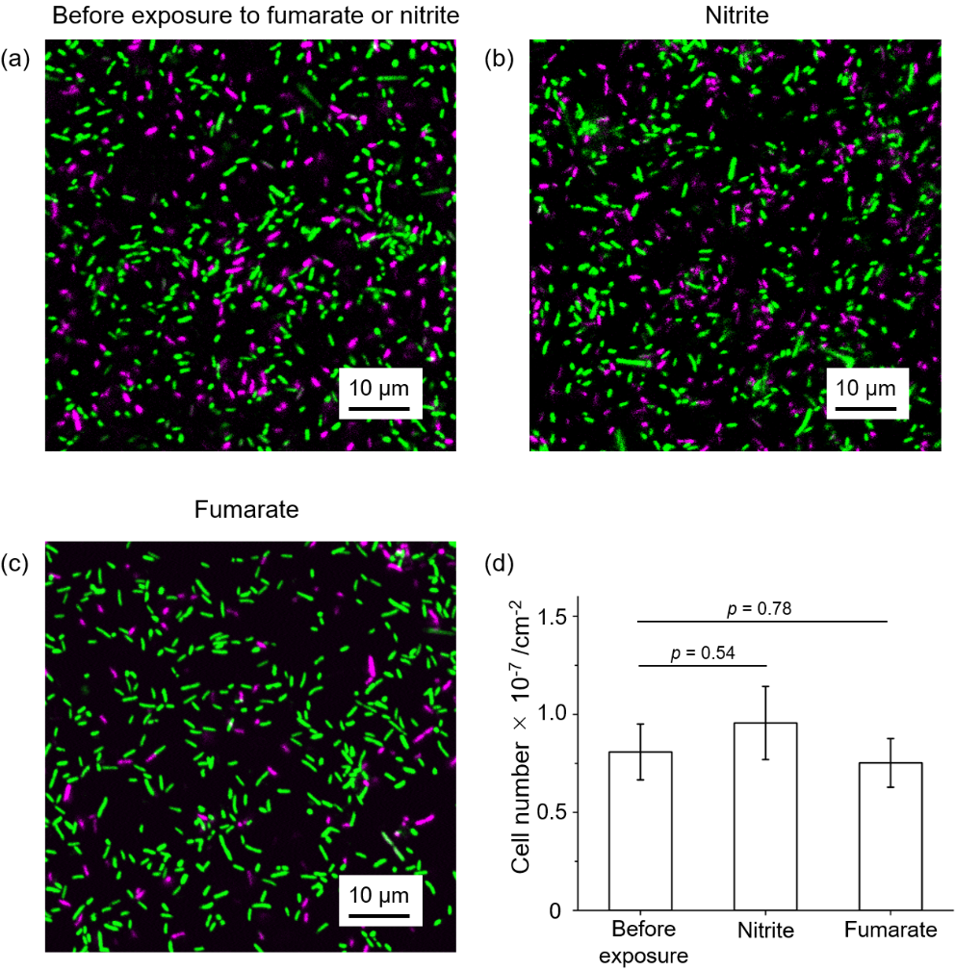
Figure S1. Representative confocal microscopic images of S. oneidensis MR-1 cells on ITO electrodes before exposure to nitrite or fumarate (a), after exposure to 5.0 mM nitrite for 1 h (b), and after exposure to 3.0 mM fumarate for 1 h (c), in DM containing 10 μM riboflavin. The images were obtained by confocal fluorescence microscopy (LSM880, Carl Zeiss) equipped with a 63× water-dipping objective lens following SYTO 9 (excitation, 488 nm; emission, 505–545 nm) and propidium iodide staining (excitation, 543 nm; emission, 620–660 nm). (d) The number of live MR-1 cells (stained by SYTO 9) on ITO electrodes under conditions of (a)~(c). Error bars represent the mean ± SEM for five individual images. P-values from unpaired two-tailed Student’s t-tests were used to compare the images before and after exposure to nitrite or fumarate.

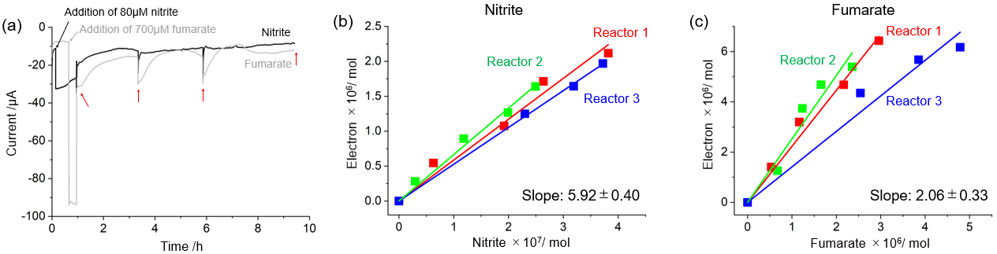
Figure S2. (a) Representative time courses for cathodic current from electrode-attached S. oneidensis MR-1 cells under potential application at −0.45 V (vs SHE) with 10 μM riboflavin when supernatant was sampled for ion chromatography to quantify nitrite and fumarate. The black arrow indicates the timing of 80 μM nitrite or 700 μM fumarate addition, and the red arrows indicate the timings of shaking reactors and sampling supernatant. Plots of the number of electrons delivered to MR-1 cells against (b) nitrite or (c) fumarate consumption at an electrode potential of −0.45 V (vs SHE), which are examined in three independent reactors. The baseline current was subtracted from the electron number. The cathodic current profile in (a) was translated into the “Reactor 1” data. The plots of “Reactor 1” are identical to the plots of Figure 2c. The error bars for slopes represent the mean±SEM obtained from three separate experiments.

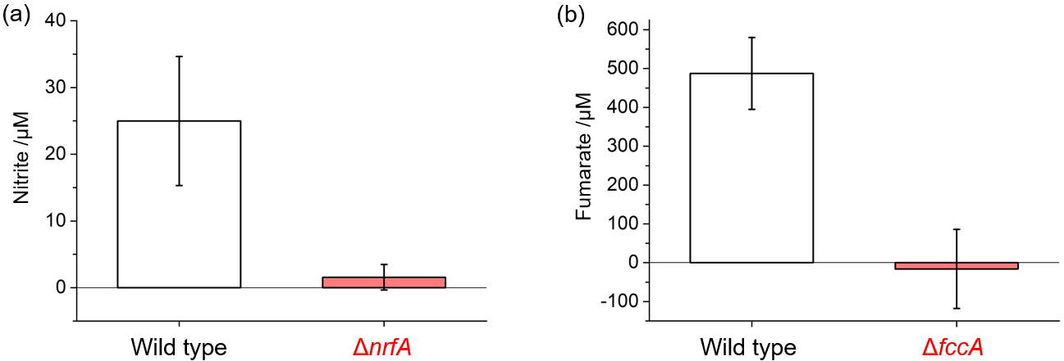
Figure S3. The extent of (a) nitrite consumption and (b) fumarate consumption after potential application at −0.45 V (vs SHE) for 30 min to cells-attached ITO electrodes. The initial concentrations of nitrite and fumarate are 0.1 mM and 1.0 mM, respectively. The concentration of nitrite and fumarate was quantified by ion chromatography. The error bars for slopes represent the mean±SEM obtained from three separate experiments.

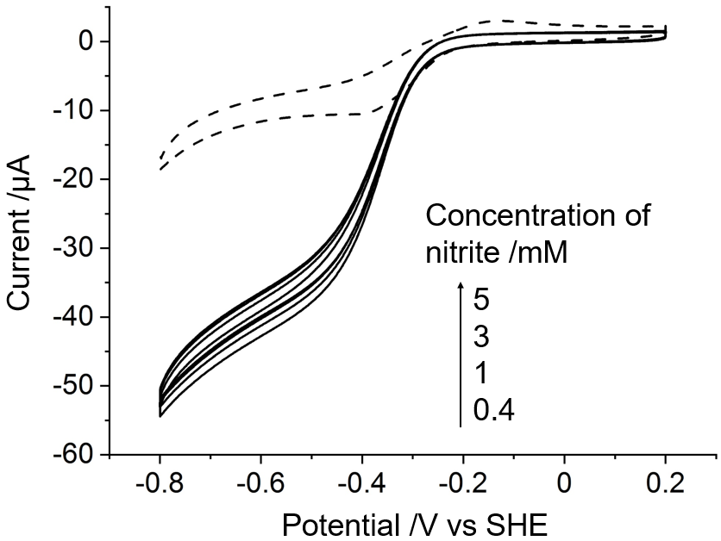
Figure S4. Cyclic voltammograms (CV) of Shewanella oneidensis MR-1 cells on an ITO electrode in the presence of 10 μM riboflavin with nitrite (solid lines) and without nitrite (dashed line). The concentration of nitrite is indicated. Scan rate is 10mVs⁻¹.

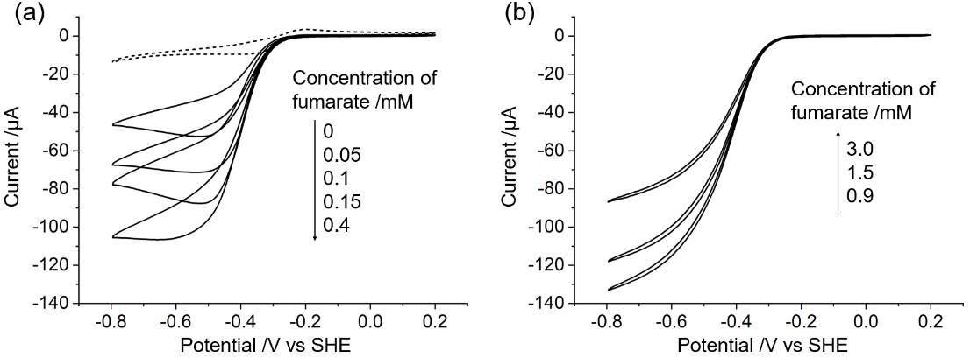
Figure S5. CV of S. oneidensis MR-1 cells on an ITO electrode with 0 ~ 0.4 mM fumarate (a) and 0.9 ~ 3.0 mM fumarate (b) in the presence of 10 μM riboflavin and 6.0 mg L⁻¹ polymyxin B. Scan rate is 10mVs⁻¹.

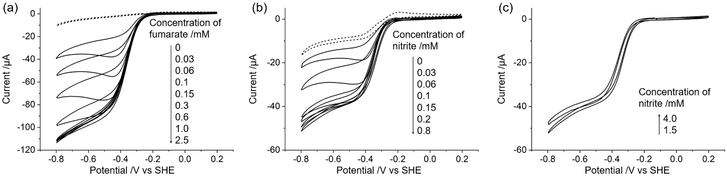
Figure S6. CV of ΔcymA cells on an ITO electrode with fumarate (a) and nitrite (b, c) in 10 μM riboflavin. Scan rate is 10 mVs⁻¹.

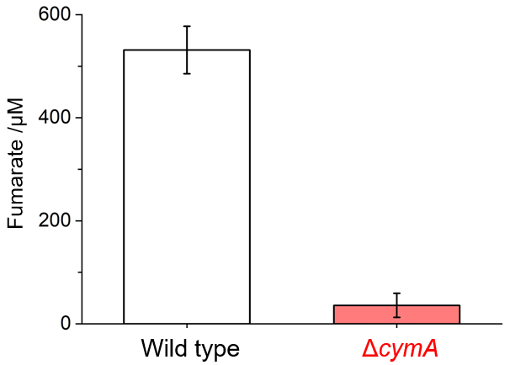
Figure S7. The amount of consumed fumarate by S. oneidensis MR-1 cells WT and ΔcymA during 90 min cultivation. Cells at OD₆₀₀ of 0.2 were incubated in anaerobic DM containing 10 mM lactate and 500 μM fumarate as the sole electron donor and acceptor, respectively.

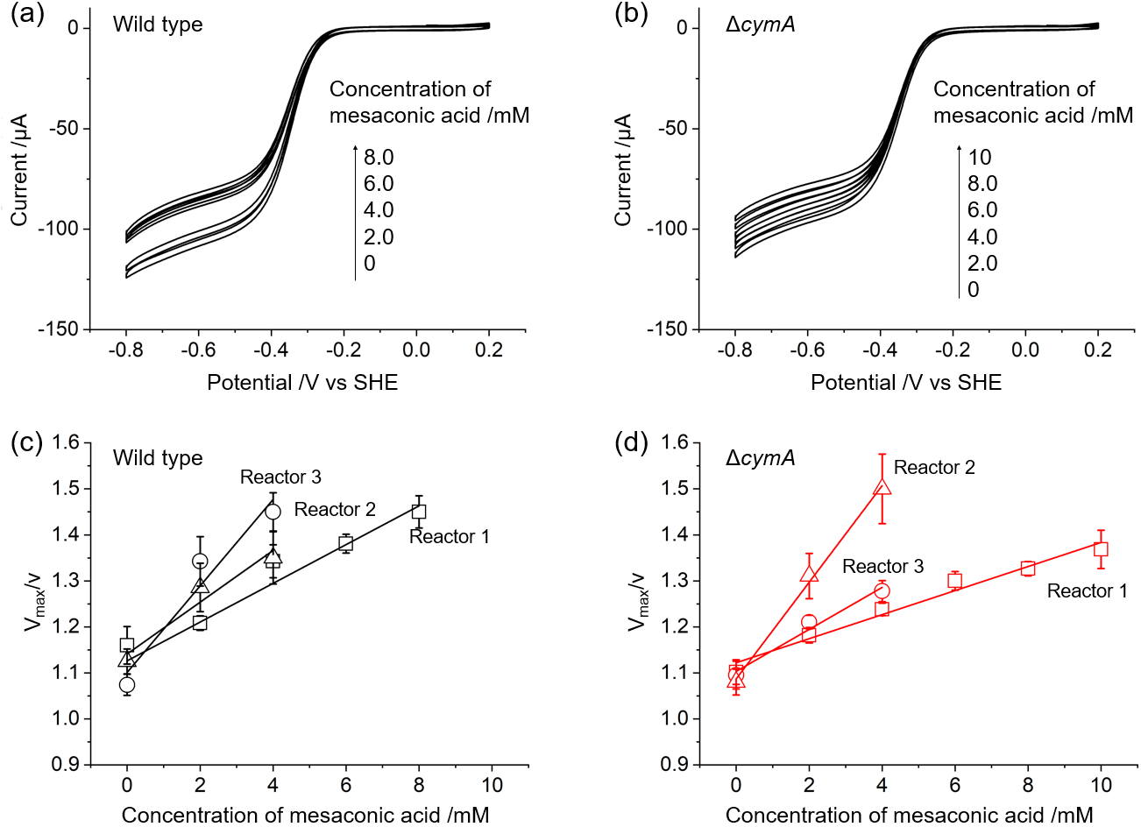
Figure S8. The impact of fumarate reductase inhibitor on the cathodic current of S. oneidensis MR-1 cells on an ITO electrode. CV of S. oneidensis MR-1 cells wild type (a) and ΔcymA (b) in the presence of 5.0 mM fumarate and 10 μM riboflavin with various concentrations of mesaconic acid. Scan rate is 10 mVs⁻¹. Plots of V_{max}/v against the concentration of mesaconic acid for wild type (c) and ΔcymA (d). Experiments were conducted three times in separate reactors. v was obtained from the cathodic limiting current after subtraction by that in the absence of fumarate and V_{max} was set as 145 μA. The slopes were 0.0626 ± 0.0166 and 0.0589 ± 0.0237, respectively. The CV data in (a) and (b) were translated into the “Reactor 1” data.

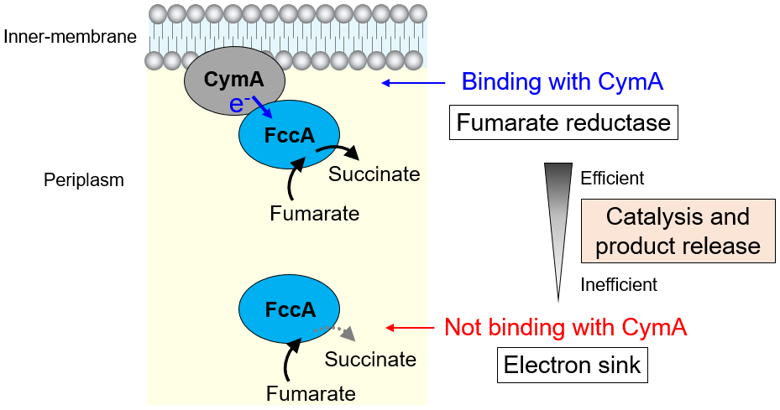

Figure S9. A proposed model of two roles in FccA dictated by association with CymA in MR-1 cells.

Table S1. Peptide groups used for quantification of FccA and NrfA by LC-MS/MS
 | Sequence
NrfA | VLGTSVNK
NrfA | LAQLLAK
NrfA | GLTDPVAIPDISTK
NrfA | EFLVGVTNER
NrfA | AKAQAVLGMDMEK
NrfA | ALDAIGTPFSK
FccA | VILLEKEPIPGGNTK
FccA | QIDVPAAELAK
FccA | SGKDAQFERPDLPR
FccA | QIMIDDTMKGGR

