Supplementary Materials
Table S1 Basic data of patients with spinal cord injury
Figure S1 Stability of node strength
Figure S2 Bootstrapped difference test for node strength
Figure S3 Stability of node bridge strength
Figure S4 Bootstrapped difference test for node bridge strength
Figure S5 Arc strength of each edge in the DAG network.
Table S2 Exact strength and directional probabilities of each edge in the DAG

Table S1 Basic data of patients with spinal cord injury
 | number | proportions
Gender
Male | 154 | 61.4%
Female | 97 | 38.6%
Age
average | 54.95±13.04
22-40 | 40 | 15.9%
41-60 | 117 | 46.6%
61-86 | 94 | 37.5%
Onset
average | 22.89±14.10
0-10 | 44 | 17.5%
11-20 | 81 | 32.3%
21-30 | 49 | 19.5%
30-40 | 38 | 15.2%
40-65 | 37 | 14.6%
Educational attainment
non-attendance | 2 | 0.8%
secondary school | 13 | 5.2%
junior high school | 89 | 35.3%
senior high school | 79 | 31.3%
vocational schools | 33 | 13.1%
undergraduate | 31 | 12.3%
postgraduates | 4 | 1.6%
Injured part
unknown | 4 | 1.6%
neck segment | 45 | 17.9%
thoracic segment | 115 | 46.0%
waist section | 74 | 29.4%
cauda equina | 10 | 4.0%

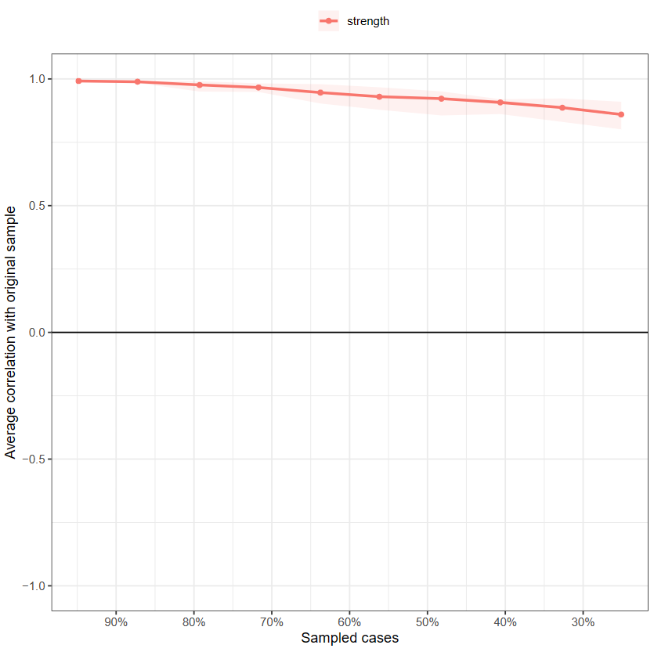
Figure S1 Stability of node strength

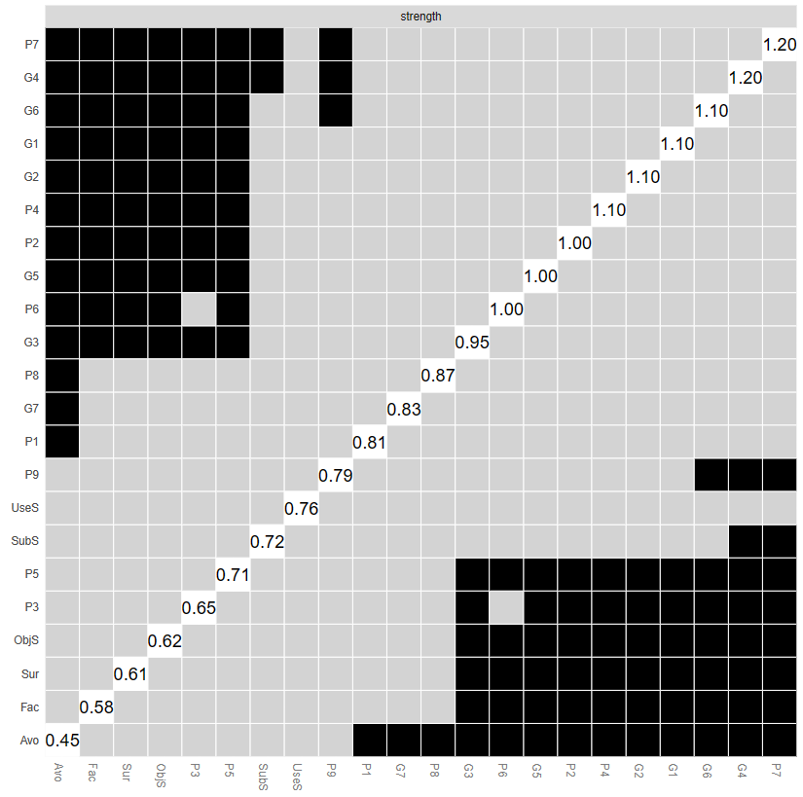
Figure S2 Bootstrapped difference test for node strength
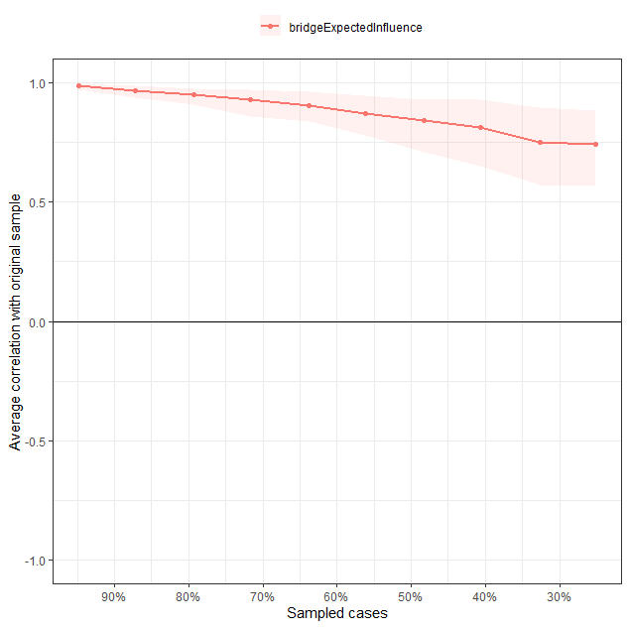
Figure S3 Stability of node bridge strength

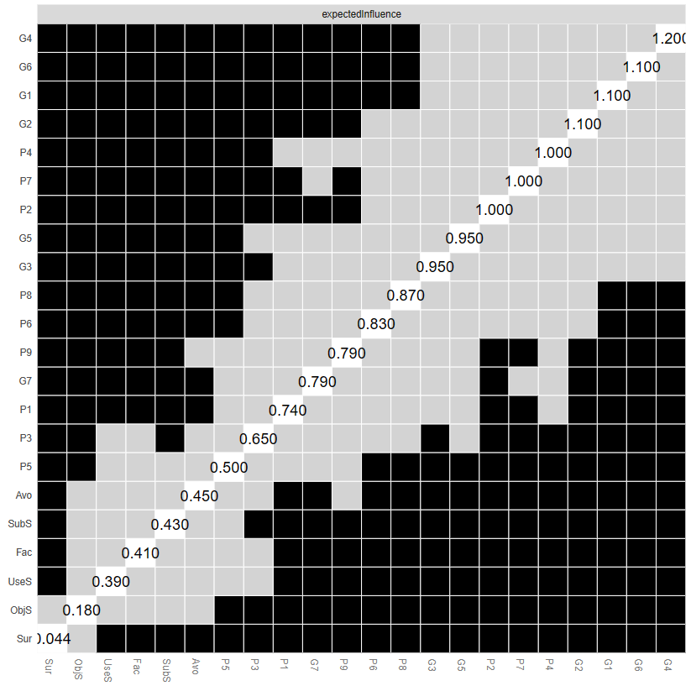
Figure S4 Bootstrapped difference test for node bridge strength

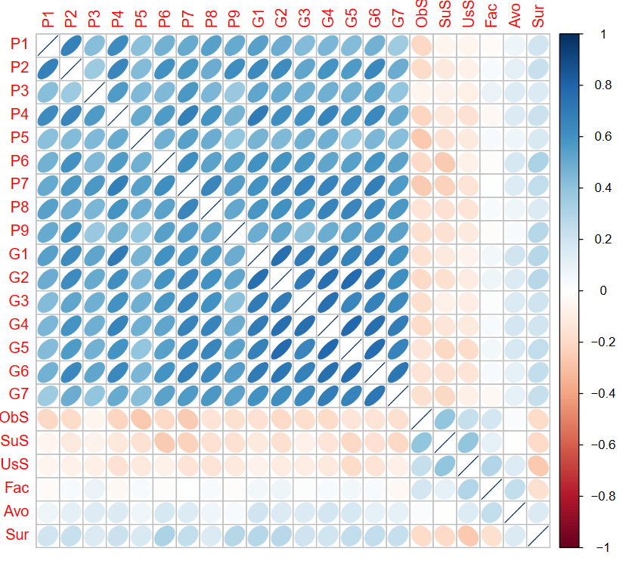
Figure S5 Arc strength of each edge in the DAG network.

Table S2 Exact strength and directional probabilities of each edge in the DAG network.
From | To | Strength | Direction
P1 | P2 | 0.997 | 0.540
P1 | P8 | 0.875 | 0.741
P2 | P3 | 0.561 | 0.525
P2 | P6 | 0.802 | 0.768
P2 | P9 | 0.937 | 0.856
P3 | P5 | 0.538 | 0.580
P4 | P1 | 0.935 | 0.588
P4 | P2 | 0.784 | 0.633
P4 | P3 | 0.751 | 0.849
P4 | P7 | 0.950 | 0.642
P4 | G4 | 0.709 | 0.549
P5 | ObS | 0.626 | 0.634
P6 | SuS | 0.763 | 0.518
P6 | Sur | 0.570 | 0.877
P7 | P3 | 0.907 | 0.854
P7 | P5 | 0.595 | 0.878
P7 | P6 | 0.645 | 0.715
P7 | P8 | 0.857 | 0.733
P7 | P9 | 0.559 | 0.571
P9 | P6 | 0.571 | 0.502
G1 | P4 | 0.945 | 0.551
G1 | P6 | 0.525 | 0.827
G1 | G2 | 0.987 | 0.581
G1 | G3 | 0.841 | 0.664
G1 | G6 | 0.585 | 0.761
G2 | P2 | 0.609 | 0.622
G2 | G3 | 0.609 | 0.561
G2 | G4 | 0.716 | 0.614
G2 | G5 | 0.966 | 0.662
G3 | P6 | 0.512 | 0.669
G3 | P7 | 0.780 | 0.592
G3 | G7 | 0.536 | 0.730
G4 | P8 | 0.600 | 0.893
G4 | G3 | 0.964 | 0.600
G4 | G5 | 0.969 | 0.665
G4 | G6 | 0.635 | 0.760
G4 | G7 | 0.725 | 0.884
G5 | P8 | 0.663 | 0.850
G5 | G6 | 0.965 | 0.714
G6 | P2 | 0.754 | 0.527
G6 | P7 | 0.614 | 0.623
G6 | G7 | 0.993 | 0.828
G7 | P9 | 0.729 | 0.683
ObS | SuS | 0.999 | 0.650
SuS | UsS | 0.998 | 0.784
UsS | Fac | 0.951 | 0.522
UsS | Sur | 0.836 | 0.862
Fac | ObS | 0.546 | 0.542
Fac | Avo | 0.840 | 0.775
Sur | Avo | 0.655 | 0.546

