SUPPLEMENTARY MATERIAL
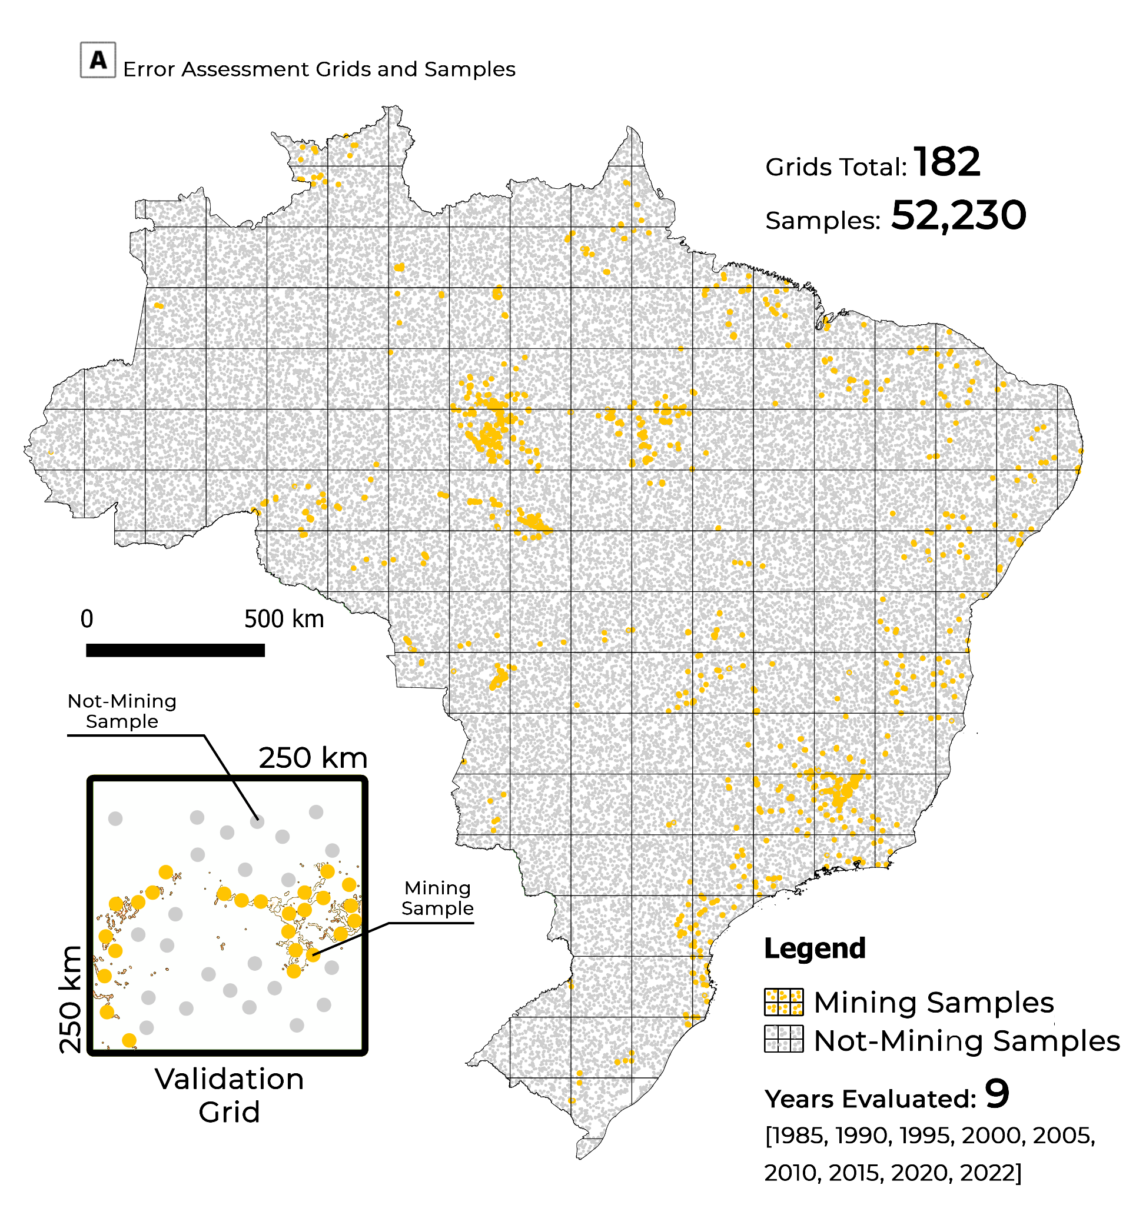
Fig 1 - Gray and orange dots are the reference/validation samples (humanly interpreted/confirmed). The gray dots represent confirmed non-mining samples, and the orange dots represent mining samples according to human eyes. A two-stage stratified random sampling approach was used to categorize 52,320 samples, based on a human/visual interpretation procedure, as belonging to the mining or non-mining category. The adopted strategy was weighted by the area of each category/class in relation to the 250 per 250 km grid. A total of 182 grids were necessary to cover Brazil’s extension.

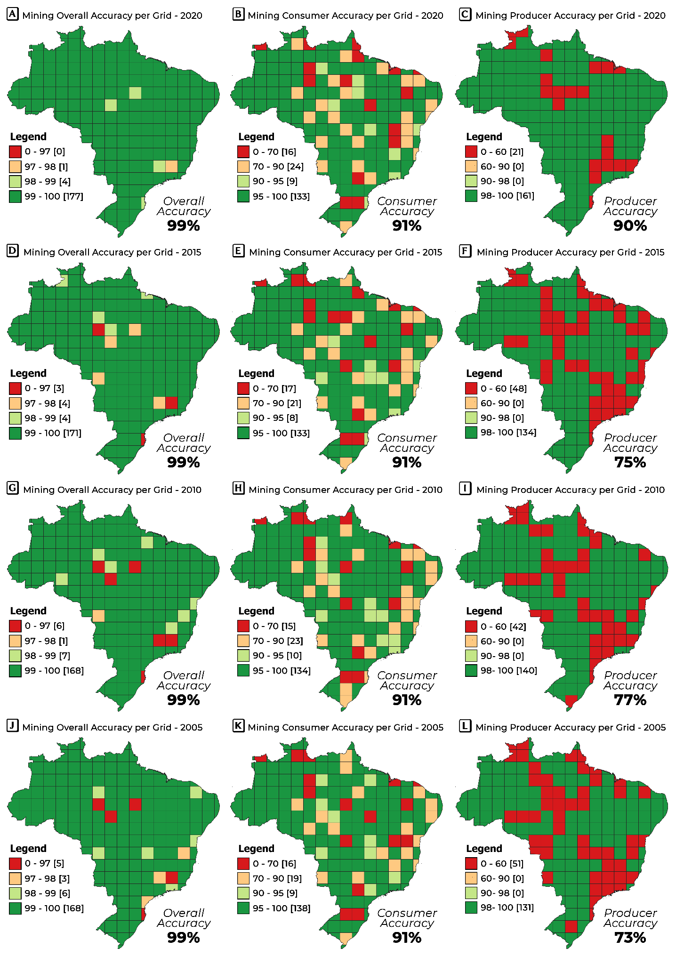
Fig 2 - Error matrix and locally distributed accuracy metrics from 2020 to 2005. The accuracy metrics for each graphed year are above 90%. Exception to the PA metrics varies between 73% and 77%. This represents that the quantity of false mining classifications of garimpo is small, but there is still some mining omission to be captured.
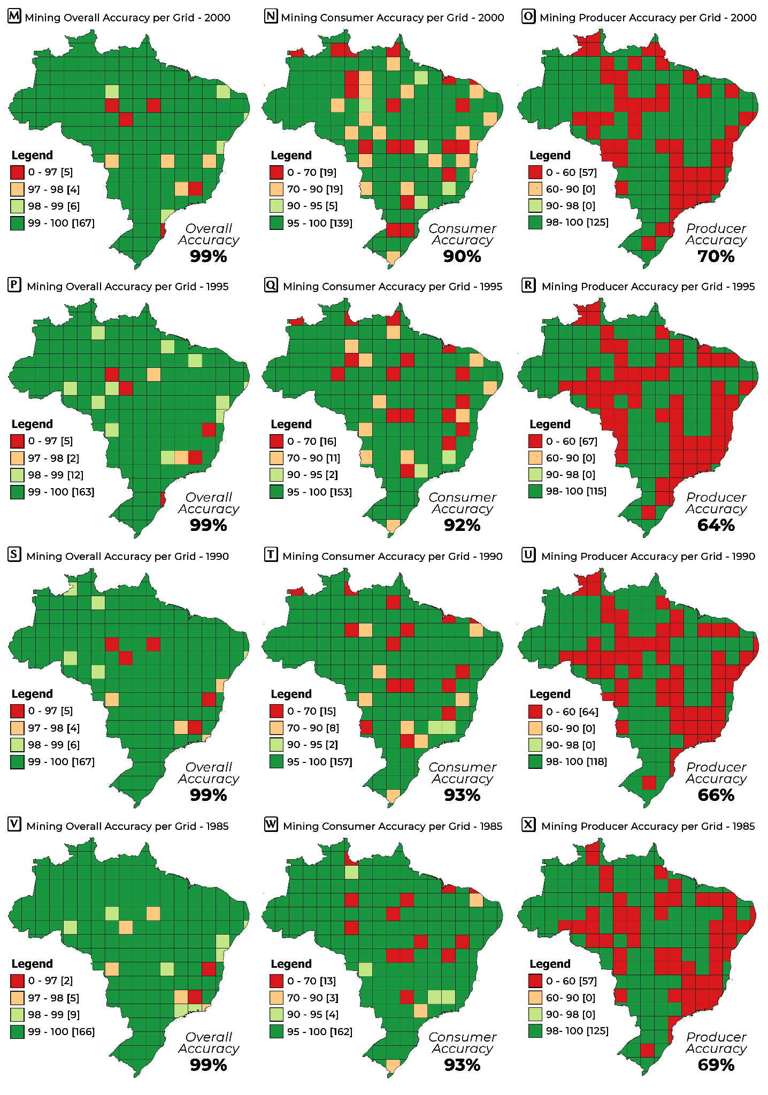
Fig 3 - Error matrix and locally distributed accuracy metrics from 2000 to 1985. Each year's OA and CA metrics are above 90%. However, the PA metrics vary between 64% and 70%. Hence, the quantity of false mining classifications is small, but some mining omissions still need to be accounted for. Moreover, 1985, 1990, and 1995 are the years that suffered the most from mining omissions.

