Supplementary materials
Supplementary Table1. Detection of 176 cases of malignant pulmonary nodules by manual and AI radiography
Characteristics | Manual reading(%) | AI reading(%) | P
Number of detected malignant lung nodules | 152 (86.4) | 171 (97.2) | < 0.001
Number of missed malignant pulmonary nodules | 24 (13.6) | 5 (2.8)
Total | 176 | 176

Supplementary Table2. Detection of lung cancer by chest LDCT in different screening result groups
Characteristics | Manual reading(%) | AI reading(%) | P
Characteristics | (N=176) | (N=176) | P
Number of lung cancers detected |  |  | < 0.001
Screening positive | 159 (90.3) | 174 (98.9)
Screening negative | 17 (9.7) | 2 (1.1)

Supplementary Table3. Detection of stage IA1 lung cancer by chest LDCT in different screening results groups
Characteristics | Manual reading(%) | AI reading(%) | P
Characteristics | (N=66) | (N=66) | P
Number of stage IA1 lung cancers detected |  |  | 0.029
Screening positive | 59 (89.4) | 65 (98.5)
Screening negative | 7 (10.6) | 1 (1.5)

Supplementary Table4. Histological types of lung cancer in different tumor stages detected by LDCT
Histological type | Total | Stage
Histological type | Total | IA |  |  | IB | II | III | IV
Histological type | Total | IA1 | IA2 | IA3
Adenocarcinoma | 130 | 57/100 (0.6) | 33/100 (0.3) | 6/100 (0.1) | 0/100 (0.0) | 1/100 (0.01) | 1/100 (0.01) | 2/100 (0.02)
Squamous carcinoma | 8 | 0/3 (0.0) | 0/3 (0.0) | 1/3 (0.3) | 0/3 (0.0) | 1/3 (0.3) | 1/3 (0.3) | 0/3 (0.0)
Small cell carcinoma | 4 | 0/2 (0.0) | 0/2 (0.0) | 0/2 (0.0) | 0/2 (0.0) | 0/2 (0.0) | 2/2 (100.0) | 0/2 (0.0)
Other | 34 | 9/17 (52.9) | 8/17 (47.1) | 0/17 (0.0) | 0/17 (0.0) | 0/17 (0.0) | 0/17 (0.0) | 0/17 (0.0)
Total | 176 | 66/122 (54.1) | 41/122 (33.6) | 7/122 (5.7) | 0/122 (0.0) | 2/122 (1.6) | 4/122 (3.3) | 2/122 (1.6)

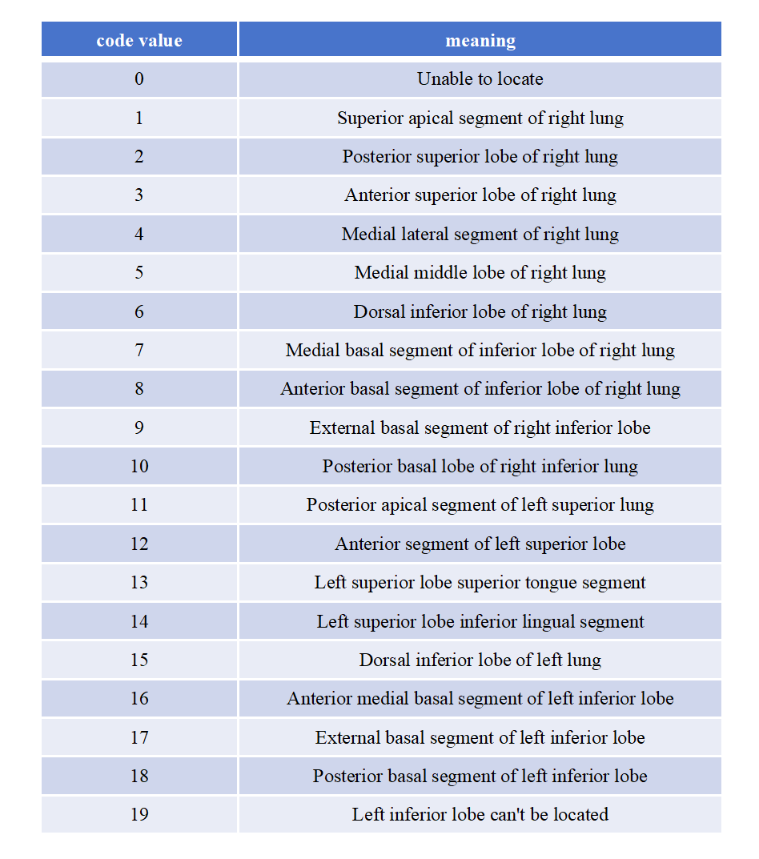
Supplementary Figure1The specific meaning of the code value of the location indicator

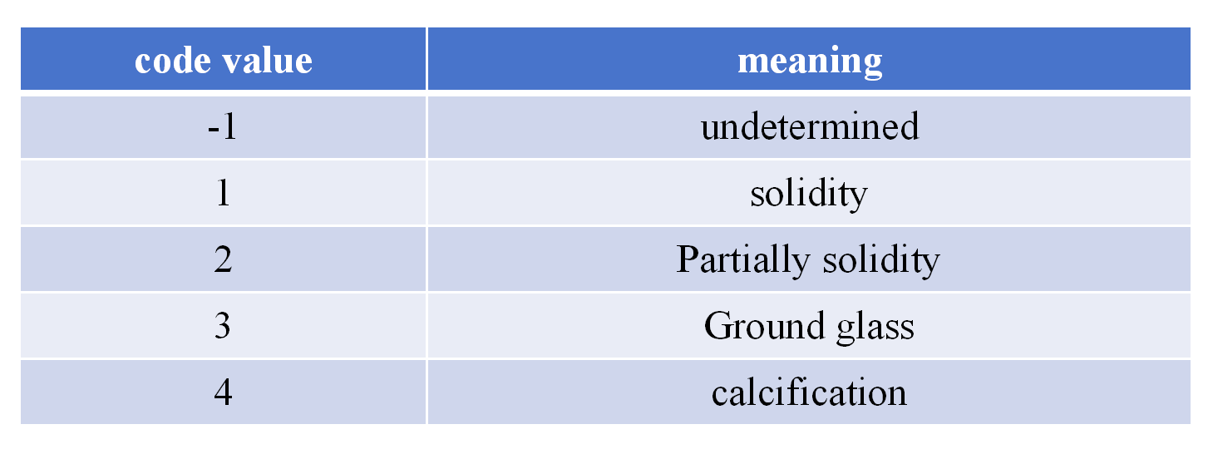
Supplementary Figure2 The specific meaning of code value of density index

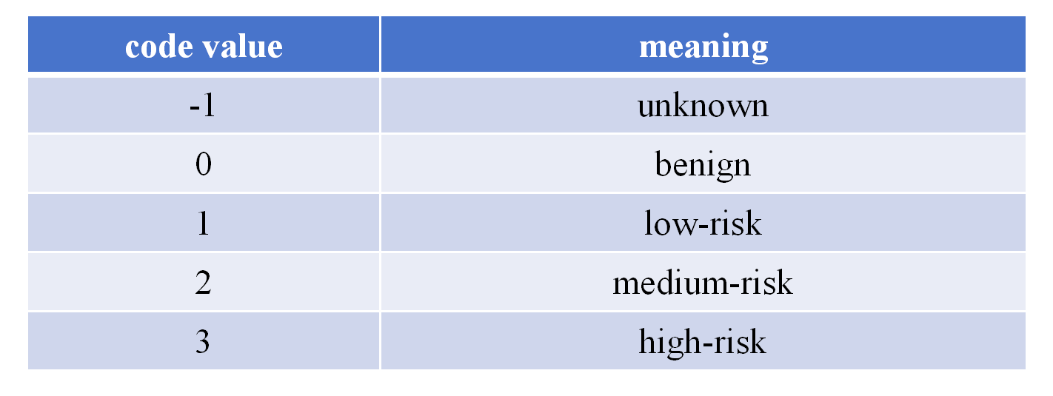
Supplementary Figure3 The specific meaning of code value of malignant probability index

