Supplementary Fig. 1
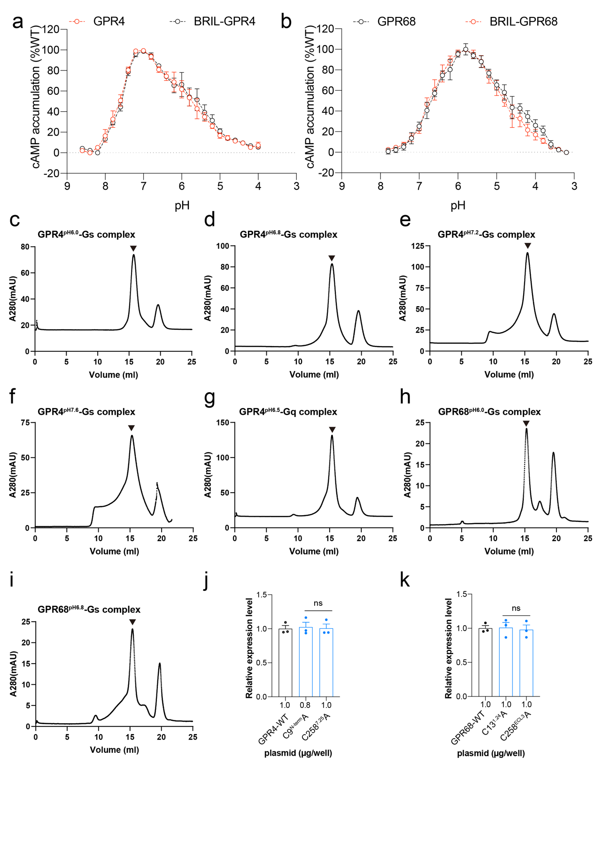
Supplementary Fig. 1| Representative size-exclusion chromatography elution profiles of GPR4–Gs and GPR4–Gq compelx using Superose 6 Increase 10/300 GL.
a, Curves showing pH-dependent cAMP accumulation in cells overexpressing GPR4 or BRIL-GPR4. Values are represented as mean ± SEM of 3 independent experiments (n = 3).
b, Curves showing pH-dependent cAMP accumulation in cells overexpressing GPR68 or BRIL-GPR68. Values are represented as mean ± SEM of 3 independent experiments (n = 3).
c-i, Representative elution profiles of in vitro reconstituted GPR4^{pH6.0}–Gs complex (c), GPR4^{pH6.8}–Gs complex (d), GPR4^{pH7.2}–Gs complex (e), GPR4^{pH7.6}–Gs complex (f), GPR4^{pH6.5}–Gq complex complex (g), GPR68^{pH6.0}–Gs complex (h), and GPR68^{pH6.8}–Gs complex (i) on Superose 6 Increase 10/300 column. The size-exclusion chromatography peaks are marked by triangles.
j-k, Elisa experiments to determine the expression levels of the GPR4 wild type and corresponding mutants (j) and GPR68 wild type and C13^{1.24}A or C258^{ECL3}A mutants (k). Values are represented as mean ± SEM of 3 independent experiments (n = 3). n.s., no significance. All data were analyzed by two-sided one-way ANOVA with Turkey test.

Supplementary Fig. 2
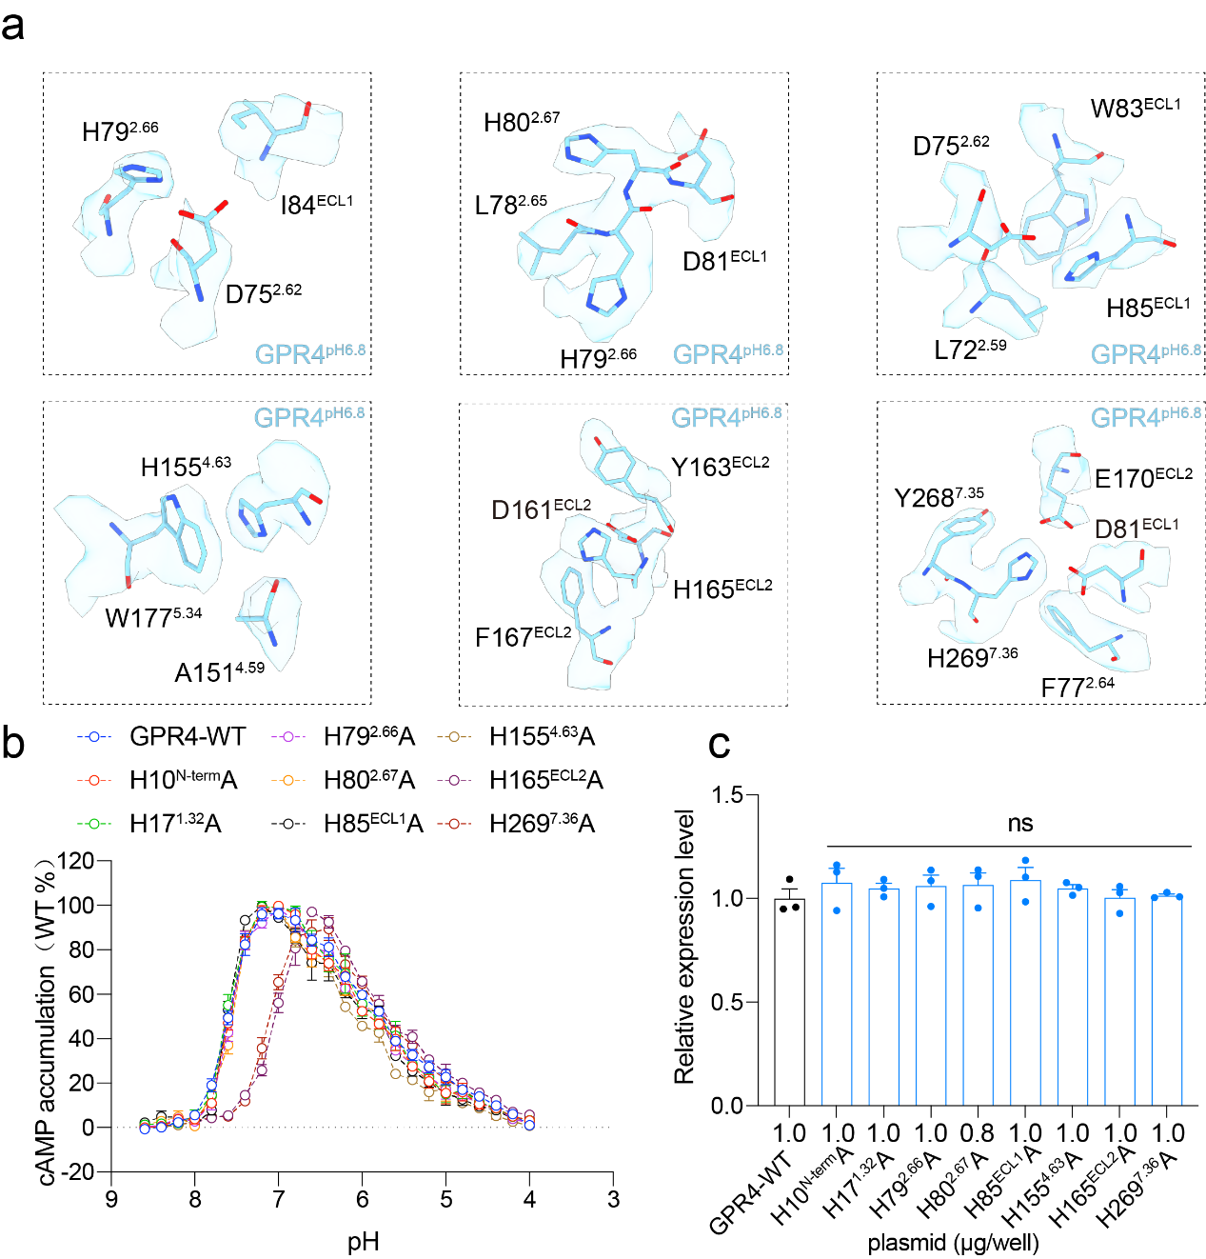
Supplementary Fig. 2| Cryo-EM density of key residues contributed to proton sensing in GPR4
a, Cryo-EM density of H79^{2.66}, H80^{2.67}, H85^{ECL1}, H155^{4.63}, H165^{ECL2}, H269^{7.36} and surrounding residues including D75^{2.62}, I84^{ECL1}, L78^{2.65}, D81^{ECL1}, L72^{2.59}, W83^{ECL1}, A151^{4.59}, W177^{5.34}, D161^{ECL2}, Y163^{ECL2}, F167^{ECL2}, F77^{2.64}, E170^{ECL2} and Y268^{7.35} in the structure of GPR4^{pH6.8}-Gs complex. Related to Figure 3d.
b, Curves showing pH-dependent cAMP accumulation in cells overexpressing GPR4, H10^{N-term} A, H17^{1.32}A, H79^{2.66}A, H80^{2.67}A, H85^{ECL1}A, H155^{4.63}A, H165^{ECL2}A or H269^{7.36}A. Values are represented as mean ± SEM of 3 independent experiments (n = 3).
c, Elisa experiments to determine the expression levels of the wild-type GPR4 and corresponding mutants. Values are mean ± SEM from three independent experiments (n=3). n.s., no significance. All data were analyzed by two-sided one-way ANOVA with Turkey test.

Supplementary Fig. 3
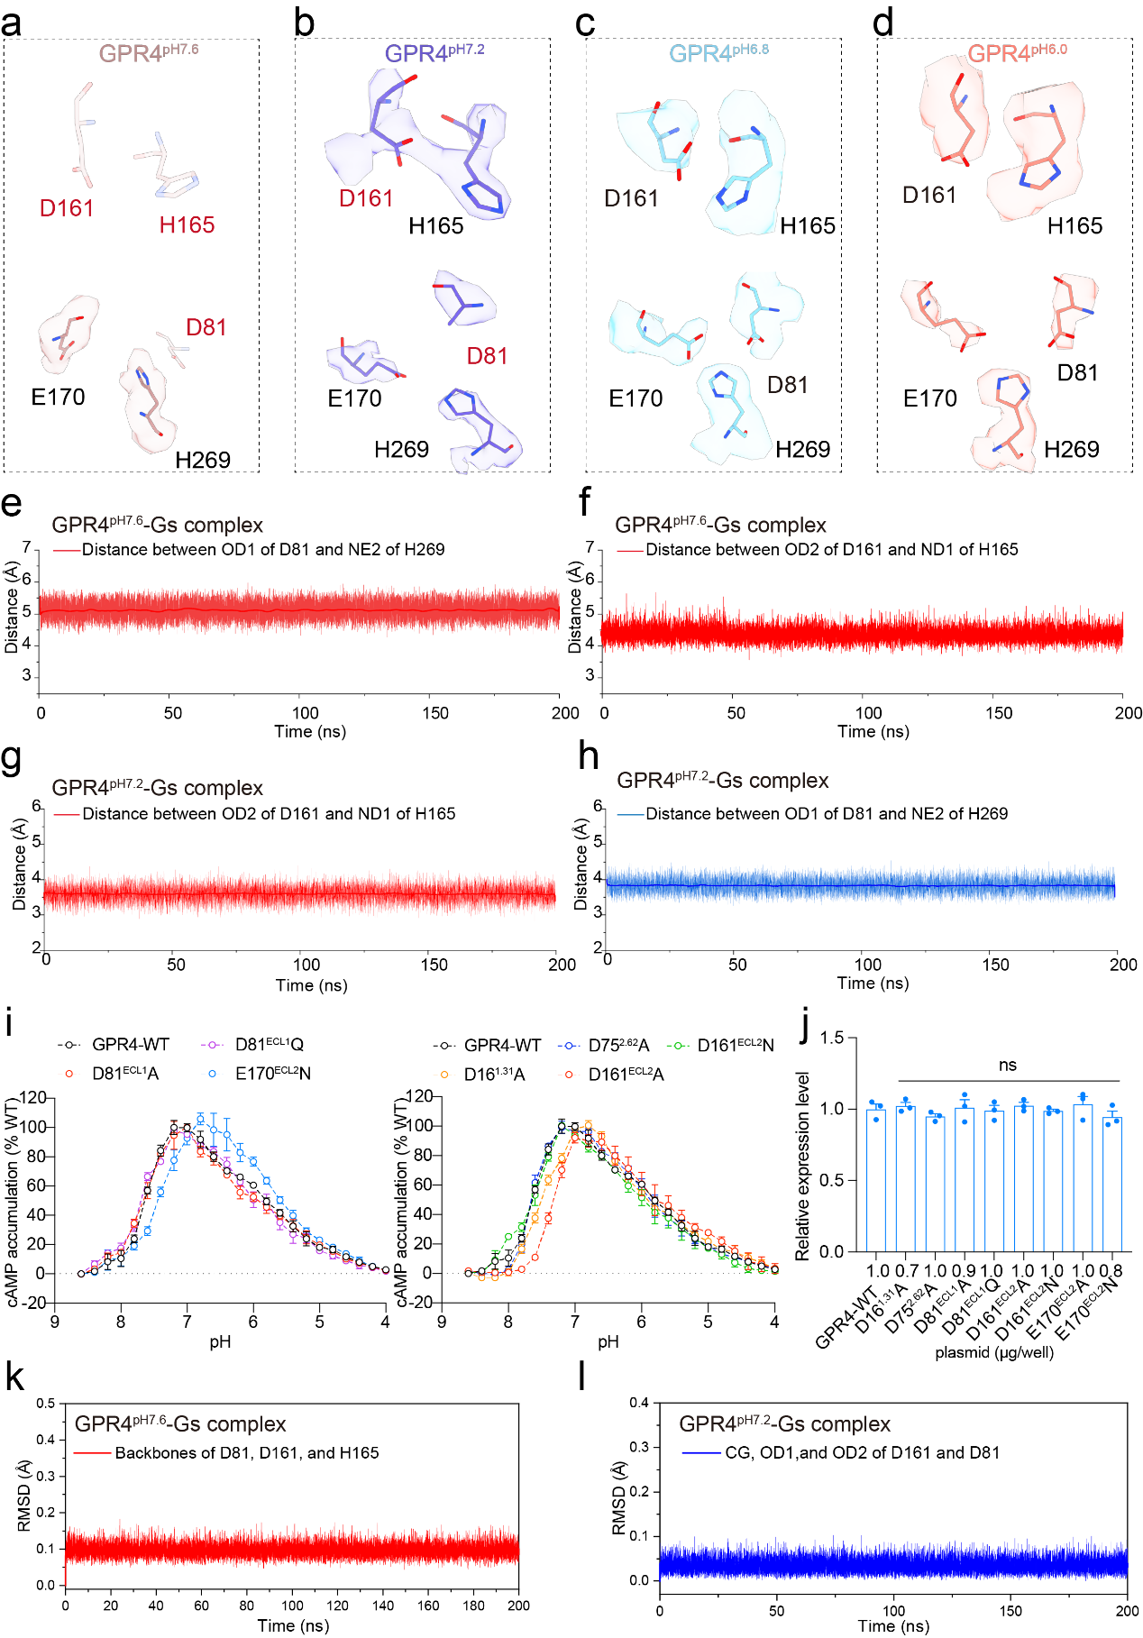
Supplementary Fig. 3| Contribution of the H-bond network to proton sensing by GPR4
a-d, Cryo-EM density of H165^{ECL2}, H269^{7.36} and surrounding residues including D161^{ECL2}, D81^{ECL1} and E170^{ECL2} in the structures of GPR4^{pH7.6}, GPR4^{pH7.2}, GPR4^{pH6.8} and GPR4^{pH6.0}-Gs.
Due to the poor density of the main chain, the residues marked as transparent have been performed to MD simulation, while other residues marked in red have also been subjected to MD simulations due to poor sidechain density. Related to Figure 4b-e.
e-f, The average distances between OD1 of D81, OD2 of D161 and NE2 of H269, as well as ND1 of H165 in the GPR4-Gs complex at pH 7.6 during triplicate 200 ns MD simulations.
g-h, The average distances between OD1 of D81, OD2 of D161 and NE2 of H269, as well as ND1 of H165 in the GPR4-Gs complex at pH 7.2 during triplicate 200 ns MD simulations.
i, Curves showing pH-dependent cAMP accumulation in cells overexpressing GPR4, D81^{ECL1}A, D81^{ECL1}Q, E170^{ECL2}N (left) or D16^{1.31}A, D75^{2.62}A, D161^{ECL2}A, D161^{ECL2}N (right). Values are represented as mean ± SEM of 3 independent experiments (n = 3).
j, Elisa experiments to determine the expression levels of the wild-type GPR4, D16^{1.31}A, D75^{2.62}A, D81^{ECL1}A, D81^{ECL1}Q, D161^{ECL2}A, D161^{ECL2}N, E170^{ECL2}A or E170^{ECL2}N mutations. Values are mean ± SEM from three independent experiments (n=3). n.s., no significance. All data were analyzed by two-sided one-way ANOVA with Turkey test.
k, The average RMSD values of D81, D161 and H165 in GPR4 ^{pH 7.6}-Gs systems during triplicate 200 ns MD simulations.
l, The average RMSD values of D81 and D161 in GPR4 ^{pH 7.2}-Gs systems during triplicate 200 ns MD simulations.

Supplementary Fig. 4

Supplementary Fig. 4| Cryo-EM density of residues of GPR4 contributed to GPR4-Gq activity
a-f, Cryo-EM density of H79^{2.66} (a), H80^{2.67} (b), H85^{ECL1}(c), H155^{4.63}(d), H165^{ECL2} (e), H269^{7.36} (f) and surrounding residues in the structure of GPR4^{pH6.5}-Gq complex. Related to Figure 5f.
g, The average RMSD values of CG, OE1, OE2 of E170 residue in GPR4^{pH6.5}-Gq systems during triplicate 200 ns MD simulations.

Supplementary Fig. 5

Supplementary Fig. 5|Cryo-EM density of residues in GPR68 contributed to proton sensing
a-b, Cryo-EM density of H269^{7.36} and surrounding residues including E174^{ECL2} (a), H84^{3.67}, H169 ^{ECL2} and surrounding residues including D85^{ECL1} and D165^{ECL2} (b) in the structure of GPR68^{pH6.0}-Gs. The residues marked in red was performed MD simulation due to poor EM density. Related to Figure 7d.
c-d, Cryo-EM density of H269^{7.36} and surrounding residues including E174^{ECL2} (c), H84^{3.67}, H169 ^{ECL2} and surrounding residues including D85^{ECL1} and D165^{ECL2} (d) in the structure of GPR68^{pH6.8}-Gs. Related to Figure 7d.
e, The average distances between OD1 of D85, OD1 of D165 and ND1 of H84, as well as ND1 of H169 in the GPR68 ^{pH6.8}-Gs complex during triplicate 200 ns MD simulations.
f, The average RMSD values of OD1, OD2 in D85, OD1, OD2 in D165 residues GPR68^{pH6.8}-Gs systems during triplicate 200 ns MD simulations.

Supplementary Fig. 6
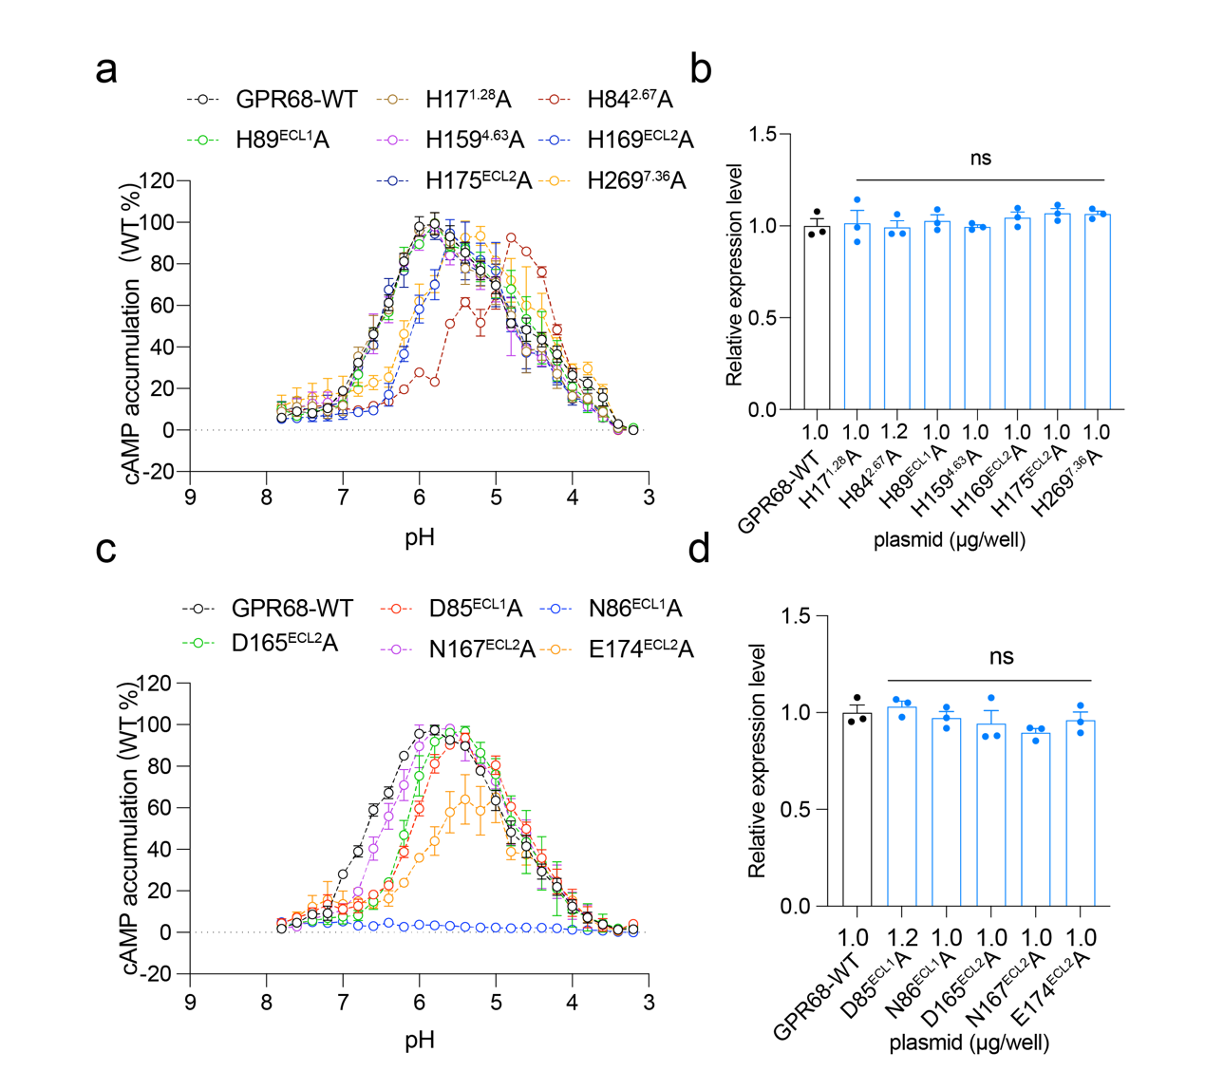
Supplementary Fig. 6 | Effects of key residues contributed to proton sensing in GPR68
a, Curves showing pH-dependent cAMP accumulation in cells overexpressing GPR68, H17^{1.28}A, H84^{2.67}A, H89^{ECL1}A, H159^{4.63}A, H169^{ECL2}A, H175^{ECL2}A or H269^{7.36}A. Values are represented as mean ± SEM of 3 independent experiments (n = 3).
b, Elisa experiments to determine the expression levels of the wild-type GPR68, H17^{1.28}A, H84^{2.67}A, H89^{ECL1}A, H159^{4.63}A, H169^{ECL2}A, H175^{ECL2}A or H269^{7.36}A mutations. Values are mean ± SEM from three independent experiments (n=3). n.s., no significance. All data were analyzed by two-sided one-way ANOVA with Turkey test.
c, Curves showing pH-dependent cAMP accumulation in cells overexpressing GPR68, D85^{ECL1}A, N86^{ECL1}A, D165^{ECL2}A, N167^{ECL2}A or E174^{ECL2}A. Values are represented as mean ± SEM of 3 independent experiments (n = 3).
d, Elisa experiments to determine the expression levels of the wild-type GPR68, D85^{ECL1}A, N86^{ECL1}A, D165^{ECL2}A, N167^{ECL2}A or E174^{ECL2}A mutations. Values are mean ± SEM from three independent experiments (n=3). n.s., no significance. All data were analyzed by two-sided one-way ANOVA with Turkey test.

Supplementary Fig. 7

Supplementary Fig. 7| Cryo-EM density of residues in the activation propagation pathway of GPR4.
a-d, Cryo-EM density of key residues along the propagation path including Y66^{2.53}, Y97^{3.32}, Y98^{3.33}, I101^{3.36}, D161^{ECL2}, H165^{ECL2}, F167^{ECL2}, E170^{ECL2}, F172^{ECL2}, P193^{5.50}, V233^{6.44}, F237^{6.48}, Y240^{6.51}, R247^{6.58}, F265^{ECL2}, Y268^{7.35}, H269^{7.36} and L272^{7.39} in the structure of GPR4^{pH6.8}-Gs complex, Related to Figure 8a-d.
e, Elisa experiments to determine the expression levels of the wild type and key residues mutations in the activation propagation pathway of GPR4. Values are mean ± SEM from three independent experiments (n=3). n.s., no significance. All data were analyzed by two-sided one-way ANOVA with Turkey test.
f-h, Cryo-EM density of of the V/IPF (F), DPxxY (G) and DRY (H) motifs including E51^{2.38}, I105^{3.40}, P193^{5.50}, V233^{6.44}, D114^{3.49}, R115^{3.50}, Y116^{3.51}, Y201^{5.58}, F237^{6.48}, P283^{7.50} and Y286^{7.53} in the structure of GPR4^{pH6.8}-Gs complex, Related to Figure 8f-h.

Supplementary Fig. 8
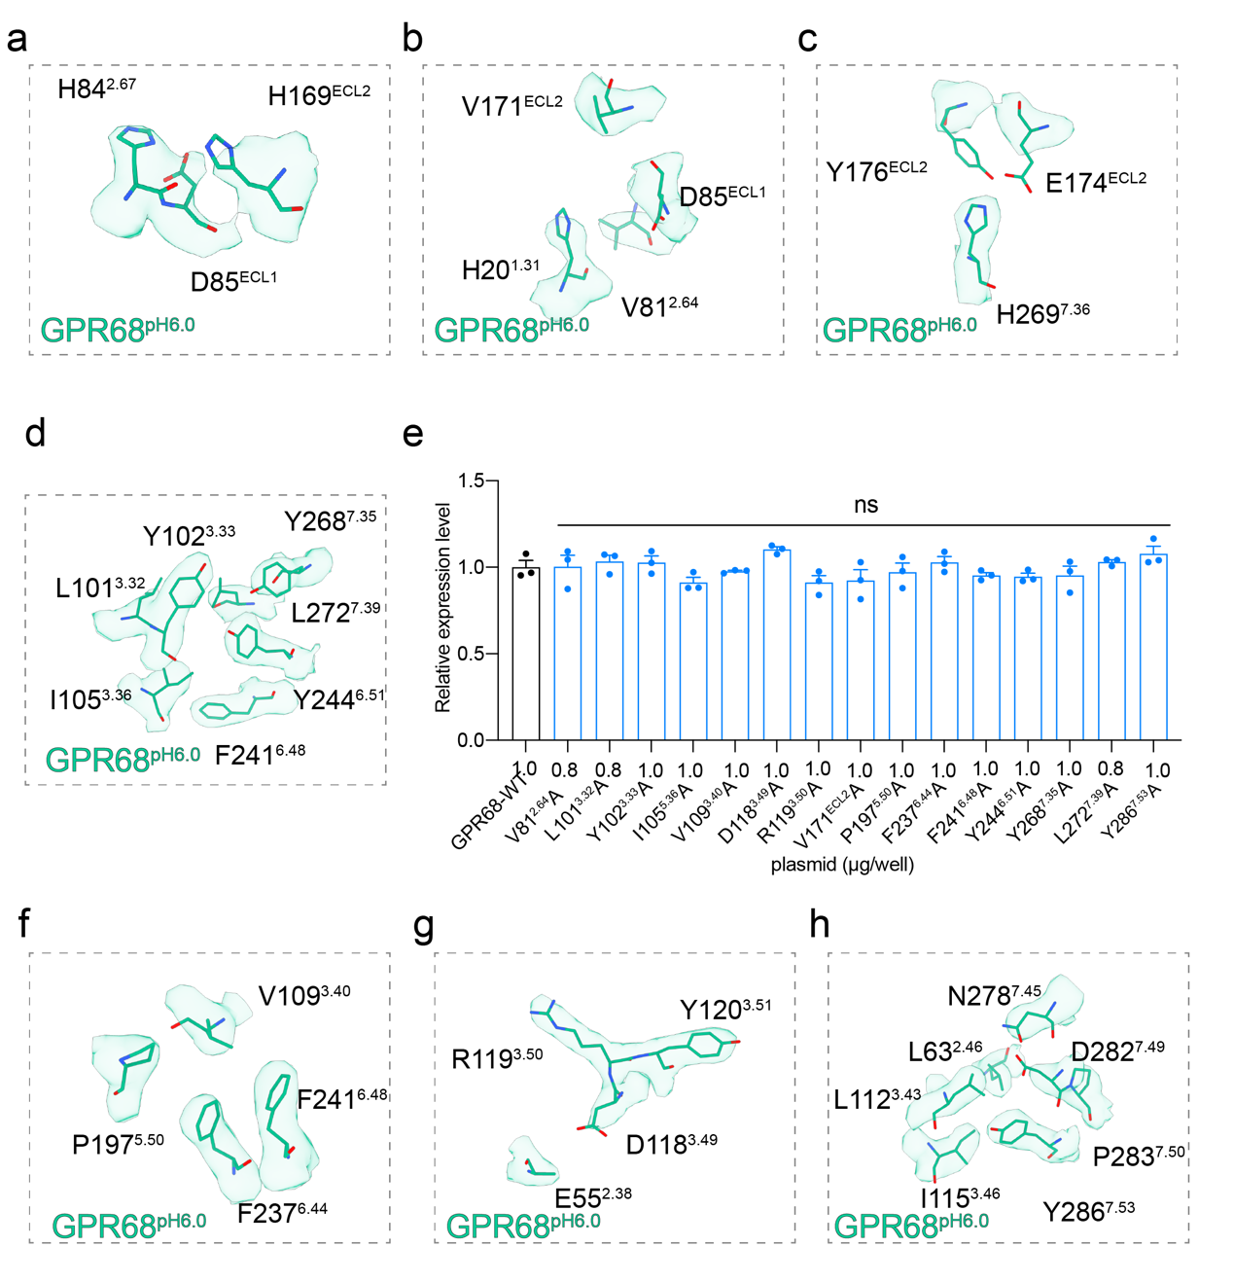
Supplementary Fig. 8| Cryo-EM density of residues in the activation propagation pathway of GPR68.
a-d. Cryo-EM density of key residues along the propagation path including H20^{1.31}, V81^{2.64}, H84^{2.67}, D85^{ECL1}, L101^{3.32}, Y102^{3.33}, I105^{3.36}, H169^{ECL2}, V171^{ECL2}, E174^{ECL2}, Y176^{ECL2}, F241^{6.48}, Y244^{6.51}, Y268^{7.35}, H269^{7.36} and L272^{7.39}, in the structure of GPR68^{pH6.0}-Gs complex, Related to Figure 9a-d.
e. Elisa experiments to determine the expression levels of the wild type and key residues mutations in the activation propagation pathway of GPR68. Values are mean ± SEM from three independent experiments (n=3). n.s., no significance. All data were analyzed by two-sided one-way ANOVA with Turkey test.
f-h. Cryo-EM density of of the V/IPF (F), DPxxY (G) and DRY (H) motifs including E55^{2.38}， L63^{2.46}, V109^{3.40}, L112^{3.43}, I115^{3.46}, D118^{3.49}, R119^{3.50}, Y120^{3.51}, P197^{5.50}, Y237^{6.44}, F241^{6.48}, N278^{7.45}, D282^{7.49}, P283^{7.50}, Y286^{7.53}, in the structure of GPR68^{pH6.0}-Gs complex.

Supplementary Fig. 9
Supplementary Fig. 9| Cryo-EM density of residues in GPR4/GPR68-Gs binding interface
a-b, Cryo-EM density of key residues about the detailed interactions of V119^{3.54}, I204^{5.61}, V208^{5.65} and I222^{6.33} in GPR4 ^{pH6.8} with L388^{G.H5.20}, L394^{G.H5.26} and L393^{G.H5.25} in Gαs and superimposition of these interactions with those of V123^{3.54}, I208^{5.61}, V212^{5.65} and L229^{6.36} in GPR68 ^{pH6.0} and L388^{G.H5.20}, L394^{G.H5.26} and L393^{G.H5.25} in Gαs, Related to Figure 10 e.
c-d, Cryo-EM density of key residues about detailed interactions between D114^{3.49} of GPR4 ^{pH6.8} and Y391^{G.H.5.23} of the α5 helix in Gαs compared to those between D118^{3.49} of GPR68^{pH6.0} and Y391^{G.H.5.23} of Gαs, Related to Figure 10 f.
e-f, Cryo-EM density of key residues about the detailed interactions of L123^{ICL2} in GPR4 ^{pH6.8}, and H41^{G.S1.02}, V227^{G.S3.01}, F376^{G.H5.15} and I383^{G.H5.15} in Gαs, and superimposition of these interactions with those of F127^{ICL2} in GPR68^{pH6.0}, and H41^{G.S1.02}, V227^{G.S3.01}, F376^{G.H5.15} and I383^{G.H5.15} in Gαs, Related to Figure 10 g.

Supplementary Fig. 10
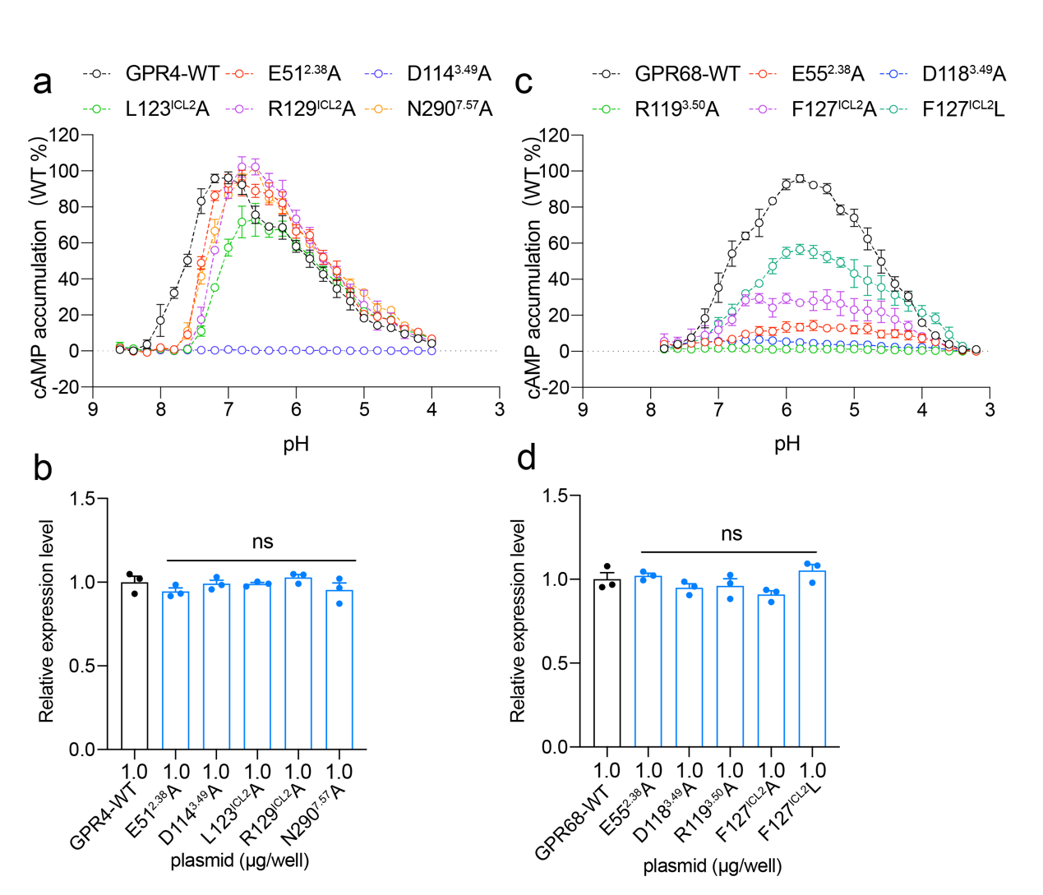
Supplementary Fig. 10| Effects of key residue mutations in the activation propagation pathway of GPR4 or GPR68 induced cAMP accumulation
a, Curves showing pH-dependent cAMP accumulation in cells overexpressing GPR4, E51^{2.38}A, D114^{3.49}A, L123^{ICL2}A, R129^{ICL2}A or N290^{7.57}A. Values are represented as mean ± SEM of 3 independent experiments (n = 3).
b, Elisa experiments to determine the expression levels of the wild-type GPR4, E51^{2.38}A, D114^{3.49}A, L123^{ICL2}A, R129^{ICL2}A or N290^{7.57}A. Values are mean ± SEM from three independent experiments (n=3). n.s., no significance. All data were analyzed by two-sided one-way ANOVA with Turkey test.
c, Curves showing pH-dependent cAMP accumulation in cells overexpressing GPR68, E55^{2.38}A, D118^{3.49}A, R119^{3.50}A, F127^{ICL2}A or F127^{ICL2}L. Values are represented as mean ± SEM of 3 independent experiments (n = 3).
d, Elisa experiments to determine the expression levels of the wild-type GPR68, E55^{2.38}A, D118^{3.49}A, R119^{3.50}A, F127^{ICL2}A or F127^{ICL2}L. Values are mean ± SEM from three independent experiments (n=3). n.s., no significance. All data were analyzed by two-sided one-way ANOVA with Turkey test.

Supplementary Table 1: The mask of the receptor region for improved EM density.
Model | Full map | Mask map | Improvement
Model | Full map | Mask map | TM | ECL
GPR4^{pH7.2} receptor in GPR4^{pH7.2}-Gs complex | GPR4^{pH7.2}_Gs_full_map | GPR4^{pH7.2}_receptor_mask_map | No improvement | F159-F167
GPR4^{pH6.8} receptor in GPR4^{pH6.8}-Gs complex | GPR4^{pH6.8}_Gs_full_map | GPR4^{pH6.8}_receptor_mask_map | D12^{1.27}-L18^{1.32}  R216^{6.27}-K221^{6.32} | D156-F159  R162-N164  K171-E175
GPR4^{pH6.0} receptor in GPR4^{pH6.0}-Gs complex | GPR4^{pH6.0}_Gs_full_map | GPR4^{pH6.0}_receptor_mask_map | No improvement | H80-N82  D161-H165  R254-R263
GPR4^{pH6.5} receptor in GPR4^{pH6.5}-Gq complex | GPR4^{pH6.5}_Gq_full_map | GPR4^{pH6.5}_receptor_mask_map | L18^{1.32}-I25^{1.40}  K913.26 | No improvement
GPR68^{pH6.8} receptor in GPR68^{pH6.8}-Gs complex | GPR68^{pH6.8}_Gs_full_map | GPR68^{pH6.8}_receptor_mask_map | No improvement | D161-H165
GPR68^{pH6.0} receptor in GPR68^{pH6.0}-Gs complex | GPR68^{pH6.0}_Gs_full_map | GPR68^{pH6.0}_receptor_mask_map | H17^{1.28}- P25^{1.36}  L74^{2.57}-Q79^{2.62}  R183^{5.33}-L191^{5.44}  N266^{7.33} | H89  V162-I163  Y176-Q179  W254

Supplementary Table 2: The summary of all models and maps.
Model | Map | Contour Level | Residue | Description
Item2_GPR4^{pH7.6} _Gs_full-model | Item1_GPR4^{pH7.6}_Gs_full_map | 0.62 rmsd | Receptor: V15-H80, I84-F154, E170-G153, E262-L304;  Gαs: T4-M18, I26-V65, V212-L394;  Gβ1: E3-N340;  Gγ2: Q11-R62;  scFv16: V2-A121, S135-V147, P151-E246. | In the section of “Cryo-EM analysis of GPR4 and GPR68 complexes”, used for structural descriptions for GPR4^{pH7.6}-Gs complex. (Fig. 1f)
Item4_GPR4^{pH7.6}_receptor_mask_model | Item3_GPR4^{pH7.6}_receptor_mask_map | 4.89 rmsd | Receptor: V15-H80, I84-F154, E170-G153, E262-L304. | In the section of “Contribution of the H-bond network to proton sensing by GPR4” (Fig. 4b and Fig. 4f)
Item6_GPR4^{pH7.2} _Gs_full-model | Item5_GPR4^{pH7.2}_Gs_full_map | 3.85 rmsd | Receptor: G8-M174, G176-L252, R254-L304;  Gαs: T4-M18, I26-V65, V212-L394;  Gβ1: E3-N340;  Gγ2: Q11-R62;  scFv16: V2-A121, S135-E246. | - In the section of “Cryo-EM analysis of GPR4 and GPR68 complexes”, used for structural descriptions for GPR4^{pH7.2}-Gs complex. (Fig. 1f).  - In the section of “Coupling of GPR4 and GPR68 with Gs”. (Fig. 10d).
Item8_GPR4^{pH7.2}_receptor_mask_model | Item7_GPR4^{pH7.2}_receptor_mask_map | 7.24 rmsd | Receptor: G8- M174, G176-L252, R254-L304. | In the section of “Contribution of the H-bond network to proton sensing by GPR4” (Fig. 4c and Fig. 4f)
Item10_GPR4^{pH6.8} _Gs_full-model | Item9_GPR4^{pH6.8}_Gs_full_map | 1.26 rmsd | Receptor: G8-D161, H165-L304;  Gαs: T4-M18, I26-V65, V212-L394;  Gβ1: E3-N340;  Gγ2: Q11-R62;  scFv16: V2-A121, S135-V147, P151-E246. | - In the section of “Cryo-EM analysis of GPR4 and GPR68 complexes”, used for structural descriptions for GPR4^{pH6.8}-Gs complex. (Fig. 1f)  - In the section of “Coupling of GPR4 and GPR68 with Gs”. (Fig. 10a, Fig. 10c-g)
Item12_GPR4^{pH6.8}_receptor_mask_model | Item11_GPR4^{pH6.8}_receptor_mask_map | 2.35 rmsd | Receptor: G8-L304. | - In the section of “Key histidine residues for GPR4-Gs coupling in response to proton sensation”. (Fig. 3a and Fig. 3d)  - In the section of “Contribution of the H-bond network to proton sensing by GPR4” (Fig. 4d and Fig. 4f)  - In the section of “Common proton sensing mechanisms shared by GPR68 and GPR4”. (Fig. 6a and Fig. 7d)  - In the section of “Activation mechanisms of GPR4” (Fig .8)
Item14_GPR4^{pH6.0} _Gs_full-model | Item13_GPR4^{pH6.0}_Gs_full_map | 0.42 rmsd | Receptor: G8- L304;  Gαs: T4-M18, I26-R61, K213-L394;  Gβ1: Q9-N340;  Gγ2: R13-R62;  scFv16: V2-A121, S135-E246. | (1) In the section of “Cryo-EM analysis of GPR4 and GPR68 complexes”. (Fig. 1f)  (2) In the section of “Coupling of GPR4 and GPR68 with Gs”. (Fig. 10d)
Item16_GPR4^{pH6.0}_receptor_mask_model | Item15_GPR4^{pH6.0}_receptor_mask_map | 2.19 rmsd | Receptor: G8- L304; | In the section of “Contribution of the H-bond network to proton sensing by GPR4”. (Fig. 4e and Fig. 4f)
Item18_GPR4^{pH6.5} _Gq_full-model | Item17_GPR4^{pH6.5}_Gq_full_map | 0.72 rmsd | Receptor: C9- A300;  Gαq: T4-H57, K180-V359;  Gβ1: E3-N340;  Gγ2: Q11-R62;  scFv16: V2-A121, S135-E246. | - In the section of “Cryo-EM analysis of GPR4 and GPR68 complexes”. (Fig. 1f)  - In the section of “Coupling of GPR4 with Gq”. (Fig. 10d)
Item20_GPR4^{pH6.5}_receptor_mask_model | Item19_GPR4^{pH6.5}_receptor_mask_map | 1.64 rmsd | Receptor: C9- H302. | In the section of “Protonation of specific histidine residue confer GPR4-Gq coupling activity”. (Fig. 5 and Fig. 6)
Item22_GPR68^{pH6.8} _Gs_full-model | GPR Item21_68^{pH6.8}_Gs_full_map | 1.36 rmsd | Receptor: C13-L297;  Gαs: T4-M18, I26-H64, V212-L394;  Gβ1: E3-T181, H183-N340;  Gγ2: Q11-R62;  scFv16: V2-S120, D137-S208, T210-L247. | (1) In the section of “Cryo-EM analysis of GPR4 and GPR68 complexes” (Fig. 1f)  (2) In the section of “Coupling of GPR4 and GPR68 with Gs”. (Fig. 10d)
GPR Item24_68^{pH6.8}_receptor_mask_model | Item23_GPR68^{pH6.8}_receptor_mask_map | 7.57 rmsd | Receptor: C13-L297. | - In the section of “Common proton sensing mechanisms shared by GPR68 and GPR4”. (Fig. 7d-e)  - In the section of “Proton sensing by H84 of GPR68”. (Fig. 7d-e)
Item26_GPR68^{pH6.0} _Gs_full-model | Item25_GPR68^{pH6.0}_Gs_full_map | 0.89 rmsd | Receptor: C13-G217; Q219-A298;  Gαs: T4-M18, I26-M60, K213-G304, S306-P326, E330-L394;  Gβ1: Q6-A309, H311-N340;  Gγ2: Q11-R62;  scFv16: V2-S120, S135- L245. | - In the section of “Cryo-EM analysis of GPR4 and GPR68 complexes”. (Fig. 1f)  - In the section of “Coupling of GPR4 and GPR68 with Gs”. (Fig. 10b-d)
Item28_GPR68^{pH6.0}_receptor_mask_model | Item27_GPR68^{pH6.0}_receptor_mask_map | 0.57 rmsd | Receptor: C13-G217; Q219-A298. | - In the section of “Common proton sensing mechanisms shared by GPR68 and GPR4”. (Fig. 7d and Fig. 7e)  - In the section of “Proton sensing by H84 of GPR68”. (Fig. 7d and Fig. 7e)  - In the section of “Activation mechanisms of GPR68”. (Fig. 9)
Item29_GPR4^{inactive}simulated_ model | - | - | Receptor: M1-H302. | - In the section of “Key histidine residues for GPR4-Gs coupling in response to proton sensation”. (Fig. 3)  - In the section of “Contribution of the H-bond network to proton sensing by GPR4”. (Fig. 4)  - In the section of “Protonation of specific His residues confer GPR4-Gq coupling activity”. (Fig. 5)  - In the section of “Common proton sensing mechanisms shared by GPR68 and GPR4” (Fig. 6a-c)  - In the section of “Activation mechanisms of GPR4” (Fig. 8)
Item30_GPR68^{inactive}simulated_ model | - | - | Receptor: M1-A298. | - In the section of “Common proton sensing mechanisms shared by GPR68 and GPR4” and Proton sensing by H84 of GPR68 (Fig. 7)  - In the section of “Activation mechanisms of GPR68” (Fig. 9)
Item31_GPR4^{pH7.6} simulated_ model | - | - | Receptor: M1-H302. | (1) In the section of “Contribution of the H-bond network to proton sensing by GPR4”, residues D81, D161 and H165 were performed MD simulation due to poor density (Fig. 4b and Fig. 4f)
Item32_GPR4^{pH7.2} simulated_ model | - | - | Receptor: M1-H302. | In the section of “Contribution of the H-bond network to proton sensing by GPR4”, residues D81 and D161 were performed MD simulation due to poor density (Fig. 4c and Fig. 4f)
Item33_GPR4^{pH6.5} simulated_ model | - | - | Receptor: M1-H302. | In the section of “Protonation of specific histidine residue confer GPR4-Gq coupling activity”, residue E170 was performed MD simulation due to poor density (Fig. 5 and Fig. 6).
Item34_GPR68^{pH6.8}simulated_ model | - | - | Receptor: M1-A298. | (1) In the section of “Common proton sensing mechanisms shared by GPR68 and GPR4”, residues D85 and D165 were performed MD simulation due to poor density (Fig. 7d-e)  (2) In the section of “Proton sensing by H84 of GPR68”. (Fig. 7d-e)

Supplementary Table 3: Summary of residues were performed MD simulation due to poor density
Structure | pH | MD
GPR4-Gq | pH6.5 | E170: CG, CD, OE1, OE2
GPR4-Gs | pH7.2 | D161: CG, OD1, OD2
GPR4-Gs | pH7.2 | D81: CG, OD1, OD2
GPR4-Gs | pH7.6 | D81
GPR4-Gs | pH7.6 | D161
GPR4-Gs | pH7.6 | H165
GPR68-Gs | pH6.8 | D85: OD1, OD2  D165: OD1, OD2

Supplementary Table 4: Interaction of GPR4 and Gαs in the GPR4^{pH6.0}- Gαs complex.
Interactions | GPR4 | Gαs | Distance (Å)
Hydrophobic  (≤4.5 Å) | E218 | L394 | 3.9
Hydrophobic  (≤4.5 Å) | T214 | L394 | 4.0
Hydrophobic  (≤4.5 Å) | I222 | L394 | 3.6
Hydrophobic  (≤4.5 Å) | I222 | L393 | 4.3
Hydrophobic  (≤4.5 Å) | L225 | L393 | 3.9
Hydrophobic  (≤4.5 Å) | R115 | L393 | 3.8
Hydrophobic  (≤4.5 Å) | I204 | L393 | 4.5
Hydrophobic  (≤4.5 Å) | V119 | L393 | 3.5
Hydrophobic  (≤4.5 Å) | L52 | E392 | 3.8
Hydrophobic  (≤4.5 Å) | L56 | E392 | 4.1
Hydrophobic  (≤4.5 Å) | R115 | E392 | 4.2
Hydrophobic  (≤4.5 Å) | Y286 | E392 | 3.5
Hydrophobic  (≤4.5 Å) | L225 | E392 | 4.4
Hydrophobic  (≤4.5 Å) | A293 | E392 | 4.5
Hydrophobic  (≤4.5 Å) | L52 | Y391 | 3.9
Hydrophobic  (≤4.5 Å) | D114 | Y391 | 4.3
Hydrophobic  (≤4.5 Å) | N50 | Y391 | 3.9
Hydrophobic  (≤4.5 Å) | A118 | Y391 | 3.3
Hydrophobic  (≤4.5 Å) | V208 | L388 | 3.3
Hydrophobic  (≤4.5 Å) | V119 | L388 | 3.2
Hydrophobic  (≤4.5 Å) | R129 | H387 | 3.9
Hydrophobic  (≤4.5 Å) | P122 | H387 | 4.4
Hydrophobic  (≤4.5 Å) | V208 | Q384 | 4.0
Hydrophobic  (≤4.5 Å) | V119 | Q384 | 3.7
Hydrophobic  (≤4.5 Å) | P122 | Q384 | 4.2
Hydrophobic  (≤4.5 Å) | P122 | I383 | 4.2
Hydrophobic  (≤4.5 Å) | L123 | I383 | 3.7
Hydrophobic  (≤4.5 Å) | P122 | R380 | 3.9
Hydrophobic  (≤4.5 Å) | S211 | D381 | 4.5
Hydrophobic  (≤4.5 Å) | P122 | R380 | 3.9
Hydrophobic  (≤4.5 Å) | L123 | R380 | 4.1
Hydrophobic  (≤4.5 Å) | V212 | Y360 | 3.4
Hydrophobic  (≤4.5 Å) | V212 | V358 | 4.3
Hydrophobic  (≤4.5 Å) | S213 | V358 | 3.5
Hydrophobic  (≤4.5 Å) | L123 | V227 | 3.9
Hydrophobic  (≤4.5 Å) | L123 | F376 | 3.3
Hydrophobic  (≤4.5 Å) | L123 | H41 | 3.5
Hydrophobic  (≤4.5 Å) | R130 | R38 | 4.5
H-Bond (≤3.5 Å) | N290 | E392 | 2.8
H-Bond (≤3.5 Å) | Q45 | E392 | 3.4
H-Bond (≤3.5 Å) | E51 | Y391 | 3.1
H-Bond (≤3.5 Å) | R115  (main chain) | Y391 | 3.4
H-Bond (≤3.5 Å) | N50 | Q390 | 3.0
H-Bond (≤3.5 Å) | A118  (main chain) | H387 | 3.0
H-Bond (≤3.5 Å) | A207 | Q384 | 3.4
H-Bond (≤3.5 Å) | S211 | Q384 | 3.4
H-Bond (≤3.5 Å) | S213 | D381 | 3.4
H-Bond (≤3.5 Å) | V212  (main chain) | D381 | 3.2
H-Bond (≤3.5 Å) | A120  (main chain) | R380 | 3.3
H-Bond (≤3.5 Å) | R126  (main chain) | R38 | 3.3
H-Bond (≤3.5 Å) | R130 | Q35 | 3.4
Polar (≤4.0 Å) | R129  (main chain) | R38 | 3.7
Polar (≤4.0 Å) | R129  (main chain) | Y391 | 3.9
Polar (≤4.0 Å) | T214 | R385 | 3.9
Polar (≤4.0 Å) | S213  (main chain) | R385 | 3.6
Polar (≤4.0 Å) | S211 | Q384 | 3.6
Polar (≤4.0 Å) | V119  (main chain) | Q384 | 3.7
Polar (≤4.0 Å) | S213 | Y360 | 3.7
Charge- charge (≤6 Å) | E218 | R385 | 3.4

Supplementary Table 5: Interaction of GPR4 and Gαs in the GPR4^{pH6.8}- Gαs complex.

Interactions | GPR4 | Gαs | Distance (Å)
Hydrophobic and Var der Waals  (≤4.5 Å) | I222 | L394 | 4.2
Hydrophobic and Var der Waals  (≤4.5 Å) | E218 | L394 | 4.2
Hydrophobic and Var der Waals  (≤4.5 Å) | I222 | L393 | 3.7
Hydrophobic and Var der Waals  (≤4.5 Å) | I204 | L393 | 4.2
Hydrophobic and Var der Waals  (≤4.5 Å) | V119 | L393 | 3.7
Hydrophobic and Var der Waals  (≤4.5 Å) | L225 | L393 | 3.8
Hydrophobic and Var der Waals  (≤4.5 Å) | L52 | E392 | 3.8
Hydrophobic and Var der Waals  (≤4.5 Å) | L225 | E392 | 4.1
Hydrophobic and Var der Waals  (≤4.5 Å) | L52 | Y391 | 3.6
Hydrophobic and Var der Waals  (≤4.5 Å) | A118 | Y391 | 3.4
Hydrophobic and Var der Waals  (≤4.5 Å) | R129 | Y391 | 3.9
Hydrophobic and Var der Waals  (≤4.5 Å) | V208 | L388 | 4.1
Hydrophobic and Var der Waals  (≤4.5 Å) | V119 | L388 | 3.4
Hydrophobic and Var der Waals  (≤4.5 Å) | I222 | L388 | 3.6
Hydrophobic and Var der Waals  (≤4.5 Å) | T214 | L388 | 3.8
Hydrophobic and Var der Waals  (≤4.5 Å) | P122 | H387 | 4.3
Hydrophobic and Var der Waals  (≤4.5 Å) | R129 | H387 | 3.7
Hydrophobic and Var der Waals  (≤4.5 Å) | V119 | H387 | 4.5
Hydrophobic and Var der Waals  (≤4.5 Å) | T214 | R385 | 2.9
Hydrophobic and Var der Waals  (≤4.5 Å) | S211 | Q384 | 3.2
Hydrophobic and Var der Waals  (≤4.5 Å) | P122 | Q384 | 4.1
Hydrophobic and Var der Waals  (≤4.5 Å) | P122 | I383 | 3.9
Hydrophobic and Var der Waals  (≤4.5 Å) | L123 | I383 | 3.7
Hydrophobic and Var der Waals  (≤4.5 Å) | S211 | D381 | 3.7
Hydrophobic and Var der Waals  (≤4.5 Å) | S213 | D381 | 3.2
Hydrophobic and Var der Waals  (≤4.5 Å) | V212 | D381 | 3.8
Hydrophobic and Var der Waals  (≤4.5 Å) | P122 | R380 | 3.9
Hydrophobic and Var der Waals  (≤4.5 Å) | L123 | R380 | 3.6
Hydrophobic and Var der Waals  (≤4.5 Å) | A120 | R380 | 4.1
Hydrophobic and Var der Waals  (≤4.5 Å) | L123 | C379 | 4.2
Hydrophobic and Var der Waals  (≤4.5 Å) | L123 | F376 | 3.3
Hydrophobic and Var der Waals  (≤4.5 Å) | V212 | Y360 | 3.9
Hydrophobic and Var der Waals  (≤4.5 Å) | V212 | Y358 | 4.3
Hydrophobic and Var der Waals  (≤4.5 Å) | S213 | Y358 | 3.5
Hydrophobic and Var der Waals  (≤4.5 Å) | L123 | H41 | 3.6
Hydrophobic and Var der Waals  (≤4.5 Å) | R130 | R38 | 4.3
Hydrophobic and Var der Waals  (≤4.5 Å) | R130 | Q35 | 4.0
H-Bond (≤3.5 Å) | Q45 | E392 | 2.6
H-Bond (≤3.5 Å) | N290 | E392 | 3.2
H-Bond (≤3.5 Å) | R115 | E392 | 3.5
H-Bond (≤3.5 Å) | E51 | Y391 | 3.2
H-Bond (≤3.5 Å) | D114 | Y391 | 3.5
H-Bond (≤3.5 Å) | R115 | Y391 | 3.1
H-Bond (≤3.5 Å) | N50 | Q390 | 3.3
H-Bond (≤3.5 Å) | A118 | H387 | 2.6
H-Bond (≤3.5 Å) | V119 | Q384 | 2.9
H-Bond (≤3.5 Å) | A120 | R380 | 3.1
H-Bond (≤3.5 Å) | R129 | R38 | 3.3
H-Bond (≤3.5 Å) | R124 | D225 | 2.2
Polar (≤4.0 Å) | N50 | Y391 | 4.0
Polar (≤4.0 Å) | S213 | R385 | 3.7
Polar (≤4.0 Å) | A207 | Q384 | 3.8
Polar (≤4.0 Å) | S213 | Y360 | 3.9
Polar (≤4.0 Å) | A126 | R38 | 3.6
Charge- charge (≤6 Å) | E218 | R389 | 4.9
Charge- charge (≤6 Å) | E218 | R385 | 2.1

Supplementary Table 6: Interaction of GPR4 and Gαs in the GPR4^{pH7.6}- Gαs complex.

Interactions | GPR4 | Gαs | Distance (Å)
Hydrophobic and van der Waals  (≤4.5 Å) | I222 | L394 | 4.3
Hydrophobic and van der Waals  (≤4.5 Å) | V119 | L393 | 3.9
Hydrophobic and van der Waals  (≤4.5 Å) | I204 | L393 | 4.4
Hydrophobic and van der Waals  (≤4.5 Å) | L52 | E392 | 4.1
Hydrophobic and van der Waals  (≤4.5 Å) | R115 | Y391 | 4.4
Hydrophobic and van der Waals  (≤4.5 Å) | A118 | Y391 | 3.5
Hydrophobic and van der Waals  (≤4.5 Å) | V119 | L388 | 3.6
Hydrophobic and van der Waals  (≤4.5 Å) | V208 | L388 | 4.2
Hydrophobic and van der Waals  (≤4.5 Å) | I222 | L388 | 4.4
Hydrophobic and van der Waals  (≤4.5 Å) | P122 | H387 | 4.4
Hydrophobic and van der Waals  (≤4.5 Å) | S213 | R385 | 3.8
Hydrophobic and van der Waals  (≤4.5 Å) | V119 | Q384 | 4.3
Hydrophobic and van der Waals  (≤4.5 Å) | P122 | Q384 | 4.3
Hydrophobic and van der Waals  (≤4.5 Å) | L123 | I383 | 3.7
Hydrophobic and van der Waals  (≤4.5 Å) | L123 | R380 | 3.7
Hydrophobic and van der Waals  (≤4.5 Å) | L123 | F376 | 3.6
Hydrophobic and van der Waals  (≤4.5 Å) | S211 | D381 | 3.5
H-Bond (≤3.5 Å) | Q45 | E392 | 2.7
H-Bond (≤3.5 Å) | N290 | E392 | 2.6
H-Bond (≤3.5 Å) | A118(main chain) | H387 | 2.9
H-Bond (≤3.5 Å) | S213 | D381 | 3.1
Polar (≤4.0 Å) | Y286 | E392 | 3.7
Polar (≤4.0 Å) | E51 | Y391 | 3.8
Polar (≤4.0 Å) | D114 | Y391 | 3.9
Polar (≤4.0 Å) | N50 | Q390 | 3.6
Polar (≤4.0 Å) | V119(main chain) | Q384 | 3.6
Charge-charge (≤6.0 Å) | R115 | E392 | 5.2
Charge-charge (≤6.0 Å) | E218 | R389 | 5.6
Charge-charge (≤6.0 Å) | E218 | R385 | 3.2
Charge-charge (≤6.0 Å) | R124 | D225 | 5.1

Supplementary Table 7: Interaction of GPR4 and Gαs in the GPR4^{pH7.2}- Gαs complex.
Interactions | GPR4 | Gαs | Distance (Å)
Hydrophobic and van der Waals  (≤4.5 Å) | E218 | L394 | 3.5
Hydrophobic and van der Waals  (≤4.5 Å) | I222 | L394 | 3.8
Hydrophobic and van der Waals  (≤4.5 Å) | R115 | L393 | 3.6
Hydrophobic and van der Waals  (≤4.5 Å) | V119 | L393 | 4.1
Hydrophobic and van der Waals  (≤4.5 Å) | I204 | L393 | 4.1
Hydrophobic and van der Waals  (≤4.5 Å) | L225 | L393 | 3.9
Hydrophobic and van der Waals  (≤4.5 Å) | L56 | E392 | 3.5
Hydrophobic and van der Waals  (≤4.5 Å) | L52 | E392 | 3.8
Hydrophobic and van der Waals  (≤4.5 Å) | A118 | T391 | 3.4
Hydrophobic and van der Waals  (≤4.5 Å) | N50 | T391 | 4.4
Hydrophobic and van der Waals  (≤4.5 Å) | A118 | T391 | 3.5
Hydrophobic and van der Waals  (≤4.5 Å) | L52 | T391 | 4.3
Hydrophobic and van der Waals  (≤4.5 Å) | V208 | L388 | 4.0
Hydrophobic and van der Waals  (≤4.5 Å) | I222 | L388 | 3.5
Hydrophobic and van der Waals  (≤4.5 Å) | T214 | L388 | 4.3
Hydrophobic and van der Waals  (≤4.5 Å) | V119 | L388 | 4.0
Hydrophobic and van der Waals  (≤4.5 Å) | P122 | H387 | 3.7
Hydrophobic and van der Waals  (≤4.5 Å) | S213 | R385 | 3.7
Hydrophobic and van der Waals  (≤4.5 Å) | L123 | I383 | 3.8
Hydrophobic and van der Waals  (≤4.5 Å) | P122 | I383 | 3.7
Hydrophobic and van der Waals  (≤4.5 Å) | P122 | R380 | 4.3
Hydrophobic and van der Waals  (≤4.5 Å) | L123 | R380 | 3.6
Hydrophobic and van der Waals  (≤4.5 Å) | L123 | F376 | 3.6
H-Bond (≤3.5 Å) | Y286  (main chain) | E392 | 2.9
H-Bond (≤3.5 Å) | D114 | E392 | 3.5
H-Bond (≤3.5 Å) | E51 | T391 | 2.2
H-Bond (≤3.5 Å) | R115 | T391 | 3.3
H-Bond (≤3.5 Å) | N50 | Q390 | 3.2
H-Bond (≤3.5 Å) | A118  (main chain) | H387 | 3.0
H-Bond (≤3.5 Å) | R129 | H387 | 3.5
H-Bond (≤3.5 Å) | V119  (main chain) | Q384 | 3.4
H-Bond (≤3.5 Å) | S213 | D381 | 3.4
H-Bond (≤3.5 Å) | V212 | D381 | 3.1
H-Bond (≤3.5 Å) | S211 | D381 | 3.5
H-Bond (≤3.5 Å) | A120  (main chain) | R380 | 3.1
H-Bond (≤3.5 Å) | S213 | Y360 | 2.4
H-Bond (≤3.5 Å) | V212 | Y358 | 3.3
Polar (≤4.0 Å) | R129 | T391 | 3.8
Polar (≤4.0 Å) | Q45 | E392 | 4.0
Polar (≤4.0 Å) | N290 | E392 | 4.0
Polar (≤4.0 Å) | T214 | R385 | 3.8
Polar (≤4.0 Å) | S211 | Q384 | 3.7
Polar (≤4.0 Å) | A207  (main chain) | Q384 | 3.7
Polar (≤4.0 Å) | G120  (main chain) | D381 | 4.0
Charge-charge (≤6.0 Å) | R115 | E392 | 5.2
Charge-charge (≤6.0 Å) | R124 | D225 | 5.7
Charge-charge (≤6.0 Å) | E218 | R389 | 6.0
Charge-charge (≤6.0 Å) | E218 | R385 | 3.1

Supplementary Table 8: Interaction of GPR4 and Gαq in the GPR4^{pH6.5}- Gαq complex.

Interactions | GPR4 | Gαq | Distance (Å)
Hydrophobic and van der Waals  (≤4.5 Å) | I222 | V359 | 3.7
Hydrophobic and van der Waals  (≤4.5 Å) | N290 | V359 | 4.3
Hydrophobic and van der Waals  (≤4.5 Å) | R115 | L358 | 3.7
Hydrophobic and van der Waals  (≤4.5 Å) | Y201 | L358 | 4.4
Hydrophobic and van der Waals  (≤4.5 Å) | I204 | L358 | 4.2
Hydrophobic and van der Waals  (≤4.5 Å) | V119 | L358 | 3.8
Hydrophobic and van der Waals  (≤4.5 Å) | I222 | L358 | 3.3
Hydrophobic and van der Waals  (≤4.5 Å) | A118 | Y356 | 3.4
Hydrophobic and van der Waals  (≤4.5 Å) | R115 | Y356 | 4.2
Hydrophobic and van der Waals  (≤4.5 Å) | L52 | Y356 | 3.8
Hydrophobic and van der Waals  (≤4.5 Å) | I204 | L353 | 3.6
Hydrophobic and van der Waals  (≤4.5 Å) | V208 | L353 | 3.8
Hydrophobic and van der Waals  (≤4.5 Å) | I222 | L353 | 3.5
Hydrophobic and van der Waals  (≤4.5 Å) | A118 | N352 | 3.9
Hydrophobic and van der Waals  (≤4.5 Å) | P122 | N352 | 3.6
Hydrophobic and van der Waals  (≤4.5 Å) | V119 | L349 | 4.2
Hydrophobic and van der Waals  (≤4.5 Å) | L123 | I348 | 3.5
Hydrophobic and van der Waals  (≤4.5 Å) | P122 | I348 | 3.9
Hydrophobic and van der Waals  (≤4.5 Å) | S211 | D346 | 3.9
Hydrophobic and van der Waals  (≤4.5 Å) | L123 | K345 | 3.7
Hydrophobic and van der Waals  (≤4.5 Å) | P122 | K345 | 3.8
Hydrophobic and van der Waals  (≤4.5 Å) | L123 | C344 | 4.2
H-Bond (≤3.5 Å) | Q45 | N357 | 3.3
H-Bond (≤3.5 Å) | R115 | N357 | 2.9
H-Bond (≤3.5 Å) | Y286 | N357 | 3.4
H-Bond (≤3.5 Å) | N290 | N357 | 3.5
H-Bond (≤3.5 Å) | R129 | Y356 | 3.5
H-Bond (≤3.5 Å) | A118(main chain) | N352 | 2.6
H-Bond (≤3.5 Å) | S213 | Q350 | 2.8
H-Bond (≤3.5 Å) | T214 | Q350 | 2.4
H-Bond (≤3.5 Å) | S213 | D346 | 2.8
Polar  (≤4.0 Å) | D114 | Y356 | 3.9
Polar  (≤4.0 Å) | N50 |  | 3.7
Polar  (≤4.0 Å) | N50 | E355 | 3.9
Polar  (≤4.0 Å) | Q45 | E355 | 3.99
Polar  (≤4.0 Å) | R129 | N352 | 3.64
Polar  (≤4.0 Å) | S211 | Q350 | 3.77

Supplementary Table 9: Interaction of GPR68 and Gαs in the GPR68^{pH6.0}- Gαs complex.

Interactions | GPR68 | Gαs | Distance (Å)
Hydrophobic and Var der Waals  (≤4.5 Å) | S290 | L394 | 4.3
Hydrophobic and Var der Waals  (≤4.5 Å) | I226 | L394 | 3.6
Hydrophobic and Var der Waals  (≤4.5 Å) | R222 | L394 | 4.2
Hydrophobic and Var der Waals  (≤4.5 Å) | V123 | L393 | 4.2
Hydrophobic and Var der Waals  (≤4.5 Å) | L229 | L393 | 3.7
Hydrophobic and Var der Waals  (≤4.5 Å) | I226 | L393 | 2.8
Hydrophobic and Var der Waals  (≤4.5 Å) | R119 | L393 | 4.2
Hydrophobic and Var der Waals  (≤4.5 Å) | I208 | L393 | 4.3
Hydrophobic and Var der Waals  (≤4.5 Å) | L60 | E392 | 4.1
Hydrophobic and Var der Waals  (≤4.5 Å) | L229 | E392 | 4.4
Hydrophobic and Var der Waals  (≤4.5 Å) | Y286 | E392 | 2.9
Hydrophobic and Var der Waals  (≤4.5 Å) | S290 | E392 | 4.4
Hydrophobic and Var der Waals  (≤4.5 Å) | T292 | E392 | 4.0
Hydrophobic and Var der Waals  (≤4.5 Å) | L56 | Y391 | 3.6
Hydrophobic and Var der Waals  (≤4.5 Å) | A122 | Y391 | 3.5
Hydrophobic and Var der Waals  (≤4.5 Å) | V212 | L388 | 4.1
Hydrophobic and Var der Waals  (≤4.5 Å) | V123 | L388 | 3.4
Hydrophobic and Var der Waals  (≤4.5 Å) | V123 | H387 | 4.4
Hydrophobic and Var der Waals  (≤4.5 Å) | P126 | H387 | 4.0
Hydrophobic and Var der Waals  (≤4.5 Å) | G217 | R385 | 4.0
Hydrophobic and Var der Waals  (≤4.5 Å) | T218 | R385 | 3.9
Hydrophobic and Var der Waals  (≤4.5 Å) | P126 | Q384 | 4.1
Hydrophobic and Var der Waals  (≤4.5 Å) | A211 | Q384 | 3.8
Hydrophobic and Var der Waals  (≤4.5 Å) | S215 | Q384 | 4.5
Hydrophobic and Var der Waals  (≤4.5 Å) | F127 | I383 | 4.0
Hydrophobic and Var der Waals  (≤4.5 Å) | P126 | I383 | 3.6
Hydrophobic and Var der Waals  (≤4.5 Å) | P126 | R380 | 4.0
Hydrophobic and Var der Waals  (≤4.5 Å) | F127 | R380 | 3.8
Hydrophobic and Var der Waals  (≤4.5 Å) | F127 | C379 | 4.1
Hydrophobic and Var der Waals  (≤4.5 Å) | F127 | F376 | 3.3
Hydrophobic and Var der Waals  (≤4.5 Å) | F127 | F276 | 3.5
Hydrophobic and Var der Waals  (≤4.5 Å) | F127 | V227 | 4.1
Hydrophobic and Var der Waals  (≤4.5 Å) | F127 | F229 | 4.4
Hydrophobic and Var der Waals  (≤4.5 Å) | F127 | H41 | 3.3
Hydrophobic and Var der Waals  (≤4.5 Å) | T134 | R38 | 3.9
Hydrophobic and Var der Waals  (≤4.5 Å) | R133 | R38 | 4.5
Polar  (≤4.0 Å) | E291 | L394 | 3.7
Polar  (≤4.0 Å) | Q49 | E392 | 3.9
Polar  (≤4.0 Å) | D118 | Y391 | 3.9
Polar  (≤4.0 Å) | R119 | Y391 | 3.6
Polar  (≤4.0 Å) | R133 | H387 | 3.9
Polar  (≤4.0 Å) | G217 | D381 | 3.6
H-Bond (≤3.5 Å) | Y286 | E392 | 2.9
H-Bond (≤3.5 Å) | R133 | Y391 | 3.4
H-Bond (≤3.5 Å) | N54 | Q390 | 3.5
H-Bond (≤3.5 Å) | A122 | H387 | 2.5
H-Bond (≤3.5 Å) | V123 | Q384 | 3.1
H-Bond (≤3.5 Å) | S215 | D381 | 2.9
H-Bond (≤3.5 Å) | A124 | R380 | 3.1
H-Bond (≤3.5 Å) | H130 | R38 | 2.9
Charge-charge (≤6 Å) | R119 | E392 | 3.4
Charge-charge (≤6 Å) | H216 | D381 | 4.2
Charge-charge (≤6 Å) | R128 | D225 | 6.0

Supplementary Table 10: Interaction of GPR68 and Gαs in the GPR68^{pH6.8}- Gαs complex.

Interactions | GPR68 | Gαs | Distance (Å)
Hydrophobic and van der Waals  (≤4.5 Å) | R222 | L394 | 3.7
Hydrophobic and van der Waals  (≤4.5 Å) | I226 | L394 | 3.7
Hydrophobic and van der Waals  (≤4.5 Å) | S290 | L394 | 4.2
Hydrophobic and van der Waals  (≤4.5 Å) | T218 | L394 | 4.4
Hydrophobic and van der Waals  (≤4.5 Å) | Q225 | L394 | 3.9
Hydrophobic and van der Waals  (≤4.5 Å) | L229 | L393 | 3.0
Hydrophobic and van der Waals  (≤4.5 Å) | I208 | L393 | 4.1
Hydrophobic and van der Waals  (≤4.5 Å) | V123 | L393 | 4.1
Hydrophobic and van der Waals  (≤4.5 Å) | V230 | L393 | 3.9
Hydrophobic and van der Waals  (≤4.5 Å) | R119 | L393 | 3.9
Hydrophobic and van der Waals  (≤4.5 Å) | I226 | L393 | 3.6
Hydrophobic and van der Waals  (≤4.5 Å) | L229 | E392 | 3.7
Hydrophobic and van der Waals  (≤4.5 Å) | Y286 | E392 | 3.8
Hydrophobic and van der Waals  (≤4.5 Å) | L60 | E392 | 3.0
Hydrophobic and van der Waals  (≤4.5 Å) | L56 | E392 | 2.6
Hydrophobic and van der Waals  (≤4.5 Å) | Q49 | E392 | 4.1
Hydrophobic and van der Waals  (≤4.5 Å) | S290 | E392 | 3.4
Hydrophobic and van der Waals  (≤4.5 Å) | T292 | E392 | 4.5
Hydrophobic and van der Waals  (≤4.5 Å) | R119 | Y391 | 3.8
Hydrophobic and van der Waals  (≤4.5 Å) | L56 | Y391 | 3.5
Hydrophobic and van der Waals  (≤4.5 Å) | D118 | Y391 | 3.2
Hydrophobic and van der Waals  (≤4.5 Å) | N54 | Y391 | 4.2
Hydrophobic and van der Waals  (≤4.5 Å) | A122 | Y391 | 3.5
Hydrophobic and van der Waals  (≤4.5 Å) | Q49 | Q390 | 3.8
Hydrophobic and van der Waals  (≤4.5 Å) | T292 | R389 | 3.7
Hydrophobic and van der Waals  (≤4.5 Å) | I226 | L388 | 3.8
Hydrophobic and van der Waals  (≤4.5 Å) | T218 | L388 | 4.5
Hydrophobic and van der Waals  (≤4.5 Å) | V123 | L388 | 4.0
Hydrophobic and van der Waals  (≤4.5 Å) | V212 | L388 | 4.2
Hydrophobic and van der Waals  (≤4.5 Å) | P126 | H387 | 4.3
Hydrophobic and van der Waals  (≤4.5 Å) | R133 | H387 | 3.2
Hydrophobic and van der Waals  (≤4.5 Å) | A122 | H387 | 3.6
Hydrophobic and van der Waals  (≤4.5 Å) | T218 | R385 | 3.3
Hydrophobic and van der Waals  (≤4.5 Å) | G217 | R385 | 3.7
Hydrophobic and van der Waals  (≤4.5 Å) | V123 | Q384 | 3.1
Hydrophobic and van der Waals  (≤4.5 Å) | P126 | Q384 | 3.7
Hydrophobic and van der Waals  (≤4.5 Å) | S215 | Q384 | 4.3
Hydrophobic and van der Waals  (≤4.5 Å) | F127 | I383 | 4.3
Hydrophobic and van der Waals  (≤4.5 Å) | P126 | I383 | 3.4
Hydrophobic and van der Waals  (≤4.5 Å) | S215 | D381 | 3.3
Hydrophobic and van der Waals  (≤4.5 Å) | F127 | R380 | 3.6
Hydrophobic and van der Waals  (≤4.5 Å) | P126 | R380 | 3.7
Hydrophobic and van der Waals  (≤4.5 Å) | H125 | R380 | 4.4
Hydrophobic and van der Waals  (≤4.5 Å) | F127 | F376 | 3.0
Hydrophobic and van der Waals  (≤4.5 Å) | H216 | Y358 | 3.2
Hydrophobic and van der Waals  (≤4.5 Å) | G217 | Y358 | 3.4
Hydrophobic and van der Waals  (≤4.5 Å) | H216 | Y366 | 3.8
Hydrophobic and van der Waals  (≤4.5 Å) | F127 | V227 | 3.0
Hydrophobic and van der Waals  (≤4.5 Å) | F127 | H41 | 3.5
Hydrophobic and van der Waals  (≤4.5 Å) | H130 | R38 | 3.8
Hydrophobic and van der Waals  (≤4.5 Å) | H130 | A39 | 3.9
Hydrophobic and van der Waals  (≤4.5 Å) | F127 | C346
Hydrophobic and van der Waals  (≤4.5 Å) | F127 | C379 | 3.9
H-Bond (≤3.5 Å) | E291 | L394 | 3.3
H-Bond (≤3.5 Å) | N54 | Q390 | 2.7
H-Bond (≤3.5 Å) | R133 | Y391 | 3.2
H-Bond (≤3.5 Å) | A122 | H387 | 2.5
H-Bond (≤3.5 Å) | A211 | Q384 | 3.5
H-Bond (≤3.5 Å) | H216 | D381 | 3.4
H-Bond (≤3.5 Å) | G217 | D381 | 3.3
H-Bond (≤3.5 Å) | A124 | R380 | 2.4
π-π stacking  (Edge-π, ≤8.0 Å) | F127 | F376 | 3.0

