Supplemental information
Table S1. List of case studies used in this study.
 | Article Title | Year
1 | Effects of land use on concentrations of metals in surface soils and ecological risk around Guanting Reservoir, China | 2007
2 | Multivariate Geostatistical Analysis of Heavy Metals in Top soils from Beijing, China | 2008
3 | Heavy metal concentrations in roadside soils and correlation with urban traffic in Beijing, China | 2010
4 | Heavy metals in urban soils with various types of land use in Beijing, China | 2011
5 | Pollution assessment of heavy metal accumulation in the farmland soils of Beijing’s suburbs | 2011
6 | Health risk assessment of heavy metals in soils and vegetables from wastewater irrigated area, Beijing-Tianjin city cluster, China | 2011
7 | Assessing the combined risks of PAHs and metals in urban soils by urbanization indicators | 2014
8 | Effect of land use type on metals accumulation and risk assessment in soil in the peri-urban area of Beijing, China | 2015
9 | Spatial pattern of heavy metals accumulation risk in urban soils of Beijing and its influencing factors | 2016
10 | Multivariate statistical and lead isotopic analyses approach to identify heavy metal sources in topsoil from the industrial zone of Beijing Capital Iron and Steel Factory | 2017
11 | Heavy metal contamination in green space soils of Beijing, China | 2017
12 | Mi Yun County, Beijing | 2018
13 | PAHs and heavy metals in the surrounding soil of a cement plant Co-Processing hazardous waste | 2018
14 | Quantitative Analysis of the Main Sources of Pollutants in the Soils | 2018
15 | Security Regional Division of Farmland Soil Heavy Metal Elements in North of the North China Plain | 2021
16 | Distribution of heavy metals in agricultural soils near a petrochemical complex in Guangzhou, China | 2021
17 | Levels and health risk assessments of heavy metals in urban soils in Dongguan, China | 2008
18 | Heavy metal contaminations in soil-rice system: source identification in relation to a sulfur-rich coal burning power plant in Northern Guangdong Province, China | 2015
19 | Bioavailability and soil-to-crop transfer of heavy metals in farmland soils: A case study in the Pearl River Delta, South China | 2016
20 | Bioavailability and soil-to-crop transfer of heavy metals in farmland soils: A case study in the Pearl River Delta, South China | 2018
21 | Regional risk assessment of trace elements in farmland soils associated with improper e-waste recycling activities in Southern China | 2018
22 | Spatial distribution and source apportionment of heavy metals in soil from a typical county-level city of Guangdong Province, China | 2018
23 | Eight Elements in Soils from a Typical Light Industrial City, China: Spatial Distribution, Ecological Assessment, and the Source Apportionment | 2018
24 | Spatial distribution and risk assessment of toxic metals in agricultural soils from endemic nasopharyngeal carcinoma region in South China | 2019
25 | Spatial distribution and risk assessment of toxic metals in agricultural soils from endemic nasopharyngeal carcinoma region in South China | 2019
26 | Spatial distribution and risk assessment of toxic metals in agricultural soils from endemic nasopharyngeal carcinoma region in South China | 2020
27 | Spatial distribution, pollution, and health risk assessment of heavy metal in agricultural surface soil for the Guangzhou-Foshan urban zone, South China | 2020
28 | Status and fuzzy comprehensive assessment of metals and arsenic contamination in farmland soils along the Yang he River, China | 2011
29 | An ecological risk assessment of heavy metal pollution of the agricultural ecosystem near a lead-acid battery factory | 2014
30 | Multivariate-Statistical Assessment of Heavy Metals for Agricultural Soils in Northern Chin | 2014
31 | Contamination and health risks from heavy metals in cultivated soil in Zhangjiakou City of Hebei Province, China | 2015
32 | Levels, sources, and spatial distribution of heavy metals in soils from a typical coal industrial city of Tangshan, China | 2019
33 | Accumulation of potentially toxic elements in agricultural soil and scenario analysis of cadmium inputs by fertilization: A case study in Qu Zhou county | 2018
34 | Assessing heavy-metal contamination and sources by GIS-based approach and multivariate analysis of urban–rural top soils in Wuhan, central China | 2019
35 | Spatial Distribution and Uncertainty Assessment of Potential Ecological Risks of Heavy Metals in Soil Using Sequential Gaussian Simulation | 2014
36 | Potential sources of and ecological risks from heavy metals in agricultural soils, Daye City, China | 2014
37 | Concentrations, distribution, sources, and ecological risk assessment of heavy metals in agricultural topsoil of the Three Gorges Dam region, China | 2015
38 | Heavy metal contamination in surface soils of the industrial district of Wuhan, China | 2015
39 | Health Risk Assessment of Vegetables Grown on the Contaminated Soils in Daye City of Hubei Province, China | 2015
40 | Source apportionment of soil heavy metals using robust absolute principal component scores-robust geographically weighted regression (RAPCS-RGWR) receptor model | 2018
41 | Spatial Distributions, Pollution Assessment, and Qualified Source Apportionment of Soil Heavy Metals in a Typical Mineral Mining City in China | 2018
42 | Estimating heavy metal concentrations in suburban soils with reflectance spectroscopy | 2019
43 | Source Apportionment and Ecological Risk Assessment of Potentially Toxic Elements in Cultivated Soils of Xiang Zhou, China: A Combined Approach of Geographic Information System and Random Forest | 2020
44 | Temporal and spatial variability and stability evaluation of soil arsenic pollution in Ju Zhang River basin | 2021
45 | Temporal and spatial variability and stability evaluation of soil arsenic pollution in Ju Zhang River basin | 2021
46 | Pollution Characteristics and Associated Risk Assessment of Heavy Metals in Farmland Soils From a Typical County of Hubei Province, Central China | 2021
47 | Apportionment of sources of heavy metals to agricultural soils using isotope fingerprints and multivariate statistical analyses | 2019
48 | Characterizing spatial distribution and sources of heavy metals in the soils from mining-smelting activities in Shuikoushan, Hunan Province, China | 2008
49 | Heavy metal pollution of soils and vegetables in the midstream and downstream of the Xiang jiang River, Hunan Province | 2008
50 | Heavy metal pollution and ecological risk assessment of the paddy soils near a zinc-lead mining area in Hunan | 2015
51 | Heavy metal contamination of agricultural soils affected by mining activities around the Gan xi River in Chen Zhou, Southern China | 2015
52 | Source identification and risk assessment of heavy metal contaminations in urban soils of Changsha, a mine-impacted city in Southern China | 2016
53 | Spatial distribution and source identification of heavy metals in surface soils in a typical coal mine city, Lian yuan, China | 2017
54 | Distribution and Risk Assessment of Heavy Metals in Soils from a Typical Pb-Zn Mining Area | 2017
55 | Heavy metal accumulation and its spatial distribution in agricultural soils: evidence from Hunan province, China | 2018
56 | Spatial distribution and sources of seven available heavy metals in the paddy soil of red region in Hunan Province of China | 2018
57 | Article Identifying the Source of Heavy Metal Pollution and Apportionment in Agricultural Soils Impacted by Different Smelters in China by the Positive Matrix Factorization Model and the Pb Isotope Ratio Method | 2021
58 | Contamination, chemical speciation and vertical distribution of heavy metals in soils of an old and large industrial zone in Northeast China | 2008
59 | Heavy metal contamination of urban soil in an old industrial city (Shenyang) in Northeast China | 2015
60 | Assessment of heavy metal pollution and human health risk in urban soils of steel industrial city (Anshan), Liaoning, Northeast China | 2015
61 | Spatial Patterns and Risk Assessment of Heavy Metals in Soils in a Resource Exhausted City, Northeast China | 2015
62 | Distribution, bioavailability, and leach ability of heavy metals in soil particle size fractions of urban soils (northeastern China) | 2016
63 | Effects of Land Reclamation on Distribution of Soil Properties and Heavy Metal Concentrations, and the Associated Environmental Pollution Assessment | 2017
64 | Soil heavy metal contamination assessment in the Hun-Tai zi River watershed, China | 2018
65 | Characteristics and Health Risk Assessment of Potentially Toxic Metals in Urban Topsoil in Shenyang City, Northeast China | 2020
66 | Article Identifying the Source of Heavy Metal Pollution and Apportionment in Agricultural Soils Impacted by Different Smelters in China by the Positive Matrix Factorization Model and the Pb Isotope Ratio Method | 2020
67 | Evaluation of ecological risk and primary empirical research on heavy metals in polluted soil over Xiao qin ling gold mining region, Shaanxi, China | 2021
68 | Content, speciation and pollution assessment of Cu, Pb and Zn in soil around the lead–zinc smelting plant of Baoji, NW China
69 | Identification of soil heavy metal sources and improvement in spatial mapping based on soil spectral information: A case study in northwest China | 2014
70 | Identification of sources of metal in the agricultural soils of the Guan Zhong plain, Northwest China | 2016
71 | Speciation, sources, and risk assessment of heavy metals in suburban vegetable garden soil in Xianyang City, Northwest China | 2016
72 | Contamination characteristics and source apportionment of heavy metals in topsoil from an area in Xi’an city, China | 2017
73 | Dynamic characteristics of heavy metal accumulation in the farmland soil over Xiao qin ling gold-mining region, Shaanxi, China | 2018
74 | Ecological risk and source analysis of soil heavy metals pollution in the river irrigation area from Baoji, China | 2015
75 | Sources of and Control Measures for PTE Pollution in Soil at the Urban Fringe in Wei Nan, China | 2021
76 | Soil heavy metal pollution source analysis based on the land use type in Feng Dong District of Xi’an, China | 2021
77 | Heavy Metals in Soil and Crops of an Intensively Farmed Area: A Case Study in Yucheng City, Shandong Province, China | 2010
78 | Multivariate geostatistical analyses of heavy metals in soils: Spatial multi-scale variations in Wu Lian, Eastern China | 2014
79 | Spatial Distribution Patterns and Potential Sources of Heavy Metals in Soils of a Crude Oil-Polluted Region in China | 2014
80 | Concentrations of Heavy Metals in Suburban Horticultural Soils and Their Uptake by Artemisia selengensis | 2015
81 | Identifying sources and hazardous risks of heavy metals in top soils of rapidly urbanizing East China | 2015
82 | Geochemical baseline establishment and ecological risk evaluation of heavy metals in greenhouse soils from Dongtai, China | 2016
83 | Quantitative source apportionment, risk assessment and distribution of heavy metals in agricultural soils from southern Shandong Peninsula of China | 2021
84 | Distribution, speciation and ecological risk assessment of heavy metals in Jinan Iron & Steel Group soils from China | 2021
85 | Distribution, speciation and ecological risk assessment of heavy metals in Jinan Iron & Steel Group soils from China | 2021
86 | Source apportionment of potentially toxic elements in soils using APCS/MLR, PMF and geo statistics in a typical industrial and mining city in Eastern China | 2020
87 | Cd, Cu, and Zn Accumulations Caused by Long-Term Fertilization in Greenhouse Soils and Their Potential Risk Assessment | 2019
88 | Source analysis and risk assessment of heavy metals in development zones: a case study in Rizhao, China | 2019
89 | Spatial Assessment of Anthropogenic Impact on Trace Metal Accumulation in Farmland Soils from a Rapid Industrializing Region, East China | 2018
90 | Source identification and spatial distribution of metals in soils in a typical area of the lower Yellow River, eastern China | 2018
91 | Spatial distribution and source apportionment of the heavy metals in the agricultural soil in a regional scale | 2017
92 | Concentration estimation of heavy metal in soils from typical sewage irrigation area of Shandong Province, China using reflectance spectroscopy | 2017
93 | Source and Health Risk Assessment of Heavy Metals in Soil–Ginger System in the Jing River Basin of Shandong Province, North China | 2021
94 | Pollution assessment, source identification, and health risks of heavy metals: a case study in a typical wheat–maize rotation area of eastern China | 2021
95 | Pollution assessment, source identification, and health risks of heavy metals: a case study in a typical wheat–maize rotation area of eastern China | 2021
96 | Distribution and Assessment of Cr, Pb, Ni and Cd in Topsoil of the Modern Yellow River Delta, China | 2021
97 | Level, source, and risk assessment of toxic elements in traditional agricultural soils and coping strategies | 2021
98 | Potentially toxic metal contamination of urban soils and roadside dust in Shanghai, China | 2008
99 | Sources and risk assessment of metal contamination in soils at the international airport of Shanghai, China | 2015
100 | Enrichment and sources of trace metals in roadside soils in Shanghai, China: A case study of two urban/rural roads | 2018
101 | Ecological and human health risk assessments in the context of soil heavy metal pollution in a typical industrial area of Shanghai, China | 2018
102 | Comprehensive assessment and source apportionment of heavy metals in Shanghai agricultural soils with different fertility levels | 2019
103 | Improved heavy metal mapping and pollution source apportionment in Shanghai City soils using auxiliary information | 2019
104 | Environmental Health and Ecological Risk Assessment of Soil Heavy Metal Pollution in the Coastal Cities of Estuarine Bay—A Case Study of Hangzhou Bay, China | 2020
105 | Health risk assessment of heavy metal(loid)s in park soils of the largest megacity in China by using Monte Carlo simulation coupled with Positive matrix factorization model | 2021
106 | The Optimization Strategy of the Existing Urban Green Space Soil Monitoring System in Shanghai, China | 2021
107 | Identification of trace element sources and associated risk assessment in vegetable soils of the urban rural transitional area of Hangzhou, China | 2007
108 | Spatial variability of heavy metals in soils across a valley plain in Southeastern China | 2007
109 | Heavy metal sources identification and sampling uncertainty analysis in a field-scale vegetable soil of Hangzhou, China | 2009
110 | Contamination and potential mobility assessment of heavy metals in urban soils of Hangzhou, China: relationship with different land uses | 2009
111 | Human health risk assessment of heavy metals in soil–vegetable system: A multi-medium analysis | 2013
112 | Sources of heavy metal pollution in agricultural soils of a rapidly industrializing area in the Yangtze Delta of China | 2014
113 | Sources and Ecological Risk Assessment of Heavy Metal(loid)s in Agricultural Soils of Huzhou, China | 2015
114 | Potentially hazardous metals contamination in soil-rice system and it's spatial variation in Sheng Zhou City, China | 2016
115 | A synthesis framework using machine learning and spatial bivariate analysis to identify drivers and hotspots of heavy metal pollution of agricultural soils | 2021
116 | The quantitative source apportionment of heavy metals in peri-urban agricultural soils with UNMIX and input fluxes analysis | 2021
117 | Risk assessment, spatial patterns and source apportionment of soil heavy metals in a typical Chinese hickory plantation region of southeastern China | 2020
118 | Comparison of the concentrations, sources, and distributions of heavy metal(loid)s in agricultural soils of two provinces in the Yangtze River Delta, China | 2020
119 | Contamination assessment and source apportionment of heavy metals in agricultural soil through the synthesis of PMF and Geo Detector models | 2020
120 | Assessment of Heavy Metal Pollution in Soil and Classification of Pollution Risk Management and Control Zones in the Industrial Developed City | 2019
121 | Spatial patterns of potentially hazardous metals in paddy soils in a typical electrical waste dismantling area and their pollution characteristics | 2019
122 | Source apportionment of heavy metals in farmland soil with application of APCS-MLR model: A pilot study for restoration of farmland in Shaoxing City Zhejiang, China | 2019
123 | Potential sources and associated risk assessment of potentially toxic elements in paddy soils of a combined urban and rural area | 2019
124 | Risk assessment and source identification of heavy metals in agricultural soil: a case study in the coastal city of Zhejiang Province, China | 2019
125 | Source Identification of Trace Elements in Peri-urban Soils in Eastern China | 2020
126 | Application of portable XRF and VNIR sensors for rapid assessment of soil heavy metal pollution | 2017
127 | Heavy metal pollution and health risk assessment of agricultural soils in a typical peri-urban area in southeast China | 2017

Table S2. Background values of potentially toxic elements in China (mg kg⁻¹).
Province | As | Cd | Cr | Cu | Hg | Ni | Pb | Zn
Beijing | 9.7 | 0.07 | 68.1 | 23.6 | 0.07 | 29 | 25.4 | 102.6
Guangdong | 8.9 | 0.06 | 50.5 | 17 | 0.08 | 14.4 | 36 | 47.3
Hubei | 12.3 | 0.17 | 86 | 30.7 | 0.08 | 37.3 | 26.7 | 83.6
Hunan | 15.7 | 0.13 | 71.4 | 27.3 | 0.12 | 31.9 | 29.7 | 94.4
Liaoning | 8.8 | 0.11 | 57.9 | 19.8 | 0.04 | 25.6 | 21.4 | 63.5
Shandong | 9.3 | 0.08 | 66 | 24 | 0.02 | 25.8 | 25.8 | 63.5
Shaanxi | 11.1 | 0.09 | 62.5 | 21.4 | 0.03 | 28.8 | 21.4 | 69.4
Shanghai | 9.1 | 0.14 | 70.2 | 27.2 | 0.1 | 29.9 | 25 | 81.3
Zhejiang | 9.2 | 0.07 | 52.9 | 17.6 | 0.09 | 24.6 | 23.7 | 70.6
Hebei | 13.6 | 0.09 | 68.30 | 21.80 | 0.04 | 30.80 | 21.50 | 78.40
China | 11.09 | 0.12 | 61.27 | 22.99 | 0.07 | 26.9 | 27.51 | 74.25
Data source: China National Environmental Monitoring Centre (CNEMC, 1990).

Table S3. The classification criteria of geo-accumulation index (Igeo).
Igeo | Classification | Pollution status
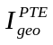 < 0 | Class 0 | No pollution
0 < ≤1 | Class 1 | No to moderate pollution
1< ≤2 | Class 2 | Moderate pollution
2 < ≤3 | Class 3 | Moderate to high pollution
3 < ≤4 | Class 4 | High pollution
4 < ≤5 | Class 5 | High to severe pollution
> 5 | Class 6 | Severe pollution

Table S4. The classification criteria of pollution load index (PLI).
PLI value | Classification | Pollution status
PLI = 0 | Class 1 | Unpolluted
0 < PLI ≤ 1 | Class 2 | Unpolluted to moderately polluted
1 < PLI ≤ 2 | Class 3 | Moderately polluted
2 < PLI ≤ 3 | Class 4 | Moderately polluted to highly polluted
3 < PLI ≤ 4 | Class 5 | Highly polluted
4 < PLI ≤ 5 | Class 6 | Highly to very highly polluted
PLI > 5 | Class 7 | Very highly polluted

Fig. S1. Location and distribution of sampling sites for the study area.
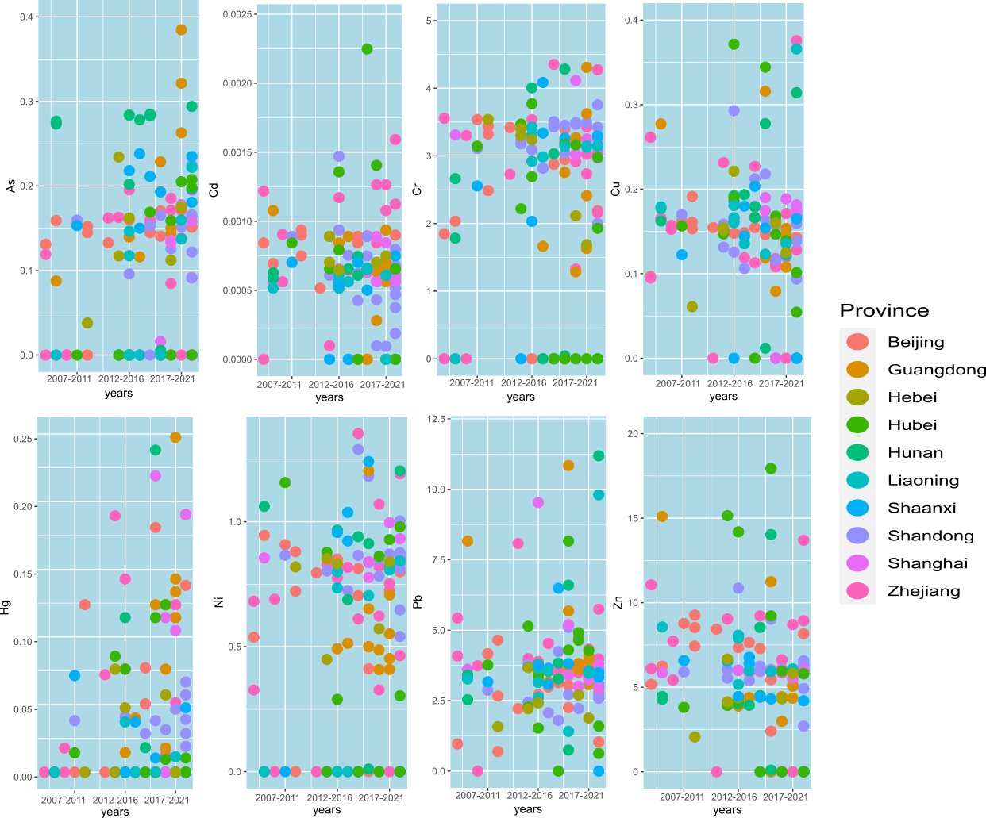
Fig. S2. Human health risk assessment of PTEs via ingestion pathways.
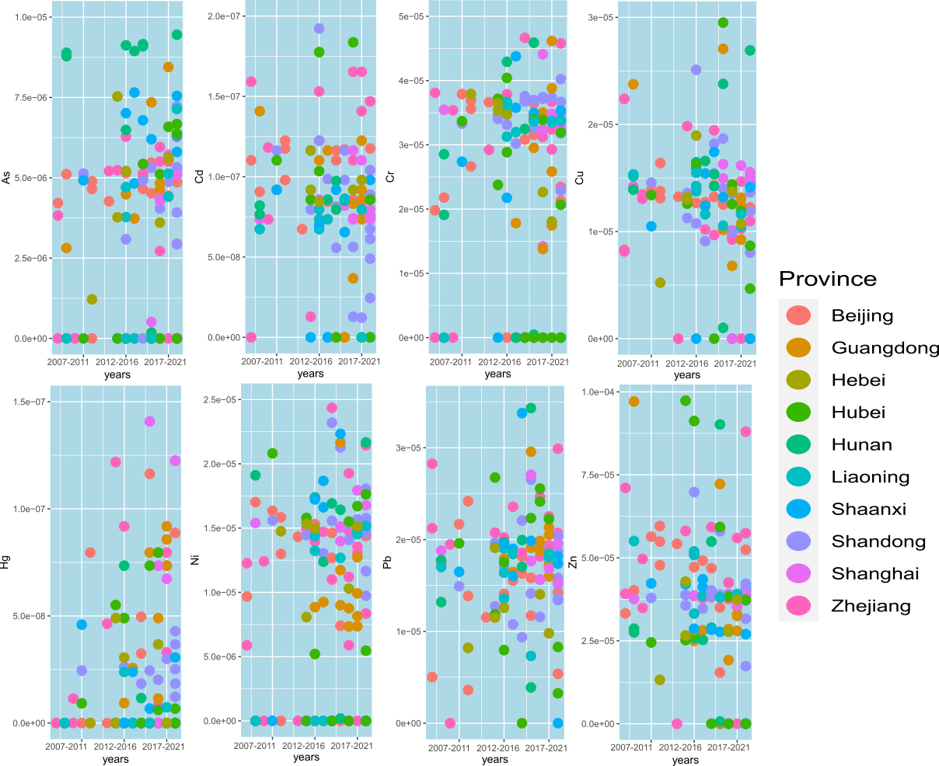
Fig. S3. Human health risk assessment of PTEs via dermal contact pathways.
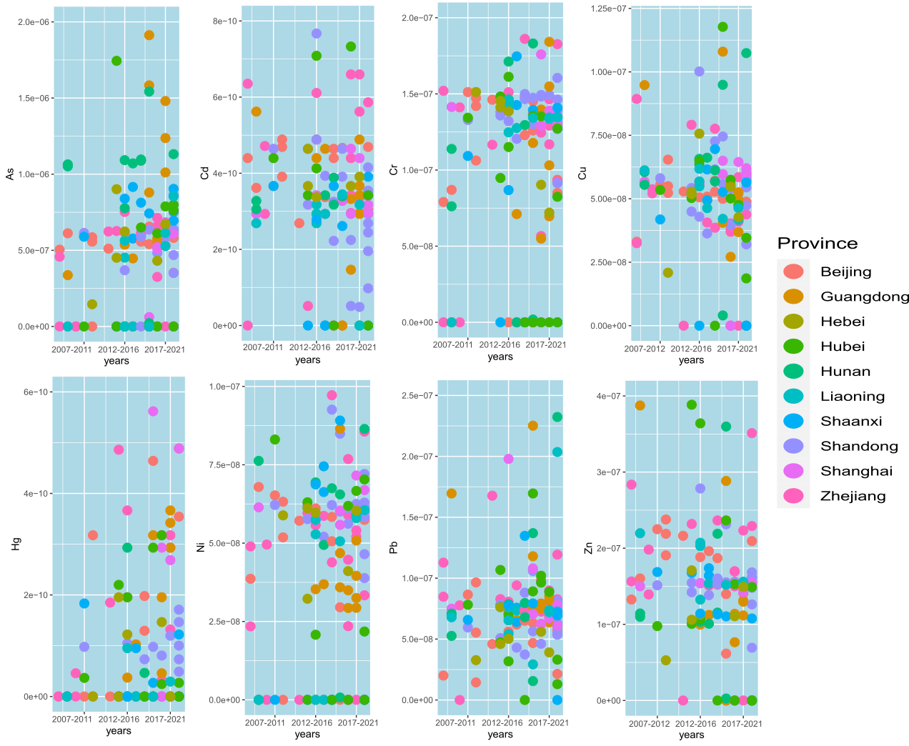
Fig. S4. Human health risk assessment of PTEs via inhalation pathways.

