Table 1. Screening the optimal reaction conditions
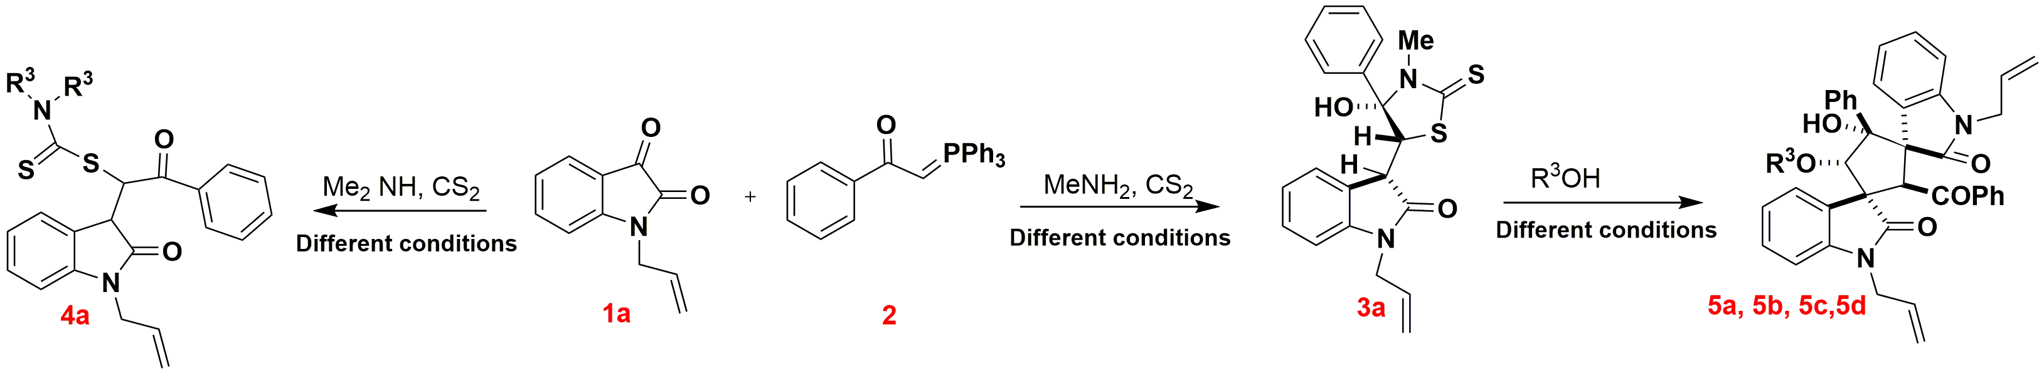
Entry ª | solvent | Base (equiv.) | Amines | Temp. (ºC) | Time | Yield^{b} of 3a (%) | Yield^{b} of 4a (%) | Yield^{b} of 5 (%)
1 | DMSO | - | MeNH₂ | 25 | 2h | 36 | - | -
2 | CHCl3 | - | MeNH₂ | 25 | 2h | 53 | - | -
3 | CH₃CN | - | MeNH₂ | 25 | 2h | 42 | - | -
4 | CH₂Cl₂ | - | MeNH₂ | 25 | 2h | 48 | - | -
5 | H₂O | - | MeNH₂ | 25 | 2h | - | - | -
6 | THF | - | MeNH₂ | 25 | 2h | - | - | -
7 | n-Octanol | - | MeNH₂ | 25 | 2h | 73 | - | -
8 | MeOH | ₋ | MeNH₂ | 25 | 2h | 79 | - | -
9 | PrOH | - | MeNH₂ | 25 | 2h | 75 | - | -
10 | PEG-400 | - | MeNH₂ | 25 | 2h | 56 | - | -
11^{C} | EtOH | - | MeNH₂ | 25 | 2h | 81 | - | -
12 | EtOH |  | MeNH₂ | reflux | 6h | - | - | -
13^{C} | EtOH | - | Me2NH | 25 | 2h | - | 83 | -
14 | MeOH | - | Me₂NH | 25 | 2h | - | 74 | -
15 | MeOH | KOH (0.8 equiv.) | MeNH₂ | 25 | 30 min | - | - | 86 (5a)
16 | MeOH | KOH (0.3 equiv.) | MeNH₂ | 25 | 30 min | - | - | 71 (5a)
17 | MeOH | KOH (excess) | MeNH₂ | 25 | 30 min | - | - | 85 (5a)
18 | MeOH | NOH (0.8 equiv.) | MeNH₂ | 25 | 30 min | - | - | 75 (5a)
19 | MeOH | K₂CO₃ (excess) | MeNH₂ | 25 | 1 h | - | - | 79 (5a)
20 | MeOH | KOH (0.8equiv.) | Me₂NH | 25 | 30 min | - | - | 79 (5a)
22 | MeOH | LDA (0.8) | MeNH₂ | 25 | 30 min | - | - | 81 (5a)
23 | n-Octanol | KOH (0.8 equiv.) | MeNH₂ | 25 | 1.5 h | - | - | 89 (5b)
24 | PrOH | KOH (0.8 equiv.) | MeNH₂ | 25 | 30 min | - | - | 79 (5c)
25 | PrOH | KOH (0.8 equiv.) | MeNH₂ | 25 | 30 min | - | - | 75 (5d)
26 | MeOH | Et₃N (excess) | MeNH₂ | 25 | 24 h | - | - | -
ªReaction conditions: Reaction of 1a (0.3 mmol), 2 (0.3 mmol), carbon disulfide (0.3 mmol) and methylamine (0.3 mmol) was performed in 2.0 mL of solvent to form 3a product. Reaction of 1a (0.3 mmol), 2 (0.3 mmol), carbon disulfide (0.3 mmol) and dimethylamine (0.3 mmol) was performed in 2.0 mL of solvent to form 4a product. Reaction of 1a (0.3 mmol), 2 (0.3 mmol), carbon disulfide (0.3 mmol) and methylamine(0.3 mmol) was performed in 2.0 mL of alcoholic solvents and after 2 h of stirring, base was added to the mixture and stirred for more 30-90 min to form 5a-5d products . ^{b}Isolated yields of products after filtering of reaction mixture. Simple filtering of the reaction mixture and washing with EtOH afforded desired products. ^{c} optimal reaction conditions.

Table 2. Generality of Substrate Scope ª
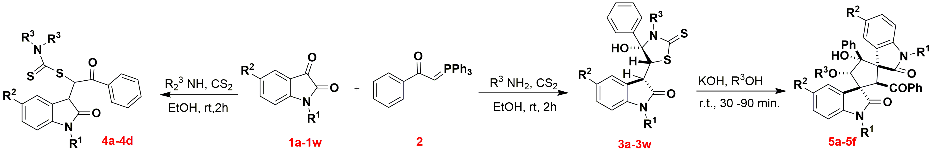
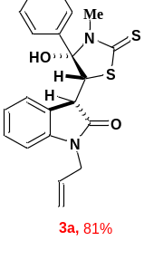 | 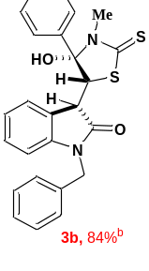 | 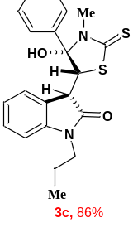 | 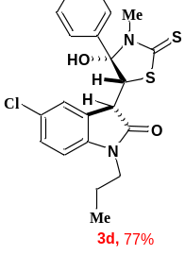
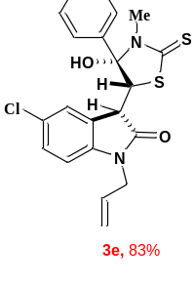 | 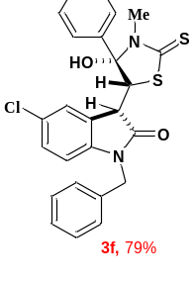 | 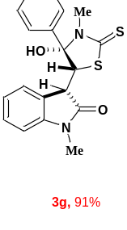 | 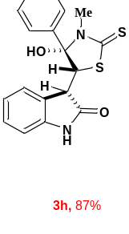
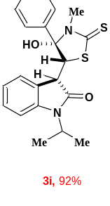 | 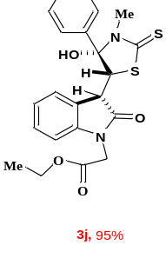 | 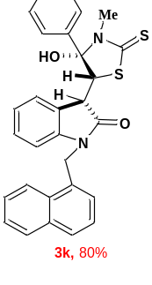 | 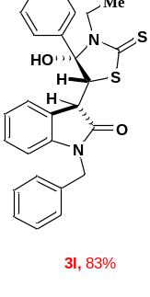
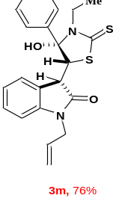 | 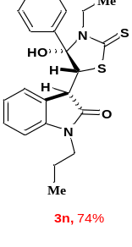 | 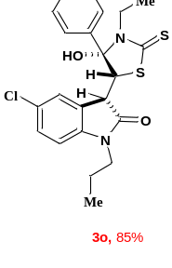 | 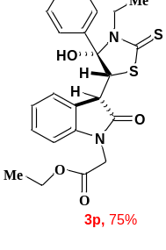

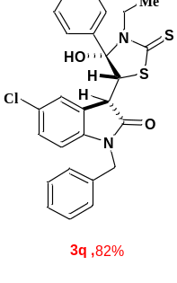 | 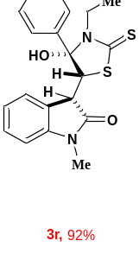 |  | 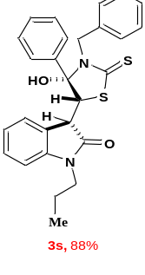 |  | 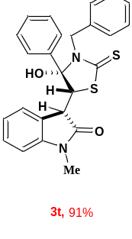
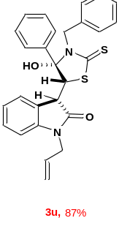 |  | 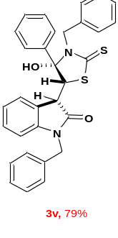 |  | 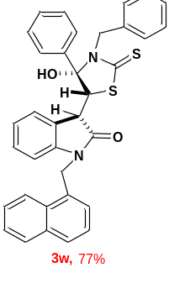
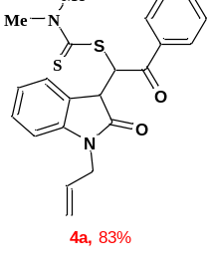 | 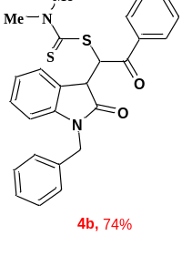 |  | 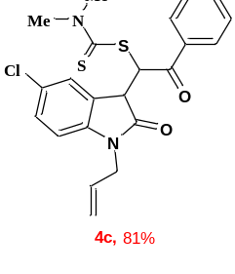 |  | 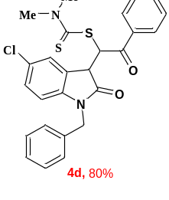
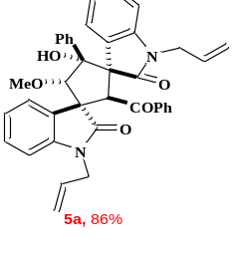 | 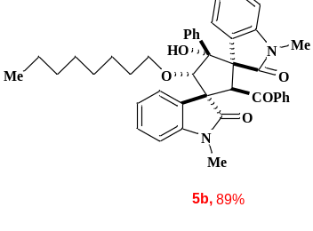 |  | 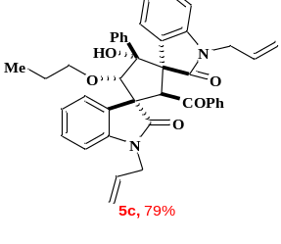 |  | 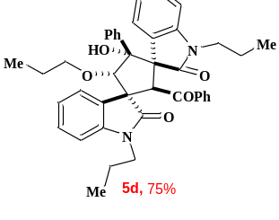
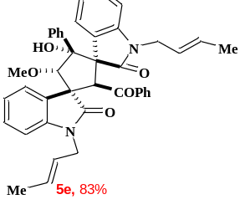 |  | 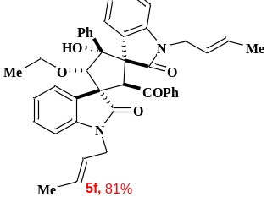 |  | 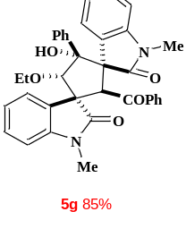
ª Reaction conditions: Reaction of 1a-1w (0.3 mmol), 2 (0.3 mmol), carbon disulfide (0.3 mmol) and primary amines (0.3 mmol) was performed in 2.0 ml of solvent to form 3a-3w products. Reaction of 1a-1d (0.3 mmol), 2 (0.3 mmol), carbon disulfide (0.3 mmol) and secondary amines (0.3 mmol) was performed in 2.0 mL of solvent to form 4a-4d products. Reaction of 1a (0.3 mmol), 2 (0.3 mmol), carbon disulfide (0.3 mmol) and primary amines (0.3 mmol) was performed in 2.0 mL of alcoholic solvents and after 2 h of stirring, KOH was added to the mixture and stirred for more 30-90 min to form 5a-5g products (5a, 5c, 5d, 5e, 5f and 5g were obtained after 30 min of stirring) .

