SUPPLEMENTARY INFORMATION FOR
A scattered volume emitter micropixel architecture for ultraefficient light extraction from DUV LEDs

Faris Azim Ahmad Fajri^{1,2,*}, Anjan Mukherjee¹, Suraj Naskar¹, Ahmad Fakhrurrazi Ahmad Noorden², and Aimi Abass¹
¹ ams OSRAM Group, Leibnizstraße 2, Regensburg, Germany.
² Center for Advanced Optoelectronics Research, Kulliyyah of Science, International Islamic University Malaysia, Kuantan Pahang, Malaysia.
*faris-azim.ahmad-fajri@ams-osram.com

Validation of the optical simulation
Our combined ray and wave optical simulations in this work are validated by modeling the LEE of the planar reference considered by López-Fraguas et al. ⁴². The epilayer properties are tabulated in Table S1, where the only difference from the properties of the SVEP epilayers (as discussed in the main text) is the thick sapphire block on top. Note that the n-side losses are omitted due to the transparency (or significantly low extinction) of the 265 nm emission.
Materials |  | Thickness | Refractive index
1 | Pt | 0.40 µm | 1.1653 + i2.4307
2 | GaN | 40 nm | 2.6981 + i0.476
3 | AlGaN | 75 nm | 2.6103 + i0.340
4 | AlGaN | 25 nm | 2.4774 + i0.119
5 | MQW | 18 nm | 2.9532
6 | AlGaN | 1.00 µm | 2.3723
7 | AlN | 4.00 µm | 2.3147
8 | Sapphire | 0.40 mm | 1.8337
Table S1. Epilayer thickness and optical properties of a “Reference” epi stack case.
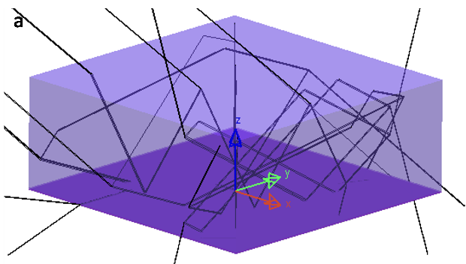 | 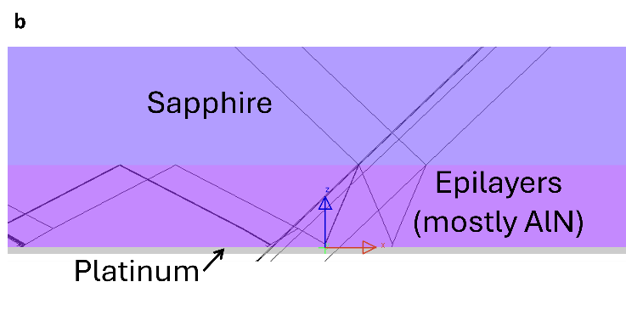
Figure S1. The 3-dimensional raytracing of 10 rays for the planar 1$×$1 mm² sapphire chip. (a) is the overall 3-dimensional view which is mostly sapphire block, and (b) is the magnified 2-dimensional XZ view where the thick, blue-colored block is sapphire, the purple block which is mostly AlN is the epilayers, and the thin gray layer is platinum.
We reproduced an LEE of 4.6% for the case of a semi-infinite LED stack with a sapphire superstrate considering an in-plane dipole emission only from multiple quantum wells (MQW). Instead, as shown in Fig. S1, considering the finite 1$×$1 mm² size of the chip and allowing rays to escape from the sidewalls and assuming an isotropic dipole orientation in the MQW, as explained in the main text, we obtained an LEE of 4.8%. Note that rays that exit the chip in the downward direction are also considered in the LEE calculation, as we assume these rays can be used.
The hybrid ray and wave optics LEEs for this simplified 1x1 mm² chip architecture for the three considered epistack cases are summarized in Table S2. As the referenced epilayer case is validated, the other two epilayer stack cases (as discussed in the main text) were chosen to further analyze the extraction capability of the SVEP architecture, i.e., a stack with a lower MQW refractive index and another stack with a lower p-side loss.
Epilayer stack | LEE by Combined Ray and Wave optics
Reference | 4.8
Low MQW RI | 6.5
Low P-side Loss | 5.4
Table S2. Simulation results of LEE based on our combined ray and wave optical modeling.
Although the "Low P-side Loss" epistack case has relatively less absorption than the "Reference" and "Low MQW RI" cases, its LEE is quite low. The main reason is that a large amount of power is sent to oblique angles in the n-epi at ~70 degrees beyond the escape cone of the n-epi to the sapphire. Because we only consider a planar chip structure, light beyond the n-epi/sapphire escape cone remains trapped in the semiconductor epilayers. The SVEP architecture exploits this very same condition by considering small micropixels architecture where light can also escape from the sidewalls of the epi into the buffer layer region.

Geometric variations with negligible LEE enhancement
Table S3 summarizes what is studied for Figs. 2-6 in the main text and other parameters that are kept constant for each figure. The parameters and study set are to mainly highlight physics instead of providing an optimum structure.
Design Parameter |  | Variation Range | Remarks
Figure 2 | Pixel side length,$L_{P}$ | 8.0 – 160.0 (µm) | $T_{B}$, $R_{B}$, and $T_{AlN}$ are 14 µm, 1 µm, and 4 µm, respectively.
Figure 4 | Pixel periodicity,$P_{P}$ | 3.0 – 30.0 ($×L_{P}$ ) | $L_{P}$, $T_{B}$, $R_{B}$, and $T_{AlN}$, are 8 µm, 14 µm, 1 µm, and 4 µm, respectively.
Figure 5 | AlN thickness, $T_{AlN}$, | 0.1 – 30.0 (µm) | $T_{B}$ $=$ ($T_{AlN}+$ 10 µm). $L_{P}$, $P_{P}$, and $R_{B}$ are 8 µm, 3$L_{P}$, and 1 µm, respectively.
Figure 6 | Buffer sheet nanotexture radius,$R_{B}$ | 0.5 – 12.0 (µm) | $L_{P}$, $T_{B}$, $P_{P}$, and $T_{AlN}$ are 8 µm, 14 µm, 3L_{P}, and 4 µm, respectively.
Table S3. The chip design variation approaches.

Buffer thickness
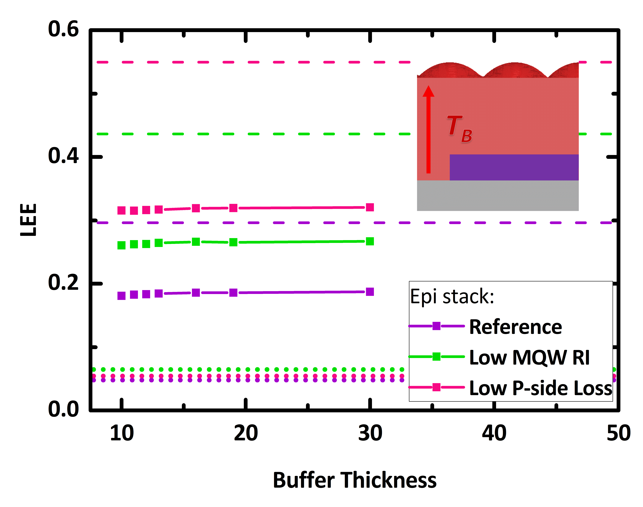
Figure S2. The LEE as a function of buffer thickness variation. Here, $L_{P}$ = 8 µm, $R_{B}=$ 1 µm, $T_{B}=$ 14 µm, $T_{AlN}=$ 4 µm, and $P_{P}$ = 3$L_{P}$.
Varying the buffer thickness, as depicted in Fig. S2, has a trivial effect on the LEE performance. This is true for all epistack cases. However, compared to their 1$×$1 mm² sapphire counterparts, our SVEP architecture outperforms the LEE by at least 3 folds. This is because the increased thickness is actually beneficial for sidewall extraction, but due to the large emission area compared to the MQW size, most of the rays are extracted upward rather than through the buffer sidewalls. Therefore, the effect of varying the buffer thickness alone on the LEE is negligible.

Buffer sheet air volume and percentage.
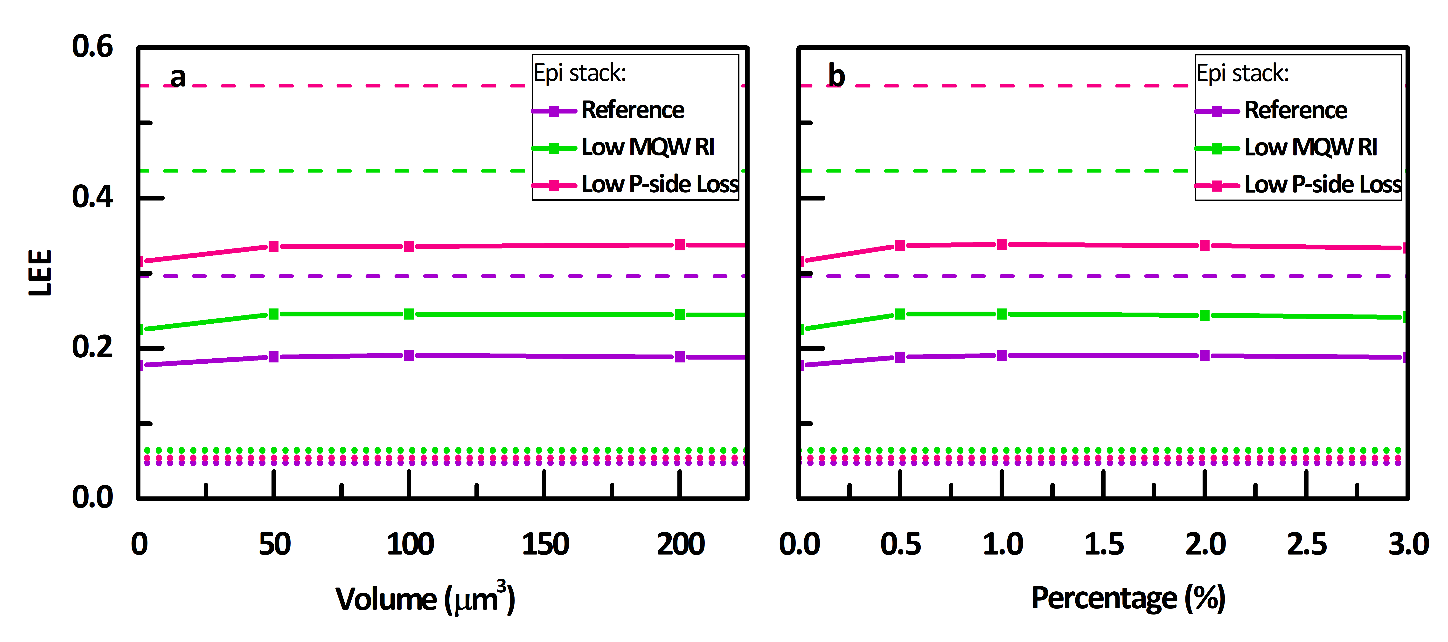
Figure S3. The LEE performance by the buffer sheet’s air volume and percentage variations. Here, $L_{P}$ = 8 µm, $R_{B}=$ 1 µm, $T_{B}=$ 14 µm, $T_{AlN}=$ 4 µm, and $P_{P}$ = 3$L_{P}$.
In Fig. S3, similar to the buffer thickness variation, the a) air volume and b) percentage variations of the buffer sheet do not have a major effect on the LEE. Nonetheless, compared to a buffer sheet without volume scatterers (the volume and percentage of air particles are zero), when air particles are in the buffer sheet, there is a slight increase in the LEE by$\sim 0.02$ for all epilayer cases. This means that scattering slightly improves the extraction in this buffer medium, but increasing the scattering probability does not further increase the extraction efficiency. While the scattering increases the variety of rays’ incident angles on the extraction surface, it also increases the TIR probability, which counteracts the efficiency by redirecting the rays into the absorbing layers.

Sample of data and results
The LEE ray-tracing calculations were performed with a minimum of 100,000 rays for each case of geometric and material epilayer property variations. We found that the LEE values converged with such a number of rays. The far-field shown in Figure 3 of the main paper was computed with 5 million rays. Fig. S4 shows an example of the SVEP's single-pixel ray tracing simulation with a 100-ray setting, where the gray block is platinum, and the red block is the SiO₂ buffer layer covering that single pixel.
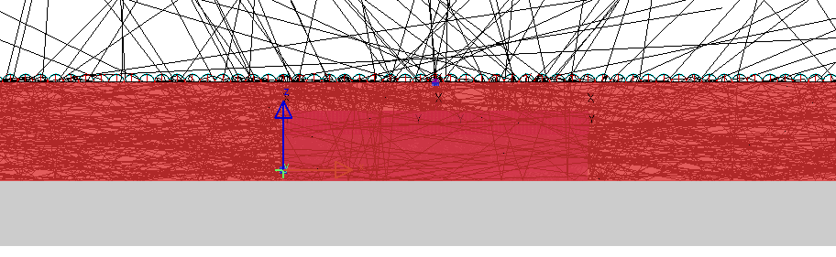
Figure S4. A sample of SVEP ray tracing simulation with a sample of 100 rays. This is a YZ-axis 2-dimensional view. The gray-colored block is platinum, and the red block is the SiO₂ buffer sheet covering the single pixel.

