Supplementary Material

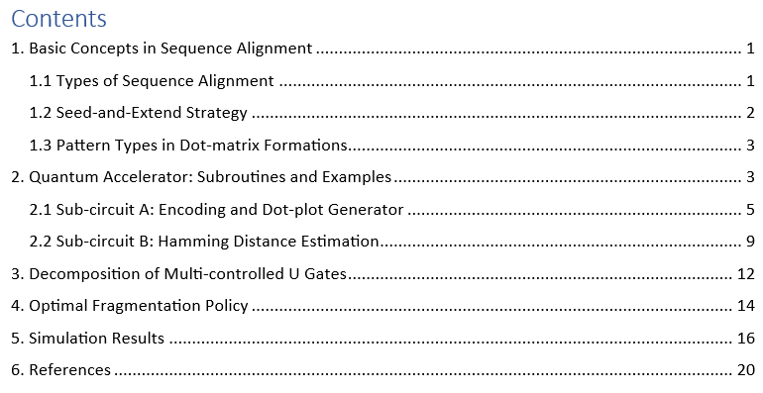

1. Basic Concepts in Sequence Alignment
Some preliminary basic terms and concepts are provided from the area of bioinformatics. More specific terms are used constantly throughout the paper and concepts around the notion of sequence alignment (SA) problem.

1.1 Types of Sequence Alignment
Initially, the discrimination between pairwise and multiple sequence alignment is clarified. In the simpler case of pairwise alignment, only two sequences are aligned in between them, while in multiple alignment more than two. Moreover, in terms of pairwise alignment, there are two modes of alignment in most established aligners: the local and the global. The first involves locating and aligning a local region that is similar, while the second entails end-to-end alignment. A short example is given to clarify these two methods in Table 1.
Table 1. Two examples for local and global alignment between a query and a reference sequence.
Local Alignment
Target Sequence
ACTACTAGATTACTTACGGATCAGGTACTTTAGAGGCTTGCAACCA
|||| |||||||| |||||||||||||||||||
TACTCACGGATGAGGTACTTTAGAGGC
Query Sequence
Global Alignment
Target Sequence
ACTACTAGATTACTTACGGATCAGGTACTTTAGAGGCTTGCAACCA
||||||||||||| |||||||| ||||||||||||||||||||||||||
ACTACTAGATT- - - - ACGGATC - - GTACTTTAGAGGCTTGCAACCA
Query Sequence
Another noteworthy operational mode in the field of sequence alignment is the database search alignment. In this case, a query sequence is compared against a database of known sequences to identify homologous or similar sequences. This method is commonly used to find sequences with similar biological functions, structures, or evolutionary relationships. As an historical example, one of the most widely used alignment-tool for database search alignment is the Basic Local Alignment Search Tool (BLAST).

1.2 Seed-and-Extend Strategy
In the last two decades, high-throughput sequencing technological advances created the need for further adjustments of aligners on the -seq technologies, leading to what is known today as seed-and-extend or q-gram filter techniques. The initial brilliant examples of this type of aligners are the FASTA [1] and BLAST [2] aligners. To identify the best fit of the query to the reference sequence, this method employs multiple seeds, or q-grams. Their main idea is to “anchor” the seeds by string searching onto the large reference sequence (or database) to avoid a brute force and expensive D.P. method, excluding large areas of the reference genome. A query sequence, which is termed as a read sequence in -seq technologies, may be split into smaller sub-string sequences known as seeds. Described roughly, the seed-and-extend procedure could be divided into five stages: (i) the preparation of an indexing structure for the reference sequence; (ii) the query (or short/long read) preparation when seeds or q-grams are required; (iii) seed mapping (a.k.a. seeding) to the reference genome; (iv) filtering out matching regions which were estimated of low-quality; and (v) the extension phase. In the latest stage, the alignment may be expanded in both directions using D.P. bridging the gaps between the matching regions. A description of these steps is depicted in Figure 1. Then, the scoring structure of the D.P. algorithm will act securing the final output result. Some alterations of this staging course may be observed in the design architectures of the various aligners, but the main concept remains the same.
Reference
Seeds
Local alignment
(SW or NW)
Matched seeds
extend
Reference
Seed mapping
Figure 1. Dataflow of the Seed-and-Extend strategy for the alignment of a read onto a reference genome.

1.3 Pattern Types in Dot-matrix Formations

The old but infallible method of the recurrent plot was embedded in the famous FASTA program to visualize the comparison between two strings. Various formations of dots due to biological diversity depict patterns that have to be translated differently. A schematic overview of the most common patterns is given in Figure 2. Most of these patterns (a-f) cases concern comparison of a single sequence by itself, while (g-h) cases concern comparison of different sequences. In our study we mainly focus on cases (a), (g), and (h).
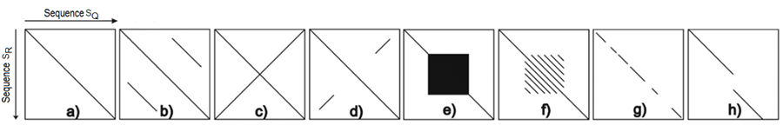
Figure 2. Possible formations of patterns using dot-matrix method between query and reference sequences of equal length. (a) perfect match, (b) repeats, (c) palindrom, (d) partial palindrom, (e) microsatellites, (f) minisatellites, (g) homologous, (h) indel.

2. Quantum Accelerator: Subroutines and Examples
A schematic representation of the acceleration quantum routine is presented in Figure 3. For simplicity, the lower-left circuit will be entitled as Subcircuit-A and the upper-right as Subcircuit-B. Both component subcircuits are analyzed into discrete operations integrated into smaller subcircuits. The logical order of the sub-circuits allows the logical execution of the SA protocol for a 2-tuples dataset concerning a single query and a reference sequence. Subcircuit A is repeated for as many times as are the reference fragments forming different sliding windows, while Subcircuit B is repeated for as many times as the acceptable diagonals are in each sliding window according to the adopted threshold.
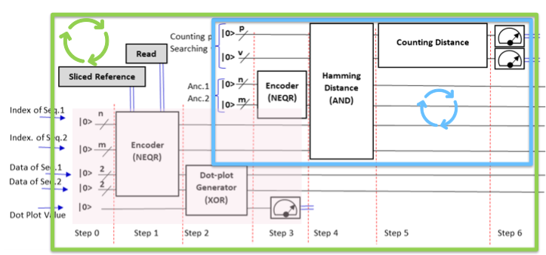
Figure 3. The full QMap circuit algorithm with the two component sub-circuits. The Hamming distance estimator (upper-right framed blue) Subcircuit-B is absolutely based on the output of the dot-plot generator (lower-left framed by a dull shape) Subcircuit-A. The arrow cycles symbolize the repetition of its part of the circuit. The outer green concerns the overall circuit while the inner blue only the upper-right framed.

Another interesting alternative is the circuit in Figure 4 which is a variation of the previous. A copy of Subcircuit-B has been appended at the end to manipulate separately an extra demand which is the calculation of the beginning or the end of a diagonal. Thus, the first copy is to calculate the dots per diagonal while the second copy has to calculate the (start, stop) indexes only on accepted diagonals. The only difference in the second copy is the type of input patterns to be prepared. Perfect diagonals are also designed to overlap with the accepted diagonals. Just a few repetitions can reveal the beginning and/or the end of the diagonal.
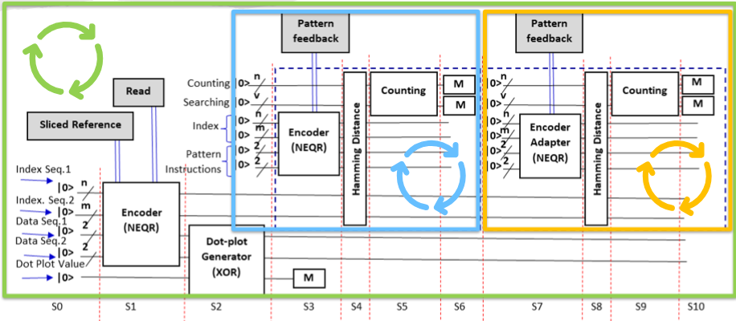
Figure 4. This circuit implementation version makes the calculation of the start-end points when a diagonal line is detected.

2.1 Sub-circuit A: Encoding and Dot-plot Generator
The dot-matrix generator or Subcircuit A is composed of two subcircuits, see Figure 5. The proposed circuit construction is based on the ideas of Clapis [3] to implement our previously mentioned Black-Box in [4] which was based on Schützhold’ s initial concepts [5]. Two quantum registers, x, and y are used to encode the indices of the reference and the query sequences. Two two-qubit registers are then used to encode the four possible letter values of a DNA sequence. Registers x and y are then entangled with their respective data registers so that each position of the sequence string is mapped to the respective letter. By performing an XOR between these two entangled registers, the dot plot can be retrieved.
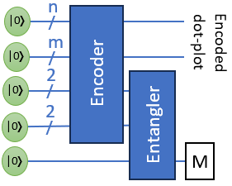 | 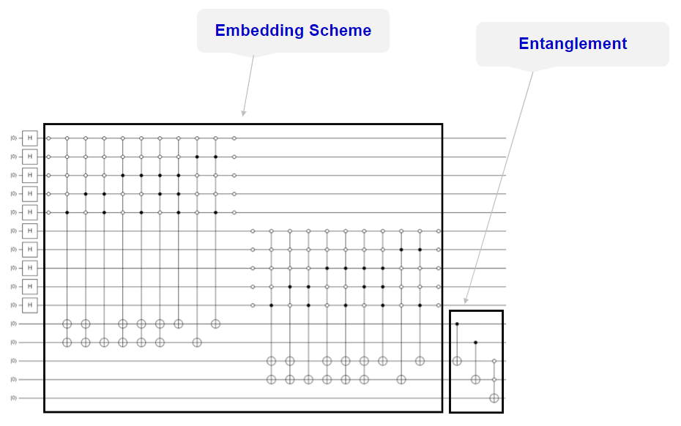
Figure 5. Example representation of the dot-matrix generator Subcircuit-A. (a) Compact form. (b) Analytical form using the virtual MCMX gate.
The way that indices are entangled with the letters is accomplished by applying traditional Quantum Programmable Logic Array (QPLA) techniques. As such, they produce multi-controlled gates that, for each possible index, define a set of conditions on all qubits. In a real scenario, this logic would be constructed dynamically based on the input data and executed on a real quantum device.
See Table 3 in [3] for an example circuit that generates a dot plot for two sequences of size 16 (replicated in Figure 6 for convenience). For each register, conditions of the multi-control gate denote the position of the index. Data registers use the encoding:
- A à 00
- G à 01
- C à 10
- T à 11
For example, the first multi-control gate in register x denotes that in position 0000 (all conditions are NOT conditions), the letter stored has a value of 1 (the G letter). This is also true for position 0010 as can be seen by the second multi-control gate. The position 0001 is omitted; this happens because this position encodes an ‘A’ letter, which has a value of 00, and, therefore, no entanglement with the data register needs to take place. For the ‘T’ letter, two successive multi-controlled gates are used with the same controlled state; this can be merged into one if multi-target gates are also allowed.
As can be seen, in general, when inputs of size N are assumed for both target and query sequences, two registers of the size of the order of logN will be required, with the depth of the circuit being of the order of N. The size of the control states (i.e., the number of conditions required for the controlled gates) will also be of the order of logN, as they will use the whole size of each register.
Executing this circuit in real hardware will generally require transpilation of the gates so they use the gate set and qubit topology of the underlying architecture, the overhead of which will depend upon the characteristics of the architecture. For example, using the Guadalupe backend of IBM’s quantum platform (see Figure 7 for its topology), a multi-control gate with a control state of size four, as depicted above, is transpiled into a circuit of size 130 (see Figure 8), with the gate set used as depicted in Table 2.
Table 2: Gate count for the transpiled encoding circuit in the iBM Guadalupe backend
Gate | cx | rz | sx
Occurences | 69 | 51 | 10

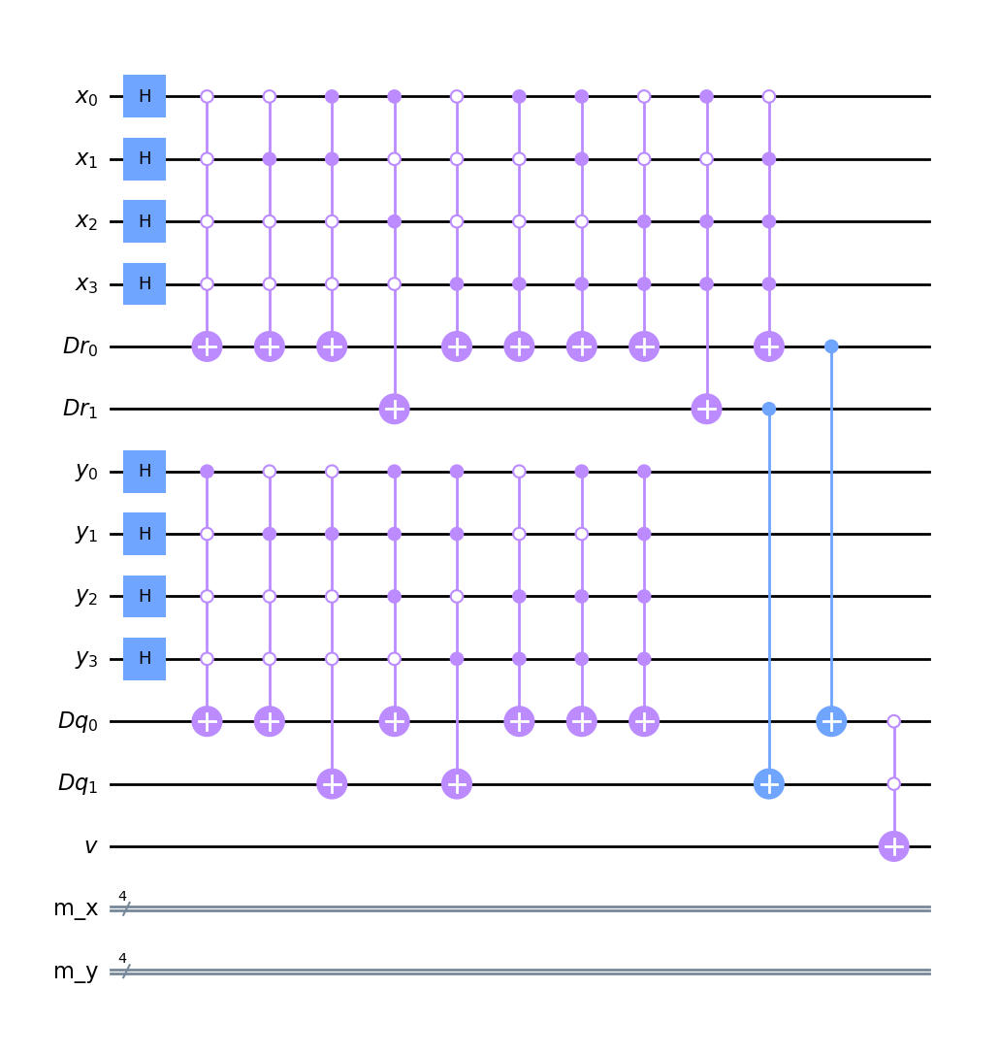
Figure 6. Example of a dot plot generator for comparing two sequences of size 16.

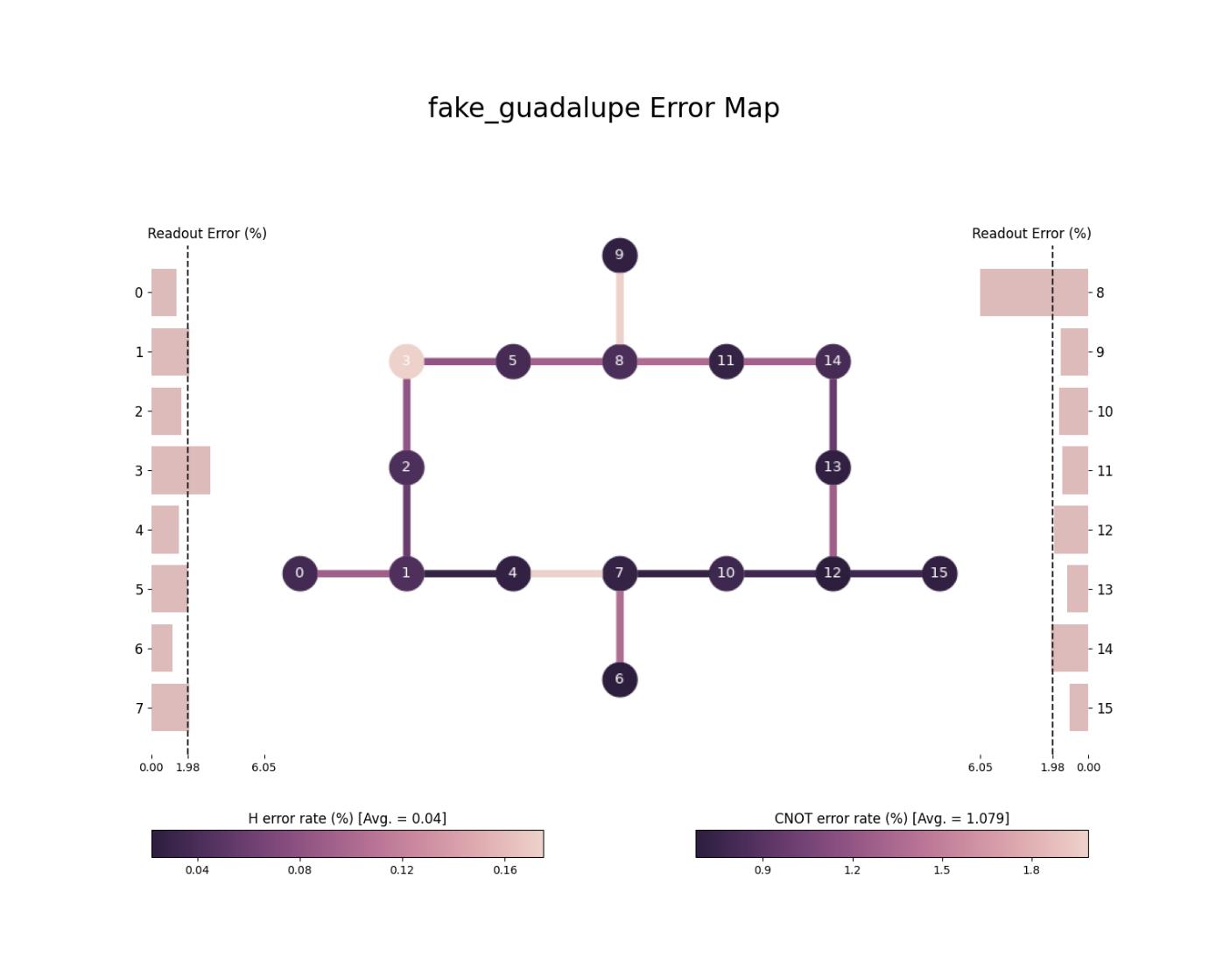
Figure 7. Topology and error map of the Guadalupe backend of IBM Quantum Platform

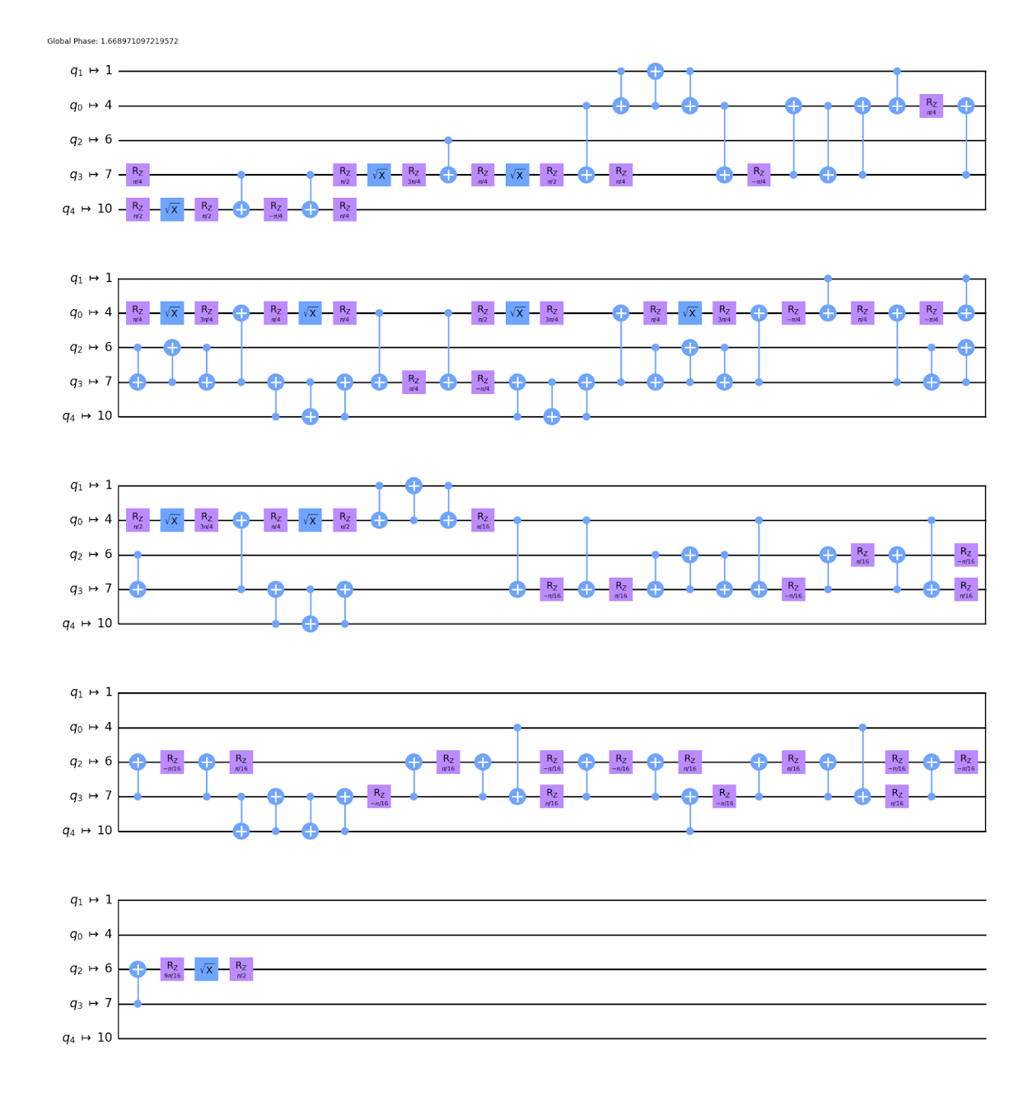
Figure 8. Example of transpiled encoding circuit

Transpiling the whole circuit will generally produce more gates than the number computed by multiplying single multi-controlled transpiled circuit sizes by the total depth of the encoder. The reason is that, in a generic architecture, the connectivity of the qubits may differ. Architectures based on Ion Traps, for example, have a high level of connectivity with qubits being coupled pairwise, while for those based on transmon physics, the connectivity is limited. Factors influencing connectivity depend on the specifics of the architecture; in Ion Traps, for example, qubits interact via shared vibrational modes, and the interactions mediated by the ion chain can have a long range. Transmon qubits, on the other hand, are implemented in a 2D mesh, and individual qubits require their own wiring for operations, couplings, and readout; combined with the phenomenon of cross-talk interference, this fact limits the amount of cross-connections between qubits in the transmon regime (of course, other limiting factors can affect the efficiency of an architecture. Ion Traps in particular, suffer from scaling, as it is difficult to control the ion chain as it gets bigger).
A way to reduce the depth of transpiled circuits is to perform some optimization technique that reduces the size of the original circuit. Indeed, as the original circuit is based on PLA, many of the conditions can be seen to be redundant. Existing techniques, such as the Espresso algorithm, can greatly reduce the number of gates encoded in classical circuitry; this technique can also be extended to truth tables of quantum circuits. This will greatly reduce the size of the transpiled circuit, especially in cases where the qubit connectivity is limited and where thus multi-control decomposition introduces a bigger overhead.
To check this in practice, a series of experiments that encode and compute the dot plot on a series of test cases has been implemented. The test cases involve the generation of random DNA sequences, in which each letter is weighted differently. An example of plots used can be seen in Figure 9. Letter ‘G’ was weighted at 50% probability so that the produced dot plots have a good amount of similarities and the produced matrices are not sparse. Table 3 depicts the comparative results of the produced circuits using QPLA and Espresso both for the QASM model and for the transpiled circuits.
As can be seen, the total number of the multi-control (MC) gates scale roughly twice the size of the problem. This is in accordance with what is expected of a fully implemented truth table in a circuit using two registers of size N each, which demand roughly N conditions each. Espresso, on the other hand, produces circuits that are fewer than the size of the register. Not only that but generally, the number of conditions of each multi-control gate is less than logN, as is the case for the full PLA case.
For the transpiled case, the difference is even more pronounced. The total number of CNOT gates has been reduced by a factor of seven, while for the single qubit gates, a reduction of a factor of roughly 4 can be seen for the X gates, of 7 for the case of SX gates and of 4 for the case of RZ.
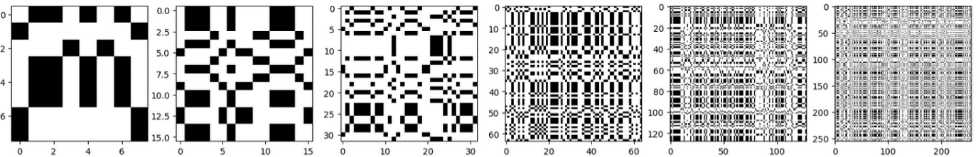
Figure 9: Random dot plots of size 8, 16, 32, 64, 128 and 256. Letter G is weighted at 50% to produce more dense matrices.

Table 3: Results of transpilation for the IBM Sherbrooke backend.
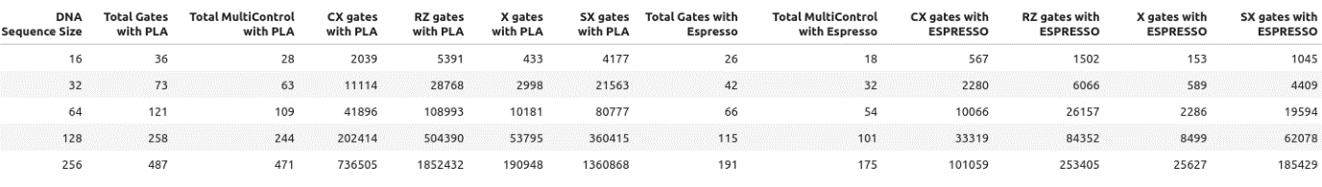

2.2 Sub-circuit B: Hamming Distance Estimation

There are three basic parts in this sub-circuit which are (a) the preparation of the training patterns via an encoding subcircuit, (b) the large AND operation and (c) the counting.
AND
m
/
n
/
|0⟩
|0⟩
|0⟩
|0⟩
Counting
M
n
/
m
/
Control
Target
Control
Trainable Pattern d[+i]
Encoded
dot-plot
Figure 10. Subcircuit-B of Hamming distance estimation.
The preparation of the training patterns aims to isolate the dots of a particular diagonal in a dot-plot. A dot-plot is prepared perfectly with dots only on the diagonal or diagonals to be isolated. Then, the application of the AND gate between the generated dot-plot and the trained dot-plot will get one by one the corresponding values (0 or 1) from each cell and the result will leave only the common dot points marked by 1. The final result is a dot matrix with 1s and the well-known quantum counting algorithm is employed to estimate the number of ones to estimate the degree of similarity. If counting returns a number higher than the threshold, it is considered a matching point or region.
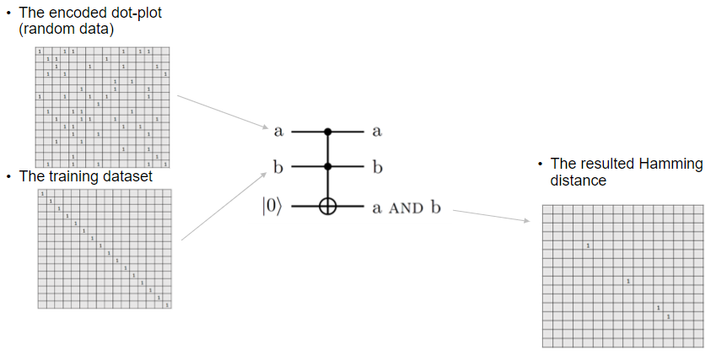
Figure 11. Example representation of AND operation between two input matrices. The resultant matrix carries the output results for each corresponding cell.
Of course, the most demanding gate to consider is the ​Multi_Controlled_1 – Multi_Controlled_2 – Multi_Target_X gate (MC1-MC1-MX gate or simply MC-MX gate) or simply MC-X since MC-MX could be decomposed into multiple MC-X. The logic application of such a gate has a large decomposition analogous to the size of the adopted sliding window or dot-plot. An illustrative example is provided to analyze how an MCMX gate is decomposed in the case of a 16x16 dot-plot in Figure 12.
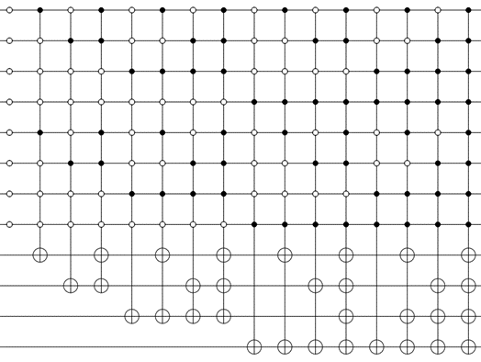
Figure 12. Implementation of example AND circuit for 16x16 dot-matrix plot. It takes as input two dot-plot matrices and outputs the resultant.
Dot-matrix 1
Dot-matrix 2
Dot-matrix 3

Quantum Counting Algorithm
The main purpose of the counting circuit is to count the number of ones in the dot plot; these then can be compared to a threshold and obtain a decision. There are various ways of counting ones in diagonals of a dot plot, and this can also depend on the encoding schema used. For the purposes of analysis, it is assumed that a basis encoding is used, which is analyzed in Section 2.1. Under this assumption, a dot plot is encoded as a superposition of states denoting indices in which there is a match. On this basis, pure diagonals are encoded in states that differ by N+1, where N is the size of the reference and query register. Schematically, and ignoring the normalization factors, diagonal states can be written as:
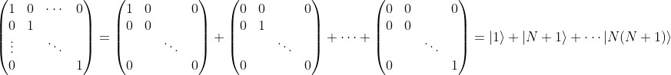
A counting algorithm may be constructed to count the number of ones by constructing a Grover operator for all the terms of the superposition and estimating its phase using the Quantum Phase Estimation algorithm. Figure 13 shows a sample circuit for the case of an 8x8 dot plot, which requires a total of log2(8x8) = 6 qubits for the Grover operator plus one qubit for converting it to the controlled version for the QPE to take place. A total of three qubits is used for the precision of the phase, but this can change depending on the required accuracy.
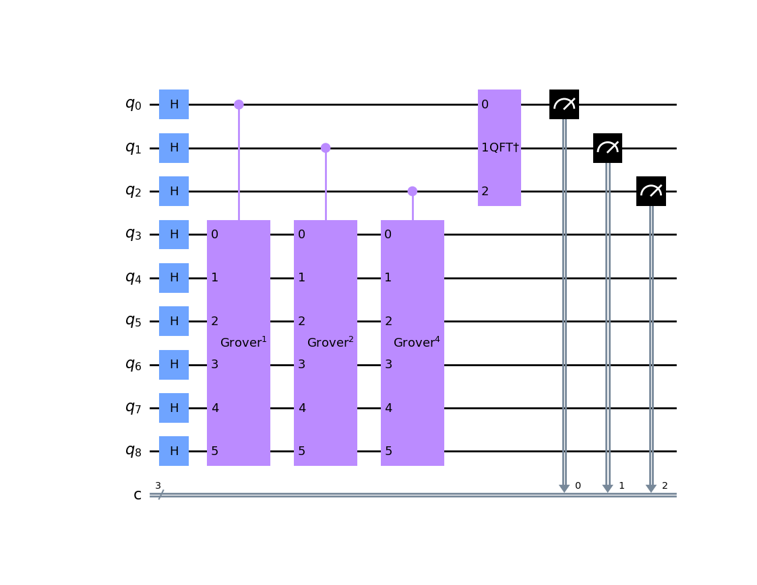
Figure 13. Sample circuit implementing the counting algorithm produced using Qiskit.
In contrast to the PLA case, the Grover operators usually require a greater amount of basic gates even when using the QASM basis gate set since they involve manipulations on the state amplitude and reflections about the average which are more complex operations than basic logic operations. However, a large part of the circuit is reused for each iteration of the QPE algorithm. Although the fact that the control qubit changes place may cause shifting and swapping of the transpiled gates to accommodate for the coupling map of the underlying architecture, a good portion of the tranpsiled circuit implementing the Grover operator is expected to remain as is without swapping.
This logic is also confirmed by the experiments conducted, which can be seen in Table 4. Although both the total and the multi-qubit gate count scale significantly with the size of the problem, it can be seen that the transpiled circuit scales much less rapidly when compared with the PLA case analyzed in Section 2.1.
Table 4. Gate counts for the transpiled circuit that implements the counting algorithm
Size | Total Gates on QASM | Total multi-qubit Gates on QASM | CX Gates | RZ Gates | X Gates | SX Gates
8 | 4090 | 2674 | 17665 | 45587 | 4478 | 32747
16 | 15796 | 10234 | 68495 | 180414 | 16162 | 130107
32 | 61998 | 40082 | 283636 | 750838 | 69938 | 542361

3. Decomposition of Multi-controlled U Gates
Universal quantum computers do not inherently provide support for multi-controlled X gates that have more than one control qubit (e.g. CCNOT and beyond). We compare two ways to synthesize these gates using the more primitive, readily available gates from the computer’s native gate set.​
A. The Advanced Single-Ancilla Technique
This method uses a total of 2n−1 V gates and 2n−2 CNOT gates, where n is the number of control qubits and V⁴ = U in this example [6].​ An example is depicted in Figure 14. Qiskit chooses to apply these methods to achieve primitive 3-CNOT and 4-CNOT gates (X gates controlled with 3 and 4 qubits, respectively). Generally, multi-controlled X gates can be recursively decomposed into a set of CNOT, CCNOT, 3-CNOT, or 4-CNOT gates.​
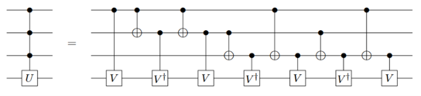
Figure 14. Decomposition of the 3-CNOT gate according to the advanced single-ancillae technique.

B. The Basic CCNOT Chain
This method requires an additional n-1 ancillary qubits along with 2(n−1) Toffoli gates and a single CU gate where n is the number of control qubits [7].​ As an example, a multi-controlled X gate is decomposed into a succession of CCNOT gates. Ancilla qubits retain the outcomes of every intermediate CCNOT. Since 𝑐 is the amount of control qubits, 𝑐−2 ancilla are needed in total. For a 5 controlled-Not gate, four ancilla are required and eight Toffoli as in Figure 15.​ This is a comparatively quick and effective way to create multi-controlled X gates.
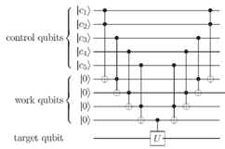
Figure 15. Decomposition of the 5-CNOT gate according to the CCNot chain method.
Which way is better?
Nielsen's method (single ancilla) uses fewer gates but has the disadvantage of requiring additional ancillary qubits. If the backend is supported with Toffoli gates, then "Single Ancilla" is better. If only CXs are in disposal, then "Basis CCNOT Chain" seems better. These suggestions do not consider topology considerations like the coupling map.​ In real experiments using IBM computers found that the multi-control gates represent a major challenge considering the number of 'CNOT' gates that they require due to the increased error rates. ​They need further advances in the technology before they are practical.​

4. Optimal Fragmentation Policy
Genomic references usually are very large portions of sequences and looking for matching regions upon them, given a query sequence, may require a special fragmentation protocol. The splitting of a reference sequence could be manipulated by multiple different ways. The golden rule is to find the optimal window size maintaining speed and accuracy in a good balance. Query size and window size may not always coincide, but the size of the window could be calculated by a formula based on the size of the query length. The performance will drop sown for small lengths of queries as it leads to more runtimes of QMap routine. On the other side, large windows may reduce sensitivity. According to the lengths of the query and the reference sequences, L_{query} and L_{ref} respectively, there are two cases:
- L_{ref} ≊ L_{query}
- L_{ref} ≫ L_{query} (or L_{ref} ≪ L_{query})
Making the consideration that the size of the window is exactly the size of the query length, a refence sequence has to be sliced into pieces equal to L_{query} . In the example in Figure ? the size of the window is escalated under the condition L_{ref} = L_{query} covering differently portions of the dotted diagonal. In the second example in Figure ?, L_{ref} = 800bps and L_{query} = 600bps, but using a window of 240bp. It means that the overall scanning requires 21 executions of the QMap routine. However, a slight increment in the size of the sliding-window will reduce drastically to 2/3 the QMap callings. Three modes are considered in the policy of the proposed method to approximate the -seq length of reads that are usually employed by NSG sequencers:
- Short windows (smaller sliding window = short read ~ 100)
- Medium windows (medium sliding window = medium read ~ 300)
- Large windows (larger sliding window = long read ~ 500)

(a) | 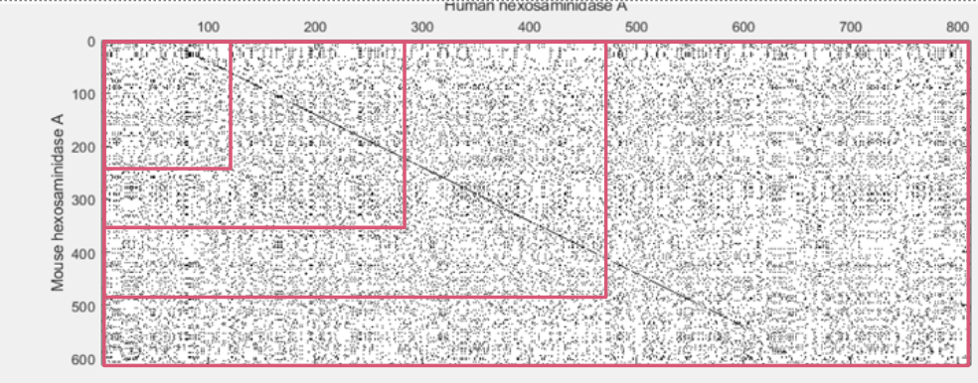
(b) | 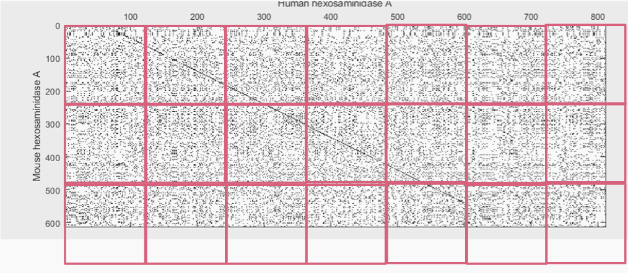
Figure 16. Example dot-plots maps displaying (a) different possible window sizes and (b) the result of a specific fragmentation policy. The fully dotted diagonal points out similarity along these two sequences.

Stitching Technique
Since there is possibility of an alignment to span in more than one window, a “stitching” technique is required to correctly identify such alignments. The aim of this technique is to prevent the algorithm from filtering out alignments that do not fit the selection criteria in each window (slice), yet they satisfy them in the whole. The specifics of the implementation of stitching depend heavily on the window (slice) size. For example, if the size of the window equals the length of the read, then an alignment cannot span in more than two slices and the alignments corresponding to the main diagonals are contained in one window, see Figure 17. In such a case, the stitching would concern neighboring windows (slices).

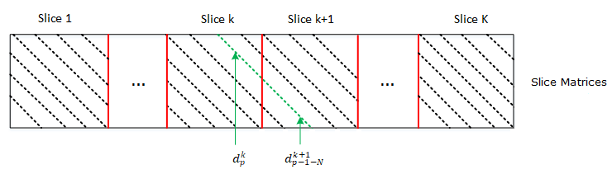
Figure 17. Stitching technique for successive windows.
With “stitching”, the overall dot-plot is essentially re-composed and the overall alignment (diagonal) is extracted from the partial alignments (diagonals) of each window, see Figure 18. For a size window equal to the read length this is achieved by using a formula that connects the $p$-upper diagonal $d_{p}^{k}$ of the $k$ slice with its corresponding lower diagonal $d_{p-1-N}^{k+1}$ of the $k+1$ (next) slice. We note that the main diagonals of each window do not take part in this process, to optimize the algorithm’s speed.

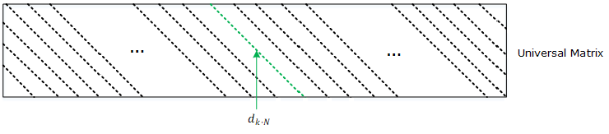
Figure 18. Re-composed dot-plot and extracted alignment.
In this way, the diagonals that do not meet the user-defined criteria (matching threshold, percentage alignment threshold, etc.) are filtered out without the possibility of a false-negative result. The extraction of the best alignment is achieved by adopting a mixed algorithmic strategy combining elements of the decrease-and-conquer, divide-and-conquer and problem-reduction approaches.

5. Simulation Results
The classical algorithm was tested on a number of reference strings provided by bioinformatics experts, comprising of a COVID-19 genome, matched with 200 smaller reads of length 32 and 64. The metric of interest were the matching percentage (the number of matched genes of the read and reference). Overall, the constructed routine of reference segmentation and read comparison yielded good matching results, with over 70% of matching. The Anderson Darling test [8] was used to verify that the matching stems from the normal distribution and it showcased positive significance levels.
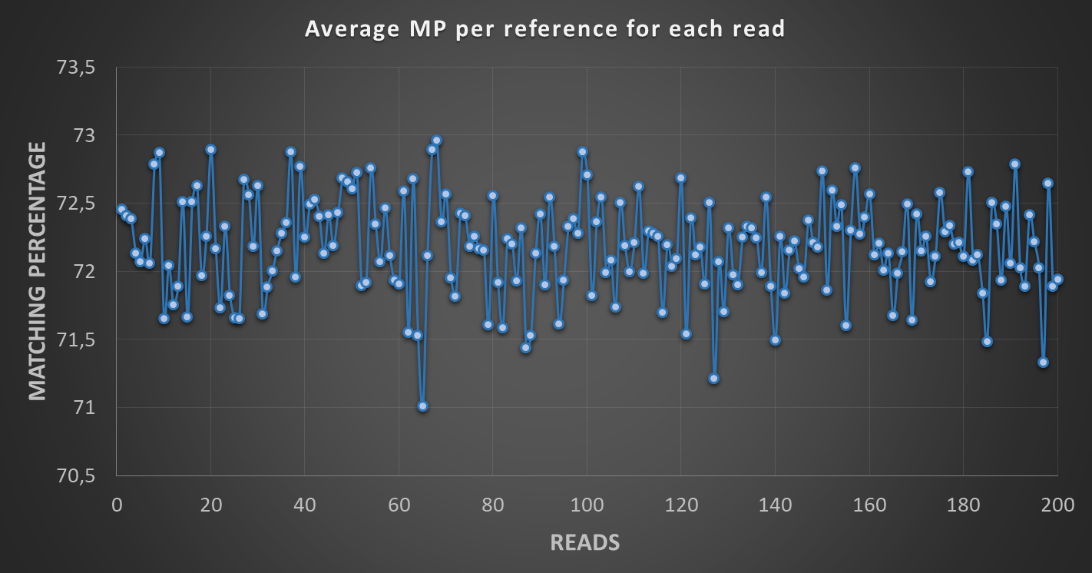
Figure 19. Matching Thresholds showcased in the comparison of references to reads. High percentages are showcased

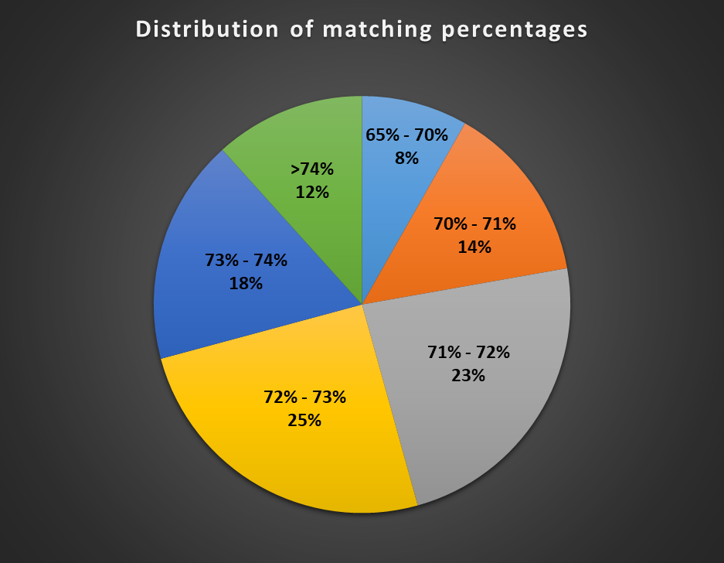
Figure 20. Distribution of matching thresholds

In addition, the stability of the executed algorithm was counted based on the standard deviation, where the average value was 1.6%. This proves that the segmentation strategy based algorithm is a viable option for sequence alignment, while the quantum part can greatly accelerate the process.
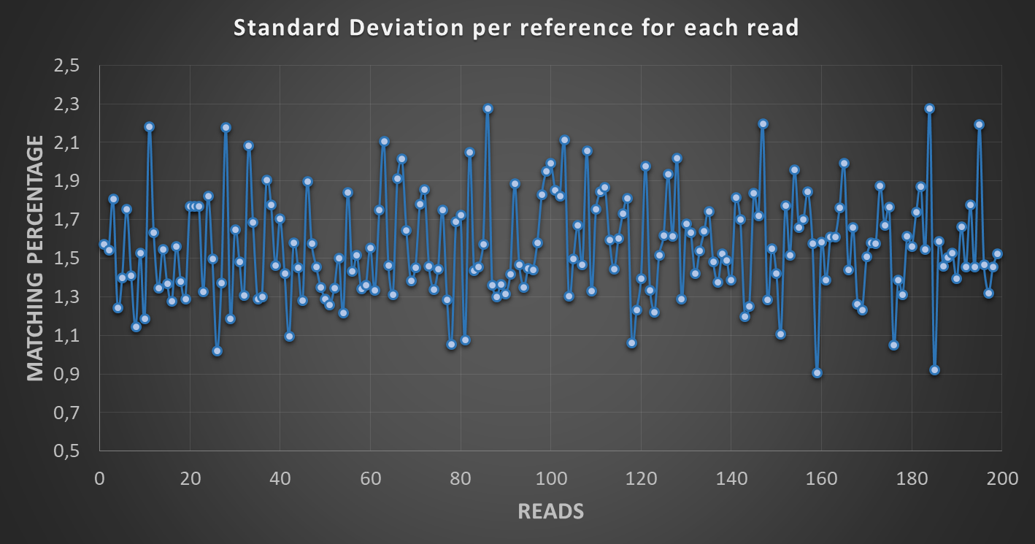
Figure 21. Stability Testing of matching algorithm. Standard deviation presents no noticeable outliers
Finally, the algorithm showcased well-rounded execution times, considering that the reference segmentation and the subsequent matching with the reads constitutes a pseudo brute-force procedure.
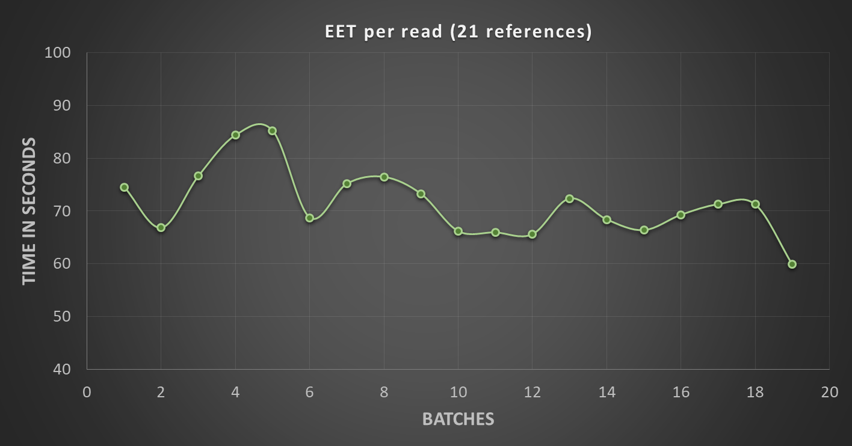
Figure 22. Execution times of described algorithm per batches of read strings
Overall, the statistical analysis of results indicates that the sliding window of the reads (32 or 64) do not present significant qualitative differences, though the executed algorithm showcases stability and high accuracy for a 20% matching threshold.

Indicative Heatmaps of Segment comparison (32 sliding window)
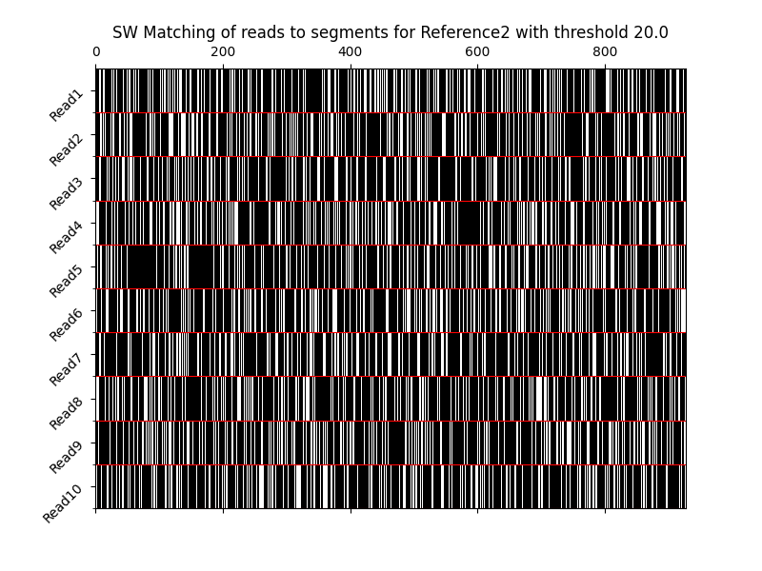
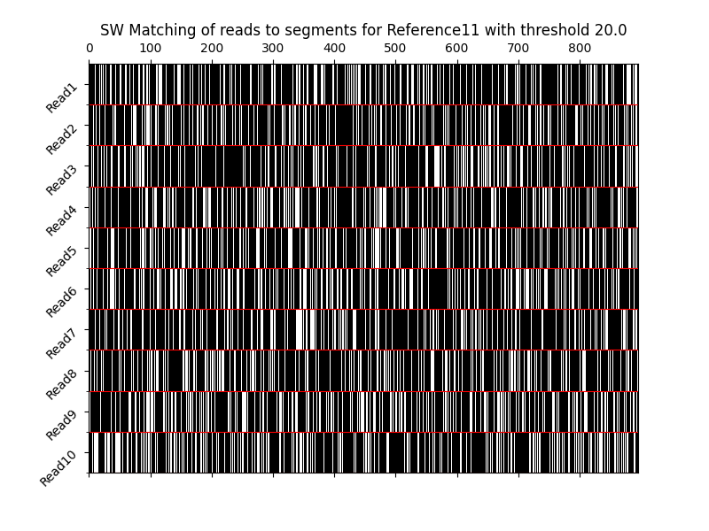
Figure 22. Above: Heatmap for large reference with selected reads with a matching threshold of 20% and a 32 sliding window. Below: Same matching setup for different reference string.

Indicative Heatmaps of Segment comparison (64 sliding window)
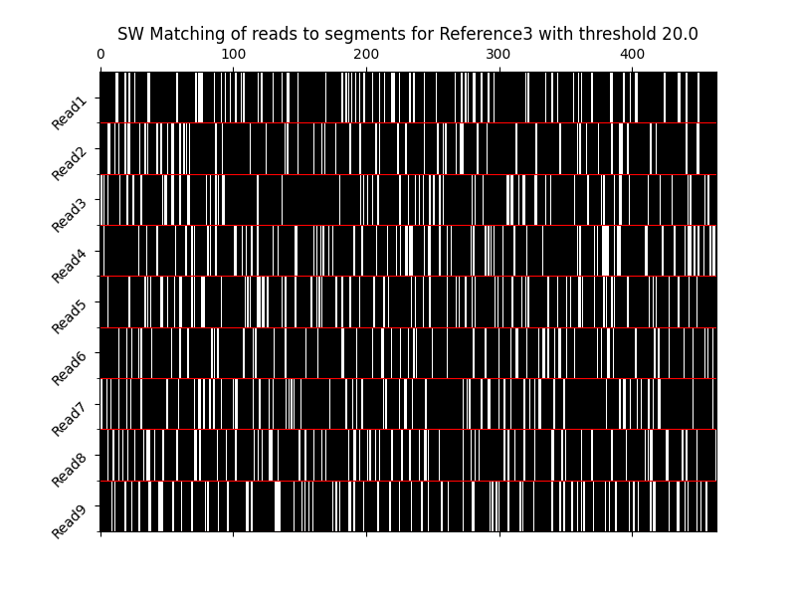
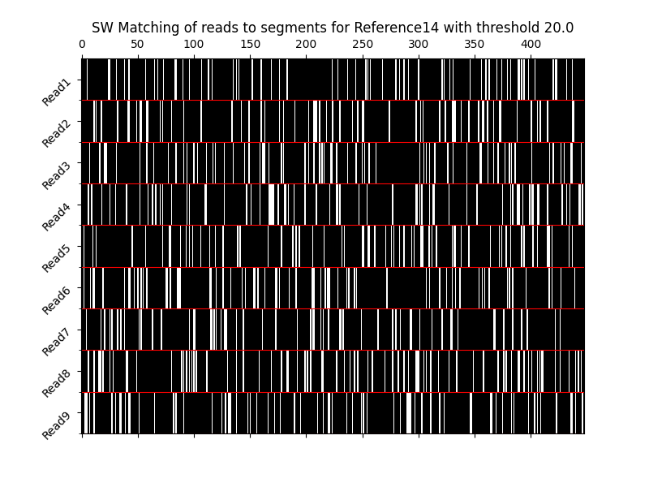
Figure 23. Above: Heatmap for large reference with selected reads with a matching threshold of 20% and a 64 sliding window. Below: Same matching setup for different reference string.

6. References
[1] Lipman, DJ; Pearson, WR . "Rapid and sensitive protein similarity searches". Science. 227 (4693): 1435-41, 1985.
[2] Altschul, S.F.; Gish, W.; Miller, W.; Myers, E.W.; Lipman, D.J. Basic local alignment search tool. J. Mol. Biol., 215, 403–410, 1990.
[3] J. Clapis. A Quantum Dot Plot Generation Algorithm for Pairwise Sequence Alignment, arXiv:2107.11346v1, 2021.
[4] Prousalis, K., Konofaos, N. Α Quantum Pattern Recognition Method for Improving Pairwise Sequence Alignment. Sci Rep 9, 7226, 2019.
[5] Schützhold, R. Pattern recognition on a quantum computer. Phys. Rev. A. 67, 062311, 2002.
[6] A. Barenco, C. H. Bennett, R. Cleve, D. P. DiVincenzo, N. Margolus, P. Shor, T. Sleator, J. A. Smolin and H. Weinfurter, "Elementary gates for quantum computation," Physical Review A, vol. 52, no. 5, pp. 3457-3467, 1995.
[7] Nielsen, M.A. & Chuang, I.L., 2011. Quantum Computation and Quantum Information: 10th Anniversary Edition, Cambridge University.
[8] Anderson, T. W., & Darling, D. A. (1952). Asymptotic theory of certain" goodness of fit" criteria based on stochastic processes. The annals of mathematical statistics, 193-212.

To be more precise, Sherbrooke uses the Echoed Cross Resonance (ECR) gates, which are equivalent to CNOT gates up to a global qubit phase. ECR gates will be treated as CNOT gates for the purposes of this analysis.

