Supporting Information
Synthesis, structure-activity relationship and evaluation of
antifungal activity of tryptanthrin derivatives against
drug-resistant Candida albicans

Yandan Wu¹•Luyi Jiang²•Ruina Liu¹•Lijiao Yang¹•Fei Zou¹•Tianyu Zhang¹•Zefei Fan¹•Tianbao Zhang¹•Huan Yang¹•Shuyun Yin¹•Ruirui Wang¹•Ganpeng Li²•Guanghui Ni^{1*}
¹ School of Chinese Materia Medica, Yunnan University of Chinese Medicine, Kunming 650500, Yunnan Province, China
² Key Laboratory of Chinese in Ethnic Medicial Resources, State Ethnic Affairs Commission & Ministry of Education, School of Ethnic Medicine, Yunnan MinUniversity, Kunming 650500, Yunnan Province, China

*e-mail: niguanghui@ynucm.edu.cn

Contents:

• ¹H and ¹³C NMR spectra of all compounds 2-33
• HRMS spectra 34-49

¹H and ¹³C NMR spectra of all compounds

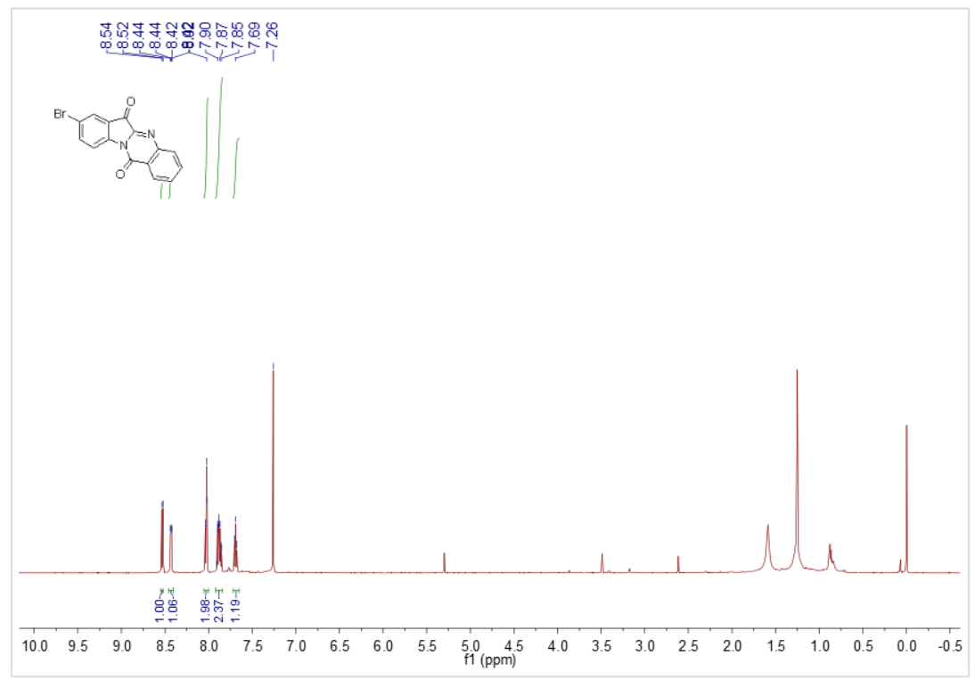
Figure 1 ¹H NMR of compound 3b
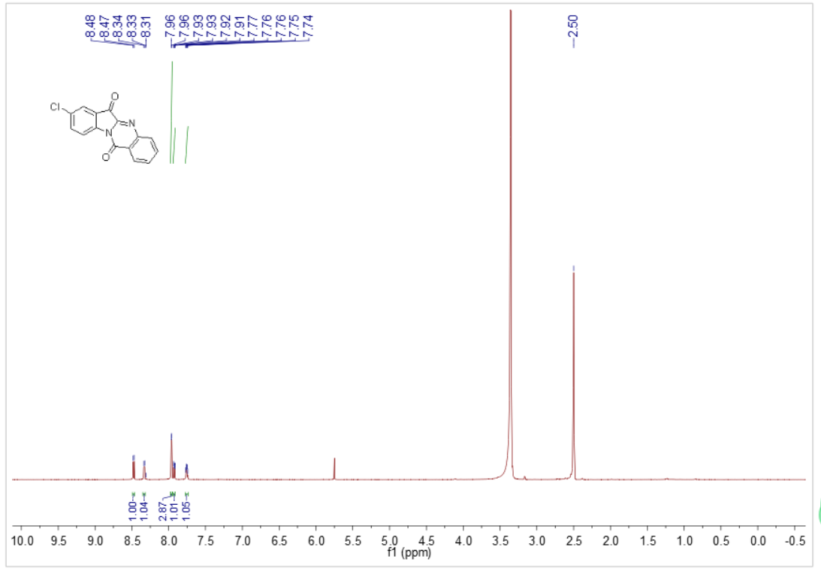
Figure 2 ¹H NMR of compound 3c

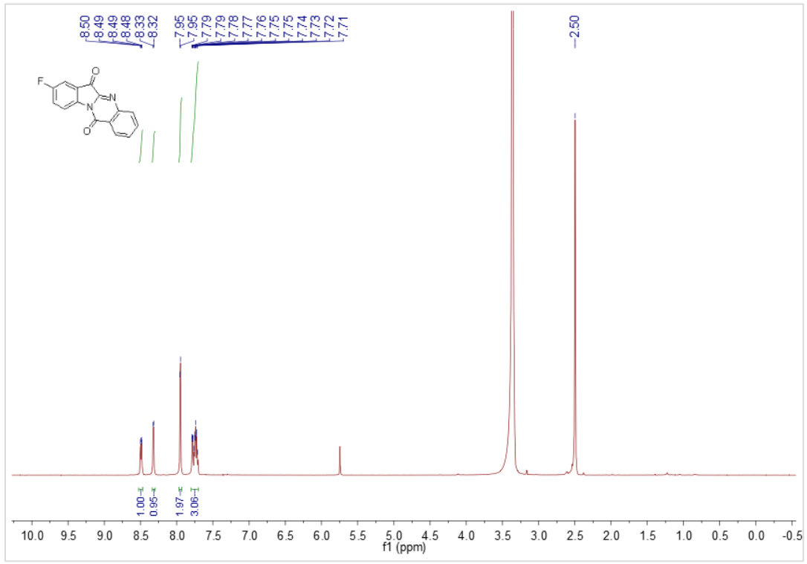
Figure 3 ¹H NMR of compound 3d

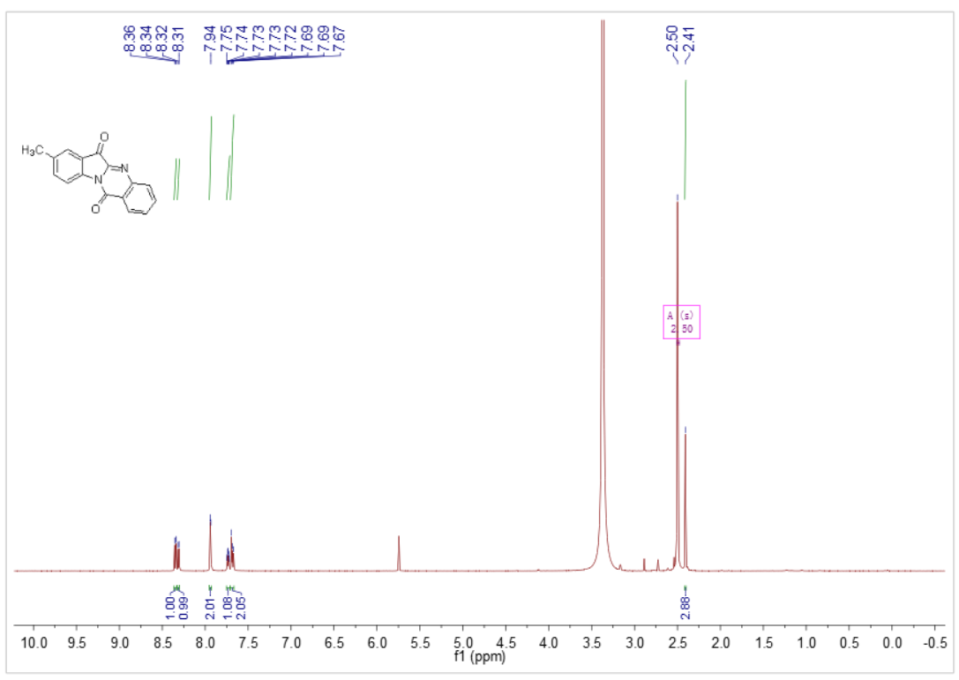
Figure 4 ¹H NMR of compound 3e

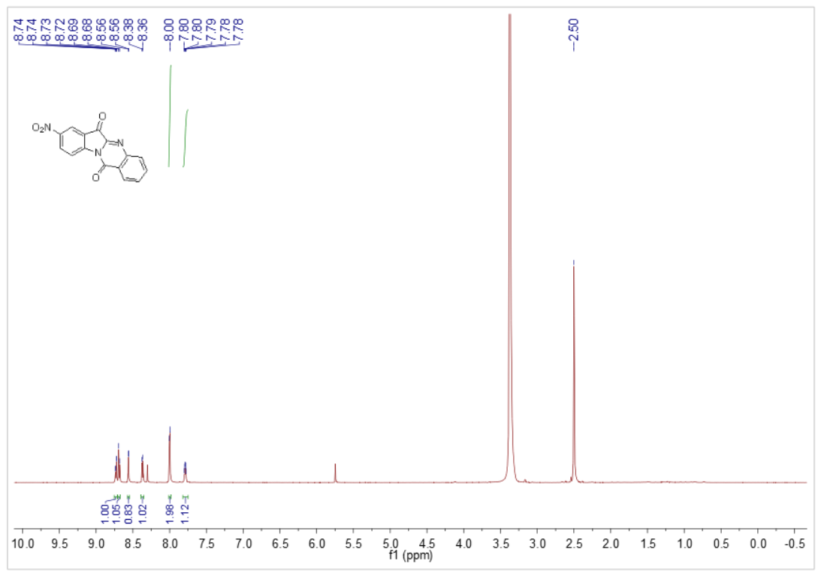
Figure 5 ¹H NMR of compound 3f

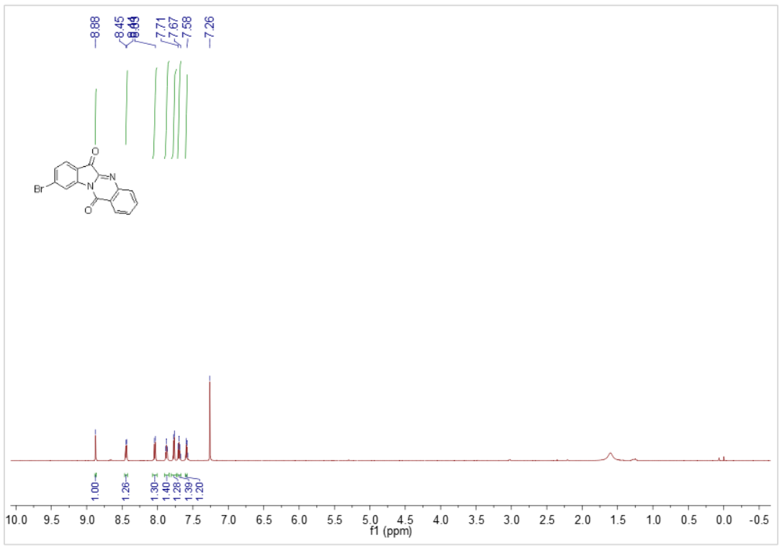
Figure 6 ¹H NMR of compound 3g

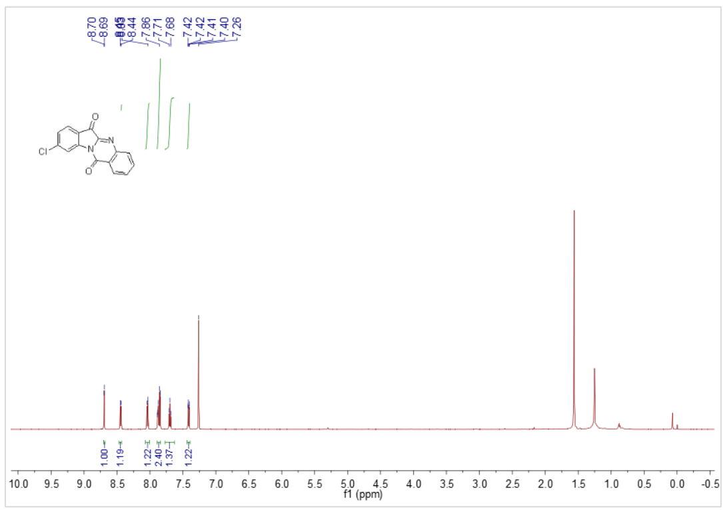
Figure 7 ¹H NMR of compound 3h

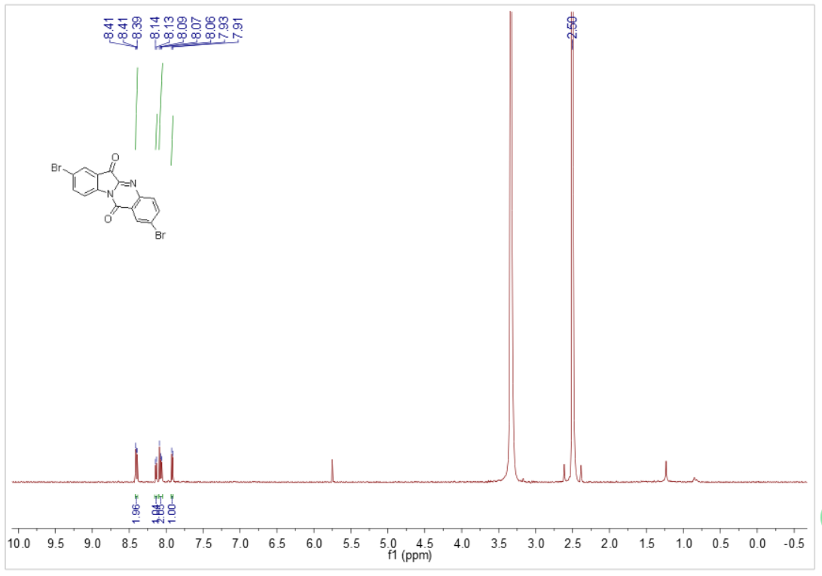
Figure 8 ¹H NMR of compound 3i

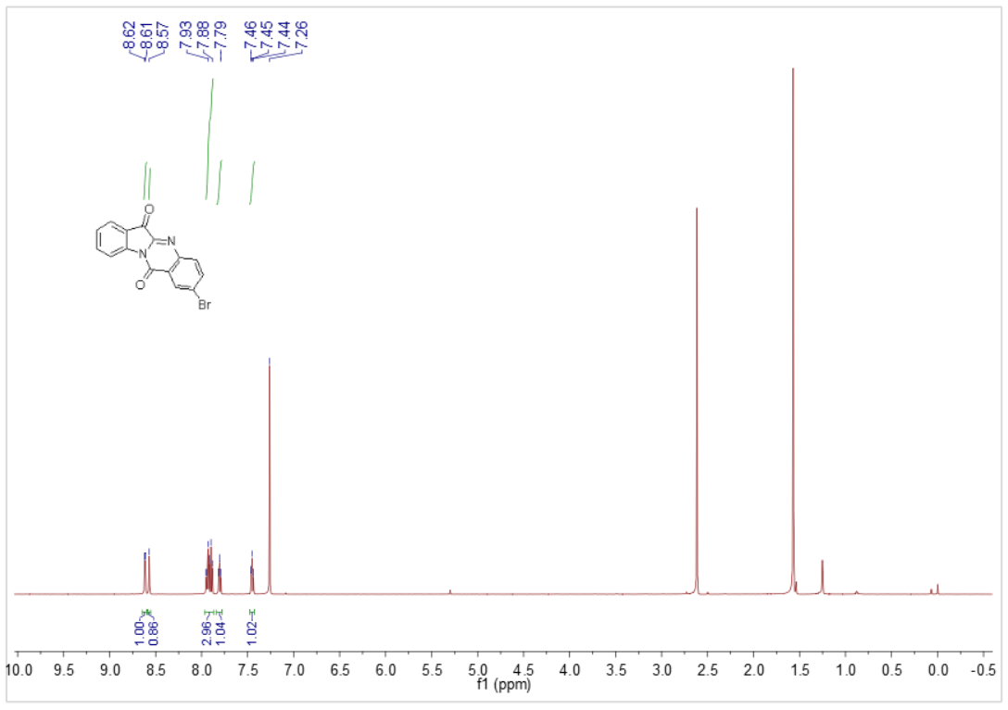
Figure 9 ¹H NMR of compound 3j

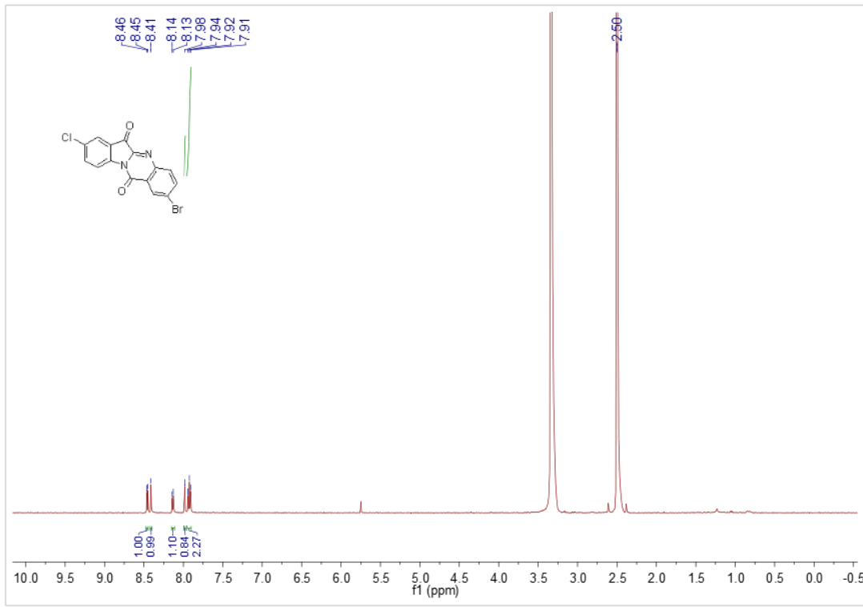
Figure 10 ¹H NMR of compound 3k

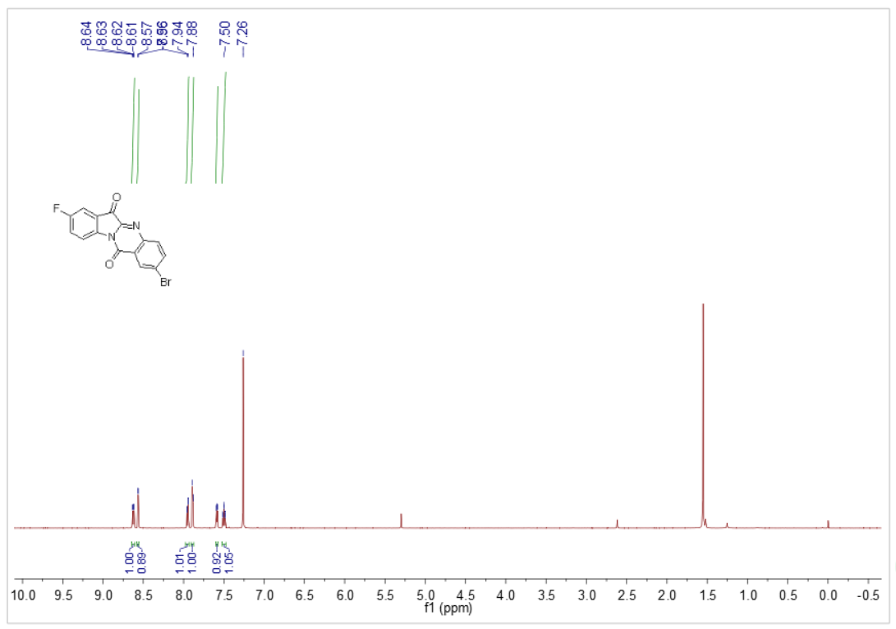
Figure 11 ¹H NMR of compound 3l

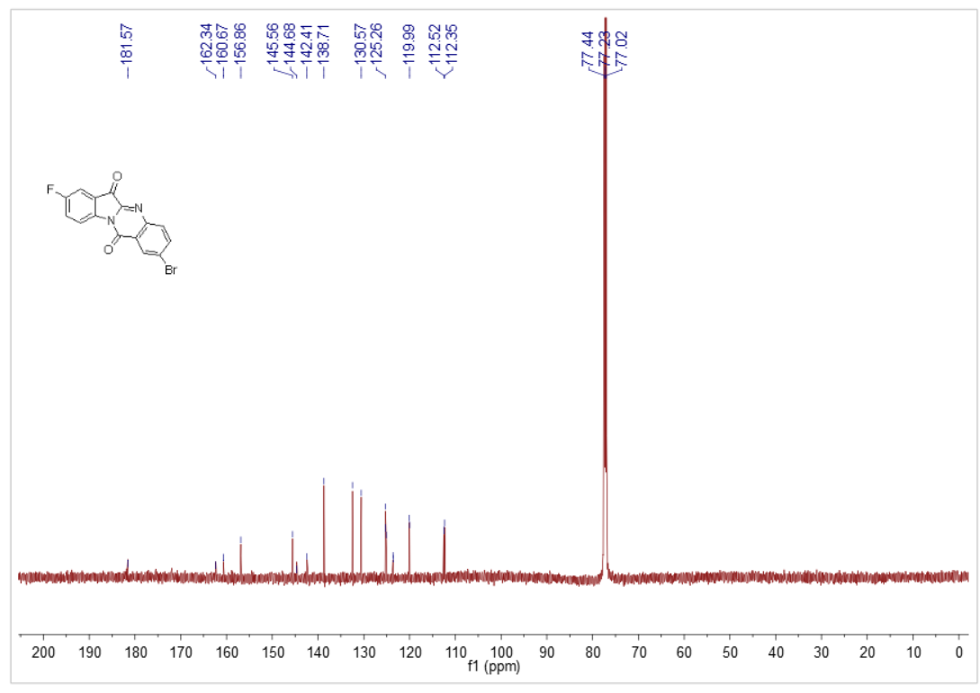
Figure 12 ¹³C NMR of compound 3l

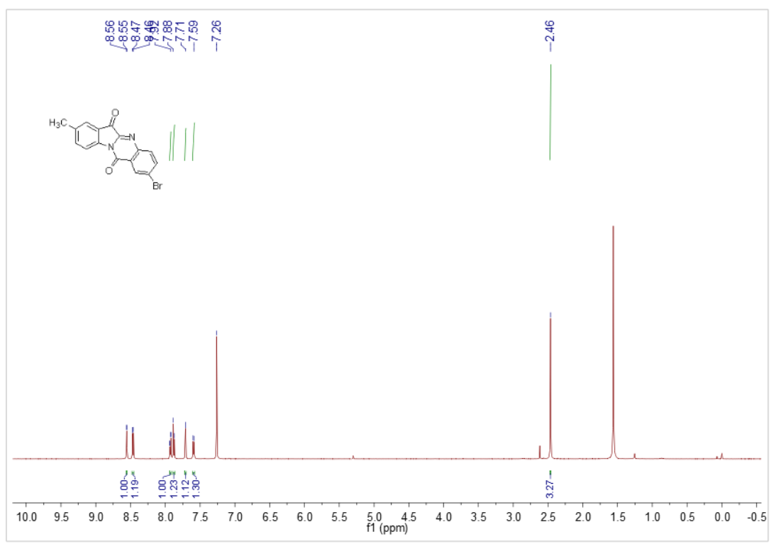
Figure 13 ¹H NMR of compound 3m

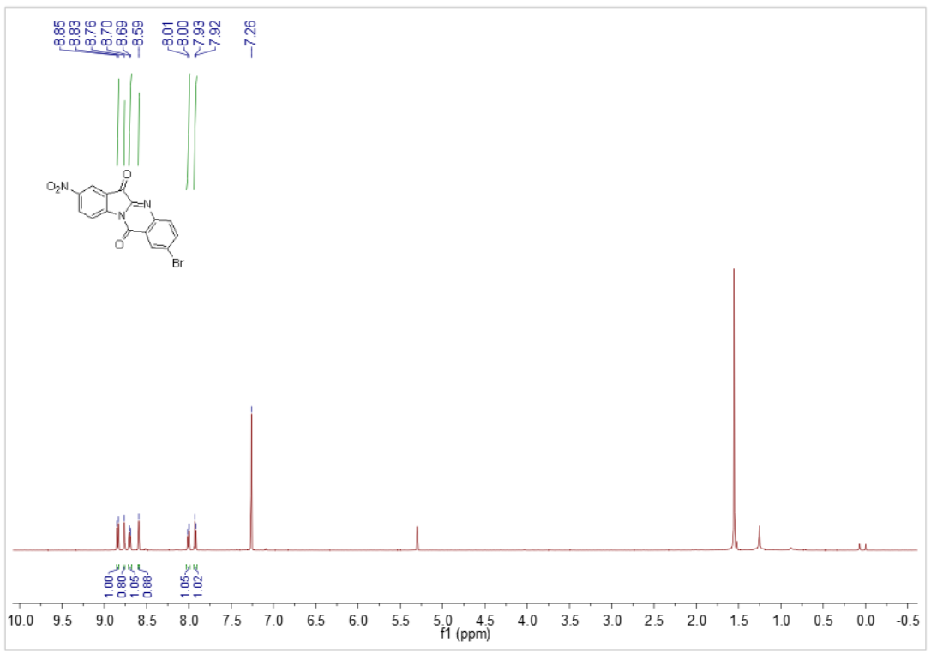
Figure 14 ¹H NMR of compound 3n

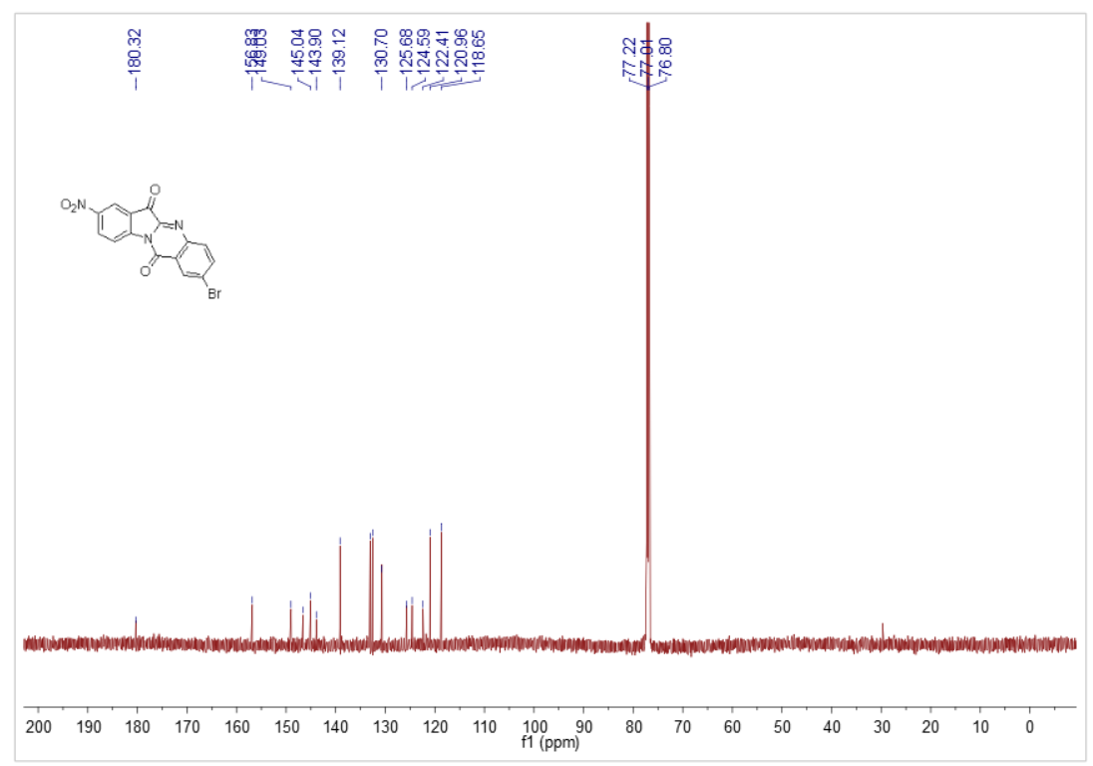
Figure 15 ¹³C NMR of compound 3n

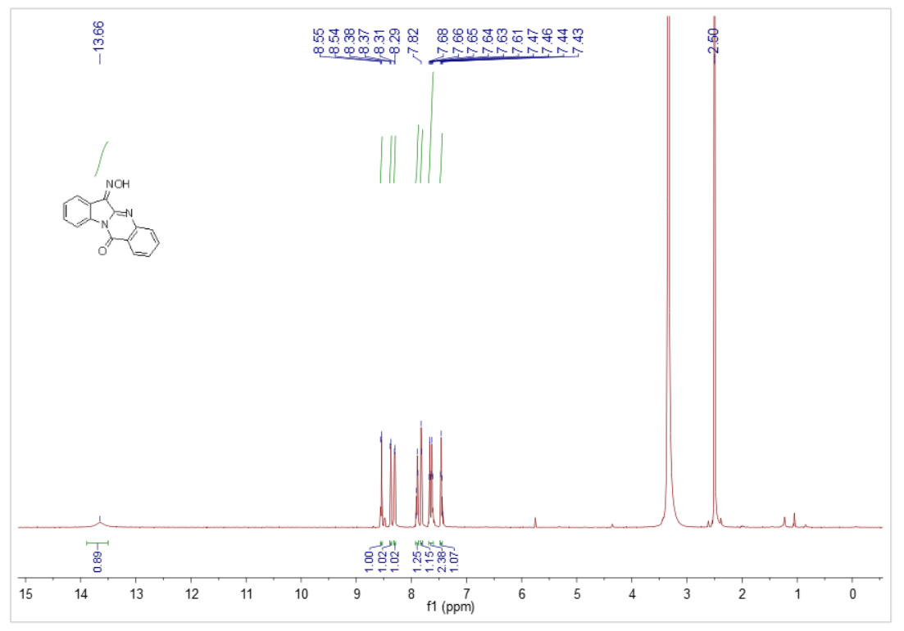
Figure 16 ¹H NMR of compound 4a

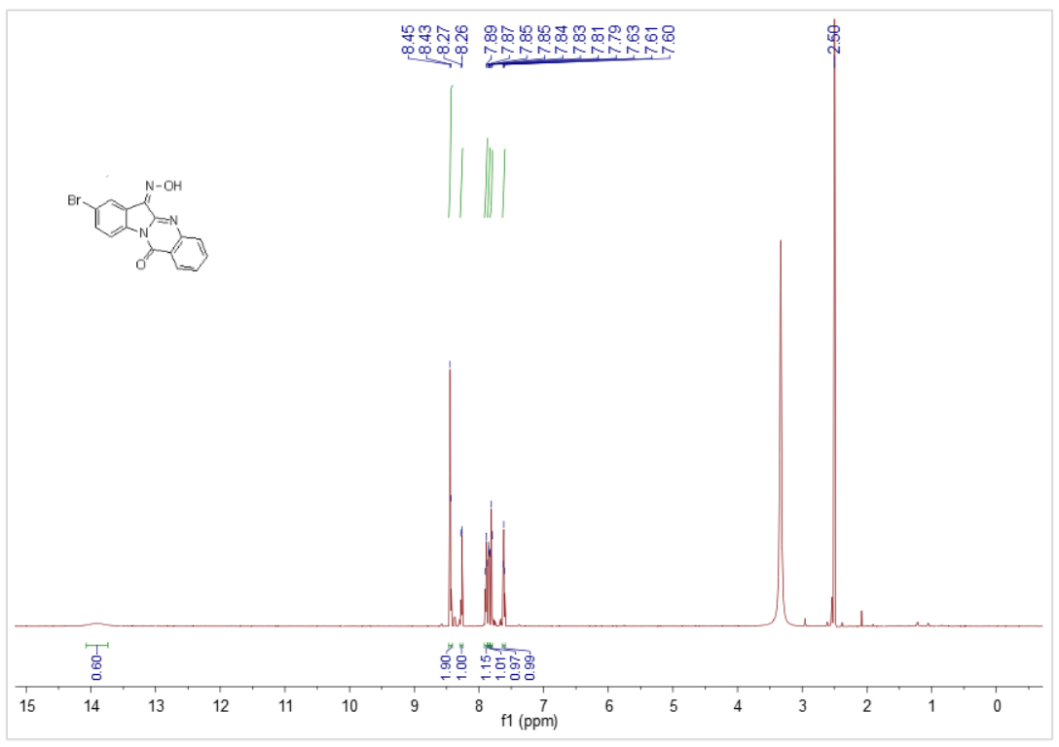
Figure 17 ¹H NMR of compound 4b
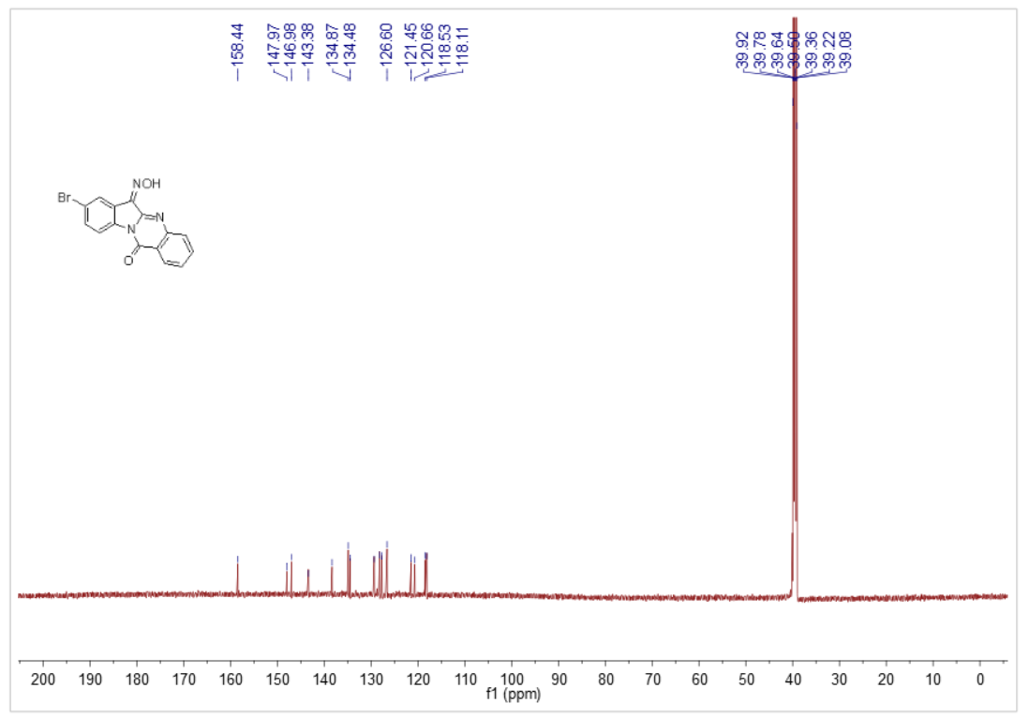
Figure 18 ¹³C NMR of compound 4b

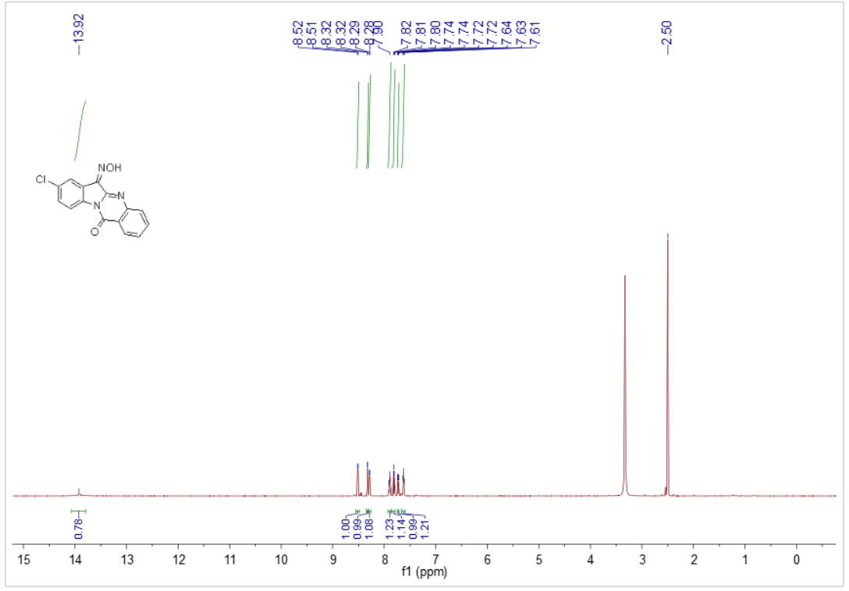
Figure 19 ¹H NMR of compound 4c

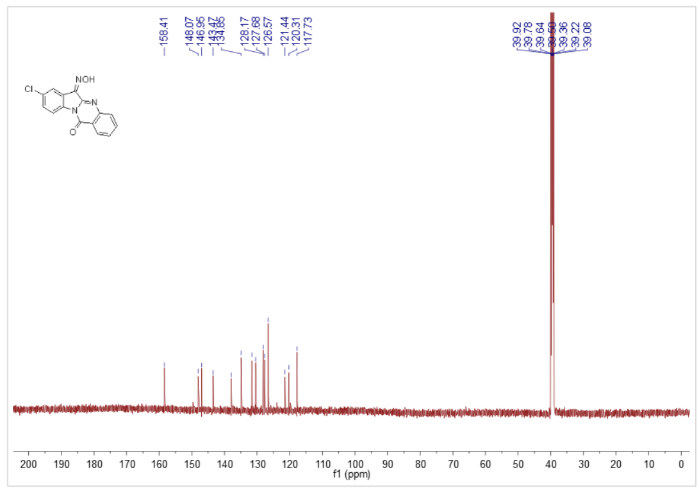
Figure 20 ¹³C NMR of compound 4c

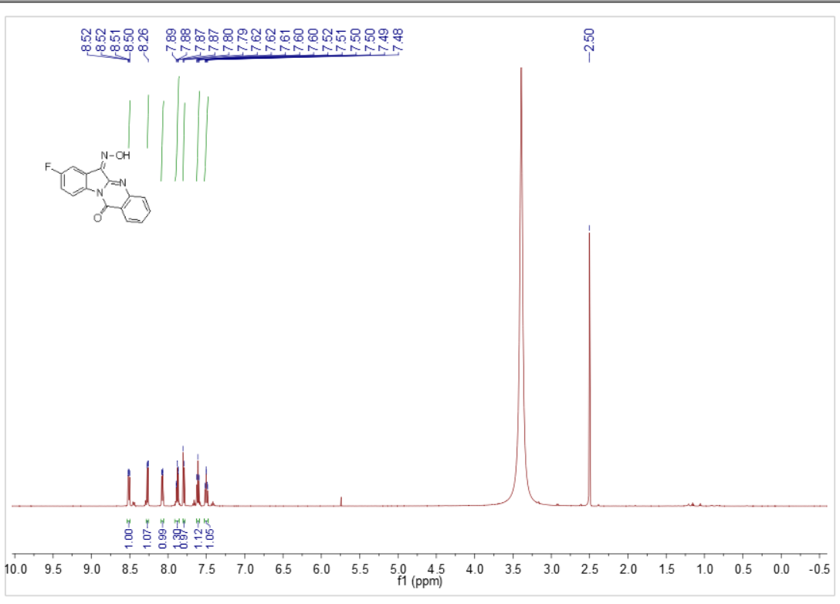
Figure 21 ¹H NMR of compound 4d

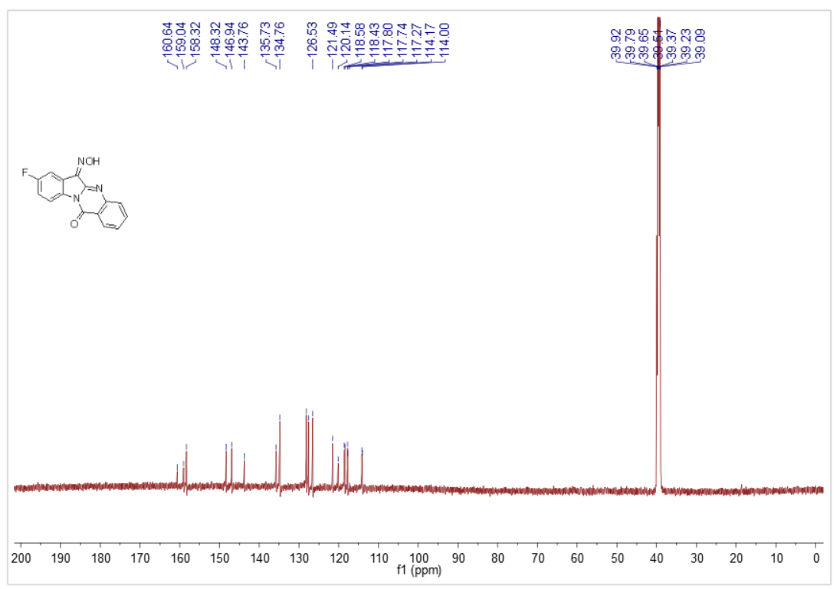
Figure 22 ¹³C NMR of compound 4d

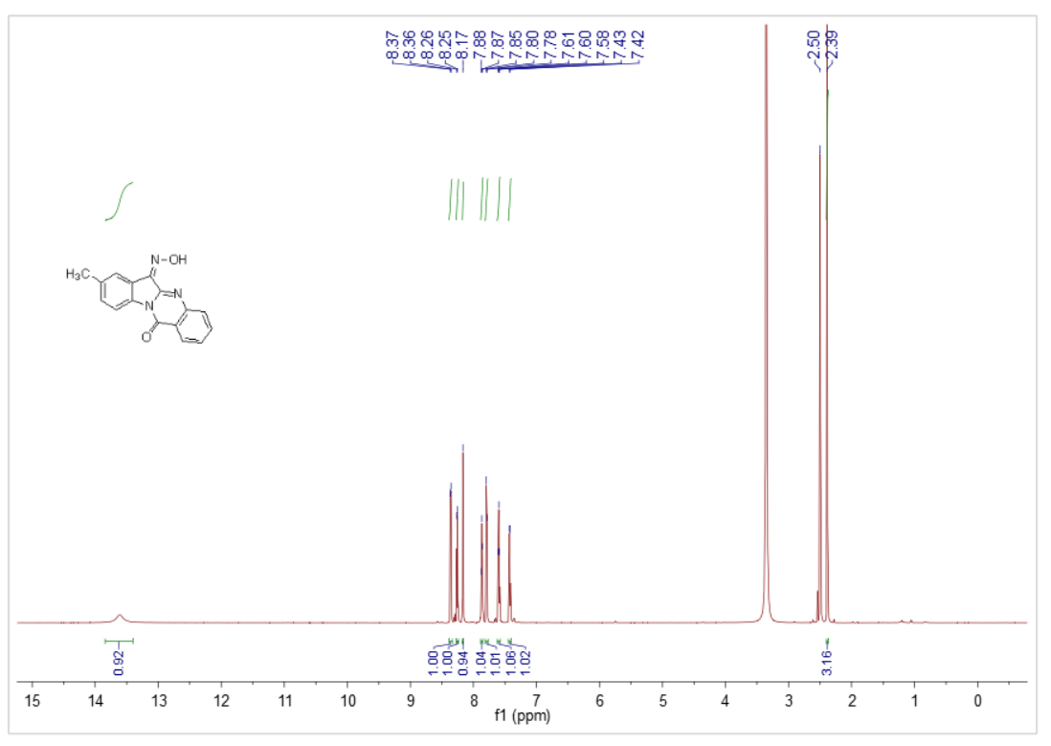
Figure 23 ¹H NMR of compound 4e

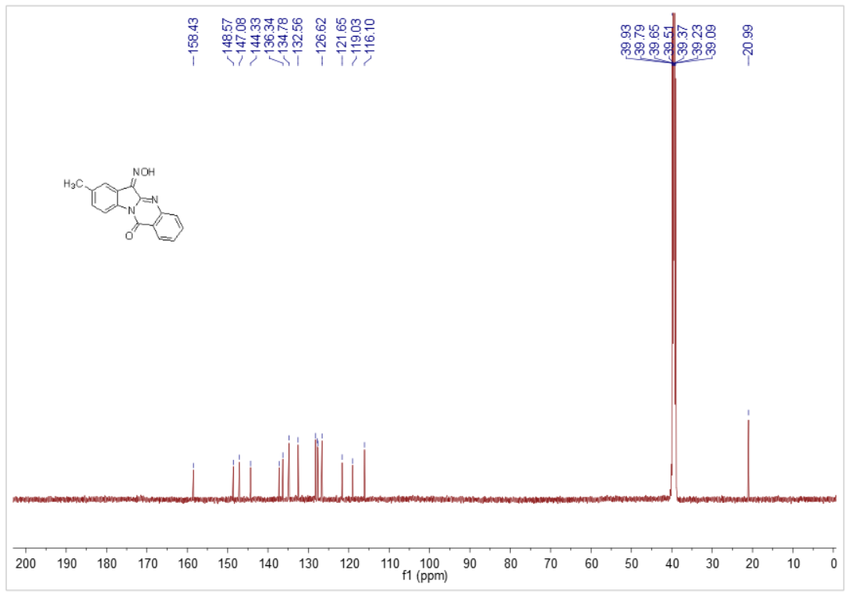
Figure 24 ¹³C NMR of compound 4e

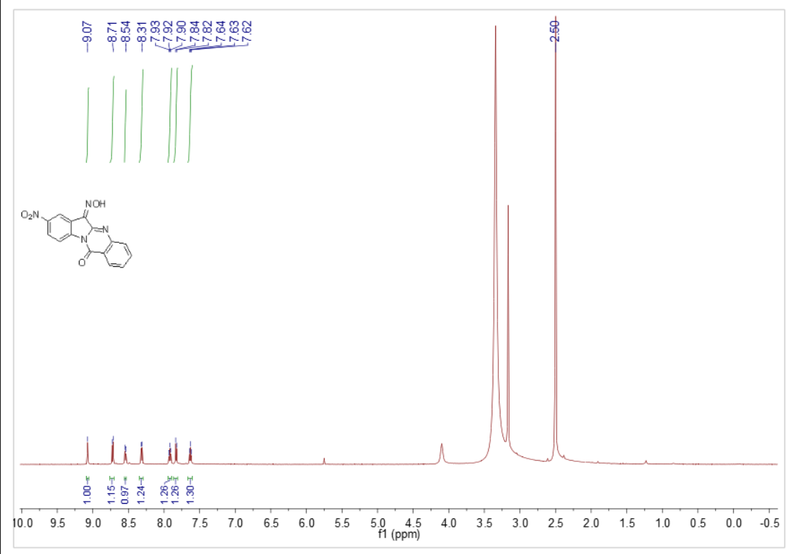
Figure 25 ¹H NMR of compound 4f

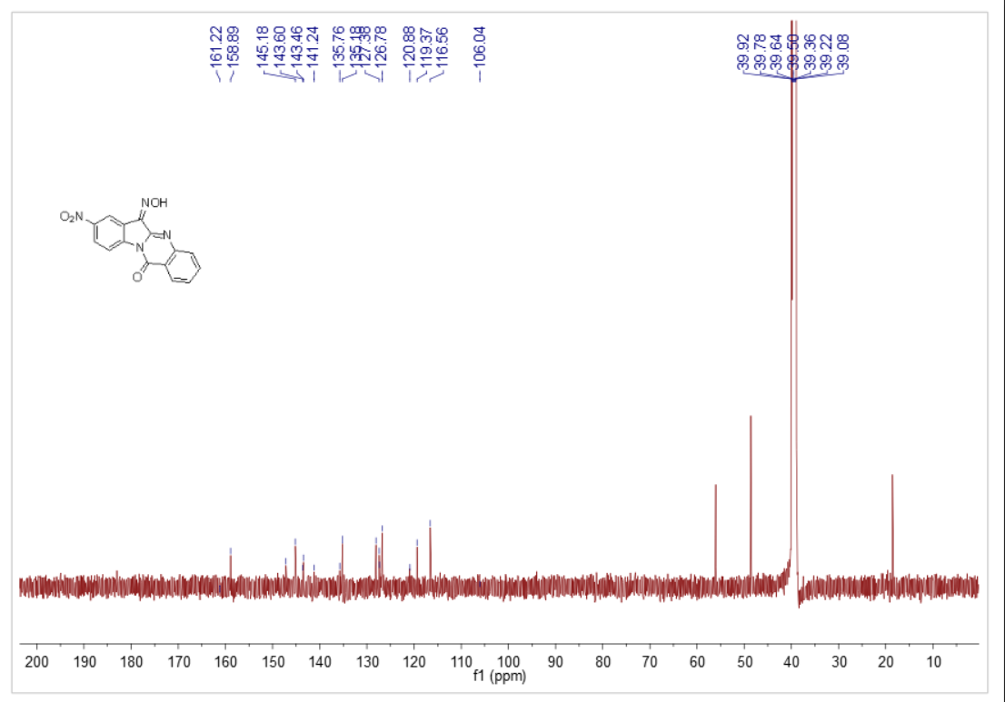
Figure 26 ¹³C NMR of compound 4f

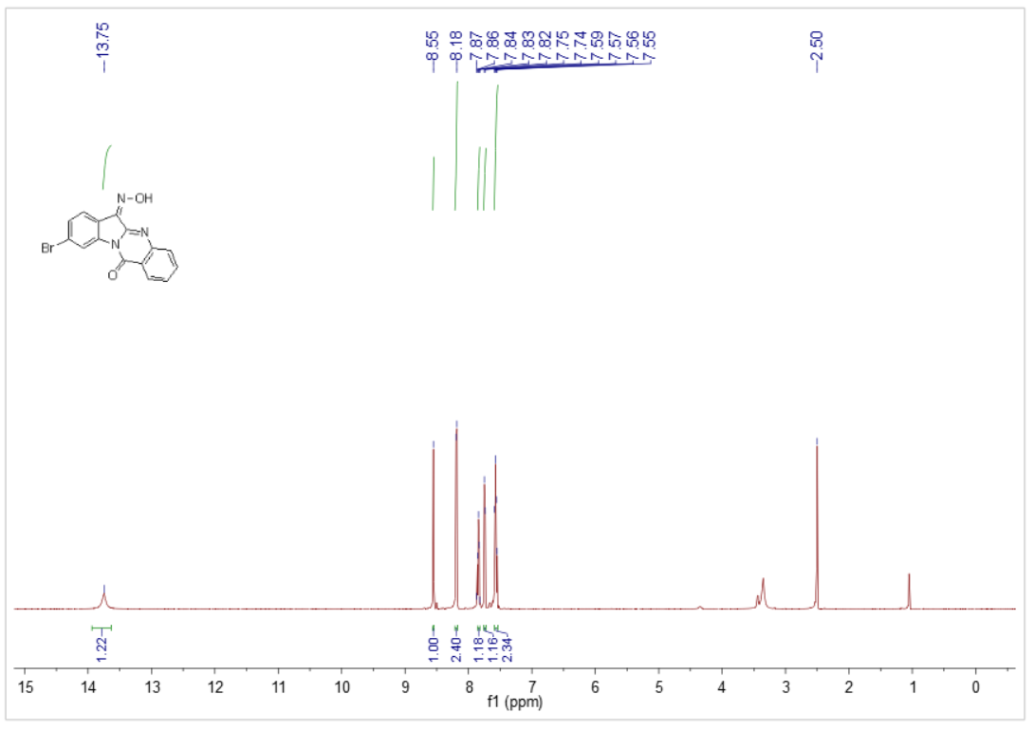
Figure 27 ¹H NMR of compound 4g
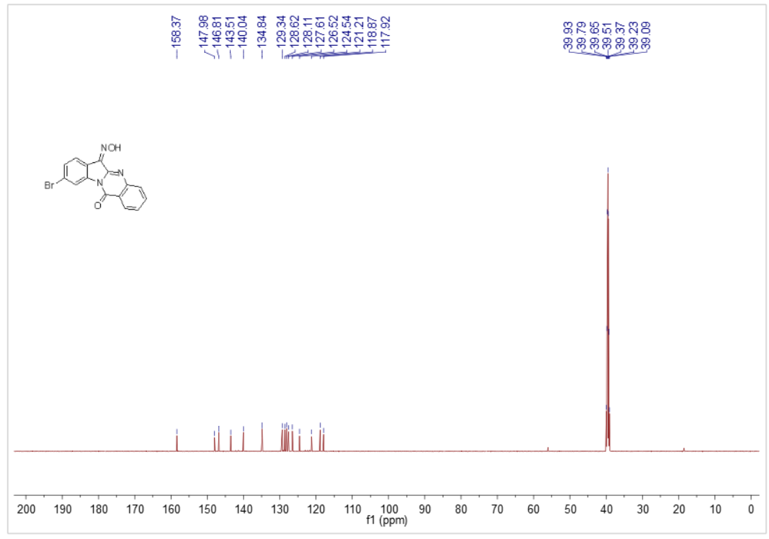
Figure 28 ¹³C NMR of compound 4g

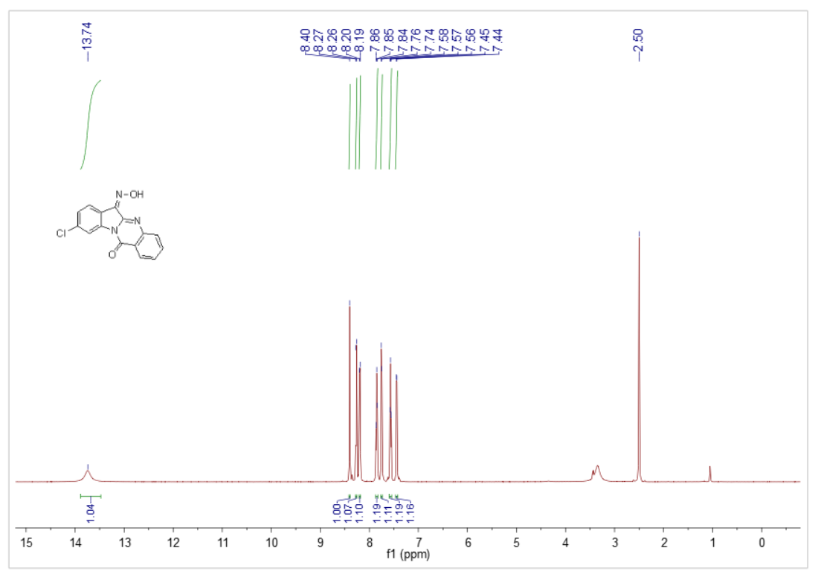
Figure 29 ¹H NMR of compound 4h
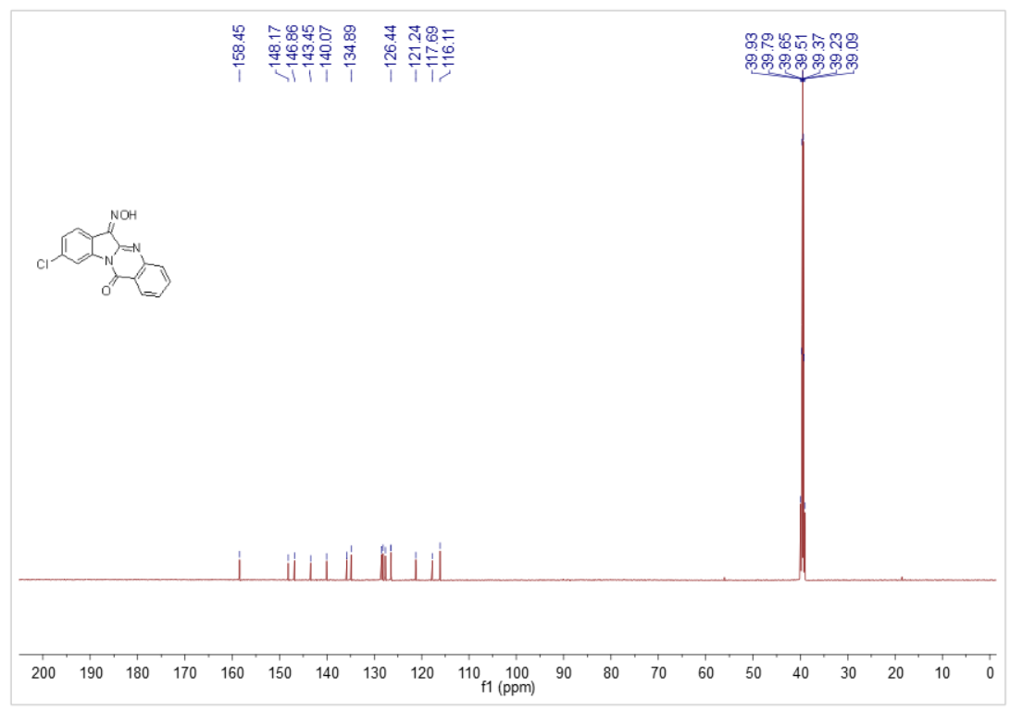
Figure 30 ¹³C NMR of compound 4h

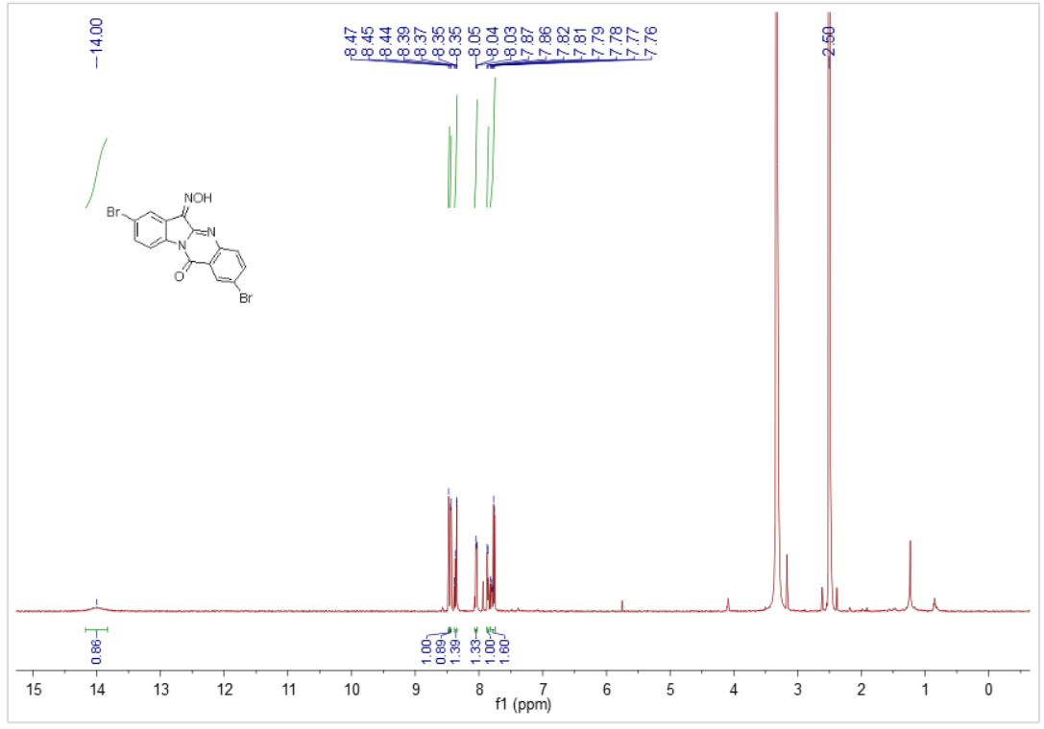
Figure 31 ¹H NMR of compound 4i
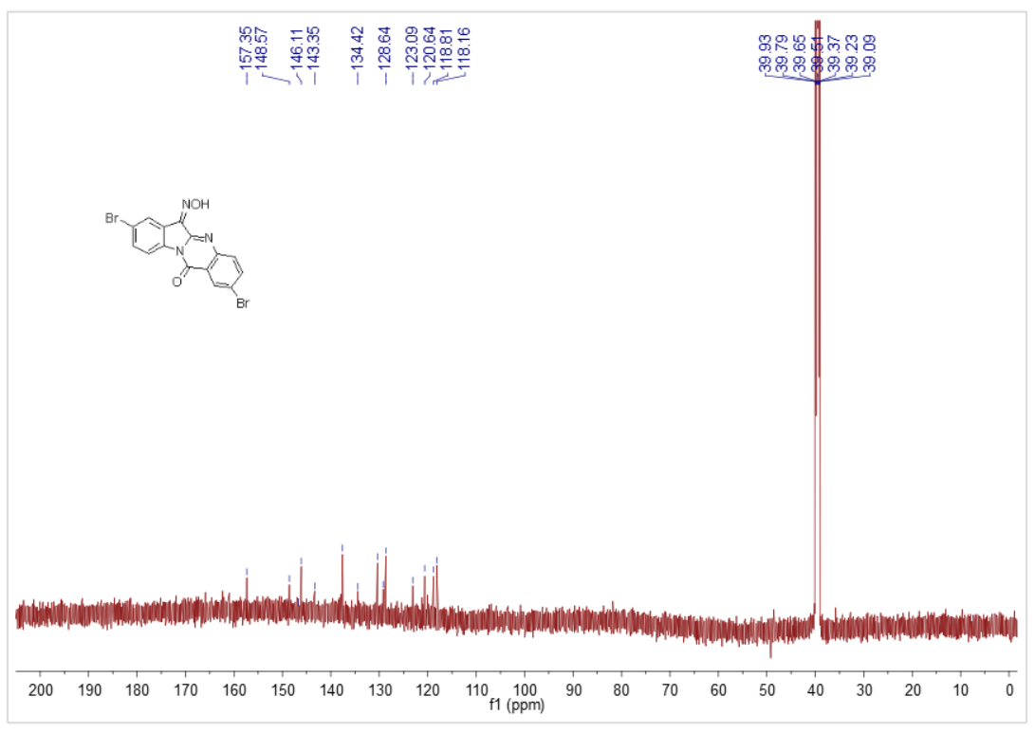
Figure 32 ¹³C NMR of compound 4i

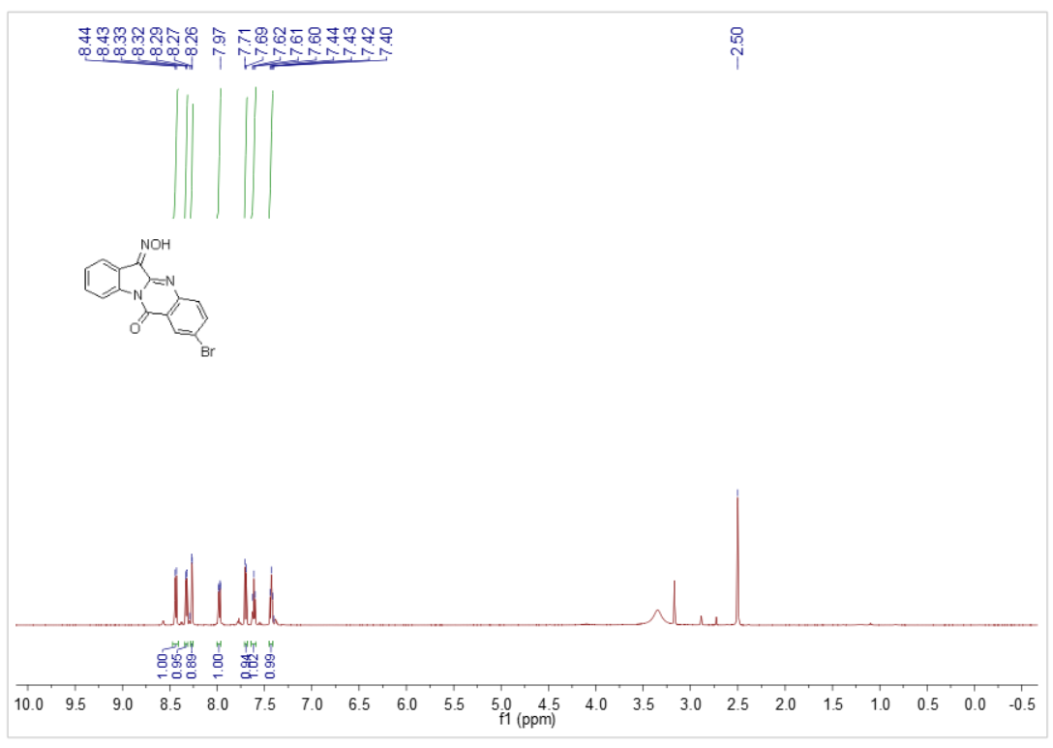
Figure 33 ¹H NMR of compound 4j

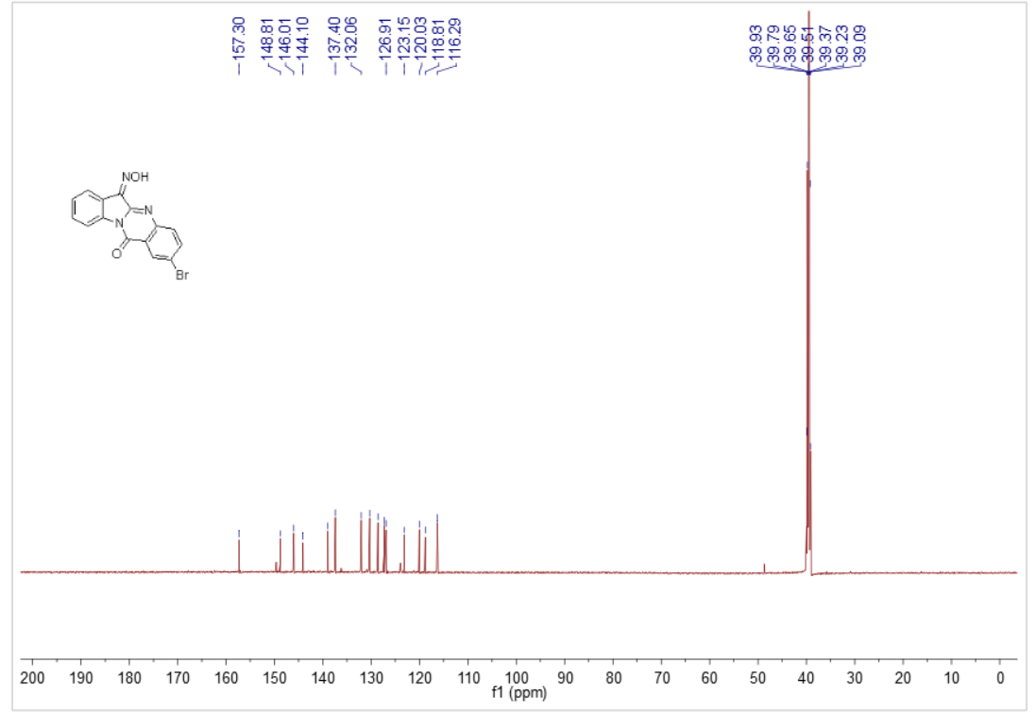
Figure 34 ¹³C NMR of compound 4j

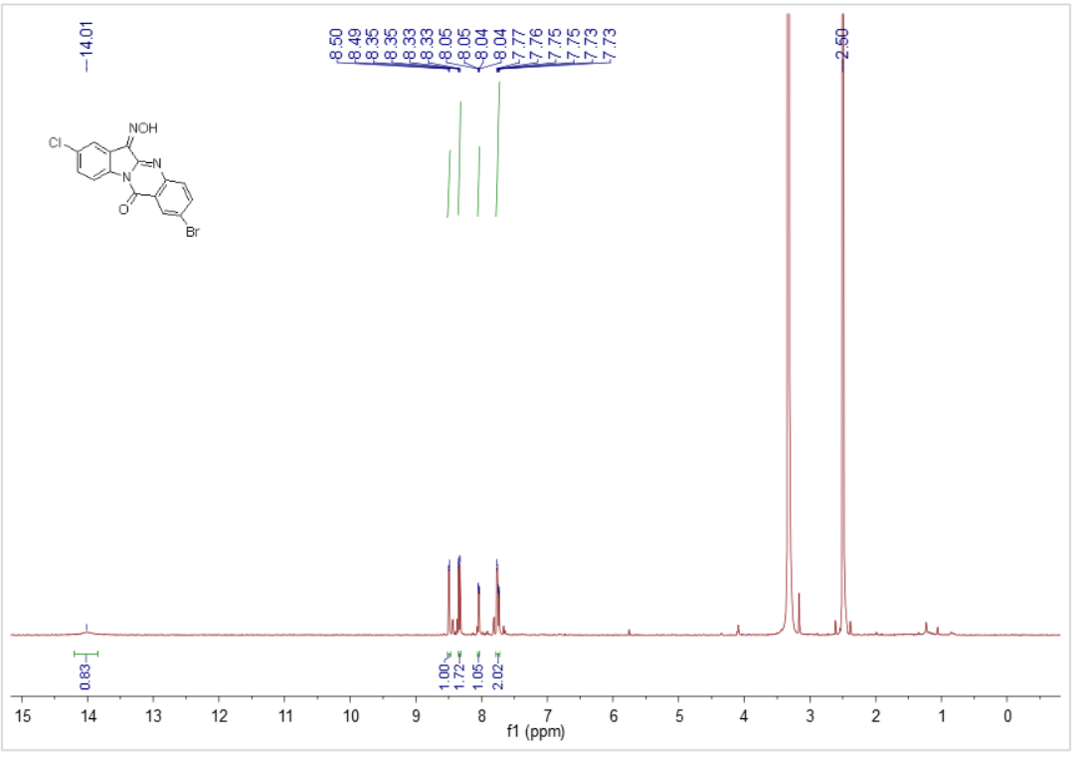
Figure 35 ¹H NMR of compound 4k

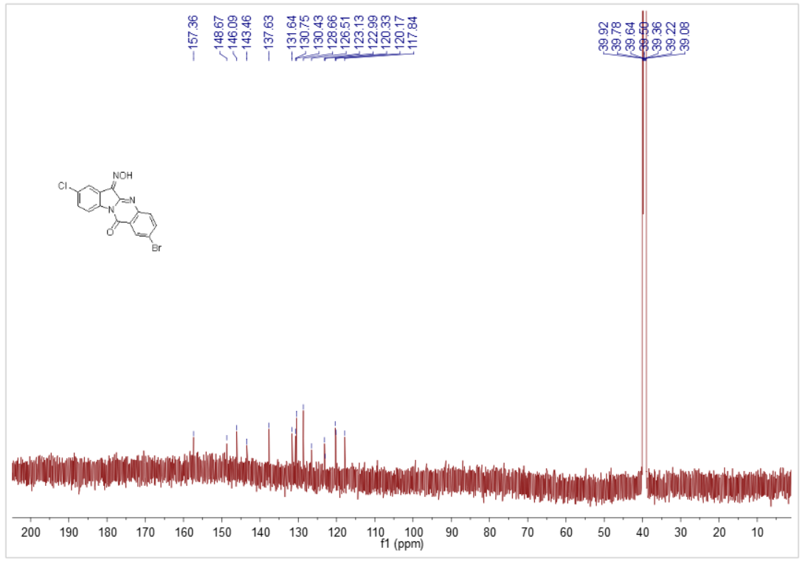
Figure 36 ¹³C NMR of compound 4k

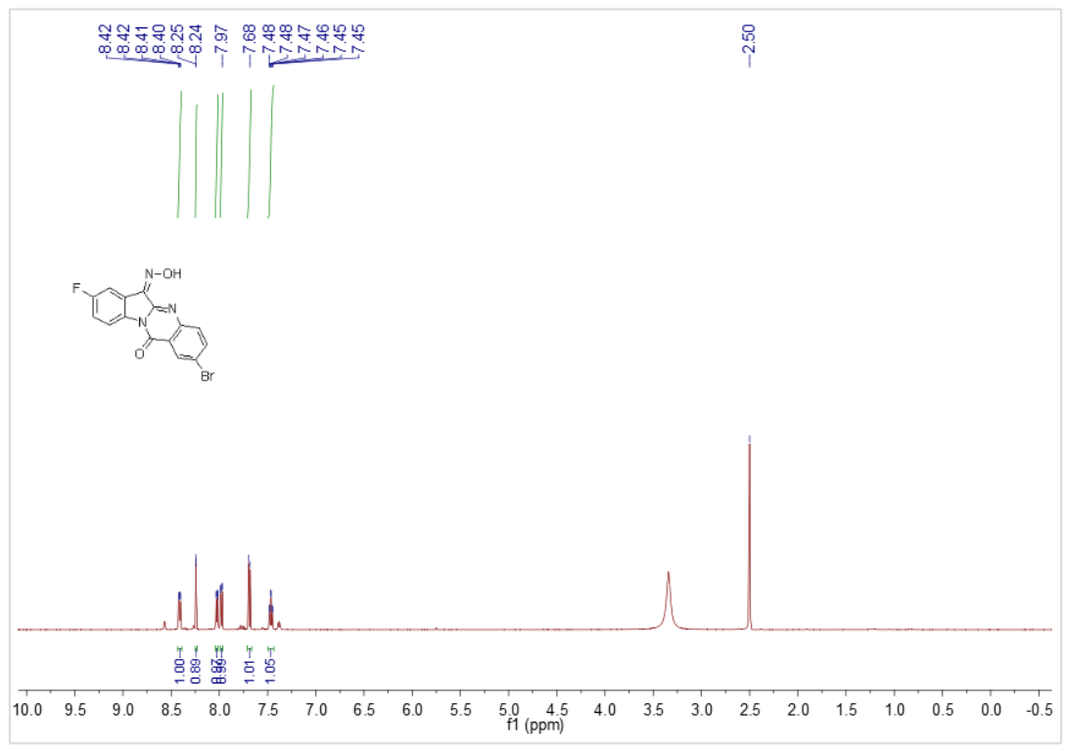
Figure 37 ¹H NMR of compound 4l

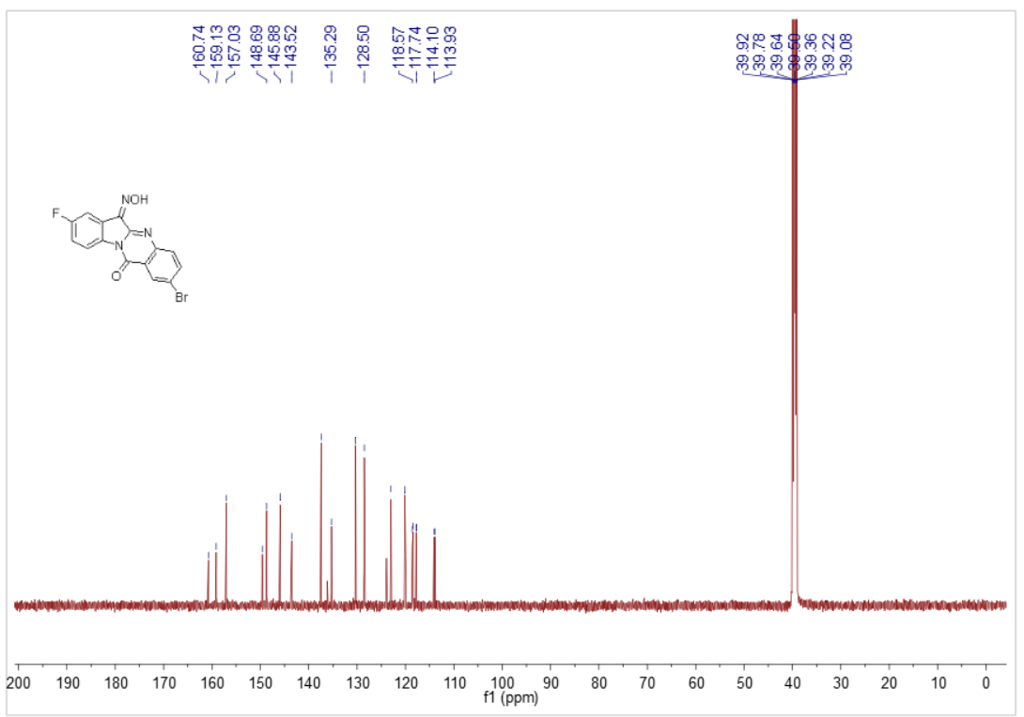

Figure 38 ¹³C NMR of compound 4l

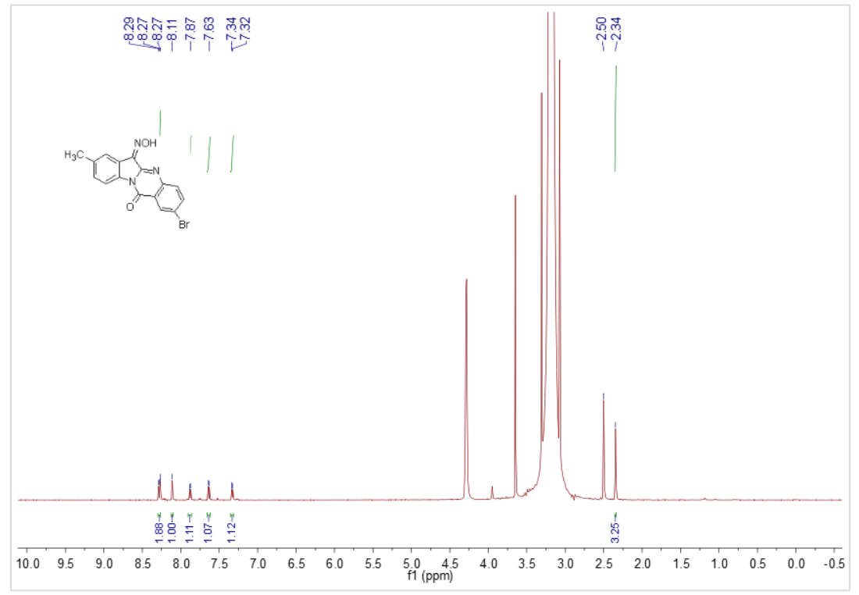
Figure 39 ¹H NMR of compound 4m

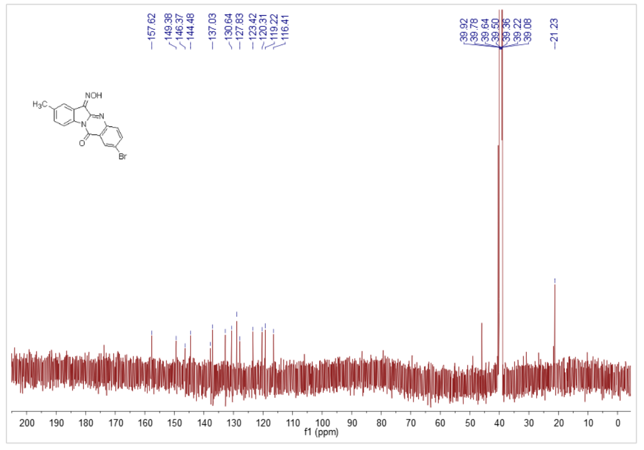
Figure 40 ¹³C NMR of compound 4m

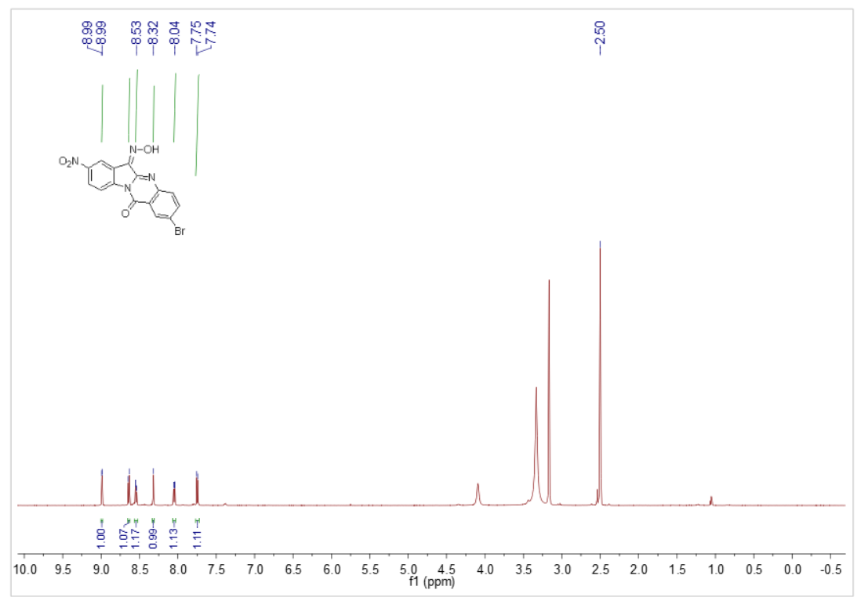
Figure 41 ¹H NMR of compound 4n

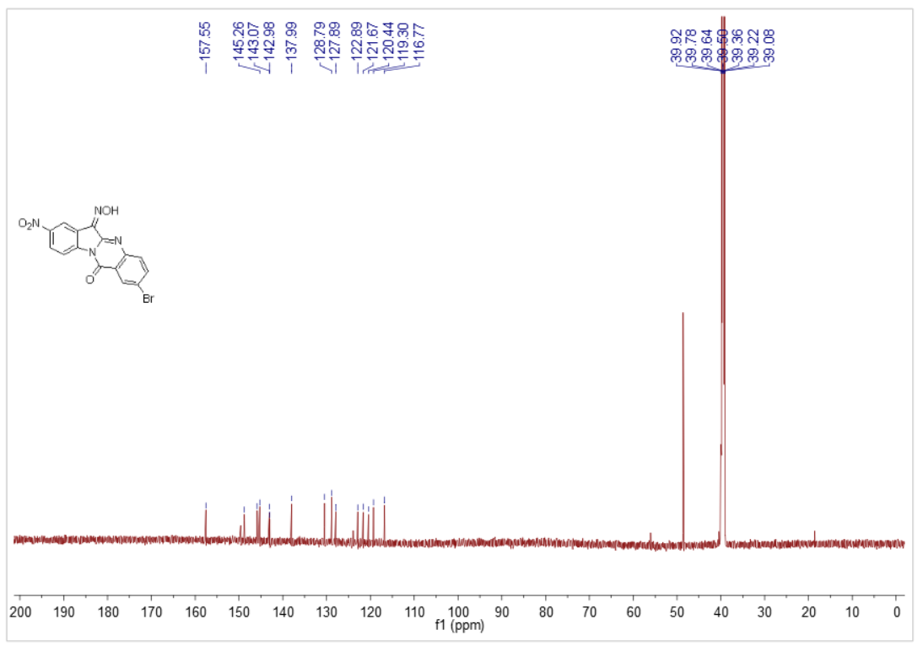
Figure 42 ¹³C NMR of compound 4n

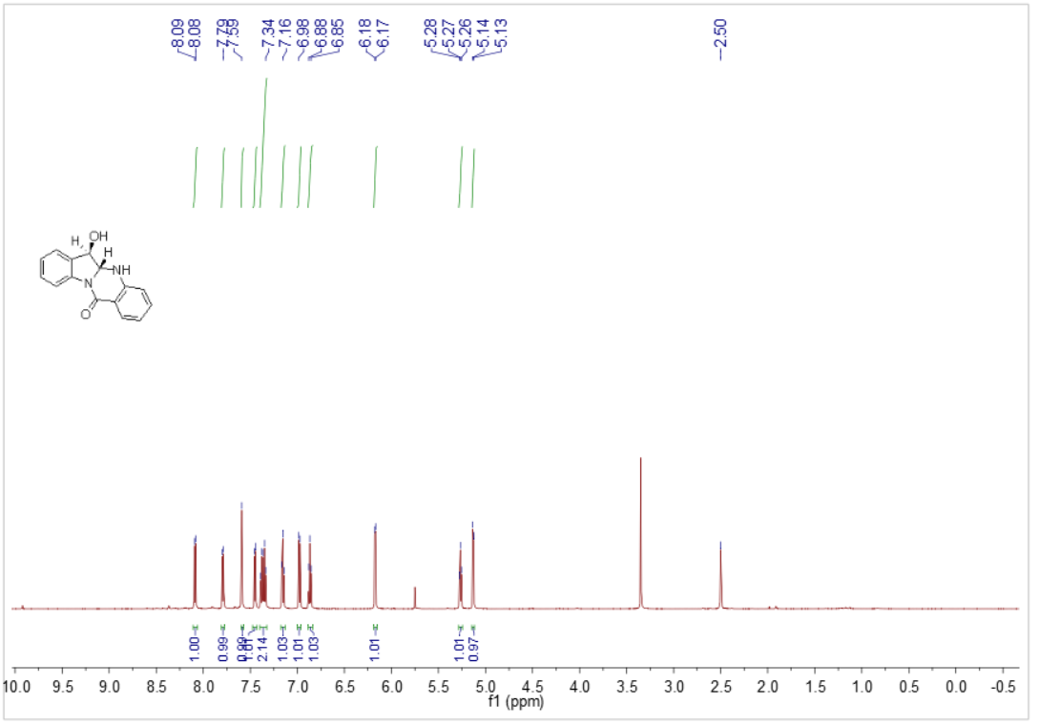
Figure 43 ¹H NMR of compound 5a

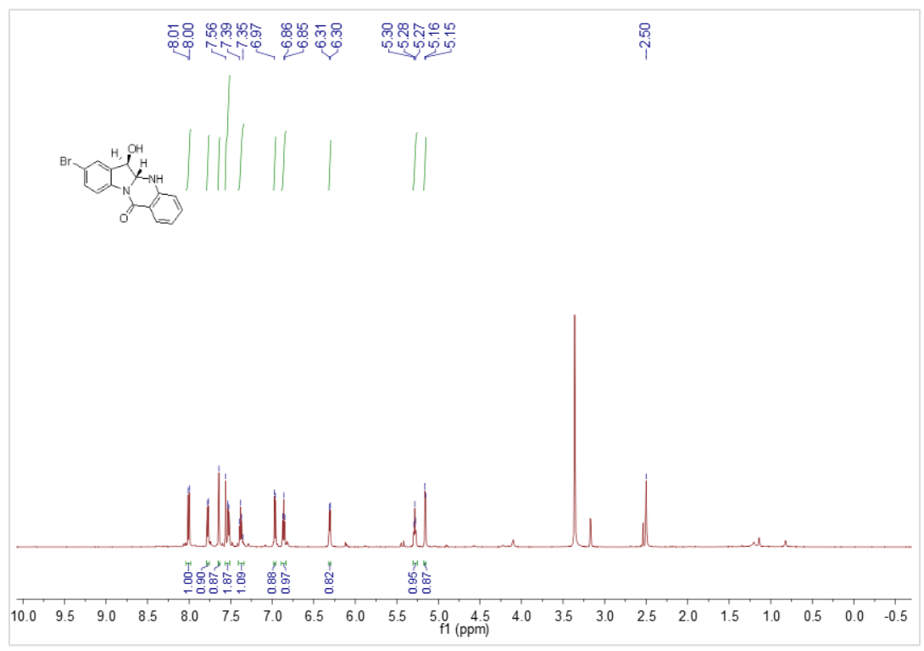
Figure 44 ¹H NMR of compound 5b

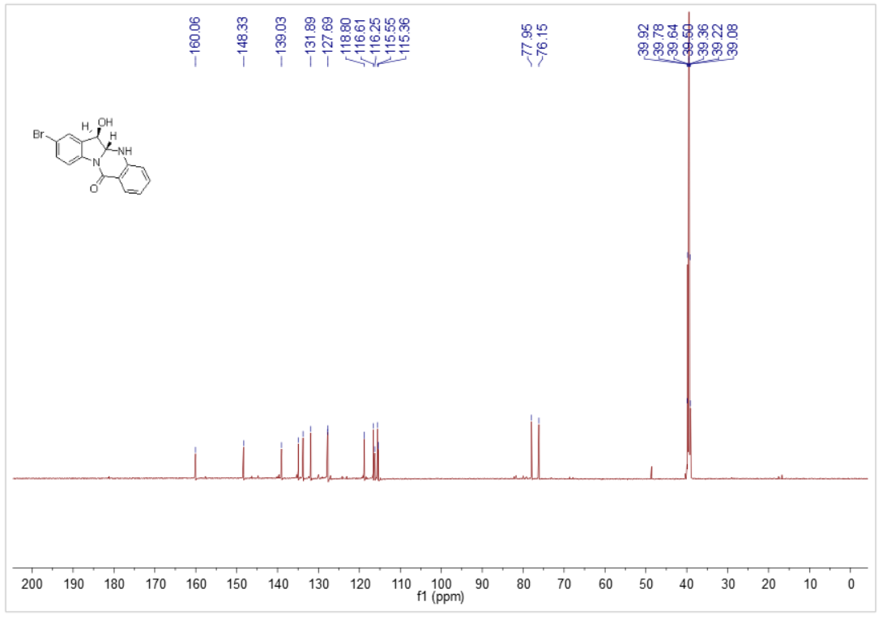
Figure 45 ¹³C NMR of compound 5b

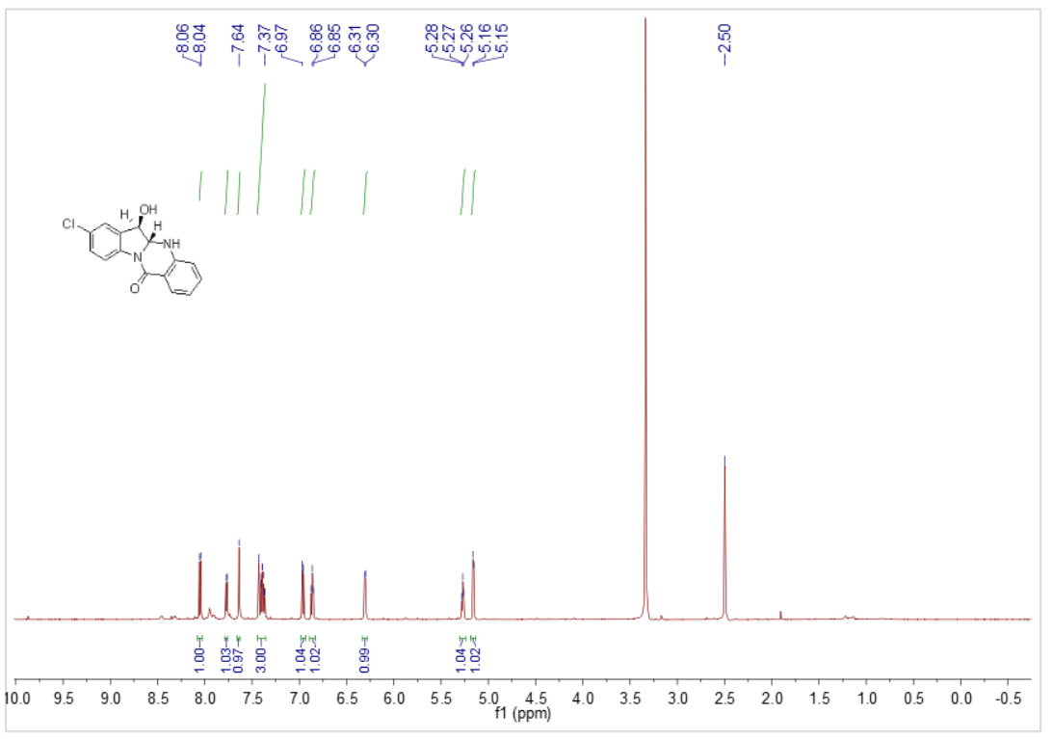
Figure 46 ¹H NMR of compound 5c

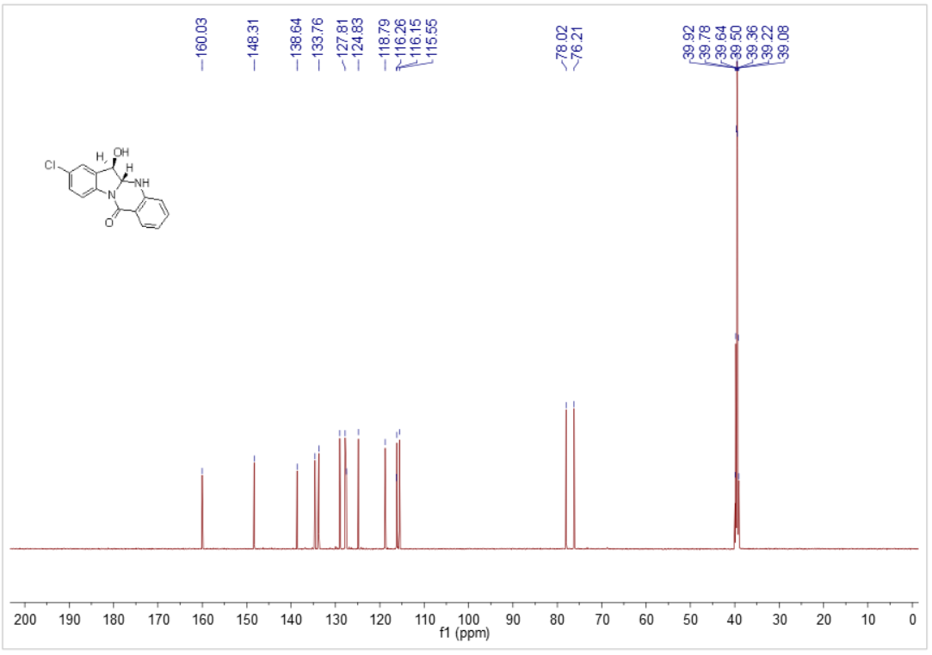
Figure 47 ¹³C NMR of compound 5c

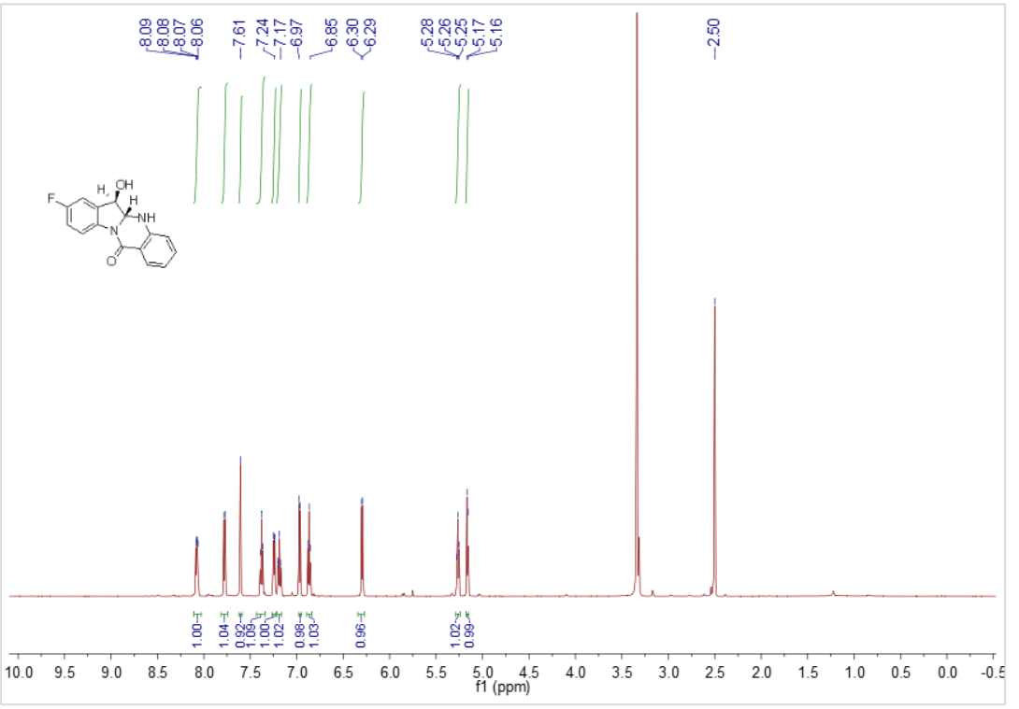
Figure 48 ¹H NMR of compound 5d

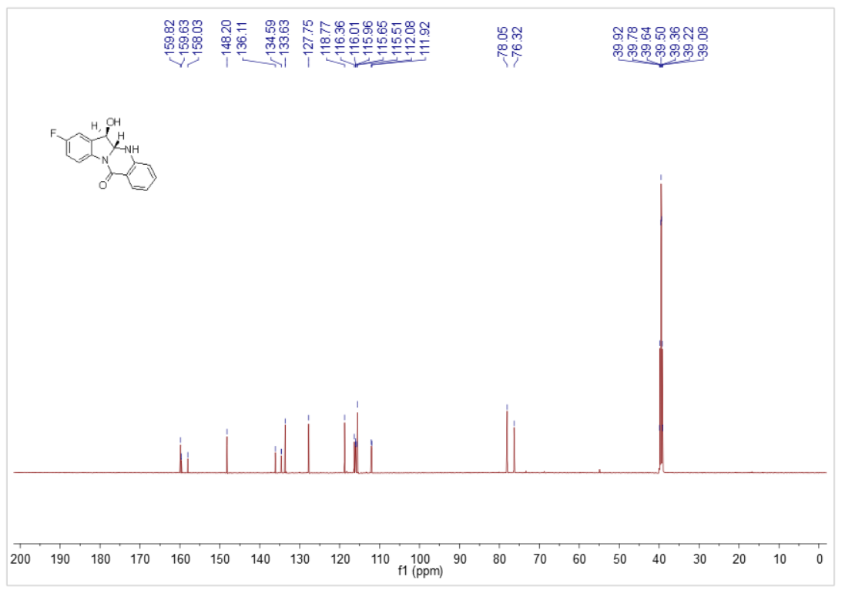
Figure 49 ¹³C NMR of compound 5d

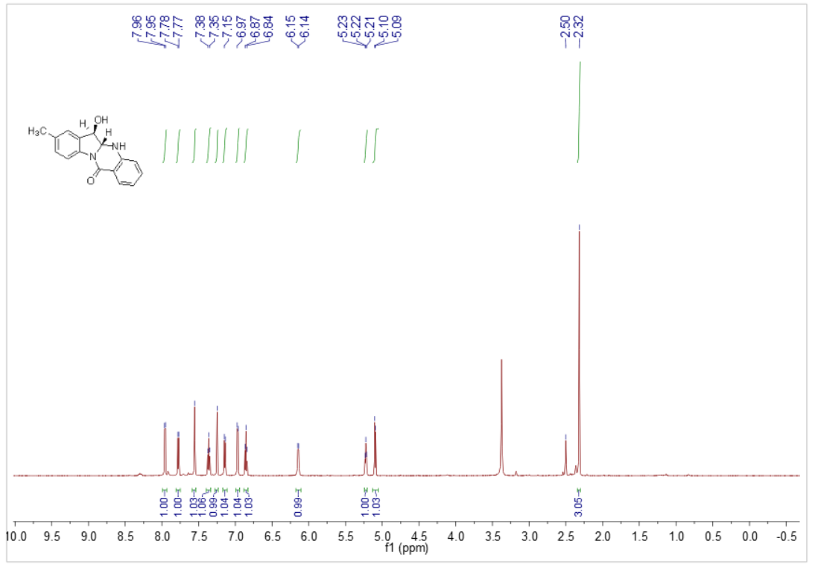
Figure 50 ¹H NMR of compound 5e

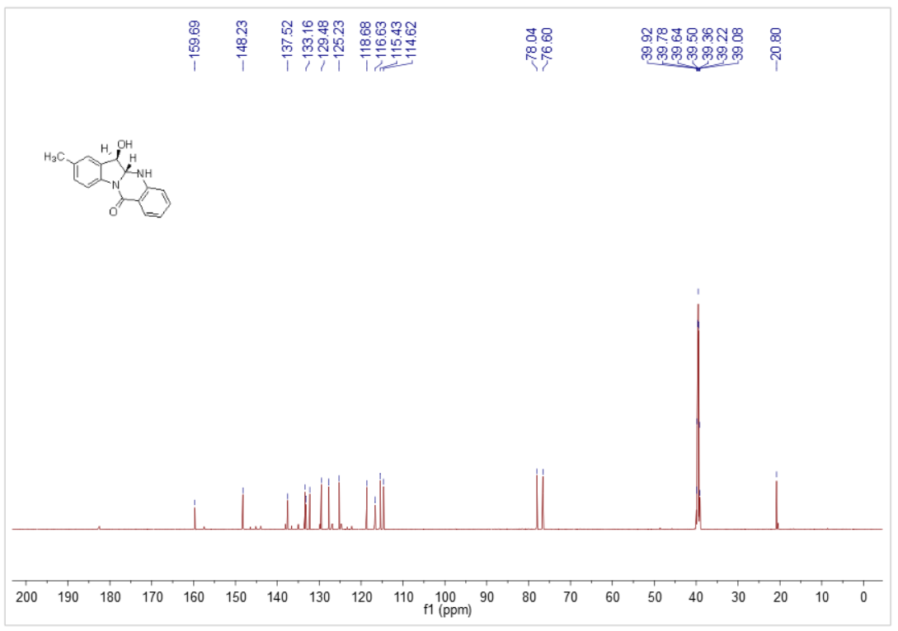
Figure 51 ¹³C NMR of compound 5e

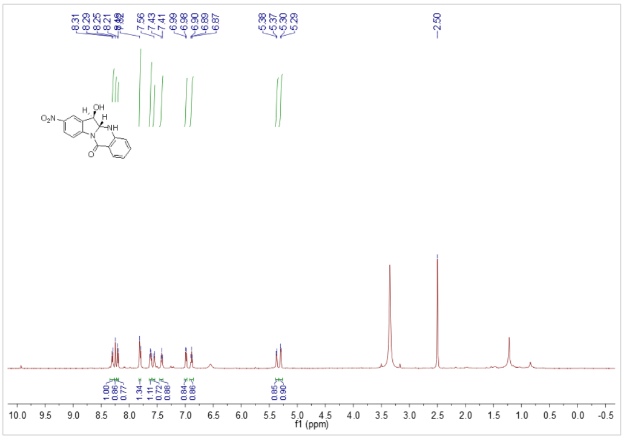
Figure 52 ¹H NMR of compound 5f

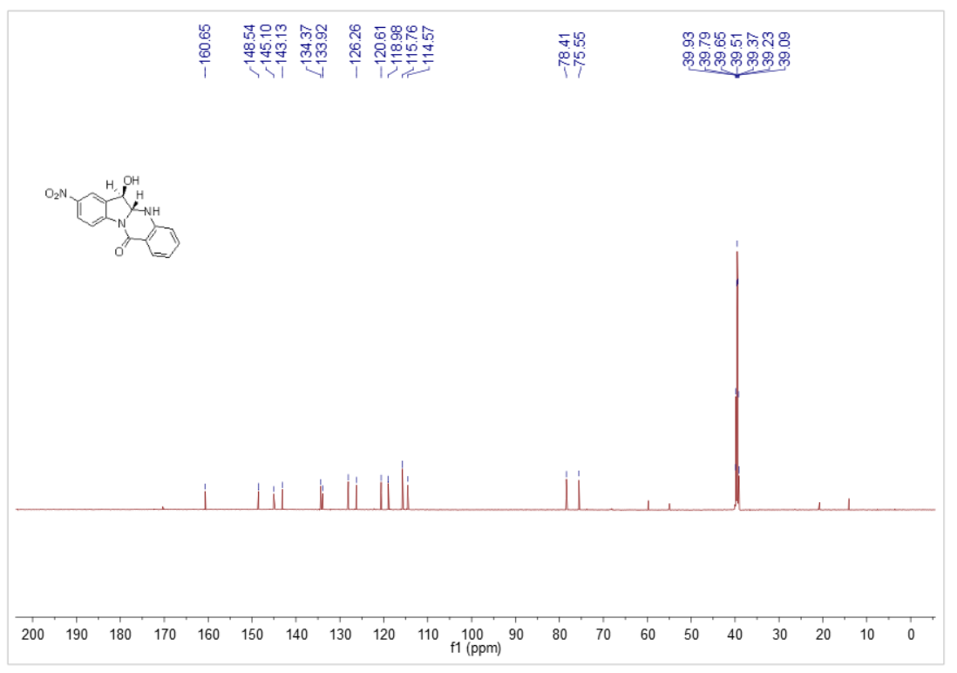
Figure 53 ¹³C NMR of compound 5f

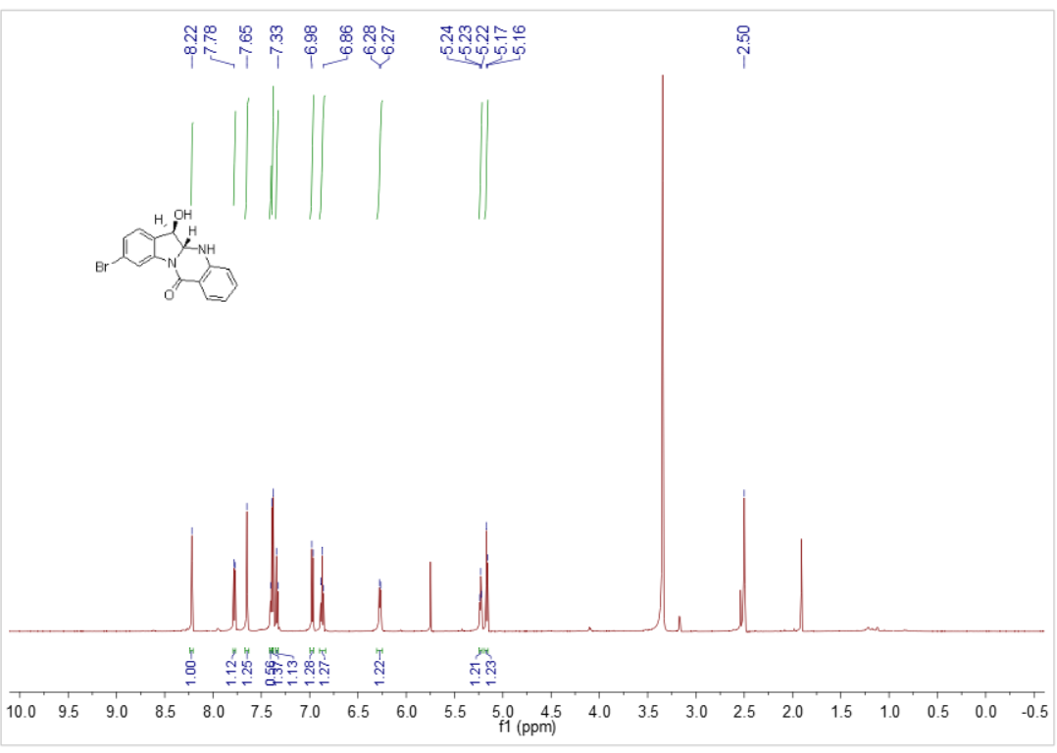
Figure 54 ¹H NMR of compound 5g

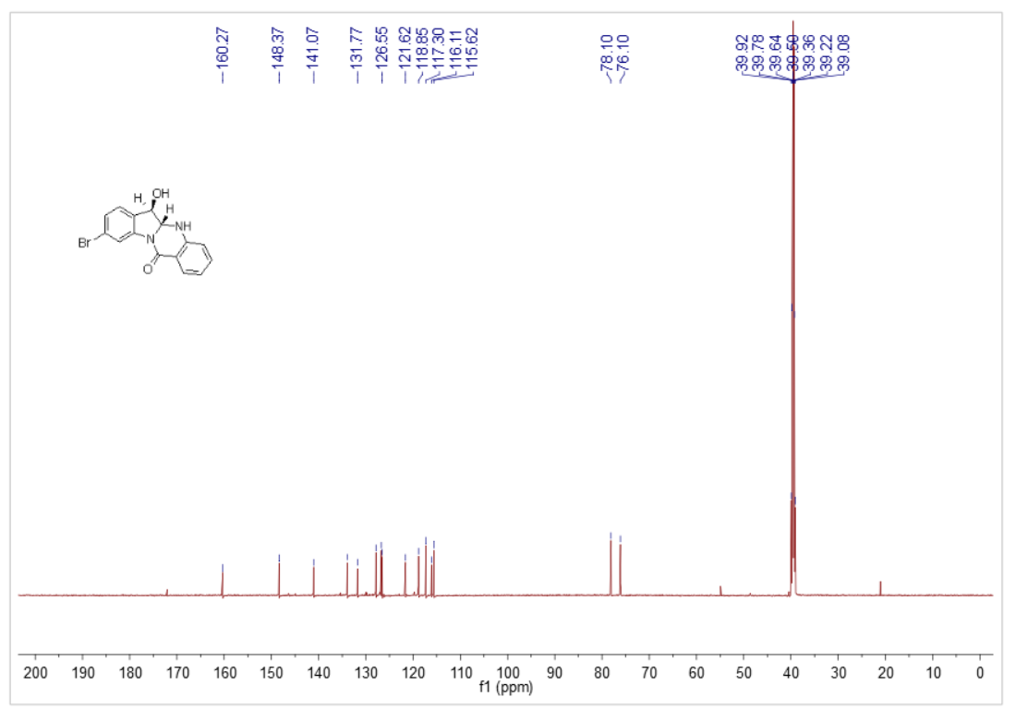
Figure 55 ¹³C NMR of compound 5g

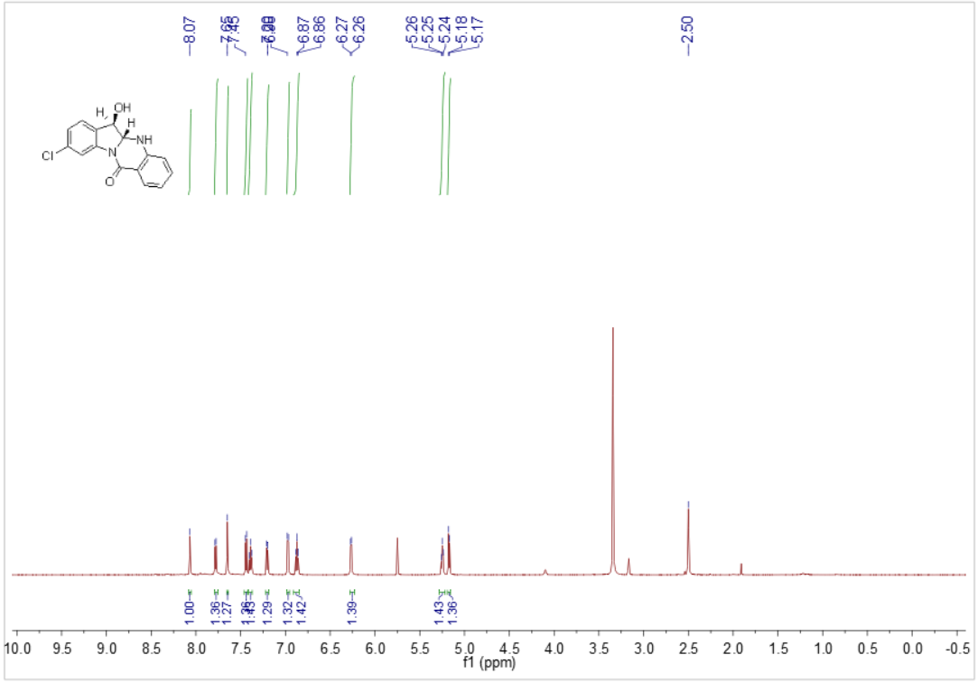
Figure 56 ¹H NMR of compound 5h

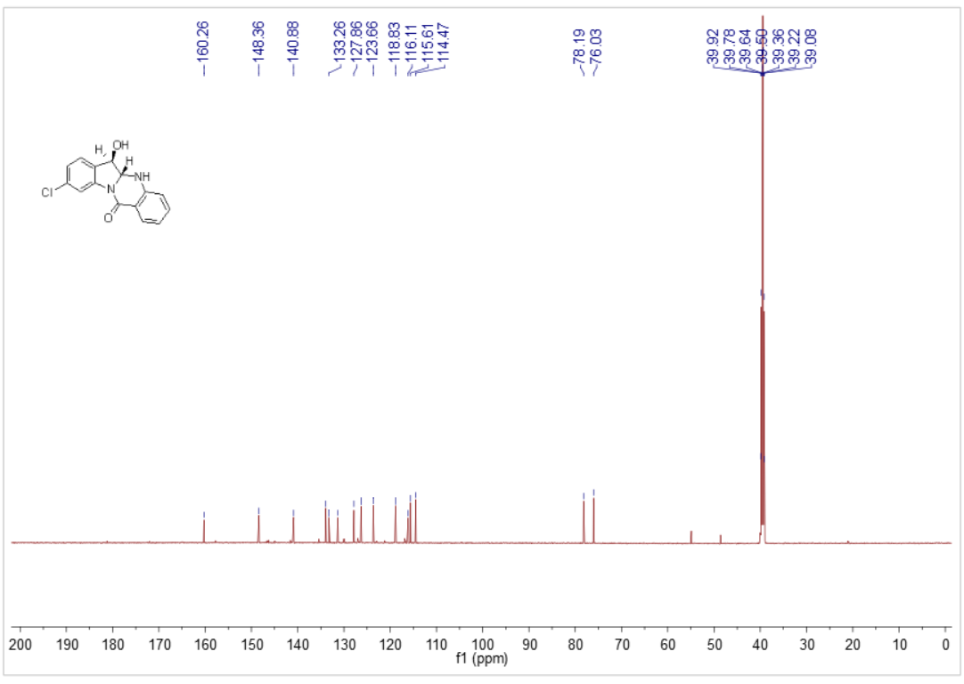
Figure 57 ¹³C NMR of compound 5h

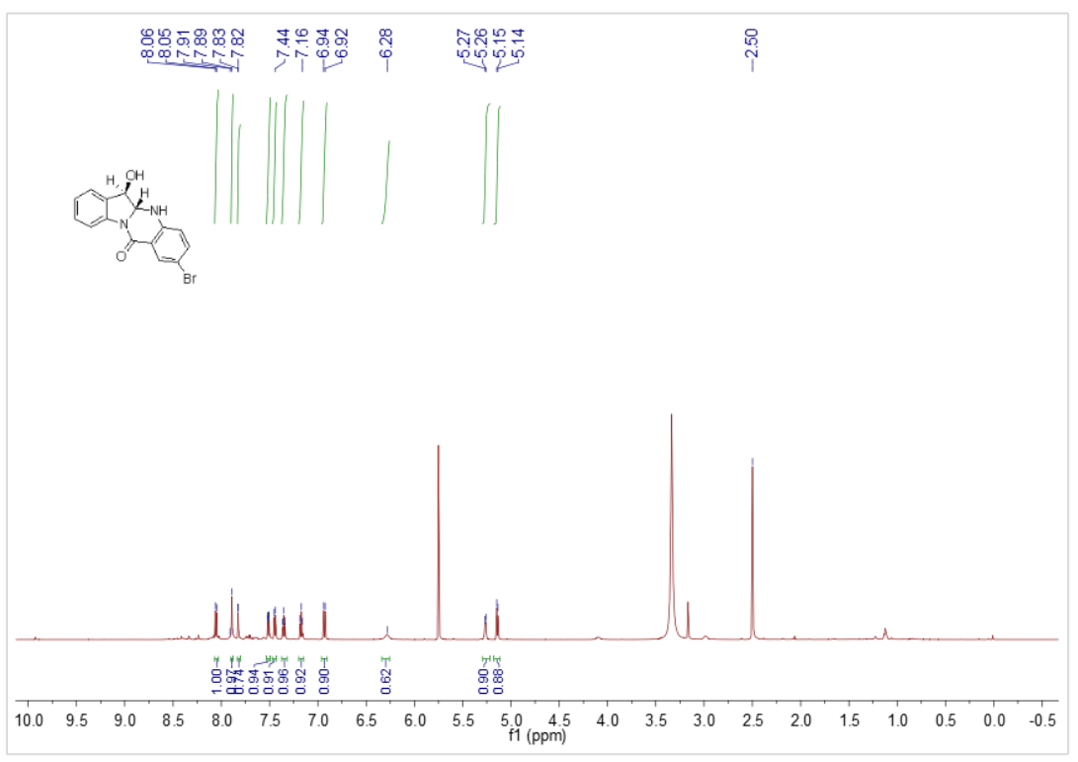
Figure 58 ¹H NMR of compound 5j

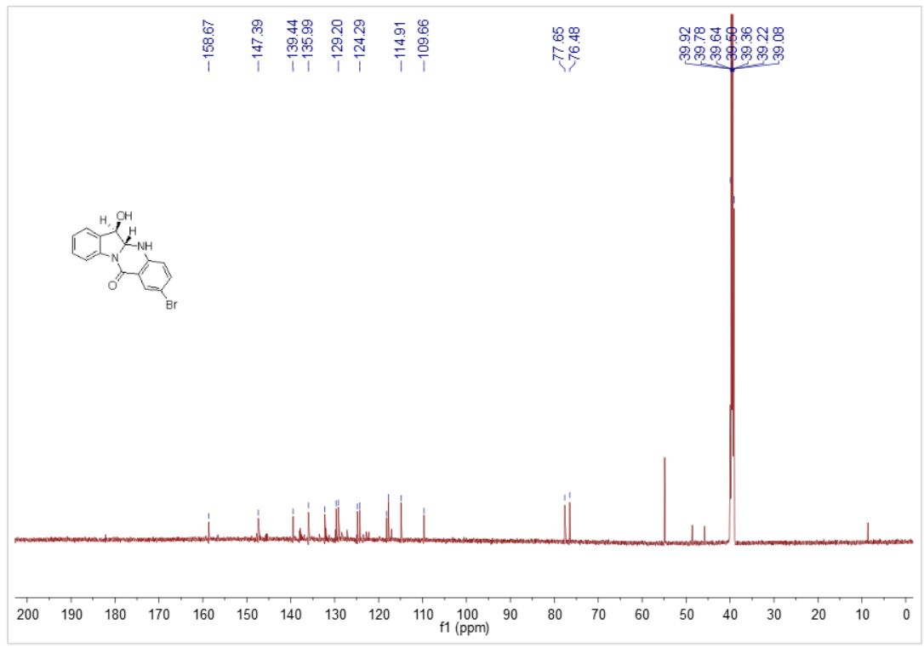
Figure 59 ¹³C NMR of compound 5j

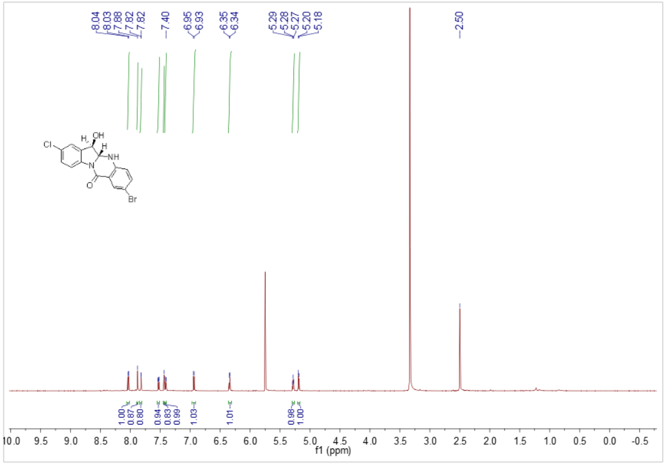
Figure 60 ¹H NMR of compound 5k

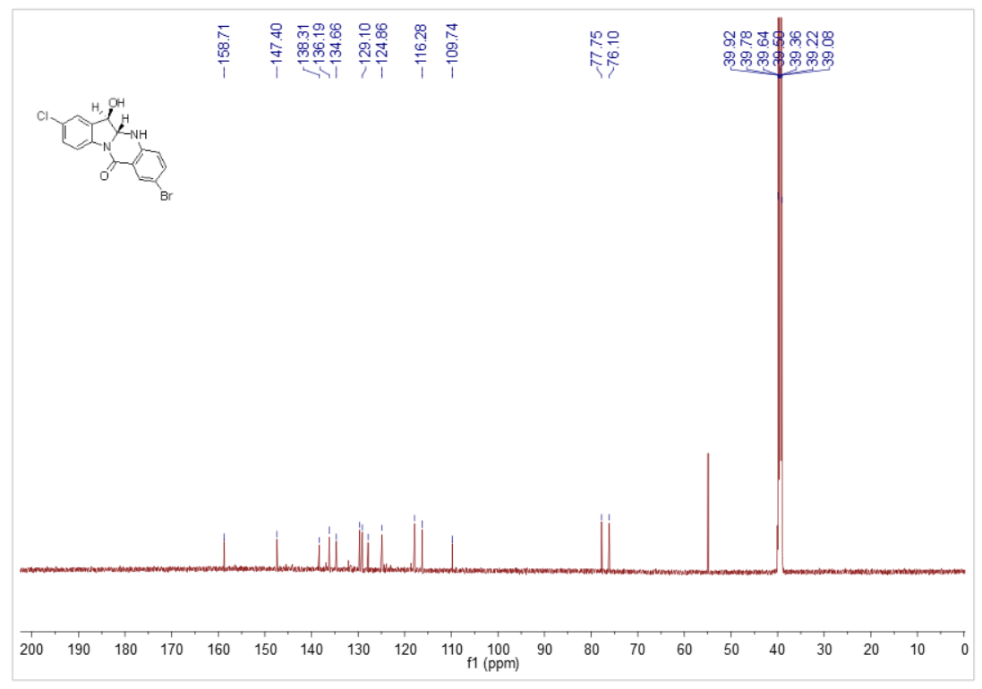
Figure 61 ¹³C NMR of compound 5k

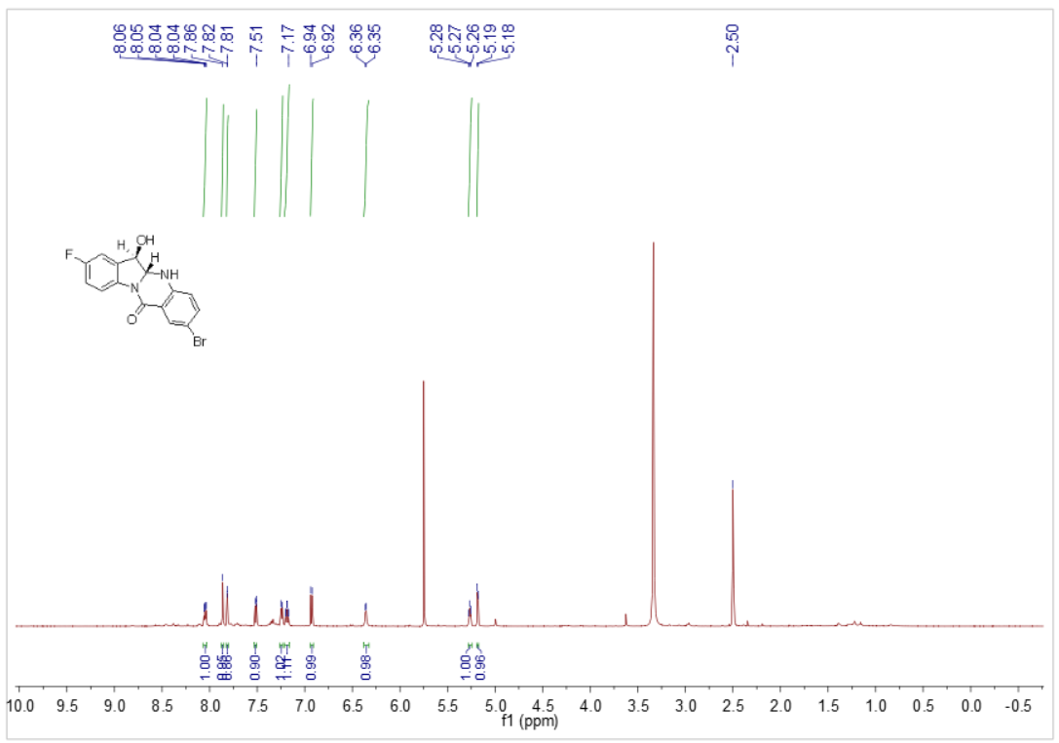
Figure 62 ¹H NMR of compound 5l

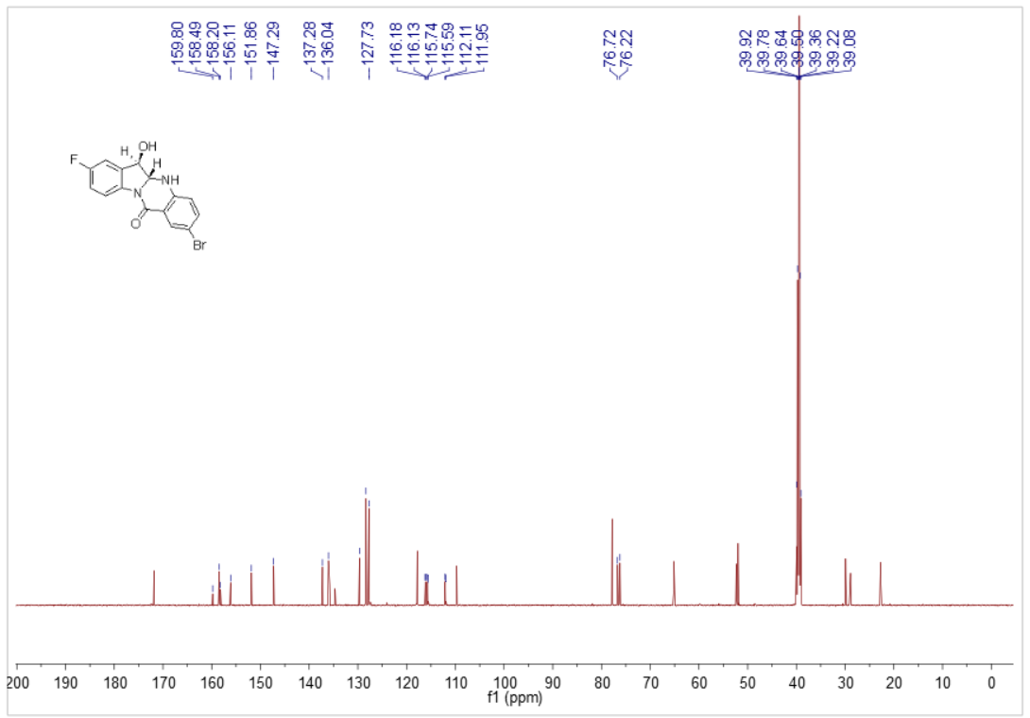
Figure 63 ¹³C NMR of compound 5l

Spectra of HRMS

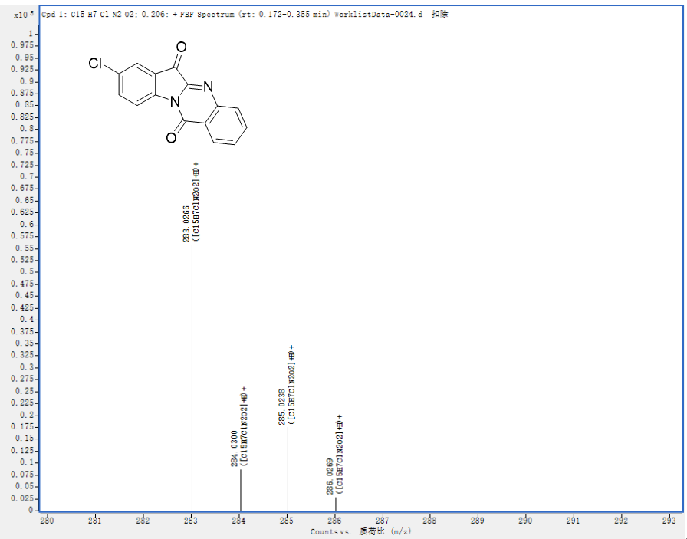
Figure 64 HRMS of compound 3c

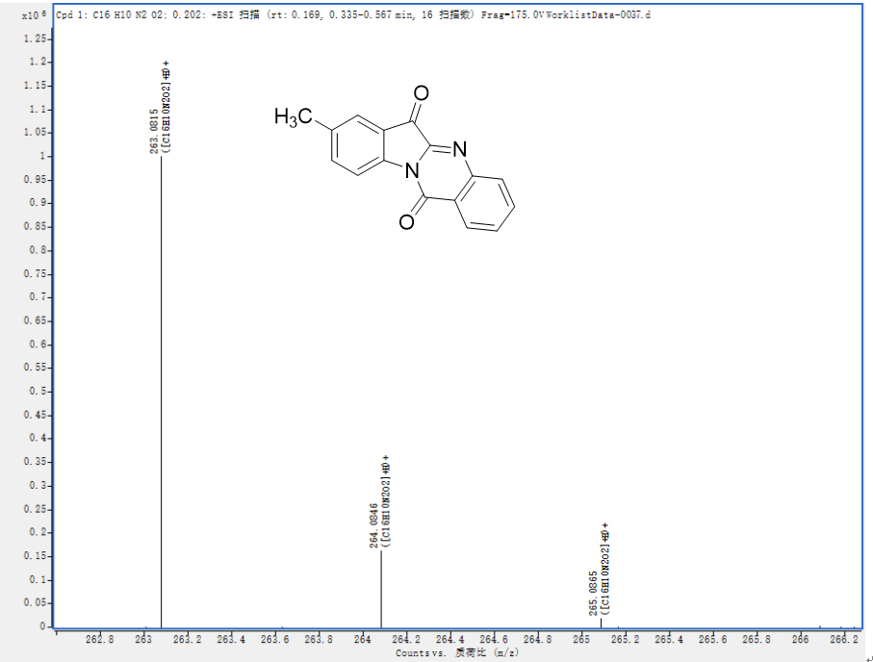
Figure 65 HRMS of compound 3e
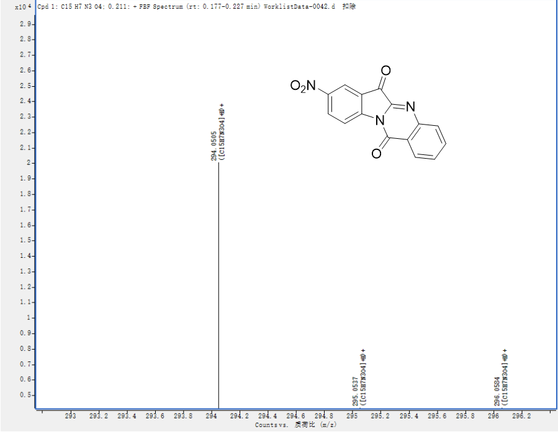
Figure 66 HRMS of compound 3f

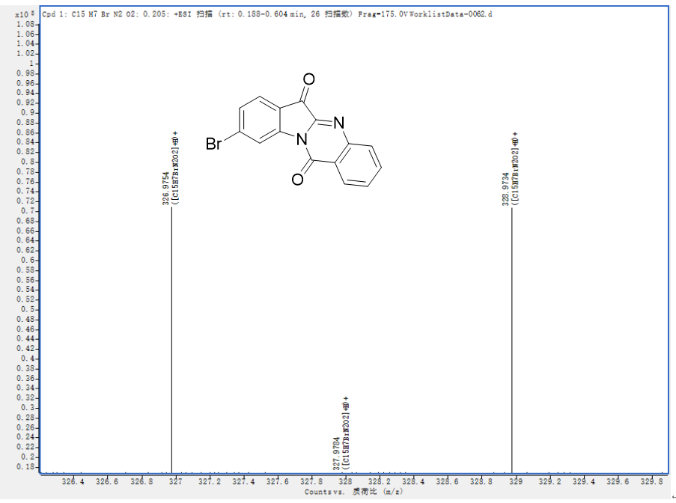
Figure 67 HRMS of compound 3g
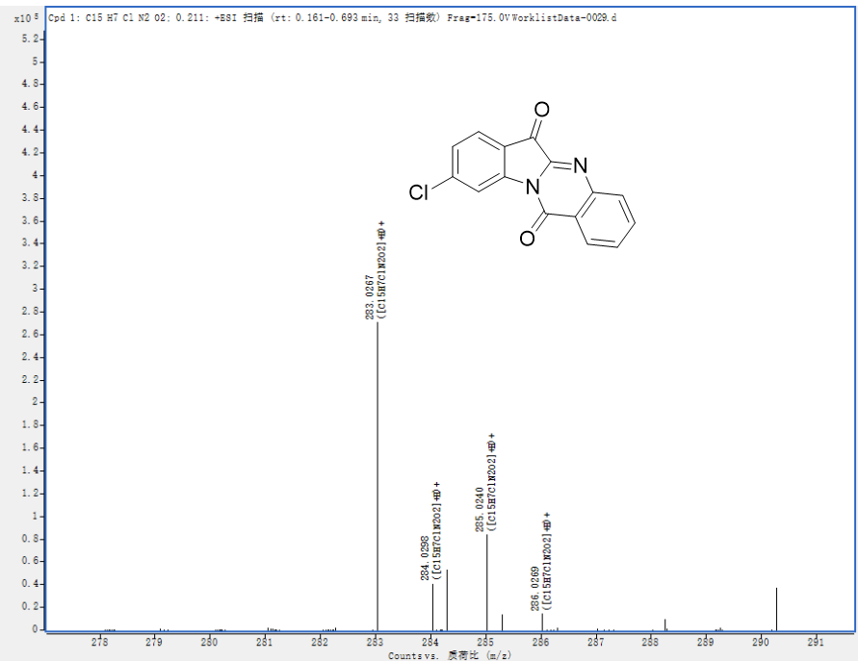
Figure 68 HRMS of compound 3h

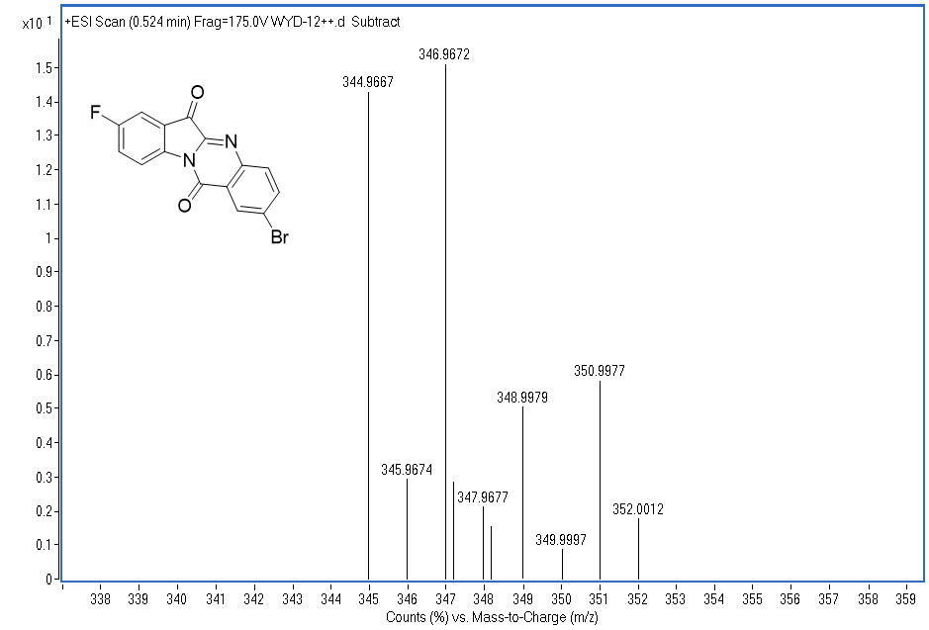
Figure 69 HRMS of compound 3i
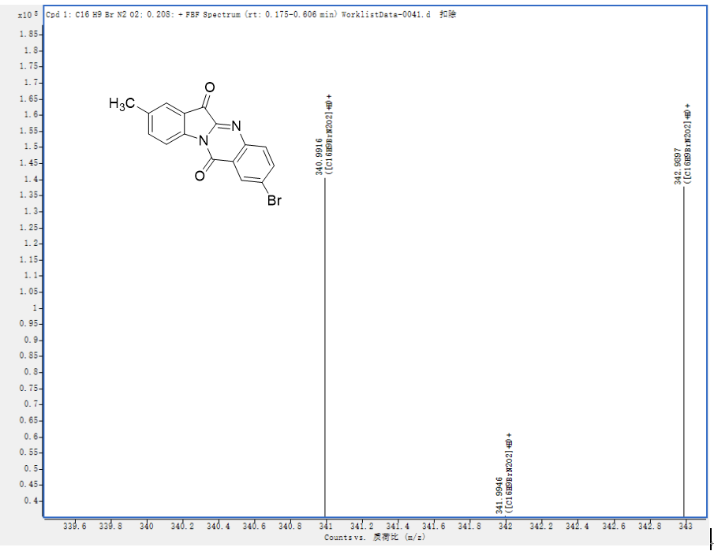
Figure 70 HRMS of compound 3m

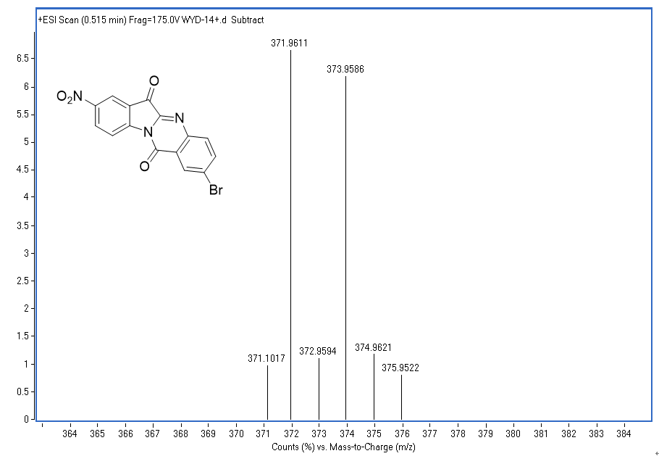
Figure 71 HRMS of compound 3n
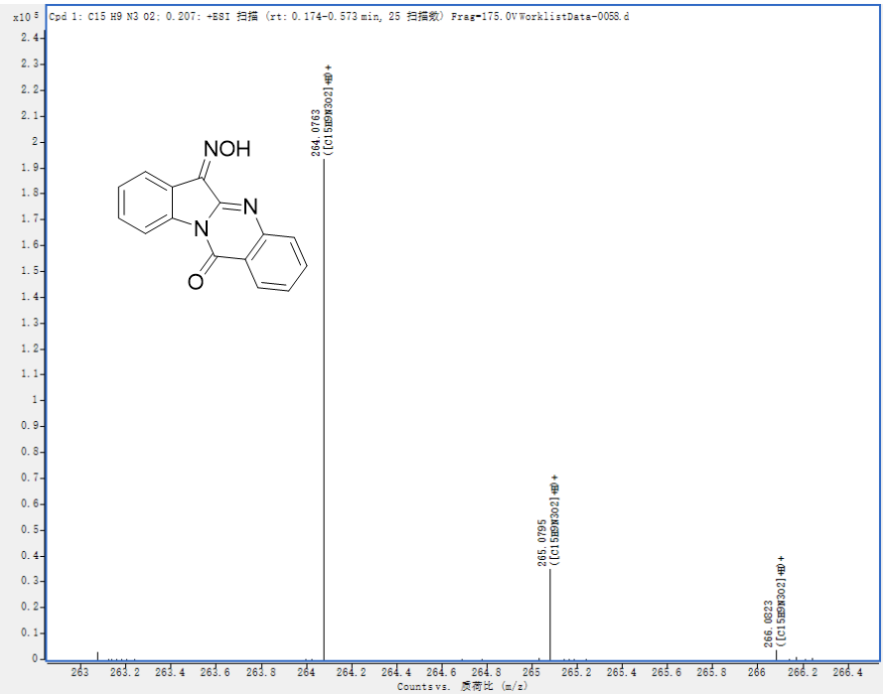

Figure 72 HRMS of compound 4a

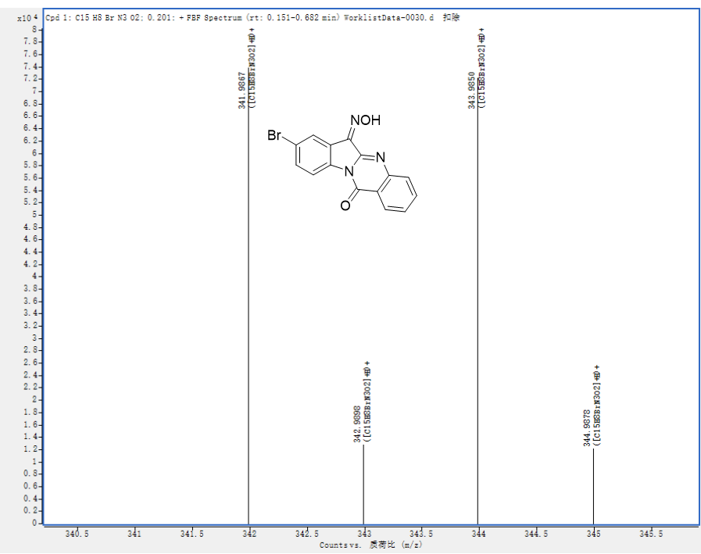
Figure 73 HRMS of compound 4b
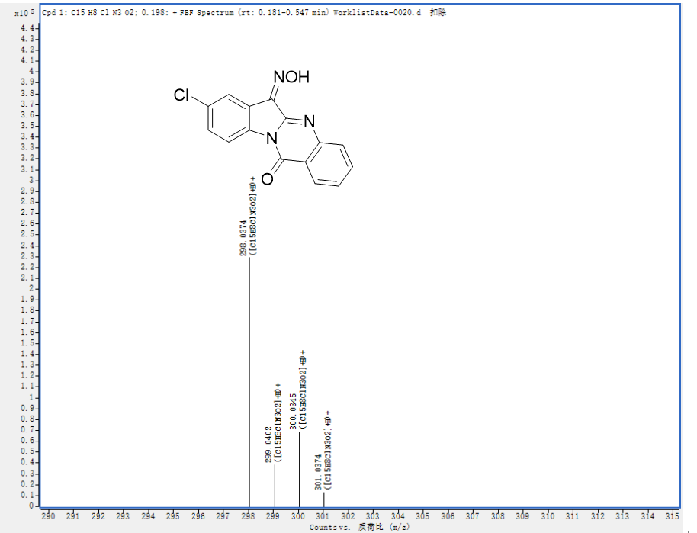
Figure 74 HRMS of compound 4c

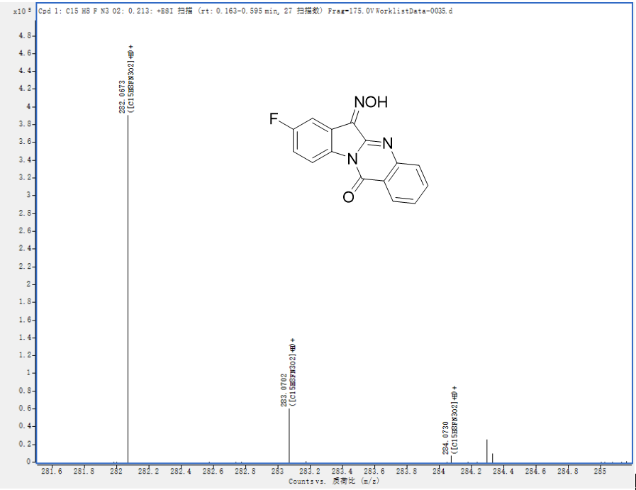
Figure 75 HRMS of compound 4d

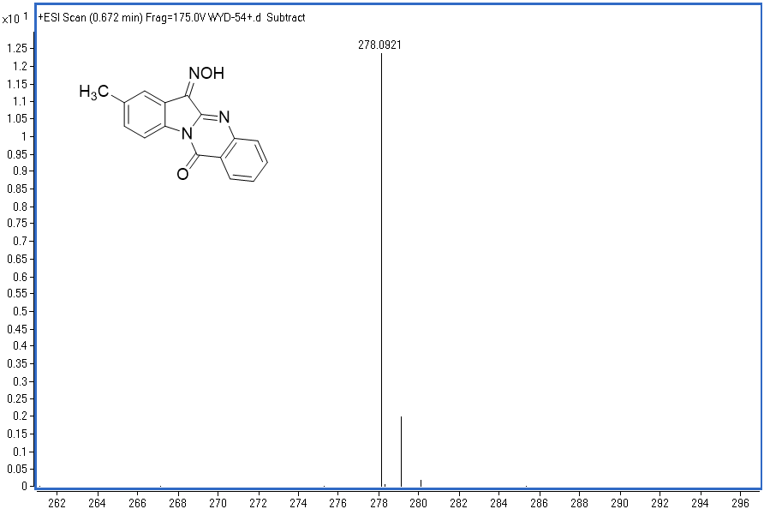
Figure 76 HRMS of compound 4e

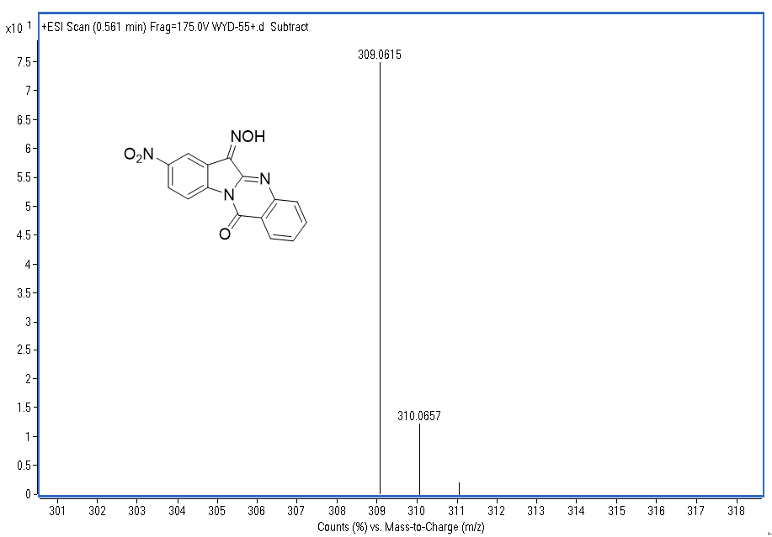
Figure 77 HRMS of compound 4f

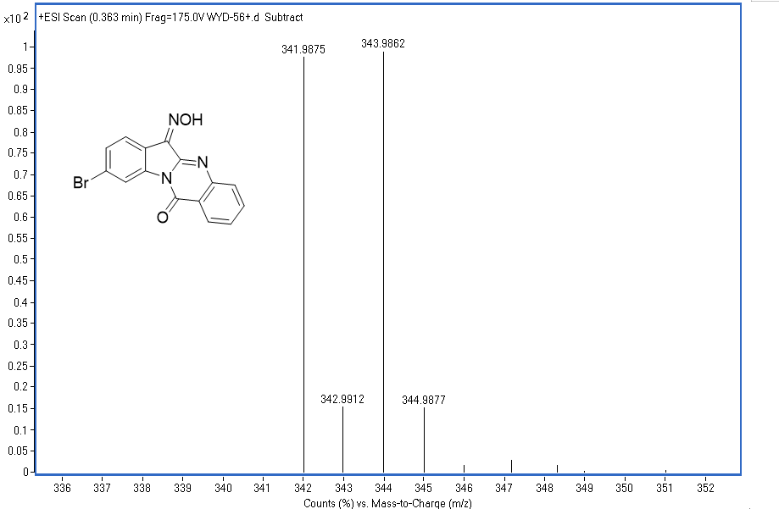
Figure 78 HRMS of compound 4g

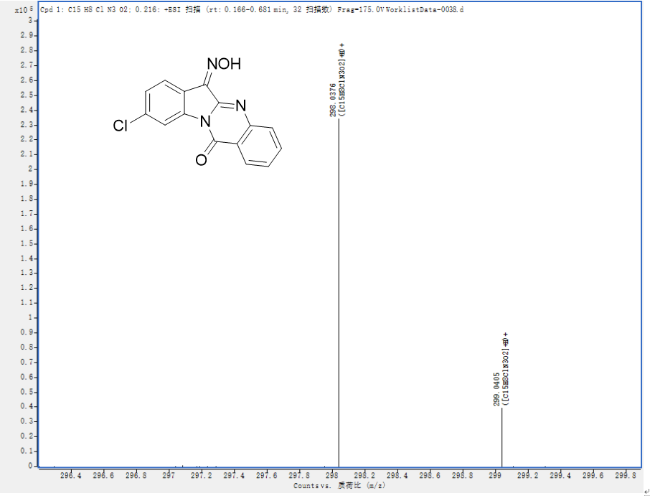
Figure 79 HRMS of compound 4h

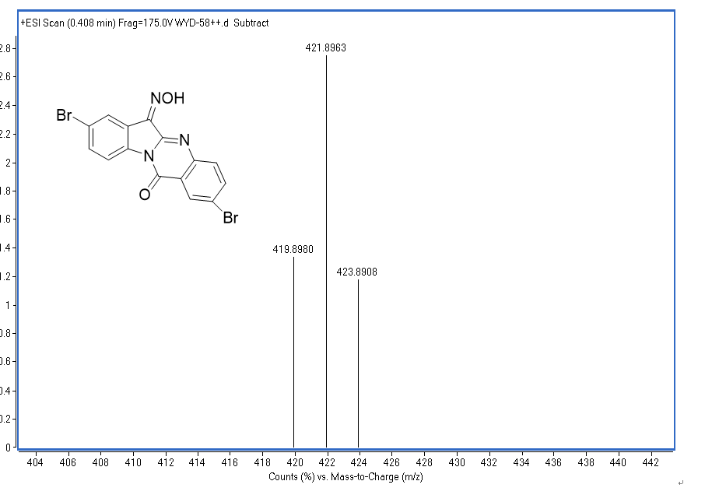
Figure 80 HRMS of compound 4i

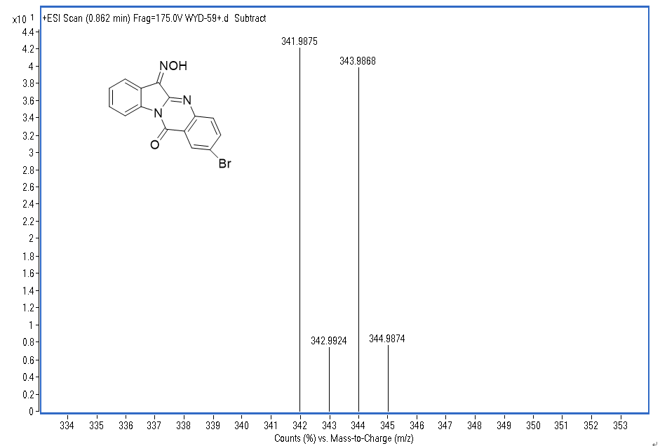

Figure 81 HRMS of compound 4j
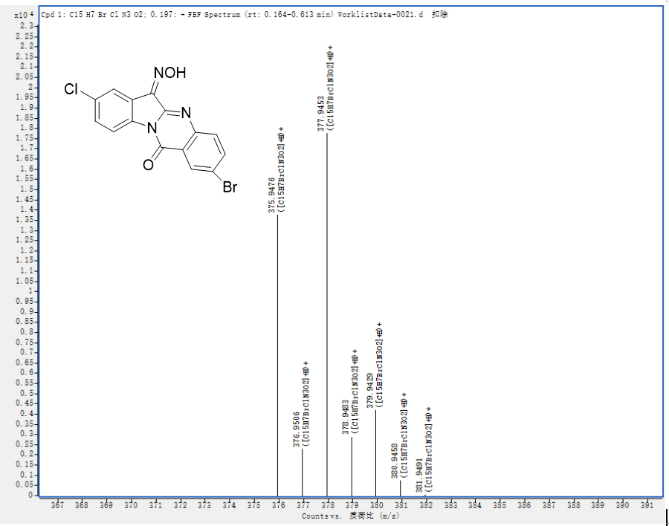
Figure 82 HRMS of compound 4k

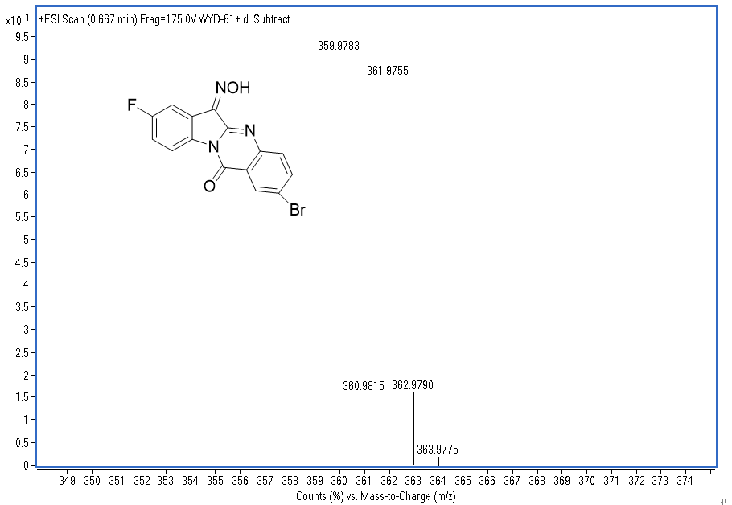
Figure 83 HRMS of compound 4l
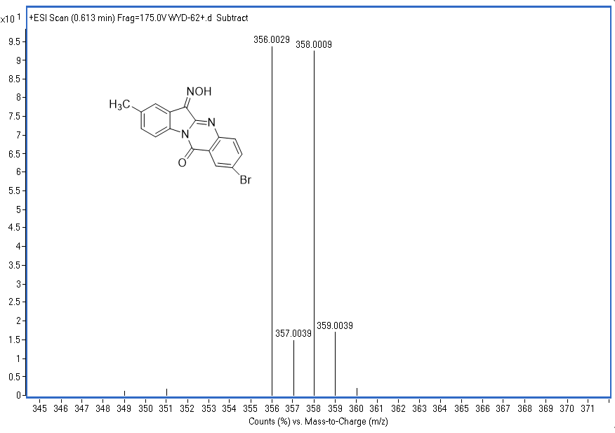
Figure 84 HRMS of compound 4m

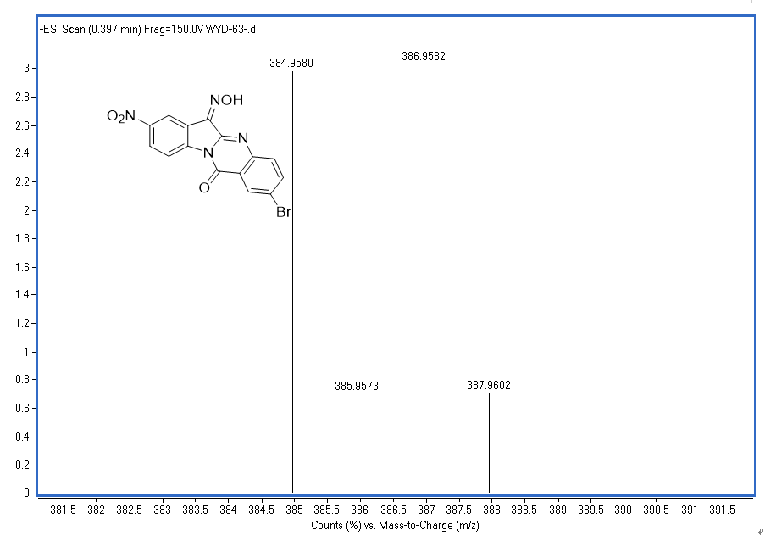Figure 85 HRMS of compound 4n
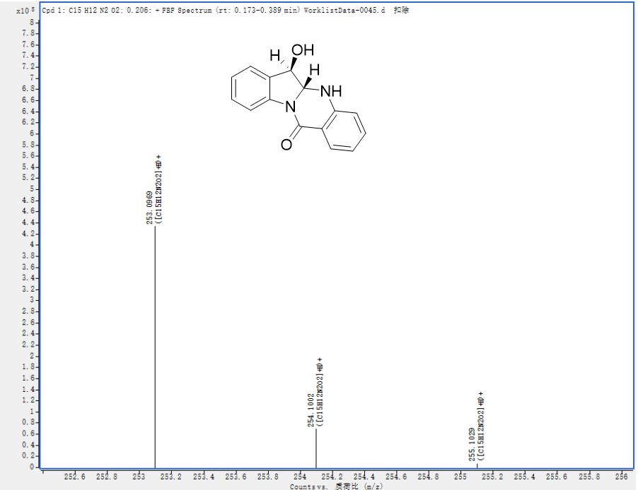Figure 86 HRMS of compound 5a

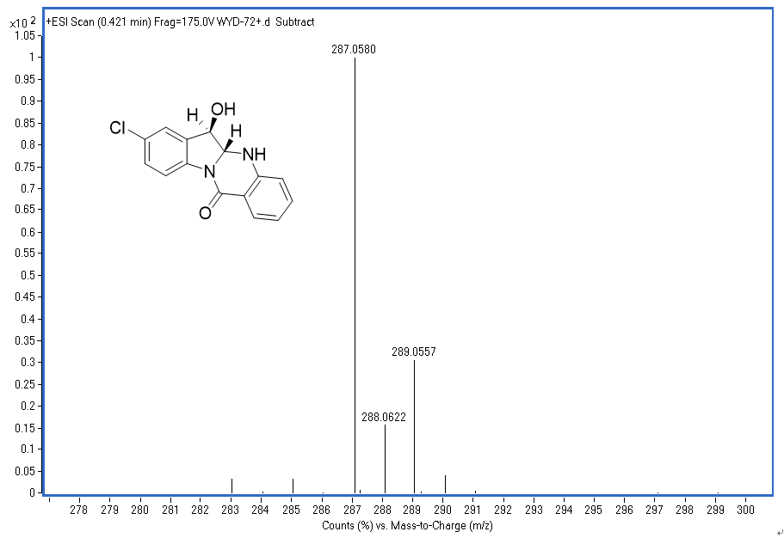Figure 87 HRMS of compound 5c
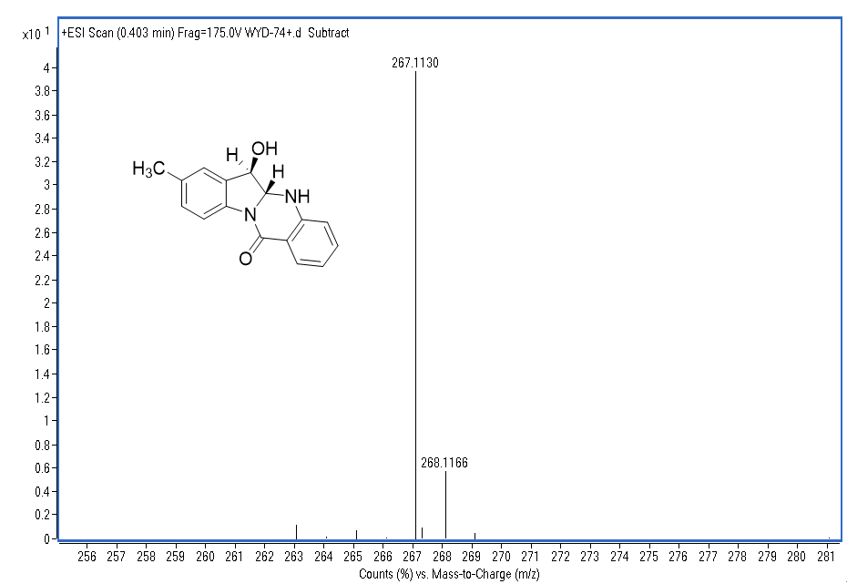Figure 88 HRMS of compound 5e

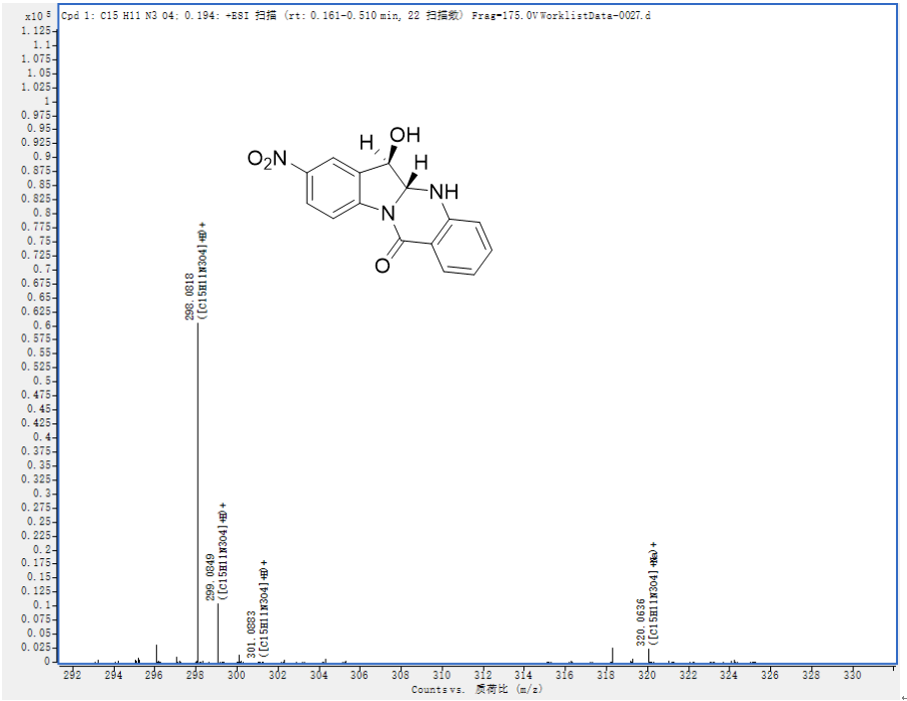Figure 89 HRMS of compound 5f
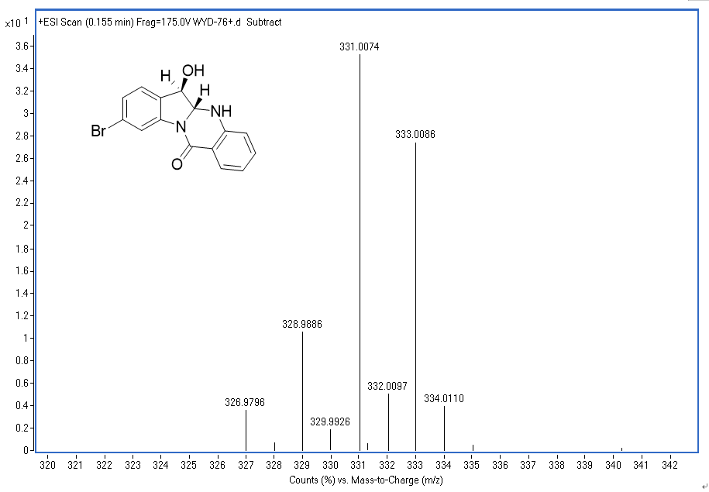
Figure 90 HRMS of compound 5g

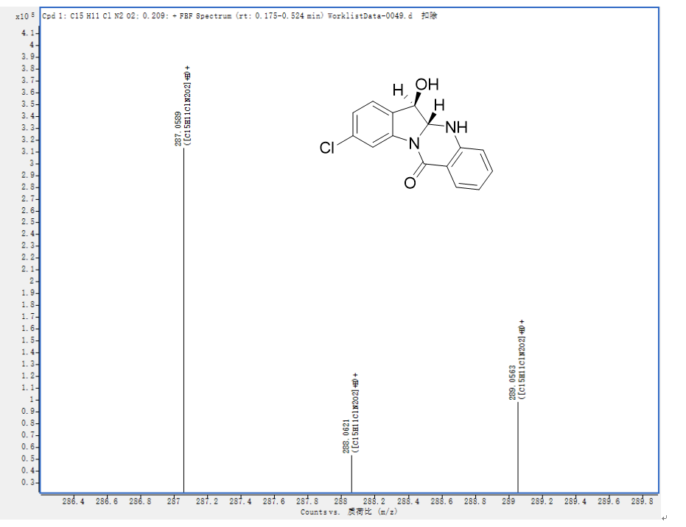Figure 91 HRMS of compound 5h
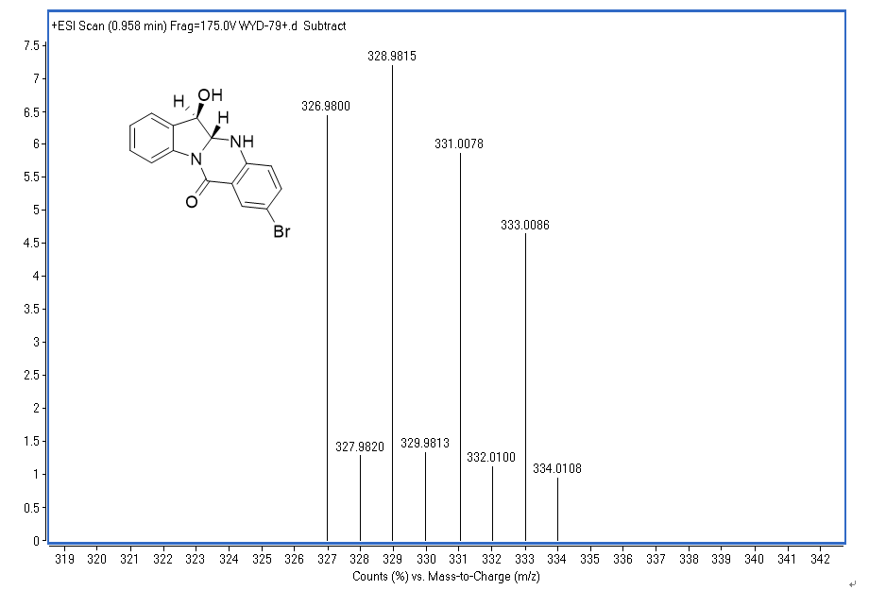Figure 92 HRMS of compound 5j

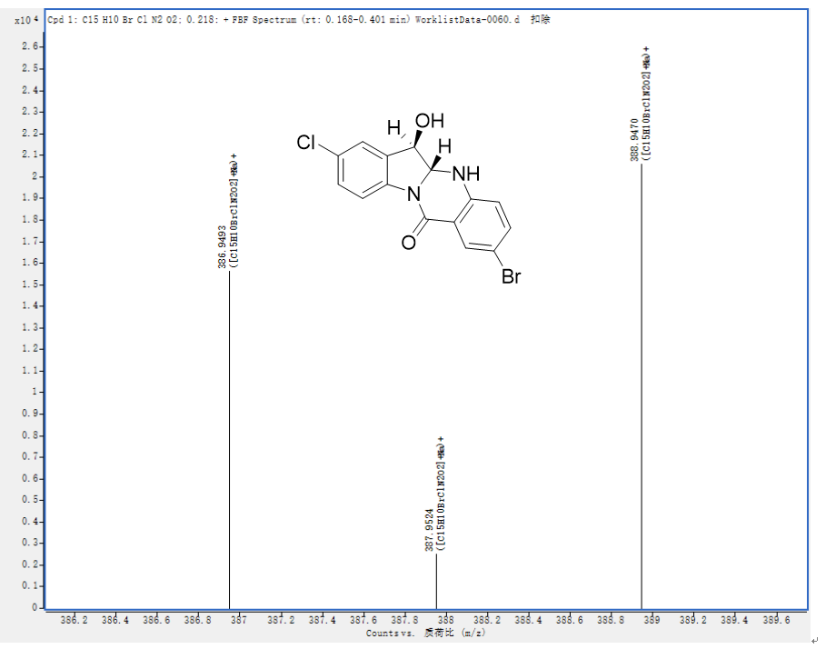Figure 93 HRMS of compound 5k
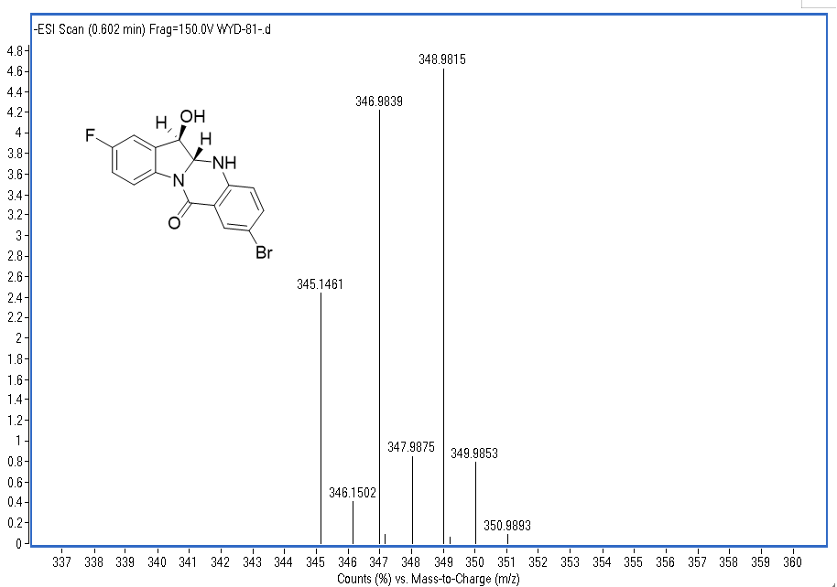Figure 94 HRMS of compound 5i

