Supplementary Materials
Sources | % Inactivation, (Q₁) |  |  |  |  | Energy consumption, (Q₂)
 | Sum of square | DF | Mean square | F-value | Prob>F | Sum of square | DF | Mean square | F-  value | Prob>F
Model | 20626.70 | 9 | 2291.86 | 11.91 | 0.0018 | 4.01 | 9 | 0.45 | 203.23 | <0.0001
X₁ | 5436.12 | 1 | 5436.12 | 28.24 | 0.0011 | 1.85 | 1 | 1.85 | 841.84 | <0.0001
X₂ | 1.55 | 1 | 1.55 | 8.047E-003 | 0.9310 | 0.077 | 1 | 0.077 | 35.13 | 0.0006
X₃ | 7479.87 | 1 | 7479.87 | 38.86 | 0.0004 | 1.37 | 1 | 1.37 | 626.03 | <0.0001
X₁² | 2193.55 | 1 | 2193.55 | 11.40 | 0.0118 | 0.057 | 1 | 0.057 | 25.81 | 0.0014
X₂² | 410.57 | 1 | 410.57 | 2.13 | 0.1875 | 7.949E-003 | 1 | 7.949E-003 | 3.62 | 0.0986
X₃² | 3636.87 | 1 | 3636.87 | 18.90 | 0.0034 | 0.028 | 1 | 0.028 | 12.82 | 0.0090
X₁X₂ | 34.16 | 1 | 34.16 | 0.18 | 0.6862 | 0.035 | 1 | 0.035 | 15.78 | 0.0054
X₁X₃ | 817.67 | 1 | 817.67 | 4.25 | 0.0782 | 0.55 | 1 | 0.55 | 252.76 | <0.0001
X₂X₃ | 21.30 | 1 | 21.30 | 0.11 | 0.7491 | 0.024 | 1 | 0.024 | 11.17 | 0.0124
Pure error | 11.59 | 4 | 2.90 |  |  | 7.225E-003 | 4 | 1.806E-003
Cor total  Residual | 21973.95  1347.26 | 16  7 | 192.47 |  |  | 4.03  0.015 | 16  7 | 2.193E-003
Lack of fit | 1335.67 | 3 | 445.22 | 153.65 | 0.0001 | 8.125E-003 | 3 | 2.708E-003 | 1.50 | 0.3430
Table S1. The ANOVA results, following the suggestion of BBD, are presented in the table for the percentage of inactivation and energy consumption

Table S2. Various R- Squared values, as suggested by BBD for different responses

Responses | R- Squared | Adj R- Squared
Q₁ | 0.9387 | 0.8599
Q₂ | 0.9962 | 0.9913

Table S3. Constraints of process variables for optimization
Variables | Goal | Lower Limit | Upper Limit
j | is in range | 1.9 | 10.0
n | is in range | 0.5 | 1.83
t | is in range | 2 | 12
% Inactivation | Maximize | 8.04 | 94.07
Energy consumption | Minimize | 0.027 | 1.904

Table S4. Optimization of desirability calculations for individual and multiple responses

Response | Current density (mA/cm²) | NaCl dose (g/L) | Time (min) | Desirability
Individual Response optimization
% Inactivation, (Q₁) = 94.8275% | 5.38 | 1.17 | 9.16 | 1.000
Energy consumption, (Q₂) = 0.025 kWh/m³ | 1.98 | 1.00 | 4.85 | 1.000
Simultaneous optimization of responses
% Inactivation, (Q₁) = 94.06%  Energy consumption, (Q₂) = 0.41 kWh/m³ | 5.90 | 1.31 | 7.53 | 0.891

Table S5. Comparison between the predicted values and the actual experimental values obtained under optimized conditions

Responses | Predicted | Actual experimental values
% Inactivation | 94.06% | 93.90%
Energy consumption (kWh/m³) | 0.41 | 0.48

Table S6. The polynomial equation and the R² values for the calculation of IC₅₀ values for the pilot-scale study of sewage wastewater

Volume (L) | Polynomial Equation | R² values
10 | y = -0.0615x² + 4.8689x + 9.0201 | 0.9335
20 | y = 0.0174x² + 2.9957x - 1.8911 | 0.973
30 | y = 0.023x² + 2.1379x + 3.7823 | 0.9747
40 | y = 0.0116x² + 1.8612x + 0.4467 | 0.9647
50 | y = -0.0024x² + 1.6618x - 0.4736 | 0.9804

Table S7. Evaluation of tentative operating cost of EO process for the treatment of sewage wastewater at a pilot-scale under batch-mode

Volume (L) | Current density (mA/cm²) | % Inactivation | Energy consumption (kWh/m³) | Running cost $/m³
10 | 5.90 | 94.9 | 0.0429 | 1.33
20 | 5.90 | 95.5 | 0.0281 | 1.360
30 | 5.90 | 95 | 0.025 | 1.368
40 | 5.90 | 95 | 0.022 | 1.374
50 | 5.90 | 96 | 0.020 | 1.381

Table S8. Evaluation of tentative operating cost of EO process

The electrical energy consumed for treating bacteria with MMO = 0.4608 kWh/m³
Price of electricity in Punjab = 0.070 $/kWh
Price of electricity consumption = 0.070* 0.4608 = 0.032 $/ m³
The price of one MMO anode used = 9.43 $
Total price of MMO anode = 9.43+ 0.032 = 9.462 $
Cost of 500 g NaCl = 1.82 $
Cost of 0.39 g NaCl = 0.0015 $
Total cost of MMO for removal of bacteria = 9.462 + 0.0015 = 9.463 $/ m³
Total runs = 100
Cost of one run = 9.463/100 = 0.094 $/ m³
Total operating cost for per run of bacterial inactivation = 0.094 $/m³

Fig. S1 Schematic representation of electrooxidation setup under (a) batch mode and (b) continuous recirculation mode featuring an MMO and a stainless-steel cathode; the operation took place under the optimized conditions of current density and NaCl concentration
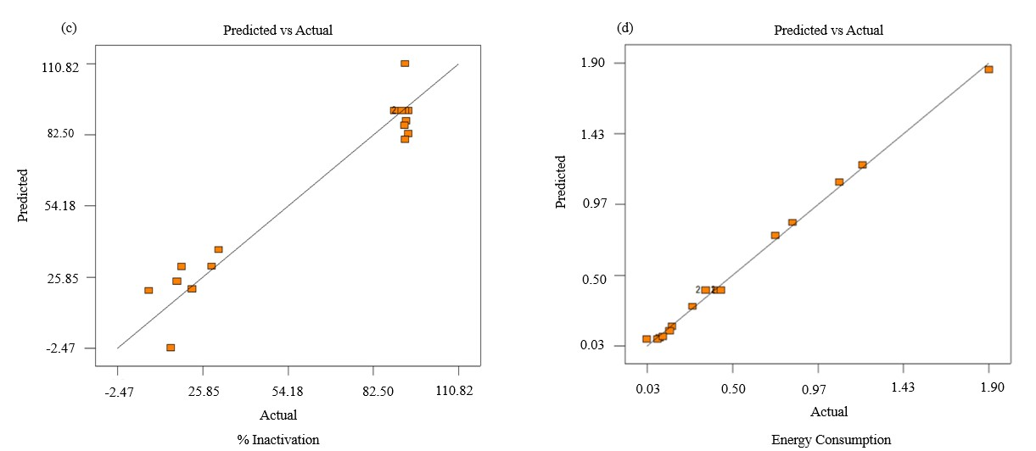 Fig. S2 The graphs display the studentized residual plot for (a) %Inactivation and (b) Energy consumption. The graphs display the predicted vs actual residual plot for (c) % Inactivation and (d) Energy consumption, demonstrating that experimental data closely align with the predicted data values
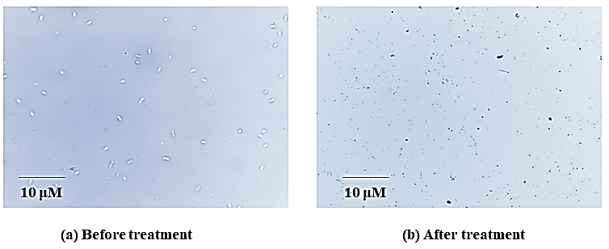
Fig. S3 The figure shows the microscopic images of live and dead bacterial cells which were stained with trypan blue. The EO treatment of the sewage wastewater was done under optimized conditions of (current density = 5.90 mA/cm², NaCl dose = 1.31 g/L) under batch mode. Here the live bacterial cells appeared colorless and the dead cells appeared blue in color

Fig. S4 The graph shows the pilot-scale EO treatment of sewage wastewater under the optimized condition of (current density = 5.90 mA/cm², NaCl dose = 1.31 g/L) under batch mode. The standard deviation has been added in the graph. There was ~ 94.9 % bacterial inactivation for 10 L sewage wastewater at 20 min of treatment time, 95.5 % for 20 L at 25 min, ~ 95% for 30 L at 30 min, ~ 93% for 40 L at 35 min and ~ 96% for 50 L at 40 min

(6)
(5)
(4)
(3)
(2)
(1)
10 L

20 L

(b)

(a)

30 L

(3)
(5)
(6)
(4)
(3)
(2)
(1)
(c)

40 L

(3)
(5)
(6)
(4)
(3)
(2)
(1)
(d)

(3)
(5)
(6)
(4)
(3)
(2)
(1)

- Glass reactor
- DC Power Supply
- Aerators
- MMO anode
- Stainless-Steel cathode
- Sewage wastewater
(3)
(3)
(6)
(5)
(4)
(2)
(1)
50 L

(e)

Fig. S5 The actual image of EO set-up at pilot-scale under batch mode for the treatment of sewage wastewater for bacterial inactivation. (a) For the treatment of 10 L (b) 20 L (c) 30 L (d) 40 L (e) 50 L volume of sewage wastewater

