Supplemental Table 1: Road Traffic Accident-related deaths stratified by Sex and Race, in the United States, 1999-2020.
 | Total Deaths
Year | Overall | Women | Men | NH White | NH Black or African American | NH Asian or Pacific Islander | NH American Indian or Alaska Native | Hispanic or Latino | Population
1999 | 46828 | 14920 | 31908 | 34184 | 5831 | 917 | 797 | 4882 | 279040168
2000 | 47117 | 14689 | 32428 | 34148 | 5794 | 972 | 805 | 5205 | 281421906
2001 | 47540 | 14599 | 32941 | 34017 | 5812 | 968 | 804 | 5766 | 284968955
2002 | 48562 | 14908 | 33654 | 34909 | 5664 | 1030 | 889 | 5893 | 287625193
2003 | 48204 | 14823 | 33381 | 34394 | 5681 | 1065 | 873 | 6018 | 290107933
2004 | 48155 | 14798 | 33357 | 34432 | 5755 | 1020 | 807 | 5989 | 292805298
2005 | 48480 | 14395 | 34085 | 34441 | 5726 | 1025 | 830 | 6332 | 295516599
2006 | 48448 | 14377 | 34071 | 34024 | 5854 | 1028 | 884 | 6528 | 298379912
2007 | 46803 | 13444 | 33359 | 33084 | 5709 | 1014 | 793 | 6081 | 301231207
2008 | 42552 | 12047 | 30505 | 30399 | 5071 | 902 | 711 | 5363 | 304093966
2009 | 38890 | 11332 | 27558 | 27362 | 4829 | 782 | 697 | 5032 | 306771529
2010 | 37889 | 11180 | 26709 | 26881 | 4638 | 842 | 653 | 4744 | 308745538
2011 | 37989 | 10916 | 27073 | 26952 | 4637 | 827 | 720 | 4753 | 311591917
2012 | 39013 | 11293 | 27720 | 27368 | 4948 | 822 | 713 | 5059 | 313914040
2013 | 37877 | 10847 | 27030 | 26164 | 4929 | 883 | 666 | 5135 | 316128839
2014 | 37818 | 10720 | 27098 | 25724 | 5025 | 911 | 718 | 5315 | 318857056
2015 | 40339 | 11353 | 28986 | 27050 | 5618 | 980 | 744 | 5797 | 321418820
2016 | 42948 | 12213 | 30735 | 28421 | 6195 | 1070 | 793 | 6370 | 323127513
2017 | 42896 | 12190 | 30706 | 28132 | 6410 | 1040 | 834 | 6346 | 325719178
2018 | 42036 | 12025 | 30011 | 27183 | 6525 | 1054 | 773 | 6412 | 327167434
2019 | 41908 | 11849 | 30059 | 26941 | 6631 | 1049 | 729 | 6479 | 328239523
2020 | 45142 | 12258 | 32884 | 27629 | 8359 | 968 | 742 | 7359 | 329484123
Total | 957,434 | 281,176 | 676,258 | 663,839 | 125,641 | 21,169 | 16,975 | 126,858 | 6,746,356,647
NH, non-Hispanic.

Supplementary Table 2: Road Traffic Accidents-related mortality stratified by Place of death in United States, 1999-2020.
 |  |  | Deaths
Year | Medical Facility - Inpatient | Medical Facility - Outpatient |  | Medical Facility - Dead on Arrival | Other Places | Nursing home/long term care | Home
1999 | 9917 | 9933 |  | 1,062 | 22333 | 381 | 578
2000 | 9954 | 9809 |  | 1,070 | 22928 | 313 | 612
2001 | 9979 | 9913 |  | 1,060 | 23288 | 341 | 569
2002 | 10089 | 9864 |  | 946 | 24561 | 384 | 515
2003 | 9894 | 9585 |  | 906 | 24786 | 342 | 647
2004 | 9859 | 9641 |  | 804 | 24957 | 382 | 649
2005 | 9712 | 9677 |  | 820 | 25240 | 380 | 668
2006 | 9903 | 9369 |  | 715 | 25334 | 403 | 731
2007 | 9869 | 8886 |  | 712 | 24706 | 341 | 683
2008 | 8818 | 7943 |  | 616 | 21996 | 319 | 612
2009 | 7808 | 7671 |  | 485 | 19596 | 305 | 558
2010 | 7934 | 7830 |  | 513 | 19639 | 299 | 521
2011 | 8320 | 7668 |  | 429 | 19601 | 358 | 548
2012 | 8154 | 8044 |  | 449 | 20237 | 340 | 673
2013 | 7982 | 7594 |  | 362 | 20012 | 326 | 546
2014 | 7865 | 7474 |  | 347 | 20084 | 314 | 547
2015 | 8408 | 8091 |  | 346 | 21587 | 277 | 532
2016 | 9246 | 8475 |  | 352 | 22938 | 305 | 545
2017 | 9335 | 8413 |  | 283 | 22879 | 339 | 616
2018 | 8917 | 8295 |  | 268 | 22652 | 351 | 574
2019 | 8865 | 8354 |  | 230 | 22567 | 328 | 612
2020 | 9110 | 8718 |  | 211 | 25079 | 363 | 735
Total | 199,938 | 191,247 |  | 12,986 | 497,000 | 7,491 | 13,271

Supplemental Table 3: Annual percent change (APC) of Road Traffic Accidents-related Age-Standardized Mortality Rates per 100,000 in the United States, from 1999 to 2020
Interval | APC (95% CI)
Overall
1999-2006 | -0.5 (-1.2 - 0.3)
2006-2010 | -7.8* (-10.4 - -5.9)
2010-2020 | 0.9* (0.4 - 1.7)
Men
1999-2006 | -0.2 (-1.0 - 0.8)
2006-2010 | -7.6* (-10.4 - -5.3)
2010-2020 | 0.9* (0.3 - 1.9)
Women
1999-2006 | -1.5* (-2.1 - -0.7)
2006-2010 | -8.1* (-10.6 - -6.2)
2010-2020 | 0.6* (0.0 - 1.4)
NH White
1999-2006 | -0.1 (-0.8 - 0.6)
2006-2010 | -6.9* (-9.1 - -5.2)
2010-2020 | 0.1 (-0.4 - 0.8)
NH Black or African American
1999-2006 | -1.4 (-2.5 - 1.3)
2006-2011 | -6.6* (-11.1 - -4.1)
2011-2020 | 5.1* (4.0 - 6.4)
NH American Indian or Alaska Native
1999-2006 | -0.9 (-5.0 - 2.8)
2006-2010 | -7.4 (-11.8 - 3.0)
2010-2017 | 2.2 (-7.7 - 8.8)
2017-2020 | -3.7 (-10.0 - 0.8)
Hispanic or Latino
1999-2006 | -0.9 (-2.1 - 0.8)
2006-2010 | -11.1* (-15.4 - -7.8)
2010-2020 | 2.2* (1.6 - 3.1)
NH Asian or Pacific Islander
1999-2006 | -2.5 (-7.6 - 0.8)
2006-2009 | -12.2 (-15.0 - 2.2)
2009-2018 | -0.4 (-11.9 - 7.0)
2018-2020 | -7.2* (-11.6 - -1.3)
Nonmetropolitan areas
1999-2006 | -0.3 (-1.1 - 0.7)
2006-2010 | -6.2* (-8.6 - -4.3)
2010-2020 | 0.2 (-0.4 - 1.1)
Metropolitan area
1999-2006 | -0.4 (-1.1 - 0.5)
2006-2010 | -8.3* (-11.0 - -6.2)
2010-2020 | 1.3* (0.6 - 2.1)

*Indicates that the annual percentage change (APC) is significantly different from zero at alpha = 0.05. ASMR = age-standardized mortality rate.

Supplemental Table 4: Overall and Sex‐Stratified Road Traffic Accidents-related Age-Standardized Mortality Rates per 100,000 in the United States, from 1999 to 2020
 | Age-Standardized Rate (95% CI)
Year | Men | Women | Overall
1999 | 23.9 (23.6 - 24.1) | 10.3 (10.2 - 10.5) | 16.8 (16.6 - 16.9)
2000 | 23.9 (23.6 - 24.2) | 10.1 (9.9 - 10.2) | 16.7 (16.6 - 16.9)
2001 | 23.9 (23.6 - 24.1) | 9.9 (9.7 - 10.0) | 16.6 (16.5 - 16.8)
2002 | 24.1 (23.8 - 24.4) | 10 (9.8 - 10.2) | 16.8 (16.6 - 16.9)
2003 | 23.7 (23.4 - 23.9) | 9.8 (9.7 - 10.0) | 16.5 (16.4 - 16.7)
2004 | 23.3 (23.1 - 23.6) | 9.7 (9.6 - 9.9) | 16.3 (16.2 - 16.5)
2005 | 23.6 (23.3 - 23.8) | 9.4 (9.2 - 9.5) | 16.2 (16.1 - 16.4)
2006 | 23.2 (23.0 - 23.5) | 9.2 (9.1 - 9.4) | 16 (15.9 - 16.2)
2007 | 22.5 (22.3 - 22.8) | 8.6 (8.4 - 8.7) | 15.4 (15.2 - 15.5)
2008 | 20.4 (20.1 - 20.6) | 7.6 (7.4 - 7.7) | 13.8 (13.7 - 13.9)
2009 | 18.2 (18.0 - 18.5) | 7.1 (6.9 - 7.2) | 12.5 (12.4 - 12.6)
2010 | 17.6 (17.3 - 17.8) | 6.9 (6.8 - 7.0) | 12 (11.9 - 12.2)
2011 | 17.5 (17.3 - 17.7) | 6.7 (6.5 - 6.8) | 11.9 (11.8 - 12.1)
2012 | 17.8 (17.5 - 18.0) | 6.8 (6.7 - 6.9) | 12.1 (12.0 - 12.3)
2013 | 17.1 (16.9 - 17.3) | 6.5 (6.4 - 6.6) | 11.7 (11.6 - 11.8)
2014 | 17 (16.8 - 17.2) | 6.4 (6.2 - 6.5) | 11.5 (11.4 - 11.7)
2015 | 17.9 (17.7 - 18.2) | 6.7 (6.6 - 6.8) | 12.2 (12.1 - 12.3)
2016 | 18.9 (18.7 - 19.1) | 7.2 (7.1 - 7.3) | 12.9 (12.8 - 13.0)
2017 | 18.7 (18.5 - 18.9) | 7.1 (6.9 - 7.2) | 12.7 (12.6 - 12.9)
2018 | 18.1 (17.9 - 18.3) | 6.9 (6.8 - 7.0) | 12.4 (12.3 - 12.5)
2019 | 18 (17.8 - 18.2) | 6.8 (6.7 - 6.9) | 12.3 (12.2 - 12.4)
2020 | 19.7 (19.5 - 19.9) | 7.1 (7.0 - 7.2) | 13.3 (13.2 - 13.4)
Total | 20.3 (20.2 - 20.3) | 8 (7.9 - 8.0) | 14 (13.9 - 14.0)

Supplemental Table 5: Road Traffic Accidents-related Age-Standardized Mortality Rates per 100,000, Stratified by Race in the United States from 1999 to 2020
 | Age-Standardized Rate (95% CI)
Year | NH White | NH Black or African American | NH American Indian or Alaska Native | Hispanic or Latino | NH Asian or Pacific Islander
1999 | 17 (16.9 - 17.2) | 17.6 (17.2 - 18.1) | 37.3 (34.5 - 40.0) | 15.4 (14.9 - 15.9) | 9.2 (8.6 - 9.8)
2000 | 17 (16.8 - 17.2) | 17.2 (16.8 - 17.7) | 35.6 (33.0 - 38.2) | 15.7 (15.2 - 16.2) | 9.5 (8.8 - 10.1)
2001 | 16.8 (16.7 - 17.0) | 16.9 (16.5 - 17.4) | 35.2 (32.6 - 37.7) | 16.7 (16.2 - 17.2) | 8.6 (8.0 - 9.1)
2002 | 17.2 (17.0 - 17.4) | 16.3 (15.9 - 16.7) | 38.5 (35.9 - 41.2) | 16.1 (15.6 - 16.5) | 8.9 (8.3 - 9.4)
2003 | 16.9 (16.8 - 17.1) | 16.3 (15.8 - 16.7) | 37.2 (34.6 - 39.8) | 15.8 (15.4 - 16.3) | 8.8 (8.3 - 9.4)
2004 | 16.9 (16.7 - 17.1) | 16.1 (15.7 - 16.5) | 34.4 (32.0 - 36.9) | 15.1 (14.7 - 15.5) | 8 (7.5 - 8.6)
2005 | 16.8 (16.6 - 17.0) | 15.8 (15.4 - 16.2) | 34.1 (31.7 - 36.5) | 15.2 (14.8 - 15.6) | 7.9 (7.4 - 8.4)
2006 | 16.6 (16.4 - 16.8) | 15.9 (15.5 - 16.3) | 36 (33.5 - 38.5) | 15.2 (14.8 - 15.6) | 7.6 (7.1 - 8.1)
2007 | 16.1 (15.9 - 16.3) | 15.3 (14.9 - 15.7) | 32.1 (29.8 - 34.4) | 13.8 (13.4 - 14.2) | 7.4 (6.9 - 7.8)
2008 | 14.7 (14.5 - 14.9) | 13.4 (13.0 - 13.8) | 28.4 (26.2 - 30.6) | 11.8 (11.5 - 12.2) | 6.2 (5.8 - 6.6)
2009 | 13.1 (13.0 - 13.3) | 12.6 (12.3 - 13.0) | 27.6 (25.4 - 29.7) | 10.7 (10.4 - 11.0) | 5.2 (4.8 - 5.6)
2010 | 12.8 (12.7 - 13.0) | 12 (11.6 - 12.3) | 26 (23.9 - 28.0) | 10.1 (9.8 - 10.5) | 5.5 (5.1 - 5.9)
2011 | 12.8 (12.7 - 13.0) | 11.8 (11.5 - 12.2) | 28 (25.9 - 30.1) | 9.7 (9.4 - 10.0) | 5.2 (4.9 - 5.6)
2012 | 12.9 (12.8 - 13.1) | 12.4 (12.1 - 12.8) | 27.3 (25.3 - 29.4) | 10.1 (9.8 - 10.4) | 4.9 (4.6 - 5.3)
2013 | 12.3 (12.2 - 12.5) | 12.1 (11.8 - 12.5) | 25.7 (23.7 - 27.8) | 10.1 (9.8 - 10.4) | 5.2 (4.8 - 5.5)
2014 | 12.1 (11.9 - 12.2) | 12.2 (11.8 - 12.5) | 27.2 (25.1 - 29.2) | 10.1 (9.8 - 10.4) | 5 (4.7 - 5.3)
2015 | 12.7 (12.5 - 12.8) | 13.4 (13.1 - 13.8) | 27.8 (25.8 - 29.8) | 10.7 (10.4 - 11.0) | 5.2 (4.8 - 5.5)
2016 | 13.3 (13.1 - 13.4) | 14.8 (14.4 - 15.1) | 29.9 (27.8 - 32.0) | 11.6 (11.3 - 11.9) | 5.5 (5.2 - 5.9)
2017 | 13.1 (12.9 - 13.3) | 15 (14.6 - 15.4) | 31.2 (29.0 - 33.3) | 11.3 (11.0 - 11.6) | 5.1 (4.8 - 5.4)
2018 | 12.6 (12.4 - 12.7) | 15.1 (14.7 - 15.4) | 28.6 (26.5 - 30.6) | 11.2 (10.9 - 11.5) | 5.1 (4.8 - 5.4)
2019 | 12.4 (12.3 - 12.6) | 15.3 (14.9 - 15.6) | 26.9 (24.9 - 28.9) | 11.2 (10.9 - 11.4) | 4.9 (4.6 - 5.2)
2020 | 12.9 (12.8 - 13.1) | 18.9 (18.5 - 19.3) | 27.3 (25.3 - 29.3) | 12.2 (11.9 - 12.5) | 4.4 (4.1 - 4.7)
Total | 14.5 (14.5 - 14.6) | 14.8 (14.7 - 14.9) | 30.6 (30.1 - 31.1) | 12.3 (12.3 - 12.4) | 6.1 (6.1 - 6.2)

Supplemental Table 6: Road Traffic Accidents-related Age-Standardized Mortality Rates per 100,000, Stratified by Urban-Rural Classification in the United States, from 1999 to 2020
 | Age-Standardized Rate (95% CI)
Year | Metropolitan | Nonmetropolitan
1999 | 14.6 (14.5 - 14.8) | 28.2 (27.7 - 28.6)
2000 | 14.7 (14.6 - 14.9) | 27.4 (26.9 - 27.9)
2001 | 14.7 (14.5 - 14.8) | 27 (26.5 - 27.5)
2002 | 14.8 (14.7 - 15.0) | 27.6 (27.1 - 28.1)
2003 | 14.5 (14.3 - 14.6) | 27.8 (27.3 - 28.3)
2004 | 14.4 (14.3 - 14.6) | 26.9 (26.4 - 27.4)
2005 | 14.3 (14.1 - 14.4) | 27.4 (26.9 - 27.9)
2006 | 14.2 (14.0 - 14.3) | 26.7 (26.2 - 27.1)
2007 | 13.5 (13.4 - 13.7) | 25.8 (25.3 - 26.2)
2008 | 12.1 (12.0 - 12.3) | 23.4 (23.0 - 23.9)
2009 | 10.8 (10.7 - 11.0) | 21.9 (21.5 - 22.4)
2010 | 10.5 (10.4 - 10.6) | 21 (20.6 - 21.4)
2011 | 10.4 (10.3 - 10.5) | 21 (20.6 - 21.4)
2012 | 10.5 (10.4 - 10.6) | 22 (21.6 - 22.4)
2013 | 10.2 (10.1 - 10.3) | 20.6 (20.2 - 21.0)
2014 | 10.1 (10.0 - 10.2) | 20 (19.6 - 20.4)
2015 | 10.7 (10.6 - 10.9) | 21 (20.6 - 21.5)
2016 | 11.5 (11.3 - 11.6) | 21.8 (21.4 - 22.2)
2017 | 11.3 (11.2 - 11.4) | 21.9 (21.5 - 22.3)
2018 | 11 (10.9 - 11.2) | 20.9 (20.5 - 21.3)
2019 | 10.9 (10.8 - 11.0) | 21 (20.5 - 21.4)
2020 | 11.9 (11.8 - 12.0) | 21.8 (21.4 - 22.3)
Total | 12.3 (12.3 - 12.3) | 23.8 (23.7 - 23.9)

Supplementary Table 7: Road Traffic Accidents-related Age-Standardized Mortality Rates per 100,000 stratified by State in United States, 1999-2020.
State | Deaths | Age Standardized Rate | Age Standardized Rate Lower 95% Confidence Interval | Age Standardized Rate Upper 95% Confidence Interval
Alabama | 24375 | 23.3 | 23 | 23.6
Alaska | 2728 | 18.2 | 17.5 | 18.9
Arizona | 23464 | 16.9 | 16.6 | 17.1
Arkansas | 14991 | 23.6 | 23.2 | 24
California | 92907 | 11.3 | 11.2 | 11.3
Colorado | 15170 | 13.6 | 13.4 | 13.9
Connecticut | 7253 | 9.1 | 8.9 | 9.3
Delaware | 2825 | 14.3 | 13.8 | 14.9
District of Columbia | 1048 | 7.5 | 7 | 7.9
Florida | 71608 | 16.8 | 16.7 | 16.9
Georgia | 35660 | 17.1 | 16.9 | 17.2
Hawaii | 2933 | 9.7 | 9.3 | 10
Idaho | 6176 | 18.3 | 17.9 | 18.8
Illinois | 30632 | 10.8 | 10.7 | 10.9
Indiana | 20759 | 14.5 | 14.3 | 14.7
Iowa | 9702 | 14.1 | 13.8 | 14.4
Kansas | 10675 | 17 | 16.6 | 17.3
Kentucky | 19554 | 20.5 | 20.2 | 20.8
Louisiana | 21268 | 21.2 | 20.9 | 21.5
Maine | 4213 | 14.1 | 13.6 | 14.5
Maryland | 14399 | 11.3 | 11.1 | 11.5
Massachusetts | 10491 | 6.9 | 6.8 | 7
Michigan | 27168 | 12.2 | 12 | 12.3
Minnesota | 13209 | 11.2 | 11 | 11.3
Mississippi | 18781 | 29 | 28.6 | 29.4
Missouri | 23451 | 17.8 | 17.5 | 18
Montana | 5309 | 24.3 | 23.6 | 24.9
Nebraska | 6129 | 15.1 | 14.7 | 15.4
Nevada | 8214 | 14.2 | 13.9 | 14.5
New Hampshire | 3056 | 10.2 | 9.9 | 10.6
New Jersey | 16064 | 8.2 | 8 | 8.3
New Mexico | 9285 | 21.2 | 20.8 | 21.7
New York | 33789 | 7.7 | 7.6 | 7.7
North Carolina | 36162 | 17.4 | 17.2 | 17.5
North Dakota | 2778 | 17.9 | 17.2 | 18.5
Ohio | 30881 | 12 | 11.8 | 12.1
Oklahoma | 17037 | 20.7 | 20.3 | 21
Oregon | 11194 | 12.9 | 12.6 | 13.1
Pennsylvania | 34270 | 11.9 | 11.8 | 12.1
Rhode Island | 1995 | 8.1 | 7.8 | 8.5
South Carolina | 22732 | 22.4 | 22.1 | 22.7
South Dakota | 3711 | 20.5 | 19.9 | 21.2
Tennessee | 27608 | 19.7 | 19.5 | 20
Texas | 87788 | 16.1 | 16 | 16.2
Utah | 7166 | 12.6 | 12.3 | 12.9
Vermont | 1739 | 12.2 | 11.6 | 12.8
Virginia | 20967 | 11.8 | 11.7 | 12
Washington | 15984 | 10.6 | 10.5 | 10.8
West Virginia | 8438 | 20.6 | 20.1 | 21
Wisconsin | 16719 | 13.2 | 13 | 13.4
Wyoming | 2979 | 24.6 | 23.7 | 25.5
Total | 957,434 | 14 | 13.9 | 14

Supplemental Table 8: Road Traffic Accidents-related Age-Standardized Mortality Rates per 100,000, stratified by Census Region in the United States, from 1999 to 2020
Census Region | Year | Age-Standardized Rate (95% CI)
Northeast | 1999 | 11 (10.7 - 11.3)
Northeast | 2000 | 10.6 (10.3 - 10.9)
Northeast | 2001 | 11.4 (11.1 - 11.7)
Northeast | 2002 | 11.1 (10.8 - 11.4)
Northeast | 2003 | 10.5 (10.3 - 10.8)
Northeast | 2004 | 10.4 (10.1 - 10.6)
Northeast | 2005 | 10.4 (10.1 - 10.6)
Northeast | 2006 | 10.3 (10.0 - 10.5)
Northeast | 2007 | 9.7 (9.4 - 9.9)
Northeast | 2008 | 8.8 (8.6 - 9.1)
Northeast | 2009 | 8.3 (8.0 - 8.5)
Northeast | 2010 | 8.4 (8.2 - 8.7)
Northeast | 2011 | 8.4 (8.2 - 8.6)
Northeast | 2012 | 8.4 (8.1 - 8.6)
Northeast | 2013 | 8 (7.7 - 8.2)
Northeast | 2014 | 7.4 (7.1 - 7.6)
Northeast | 2015 | 7.4 (7.2 - 7.7)
Northeast | 2016 | 7.7 (7.5 - 7.9)
Northeast | 2017 | 7.7 (7.5 - 8.0)
Northeast | 2018 | 7.4 (7.2 - 7.6)
Northeast | 2019 | 7 (6.8 - 7.2)
Northeast | 2020 | 7.7 (7.5 - 8.0)
Northeast | Total | 9 (8.9 - 9.0)
Midwest | 1999 | 16.5 (16.2 - 16.8)
Midwest | 2000 | 16 (15.7 - 16.4)
Midwest | 2001 | 15.7 (15.4 - 16.0)
Midwest | 2002 | 16.2 (15.9 - 16.5)
Midwest | 2003 | 15.6 (15.3 - 15.9)
Midwest | 2004 | 14.9 (14.6 - 15.2)
Midwest | 2005 | 15 (14.7 - 15.3)
Midwest | 2006 | 14.2 (13.9 - 14.5)
Midwest | 2007 | 14 (13.8 - 14.3)
Midwest | 2008 | 12.5 (12.3 - 12.8)
Midwest | 2009 | 11.2 (10.9 - 11.5)
Midwest | 2010 | 11.6 (11.3 - 11.9)
Midwest | 2011 | 11.3 (11.0 - 11.6)
Midwest | 2012 | 11.7 (11.4 - 11.9)
Midwest | 2013 | 11.1 (10.8 - 11.3)
Midwest | 2014 | 10.7 (10.5 - 11.0)
Midwest | 2015 | 11.2 (10.9 - 11.5)
Midwest | 2016 | 11.8 (11.6 - 12.1)
Midwest | 2017 | 12.1 (11.8 - 12.3)
Midwest | 2018 | 11.6 (11.3 - 11.8)
Midwest | 2019 | 11.5 (11.3 - 11.8)
Midwest | 2020 | 12.6 (12.4 - 12.9)
Midwest | Total | 13.1 (13.1 - 13.2)
South | 1999 | 21.1 (20.9 - 21.4)
South | 2000 | 21.2 (20.9 - 21.5)
South | 2001 | 20.8 (20.6 - 21.1)
South | 2002 | 20.8 (20.6 - 21.1)
South | 2003 | 20.7 (20.4 - 20.9)
South | 2004 | 20.8 (20.6 - 21.1)
South | 2005 | 20.5 (20.3 - 20.8)
South | 2006 | 20.5 (20.2 - 20.7)
South | 2007 | 19.7 (19.5 - 20.0)
South | 2008 | 17.9 (17.7 - 18.2)
South | 2009 | 16.2 (15.9 - 16.4)
South | 2010 | 15.3 (15.1 - 15.6)
South | 2011 | 15.1 (14.8 - 15.3)
South | 2012 | 15.4 (15.2 - 15.6)
South | 2013 | 14.6 (14.4 - 14.8)
South | 2014 | 14.6 (14.3 - 14.8)
South | 2015 | 15.4 (15.2 - 15.7)
South | 2016 | 16.4 (16.2 - 16.6)
South | 2017 | 15.9 (15.6 - 16.1)
South | 2018 | 15.5 (15.3 - 15.7)
South | 2019 | 15.5 (15.3 - 15.8)
South | 2020 | 16.7 (16.5 - 16.9)
South | Total | 17.6 (17.6 - 17.7)
West | 1999 | 15.1 (14.8 - 15.4)
West | 2000 | 15.5 (15.2 - 15.8)
West | 2001 | 15.2 (14.9 - 15.5)
West | 2002 | 15.8 (15.5 - 16.1)
West | 2003 | 15.8 (15.5 - 16.1)
West | 2004 | 15.4 (15.1 - 15.7)
West | 2005 | 15.5 (15.2 - 15.8)
West | 2006 | 15.4 (15.1 - 15.7)
West | 2007 | 14.2 (13.9 - 14.5)
West | 2008 | 12.4 (12.1 - 12.7)
West | 2009 | 11.1 (10.8 - 11.3)
West | 2010 | 10.1 (9.9 - 10.3)
West | 2011 | 10.4 (10.1 - 10.6)
West | 2012 | 10.3 (10.0 - 10.5)
West | 2013 | 10.4 (10.2 - 10.7)
West | 2014 | 10.6 (10.4 - 10.8)
West | 2015 | 11.3 (11.1 - 11.6)
West | 2016 | 12.1 (11.9 - 12.4)
West | 2017 | 12.1 (11.8 - 12.3)
West | 2018 | 11.8 (11.5 - 12.0)
West | 2019 | 11.5 (11.3 - 11.7)
West | 2020 | 12.3 (12.0 - 12.5)
West | Total | 12.8 (12.8 - 12.9)
Total | Total | 14.0 (13.9 - 14.0)

Supplementary Figure 1: Figure showing Joinpoint Model line of best-fit Age-standardized Mortality Rate for Overall, Men and Women from 1999-2020.
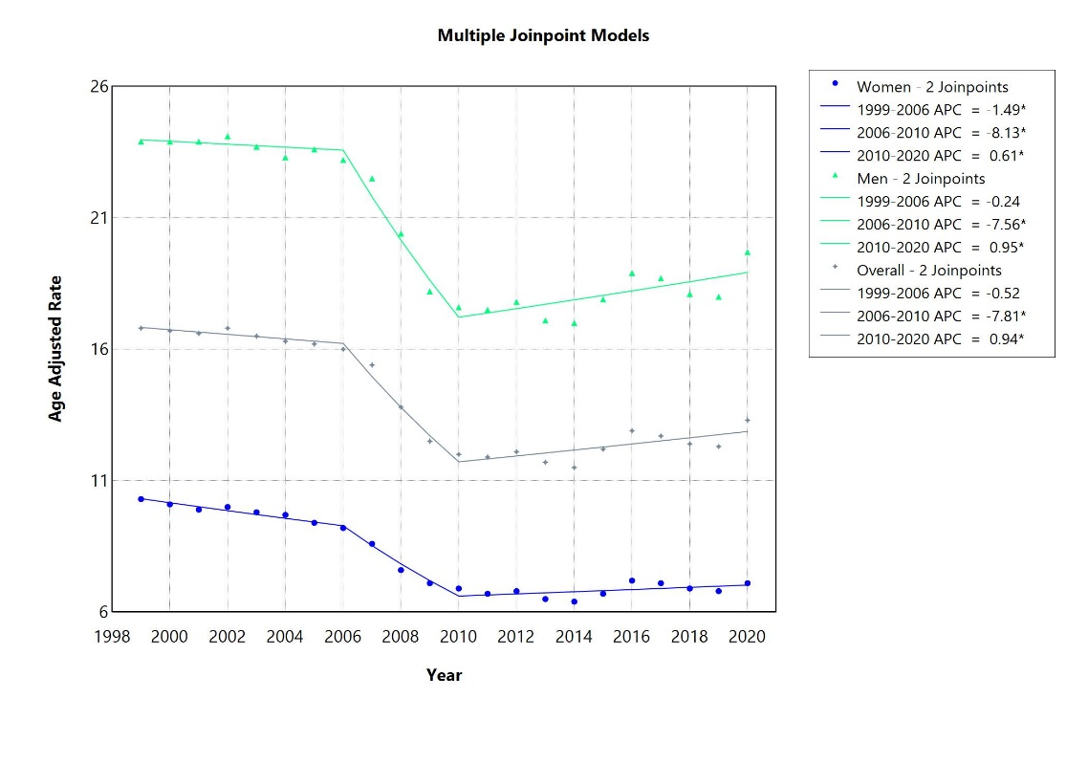

Supplementary Figure 2: Figure showing Joinpoint Model line of best fit for Age-standardized mortality rate for each race (Hispanic, Black, White, Asian American, and American Indian)
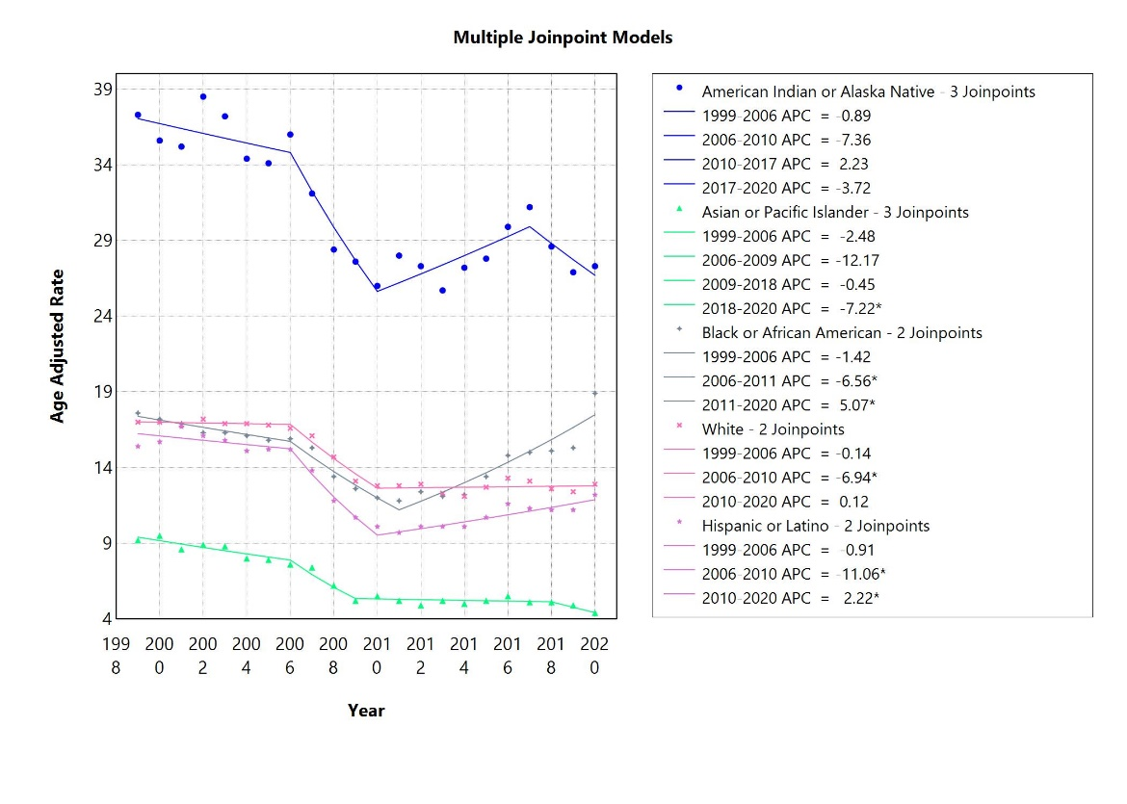

Supplementary Figure 3: Figure showing Joinpoint Model line of best fit for Age-standardized mortality rate for Urban-Rural Status (Metropolitan, Non-metropolitan areas)
