Table 1. DECO-MOM environmental prenatal health program as mobile application
Session | Step | Themes | Content | Methods | Duration | Screen shot
Week  1 | Sensitivity  Susceptibility | -Chemicals, electromagnetic waves, harmful food  -Reproductive & general  health problems | 30 minutes | Orientation  Cartoon  Explanation  Question and Answer | 30 minutes | 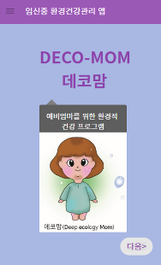 | 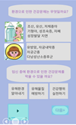
Week  2 | Response  Efficacy  Self-efficacy | -Avoid toxicant,  pursuit of health  -Preventive, judgment,  & control efficacy | 30 minutes | Animation  Cartoon  Explanation  Question and Answer | 30 minutes | 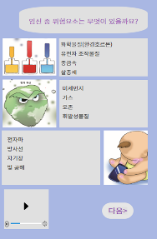 | 
Week  3 | Cost  Benefit | -Negative atmosphere  & burden  -Psychological  & physical gain | 30 minutes | Animation  Cartoon  Explanation  Question and Answer | 30 minutes | 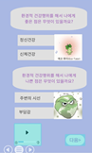 | 
Week  4 | Personal  Behavior  Community  behavior | -Lifestyle, personal goods, food, & dust  -Reduction, involvement, recycling, & reuse | 30 minutes | Animation  Cartoon  Explanation  Question and Answer  Trophy  Wrap-up | 30 minutes | 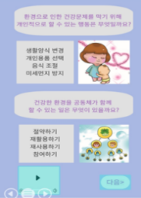 | 