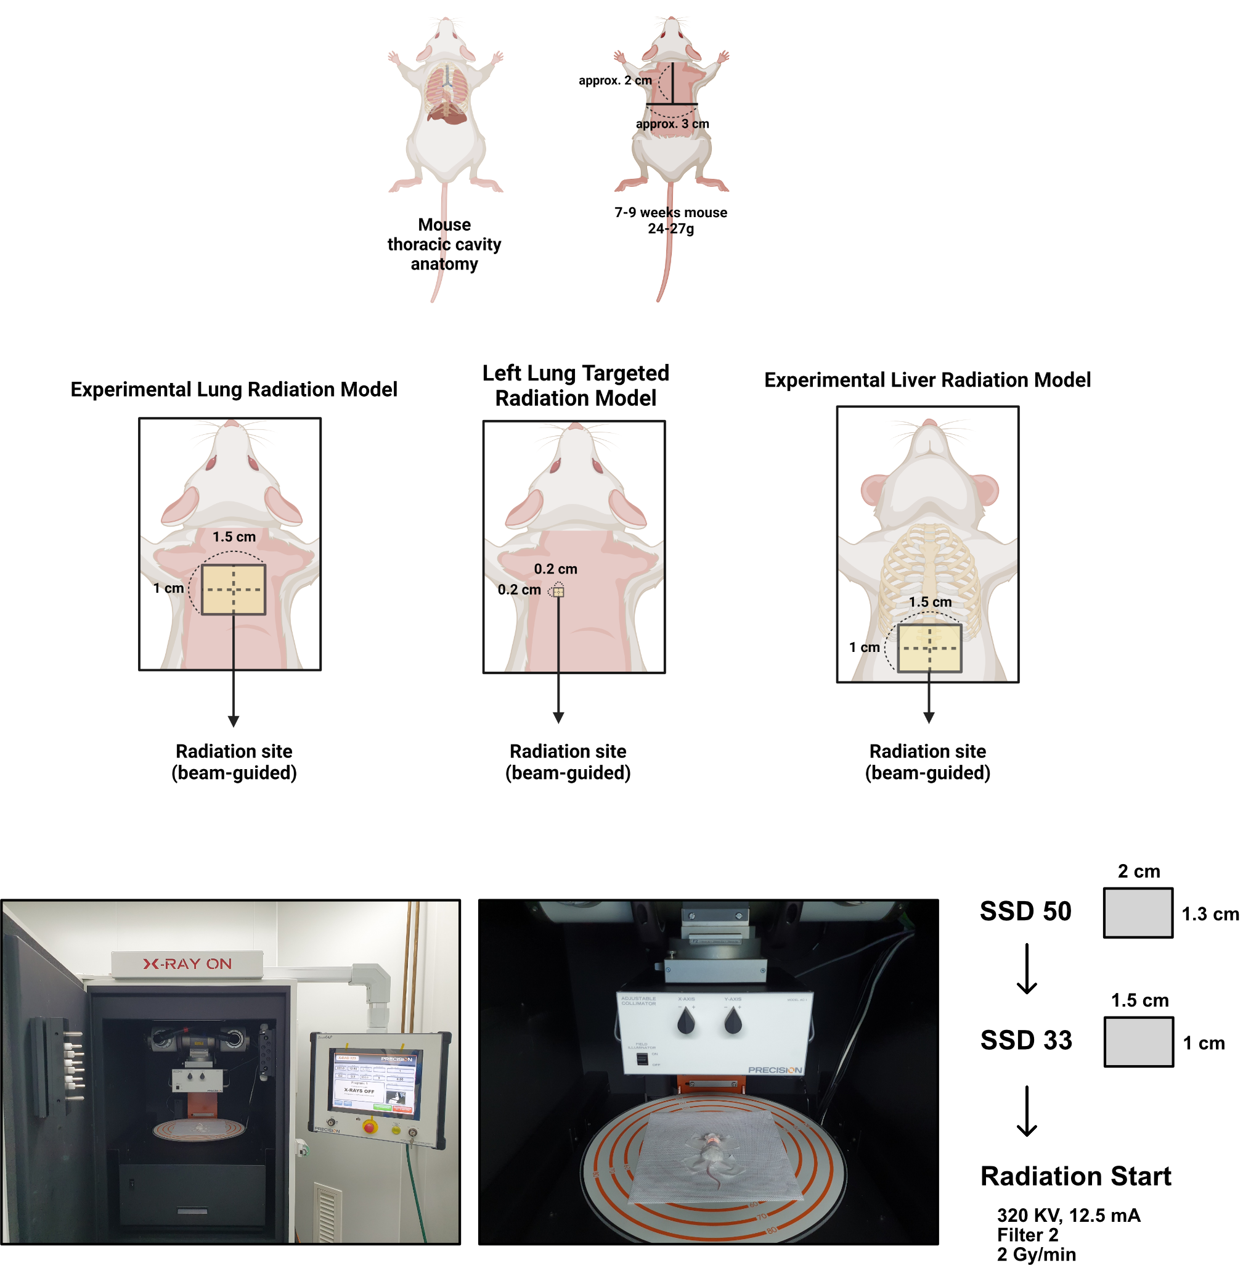
Extended Data Fig. 1┃Experimental mouse radiotherapy model
Schematic illustration of experimental mouse radiotherapy model. For the experimental implementation of lung radiotherapy, radiation was delivered to a 1.5 cm×1 cm area on the dorsal of the thoracic cavity (left). To mimic stereotactic body radiotherapy, radiation was delivered to a 0.2 cm×0.2 cm area on the dorsal of the left thoracic cavity (middle). For the experimental implementation of liver radiotherapy, radiation was delivered to a 1.5 cm×1.5 cm area on the abdomen (right). The irradiation procedures were conducted using the X-RAD 320 (Precision) equipped with a Dynamic Collimator (Precision) and an F2 filter.
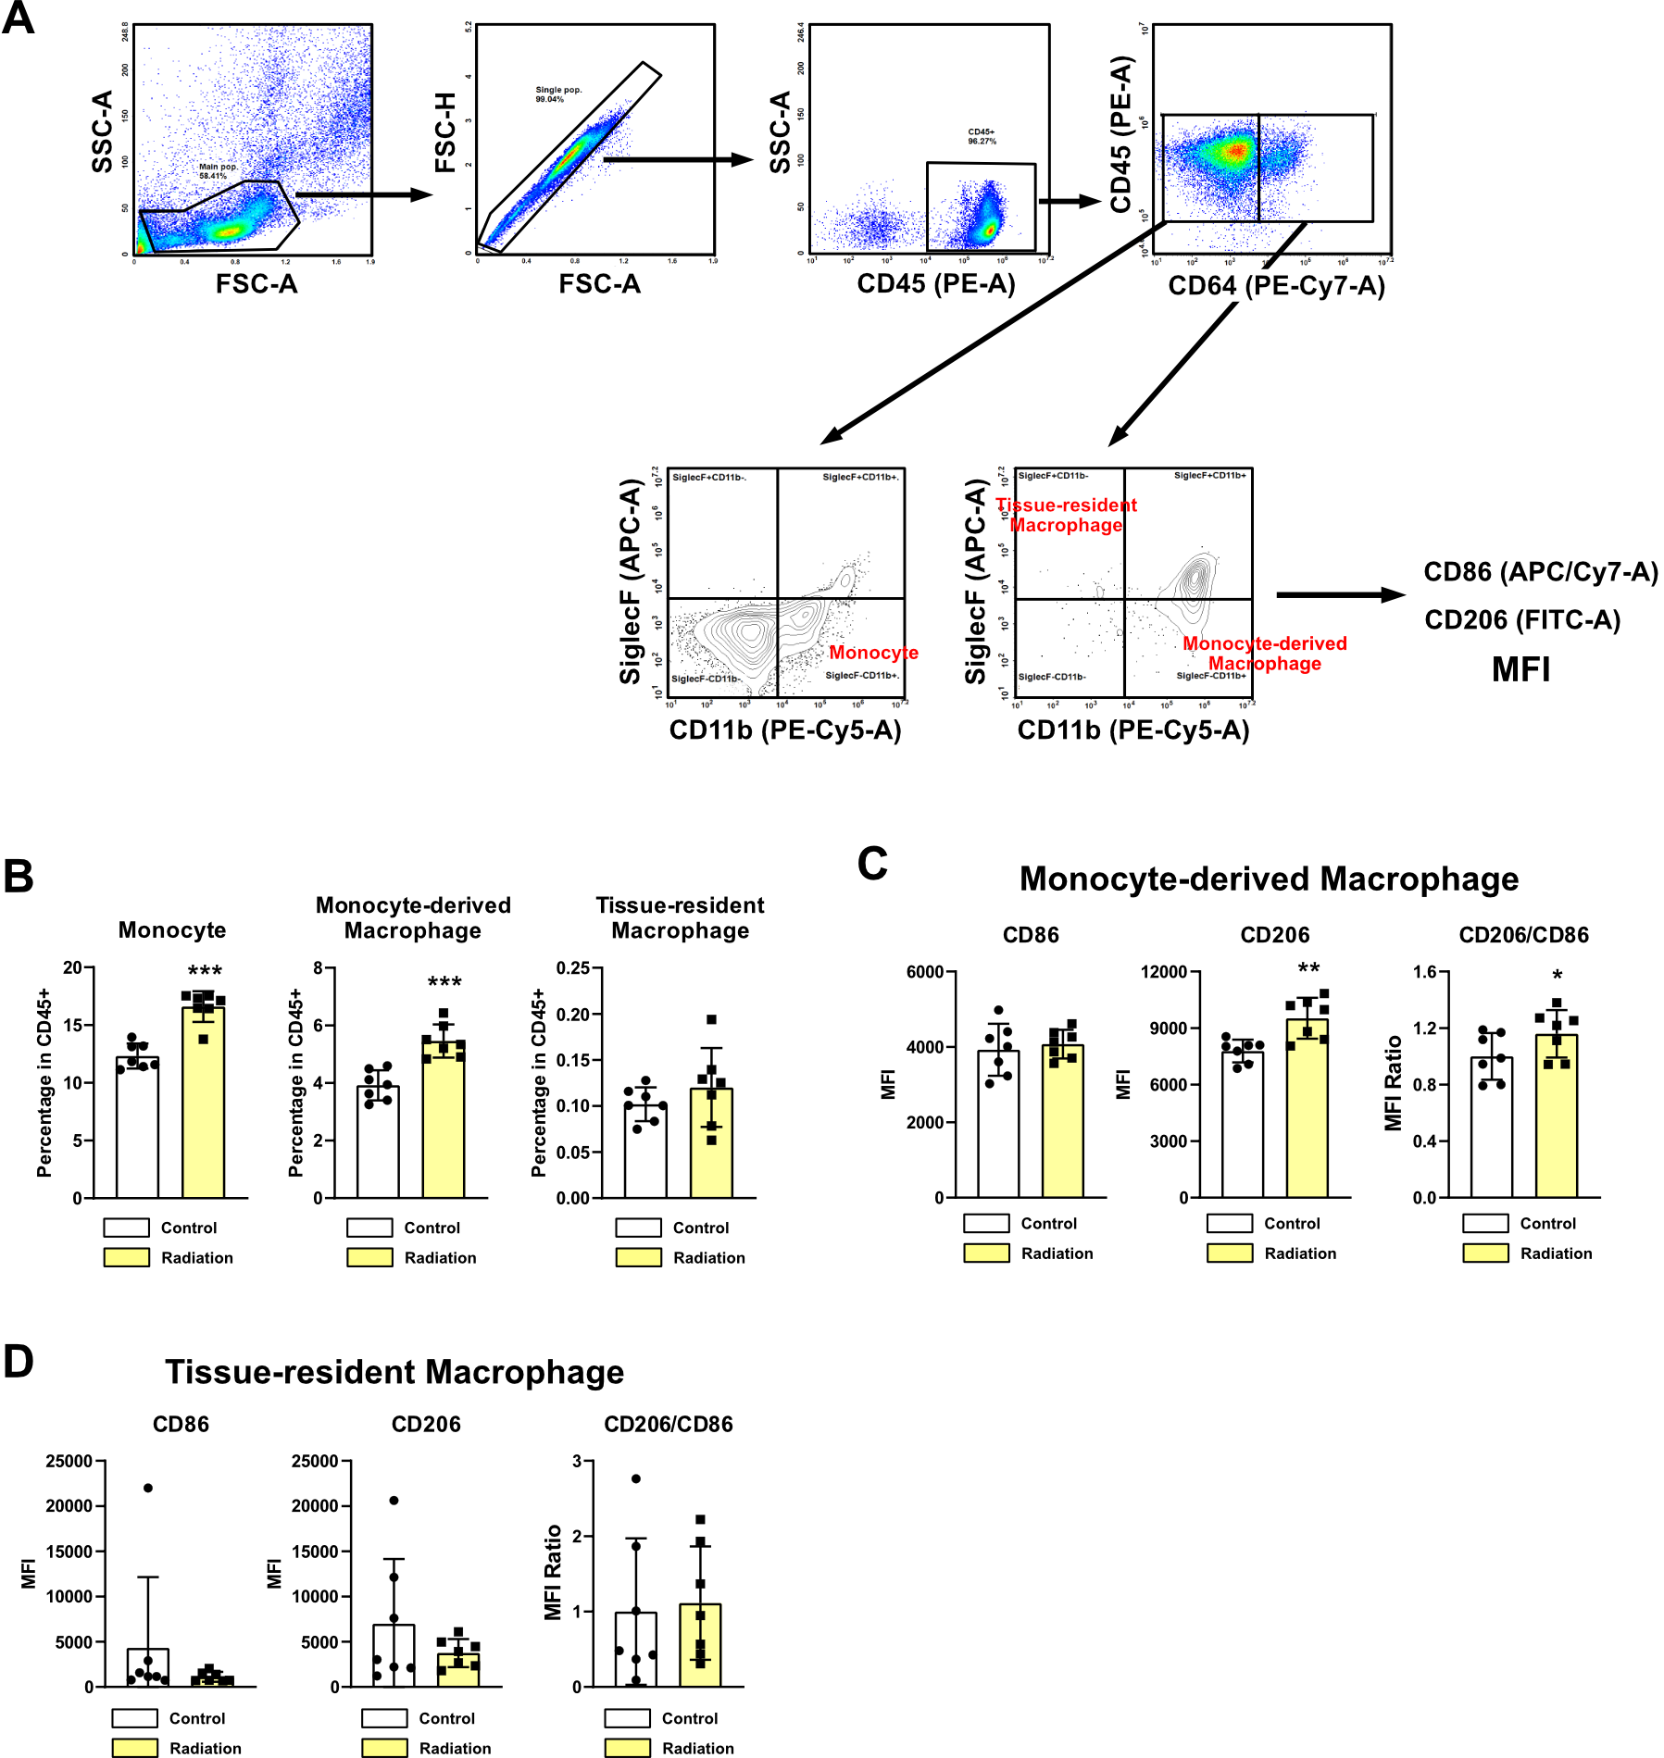

Extended Data Fig. 2┃Radiation-induced changes of monocyte-derived macrophages and tissue-resident macrophages in mouse lung tissues
Changes in immune cells infiltration in lung tissues. Lung tissues were collected 2 weeks after radiation (22 Gy×2). n = 6/group. A Gating strategies in flow cytometry. B Percentage of monocytes, monocyte-derived macrophages, and tissue-resident macrophages. C M2 differentiation of monocyte-derived macrophages. D M2 differentiation of tissue-resident macrophages. All data were presented as mean ± SD. Statistical significance of the differences was determined by two-tailed Student t-test. Source data are provided in Source Data file. The used flow cytometry antibodies are listed in Supplementary Table 3.

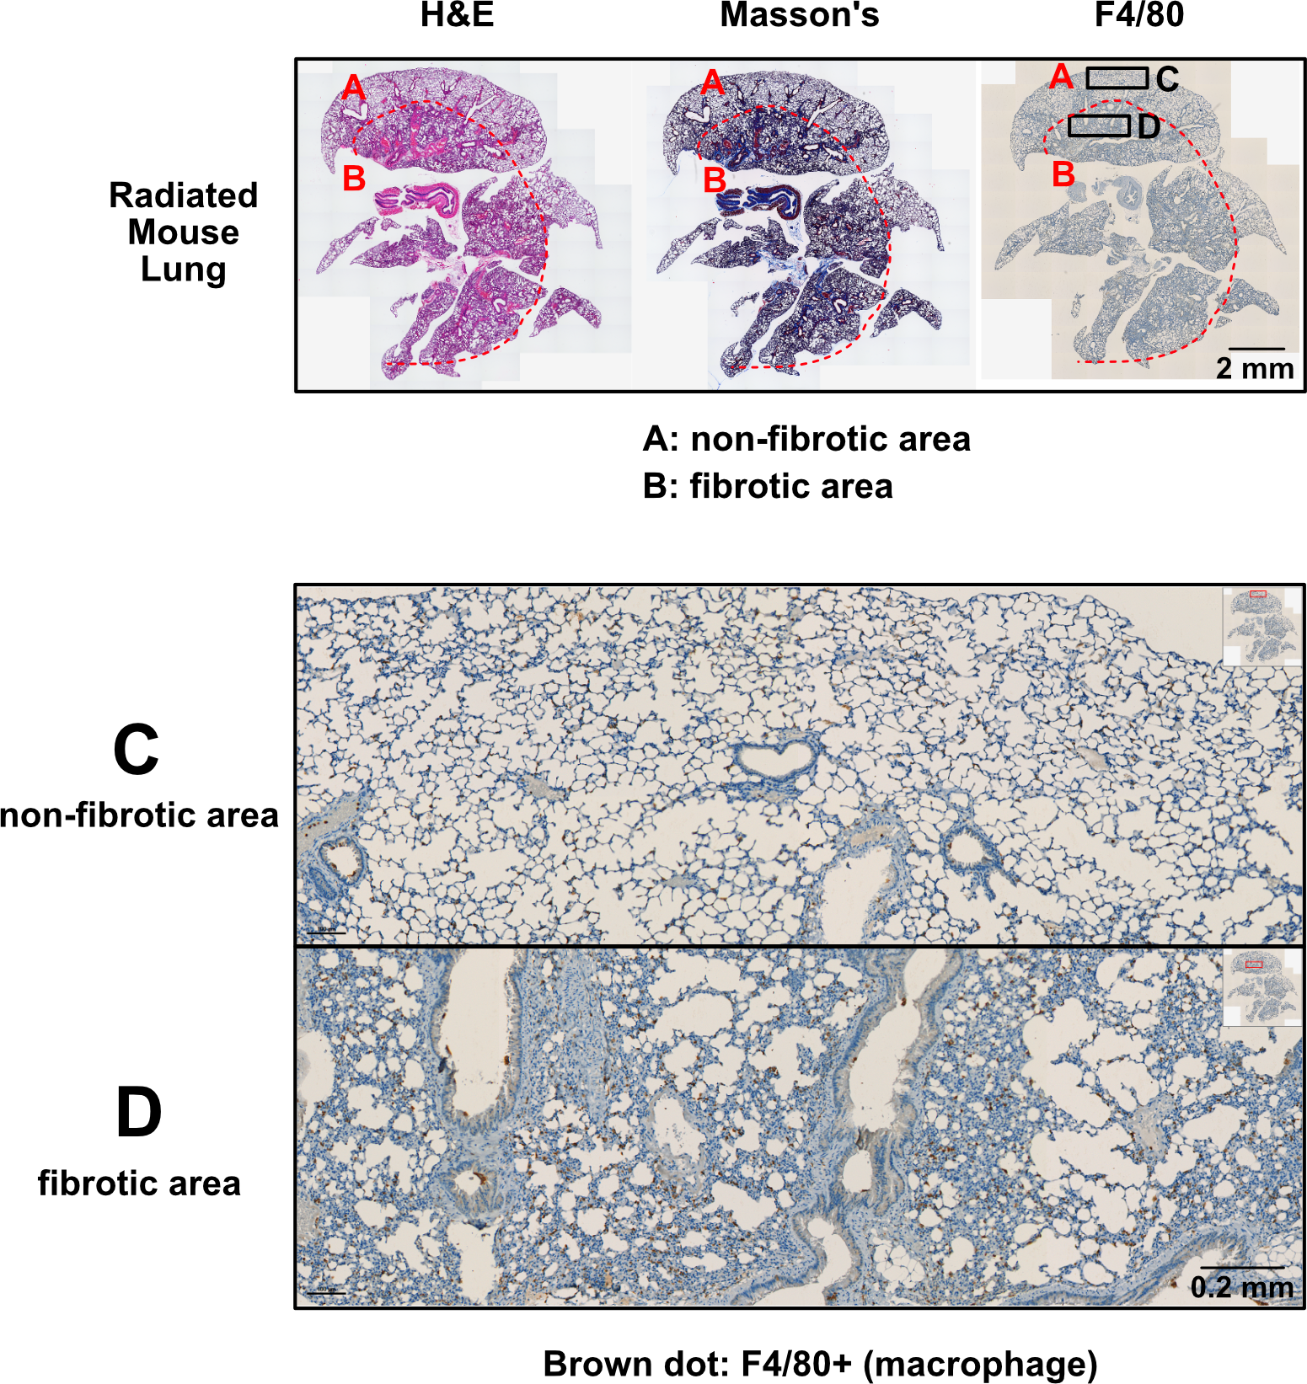
Extended Data Fig. 3┃The co-localization of fibrotic areas in lungs with macrophage infiltration
Immunohistochemistry (IHC) was performed using the sample depicted in Fig. 1F. The used IHC antibody is listed in Supplementary Table 3.

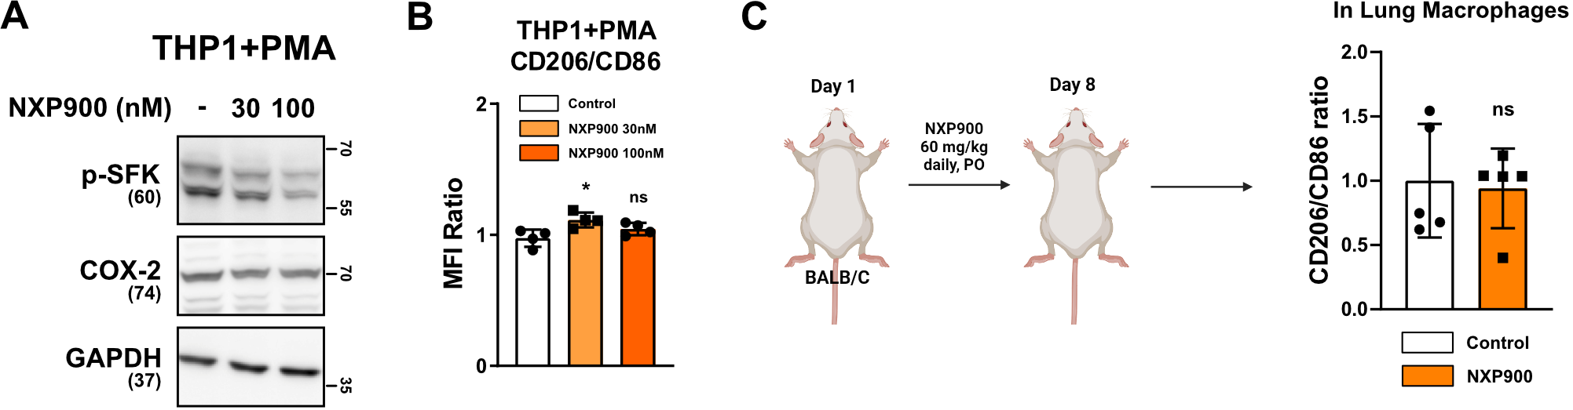

Extended Data Fig. 4┃Effect of SFK-targeted inhibitor on macrophage
A, B Effects of NXP900 on THP1 human macrophages. C Effects of NXP900 on mouse lung macrophages. NXP900 was orally administered daily during one week. BALB/c mice were used. n = 5/group. All data were presented as mean ± SD. Statistical significance of the differences was determined by two-tailed Student t-test or one-way ANOVA followed by the Tukey’s test. Source data are provided in Source Data file.

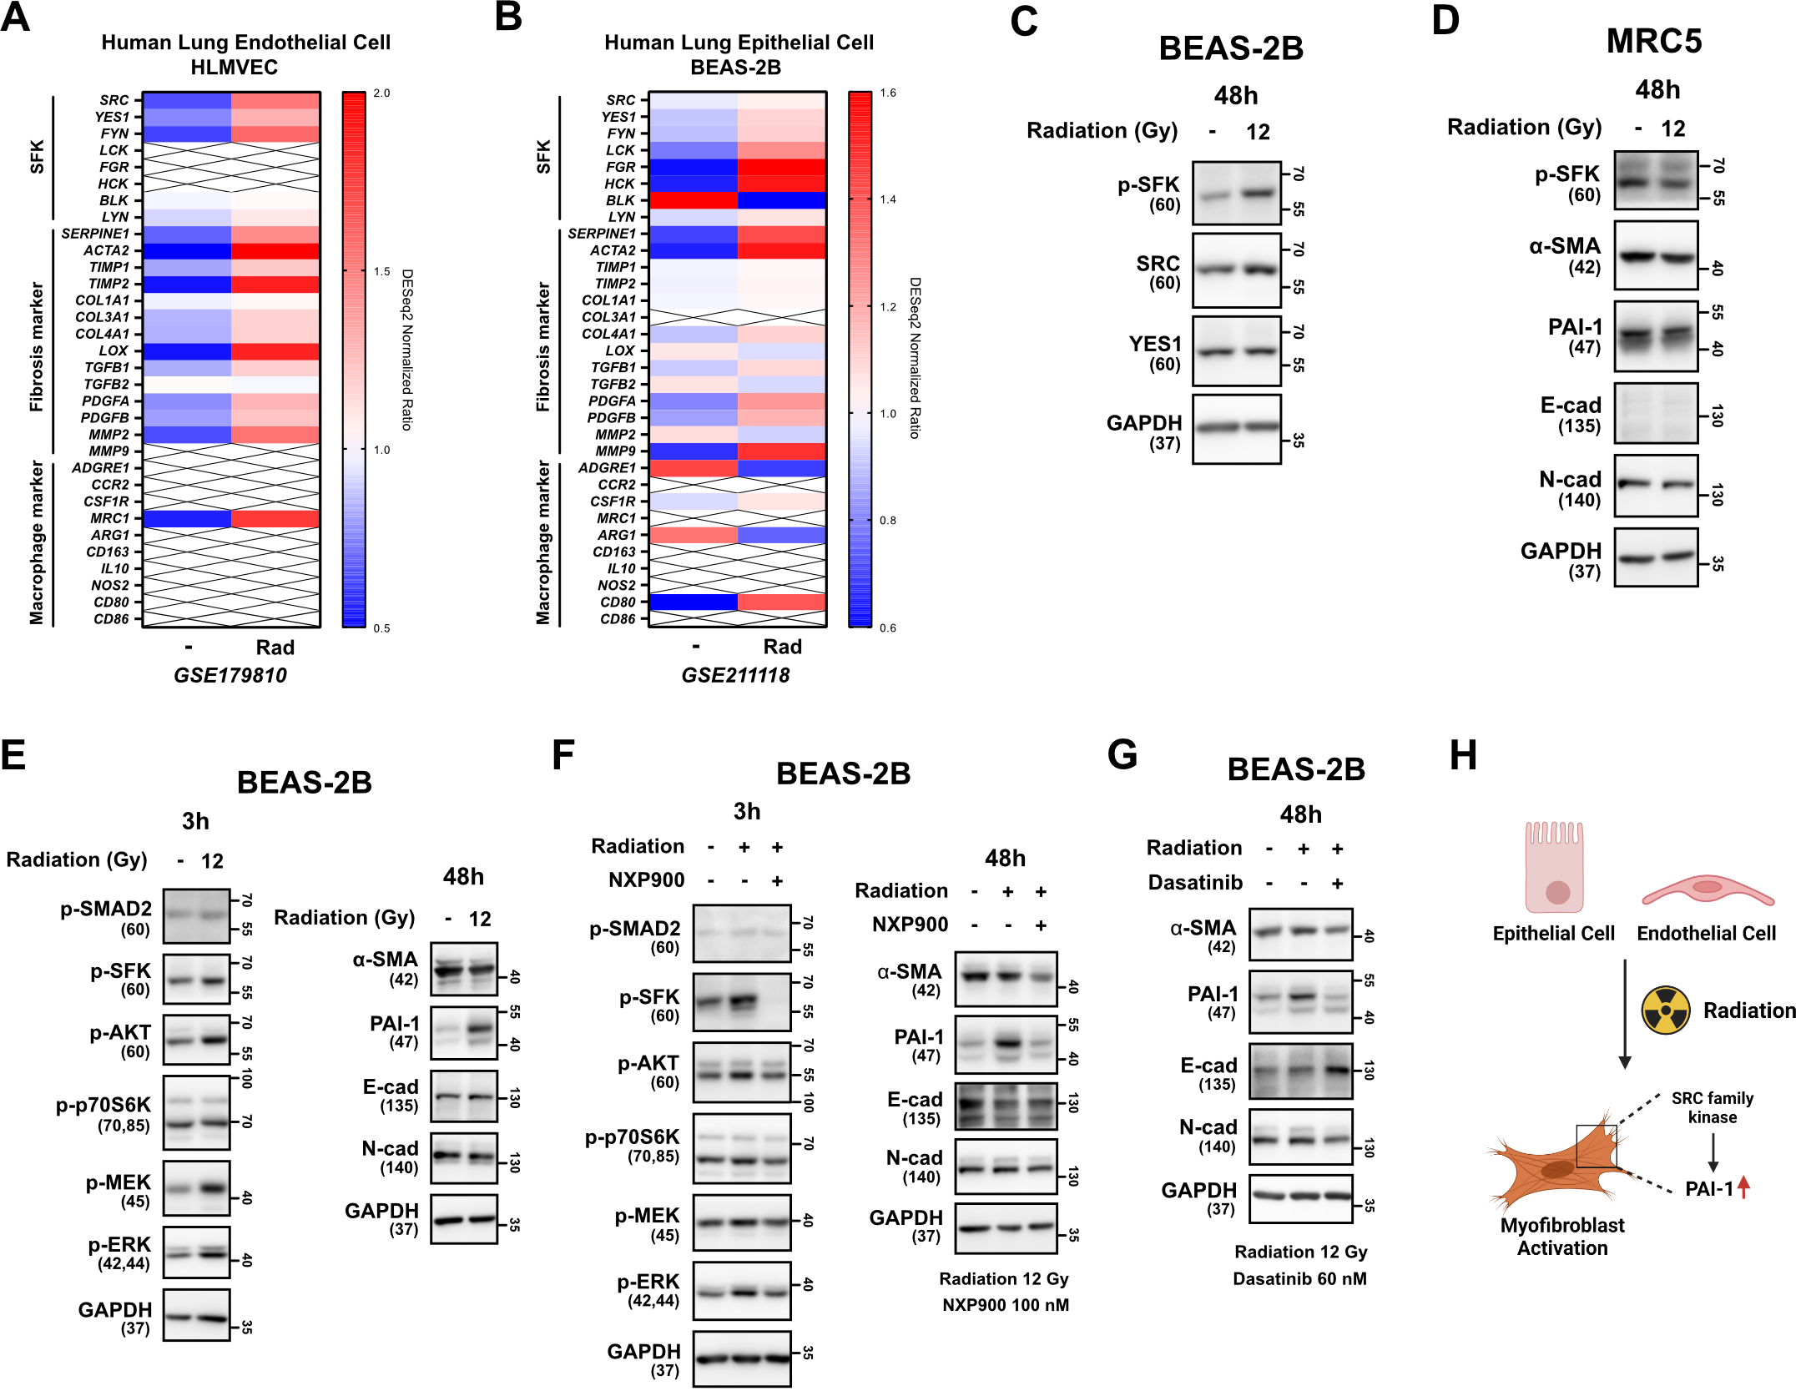

Extended Data Fig. 5┃SFK-targeted inhibitors suppress direct radiation-induced myofibroblast activation
A, B Comparison gene expression of SFKs, fibrosis, macrophage infiltration markers in HLMVEC and BEAS-2B cells. Cell samples were obtained 24 h after 10 Gy radiation. The NCBI public dataset, GSE179810, GSE211118, were used. C SFKs expression and activation by direct irradiation (12 Gy) in BEAS-2B cells. D Myofibroblast activation by direct irradiation in MRC5 cells (12 Gy). E Myofibroblast activation by direct irradiation in BEAS-2B cells (12 Gy). F, G Reversal of direct radiation-induced myofibroblast activation by SFK-inhibitors. H Schematic illustration representing Ex. Fig. 5 results. All western blot analyses in this study were repeated three times independently and are presented in Supplementary Materials. Source data are provided in Source Data file.
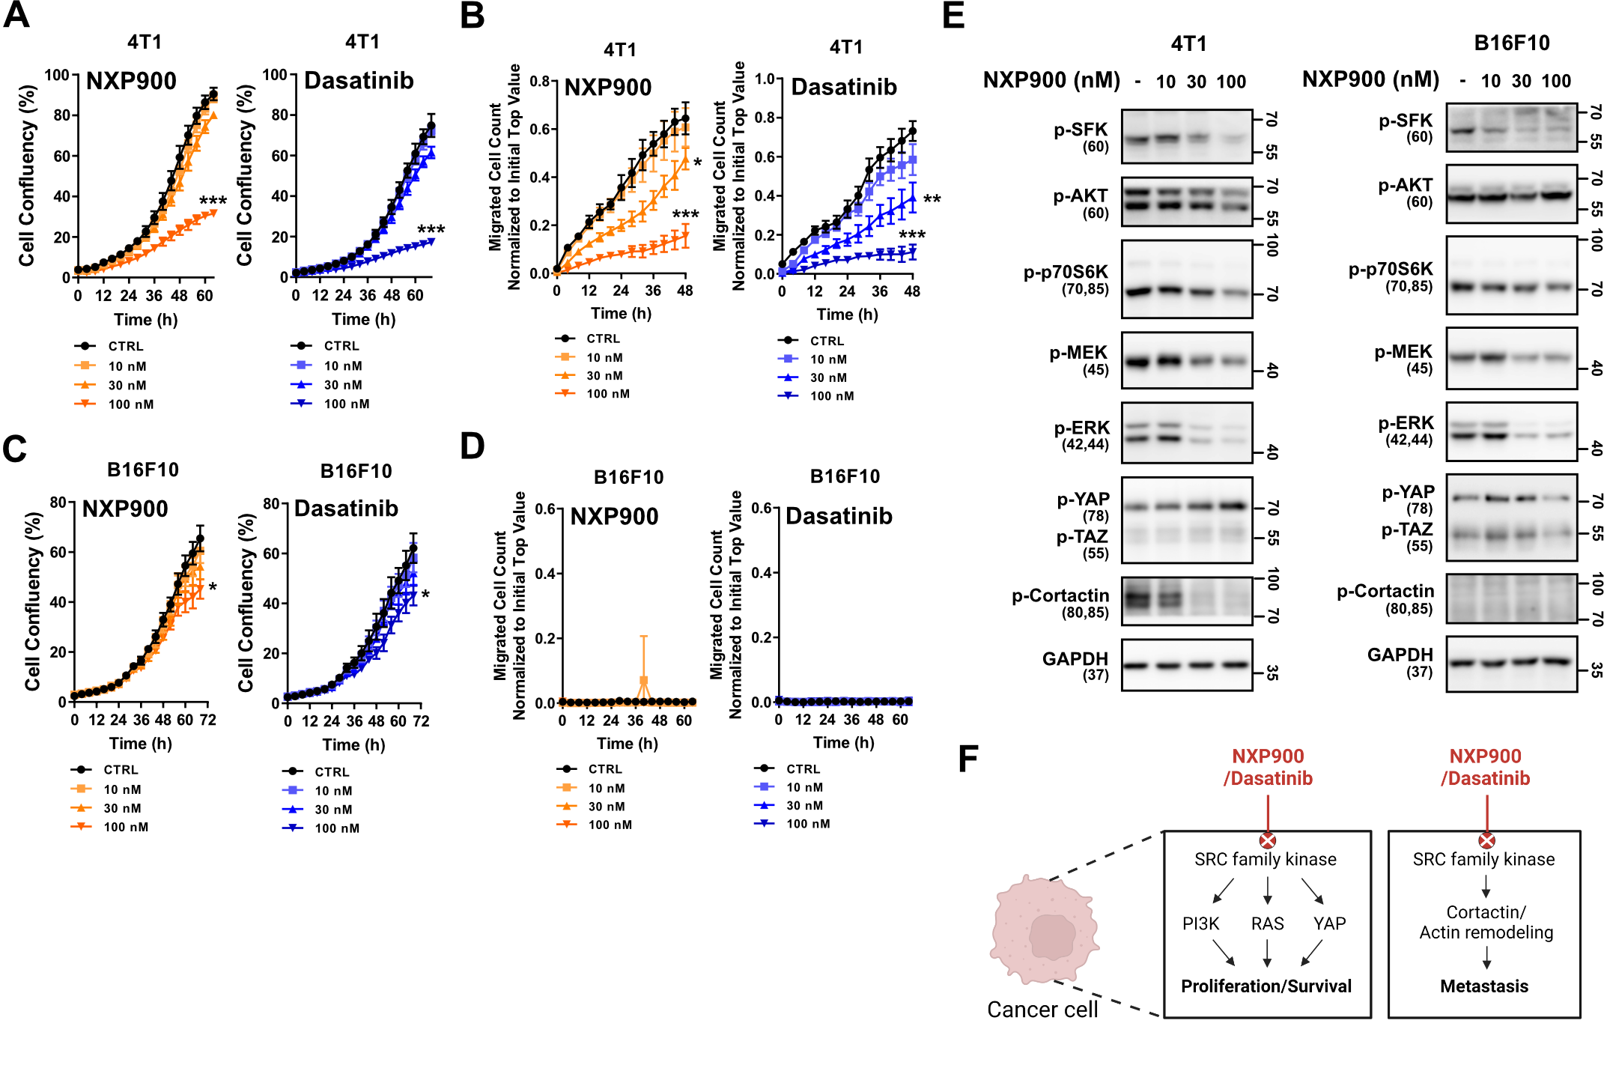
Extended Data Fig. 6┃Direct effect of SFK-targeted inhibitors on cancer cells
A Anti-proliferative activities of SFK-targeted inhibitors in 4T1 mouse breast cancer cells. B Anti-migratory activities of SFK-targeted inhibitors in 4T1 cells. C Anti-proliferative activities of SFK-targeted inhibitors in B16F10 mouse melanoma cells. D Anti-migratory activities of SFK-inhibitors in B16F10 cells. E Inhibition of SFKs downstream pathways by SFK-targeted inhibitors in mouse cancer cells. F Schematic illustration representing this figure. All data were presented as mean ± SD. Statistical significance of the differences was determined by two-tailed Student t-test or one-way ANOVA followed by the Tukey’s test. Source data are provided in Source Data file.

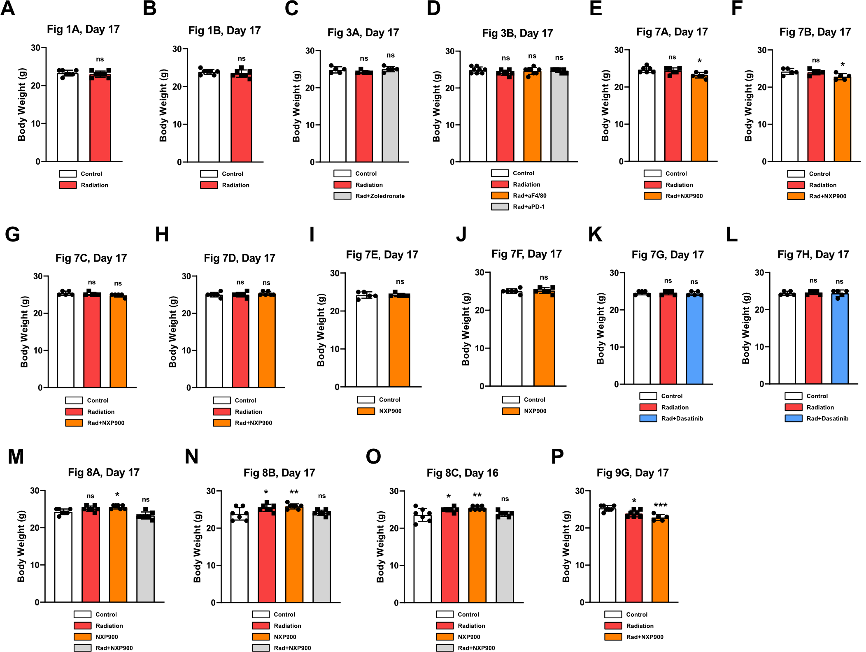
Supplementary Fig. 1┃Body weight changes in this study
A-P Weight changes were represented in all animal experiments. The corresponding figure number is entered for each graph. All data were presented as mean (SD). Statistical significance of the differences was determined by two-tailed Student t-test or one-way ANOVA followed by the Tukey’s test. Source data are provided in Source Data file.

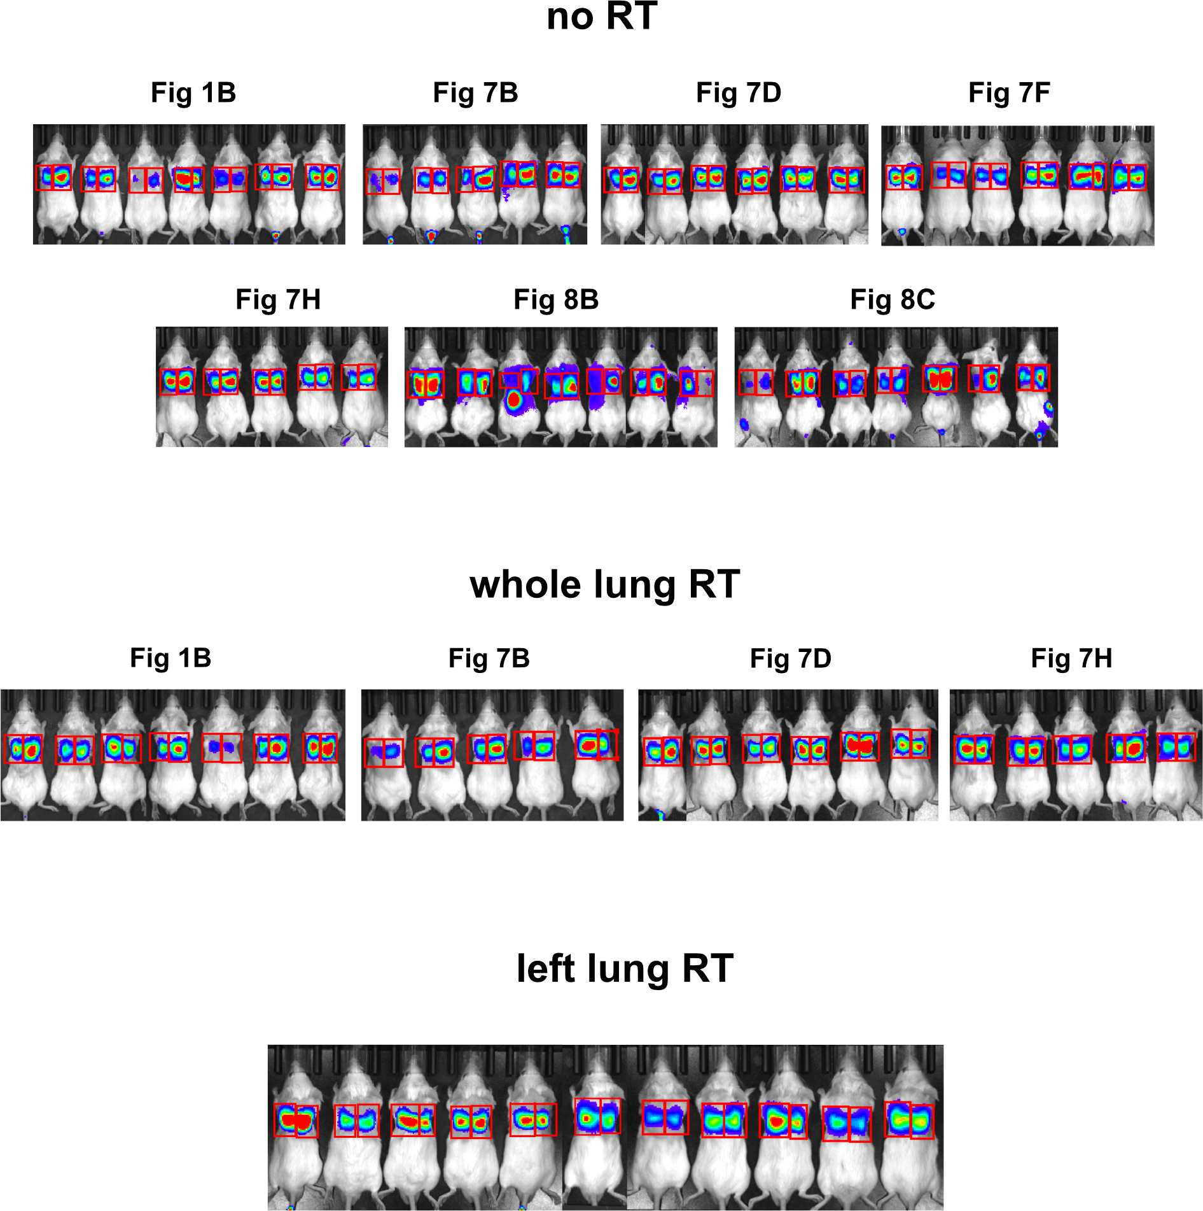

Supplementary Fig. 2┃Pictures of the lung engraftment ratio
Lung engraftment luminescence were captured and calculated using IVIS spectrum (PerkinElmer). This data supplements Fig 1G.

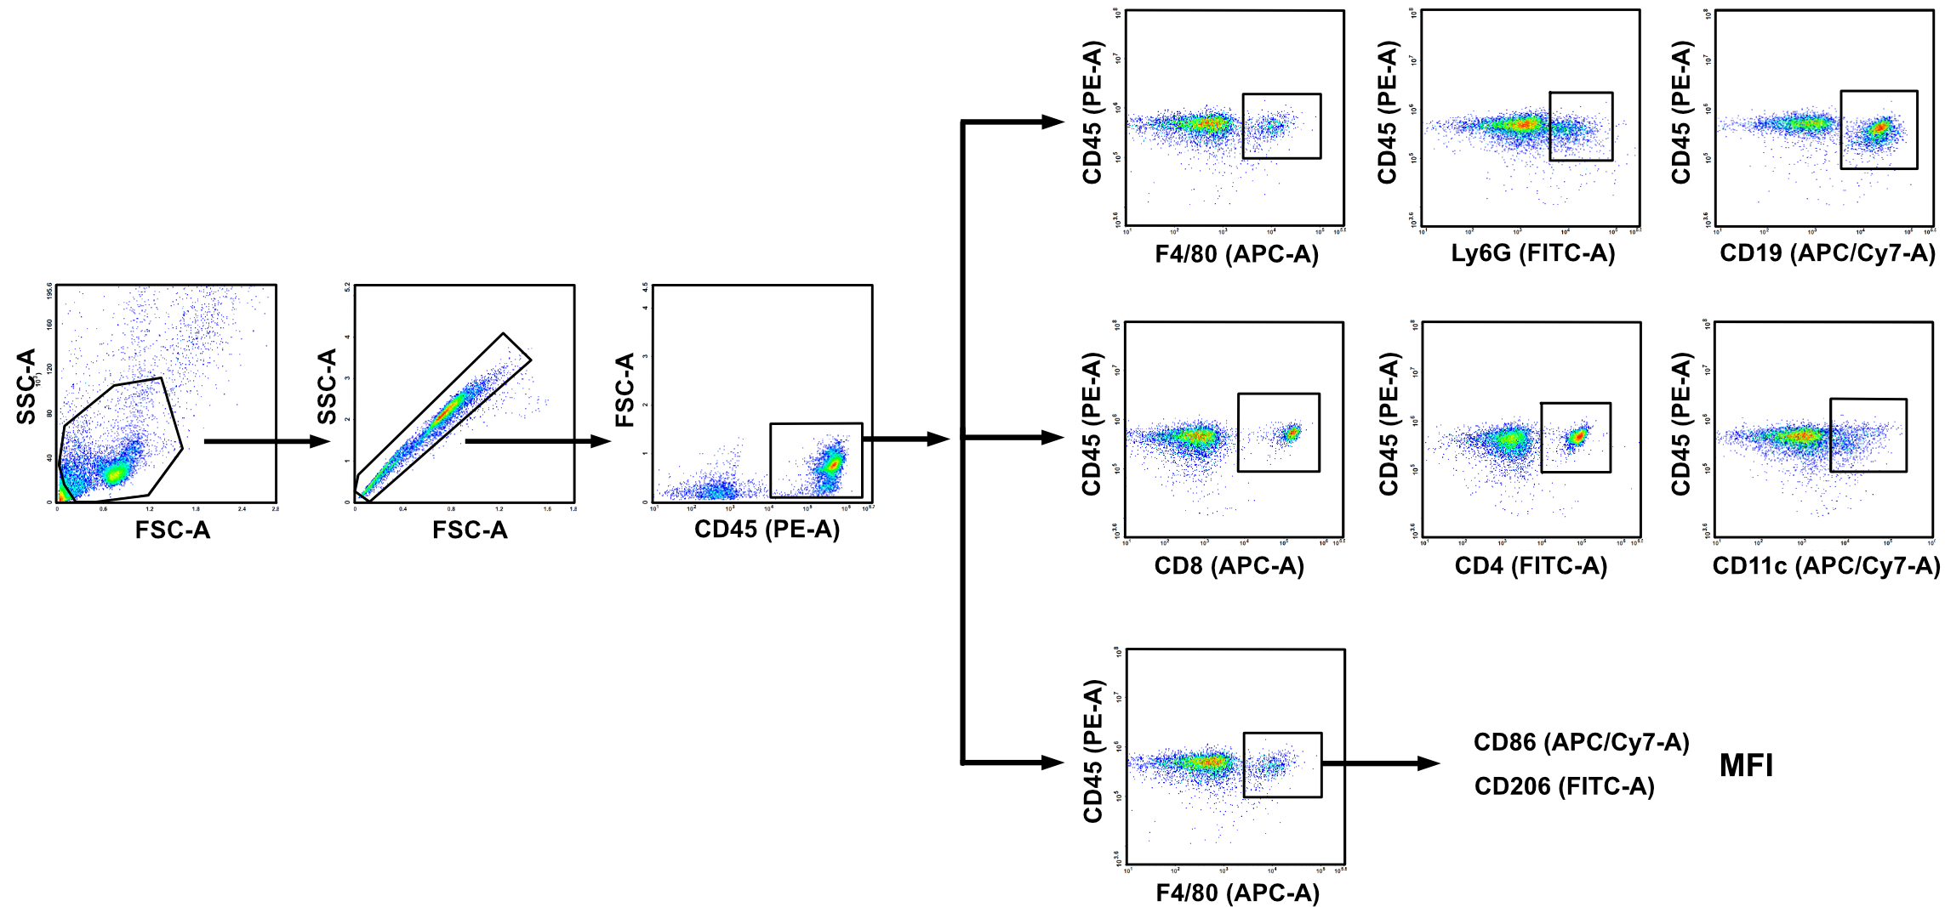
Supplementary Fig. 3┃Gating strategies in flow cytometry
Gating strategies for Fig. 2 and 7. The used flow cytometry antibodies are listed in Supplementary Table 3.

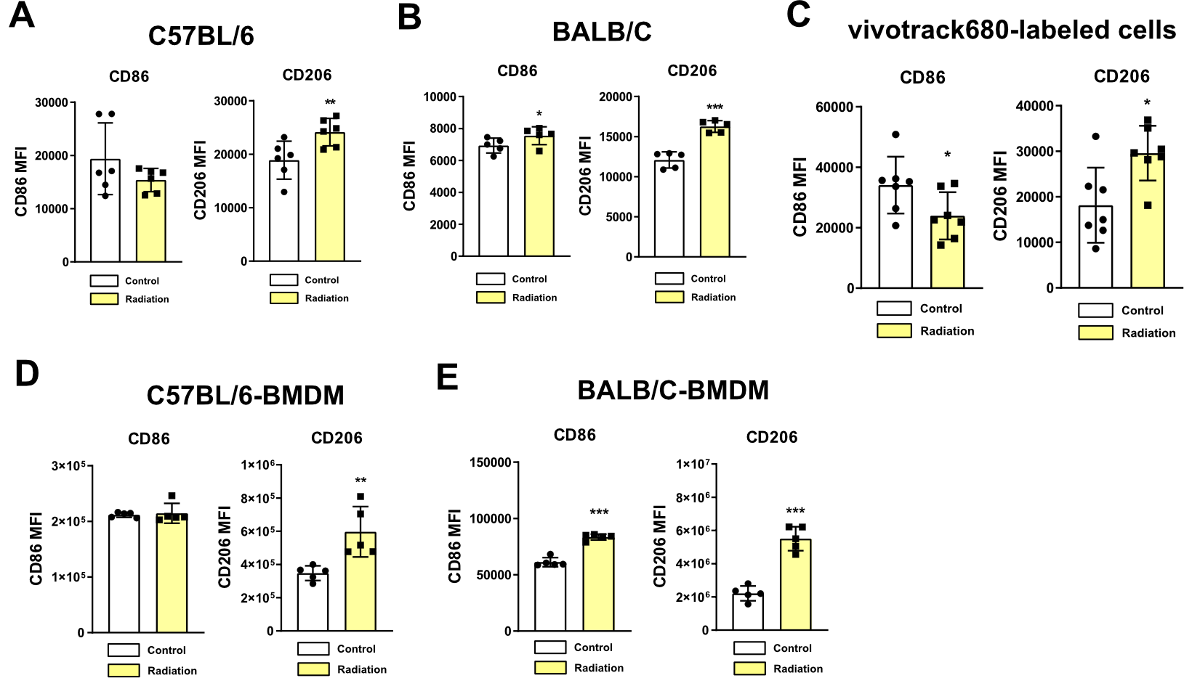

Supplementary Fig. 4┃Individual values of M1, M2 markers
A-E Individual values of Fig. 2C, D, F, and G, respectively. All data were presented as mean ± SD. Statistical significance of the differences was determined by two-tailed Student t-test. Source data are provided in Source Data file.

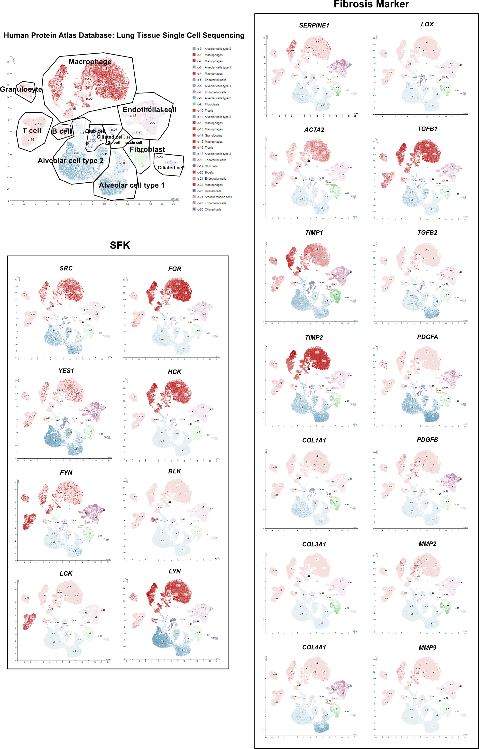
Supplementary Fig. 5┃Gene expression of SFKs and fibrosis markers in human lung tissues: single cell sequencing analysis
Expression analysis of SFKs and fibrosis-related genes through lung tissue single cell sequencing using The Human Protein Atlas database.

