dag {
"All-cause mortalities" [outcome,pos="1.100,0.654"]
"BPD Stage at PMA 36wks" [outcome,pos="1.034,-0.136"]
"Birth weight" [adjusted,pos="-0.675,-1.087"]
"Hospital courses" [pos="-0.403,-0.030"]
"Oxygen needs at PNA 28ds" [outcome,pos="0.294,0.686"]
"PDA treatment method" [exposure,pos="-0.836,0.561"]
"Treatment failure(Surgical ligation)" [outcome,pos="0.291,0.079"]
GA [adjusted,pos="-1.135,-0.820"]
"Birth weight" -> "BPD Stage at PMA 36wks"
"Birth weight" -> "Hospital courses"
"Birth weight" -> "Oxygen needs at PNA 28ds"
"Birth weight" -> "PDA treatment method"
"Birth weight" -> "Treatment failure(Surgical ligation)"
"Hospital courses" -> "All-cause mortalities" [pos="0.414,0.589"]
"Hospital courses" -> "BPD Stage at PMA 36wks"
"Hospital courses" -> "Oxygen needs at PNA 28ds"
"Hospital courses" -> "Treatment failure(Surgical ligation)"
"Oxygen needs at PNA 28ds" -> "All-cause mortalities"
"Oxygen needs at PNA 28ds" -> "BPD Stage at PMA 36wks"
"PDA treatment method" -> "Oxygen needs at PNA 28ds"
"PDA treatment method" -> "Treatment failure(Surgical ligation)"
"Treatment failure(Surgical ligation)" -> "All-cause mortalities"
"Treatment failure(Surgical ligation)" -> "BPD Stage at PMA 36wks"
GA -> "All-cause mortalities" [pos="0.613,-0.128"]
GA -> "Hospital courses"
GA -> "Oxygen needs at PNA 28ds" [pos="-0.604,0.103"]
GA -> "PDA treatment method"
GA -> "Treatment failure(Surgical ligation)"
}
Supplementary materials 1. DAG codes
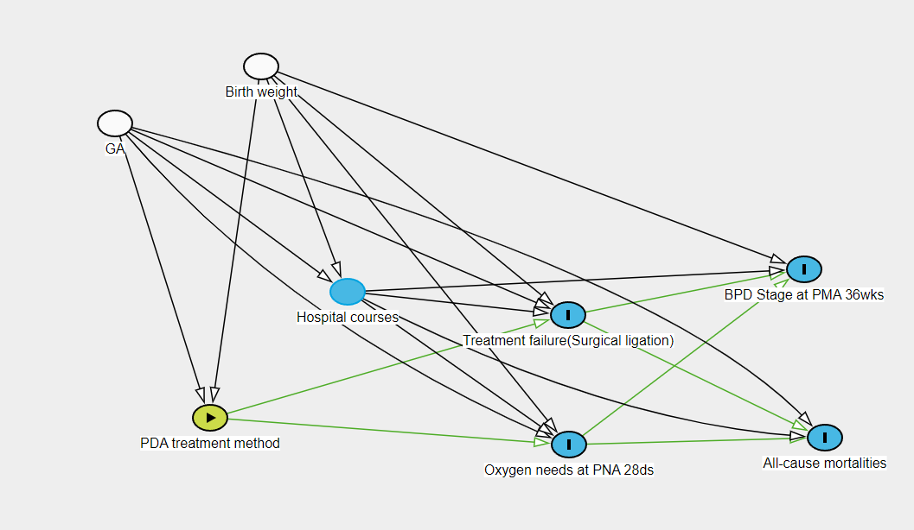
Supplementary materials 2. DAG
GA, Gestational age; PDA, Patent ductus arteriosus; BPD, Bronchopulmonary dysplasia

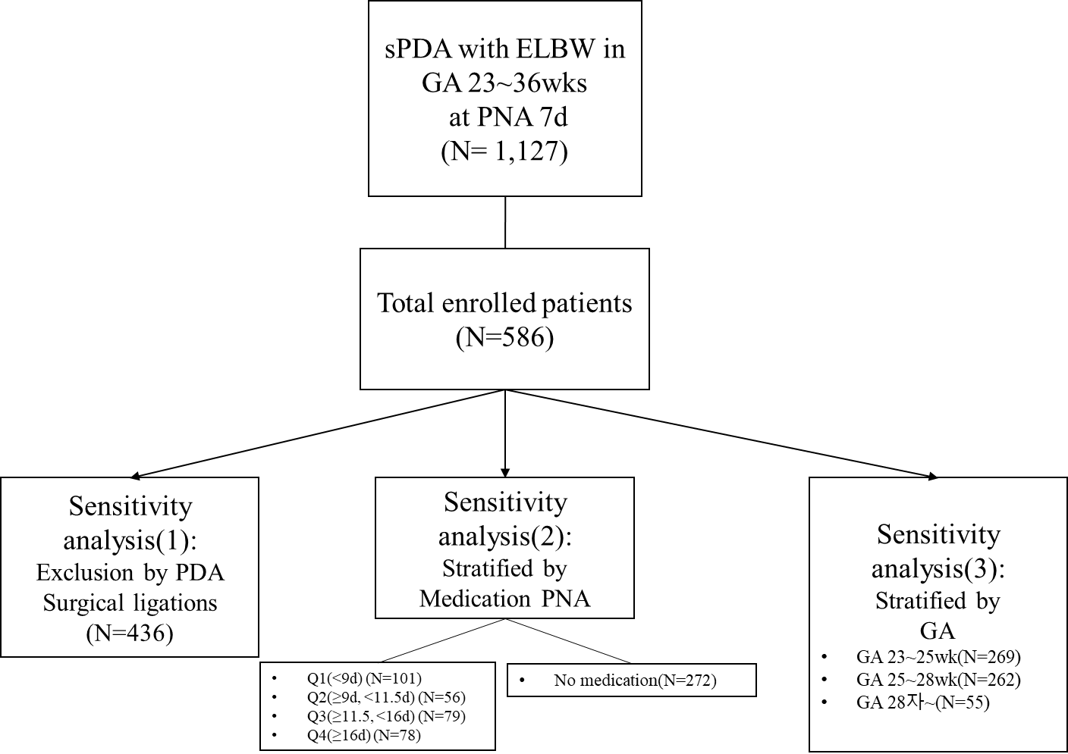
Supplementary materials 3. Diagram for sensitivity analysis
GA, Gestational age; PDA, Patent ductus arteriosus; PNA, Post-natal age

 | Patients without Ligation, No (%)
 | No medication | Medication |  | p
 | (N=210) | (N=226)
sex |  |  |  | 0.929
- Male | 92 (43.8%) | 101 (44.7%)
- Female | 118 (56.2%) | 125 (55.3%)
Multiple gestation |  |  |  | 0.97
- singleton | 146 (69.5%) | 155 (68.6%)
- twin | 61 (29.0%) | 68 (30.1%)
- triple | 3 ( 1.4%) | 3 ( 1.3%)
Artificial insemination |  |  |  | 0.572
- No | 152 (72.4%) | 170 (75.2%)
- Yes | 58 (27.6%) | 56 (24.8%)
Maternal diabetes status |  |  |  | 0.3
- No | 195 (92.9%) | 217 (96.0%)
- GDM | 10 ( 4.8%) | 7 ( 3.1%)
- Overt DM | 5 ( 2.4%) | 2 ( 0.9%)
Maternal hypertension status |  |  |  | 0.294
- No | 154 (73.3%) | 176 (77.9%)
- Pregnancy indued | 51 (24.3%) | 42 (18.6%)
- Chronic hypertension | 5 ( 2.4%) | 8 ( 3.5%)
Histologic Chorioamnionitis |  |  |  | 0.69
- No | 101 (48.1%) | 111 (49.1%)
- Yes | 91 (43.3%) | 91 (40.3%)
- unknown | 18 ( 8.6%) | 24 (10.6%)
PPROM |  |  |  | 0.63
- No | 144 (68.6%) | 156 (69.0%)
- Yes | 65 (31.0%) | 67 (29.6%)
- unknown | 1 ( 0.5%) | 3 ( 1.3%)
Antenatal steroid |  |  |  | 0.092
- No | 12 ( 5.7%) | 24 (10.6%)
- Yes | 198 (94.3%) | 202 (89.4%)
Maternal age, mean (SD), year | 33.8 (4.0) | 33.1 (4.5) |  | 0.058
Delivery mode |  |  |  | 0.455
- V/D | 47 (22.4%) | 43 (19.0%)
- C/S | 163 (77.6%) | 183 (81.0%)
GA, mean (SD), weeks | 26.0 (2.0) | 26.0(1.8) |  | 0.928
1min A/S, mean (SD), score | 4.6(1.8) | 3.7(1.9) |  | <0.001
5min A/S, mean (SD), score | 7.2(1.6) | 6.1(2.1) |  | <0.001
Birth weight, mean(SD), g | 744.1(159.9) | 793.3(135.6) |  | 0.001
Air leak |  |  |  | 0.248
- No | 192 (91.4%) | 214 (94.7%)
- Yes | 18 ( 8.6%) | 12 ( 5.3%)
Massive pulmonary hemorrhage |  |  |  | 0.692
- No | 196 (93.3%) | 214 (94.7%)
- Yes | 14 ( 6.7%) | 12 ( 5.3%)
pulmonary hemorrhage |  |  |  | 0
- No | 153 (72.9%) | 200 (88.5%)
- Yes | 57 (27.1%) | 26 (11.5%)
RDS |  |  |  | 0.993
- No | 12 ( 5.7%) | 14 ( 6.2%)
- Yes | 198 (94.3%) | 212 (93.8%)
Surfactant for RDS |  |  |  | 1
- No | 10 ( 4.8%) | 10 ( 4.4%)
- Yes | 200 (95.2%) | 216 (95.6%)
Steroid for prevent BPD |  |  |  | <0.001
- No | 75 (35.7%) | 135 (59.7%)
- Yes | 135 (64.3%) | 91 (40.3%)
Oxygen status at PNA 28d |  |  |  | <0.001
- No | 48 (25.3%) | 22 (10.2%)
- lower 30% | 69 (36.3%) | 122 (56.7%)
-higher 30% | 73 (38.4%) | 71 (33.0%)
BPD at PMA 36wks |  |  |  | <0.001
- No | 12 ( 5.7%) | 6 ( 2.7%)
- Stage1 | 46 (21.9%) | 97 (42.9%)
- Stage2 | 50 (23.8%) | 38 (16.8%)
- Stage 3 | 72 (34.3%) | 60 (26.5%)
- unknown(Transfer out or expire) | 26 (12.4%) | 18 ( 8.0%)
- Missing | 4 ( 1.9%) | 7 ( 3.1%)
Sepsis during hospital course |  |  |  | 0.825
- No | 159 (75.7%) | 168 (74.3%)
- Yes | 51 (24.3%) | 58 (25.7%)
Meningitis during hospital course |  |  |  | 1
- No | 209 (99.5%) | 224 (99.1%)
- Yes | 1 ( 0.5%) | 2 ( 0.9%)
Mortality during PNA 90d |  |  |  | 0.311
- No | 179 (85.2%) | 199 (88.1%)
- Yes | 27 (12.9%) | 20 ( 8.8%)
- missing | 4 ( 1.9%) | 7 ( 3.1%)
Periventricular leukomalacia |  |  |  | 0.499
- No | 201 (95.7%) | 212 (93.8%)
- Yes | 9 ( 4.3%) | 14 ( 6.2%)
IVH stage |  |  |  | 0
- No | 64 (30.5%) | 141 (62.4%)
- Stage 1 | 146 (69.5%) | 85 (37.6%)
NEC over stage 2 |  |  |  | 0.451
- No | 203 (96.7%) | 214 (94.7%)
- Yes | 7 ( 3.3%) | 11 ( 4.9%)
- T/O for surgery | 0 ( 0.0%) | 1 ( 0.4%)
SIP |  |  |  | 0.511
- No | 210 (100.0%) | 224 (99.1%)
- Yes | 0 ( 0.0%) | 2 ( 0.9%)
Transfer out |  |  |  | 0.626
- No | 206 (98.1%) | 219 (96.9%)
- Yes | 4 ( 1.9%) | 7 ( 3.1%)

Supplementary material 4. Sensitivity analysis (1) Patients characteristics without ligation
GDM, Gestational diabetes; DM, Diabetes mellitus; PPROM, Preterm Premature Rupture of Membranes; V/D, Vaginal delivery; C/S, caesarean section; GA, Gestational age; RDS, Repiratory distress syndrome; BPD, Bronchopulmonary dysplasia; PNA, post-natal age; PDA, patent ductus arteriosus; IVH, Intraventricular hemorrhage; NEC, Necrotizing enterocolitis; SIP, spontaneous intestinal perforation

Logistic regression | Model 1 |  | Model2 |  | Model3
 | OR | 95%CI | OR | 95%CI | OR | 95%CI
Oxygen supply at PNA 28d
no need
FiO2 < 30% | 3.858 | 2.150~6.922 | 3.903 | 2.573~5.919 | 4.373 | 2.833~6.749
FiO2 > 30% | 2.122 | 1.163~3.871 | 2.323 | 1.511~3.572 | 3.498 | 2.193~5.579
BPD
No
Mild | 4.218 | 1.489~11.944 | 3.331 | 1.625~6.825 | 4.537 | 2.180~9.445
Moderate | 1.520 | 0.523~4.418 | 1.274 | 0.609~2.666 | 2.006 | 0.937~4.292
Severe | 1.667 | 0.590~4.707 | 1.721 | 0.840~3.526 | 3.505 | 1.644~7.474
Unknown | 1.385 | 0.439~4.371 | 1.480 | 0.666~3.290 | 2.058 | 0.908~4.665
Mortality | 0.961 | 0.905~1.020 | 0.979 | 0.923~1.038 | 0.967 | 0.910~1.028
* Model 1, non adjusted; Model 2, weighted by IPW; Model3, model2 + adjusted by RDS, Postnatal steroid
Supplementary material 5. Sensitivity analysis (1) Logistic regression without ligation
PNA, Post-natal age; FiO2, fraction inhalation of Oxygen; OR, Odd ratio; CI, confidential index

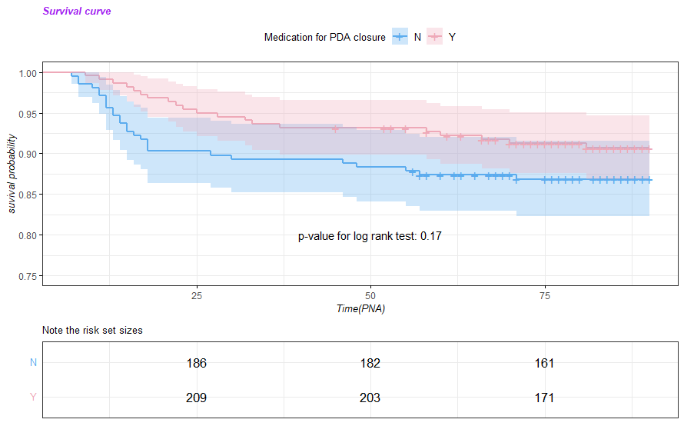
Supplementary material 6. Sensitivity analysis (1) KM plot and log rank test without ligation
PDA, patent ductus arteriosus; PNA, post-natal age(for days)

Stratified by medication PNA | Q1 | Q2 | Q3 | Q4 | No medication | p
No.(%) | (N=101) | (N=56) | (N=79) | (N=78) | (N=272)
sex |  |  |  |  |  | 0.348
- Male | 47 (46.5%) | 19 (33.9%) | 41 (51.9%) | 36 (46.2%) | 121 (44.5%)
- Female | 54 (53.5%) | 37 (66.1%) | 38 (48.1%) | 42 (53.8%) | 151 (55.5%)
Multiple gestation |  |  |  |  |  | 0.79
- singleton | 79 (78.2%) | 39 (69.6%) | 54 (68.4%) | 51 (65.4%) | 191 (70.2%)
- twin | 21 (20.8%) | 16 (28.6%) | 23 (29.1%) | 26 (33.3%) | 77 (28.3%)
- triple | 1 ( 1.0%) | 1 ( 1.8%) | 2 ( 2.5%) | 1 ( 1.3%) | 4 ( 1.5%)
Artifical insemination |  |  |  |  |  | 0.682
- No | 80 (79.2%) | 40 (71.4%) | 59 (74.7%) | 55 (70.5%) | 198 (72.8%)
- Yes | 21 (20.8%) | 16 (28.6%) | 20 (25.3%) | 23 (29.5%) | 74 (27.2%)
Maternal diabetes status |  |  |  |  |  | 0.443
- No | 98 (97.0%) | 54 (96.4%) | 77 (97.5%) | 72 (92.3%) | 250 (91.9%)
- GDM | 3 ( 3.0%) | 2 ( 3.6%) | 1 ( 1.3%) | 4 ( 5.1%) | 16 ( 5.9%)
- Overt DM | 0 ( 0.0%) | 0 ( 0.0%) | 1 ( 1.3%) | 2 ( 2.6%) | 6 ( 2.2%)
Maternal hypertension status |  |  |  |  |  | 0.487
- No | 83 (82.2%) | 42 (75.0%) | 58 (73.4%) | 62 (79.5%) | 201 (73.9%)
- Pregnancy indued | 16 (15.8%) | 11 (19.6%) | 16 (20.3%) | 14 (17.9%) | 64 (23.5%)
- Chronic hypertension | 2 ( 2.0%) | 3 ( 5.4%) | 5 ( 6.3%) | 2 ( 2.6%) | 7 ( 2.6%)
Histologic Chorioamnionitis |  |  |  |  |  | 0.127
- No | 39 (38.6%) | 29 (51.8%) | 43 (54.4%) | 44 (56.4%) | 136 (50.0%)
- Yes | 44 (43.6%) | 21 (37.5%) | 30 (38.0%) | 27 (34.6%) | 114 (41.9%)
- unknown | 18 (17.8%) | 6 (10.7%) | 6 ( 7.6%) | 7 ( 9.0%) | 22 ( 8.1%)
PPROM |  |  |  |  |  | 0.466
- No | 61 (60.4%) | 36 (64.3%) | 52 (65.8%) | 57 (73.1%) | 183 (67.3%)
- Yes | 38 (37.6%) | 18 (32.1%) | 25 (31.6%) | 21 (26.9%) | 87 (32.0%)
- unknown | 2 ( 2.0%) | 2 ( 3.6%) | 2 ( 2.5%) | 0 ( 0.0%) | 2 ( 0.7%)
Antenatal steroid |  |  |  |  |  | 0.199
- No | 12 (11.9%) | 2 ( 3.6%) | 11 (13.9%) | 7 ( 9.0%) | 18 ( 6.6%)
- Yes | 89 (88.1%) | 53 (94.6%) | 68 (86.1%) | 70 (89.7%) | 253 (93.0%)
- unknown | 0 ( 0.0%) | 1 ( 1.8%) | 0 ( 0.0%) | 1 ( 1.3%) | 1 ( 0.4%)
Maternal age, mean (SD), year | 33.0 (4.6) | 33.7(4.3) | 33.0(4.4) | 33.3(4.2) | 33.8 (4.2) | 0.334
Delivery mode |  |  |  |  |  | 0.858
- V/D | 20 (19.8%) | 8 (14.3%) | 16 (20.3%) | 16 (20.5%) | 57 (21.0%)
- C/S | 81 (80.2%) | 48 (85.7%) | 63 (79.7%) | 62 (79.5%) | 215 (79.0%)
GA, mean (SD), weeks | 26.1 (1.9) | 25.4(1.5) | 26.0 (1.9) | 25.5 (1.4) | 26.0 (2.0) | 0.045
1min A/S, mean (SD), score | 3.8 (1.9) | 3.2(1.8) | 3.5 (1.8) | 3.6 (1.8) | 4.3 (1.8) | <0.001
5min A/S, mean (SD), score | 6.2(2.1) | 5.6 (2.2) | 6.1 (1.9) | 6.0 (2.0) | 6.9 (1.8) | <0.001
Birth weight, mean (SD), g | 821.8 (125.9) | 760.0 (133.9) | 796.1 (129.1) | 759.5 (141.8) | 743.9 (158.1) | <0.001
Air leak |  |  |  |  |  | 0.779
- No | 94 (93.1%) | 53 (94.6%) | 74 (93.7%) | 73 (93.6%) | 247 (90.8%)
- Yes | 7 ( 6.9%) | 3 ( 5.4%) | 5 ( 6.3%) | 5 ( 6.4%) | 25 ( 9.2%)
Massive pulmonary hemorrhage |  |  |  |  |  | 0.953
- No | 95 (94.1%) | 52 (92.9%) | 75 (94.9%) | 74 (94.9%) | 253 (93.0%)
- Yes | 6 ( 5.9%) | 4 ( 7.1%) | 4 ( 5.1%) | 4 ( 5.1%) | 19 ( 7.0%)
pulmonary hemorrhage |  |  |  |  |  | <0.001
- No | 88 (87.1%) | 49 (87.5%) | 70 (88.6%) | 64 (82.1%) | 195 (71.7%)
- Yes | 13 (12.9%) | 7 (12.5%) | 9 (11.4%) | 14 (17.9%) | 77 (28.3%)
RDS |  |  |  |  |  | 0.849
- No | 7 ( 6.9%) | 3 ( 5.4%) | 4 ( 5.1%) | 6 ( 7.7%) | 13 ( 4.8%)
- Yes | 94 (93.1%) | 53 (94.6%) | 75 (94.9%) | 72 (92.3%) | 259 (95.2%)
Surfactant for RDS |  |  |  |  |  | 0.852
- No | 6 ( 5.9%) | 3 ( 5.4%) | 3 ( 3.8%) | 2 ( 2.6%) | 13 ( 4.8%)
- Yes | 95 (94.1%) | 53 (94.6%) | 76 (96.2%) | 76 (97.4%) | 259 (95.2%)
Steroid for prevent BPD |  |  |  |  |  | <0.001
- No | 58 (57.4%) | 22 (39.3%) | 43 (54.4%) | 41 (52.6%) | 97 (35.7%)
- Yes | 43 (42.6%) | 34 (60.7%) | 36 (45.6%) | 37 (47.4%) | 175 (64.3%)
Oxygen status at PNA 28d |  |  |  |  |  | <0.001
- No | 17 (18.5%) | 4 ( 7.7%) | 2 ( 2.6%) | 4 ( 5.1%) | 54 (22.0%)
- lower 30% | 45 (48.9%) | 18 (34.6%) | 44 (57.1%) | 49 (62.8%) | 90 (36.6%)
-higher 30% | 30 (32.6%) | 30 (57.7%) | 31 (40.3%) | 25 (32.1%) | 102 (41.5%)
BPD at PMA 36wks |  |  |  |  |  | 0.007
- No | 4 ( 4.0%) | 0 ( 0.0%) | 2 ( 2.5%) | 1 ( 1.3%) | 12 ( 4.4%)
- Stage1 | 37 (36.6%) | 19 (33.9%) | 30 (38.0%) | 28 (35.9%) | 49 (18.0%)
- Stage2 | 13 (12.9%) | 9 (16.1%) | 14 (17.7%) | 14 (17.9%) | 55 (20.2%)
- Stage 3 | 30 (29.7%) | 21 (37.5%) | 24 (30.4%) | 32 (41.0%) | 116 (42.6%)
- unknown(Transfer out or expire) | 13 (12.9%) | 5 ( 8.9%) | 6 ( 7.6%) | 2 ( 2.6%) | 35 (12.9%)
- Missing | 4 ( 4.0%) | 2 ( 3.6%) | 3 ( 3.8%) | 1 ( 1.3%) | 5 ( 1.8%)
Treatment failure |  |  |  |  |  | 0.154
- No | 64 (63.4%) | 36 (64.3%) | 57 (72.2%) | 62 (79.5%) | 206 (75.7%)
- Yes | 33 (32.7%) | 19 (33.9%) | 20 (25.3%) | 16 (20.5%) | 62 (22.8%)
- Missing | 4 ( 4.0%) | 1 ( 1.8%) | 2 ( 2.5%) | 0 ( 0.0%) | 4 ( 1.5%)
Sepsis during hospital course |  |  |  |  |  | 0.714
- No | 73 (72.3%) | 36 (64.3%) | 56 (70.9%) | 59 (75.6%) | 194 (71.3%)
- Yes | 28 (27.7%) | 20 (35.7%) | 23 (29.1%) | 19 (24.4%) | 78 (28.7%)
Meningitis during hospital course |  |  |  |  |  | 0.444
- No | 101 (100.0%) | 55 (98.2%) | 79 (100.0%) | 77 (98.7%) | 271 (99.6%)
- Yes | 0 ( 0.0%) | 1 ( 1.8%) | 0 ( 0.0%) | 1 ( 1.3%) | 1 ( 0.4%)
Mortality during PNA 90d |  |  |  |  |  | 0.356
- No | 84 (83.2%) | 48 (85.7%) | 69 (87.3%) | 74 (94.9%) | 231 (84.9%)
- Yes | 13 (12.9%) | 6 (10.7%) | 7 ( 8.9%) | 3 ( 3.8%) | 36 (13.2%)
- Missing | 4 ( 4.0%) | 2 ( 3.6%) | 3 ( 3.8%) | 1 ( 1.3%) | 5 ( 1.8%)
Periventricular leukomalacia |  |  |  |  |  | 0.879
- No | 96 (95.0%) | 54 (96.4%) | 74 (93.7%) | 72 (92.3%) | 256 (94.1%)
- Yes | 5 ( 5.0%) | 2 ( 3.6%) | 5 ( 6.3%) | 6 ( 7.7%) | 16 ( 5.9%)
IVH stage |  |  |  |  |  | <0.001
- No | 62 (61.4%) | 30 (53.6%) | 51 (64.6%) | 42 (53.8%) | 96 (35.3%)
- Stage 1 | 39 (38.6%) | 26 (46.4%) | 28 (35.4%) | 36 (46.2%) | 176 (64.7%)
NEC over stage 2 |  |  |  |  |  | 0.018
- No | 91 (90.1%) | 50 (89.3%) | 74 (93.7%) | 77 (98.7%) | 261 (96.0%)
- Yes | 10 ( 9.9%) | 5 ( 8.9%) | 5 ( 6.3%) | 1 ( 1.3%) | 11 ( 4.0%)
- T/O for surgery | 0 ( 0.0%) | 1 ( 1.8%) | 0 ( 0.0%) | 0 ( 0.0%) | 0 ( 0.0%)
SIP |  |  |  |  |  | 0.831
- No | 100 (99.0%) | 55 (98.2%) | 78 (98.7%) | 78 (100.0%) | 270 (99.3%)
- Yes | 1 ( 1.0%) | 1 ( 1.8%) | 1 ( 1.3%) | 0 ( 0.0%) | 2 ( 0.7%)
Transfer out |  |  |  |  |  | 0.629
- No | 97 (96.0%) | 54 (96.4%) | 76 (96.2%) | 77 (98.7%) | 267 (98.2%)
- Yes | 4 ( 4.0%) | 2 ( 3.6%) | 3 ( 3.8%) | 1 ( 1.3%) | 5 ( 1.8%)
Supplementary materials 7. Sensitivity analysis (2), patients characteristics stratified by medication PNA
. GDM, Gestational diabetes; DM, Diabetes mellitus; PPROM, Preterm Premature Rupture of Membranes; V/D, Vaginal delivery; C/S, caesarean section; GA, Gestational age; RDS, Repiratory distress syndrome; BPD, Bronchopulmonary dysplasia; PNA, post-natal age; PDA, patent ductus arteriosus; IVH, Intraventricular hemorrhage; NEC, Necrotizing enterocolitis; SIP, spontaneous intestinal perforation

 | Logistic regression | No medication | Model 1 |  | Model2 |  | Model3
Q1  (<9d) |  | (REF) | OR | 95%CI | OR | 95%CI | OR | 95%CI
Q1  (<9d) | Oxygen supply at PNA 28d
Q1  (<9d) | no need
Q1  (<9d) | FiO2 < 30% |  | 1.588 | 0.827~3.049 | 1.537 | 1.017~2.321 | 1.796 | 1.168~2.761
Q1  (<9d) | FiO2 > 30% |  | 0.934 | 0.473~1.845 | 1.090 | 0.717~1.656 | 1.657 | 1.048~0.620
Q1  (<9d) | Treatment failure |  | 1.115 | 1.007~1.234 | 1.108 | 1.010~1.214 | 1.159 | 1.057~1.270
Q1  (<9d) | BPD higher than moderate |  | 0.798 | 0.712~0.895 | 0.832 | 0.749~0.923 | 0.904 | 0.818~0.999
Q1  (<9d) | Mortality |  | 0.999 | 0.923~1.082 | 1.047 | 0.973~1.126 | 1.030 | 0.957~1.108
Q2  (PNA≥9d, <11.5d) |  |  | OR | 95%CI | OR | 95%CI | OR | 95%CI
Q2  (PNA≥9d, <11.5d) | Oxygen supply at PNA 28d
Q2  (PNA≥9d, <11.5d) | no need
Q2  (PNA≥9d, <11.5d) | FiO2 < 30% |  | 2.700 | 0.868~8.397 | 1.877 | 1.145~3.078 | 2.126 | 1.253~3.607
Q2  (PNA≥9d, <11.5d) | FiO2 > 30% |  | 3.970 | 1.329~11.858 | 2.398 | 1.487~3.869 | 3.179 | 1.878~5.381
Q2  (PNA≥9d, <11.5d) | Treatment failure |  | 1.121 | 0.989~1.271 | 1.118 | 1.014~1.233 | 1.113 | 1.090~1.228
Q2  (PNA≥9d, <11.5d) | BPD higher than moderate |  | 0.883 | 0.768~1.014 | 0.907 | 0.815~1.011 | 0.925 | 0.835~1.024
Q2  (PNA≥9d, <11.5d) | Mortality |  | 0.977 | 0.885~1.078 | 0.969 | 0.903~1.040 | 0.960 | 0.896~1.030
Q3  (PNA≥11.5d, <16d) |  |  | OR | 95%CI | OR | 95%CI | OR | 95%CI
Q3  (PNA≥11.5d, <16d) | Oxygen supply at PNA 28d
Q3  (PNA≥11.5d, <16d) | no need
Q3  (PNA≥11.5d, <16d) | FiO2 < 30% |  | 13.200 | 3.076~56.646 | 11.955 | 5.825~24.537 | 14.866 | 5.162~23.884
Q3  (PNA≥11.5d, <16d) | FiO2 > 30% |  | 8.205 | 1.891~35.596 | 7.624 | 3.701~15.705 | 11.104 | 2.412~19.415
Q3  (PNA≥11.5d, <16d) | Treatment failure |  | 1.029 | 0.923~1.146 | 1.039 | 0.948~1.139 | 1.047 | 0.953~1.149
Q3  (PNA≥11.5d, <16d) | BPD higher than moderate |  | 0.823 | 0.729~0.930 | 0.848 | 0.762~0.943 | 0.908 | 0.820~1.006
Q3  (PNA≥11.5d, <16d) | Mortality |  | 0.958 | 0.001~1.043 | 0.932 | 0.932~1.075 | 0.986 | 0.917~1.059
Q4  (PNA≥16d) |  |  | OR | 95%CI | OR | 95%CI | OR | 95%CI
Q4  (PNA≥16d) | Oxygen supply at PNA 28d
Q4  (PNA≥16d) | no need
Q4  (PNA≥16d) | FiO2 < 30% |  | 7.350 | 2.512~21.503 | 6.389 | 3.716~10.985 | 8.344 | 4.652~14.964
Q4  (PNA≥16d) | FiO2 > 30% |  | 3.309 | 1.095~9.997 | 2.573 | 1.475~4.488 | 4.255 | 2.302~7.867
Q4  (PNA≥16d) | Treatment failure |  | 0.974 | 0.876~1.083 | 0.981 | 0.898~1.071 | 0.993 | 0.909~1.086
Q4  (PNA≥16d) | BPD higher than moderate |  | 0.884 | 0.785~0.994 | 0.904 | 0.815~1.002 | 0.951 | 0.858~1.055
Q4  (PNA≥16d) | Mortality |  | 0.909 | 0.839~0.984 | 0.914 | 0.862~0.971 | 0.910 | 0.857~0.967
Supplementary materials 8. Sensitivity analysis(2) Logistic regression model, stratified by medication PNA
* Model 1, non adjusted; Model 2, weighted by IPW; Model3, model2 + adjusted by RDS, Postnatal steroid
PNA, Post-natal age; FiO2, fraction inhalation of Oxygen; OR, Odd ratio; CI, confidential index

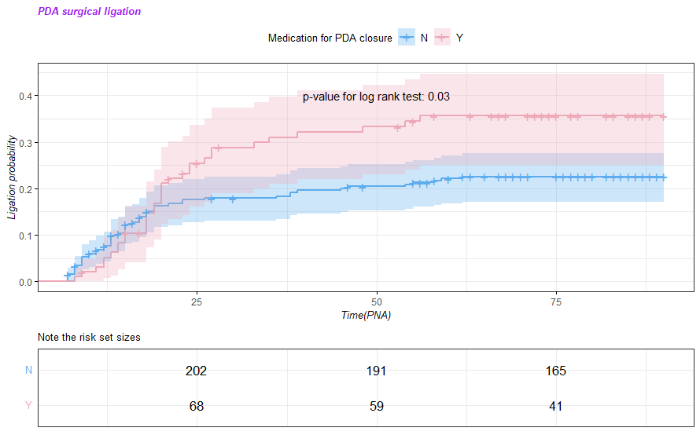
- Surgical ligation; Q1 vs Non medication
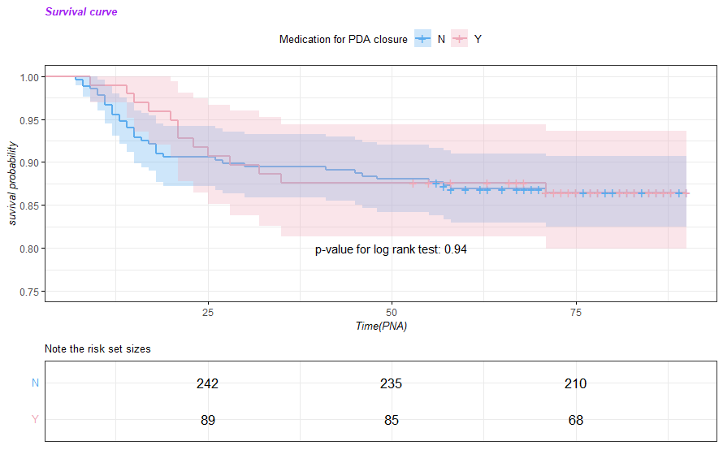
- Survival curve; Q1 vs Non medication

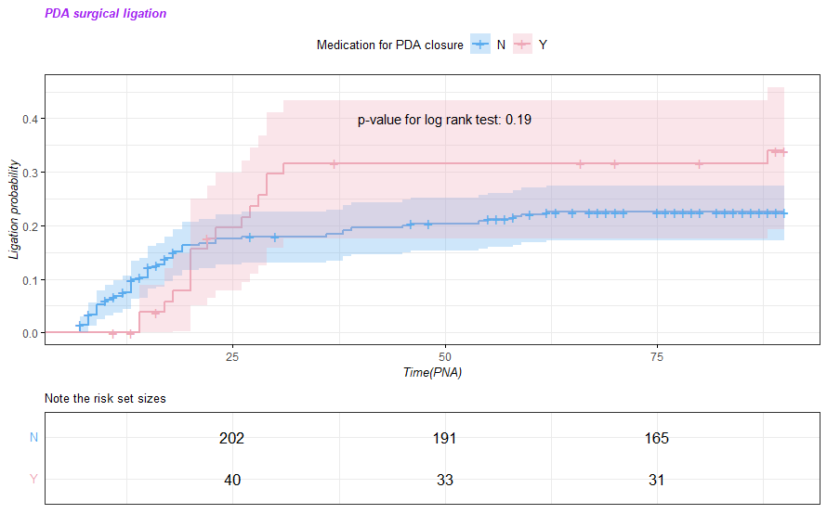
- Surgical ligation; Q2 vs Non medication
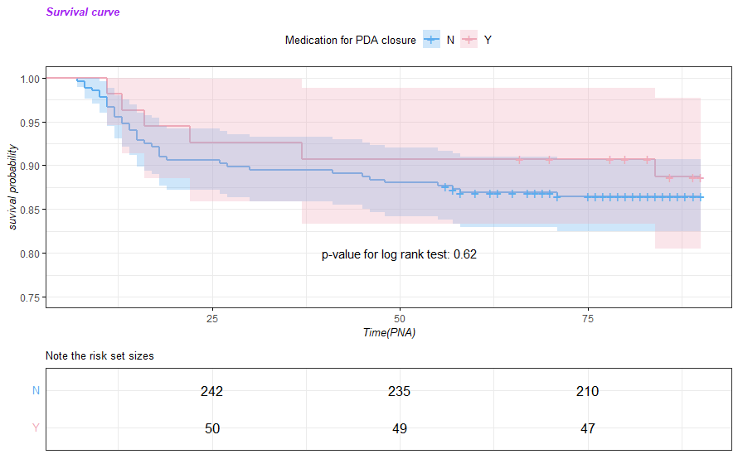

- Survival curve; Q2 vs Non medication
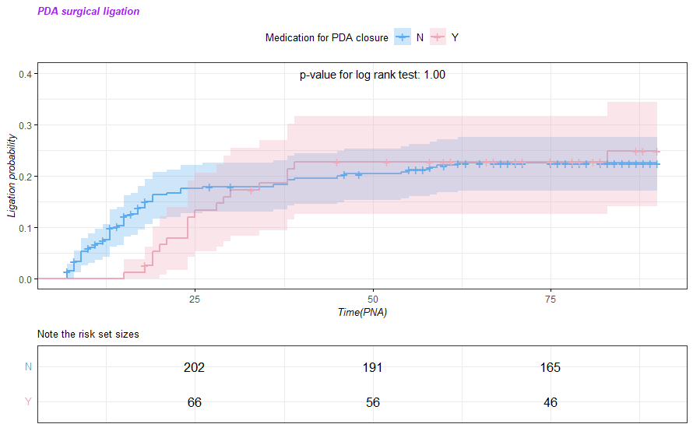
- Surgical ligation; Q3 vs Non medication
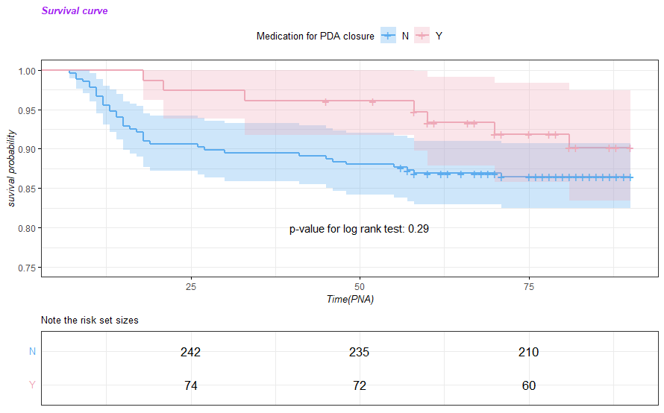

- Survival curve; Q3 vs Non medication
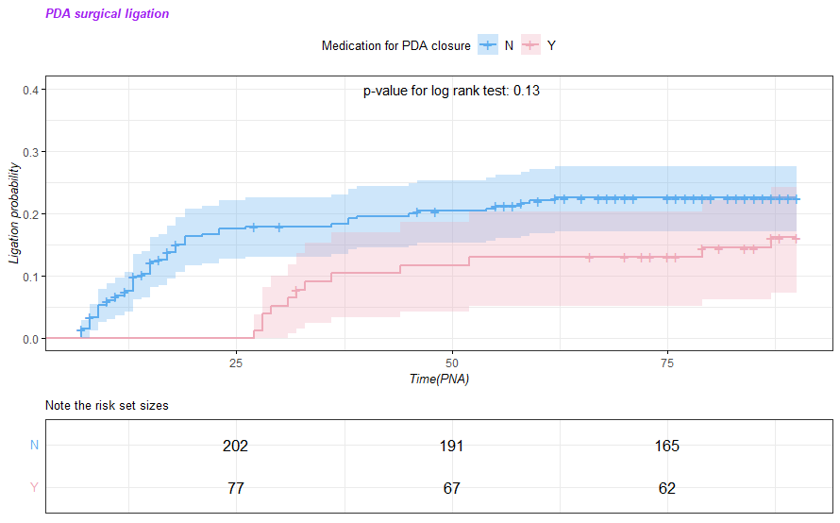
- Surgical ligation; Q4 vs Non medication
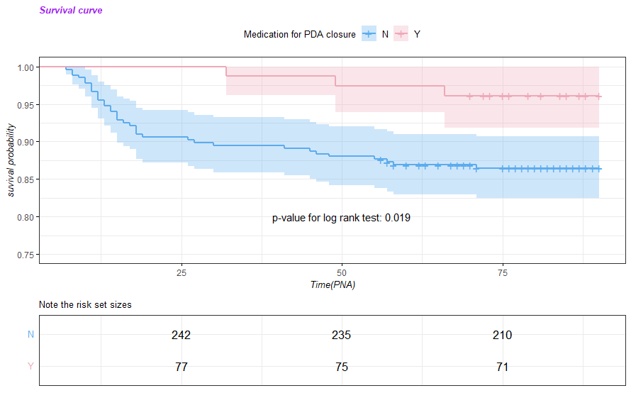
- Survival curve; Q4 vs Non medication

Supplementary material 9. Sensitivity analysis (2) KM plot and log rank test, stratified by medication PNA
PDA, patent ductus arteriosus; PNA, post-natal age(for days)
Stratified by Gestational age | GA 23~25 |  |  | GA 25~28 |  |  | GA 28~
No.(%) | Non-  medication | Medication | p | Non-  medication | Medication | p | Non-  medication | Medication | p
 | (N=124) | (N=145) |  | (N=115) | (N=147) |  | (N=33) | (N=22)
sex |  |  | 0.918 |  |  | 0.62 |  |  | 1
- Male | 59 (47.6%) | 67 (46.2%) |  | 48 (41.7%) | 67 (45.6%) |  | 14 (42.4%) | 9 (40.9%)
- Female | 65 (52.4%) | 78 (53.8%) |  | 67 (58.3%) | 80 (54.4%) |  | 19 (57.6%) | 13 (59.1%)
Multiple gestation |  |  | 0.418 |  |  | 0.58 |  |  | 0.955
- singleton | 86 (69.4%) | 110 (75.9%) |  | 84 (73.0%) | 99 (67.3%) |  | 21 (63.6%) | 14 (63.6%)
- twin | 36 (29.0%) | 32 (22.1%) |  | 30 (26.1%) | 47 (32.0%) |  | 11 (33.3%) | 7 (31.8%)
- triple | 2 ( 1.6%) | 3 ( 2.1%) |  | 1 ( 0.9%) | 1 ( 0.7%) |  | 1 ( 3.0%) | 1 ( 4.5%)
Artificial insemination |  |  | 0.473 |  |  | 1 |  |  | 1
- No | 83 (66.9%) | 104 (71.7%) |  | 89 (77.4%) | 113 (76.9%) |  | 26 (78.8%) | 17 (77.3%)
- Yes | 41 (33.1%) | 41 (28.3%) |  | 26 (22.6%) | 34 (23.1%) |  | 7 (21.2%) | 5 (22.7%)
Maternal diabetes status |  |  | 0.504 |  |  | 0.076 |  |  | 0.784
- No | 114 (91.9%) | 136 (93.8%) |  | 108 (93.9%) | 145 (98.6%) |  | 28 (84.8%) | 20 (90.9%)
- GDM | 7 ( 5.6%) | 8 ( 5.5%) |  | 6 ( 5.2%) | 1 ( 0.7%) |  | 3 ( 9.1%) | 1 ( 4.5%)
- Overt DM | 3 ( 2.4%) | 1 ( 0.7%) |  | 1 ( 0.9%) | 1 ( 0.7%) |  | 2 ( 6.1%) | 1 ( 4.5%)
Maternal hypertension status |  |  | 0.125 |  |  | 0.697 |  |  | 0.62
- No | 109 (87.9%) | 131 (90.3%) |  | 75 (65.2%) | 103 (70.1%) |  | 17 (51.5%) | 11 (50.0%)
- Pregnancy indued | 14 (11.3%) | 9 ( 6.2%) |  | 35 (30.4%) | 39 (26.5%) |  | 15 (45.5%) | 9 (40.9%)
- Chronic hypertension | 1 ( 0.8%) | 5 ( 3.4%) |  | 5 ( 4.3%) | 5 ( 3.4%) |  | 1 ( 3.0%) | 2 ( 9.1%)
Histologic Chorioamnionitis |  |  | 0.458 |  |  | 0.399 |  |  | 0.347
- No | 41 (33.1%) | 57 (39.3%) |  | 66 (57.4%) | 82 (55.8%) |  | 29 (87.9%) | 16 (72.7%)
- Yes | 71 (57.3%) | 72 (49.7%) |  | 40 (34.8%) | 46 (31.3%) |  | 3 ( 9.1%) | 4 (18.2%)
- unknown | 12 ( 9.7%) | 16 (11.0%) |  | 9 ( 7.8%) | 19 (12.9%) |  | 1 ( 3.0%) | 2 ( 9.1%)
PPROM |  |  | 0.778 |  |  | 0.416 |  |  | 1
- No | 69 (55.6%) | 77 (53.1%) |  | 83 (72.2%) | 108 (73.5%) |  | 31 (93.9%) | 21 (95.5%)
- Yes | 53 (42.7%) | 64 (44.1%) |  | 32 (27.8%) | 37 (25.2%) |  | 2 ( 6.1%) | 1 ( 4.5%)
- unknown | 2 ( 1.6%) | 4 ( 2.8%) |  | 0 ( 0.0%) | 2 ( 1.4%) |  | 0 ( 0.0%) | 0 ( 0.0%)
Antenatal steroid |  |  | 0.122 |  |  | 0.935 |  |  | 1
- No | 8 ( 6.5%) | 19 (13.1%) |  | 9 ( 7.8%) | 10 ( 6.8%) |  | 1 ( 3.0%) | 3 (13.6%)
- Yes | 116 (93.5%) | 125 (86.2%) |  | 105 (91.3%) | 136 (92.5%) |  | 32 (97.0%) | 19 (86.4%)
- unknown | 0 ( 0.0%) | 1 ( 0.7%) |  | 1 ( 0.9%) | 1 ( 0.7%) |  | 0 ( 0.0%) | 0 ( 0.0%)
Maternal age, mean(SD), year | 33.6 (3.9) | 32.9(4.6) | 0.179 | 34.0(4.4) | 33.6 (4.2) | 0.378 | 34.2 (4.6) | 32.8 (4.3) | 0.264
Delivery mode |  |  | 0.473 |  |  | 1 |  |  | 1
- V/D | 41 (33.1%) | 41 (28.3%) |  | 15 (13.0%) | 19 (12.9%) |  | 1 ( 3.0%) | 0 ( 0.0%)
- C/S | 83 (66.9%) | 104 (71.7%) |  | 100 (87.0%) | 128 (87.1%) |  | 32 (97.0%) | 22 (100.0%)
GA, mean(SD), weeks | 24.3 (0.8) | 24.4 (0.7) | 0.304 | 26.7 (0.8) | 26.6 (0.7) | 0.084 | 29.8 (1.2) | 30.0 (1.4) | 0.587
1min A/S, mean(SD), score | 4.2 (1.6) | 3.1 (1.8) | <0.001 | 4.4 (1.9) | 3.9 (1.8) | 0.034 | 4.8 (2.2) | 4.6 (1.7) | 0.726
5min A/S, mean(SD), score | 6.8 (1.7) | 5.5 (2.2) | <0.001 | 6.8 (1.9) | 6.4 (1.8) | 0.096 | 7.4 (1.6) | 6.6 (2.1) | 0.125
Birth weight, mean(SD), g | 696.5 (147.2) | 738.7 (125.7) | 0.012 | 782.3 (158.1) | 829.1 (131.2) | 0.011 | 788.6 (152.6) | 850.2 (90.2) | 0.066
Air leak |  |  | 0.812 |  |  | 0.071 |  |  | 0.837
- No | 110 (88.7%) | 131 (90.3%) |  | 104 (90.4%) | 142 (96.6%) |  | 33 (100.0%) | 21 (95.5%)
- Yes | 14 (11.3%) | 14 ( 9.7%) |  | 11 ( 9.6%) | 5 ( 3.4%) |  | 0 ( 0.0%) | 1 ( 4.5%)
Massive pulmonary hemorrhage |  |  | 1 |  |  | 0.557 |  |  | 1
- No | 118 (95.2%) | 139 (95.9%) |  | 104 (90.4%) | 137 (93.2%) |  | 31 (93.9%) | 20 (90.9%)
- Yes | 6 ( 4.8%) | 6 ( 4.1%) |  | 11 ( 9.6%) | 10 ( 6.8%) |  | 2 ( 6.1%) | 2 ( 9.1%)
pulmonary hypertension |  |  | 0.004 |  |  | 0.016 |  |  | 0.074
- No | 81 (65.3%) | 118 (81.4%) |  | 90 (78.3%) | 132 (89.8%) |  | 24 (72.7%) | 21 (95.5%)
- Yes | 43 (34.7%) | 27 (18.6%) |  | 25 (21.7%) | 15 (10.2%) |  | 9 (27.3%) | 1 ( 4.5%)
RDS |  |  | 0.262 |  |  | 0.943 |  |  | 0.23
- No | 2 ( 1.6%) | 7 ( 4.8%) |  | 5 ( 4.3%) | 5 ( 3.4%) |  | 6 (18.2%) | 8 (36.4%)
- Yes | 122 (98.4%) | 138 (95.2%) |  | 110 (95.7%) | 142 (96.6%) |  | 27 (81.8%) | 14 (63.6%)
Surfactant for RDS |  |  | 1 |  |  | 0.741 |  |  | 0.354
- No | 2 ( 1.6%) | 3 ( 2.1%) |  | 4 ( 3.5%) | 3 ( 2.0%) |  | 7 (21.2%) | 8 (36.4%)
- Yes | 122 (98.4%) | 142 (97.9%) |  | 111 (96.5%) | 144 (98.0%) |  | 26 (78.8%) | 14 (63.6%)
Steroid for prevent BPD |  |  | 0.002 |  |  | 0.009 |  |  | 0.08
- No | 28 (22.6%) | 59 (40.7%) |  | 47 (40.9%) | 85 (57.8%) |  | 22 (66.7%) | 20 (90.9%)
- Yes | 96 (77.4%) | 86 (59.3%) |  | 68 (59.1%) | 62 (42.2%) |  | 11 (33.3%) | 2 ( 9.1%)
Oxygen status at PNA 28d |  |  | 0.004 |  |  | 0.005 |  |  | 0.02
- No | 14 (12.5%) | 4 ( 2.9%) |  | 27 (26.0%) | 15 (10.6%) |  | 13 (43.3%) | 8 (36.4%)
- lower 30% | 35 (31.2%) | 61 (44.9%) |  | 45 (43.3%) | 81 (57.4%) |  | 10 (33.3%) | 14 (63.6%)
-higher 30% | 63 (56.2%) | 71 (52.2%) |  | 32 (30.8%) | 45 (31.9%) |  | 7 (23.3%) | 0 ( 0.0%)
BPD at PMA 36wks |  |  | 0.001 |  |  | 0.021 |  |  | 0.107
- No | 1 ( 0.8%) | 0 ( 0.0%) |  | 6 ( 5.2%) | 2 ( 1.4%) |  | 5 (15.2%) | 5 (22.7%)
- Stage1 | 19 (15.3%) | 51 (35.2%) |  | 25 (21.7%) | 54 (36.7%) |  | 5 (15.2%) | 9 (40.9%)
- Stage2 | 28 (22.6%) | 26 (17.9%) |  | 22 (19.1%) | 22 (15.0%) |  | 5 (15.2%) | 2 ( 9.1%)
- Stage 3 | 56 (45.2%) | 44 (30.3%) |  | 49 (42.6%) | 57 (38.8%) |  | 11 (33.3%) | 6 (27.3%)
- unknown(Transfer out or expire) | 19 (15.3%) | 17 (11.7%) |  | 13 (11.3%) | 9 ( 6.1%) |  | 3 ( 9.1%) | 0 ( 0.0%)
- Missing | 1 ( 0.8%) | 7 ( 4.8%) |  | 0 ( 0.0%) | 3 ( 2.0%) |  | 4 (12.1%) | 0 ( 0.0%)
Treatment failure |  |  | 0.001 |  |  | 0.306 |  |  | 0.219
- No | 100 (80.6%) | 88 (60.7%) |  | 85 (73.9%) | 114 (77.6%) |  | 21 (63.6%) | 17 (77.3%)
- Yes | 24 (19.4%) | 52 (35.9%) |  | 30 (26.1%) | 31 (21.1%) |  | 8 (24.2%) | 5 (22.7%)
- Missing | 0 ( 0.0%) | 5 ( 3.4%) |  | 0 ( 0.0%) | 2 ( 1.4%) |  | 4 (12.1%) | 0 ( 0.0%)
Sepsis during hospital course |  |  | 0.874 |  |  | 0.952 |  |  | 0.842
- No | 85 (68.5%) | 97 (66.9%) |  | 84 (73.0%) | 109 (74.1%) |  | 25 (75.8%) | 18 (81.8%)
- Yes | 39 (31.5%) | 48 (33.1%) |  | 31 (27.0%) | 38 (25.9%) |  | 8 (24.2%) | 4 (18.2%)
Meningitis during hospital course |  |  | 1 |  |  | 1 |  |  | 1
- No | 123 (99.2%) | 143 (98.6%) |  | 115 (100.0%) | 147 (100.0%) |  | 33 (100.0%) | 22 (100.0%)
- Yes | 1 ( 0.8%) | 2 ( 1.4%) |  | 0 ( 0.0%) | 0 ( 0.0%) |  | 0 ( 0.0%) | 0 ( 0.0%)
Mortality during PNA 90d |  |  | 0.143 |  |  | 0.144 |  |  | 0.044
- No | 104 (83.9%) | 119 (82.1%) |  | 102 (88.7%) | 134 (91.2%) |  | 25 (75.8%) | 22 (100.0%)
- Yes | 19 (15.3%) | 19 (13.1%) |  | 13 (11.3%) | 10 ( 6.8%) |  | 4 (12.1%) | 0 ( 0.0%)
- Missing | 1 ( 0.8%) | 7 ( 4.8%) |  | 0 ( 0.0%) | 3 ( 2.0%) |  | 4 (12.1%) | 0 ( 0.0%)
Periventricular leukomalacia |  |  | 0.59 |  |  | 0.943 |  |  | 0.396
- No | 116 (93.5%) | 132 (91.0%) |  | 110 (95.7%) | 142 (96.6%) |  | 30 (90.9%) | 22 (100.0%)
- Yes | 8 ( 6.5%) | 13 ( 9.0%) |  | 5 ( 4.3%) | 5 ( 3.4%) |  | 3 ( 9.1%) | 0 ( 0.0%)
IVH stage |  |  | <0.001 |  |  | 0.001 |  |  | 0.407
- No | 32 (25.8%) | 79 (54.5%) |  | 48 (41.7%) | 92 (62.6%) |  | 16 (48.5%) | 14 (63.6%)
- Stage 1 | 92 (74.2%) | 66 (45.5%) |  | 67 (58.3%) | 55 (37.4%) |  | 17 (51.5%) | 8 (36.4%)
NEC over stage 2 |  |  | 0.34 |  |  | 1 |  |  | 1
- No | 118 (95.2%) | 132 (91.0%) |  | 111 (96.5%) | 139 (94.6%) |  | 32 (97.0%) | 21 (95.5%)
- Yes | 6 ( 4.8%) | 12 ( 8.3%) |  | 4 ( 3.5%) | 8 ( 5.4%) |  | 1 ( 3.0%) | 1 ( 4.5%)
- T/O for surgery | 0 ( 0.0%) | 1 ( 0.7%) |  | 0 ( 0.0%) | 0 ( 0.0%) |  | 0 ( 0.0%) | 0 ( 0.0%)
SIP |  |  | 1 |  |  | 1 |  |  | 1
- No | 122 (98.4%) | 143 (98.6%) |  | 115 (100.0%) | 146 (99.3%) |  | 33 (100.0%) | 22 (100.0%)
- Yes | 2 ( 1.6%) | 2 ( 1.4%) |  | 0 ( 0.0%) | 1 ( 0.7%) |  | 0 ( 0.0%) | 0 ( 0.0%)
Transfer out |  |  | 0.115 |  |  | 0.339 |  |  | 0.244
- No | 123 (99.2%) | 138 (95.2%) |  | 115 (100.0%) | 144 (98.0%) |  | 29 (87.9%) | 22 (100.0%)
- Yes | 1 ( 0.8%) | 7 ( 4.8%) |  | 0 ( 0.0%) | 3 ( 2.0%) |  | 4 (12.1%) | 0 ( 0.0%)
Supplementary materials 10. Sensitivity analysis (3), characteristics stratified by GA.
GDM, Gestational diabetes; DM, Diabetes mellitus; PPROM, Preterm Premature Rupture of Membranes; V/D, Vaginal delivery; C/S, caesarean section; GA, Gestational age; RDS, Repiratory distress syndrome; BPD, Bronchopulmonary dysplasia; PNA, post-natal age; PDA, patent ductus arteriosus; IVH, Intraventricular hemorrhage; NEC, Necrotizing enterocolitis; SIP, spontaneous intestinal perforation
 | Logistic regression | Model 1 |  | Model2 |  | Model3
 |  | OR | 95%CI | OR | 95%CI | OR | 95%CI
 | Oxygen supply at PNA 28d
GA 23~25wks | no need
GA 23~25wks | FiO2 < 30% | 6.087 | 1.860~19.918 | 5.886 | 2.484~13.951 | 6.549 | 2.651~16.181
GA 23~25wks | FiO2 > 30% | 3.935 | 1.232~12.563 | 4.209 | 1.803~9.827 | 5.630 | 2.298~13.797
GA 23~25wks | Treatment failure | 1.179 | 1.060~1.312 | 1.176 | 1.059~1.307 | 1.211 | 1.088~1.347
GA 23~25wks | BPD higher than moderate | 0.868 | 0.774~0.975 | 0.868 | 0.774~0.975 | 0.868 | 0.774~0.975
GA 23~25wks | All-cause mortalities during PNA 90d | 0.983 | 0.902~1.072 | 1.004 | 0.923~1.092 | 0.985 | 0.905~1.072
GA 25~28wks |  | OR | 95%CI | OR | 95%CI | OR | 95%CI
GA 25~28wks | Oxygen supply at PNA 28d
GA 25~28wks | no need
GA 25~28wks | FiO2 < 30% | 3.240 | 1.563~6.716 | 3.571 | 2.112~6.038 | 3.702 | 2.170~6.315
GA 25~28wks | FiO2 > 30% | 2.532 | 1.164~5.506 | 2.823 | 1.611~4.946 | 3.235 | 1.814~5.770
GA 25~28wks | Treatment failure during PNA 90d | 0.951 | 0.858~1.055 | 0.949 | 0.857~1.501 | 0.955 | 0.861~1.059
GA 25~28wks | BPD higher than moderate | 0.895 | 0.791~1.013 | 0.927 | 0.820~1.048 | 0.957 | 0.850~1.077
GA 25~28wks | Mortality | 0.957 | 0.893~1.027 | 0.971 | 0.904~1.043 | 0.964 | 0.896~1.036
GA 25~28wks |  | OR | 95%CI | OR | 95%CI | OR | 95%CI
GA 25~28wks | Oxygen supply at PNA 28d
GA 25~28wks | no need
GA 25~28wks | FiO2 < 30% | 2.275 | 0.687~7.536 | 2.023 | 0.879~4.652 | 3.013 | 1.182~7.685
GA 25~28wks | FiO2 > 30% | 0.000 | 1.717e-50~3.790e+41 | 0.000 | 1.541e-23~2.286e+15 | 0.000 | 8.696e-102~3.593e+91
GA 25~28wks | Treatment failure | 0.985 | 0.780~1.244 | 1.045 | 0.825~1.324 | 1.054 | 0.823~1.350
GA 25~28wks | BPD higher than moderate | 0.777 | 0.587~1.030 | 0.872 | 0.661~1.150 | 0.894 | 0.667~1.180
GA 25~28wks | All-cause mortalities during PNA 90d | 0.871 | 0.752~1.009 | 0.893 | 0.790~1.010 | 0.883 | 0.778~1.003
Supplementary materials 11. Sensitivity analysis (3), logistic regressions stratified by GA
* Model 1, non adjusted; Model 2, weighted by IPW; Model3, model2 + adjusted by RDS, Postnatal steroid
PNA, Post-natal age; FiO2, fraction inhalation of Oxygen; OR, Odd ratio; CI, confidential index

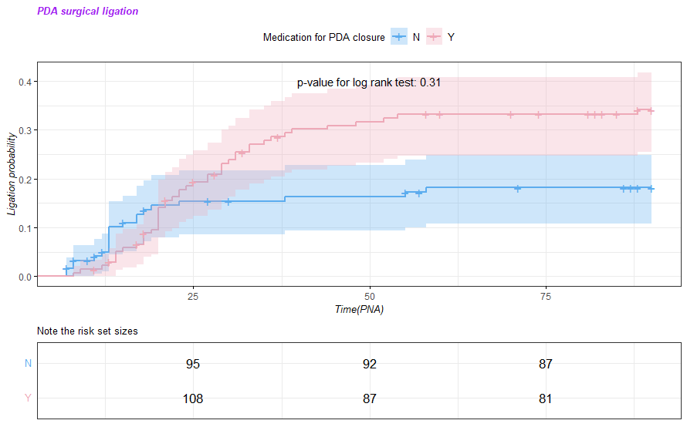
- Surgical ligation in GA 23⁺⁰~25⁺⁶wks
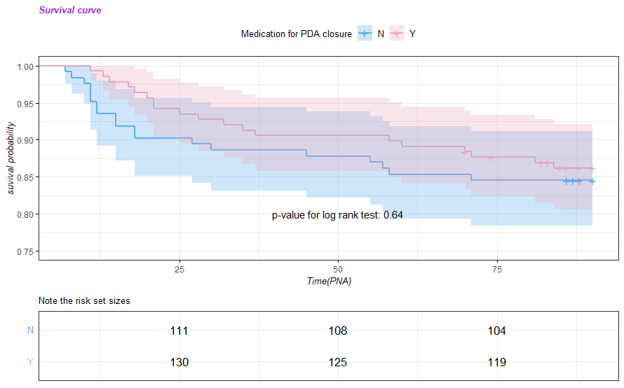
- Survival curve in GA 23⁺⁰~25⁺⁶wks

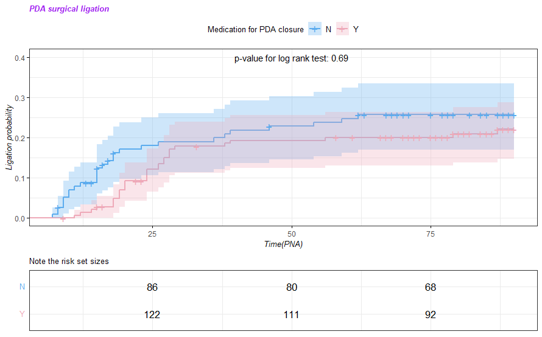
- Surgical ligation in GA 26⁺⁰~28⁺⁶wks
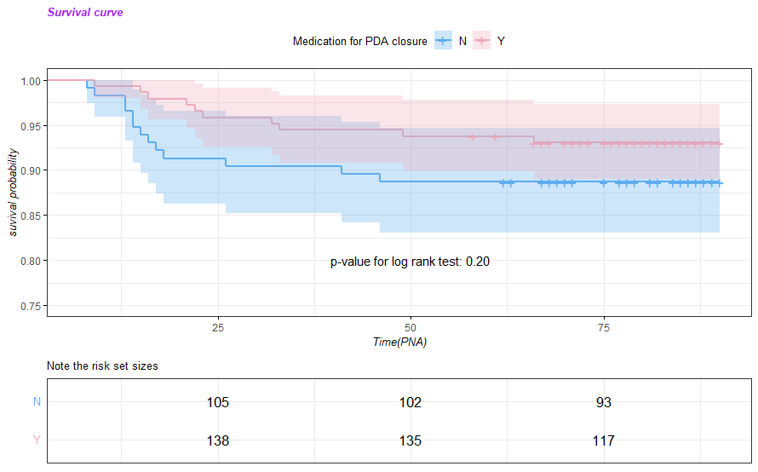

- Survival curve in GA 26⁺⁰~28⁺⁶wks
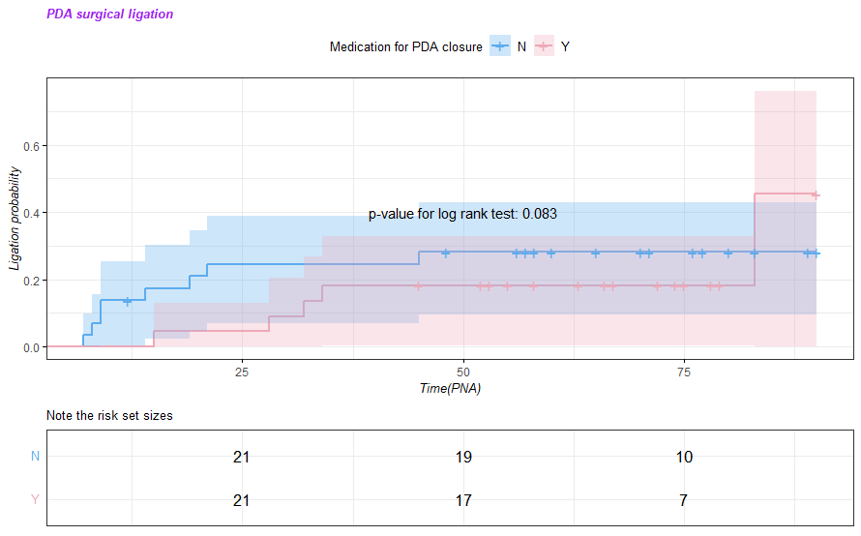
- Surgical ligation in GA 29⁺⁰~36⁺⁶wks
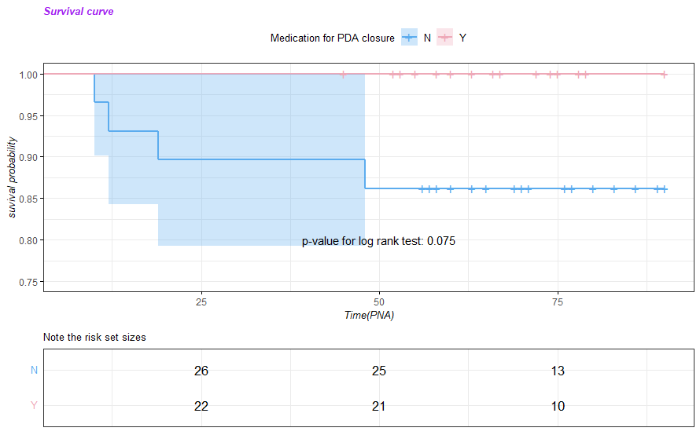

- Survival curve in GA 29⁺⁰~36⁺⁶wks

Supplementary material 12. Sensitivity analysis (3) KM plot and log rank test stratified by GA
PDA, patent ductus arteriosus; Time, post-natal age(for days)

