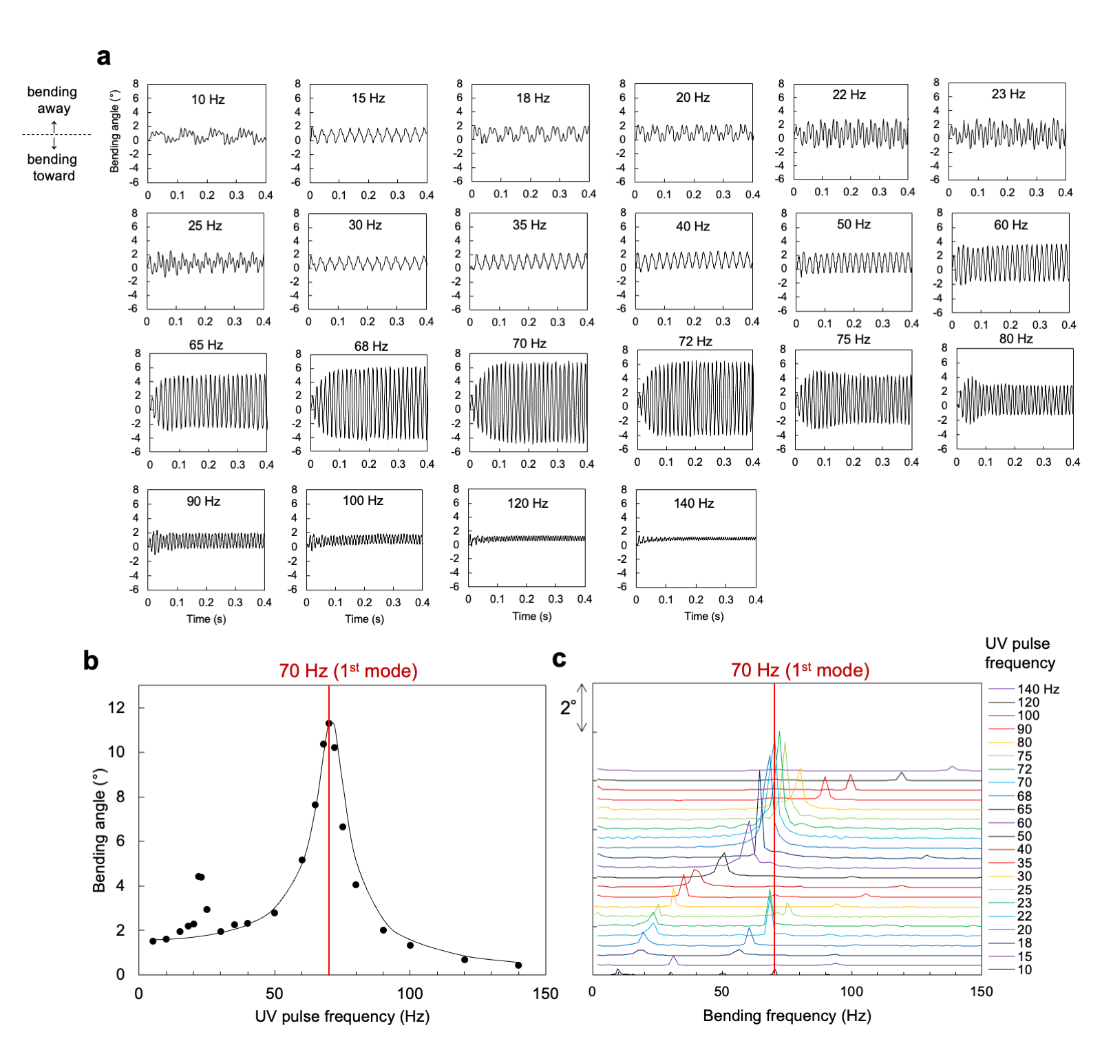

Extended Data Fig. 1. First natural vibration mode of crystal I. (a) Time dependence of bending angle upon pulsed UV (375 nm; 961 mW cm^{–2}) irradiation from 10 to 140 Hz. (b) UV pulse frequency dependence of bending angle. (c) Extraction of the oscillatory frequencies by FFT.

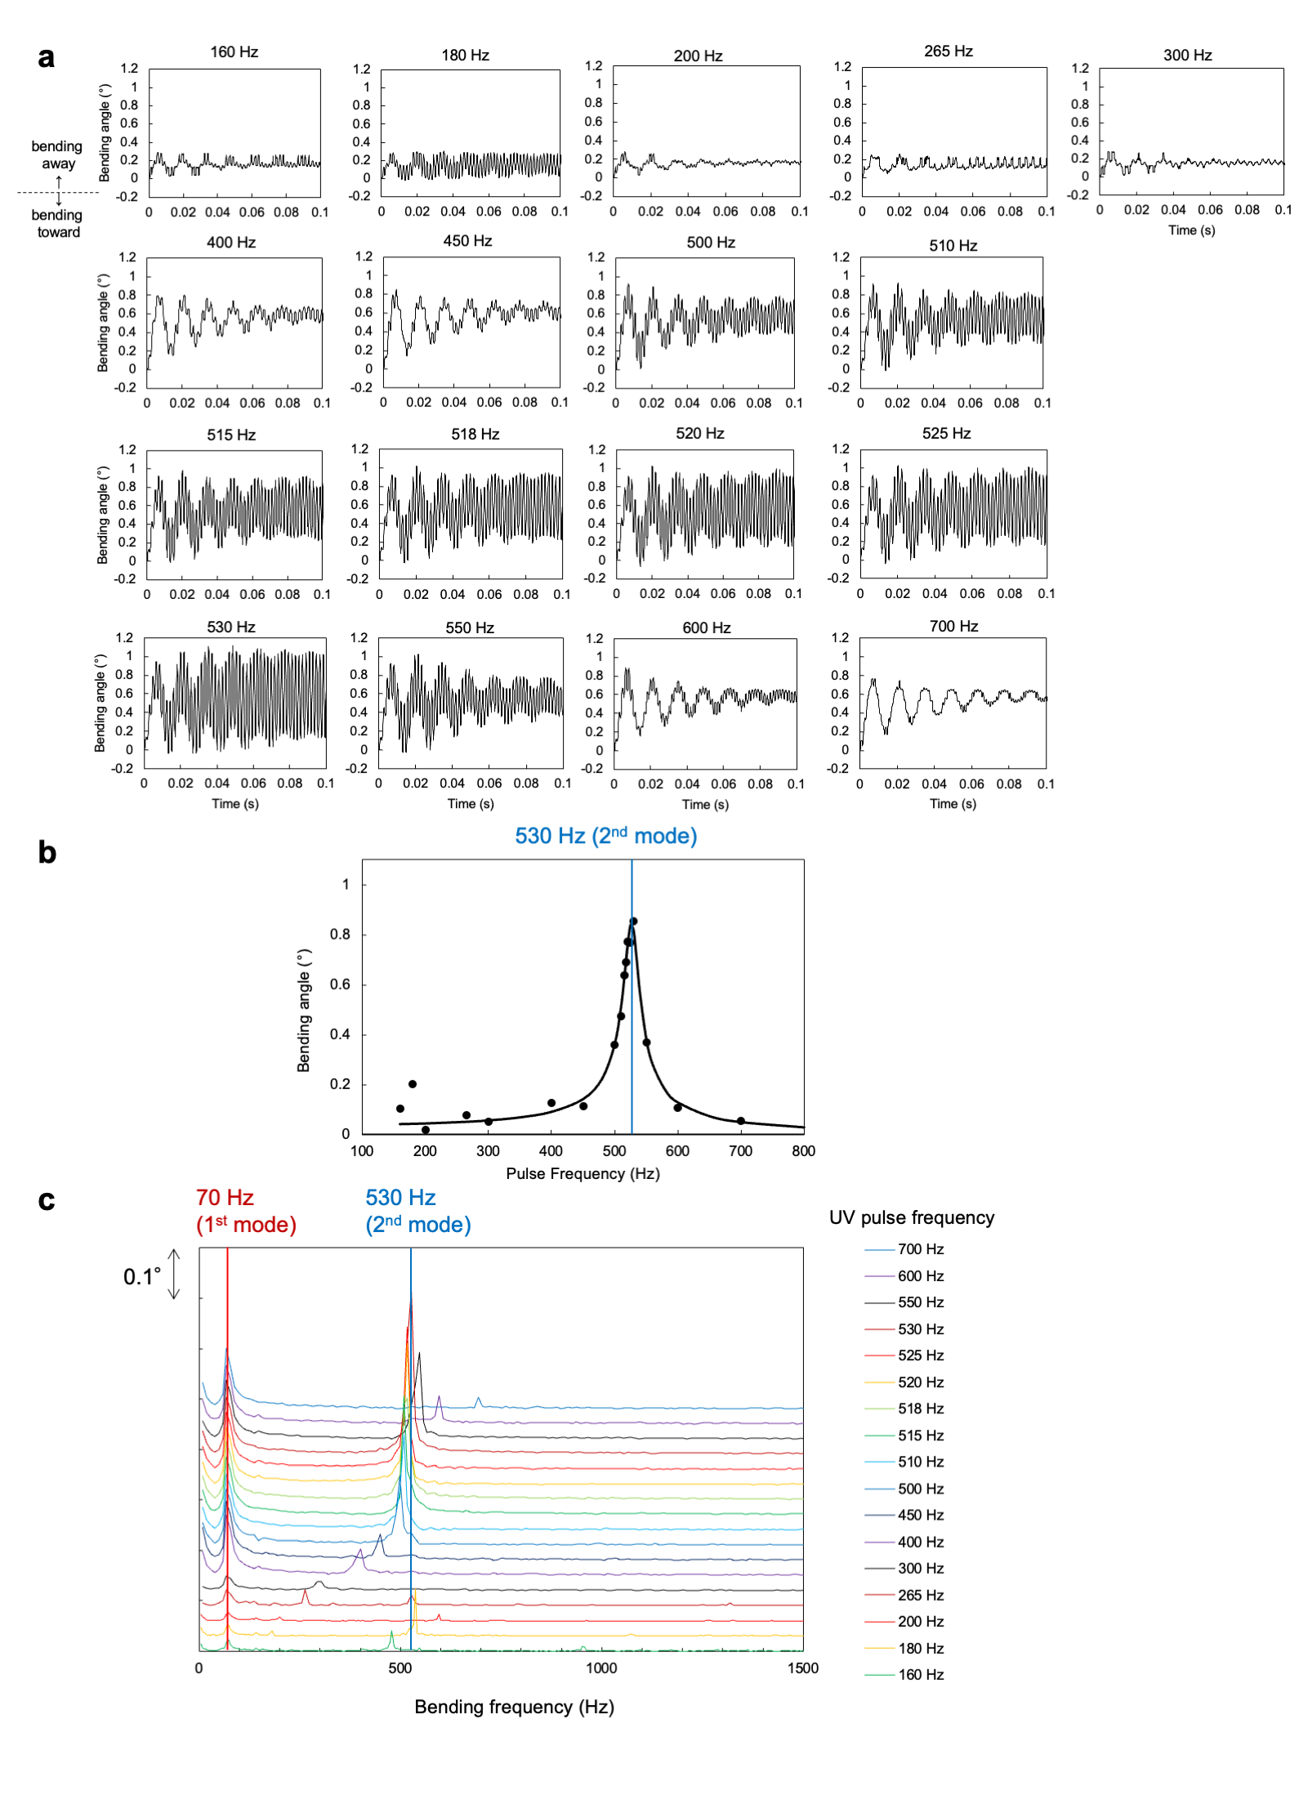
Extended Data Fig. 2. Second natural vibration mode of crystal I. (a) Time dependence of bending angle upon pulsed UV (375 nm; 961 mW cm^{–2}) irradiation from 160 to 700 Hz. (b) UV pulse frequency dependence of bending angle. (c) Extraction of the oscillatory frequencies by FFT.

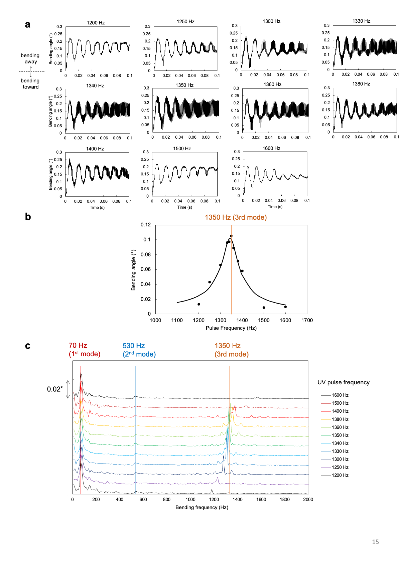

Extended Data Fig. 3. Third natural vibration mode of crystal I. (a) Time dependence of the bending angle upon pulsed UV (375 nm; 961 mW cm^{–2}) irradiation from 1200 to 1600 Hz. (b) UV pulse frequency dependence of bending angle. (c) Extraction of the oscillatory frequencies by FFT.

