Supplementary Information

On the crack resistance and damage tolerance of 3D-printed nature-inspired hierarchical composite architecture
Siwon Yu^{1,2,3}, Seunggyu Park³, Kang Taek Lee⁴, Jun Yeon Hwang^{3*}, Soon Hyung Hong^{2*}
& Thomas James Marrow^{1*}

¹Department of Materials, University of Oxford, Oxford OX1 3PH, UK
²Department of Material Science and Engineering, Korea Advanced Institute of Science and Technology (KAIST), 291 Daehak-ro, Yuseong-gu, Daejeon, 34141, Republic of Korea
³Institute of Advanced Composite Materials, Korea Institute of Science and Technology
(KIST), Jeonbuk, 55324, Republic of Korea
⁴Department of Mechanical Engineering, Korea Advanced Institute of Science and
Technology (KAIST), 291 Daehak-ro, Yuseong-gu, Daejeon, 34141, Republic of Korea

*e-mail: Junyeon.Hwang@kist.re.kr; shhong@kaist.ac.kr; james.marrow@materials.ox.ac.uk

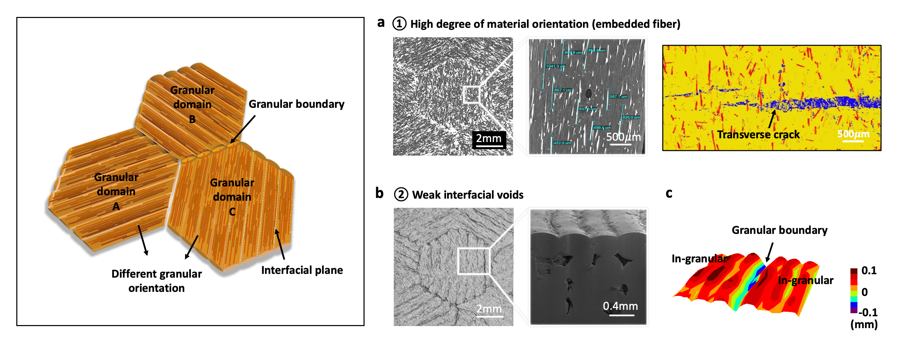

Fig. S1 | Two process-induced microstructural features.
a, High degree of material alignment (fused filament and embedded fiber) due to the shear-driven printing process. Effective obstruction of embedded fibers against crack penetration into the trans-filament. b, c, Weak interfacial voids as grain boundary and crystal plane. The depth profile shows the different interfacial adhesion areas between the grain boundary and crystal plane.
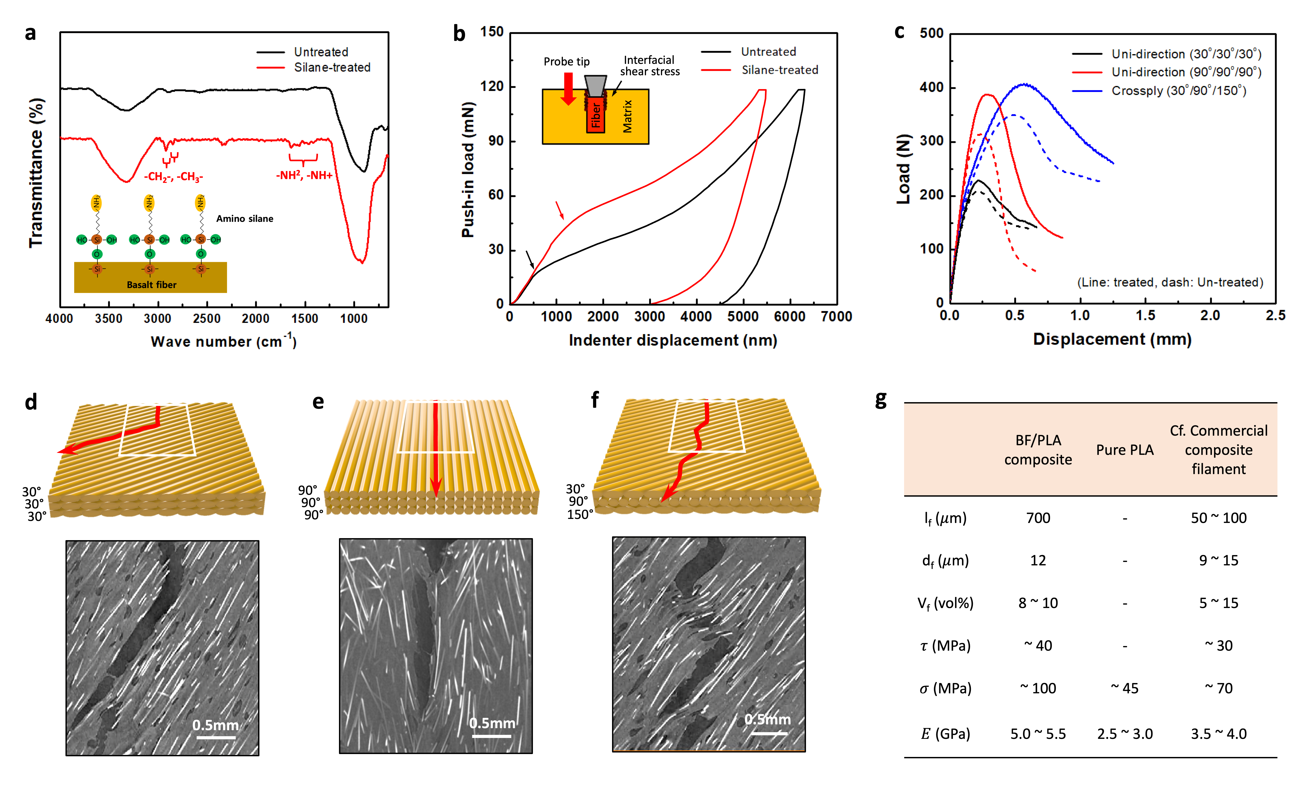
Fig. S2 | Comparison of fracture toughness of three monolithic samples before and after surface treatment.
a, FT-IR results showing the change in chemical bonding of the fiber surface before and after surface treatment. b, Nano-indentation push-in test results showing the change in interfacial adhesion between fiber and matrix before and after surface treatment. c, Load-displacement (L-D) curve showing the characteristic mechanical responses of notched samples in monolithic composites. Line and dash compare L-D curves before and after fiber treatment. d, e, f, X-ray tomography images showing the notch fracture toughness behavior of three monolithic composites. Unidirectional samples (d) [30°/30°/30°], (e) [90°/90°/90°], and crossply sample (f) [30°/90°/150°]. g, Comparison of geometric parameters and physical properties between composite and pure filaments. l_{f}: fiber length, d_{f}: fiber diameter, V_{f}: fiber volume fraction, 𝜏: interfacial shear strength (IFSS), 𝜎: tensile strength, E: tensile modulus (stiffness).
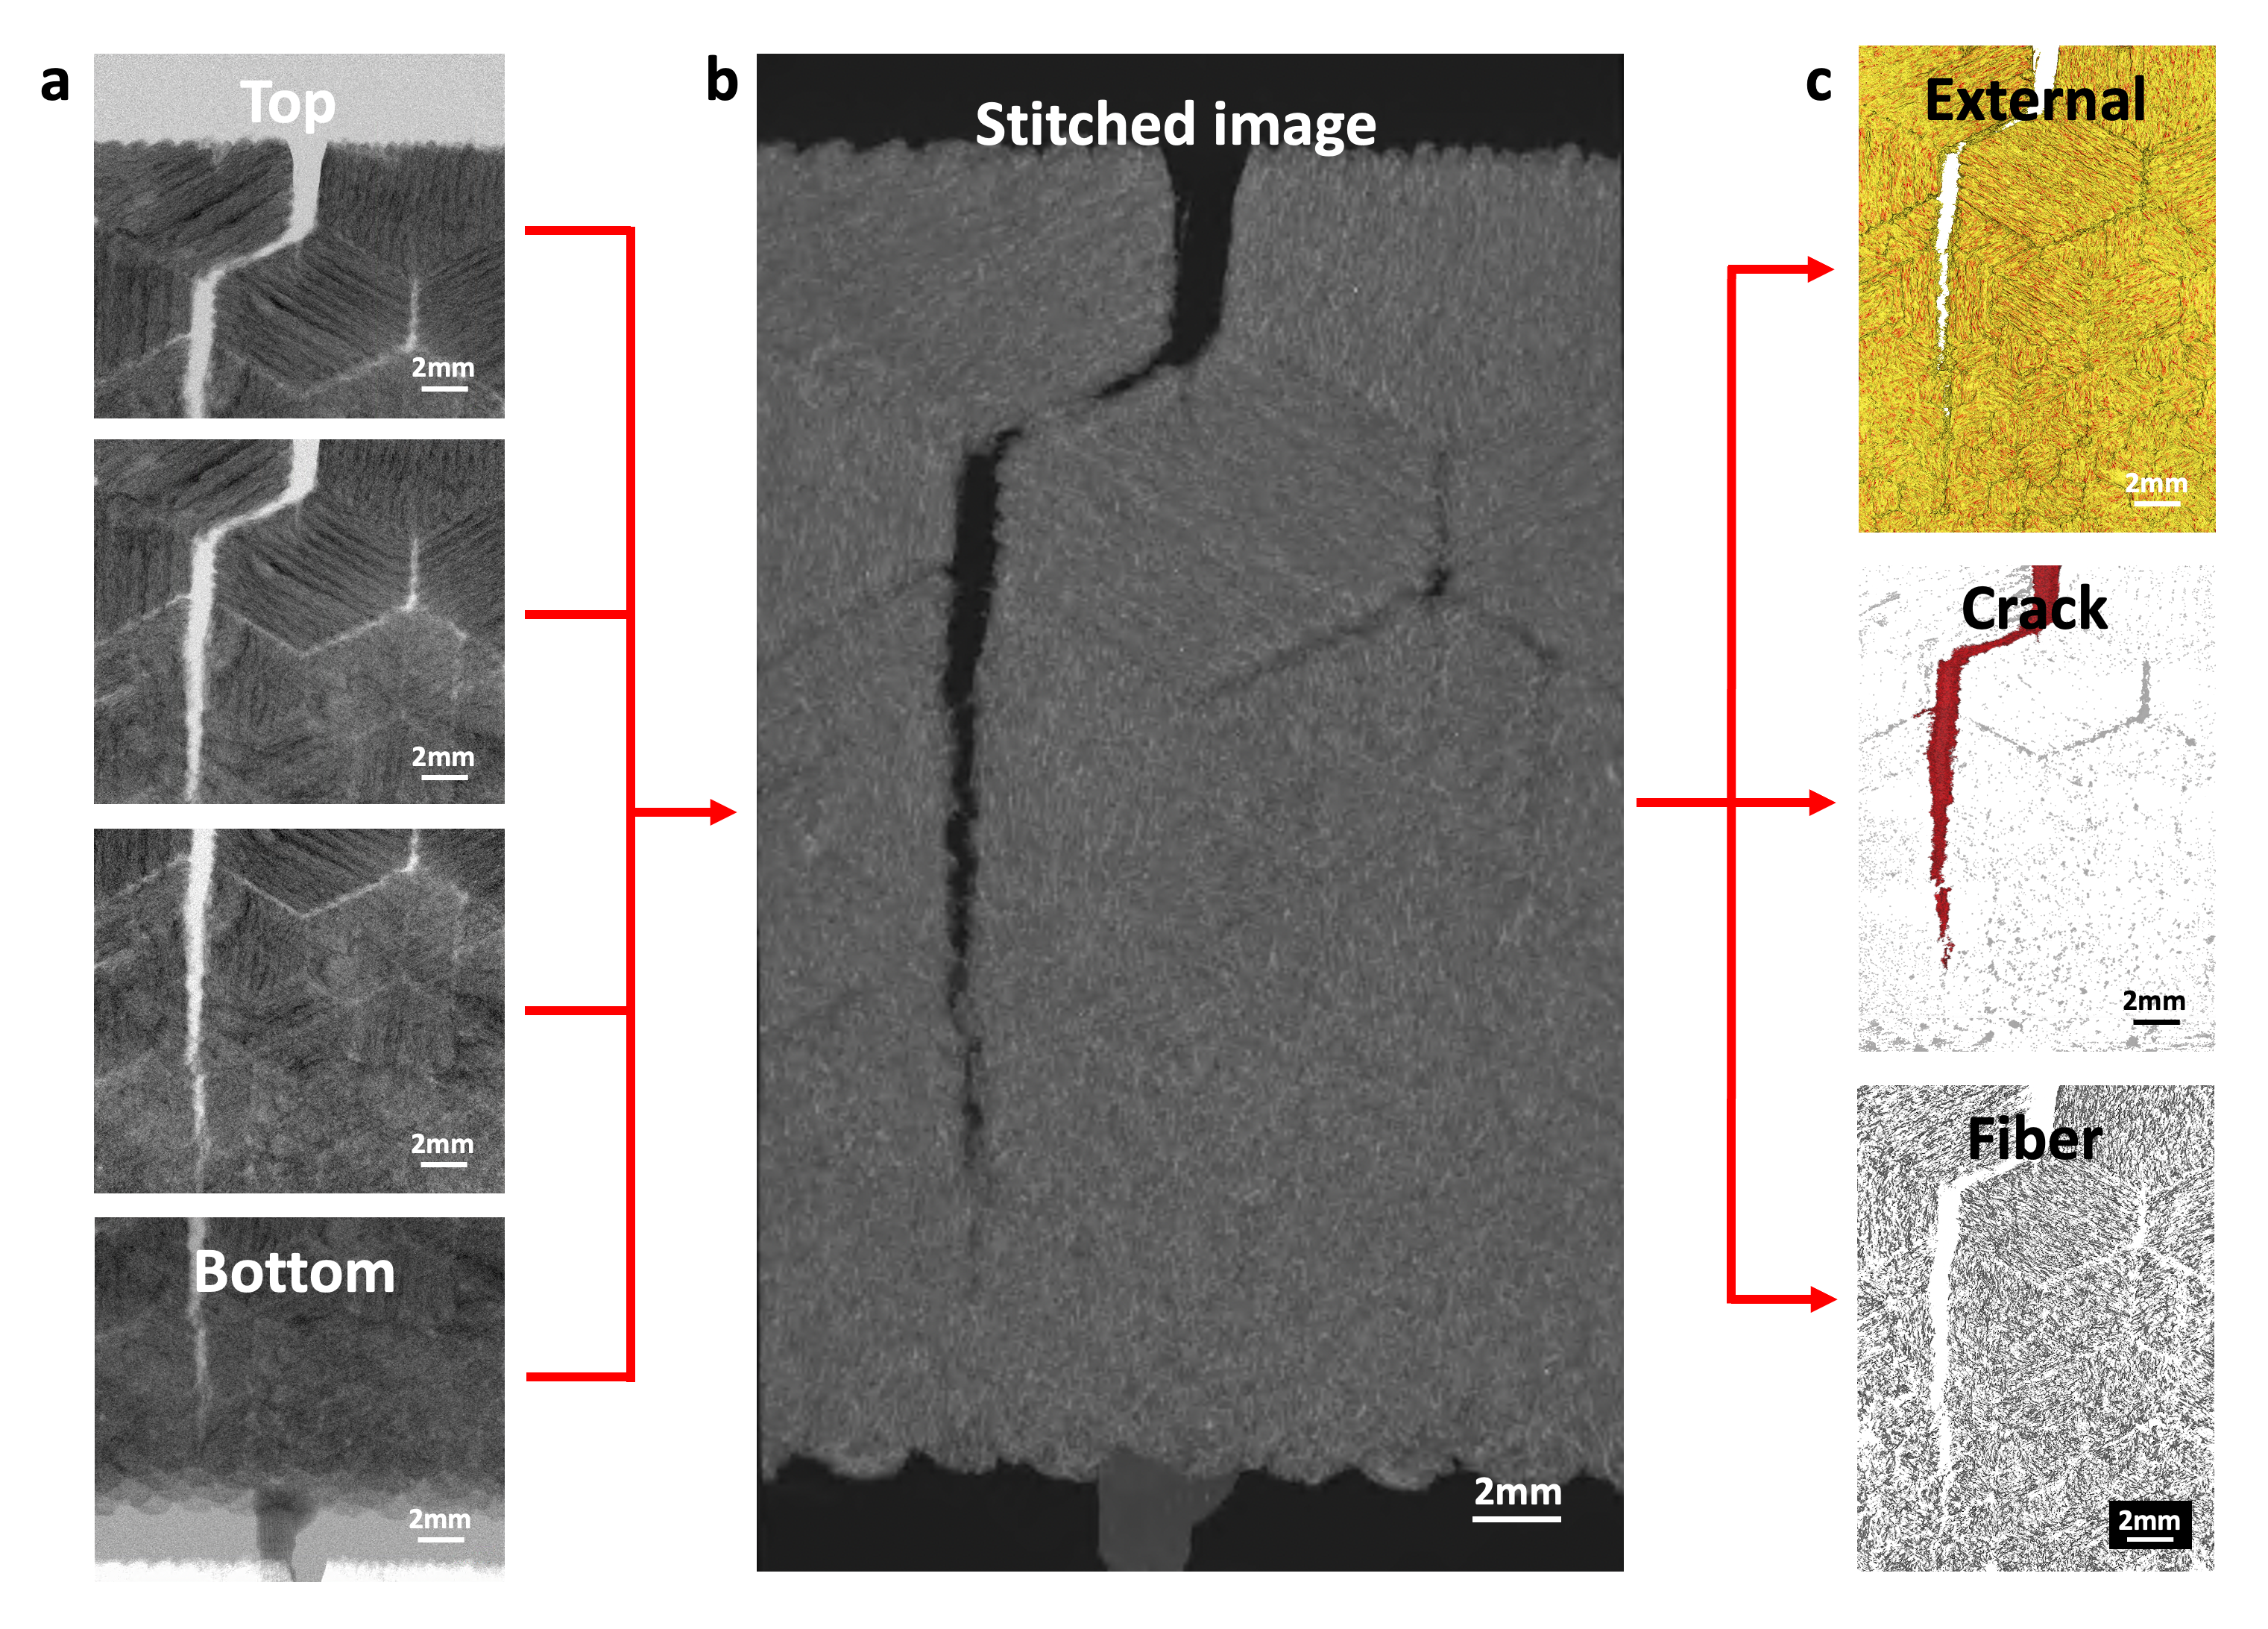
Fig. S3 | Large field of view XRM imaging with stitch mode.
a, Successive tomographic images from top to bottom in four partitioned windows. b, One stitched image with a large field of view and high resolution. c, Image segmentation results of stitched image showing microscale fiber orientation/distributions as well as macroscale crack morphology (Sample size= 30x35mm, Fiber length= 700μm). Stitching mode captures multiple images and stitches them together to visualize large samples wider and taller than standard fields of view. As shown in Fig. S1, successive tomographic images from top to bottom in four partitioned windows create one stitched image with a large field of view and high resolution. As a result, stitched images provide all the results for microscale fiber orientation/distributions as well as macroscale crack morphology.

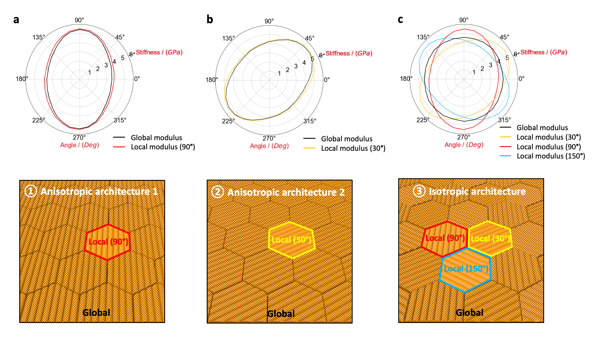
Fig. S4 | Geometric image-based simulations showing anisotropic approximations of the local granular domain and the global architecture.
a, b, c, Spherical graph plotted as modulus over azimuth angle in the X-Y plane; Anisotropic architecture 1 (a), anisotropic architecture 2 (b), and isotropic architecture (c).
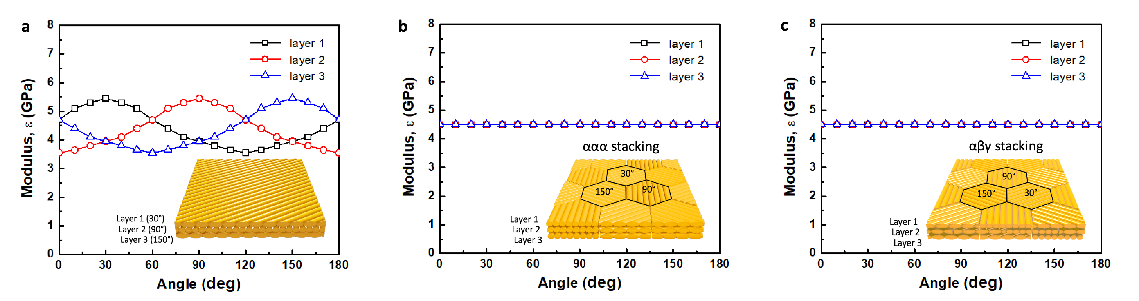
Fig. S5 | Modulus variation with radiation angle for each layer in monolithic and granular architecture composites.
a, Monolithic composites with global isotropy, but different interlaminar modulus. b, c, Granular architecture composites of ααα and αβγ stacking sequences with global isotropy and equal interlayer modulus.

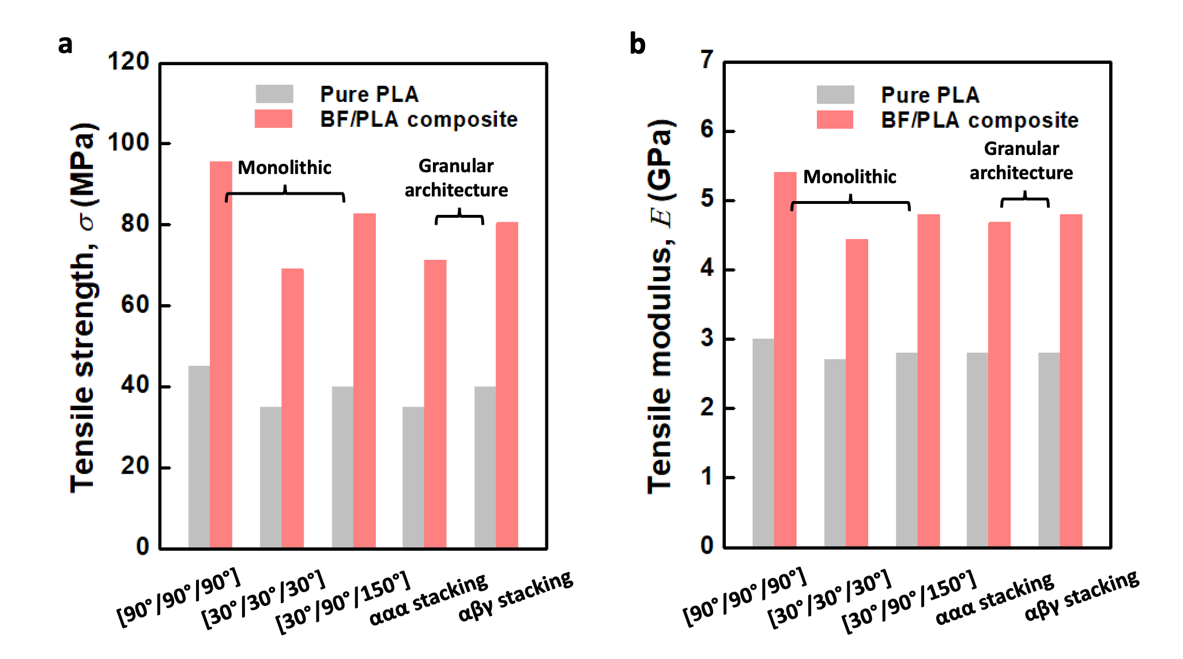
Fig. S6 | Comparison of non-notch tensile strengths of monolithic layup and granular architecture composites. a, Tensile strength (σ), and b, tensile modulus (E). To ensure a fair comparison with the monolithic samples, the filament packing density in the inter- and inner-granular domains was fully filled.

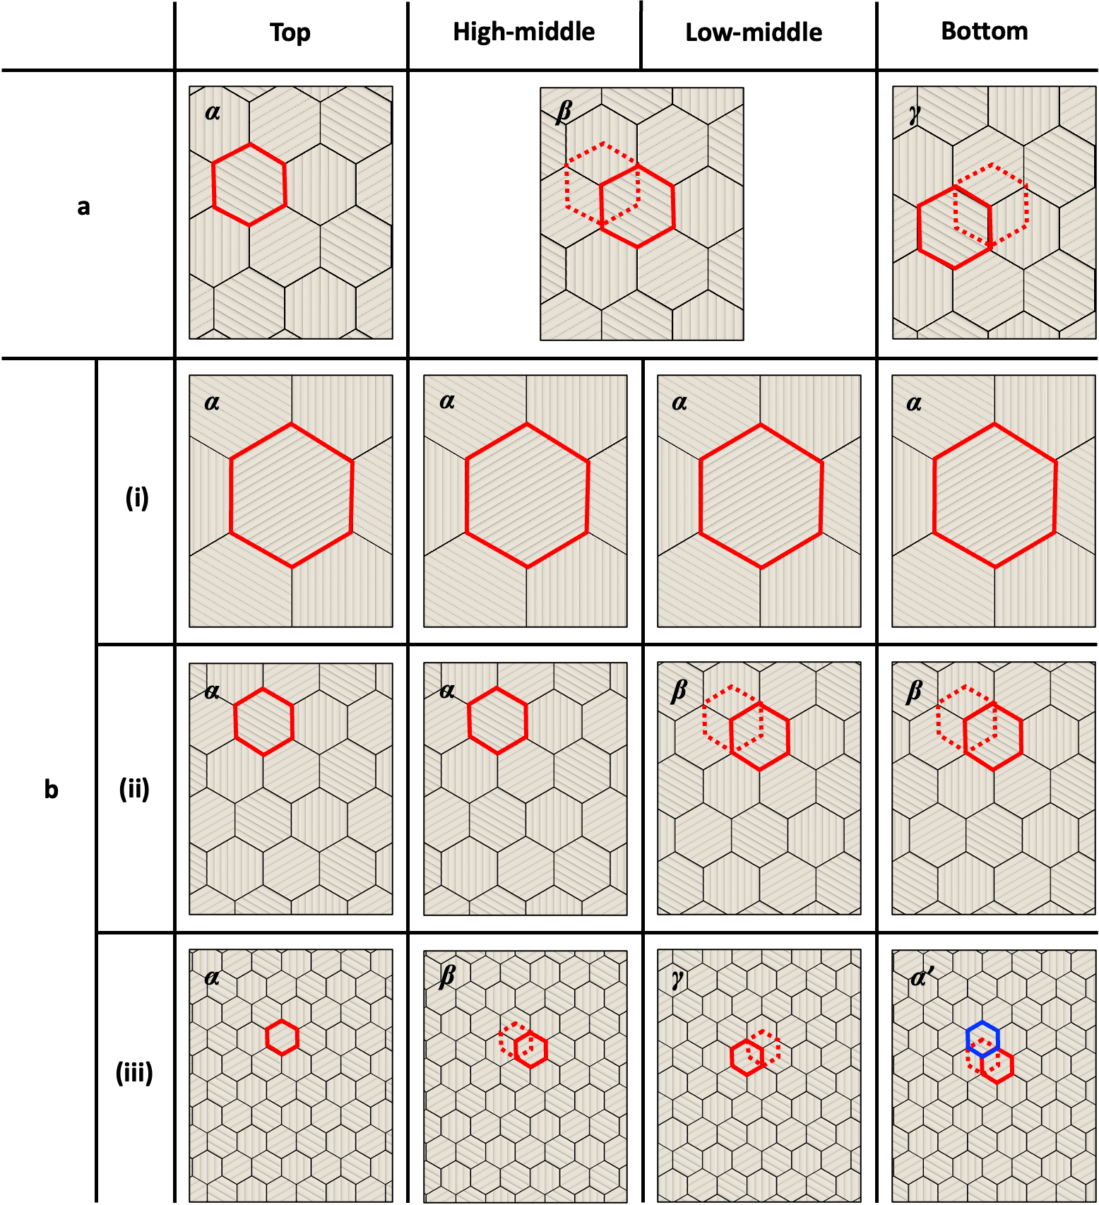
Fig. S7 | Detailed definition of drawings showing the stacking sequence of the architectures.
a, Alternating αβγ stacking sequence architecture. b, Grains L-, M-, S-inspired architectures; (i) αααα, (ii) ααββ, and (iii) αβγα’ stacking sequences of L-, M-, and S-inspired architectures. The αβγ stacking sequence matches the center points of the upper layer granular blocks to the angular points of the lower layer granular blocks. The center points of the granular blocks are shifted layer by layer in a zig-zag form to the right and left lower angular points, along with the accompanying orientation movements. Red solid line: current position, red dot line: previous position, blue solid line: α' position (same position as α, but different grain orientation)

