Table S1 (a) Pairwise comparison of each treatment plot to the control in a Dunnett’s test and (b) ANODEV table of between-treatment effects for the model of final native cover as a function of seed mix functional group and native seeding density for the 2022 growing season at Farmington Bay. There was no evidence for an effect of group when multiple comparisons were made using the Tukey HSD method at α = 0.10
(a) Contrast | Ratio | SE | P-value
Perennial forb 𝗑 Low – Control | -0.08 | 0.06 | 0.76
Perennial forb 𝗑 High – Control | -0.06 | 0.06 | 0.89
Rush 𝗑 Low – Control | -0.09 | 0.06 | 0.67
Rush 𝗑 High – Control | -0.08 | 0.06 | 0.76
Grass 𝗑 Low – Control | 0.05 | 0.06 | 0.93
Grass 𝗑 High – Control | 0.03 | 0.06 | 0.99
Bulrush 𝗑 Low – Control | 0.03 | 0.06 | 0.99
Bulrush 𝗑 High – Control | -0.0008 | 0.06 | 1.00
Annual forb 𝗑 Low – Control | -0.10 | 0.06 | 0.54
Annual forb 𝗑 High – Control | 0.03 | 0.06 | 0.99
(b) Model | Χ² | Df | Pr(>c²)
Group | 10.7 | 4 | 0.03
Density | 0.6 | 1 | 0.44
Group 𝗑 Density | 5.2 | 4 | 0.27

Table S2 (a) Pairwise comparison of each treatment plot to the control in a Dunnett’s test and (b) ANODEV table of between-treatment effects for the model of final native cover as a function of seed mix functional group and native seeding density for the 2023 growing season at Farmington Bay
(a) Contrast | Ratio | SE | P-value
Perennial forb 𝗑 Low – Control | 0.35 | 0.20 | 0.39
Perennial forb 𝗑 High – Control | 0.41 | 0.24 | 0.58
Rush 𝗑 Low – Control | 0.70 | 0.41 | 0.97
Rush 𝗑 High – Control | 0.94 | 0.55 | 0.99
Grass 𝗑 Low – Control | 1.20 | 0.70 | 0.99
Grass 𝗑 High – Control | 0.80 | 0.47 | 0.99
Bulrush 𝗑 Low – Control | 1.11 | 0.65 | 0.99
Bulrush 𝗑 High – Control | 1.56 | 0.91 | 0.95
Annual forb 𝗑 Low – Control | 0.60 | 0.35 | 0.91
Annual forb 𝗑 High – Control | 0.93 | 0.54 | 0.99
(b) Model | Χ² | Df | Pr(>c²)
Group | 4.1 | 4 | 0.39
Density | 0.1 | 1 | 0.74
Group 𝗑 Density | 0.9 | 4 | 0.93

Table S3 (a) Pairwise comparison of each treatment plot to the control in a Dunnett’s test and (b) ANODEV table of between-treatment effects for the model of final native cover as a function of seed mix functional group and native seeding density for the 2022 growing season at Utah Lake
(a) Contrast | Ratio | SE | P-value
Perennial forb 𝗑 Low – Control | 1.00 | 0.12 | 1.00
Perennial forb 𝗑 High – Control | 1.09 | 0.13 | 0.96
Rush 𝗑 Low – Control | 1.07 | 0.13 | 0.98
Rush 𝗑 High – Control | 1.30 | 0.16 | 0.23
Grass 𝗑 Low – Control | 1.21 | 0.15 | 0.56
Grass 𝗑 High – Control | 1.06 | 0.13 | 0.99
Bulrush 𝗑 Low – Control | 1.17 | 0.14 | 0.74
Bulrush 𝗑 High – Control | 1.09 | 0.13 | 0.96
Annual forb 𝗑 Low – Control | 1.03 | 0.13 | 1.00
Annual forb 𝗑 High – Control | 1.33 | 0.16 | 0.17
(b) Model | Χ² | Df | Pr(>c²)
Group | 2.4 | 4 | 0.67
Density | 1.4 | 1 | 0.23
Group 𝗑 Density | 6.7 | 4 | 0.15

Table S4 Pairwise comparison of functional groups for the model of final invasive cover as a function of seed mix functional group and native seeding density for the 2022 growing season at Farmington Bay. Calculated using the Tukey HSD method at α = 0.10
Contrast | Odds Ratio | SE | P-value
Perennial forb – Rush | 0.94 | 0.21 | 1.00
Perennial forb – Grass | 1.11 | 0.26 | 0.99
Perennial forb – Bulrush | 0.72 | 0.16 | 0.56
Perennial forb – Annual forb | 1.54 | 0.38 | 0.42
Rush – Grass | 1.17 | 0.27 | 0.95
Rush – Bulrush | 0.76 | 0.16 | 0.71
Rush – Annual forb | 1.63 | 0.40 | 0.28
Grass – Bulrush | 0.65 | 0.14 | 0.30
Grass – Annual forb | 1.39 | 0.35 | 0.68
Bulrush – Annual forb | 2.15 | 0.51 | 0.02

Table S5 (a) Pairwise comparison of each treatment plot to the control in a Dunnett’s test and (b) ANODEV table of between-treatment effects for the model of final invasive cover as a function of seed mix functional group and native seeding density for the 2023 growing season at Farmington Bay
(a) Contrast | Ratio | SE | P-value
Perennial forb 𝗑 Low – Control | 0.95 | 0.35 | 0.99
Perennial forb 𝗑 High – Control | 0.80 | 0.30 | 0.98
Rush 𝗑 Low – Control | 0.79 | 0.30 | 0.97
Rush 𝗑 High – Control | 0.77 | 0.29 | 0.96
Grass 𝗑 Low – Control | 1.02 | 0.37 | 0.99
Grass 𝗑 High – Control | 1.26 | 0.45 | 0.97
Bulrush 𝗑 Low – Control | 0.79 | 0.30 | 0.97
Bulrush 𝗑 High – Control | 0.58 | 0.23 | 0.69
Annual forb 𝗑 Low – Control | 0.65 | 0.25 | 0.82
Annual forb 𝗑 High – Control | 0.63 | 0.24 | 0.78
(b) Model | Χ² | Df | Pr(>c²)
Group | 5.2 | 4 | 0.27
Density | 0.1 | 1 | 0.76
Group 𝗑 Density | 0.9 | 4 | 0.92

Table S6 (a) Pairwise comparison of each treatment plot to the control in a Dunnett’s test and (b) ANODEV table of between-treatment effects for the model of final invasive cover as a function of seed mix functional group and native seeding density for the 2022 growing season at Utah Lake
(a) Contrast | Ratio | SE | P-value
Perennial forb 𝗑 Low – Control | 0.27 | 0.40 | 0.96
Perennial forb 𝗑 High – Control | -0.13 | 0.42 | 1.00
Rush 𝗑 Low – Control | -0.22 | 0.43 | 0.99
Rush 𝗑 High – Control | -0.18 | 0.42 | 0.99
Grass 𝗑 Low – Control | 0.05 | 0.40 | 1.00
Grass 𝗑 High – Control | -0.18 | 0.42 | 0.99
Bulrush 𝗑 Low – Control | -0.28 | 0.43 | 0.97
Bulrush 𝗑 High – Control | -0.72 | 0.45 | 0.51
Annual forb 𝗑 Low – Control | 0.14 | 0.40 | 1.00
Annual forb 𝗑 High – Control | -0.28 | 0.42 | 0.97
(b) Model | Χ² | Df | Pr(>c²)
Group | 3.5 | 4 | 0.48
Density | 2.2 | 1 | 0.14
Group 𝗑 Density | 0.8 | 4 | 0.94

Table S7 Pairwise comparison of functional groups for the model of final bulrush functional group cover as a function of seed mix functional group and native seeding density for the 2022 growing season at Farmington Bay. Calculated using the Tukey HSD method at α = 0.10
Contrast | Estimate | SE | P-value
Perennial forb – Rush | -0.14 | 0.36 | 0.99
Perennial forb – Grass | -0.55 | 0.35 | 0.54
Perennial forb – Bulrush | -1.61 | 0.32 | <0.001
Perennial forb – Annual forb | -0.46 | 0.35 | 0.69
Rush – Grass | -0.41 | 0.35 | 0.77
Rush – Bulrush | -1.47 | 0.31 | <0.001
Rush – Annual forb | -0.32 | 0.35 | 0.88
Grass – Bulrush | -1.07 | 0.30 | <0.01
Grass – Annual forb | 0.08 | 0.33 | 1.00
Bulrush – Annual forb | 1.15 | 0.30 | <0.01

Table S8 (a) Pairwise comparison of each treatment plot to the control in a Dunnett’s test and (b) ANODEV table of between-treatment effects for the model of final grass functional group cover as a function of seed mix functional group and native seeding density for the 2022 growing season at Farmington Bay
(a) Contrast | Ratio | SE | P-value
Perennial forb 𝗑 Low – Control | 3.03 | 2.02 | 0.49
Perennial forb 𝗑 High – Control | 0.68 | 0.45 | 0.98
Rush 𝗑 Low – Control | 0.84 | 0.56 | 1.00
Rush 𝗑 High – Control | 0.61 | 0.41 | 0.95
Grass 𝗑 Low – Control | 1.26 | 0.84 | 1.00
Grass 𝗑 High – Control | 5.07 | 3.39 | 0.13
Bulrush 𝗑 Low – Control | 1.67 | 1.11 | 0.95
Bulrush 𝗑 High – Control | 0.54 | 0.36 | 0.90
Annual forb 𝗑 Low – Control | 0.54 | 0.36 | 0.90
Annual forb 𝗑 High – Control | 0.54 | 0.36 | 0.90
(b) Model | Χ² | Df | Pr(>c²)
Group | 12.0 | 4 | 0.02
Density | 1.0 | 1 | 0.32
Group 𝗑 Density | 10.5 | 4 | 0.03

Table S9 (a) Pairwise comparison of each treatment plot to the control in a Dunnett’s test and (b) ANODEV table of between-treatment effects for the model of final annual forb functional group cover as a function of seed mix functional group and native seeding density for the 2022 growing season at Utah Lake
(a) Contrast | Ratio | SE | P-value
Perennial forb 𝗑 Low – Control | 2.71 | 1.98 | 0.67
Perennial forb 𝗑 High – Control | 4.47 | 3.27 | 0.27
Rush 𝗑 Low – Control | 8.85 | 6.47 | 0.03
Rush 𝗑 High – Control | 5.37 | 3.93 | 0.17
Grass 𝗑 Low – Control | 17.51 | 12.80 | <0.01
Grass 𝗑 High – Control | 12.14 | 8.87 | 0.01
Bulrush 𝗑 Low – Control | 7.37 | 5.39 | 0.06
Bulrush 𝗑 High – Control | 1.00 | 0.73 | 1.00
Annual forb 𝗑 Low – Control | 5.37 | 3.93 | 0.17
Annual forb 𝗑 High – Control | 2.71 | 1.98 | 0.67
(b) Model | Χ² | Df | Pr(>c²)
Group | 11.4 | 4 | 0.02
Density | 2.4 | 1 | 0.12
Group 𝗑 Density | 3.9 | 4 | 0.42

Table S10 (a) Pairwise comparison of each treatment plot to the control in a Dunnett’s test and (b) ANODEV table of between-treatment effects for the model of final bulrush functional group cover as a function of seed mix functional group and native seeding density for the 2022 growing season at Utah Lake
(a) Contrast | Ratio | SE | P-value
Perennial forb 𝗑 Low – Control | 1.68 | 0.72 | 0.76
Perennial forb 𝗑 High – Control | 1.29 | 0.57 | 0.98
Rush 𝗑 Low – Control | 1.72 | 0.74 | 0.73
Rush 𝗑 High – Control | 2.00 | 0.84 | 0.49
Grass 𝗑 Low – Control | 1.02 | 0.46 | 1.00
Grass 𝗑 High – Control | 0.80 | 0.37 | 0.99
Bulrush 𝗑 Low – Control | 2.79 | 1.15 | 0.11
Bulrush 𝗑 High – Control | 2.27 | 0.94 | 0.30
Annual forb 𝗑 Low – Control | 1.90 | 0.80 | 0.57
Annual forb 𝗑 High – Control | 1.25 | 0.55 | 0.99
(b) Model | Χ² | Df | Pr(>c²)
Group | 12.5 | 4 | 0.01
Density | 1.1 | 1 | 0.30
Group 𝗑 Density | 1.0 | 4 | 0.91

Table S11 (a) Pairwise comparison of each treatment plot to the control in a Dunnett’s test and (b) ANODEV table of between-treatment effects for the model of final perennial forb functional group cover as a function of seed mix functional group and native seeding density for the 2022 growing season at Utah Lake
(a) Contrast | Ratio | SE | P-value
Perennial forb 𝗑 Low – Control | 0.49 | 0.25 | 0.65
Perennial forb 𝗑 High – Control | 0.99 | 0.47 | 1.00
Rush 𝗑 Low – Control | 0.56 | 0.28 | 0.78
Rush 𝗑 High – Control | 0.80 | 0.38 | 0.99
Grass 𝗑 Low – Control | 0.57 | 0.28 | 0.81
Grass 𝗑 High – Control | 0.38 | 0.19 | 0.35
Bulrush 𝗑 Low – Control | 1.34 | 0.63 | 0.97
Bulrush 𝗑 High – Control | 0.72 | 0.35 | 0.97
Annual forb 𝗑 Low – Control | 0.96 | 0.45 | 1.00
Annual forb 𝗑 High – Control | 1.51 | 0.70 | 0.91
(b) Model | Χ² | Df | Pr(>c²)
Group | 9.0 | 4 | 0.06
Density | 0.1 | 1 | 0.71
Group 𝗑 Density | 5.2 | 4 | 0.26

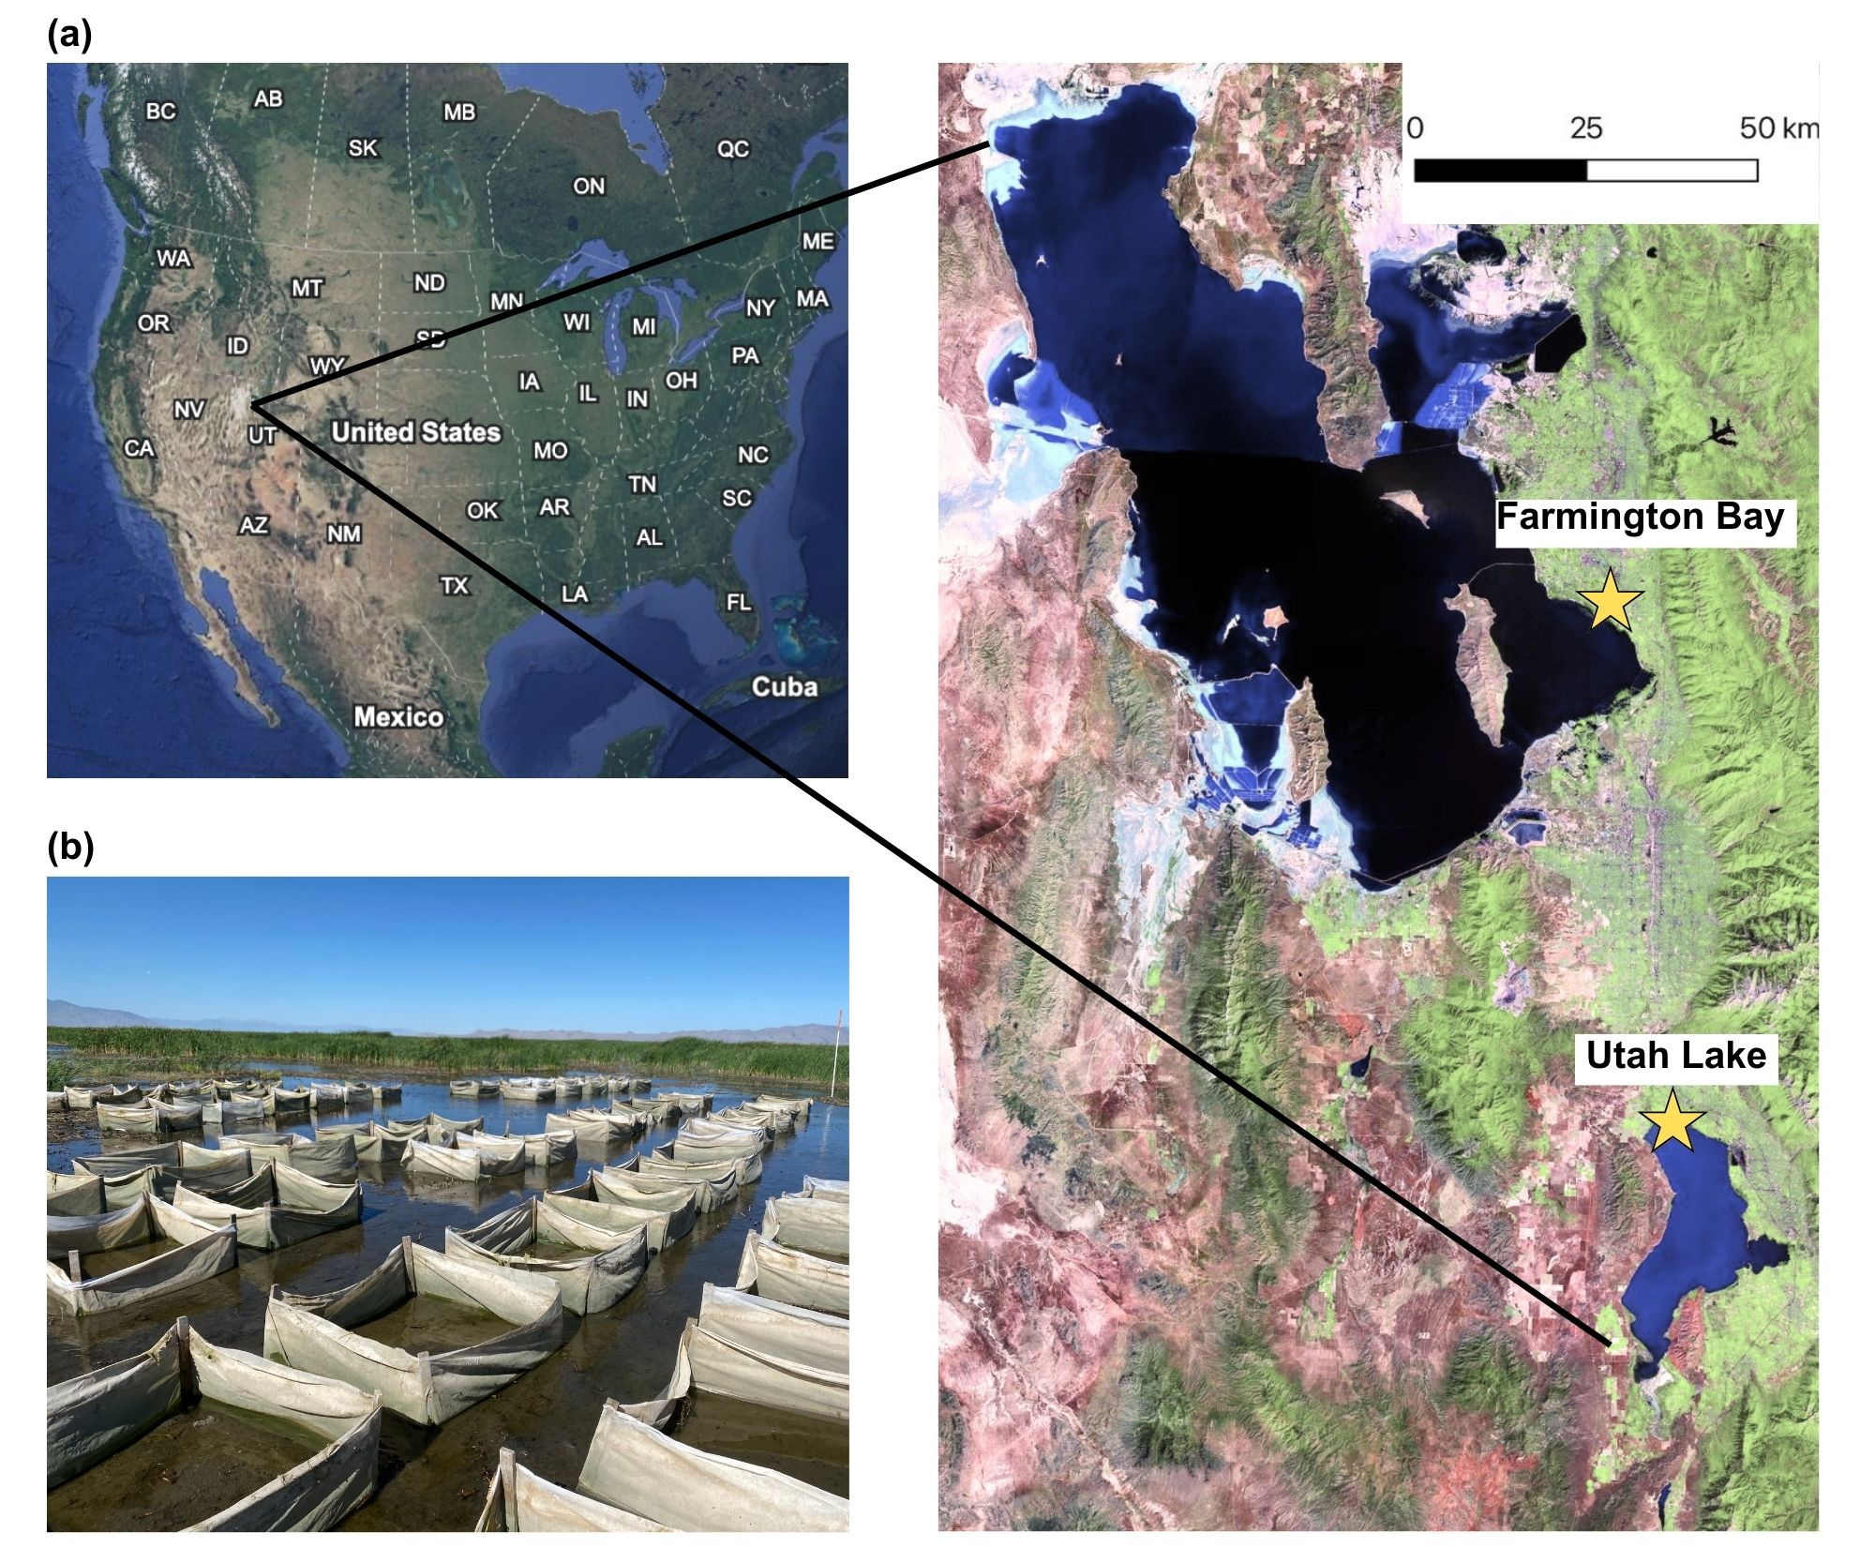Fig. S1 (a) Field site locations at the Farmington Bay of the Great Salt Lake and the north shore of Utah Lake in Utah, USA. (b) Photo of the seeded plots surrounded by mesh fabric, taken at Farmington Bay in July 2022. Map was created with imagery from ETM+ Pan Mosaics (1999–2003) and Google Earth 10.49.0.0 (4/10/2013–12/14/2015)

