Interface-driven structural evolution on diltiazem as novel uPAR inhibitors: From in silico design to in vitro evaluation

Song Xie^{a, b#}, Yang Zhou^{b#}, Hao Zhuª, Xinyi Xu^{b}, Han Zhang^{b}, Cai Yuan^{c}, Mingdong Huangª, Peng Xu^{c}, Jinyu Li^{b, d, *}, Yichang Liu^{a, *}

ª School of Pharmacy, Nantong University, Nantong 226001, Jiangsu, China
^{b} College of Chemistry, Fuzhou University, 350116 Fuzhou, China
^{c} College of Biological Science and Engineering, Fuzhou University, 350116 Fuzhou, China
^{d} Fujian Provincial Key Laboratory of Theoretical and Computational Chemistry, 361005 Xiamen, China

#These authors contributed equally to this study.
*Corresponding author. Tel: +86 591 22867607. E-mail: j.li@fzu.edu.cn (J. Li)
*Corresponding author. Tel: +86-0513-85051726. E-mail: yichangliu@ntu.edu.cn (Y. Liu)

Supplementary Methods
MM-GBSA calculations
The binding free energies between uPAR and the ligands were calculated on a set of 100 snapshots extracted from the last 100 ns-long MD trajectories using MM-GBSA. ΔG_{MMGBSA} can be expressed as follows:
$ΔG_{\text{MMGBSA}}=E_{\text{gas}}+ΔG_{\text{GB}}+ΔG_{\text{SA}}$ (1)
$E_{\text{gas}}=E_{\text{ele}}+E_{\text{vdW}}$ (2)
$ΔG_{\text{SA}}=γ(SASA)+β$ (3)
The E_{gas} includes electrostatic potential (E_{ele}) and van der Waals potential (E_{vdW}), both of which are readily available from MD simulation. The ΔG_{sol}, containing contributions of polar (ΔG_{GB}) and nonpolar (ΔG_{SA}) terms, can be empirically determined by the analytical expression for the polar solvation with a generalized Born scheme and SASA change. The γ and β are empirical constants set as the default values (0.00542 kcal⋅mol⁻¹⋅Å⁻² and 0.92 kcal⋅mol⁻¹).
TI calculations
Thermodynamic integration (TI) calculations were executed utilizing the standard three-stage method in Amber16. Each system underwent a 50,000-step steepest descent procedure, succeeded by a 10,000-step conjugate gradient technique, to eradicate undesirable atomic interactions at λ = 0.5 without imposing constraint limitations. Following this, each system was progressively heated from 0 K to 300 K and equilibrated within the NVT ensemble for 1 ns. The system was then stabilized at 300 K and further equilibrated by applying 1 pressure bar in the NPT ensemble for an additional 1 ns Energy calculations were partitioned into three components: Discharge atoms, van der Waals bonded, and Charge atoms. Each component was further subdivided into 21 λ windows, culminating in 63 windows. A 50 ps warming simulation was conducted in each window to elevate the system's temperature from 0 K to 300 K, followed by a 1 ns equilibrium simulation within the NVT ensemble. Subsequently, a 1 ns equilibrium simulation was performed, succeeded by a 5 ns NPT simulation to gather the ∂U/∂λ data. Upon the simulation's completion, a Gaussian integral was employed to numerically integrate all the ∂U/∂λ values, yielding the final ΔΔG value.
$∆∆G=∆G_{221-n}-∆G_{22}$ (4)

Chemical synthesis
221-8: Diltiazem EP Impurity B (0.20 g, 0.58 mmol), K₂CO₃ (0.15 g, 0.58 mmol) and methyl 4-bromomethylbenzoate (0.10 g, 0.44 mmol) were added to 10 mL acetonitrile, the solution was reacted at 90 ℃. The product was purified by column chromatography (CH₂Cl₂:CH₃OH = 50:1) yielded 0.12 g (53%) of 221-8 as a yellow oily liquid, ¹H NMR (600 MHz, CDCl₃) δ 8.00 (d, J = 8.0 Hz, 2H), 7.68 (d, J = 7.6 Hz, 1H), 7.47 (d, J = 7.9 Hz, 2H), 7.43 (t, J = 7.8 Hz, 1H), 7.37 (d, J = 8.4 Hz, 2H), 7.33 (d, J = 8.0 Hz, 1H), 7.25 (t, J = 7.5 Hz, 1H), 6.89 (d, J = 8.4 Hz, 2H), 5.35 (d, J = 15.5 Hz, 1H), 5.27 (d, J = 7.4 Hz, 1H), 5.14 (d, J = 15.5 Hz, 1H), 5.05 (d, J = 7.4 Hz, 1H), 3.91 (s, 3H), 3.84 (s, 3H), 1.95 (s, 3H); ¹³C NMR (151 MHz, CDCl₃) δ 186.08, 169.72, 167.19, 159.76, 145.63, 141.48, 135.51, 134.34, 132.47, 131.33, 131.13, 130.82, 128.27, 127.69, 126.53, 124.07, 113.79, 71.19, 55.88, 55.24, 54.40, 20.53.
221-57: Diltiazem EP Impurity B (0.20 g, 0.58 mmol), K₂CO₃ (0.15 g, 0.58 mmol) and methyl 5-bromovalerate (0.10 g, 0.51 mmol) were added to 10 mL acetonitrile, the solution was reacted at 90 ℃. The product was purified by column chromatography (CH₂Cl₂:CH₃OH = 50:1) yielded 0.11 g (49%) of 221-57 as a yellow oily liquid, ¹H NMR (600 MHz, CDCl₃) δ 7.69 (dd, J = 7.6, 1.5 Hz, 2H), 7.50 – 7.46 (m, 2H), 7.39 – 7.36 (m, 5H), 7.25 (d, J = 3.0 Hz, 2H), 6.88 (d, J = 8.8 Hz, 2H), 5.14 (d, J = 7.6 Hz, 1H), 5.00 (d, J = 7.6 Hz, 1H), 3.80 (s, 4H), 3.62 (s, 5H), 2.32 (td, J = 6.8, 3.0 Hz, 4H), 1.88 (s, 4H), 1.81 – 1.51 (m, 8H); ¹³C NMR (151 MHz, CDCl₃) δ 186.08, 169.72, 167.19, 159.76, 145.63, 141.48, 135.51, 134.34, 132.47, 131.33, 131.13, 130.82, 128.27, 127.69, 126.53, 124.07, 113.79, 71.19, 55.88, 55.24, 54.40, 20.53.
221-68: Diltiazem EP Impurity B (0.20 g, 0.58 mmol), K₂CO₃ (0.15 g, 0.58 mmol) and butyl bromide (0.10 g, 0.66 mmol) were added to 10 mL acetonitrile, the solution was reacted at 90 ℃. The product was purified by column chromatography (CH₂Cl₂:CH₃OH = 50:1) yielded 0.11 g (46%) of 221-68 as a yellow oily liquid, ¹H NMR (600 MHz, CDCl₃) δ 8.00 (d, J = 8.0 Hz, 2H), 7.68 (d, J = 7.6 Hz, 1H), 7.47 (d, J = 7.9 Hz, 2H), 7.43 (t, J = 7.8 Hz, 1H), 7.37 (d, J = 8.4 Hz, 2H), 7.33 (d, J = 8.0 Hz, 1H), 7.25 (t, J = 7.5 Hz, 1H), 6.89 (d, J = 8.4 Hz, 2H), 5.35 (d, J = 15.5 Hz, 1H), 5.27 (d, J = 7.4 Hz, 1H), 5.14 (d, J = 15.5 Hz, 1H), 5.05 (d, J = 7.4 Hz, 1H), 3.91 (s, 3H), 3.84 (s, 3H), 1.95 (s, 3H);¹³C NMR (151 MHz, CDCl₃) δ 186.08, 169.72, 167.19, 159.76, 145.63, 141.48, 135.51, 134.34, 132.47, 131.33, 131.13, 130.82, 128.27, 127.69, 126.53, 124.07, 113.79, 71.19, 55.88, 55.24, 54.40, 20.53.

We synthesized three 22 derivatives (221-8, 221-57, and 221-68). The synthetic route of these derivatives was shown in Fig. S3. 221-8 was synthesized by the nucleophilic reaction between diltiazem EP Impurity B 1, namely 221, and methyl 4-bromomethylbenzoate under the catalysis of K₂CO₃ in acetonitrile. 221-57 was synthesized by the nucleophilic reaction between 221 and methyl 5-bromovalerate under the catalysis of K₂CO₃ in acetonitrile. 221-68 was synthesized by the nucleophilic reaction between 221 and butyl bromide under the catalysis of K₂CO₃ in acetonitrile. The characterization data were presented in Figs. S3-S7.

Supplementary Figures

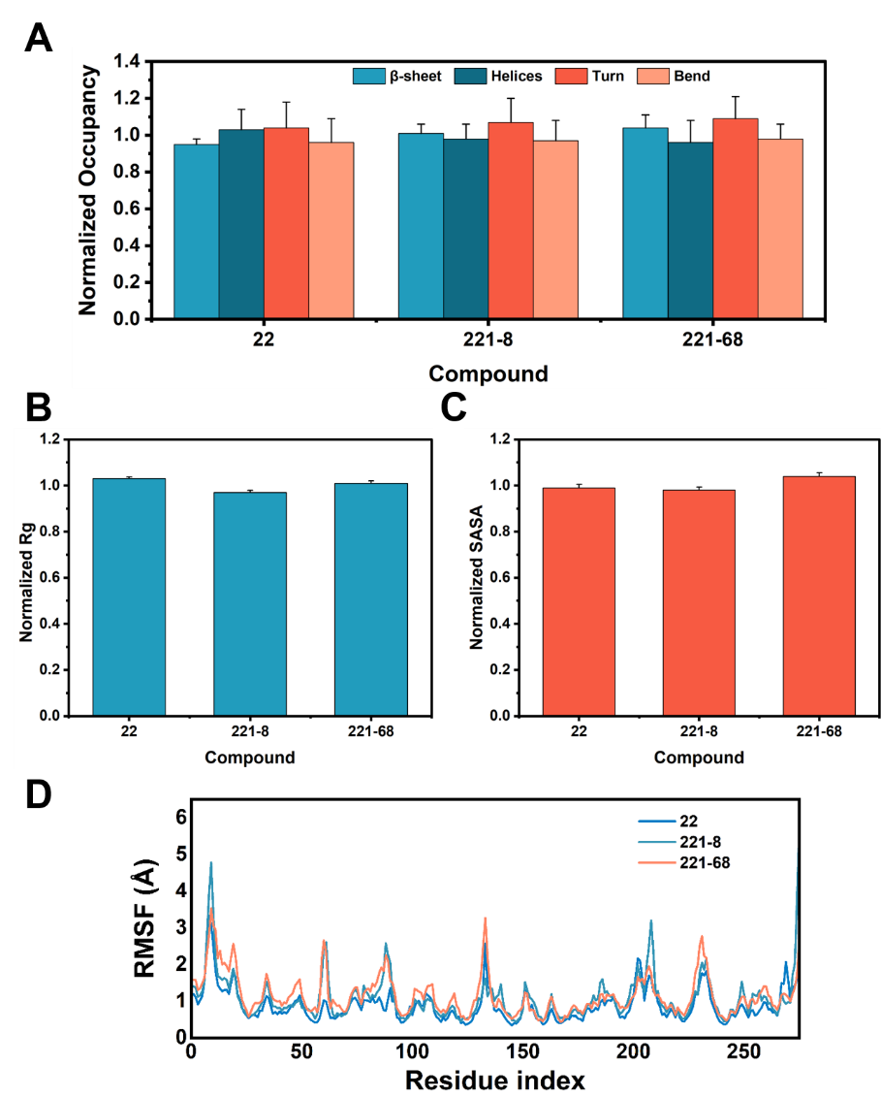
Fig. S1. The occupancy of secondary structural elements, Rg, SASA and RMSF of uPAR in complexes with 22 and 221-8, and 221-68 during MD simulations.

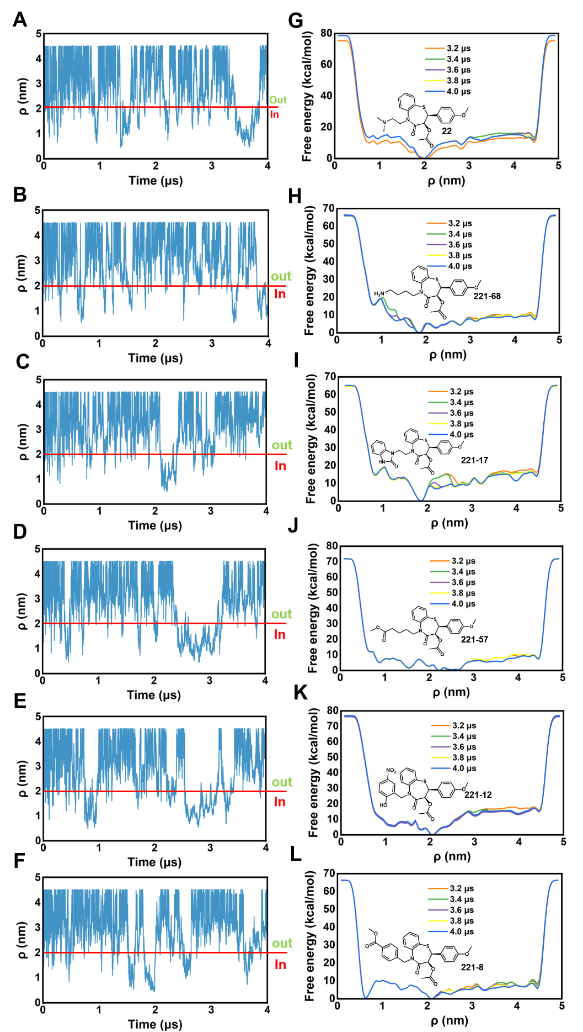
Fig. S2. The convergence of the LV-MetaD simulations on uPAR:22 (A and G), uPAR:221-68 (B and H), uPAR:221-17 (C and I), uPAR:221-57 (D and J), uPAR:221-12 (E and K), and uPAR:221-8 (F and L) complexes. (A-F) Multiple recrossing events occurred between in-pocket (in) and out-pocket (out) states. (G-L) Free energy profiles of ligand binding/unbinding as a function of ρ constructed based on different simulation timescales.
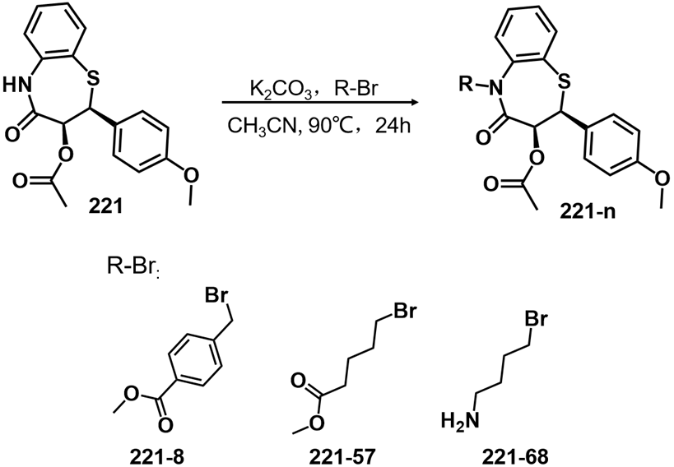
Fig. S3. The synthetic route of 221-8, 221-57, and 221-68.

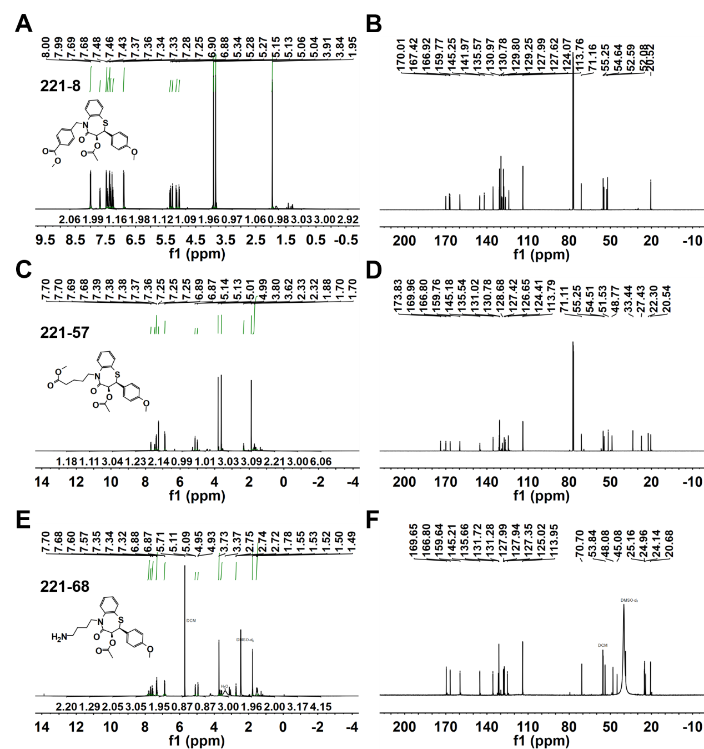
Fig. S4. ¹HMMR (A, C and E) together with ¹³CNMR (B, D and F) profiles of 221-8, 221-57 and 221-68.
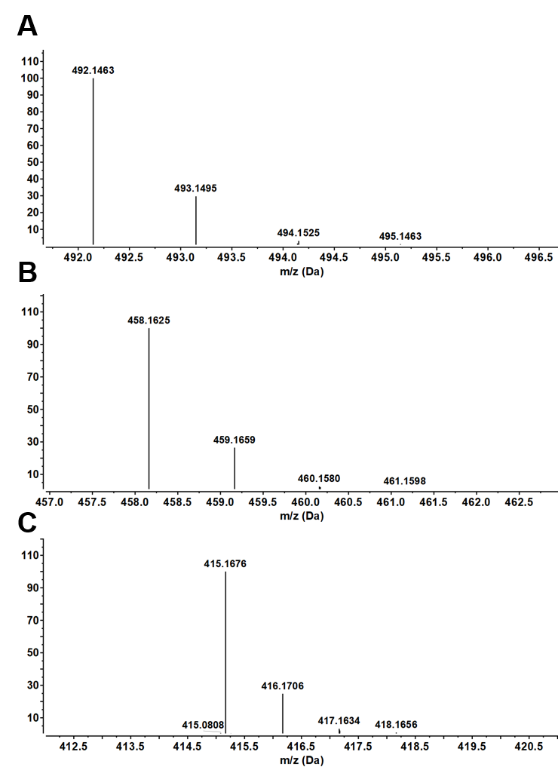
Fig. S5. HRMS profiles of 221-8, 221-57 and 221-68

Fig. S6. Analytical high-performance liquid chromatography of 22 (A), 221-8 (B), 221-57 (C), 221-68 (D) (purity > 95 %). The determination wavelength was 260 nm.

Fig. S7. Scanning of the absorption spectra of 22, 221-8, 221-57, 221-68 in dimethyl sulfoxide using UV spectrophotometer showed that all the four compounds were present with maximum absorption at 260 nm.

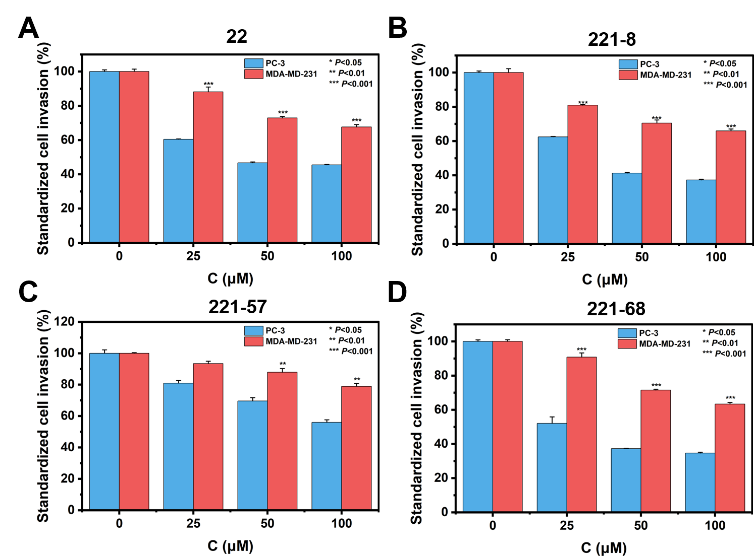

Fig. S8. uPAR-dependent anti-tumor metastatic activity of 22 (A), 221-8 (B), 221-57 (C), and 221-68 (D). Values are represented as mean ± standard deviation (SD) (N = 2). The statistical significance was analyzed by using one-way ANOVA followed by Bartlett test using the software of GraphpadPrism 7. A. P value of less than 0.05 was considered statistically significant.

Supplementary Tables

Table S1. The binding free energy calculations of the ligands bound to uPAR using MM-GBSA. Energy units are in kcal/mol.
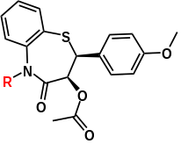
Compound | R | ΔE_{gas} | ΔE_{solv, B} | ΔE_{solv, A} | ΔG_{MM-GBSA}
22 | 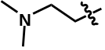 | −53.3±3.6 | 18.1±3.7 | −6.7±0.4 | −41.9 ± 4.1
221-2 | 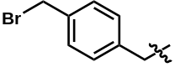 | −78. 8±7.3 | 25.4±5.6 | −7.5±0.2 | −61.1±5.6
221-17 | 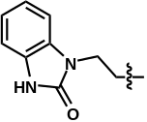 | −87.0±4.8 | 42.0±7.4 | −6.7±0.1 | −52.3±6.9
221-15 | 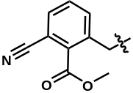 | −93.8±5.7 | 51.4±8.6 | −7.3±0.3 | −50.4±5.9
221-8 | 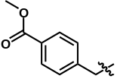 | −73.8±6.4 | 31.7±4.7 | −7.8±0.4 | −49.8±6.2
221-28 | 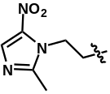 | −83.4±5.1 | 40.9±3.2 | −7.4±0.1 | −49.5±5.8
221-14 | 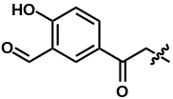 | −87.1±7.2 | 45.7±2.4 | −7.5±0.2 | −48.8±6.2
221-18 | 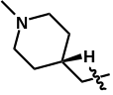 | −219.2±20.4 | 177.3±18.7 | −6.7±0.1 | −48.5±5.1
221-10 | 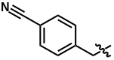 | −79.3±6.7 | 38.8±5.6 | −7.7±0.3 | −47.9±8.0
221-47 | 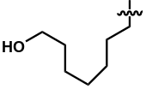 | −77.6±8.2 | 37.5±4.7 | −7.1±0.1 | −47.8±4.7
221-24 | 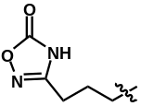 | −105.9±12.7 | 65.8±5.3 | −6.9±0.4 | −47.5±5.6
221-7 | 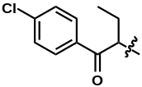 | −90.8±5.4 | 50.9±6.5 | −7.2±0.2 | −47.4±7.5

Table S1 (continuous). The binding free energy calculations of the ligands bound to uPAR using MM-GBSA. Energy units are in kcal/mol.
Compound | R | ΔG_{gas} | ΔG_{solv, B} | ΔG_{solv, A} | ΔG_{bind}
221-36 | 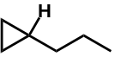 | −81.6±8.1 | 41.2±4.3 | −6.7±0.1 | −47.1±7.6
221-27 | 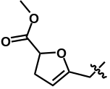 | −86±7.3 | 46.8±3.4 | −6.5±0.3 | −46.9±4.5
221-16 | 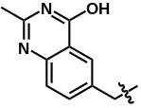 | −87.7±6.8 | 48.3±4.3 | −6.9±0.1 | −46.6±6.5
221-32 | 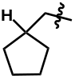 | −80.4±4.2 | 41.1±5.4 | −7.8±0.2 | −46.2±7.4
221-5 | 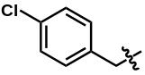 | −70.6±4.9 | 31.7±3.1 | −7.6±0.2 | −46.1±5.7
221-66 | 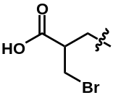 | 10.4±1.4 | −49.5±4.3 | −6.9±0.3 | −45.8±6.1
221-35 | 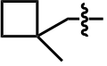 | −69.3±6.4 | 30.1±5.7 | −6.7±0.4 | −45.7±6.3
221-40 | 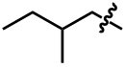 | −81.4±6.2 | 42.7±4.2 | −7.1±0.4 | −45.6±7.1
221-9 | 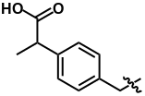 | 51.3±5.3 | −88.7±4.8 | −7.1±0.3 | −45.2±5.6
221-57 | 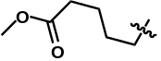 | −76.7±6.1 | 39.5±3.7 | −6.9±0.2 | −44.8±5.8
221-1 | 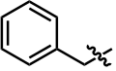 | −77.6±7.6 | 39.9±3.9 | −6.8±0.1 | −44.6±6.2
221-68 | 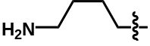 | −69.6±7.9 | 31.8±4.3 | −6.8±0.3 | −44.5±5.4
221-12 | 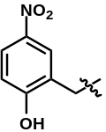 | −88.2±8.3 | 50.7±5.2 | −6.6±0.4 | −44.5±4.7
Table S1 (continuous). The binding free energy calculations of the ligands bound to uPAR using MM-GBSA. Energy units are in kcal/mol.
Compound | R | ΔG_{gas} | ΔG_{solv, B} | ΔG_{solv, A} | ΔG_{bind}
221-4 | 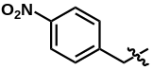 | −76.0±8.4 | 38.8±5.4 | −7.2±0.1 | −44.3±6.2
221-46 | 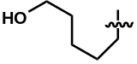 | −75.5±9.8 | 38.2±3.3 | −6.5±0.1 | −44.2±5.8
221-41 | 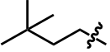 | −72.2±5.7 | 35.2±3.7 | −6.9±0.3 | −44.0±6.4
221-25 | 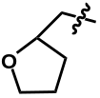 | −84.2±5.2 | 47.1±3.9 | −6.8±0.3 | −44.1±5.7
221-39 | 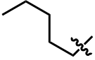 | −74.9±6.8 | 37.9±4.1 | −6.6±0.2 | −43.5±5.1
221-11 | 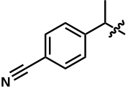 | −73.7±7.4 | 37.3±4.4 | −6.4±0.1 | −43.6±6.4
221-3 | 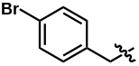 | −75.8±8.3 | 38.8±4.6 | −6.5±0.2 | −43.5±5.7
221-13 | 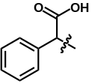 | 11.4±7.7 | −47.9±6.1 | −7.1±0.4 | −43.5±8.3
221-38 | 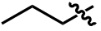 | −77.9±9.6 | 42.1±5.7 | −6.6±0.3 | −42.8±5.4
221-6 | 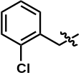 | −73.2±4.7 | 37.2±5.1 | −6.2±0.3 | −42.6±7.4
221-30 | 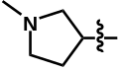 | −217.6±23.4 | 181.8±20.6 | −6.9±0.5 | −42.2±8.2
221-23 | 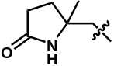 | −78.1±7.3 | 42.8±5.5 | −6.6±0.3 | −41.7±7.8
221-60 | 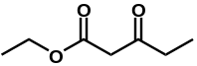 | −85.0±6.9 | 50.4±6.3 | −6.9±0.1 | −41.7±6.1
221-31 | 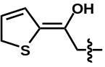 | −79.1±6.2 | 44.6±2.4 | −6.5±0.2 | −41.2±8.8
221-29 | 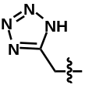 | 18.6±7.8 | −53.4±4.6 | −6.5±0.2 | −41.0±9.2
Table S1 (continuous). The binding free energy calculations of the ligands bound to uPA using MM-GBSA. Energy units are in kcal/mol.
Compound | R | ΔG_{gas} | ΔG_{solv, B} | ΔG_{solv, A} | ΔG_{bind}
221-48 | 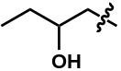 | −74.8±7.2 | 40.8±4.7 | −6.3±0.3 | −40.9±6.9
221-19 | 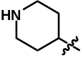 | −242.9±26.4 | 208.8±21.3 | −6.1±0.4 | −40.7±6.7
221-56 | 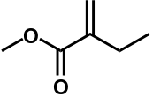 | −69.6±5.4 | 35.7±3.7 | −6.2±0.2 | −40.8±7.9
221-21 | 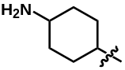 | −236.2±23.6 | 202.5±24.8 | −6.8±0.2 | −40.2±5.7
221-50 | 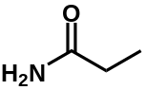 | −82.1±6.4 | 48.3±3.9 | −7.0±0.2 | −40.3±8.9
221-26 | 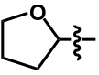 | −76.6±8.6 | 42.8±3.1 | −6.3±0.4 | −40.1±7.3
221-34 | 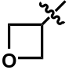 | −73.6±8.1 | 39.7±3.6 | −6.4±0.1 | −39.9±6.1
221-43 | 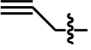 | −64.9±9.6 | 31.3±2.2 | −6.5±0.1 | −39.8±6.3
221-54 | 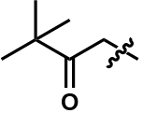 | −75.5±5.3 | 43.3±2.9 | −6.4±0.1 | −39.2±9.1
221-51 | 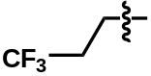 | −75.9±5.7 | 44.1±4.9 | −6.4±0.2 | −39.1±7.1
221-22 | 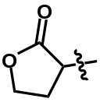 | −81.5±9.2 | 49.2±4.4 | −5.7±0.3 | −38.6±7.6
221-45 | 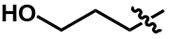 | −74.3±6.1 | 42.3±4.1 | −6.2±0.3 | −38.3±8.6
221-58 | 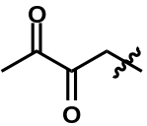 | −79.7±7.8 | 48.0±3.7 | −6.8±0.4 | −38.2±6.3
221-20 | 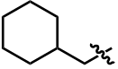 | −244.8±19.4 | 213.1±21.7 | −5.7±0.2 | −38.2±7.6
Table S1 (continuous). The binding free energy calculations of the ligands bound to uPAR using MM-GBSA. Energy units are in kcal/mol.
Compound | R | ΔG_{gas} | ΔG_{solv, B} | ΔG_{solv, A} | ΔG_{bind}
221-44 | 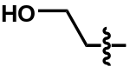 | −72.3±10.3 | 40.7±3.8 | −6.2±0.2 | −38.1±6.2
221-37 | 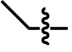 | −62.8±9.2 | 30.6±3.2 | −7.1±0.2 | −38.0±8.9
221-42 | 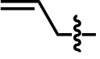 | −66.5±8.6 | 34.9±4.7 | −6.7±0.1 | −37.8±6.2
221-59 | 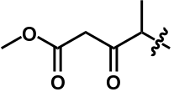 | −78.6±7.3 | 47.8±5.2 | −5.7±0.4 | −37.6±7.8
221-64 | 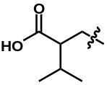 | 68.0±5.8 | −99.7±9.3 | −5.9±0.3 | −37.4±6.2
221-55 | 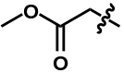 | −73.7±6.5 | 42.7±4.6 | −6.2±0.2 | −37.2±5.0
221-63 | 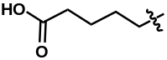 | 72.5±4.3 | −101.7±9.9 | −5.8±0.1 | −36.3±4.7
221-53 | 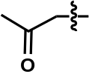 | −71.7±8.5 | 42.3±4.5 | −6.1±0.2 | −36.1±10.1
221-62 | 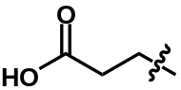 | 44.1±4.7 | −73.4±6.8 | −5.9±0.2 | −35.1±8.2
221-49 | 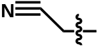 | −64.6±6.9 | 36.4±3.4 | −5.8±0.2 | −34.1±4.1
221-52 | 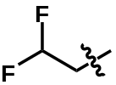 | −52.8±4.9 | 26.2±2.3 | −7.1±0.1 | −32.8±6.1
221-67 | 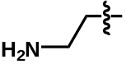 | −232.2±22.6 | 206.3±19.0 | −7.5±0.2 | −31.7±7.7
221-65 | 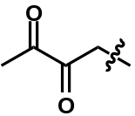 | 54.3±5.8 | −79.6±6.6 | −6.7±0.1 | −31.4±8.1
221-33 | 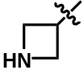 | −207.8±21.5 | 186.3±20.3 | −7.3±0.3 | −27.4±6.4
221-61 | 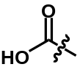 | 67.5±6.8 | −85.8±7.6 | −7.8±0.4 | −24.1±4.8

Table S2. The binding free energy calculations of the ligands bound to uPAR using TI. Energy units are in kcal/mol.
Ligand1 | Ligand2 | ΔΔG（kcal/mol）
22 | 221-68 | −3.7
22 | 221-17 | −3.5
22 | 221-57 | −3.4
22 | 221-12 | −3.3
22 | 221-8 | −3.1
22 | 221-13 | −2.9
22 | 221-5 | −2.8
22 | 221-15 | −2.6
22 | 221-20 | −2.5
22 | 221-47 | −2.5
22 | 221-41 | −2.4
22 | 221-4 | −2.1
22 | 221-28 | −2.0
22 | 221-14 | −1.8
22 | 221-2 | −1.7
22 | 221-24 | −1.5
22 | 221-11 | −1.4
22 | 221-3 | −1.2
22 | 221-36 | −1.0
22 | 221-39 | −1.0
22 | 221-46 | 0.7
22 | 221-40 | 0.7
22 | 221-66 | 0.8
22 | 221-18 | 1.2
22 | 221-30 | 1.2
22 | 221-38 | 1.5
22 | 221-1 | 1.6
22 | 221-9 | 1.6
22 | 221-7 | 1.9
22 | 221-35 | 2.3
22 | 221-32 | 2.4

Table S2 (continuous). The binding free energy calculations of the ligands bound to uPAR using TI. Energy units are in kcal/mol.
Ligand1 | Ligand2 | ΔΔG（kcal/mol）
22 | 221-16 | 2.6
22 | 221-25 | 2.9
22 | 221-6 | 3.0
22 | 221-10 | 3.1

Table S3. Growth inhibition of PC-3 cells by 22 and its derivatives (percentage of survival: Mean ± SD, n = 4)
Concentration/μM | 22 | 221-8 | 221-57 | 221-68
0 | 100±5.9 | 100±15.7 | 100±10.4 | 100±10.2
25 | 82.4±2.3 | 101.4±15.4 | 99.4±5.0 | 105.9±12
50 | 81.5±8.8 | 82.4±13.0 | 107.1±5.7 | 117.7±25.6
100 | 88.9±8.7 | 83.4±9.7 | 106.2±5.2 | 113.3±22

Table S4. Inhibitory activity of 22 and its derivatives on PC-3 cell invasion (percentage of invasion: Mean ± SD, n = 2)
Concentration/μM | 22 | 221-8 | 221-57 | 221-68
0 | 100±1.0 | 100±0.9 | 100±0.9 | 100±0.9
25 | 60.4±0.2 | 62.4±0.2 | 81.0±1.6 | 52.1±3.8
50 | 46.7±0.5 | 41.3±0.4 | 69.5±2.2 | 37.3±0.2
100 | 45.5±0.2 | 37.3±0.4 | 55.9±1.6 | 34.7±0.5
IC₅₀ / μM | 54.13±0.02 | 42.02±0.13 | 133.55±19.02 | 25.02±8.46

Table S5. Growth inhibition of MDA-MB-231 cells by 22 and its derivatives (percentage of survival: Mean ± SD, n = 4)
Concentration/μM | 22 | 221-8 | 221-57 | 221-68
0 | 100.1±30.2 | 100.2±22.1 | 100.6±14.4 | 100.4±10.2
25 | 98.1±30.4 | 105.1±15.4 | 122.4±7.6 | 115.4±11.4
50 | 92.3±14.5 | 106.4±6.0 | 93.5±14.5 | 106.4±19.3
100 | 67.4±8.7 | 108.4±9.7 | 102.5±23.4 | 96.4±8.5

Table S6. Inhibitory activity of 22 and its derivatives on MDA-MB-231 cell invasion (percentage of invasion: Mean ± SD, n = 2)
Concentration/μM | 22 | 221-8 | 221-57 | 221-68
0 | 100.5±1.4 | 100.7±2.2 | 100.5±0.4 | 100.1±1.0
25 | 88.1±2.8 | 80.9±0.4 | 93.4±1.6 | 90.8±2.4
50 | 72.9±1.0 | 70.4±1.9 | 87.9±2.3 | 71.5±0.5
100 | 67.7±1.4 | 65.9±0.4 | 78.9±2.0 | 63.3±1.0
IC₅₀ / μM | 233.70±7.50 | 329.20±87.40 | 457.30±219.60 | 160.45±24.40

