Materials and Methodology

Design and Manufacturing
Sheet-based gyroid sandwich beams were modeled using a constant unit cell size of (10 x 10 x 10 mm). To maintain constant stress throughout the beam specimens, irrespective of material, the gyroid surface thickness was varied according to the yield strength in the constituent materials according to the Gibson-Ashby model¹. Using a yield strength of 270 MPa and 130 MPa for 904L stainless steel and CuSn10 respectively, the ratio of thickness to produce equivalent strain was found to be 1:1.42, i.e., a thickness of 1mm for steel sections and 1.42 mm for CuSn10 sheets.
The generative design software nTopology (nTopology, Version 3.33.2, US) was used to model multi-material specimens. Flexural test coupons with end plates (thickness of three times the TPMS wall thickness of the strongest material² were included for mechanical testing (Figure 7).
Witness coupons (10 x 10 x 10 mm) were printed in four unique build orientations (Figure S1) along with the flexural testing specimens for microstructural, crystallographic, and chemical composition analysis using SEM, EBSD, and EDS. These four material orientations will be used to study micro defects in material fusion as shown in Figure 3.
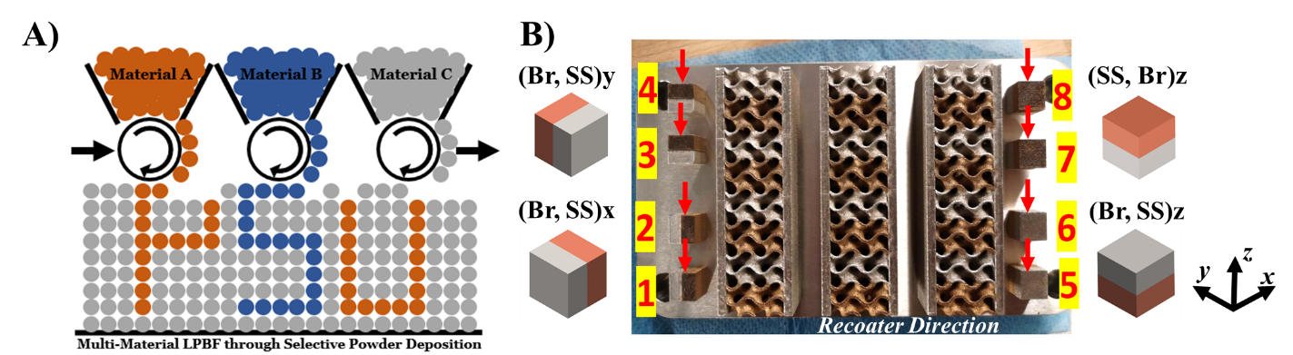
Figure S1: A) Selective powder deposition (SPD) to enable MM-LPBF B) Specimen build plate with witness coupons made in 4 build orientations with respect to the recoater and Cartesian directions. Witness cube nomenclature indicates the sequential material placement along the direction normal to the fusion plane.

Specimens were manufactured on an Aconity MIDI+ (Aconity3D GmbH, Germany) equipped with an Aerosint SPD v1 (Aerosint SA, Belgium), with a single mode fiber laser at a continuous wavelength of 1070 nm and effective spot size of 80 µm. Since bronze and 904L SS are dissimilar materials in terms of thermal conductivity and optical absorption of infrared light, different process parameters, detailed in Table I, were utilized for each. A sequential scanning strategy was selected for each material subsection (904L SS followed by bronze). The interlayer rotation is 67° for the three-point flexural specimens, and 90° for the witness coupons. The chamber was flushed with argon gas, and O₂ concentrations were kept below 500 ppm throughout the entire process.

Table I: List of Processing parameters by material
Material | Power (W) | Scanning Speed (mm/s) | Hatch Spacing (µm) | Layer Thickness (µm)
Bronze | 200 | 500 | 120 | 40
904L SS | 250 | 750 | 80 | 40

SEM characterization of both powders was performed at an operating voltage and current of 5kV and 0.10mA at a working distance of 10.1 mm. Analysis of both particles showed a consistent spherical shape. Particle size distribution characterization on both powders (Mastersizer 3000, Malvern Panalytical, UK) yielded a 10-90% percentile range of 18.7-46.1 µm for 904L stainless steel powder (Thyssenkrupp Materials Trading GmbH, Germany) and 6.01-33.4 µm for bronze (Eckart TLS GmbH, Germany), averaged across 6 measurements for each material.

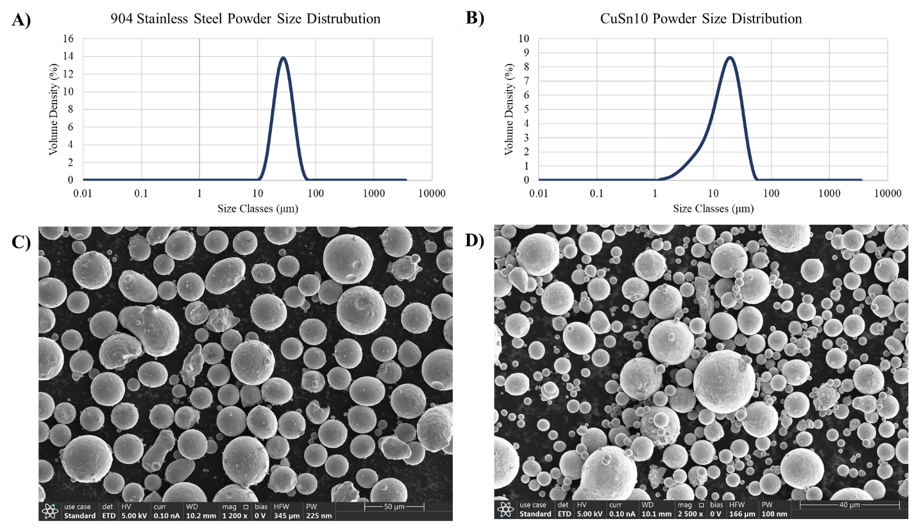
Figure S2: A) PSD of 904L SS powder B) PSD of CuSn10 powder C) SEM image of 904L stainless steel feedstock powder D) SEM image of bronze, CuSn10 feedstock powder.

Table II: 904L stainless steel powder composition sourced from Thyssenkrupp Materials Trading GmbH, Germany³.
 | C | Si | Mn | P | S | Cr | Ni | N | Mo | Cu | Fe
% | 0.02 | 0.70 | 2.00 | 0.03 | 0.01 | 19.00-21.00 | 24.00-26.99 | 0.15 | 4.00-5.00 | 1.20-2.00 | Bal.

Table III: CuSn10 powder composition sourced from Eckart TLS GmbH, Germany⁴.
 | Sn | Cu
% | 0.10 | Bal.

Microstructure and Surface Characterization

SEM & EDS & EBSD
One witness coupon of each orientation was randomly selected and mounted in EpoxySet (Allied High-Tech Products, Inc., USA, #145-20010 Hardener & #145-20005 Resin) for ease of handling and prepared through grinding and mechanical polishing using a MetPrep 3 (Allied High-Tech Products, Inc., USA). A series of silicon carbine discs of grit sizes 320, 600, and 800 were used for 3 minutes each at 80 RPM, followed by wool Diamat with 6 µm glycol for 4 minutes at 150 RPM, 1-, and 0.05-µm felt polishing pad with diamond slurries for 3 minutes each at 150 RPM. Between the wool and felt polishing sequences, the coupons were placed in an ultrasonic bath of isopropyl alcohol for 1-3 minutes to remove residual diamond slurry and blown dry with nitrogen.
To characterize surface microstructure and alloy distribution at the fusion plane, the four orientations underwent scanning electron microscopy (SEM), electron dispersive spectroscopy (EDS) and electron backscatter diffraction (EBSD) analysis. EDSM imaging determined the shape and location of continent material grain boundaries, and EDS analysis provided additional chemical characterization near the fusion area of the witness coupons. Scanning electron microscopy (Apreo 5) was performed at an operating voltage of 5 kV and 0.1 mA and working distance of 10 mm. EBSD was performed with a constant working distance, and operating voltage of 20kV and 3.2 mA.

Morphological Analysis
Micro-computed tomography (micro-CT) was performed on all three specimens prior to testing to evaluate the quality of morphological characteristics of the as-built parts. All three specimens were micro-CT scanned (pheonix v|tome|xL, Waygate Technologies, NY, USA) at 210 kV and 160 mA with a voxel size of 25 µm. CT volume data was converted into 8-bit images through ImageJ, and imported into the Avizo (version 2022.1, Amira-Avizo, FEI, Thermo Fisher Scientific, USA) software for analysis and imaging. Avizo was employed for various morphological analyses, including porosity computation, pore size distribution, pore connectivity, tortuosity, and specific surface area. To ensure consistency across specimens, the same volume was used for all samples. A thresholding method was employed to segment material space and void space, enabling the calculation of volume fraction and part porosity. The void space volume encompassed both gyroid channels and porosity. Unconnected pores were embedded within the printed part and treated as defects. The percentage of unconnected pores was determined by comparing the void space with the gyroid channels. The gyroid channels served as a connected pore network, and a network modeling tool in Avizo was utilized to assess pore size distribution.

As-Build TPMS Porosity
At a scanning voxel resolution of 25 microns, as-built density was found to be 99.98%, and 99.99% for the steel and bronze section, respectively. It is important to note that this density only reflects voids caused by lack of fusion or keyhole porosity, while void space due to cracking is not considered within this defect porosity. The pore size of the specimens ranged from 50 μm to 1000 μm which is expected for this type of manufacturing process^{5–7}.
Table IV: Morphological parameters of multi-material gyroid specimen
 | Micro-CT Metal volume fraction  Designed = 45% | Void  Space  Designed = 55% | Gyroid channel | Defect  Porosity  (% vol) | Avg pore size (μm)
Steel | 20.62% | 24.83% | 24.81% | 0.02% | 798.35
Bronze | 24.11% | 30.43% | 30.42% | 0.01% | 560.36
 | ∑44.73% | ∑55.27%

Mechanical Characterization

Digital Image Correlation (DIC)
Two gyroid bending specimens were randomly selected to undergo mechanical testing with DIC. To prepare the specimens for DIC imaging, the front surface was painted white for a high-contrast background to image. A micro-sized black speckling pattern was applied using an IWATA Micron-CMB airbrush. Strain was measured using the digital image correlation (DIC) technique for experimental full-field strain on the surface of the test specimens at a step size of 55 pixels. DIC images were collected using Flea3 digital cameras (FLIR Systems, Inc., USA) at a frequency of 1 Hz. Image post-processing was performed in Vic-2D (version 6, Correlated Solutions, Inc., USA).

Quasi-Static Three-point Flextural with Intermittent micro-CT
All three specimens were tested under three-point flexural loading conditions on MTS load frames equipped with a 50kN load cell. In accordance with ASTM D7250/D7250M, testing was conducted at a constant quasi-static displacement rate of 0.008 mm/s. Testing was terminated after either a 90% drop in max stress, or complete delamination of adjacent material sections. One of the three specimens also underwent intermittent micro-CT analysis during loading.
Intermittent micro-CT analysis consisted of three intervals of plastic deformation and micro-CT imaging to visualize the progression of failure as material sections delaminated. The intervals were selected based on observed plastic deformation and force-displacement trends. At each interval, the specimen was removed from the load frame and micro-CT scanned in its deformed state. To maintain a high voxel resolution, only one half of the specimen was scanned. Micro-CT data volume was processed using VGStudio Max 2023.3. Datasets for the undeformed specimen were incorporated with the three incremental scans performed during three-point flexural testing above.

Finite Element Analysis
Numerical analysis was performed using Abaqus. The gyroid was imported from nTopology and discretized using shell elements (C3D8). The top and bottom plates were treated as 3D solids using hexahedra (C3D20) and connected to the gyroid via shell-to-solid constraints. The three loading points were explicitly modeled as cylindrical rigid bodies. One of the bottom surfaces was tied to the assembled beam to restrain motion parallel to the beam axis. The remaining two (top and bottom) were connected to the beam through surface contact. In accordance with experimental results, a displacement of 3 mm was applied to the top cylinder, while the bottom two cylinders were fixed in all directions.

References
1. Maconachie, T. et al. SLM lattice structures: Properties, performance, applications and challenges. Mater. Des. 183, 108137 (2019).
2. Shen, Y., Cantwell, W. & Li, Y. Skin-core adhesion in high performance sandwich structures. J. Zhejiang Univ. Sci. A 15, 61–67 (2014).
3. Stainless Steel 904L - Data Sheet - thyssenkrupp Materials (UK). Materials UK https://www.thyssenkrupp-materials.co.uk/stainless-steel-904l-14539.html.
4. ECKART TLS POWDER ALLOYS | Eckart NAFTA. https://www.eckart.net/us/en/am/tls.
5. Ahmed Obeidi, M. et al. Comparison of the porosity and mechanical performance of 316L stainless steel manufactured on different laser powder bed fusion metal additive manufacturing machines. J. Mater. Res. Technol. 13, 2361–2374 (2021).
6. Wang, D. et al. A review and a statistical analysis of porosity in metals additively manufactured by laser powder bed fusion. Opto-Electron. Adv. 5, 1–34 (2022).
7. Zhao, R., Shmatok, A., Fischer, R. & Prorok, B. C. Investigation of Causal Relationships between Printing Parameters, Pore Properties and Porosity in Laser Powder Bed Fusion. Metals 13, (2023).

