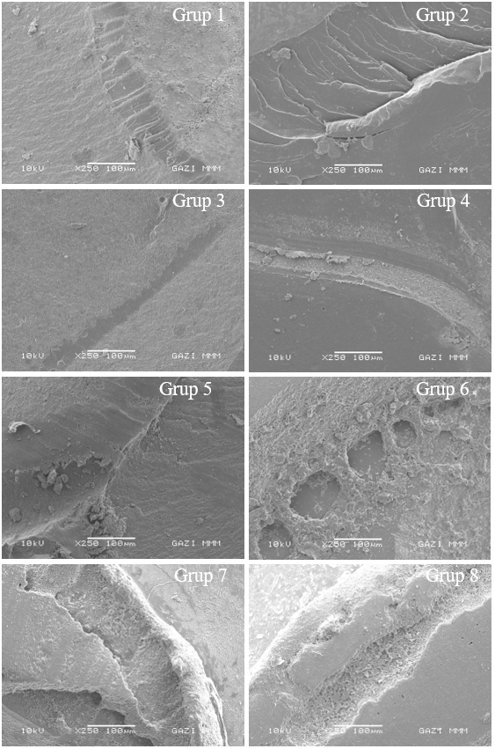
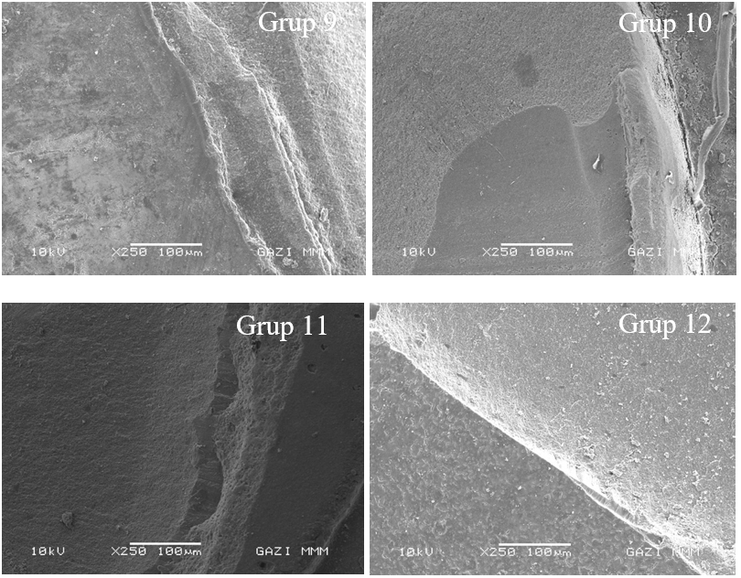

Picture 1. SEM images were taken from a sample of each of the tested groups after the shear bond strength test in the study.

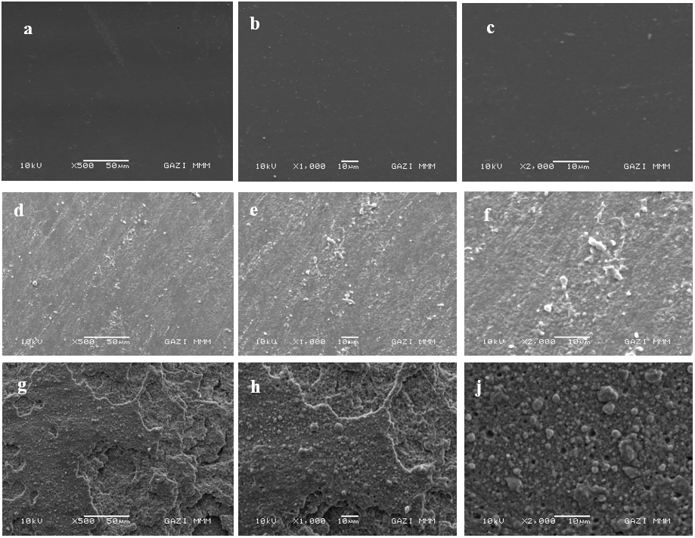
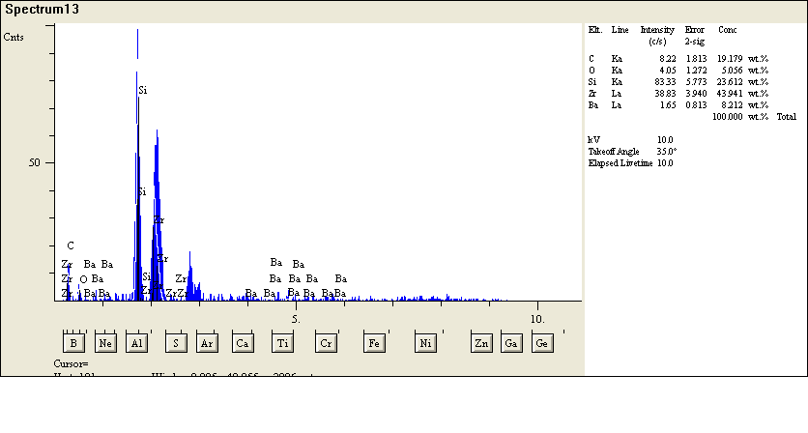
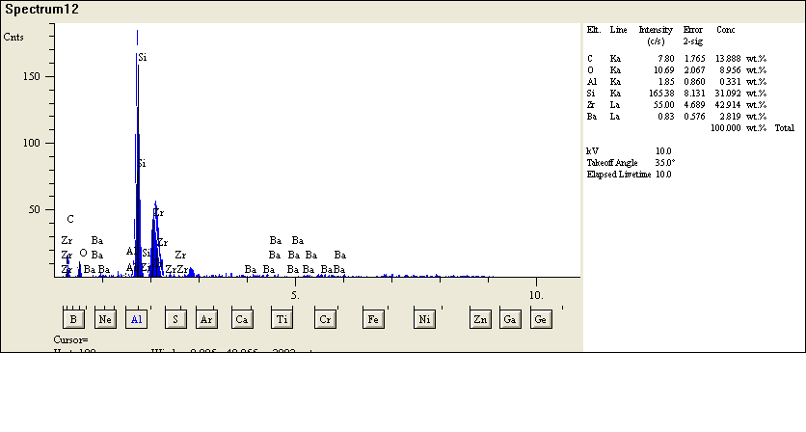
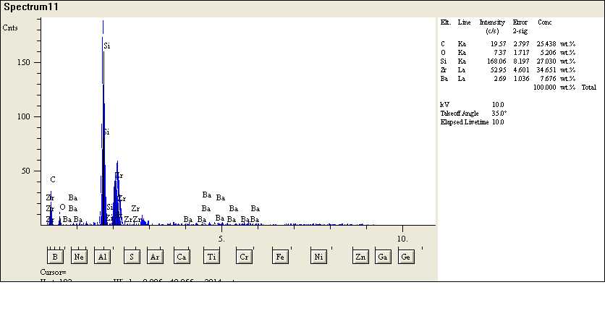

Picture 2. SEM and EDS images taken from the sample surfaces to which surface preparation was applied (a, b, c: SEM image of the sample surfaces of the control group at x500, x1000, x2000 magnification, d, e, f: x500, SEM image at x1000, x2000 magnification, g, h, j: SEM image of the sample surfaces belonging to the Er,Cr:YSGG laser applied group at x500, x1000, x2000 magnification)

