Supplementary Information for

An sp-sp²-hybridized molecular carbon allotrope: C₁₆ flake

Wenze Gao, Wei Zheng, Luye Sun, Faming Kang, Zheng Zhou, Wei Xu*

*Corresponding author: xuwei@tongji.edu.cn

The supplementary information includes:

Supplementary Figures 1-4

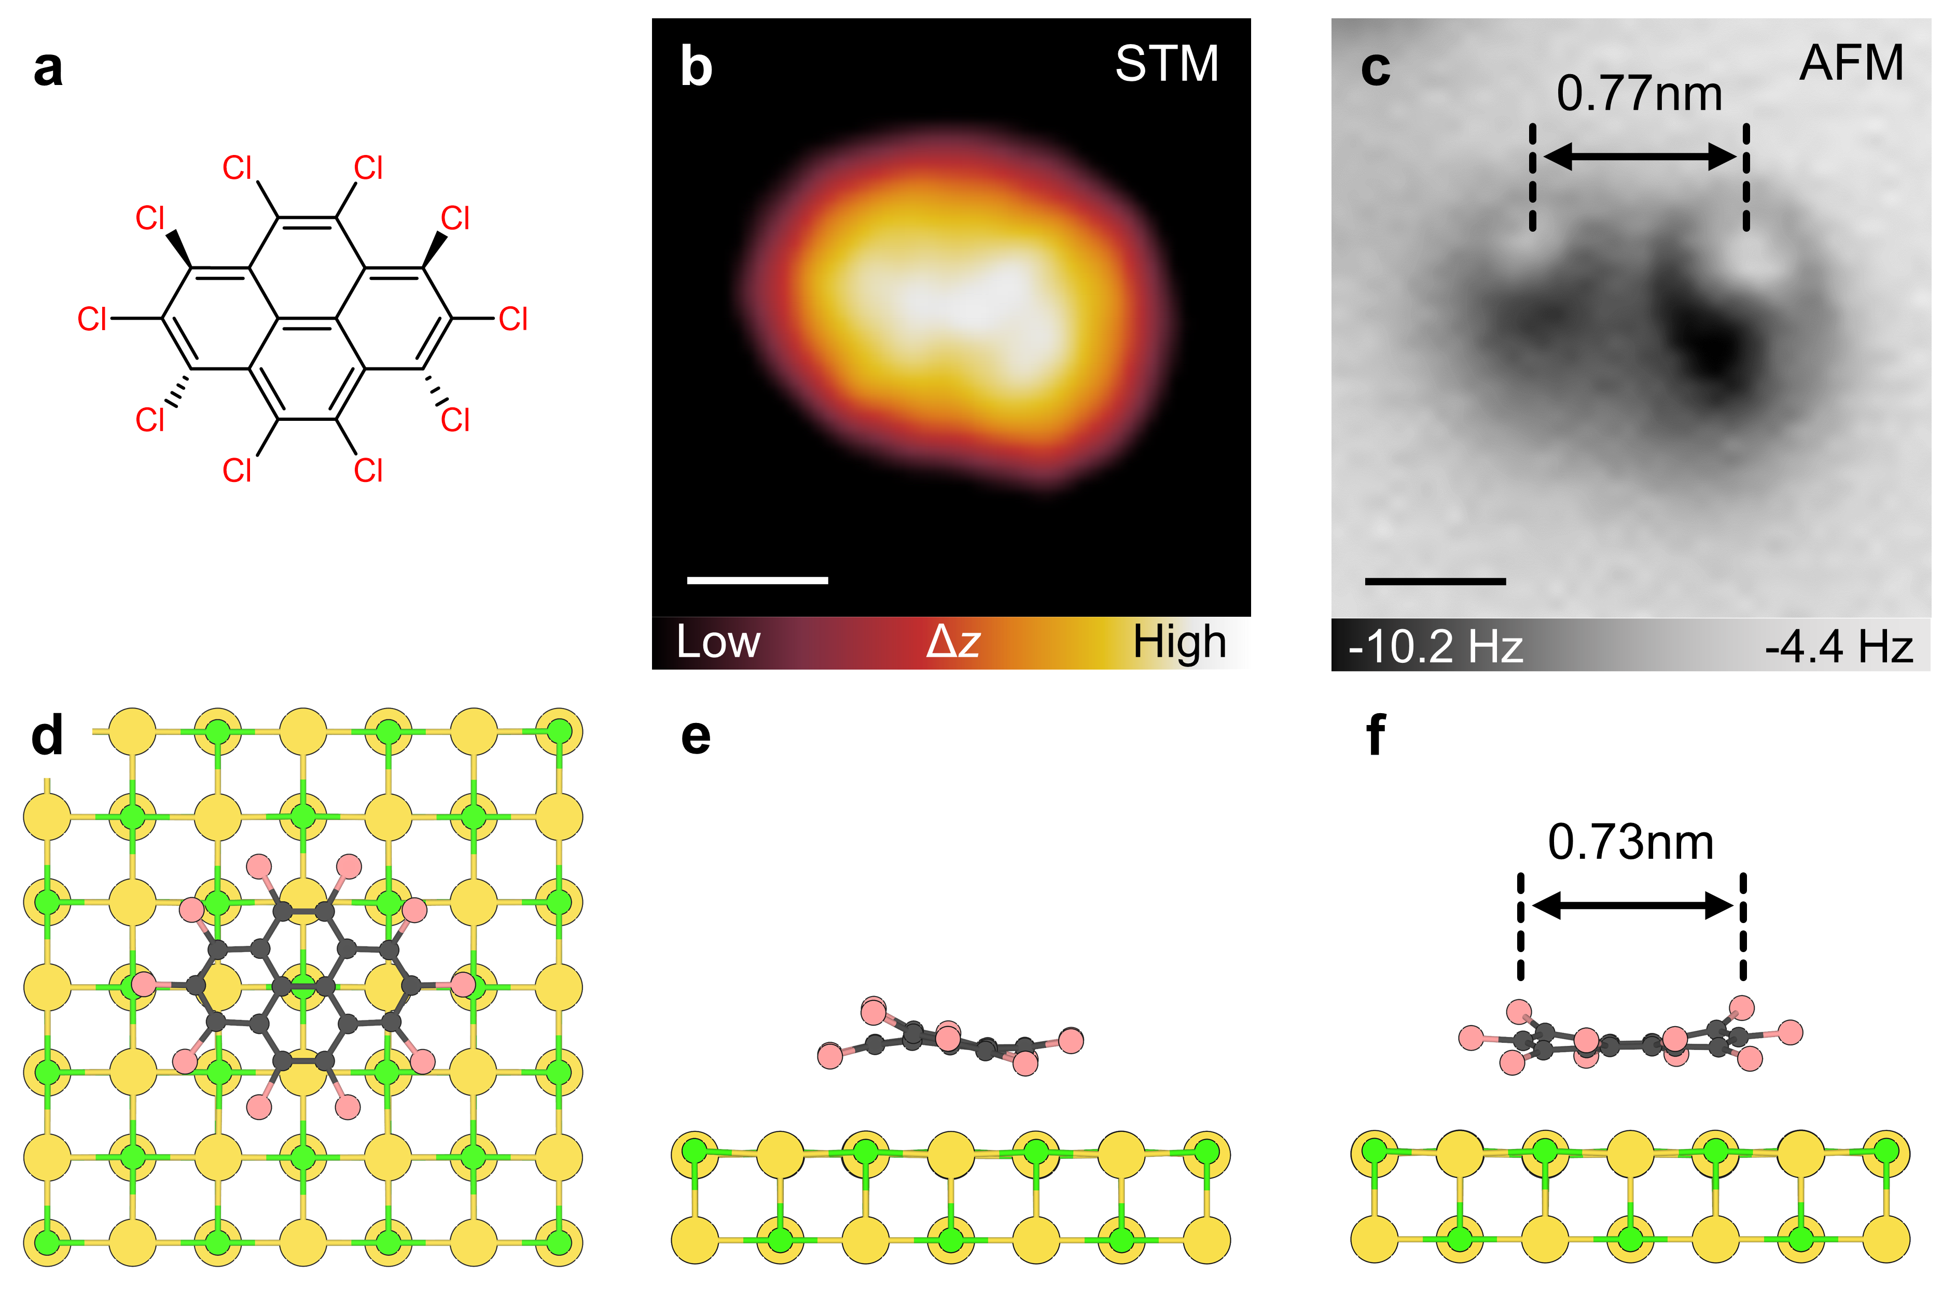

Supplementary Fig. 1. Characterizations of the C₁₆Cl₁₀ precursor. (a) Chemical structure, (b) STM, and (c) AFM images of C₁₆Cl₁₀. (d-f) Top, left, and front views of DFT-calculated structure of C₁₆Cl₁₀ molecule on the NaCl surface. AFM image was recorded with a CO-functionalized tip, with respect to an STM set point of I = 3 pA, V = 0.3 V above the NaCl surface. Scale bars: 0.5 nm.

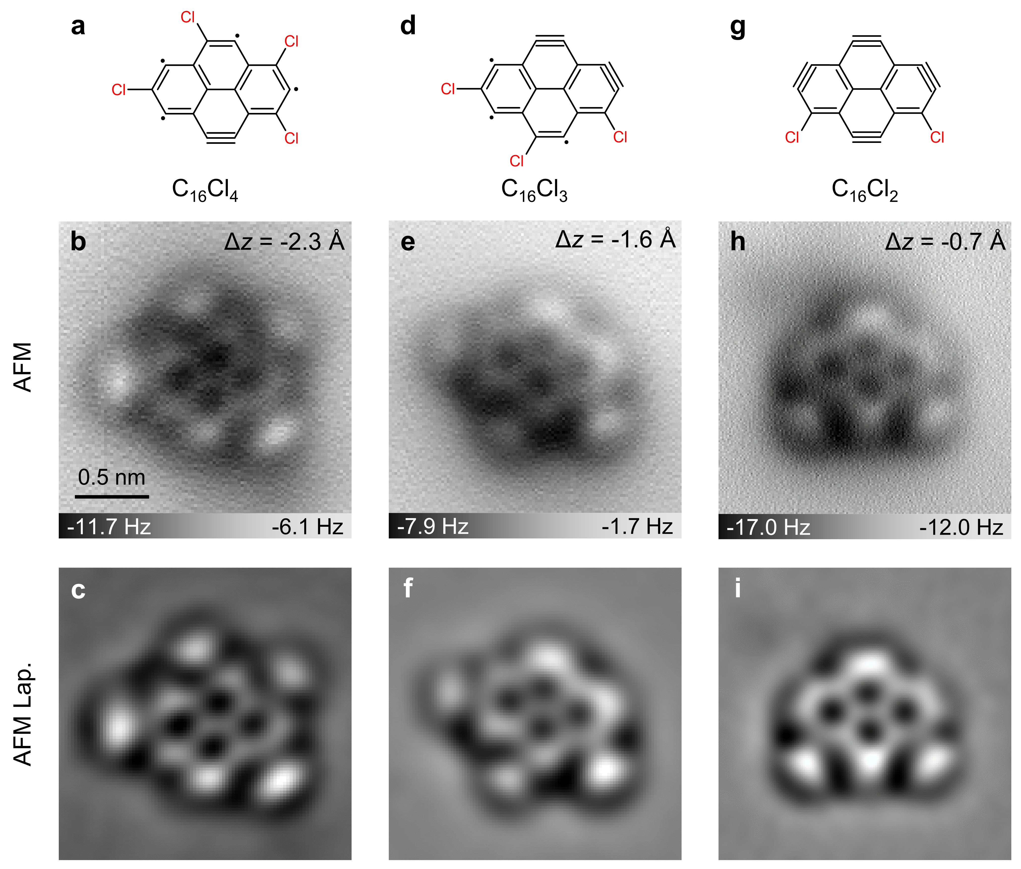

Supplementary Fig. 2. Other observed intermediates generated after the manipulation of C₁₆Cl₁₀. (a-c) C₁₆Cl₄. (d-f) C₁₆Cl₃. (g-i) C₁₆Cl₂. Molecular structures are shown in line 1. AFM images (line 2) were recorded with a CO-functionalized tip, with respect to an STM set point of I = 3 pA, V = 0.3 V above the NaCl surface. Line 3 shows corresponding Laplace-filtered AFM images. The scale bar in (b) applies to all images.

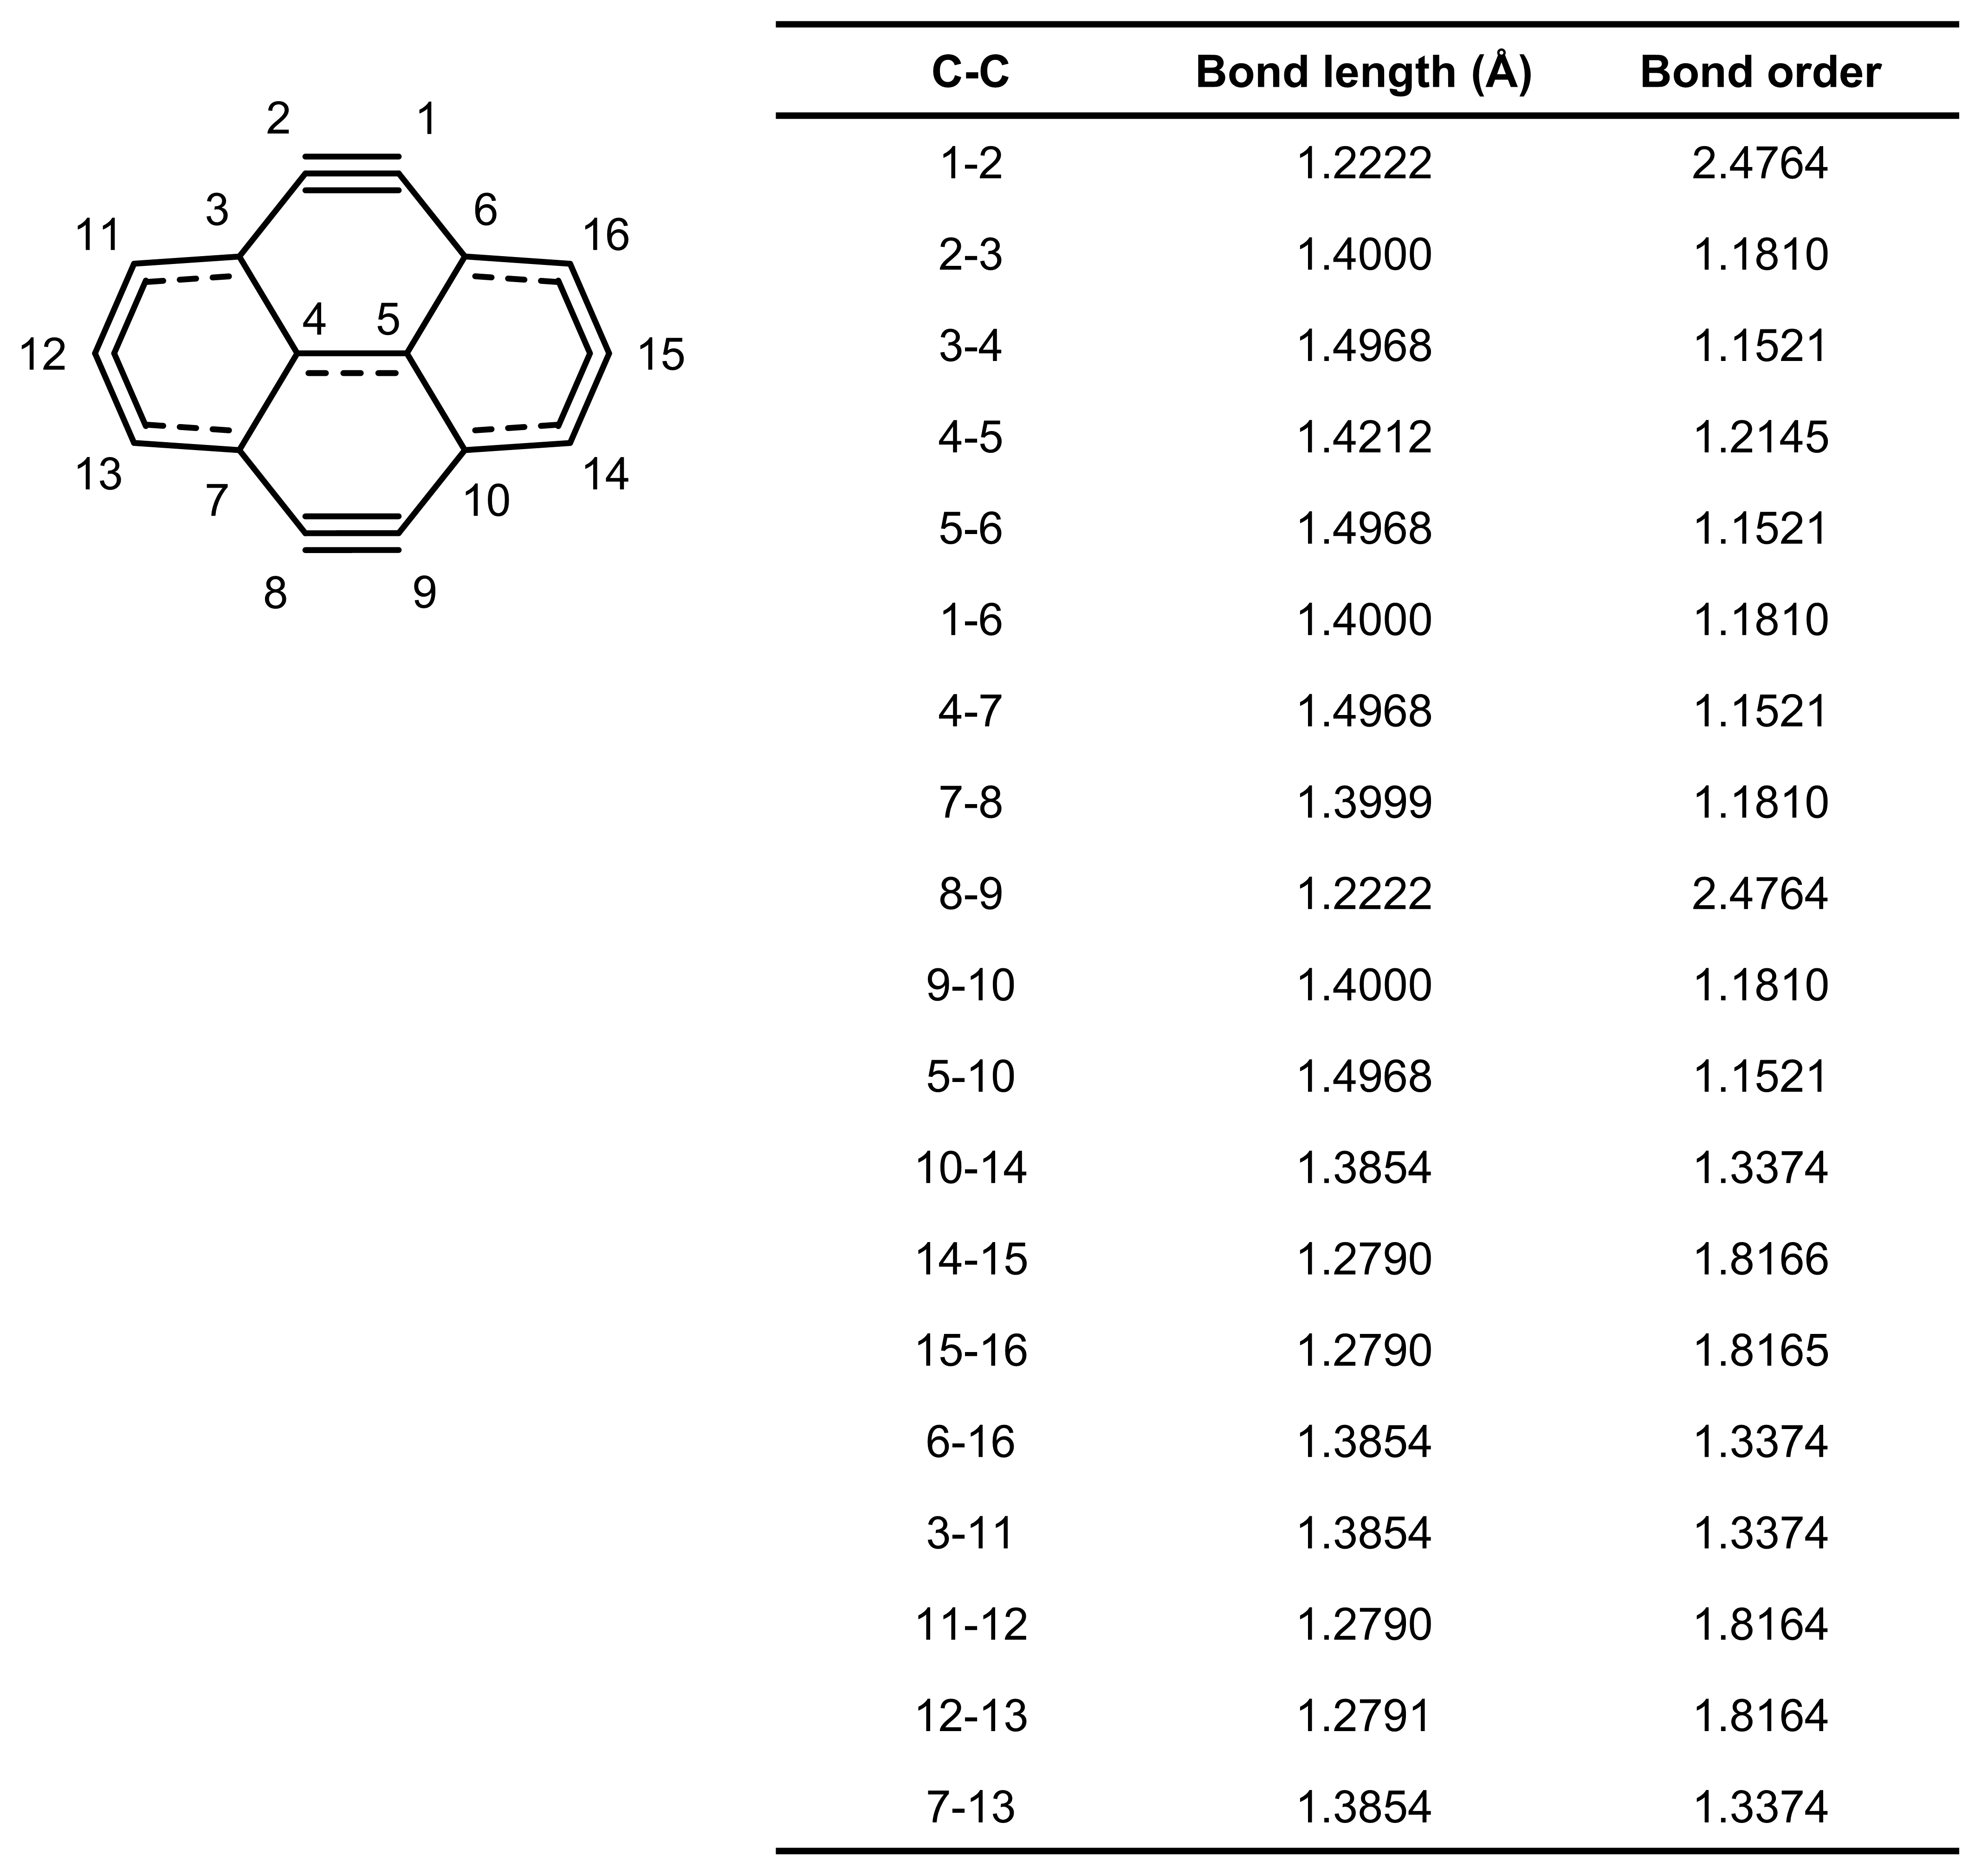

Supplementary Fig. 3. Bond length and Mayer bond order analysis of C₁₆ flake. Calculations were conducted at the ωB97XD/def2-TZVP level.

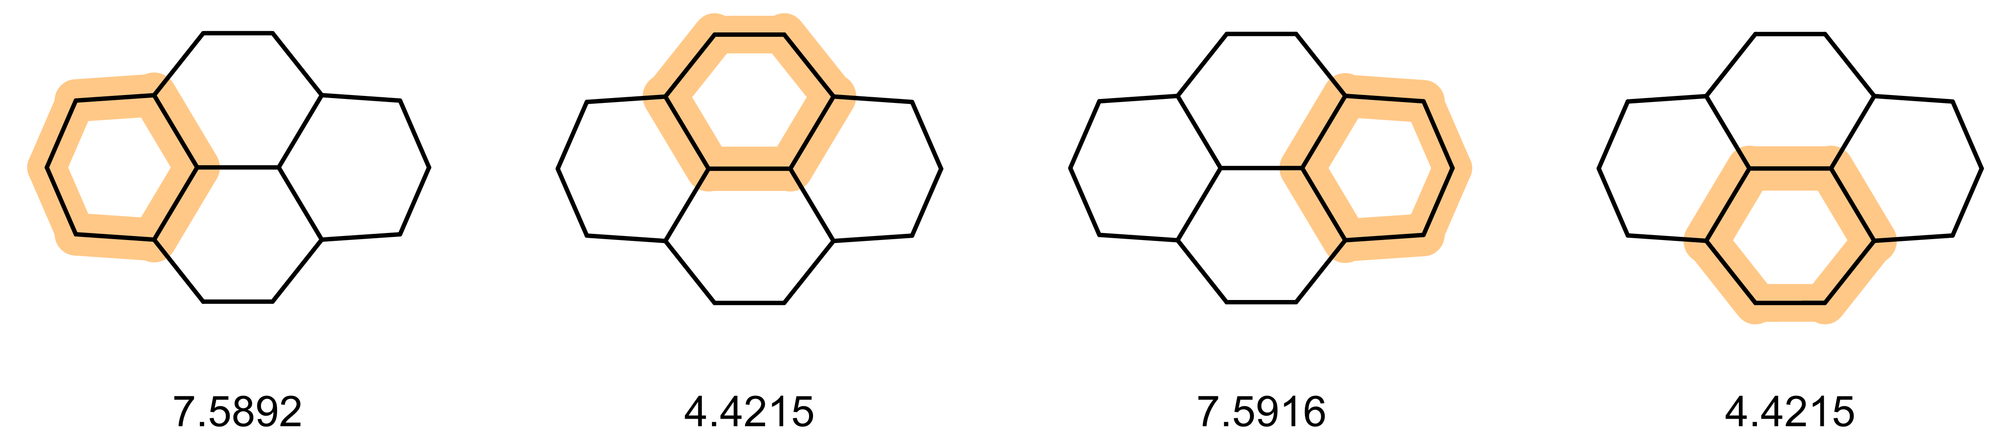

Supplementary Fig. 4. AV1245 analysis for C₁₆ flake calculated over the path indicated by highlight colour (ωB97XD/def2-TZVP). The AV1245 is a robust method for quantifying electron delocalization along a specific path. A higher positive value of AV1245 indicates greater delocalization along the path.

