- RAFLS cell migration and invasion -related proteins
Figure 3C MMP-9 78 kDa
180 kDa
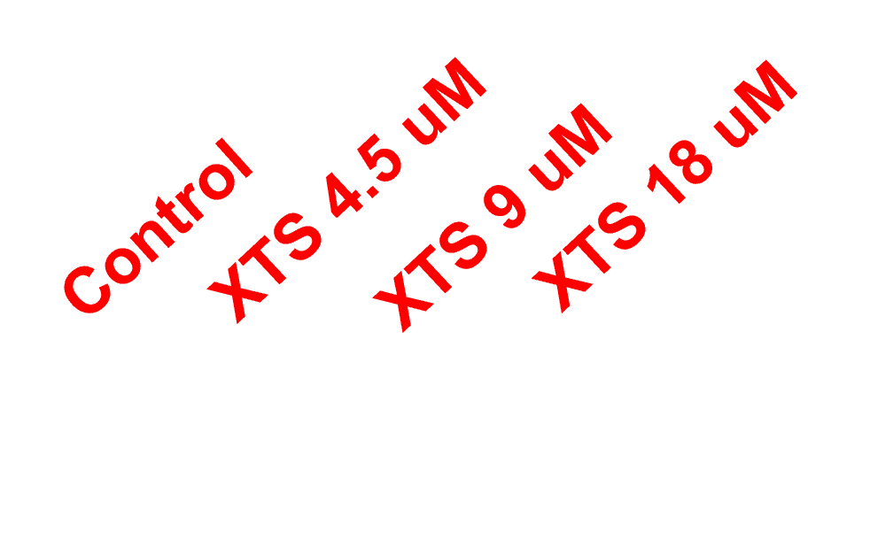
MMP9
70 kDa
55 kDa
40 kDa
25 kDa
35 kDa
100 kDa
130 kDa
15 kDa
Original Marked figure

Figure 3C HMGB-1 30 kDa
180 kDa
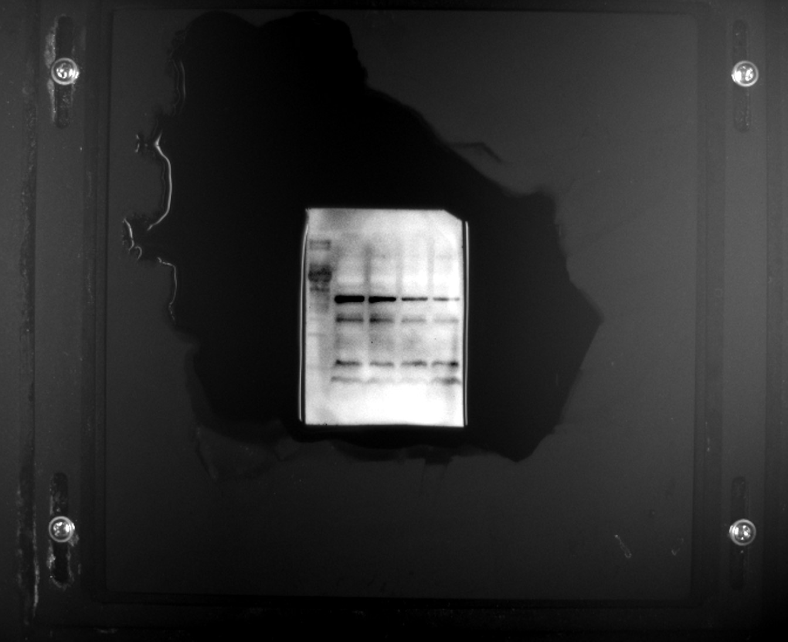
HMGB-1
15 kDa
25 kDa
35 kDa
40 kDa
55 kDa
70 kDa
130 kDa
100 kDa
Original Marked figure

Figure 3C β-actin 43 kDa
130 kDa
180 kDa
25 kDa
40 kDa
35 kDa
55 kDa
70 kDa
100 kDa
β-actin
Original Marked figure
- Apoptosis-related proteins of RAFLS cell
Figure 4B Caspase-3 17 kDa
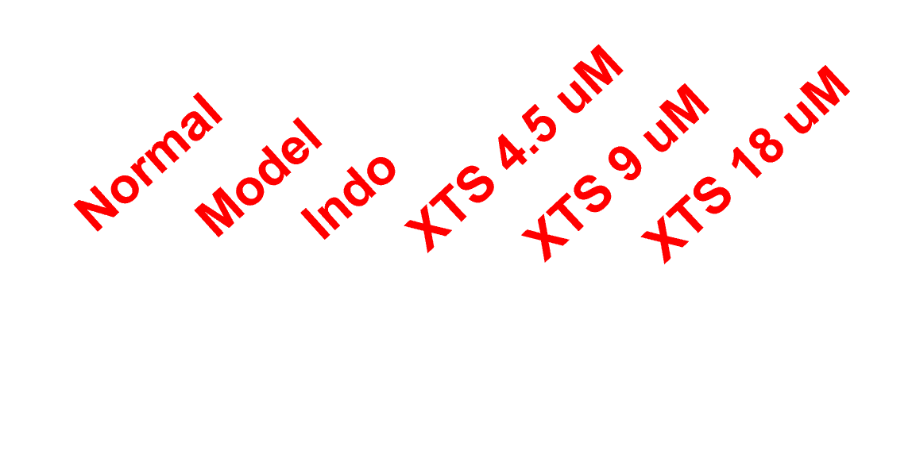
130 kDa
70 kDa
100 kDa
55 kDa
40 kDa
25 kDa
35 kDa
15 kDa
Caspase-3
Original Marked figure

Figure 4B Bax 21 kDa
180 kDa
70 kDa
100 kDa
130 kDa
15 kDa
25 kDa
35 kDa
40 kDa
50 kDa
Bax
Original Marked figure

Figure 4B Bcl-2 26 kDa
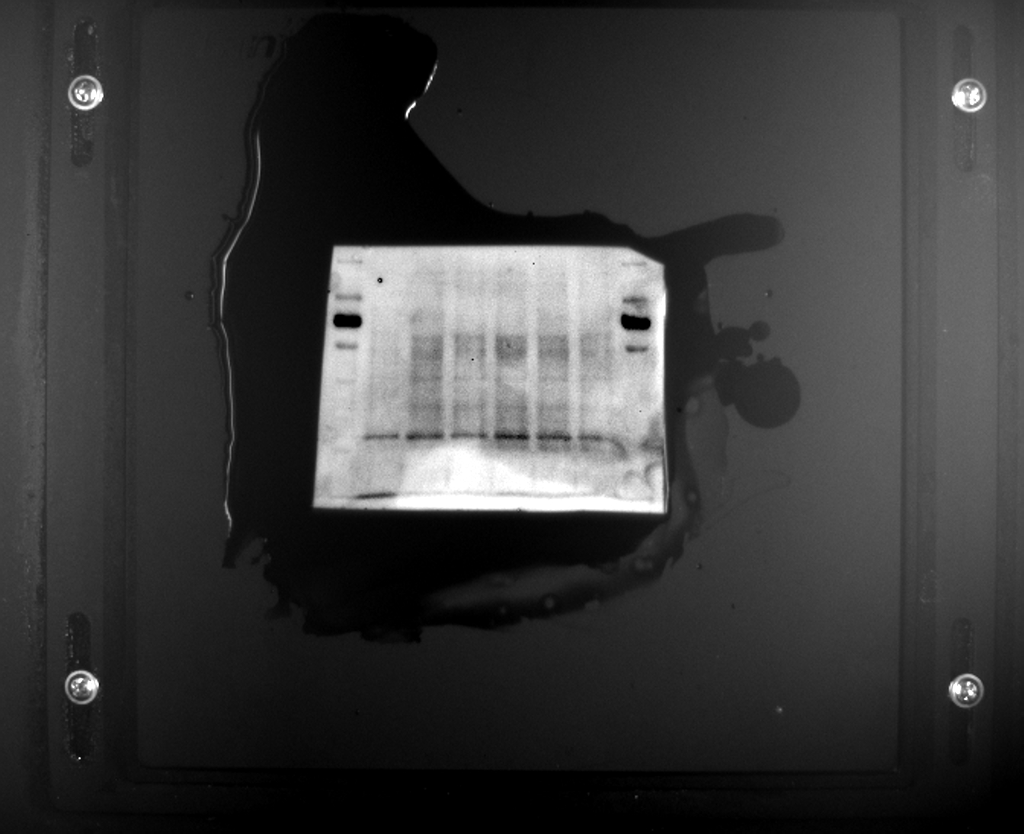
10 kDa
15 kDa
25 kDa
70 kDa
50 kDa
40 kDa
35 kDa
180 kDa
130 kDa
100 kDa
Bcl-2
Original Marked figure

Figure 4B β-actin 43 kDa
180 kDa
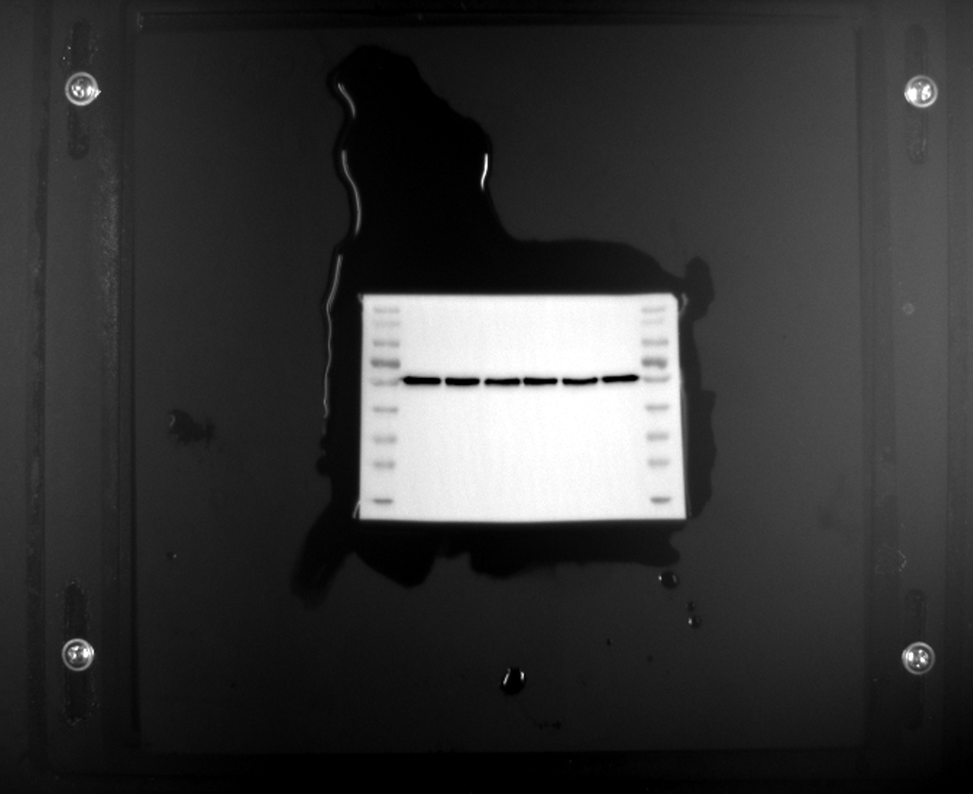
β-actin
15 kDa
25 kDa
35 kDa
40 kDa
50 kDa
70 kDa
100 kDa
130 kDa
Original Marked figure

- Apoptosis-related proteins of RA joint
Figure 6A Caspase-3 17 kDa
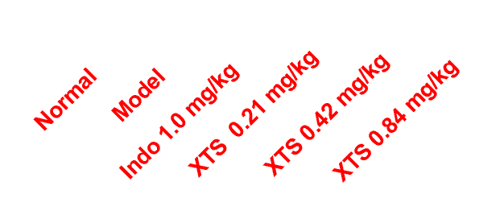
Caspase-3
180 kDa
130 kDa
100 kDa
25 kDa
35 kDa
40 kDa
50 kDa
70 kDa
Original Marked figure

Figure 6A Bax 21 kDa
180 kDa
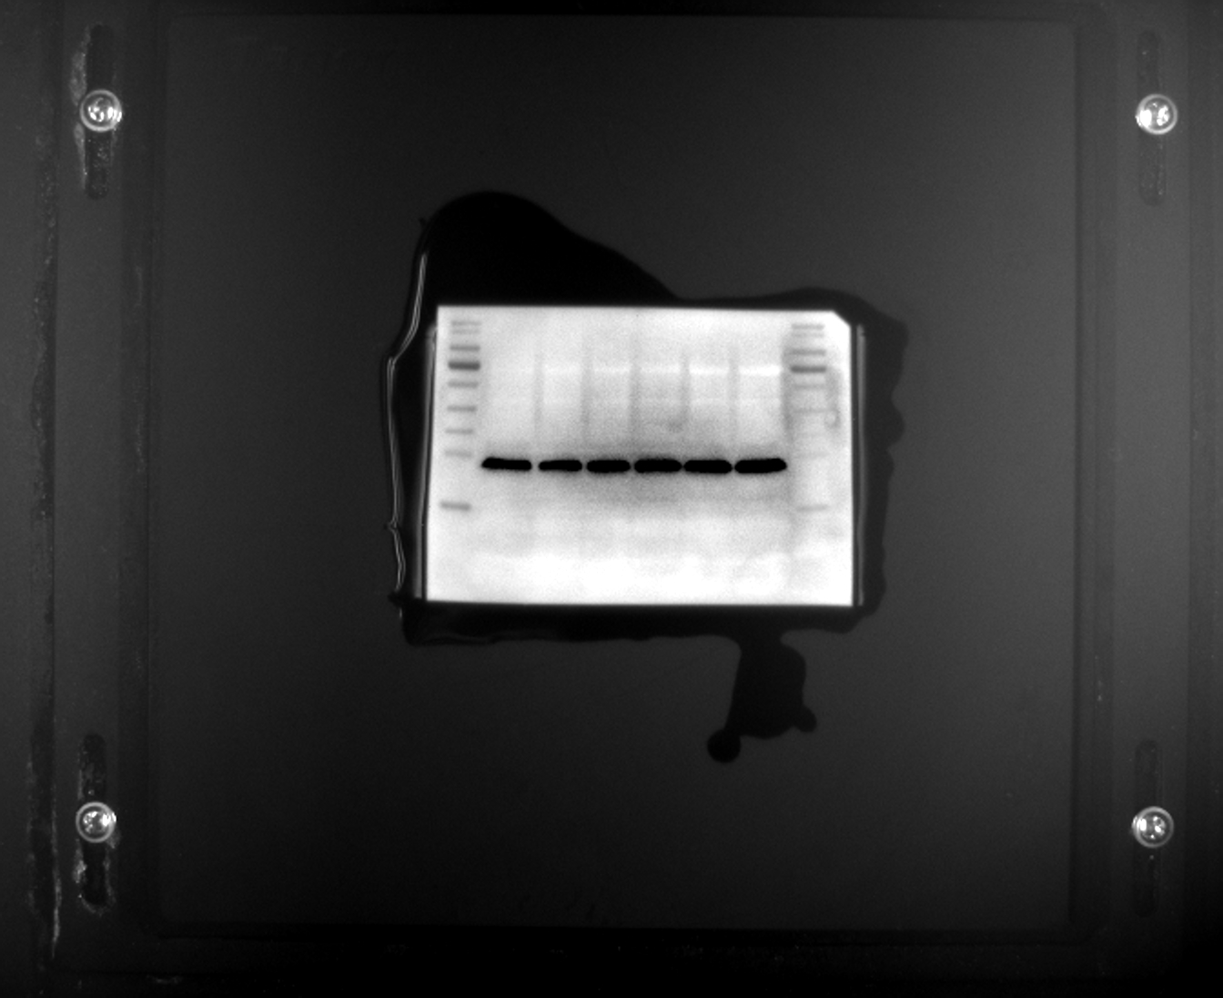
70 kDa
50 kDa
40 kDa
35 kDa
25 kDa
15 kDa
130 kDa
100 kDa
Bax
Original Marked figure

Figure 6A Bcl-2 26 kDa
180 kDa
100 kDa
15 kDa
25 kDa
35 kDa
40 kDa
50 kDa
70 kDa
130 kDa
Bcl-2
Original Marked figure

Figure 6A β-actin 43 kDa
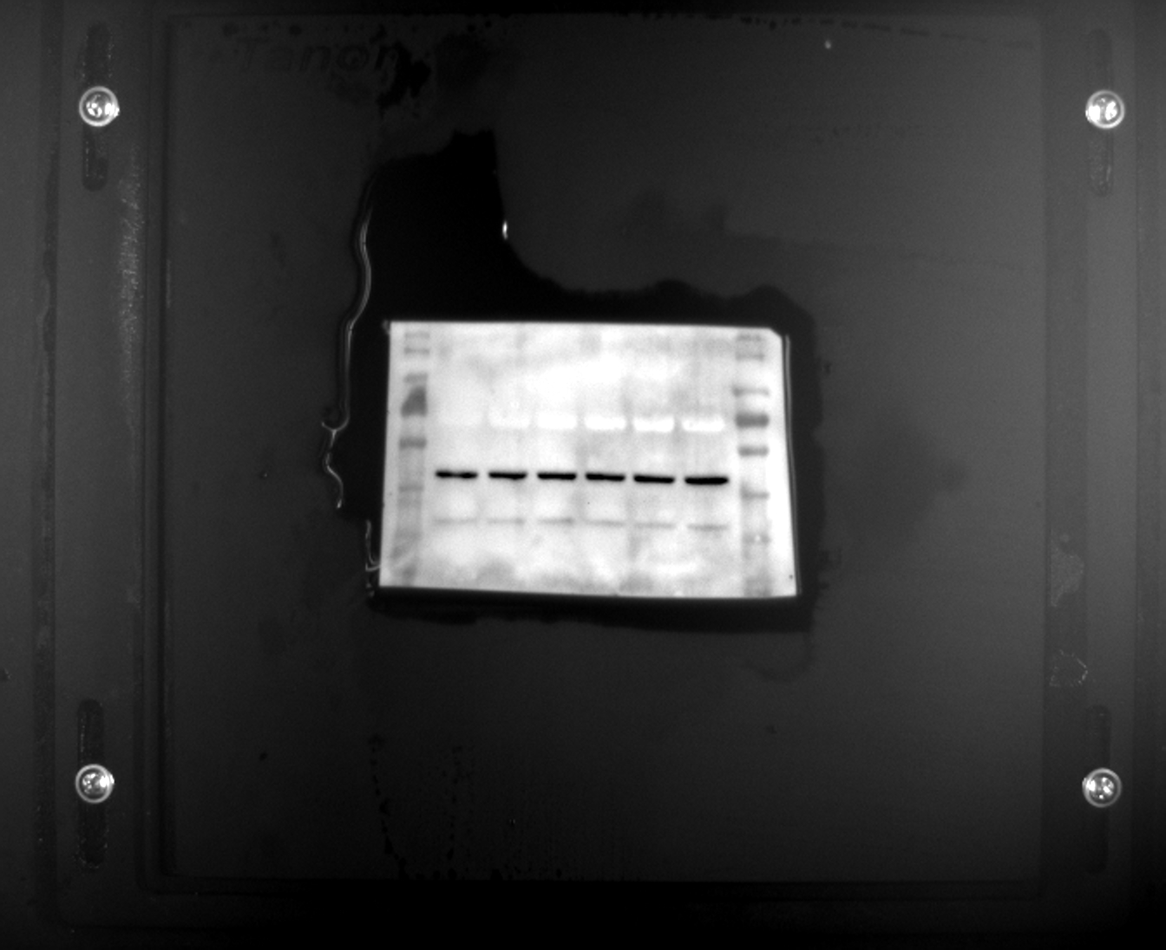
25 kDa
180 kDa
130 kDa
100 kDa
70 kDa
50 kDa
40 kDa
35 kDa
β-actin
Original Marked figure

