Optimal Extraction of Xuetongsu and its Mechanisms in Inhibiting RA Synovial Hyperplasia: Intervention in Migration and Apoptosis of Synovial Cells
Supplementary Material
Yasi Deng, Hao Zheng, Shiqi Liu, Ying Deng, Yuxin Chen, Mengyun Wang, Ling Liang, Qingling Xie, Yupei Yang, Bin Li, Juan Huang, Hanwen Yuan, Wei Wang*, Huanghe Yu *

TCM and Ethnomedicine Innovation & Development International Laboratory, Innovative Materia Medica Research Institute, School of Pharmacy, Hunan University of Chinese Medicine, Changsha, 410208, China.

*Corresponding author. TCM and Ethnomedicine Innovation & Development International Laboratory, Innovative Materia Medica Research Institute, School of Pharmacy, Hunan University of Chinese Medicine, Changsha, 410208, China.

E-mail addresses:
wangwei402@hotmail.com (Wang Wei)
yhh@hnucm.edu.cn (Huanghe Yu);

Table S1. ¹H NMR (600 MHz, CDCl₃) and ¹³C NMR (150 MHz, CDCl₃) of SE
Position | δ_{H} (J in Hz) | δ_{C} | ¹H-¹H COSY | HMBC | ROESY
1 | 2.29 (1H, m)  2.55 (1H, m) | 31.2 | H1 ↔ H2 | H-1 → C-2, C-3
2 | 1.28 (1H, m)  1.74 (1H, m) | 27.0 | H2 ↔ H1 | H-2 → C-1, C-3, C-10
3 | - | 178.2
4 | - | 149.4
5 | 2.42 (1H, m) | 46.0 | H-5 ↔ H-6 | H-5 → C-1, C-4, C-6, C-7, C-28, C-29 | H-5 ↔ H-28
6 | 1.09 (1H, m)  1.29 (1H, m) | 25.1 | H-6 ↔ H-5, H-7 | H-6 → C-5, C-7, C-8
7 | 1.10 (1H, m)  1.52 (1H, m) | 27.8 | H-7 ↔ H-6 | H-7 → C-6, C-8, C-9
8 | 1.59 (1H, m) | 47.7 | H8 ↔ H7 | H-8 → C-7, C-9, C-14
9 | - | 21.4
10 | - | 27.2
11 | 1.39 (1H, m)  2.10 (1H, m) | 27.1 | H-11 ↔ H-12 | H-11 → C-9, C-13, C-19
12 | 1.34 (2H, m) | 35.8 | H-12 ↔ H-13 | H-12 → C-11, C-13, C-18
13 | - | 45.8
14 | - | 48.7
15 | 1.65 (2H, m) | 33.0 | H-15 ↔ H-16 | H-15 → C-14, C-16, C-17, C-30
16 | 1.39 (1H, m)  2.08 (1H, m) | 28.9 | H-16 ↔ H-15, H-17 | H-16 → C-14, C-13
17 | 1.59 (1H, m) | 48.3 | H-17 ↔ H-16, H-20 | H-17 → C-20
18 | 0.93 (3H, s) | 19.9 |  | H-18 → C-12, C-13, C-17 | H-18 ↔ H-9, H-20
19 | 0.75 (1H, d, 4.5)  0.43 (1H, d, 4.5) | 30.0 |  | H-19 → C-8, C-9, C-10 | H-9 ↔ H-8, H-18
20 | 2.03 (1H, m) | 39.3
21 | 0.97 (3H, d, 6.7) | 13.2 |  | H-21 → C-17, C-20, C-22
22 | 4.47 (1H, dt, 13.2, 3.5) | 80.7 | H-22 ↔ H-20, H-23
23 | 2.37 (1H, m)  2.09 (1H, m) | 23.6 | H-23 ↔ H-22, H-24 | H-23 → C-24, C-25
24 | 6.61 (1H, dt, 6.6, 1.8) | 139.6 |  | H-24 → C-22, C-23, C-26, C-27
25 | - | 128.5
26 | - | 166.8
27 | 1.92 (3H, t, 1.7) | 17.2 |  | H-27 → C-24, C-25, C-26
28 | 4.81 (1H, m)  4.74 (1H, m) | 111.8 |  | H-28 → C-4, C-5, C-29
29 | 1.68 (3H, s) | 19.6 |  | H-29 → C-4, C-5, C-28
30 | 1.00 (3H, s) | 18.0 |  | H-30 → C-8, C-14, C-15 | H-30 ↔ H-17

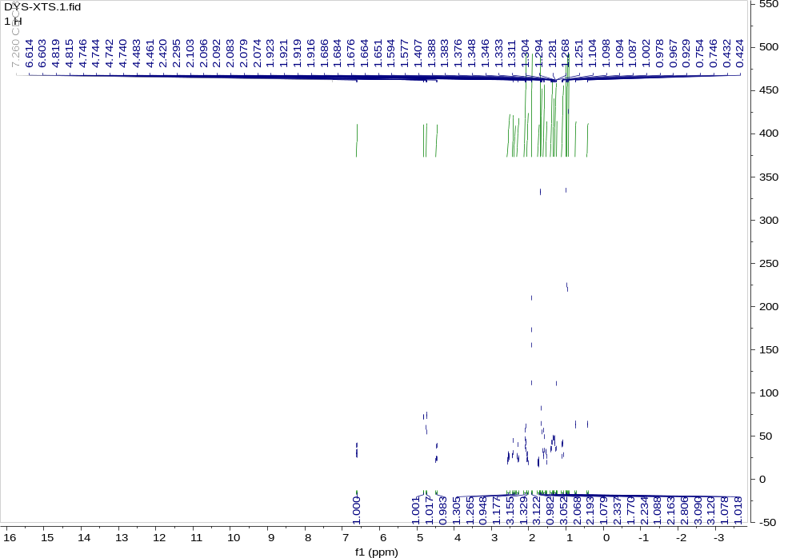
Fig. S1 ¹H NMR (600 MHz, CDCl₃) spectrum of 1

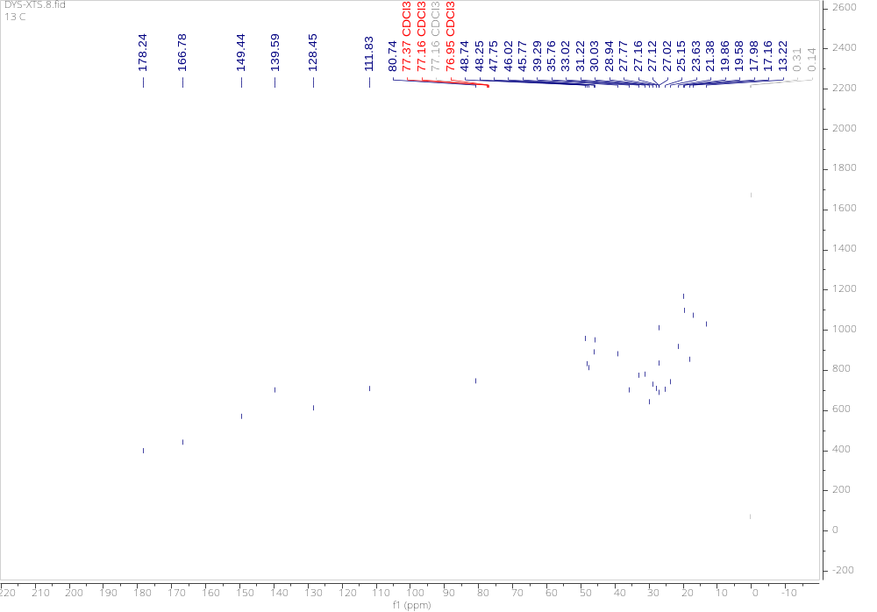
Fig. S2 ¹³C NMR (150 MHz, CDCl₃) spectrum of 1

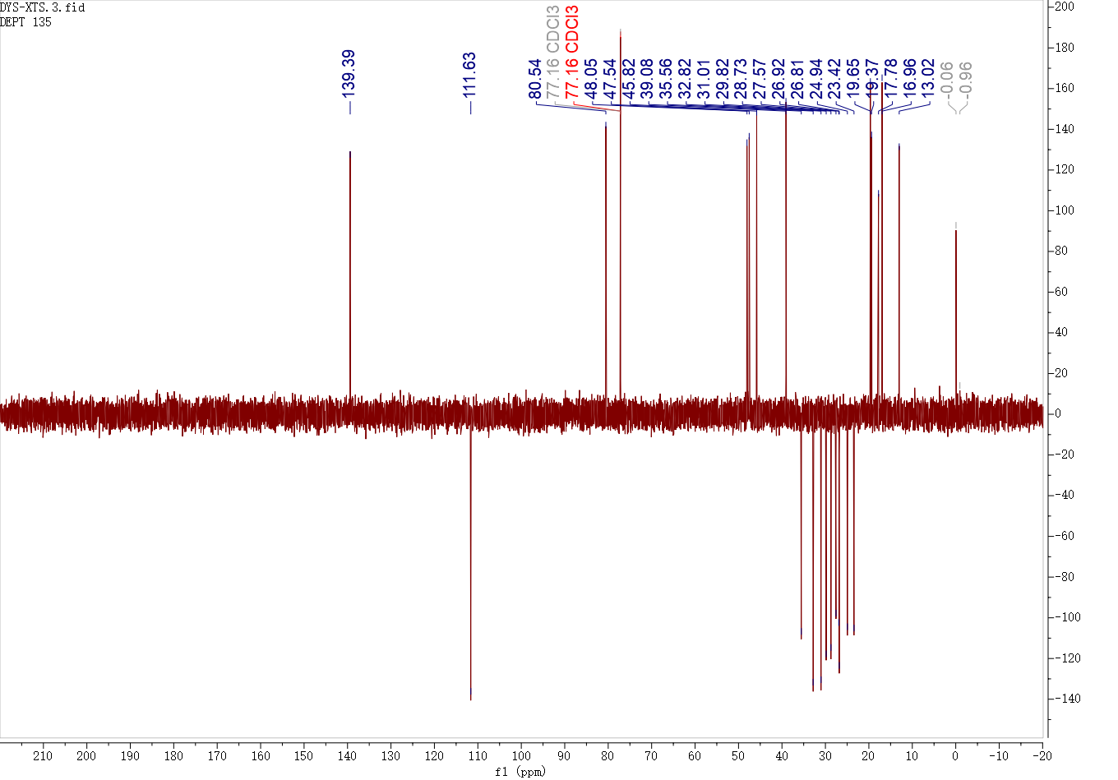
Fig. S3 DEPT 135°NMR (150 MHz, CDCl₃) spectrum of 1

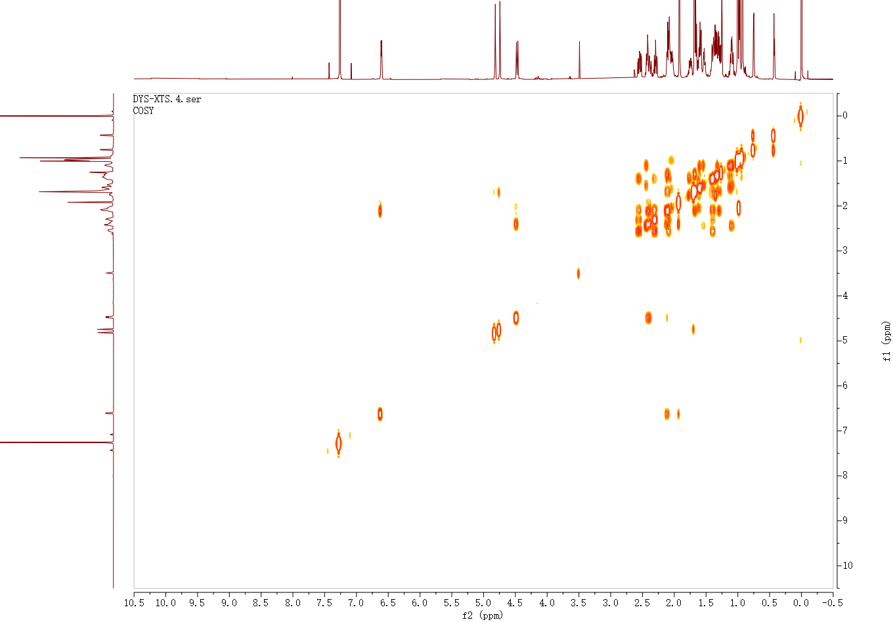
Fig. S4 ¹H-¹H COSY NMR (600 MHz, CDCl₃) spectrum of 1

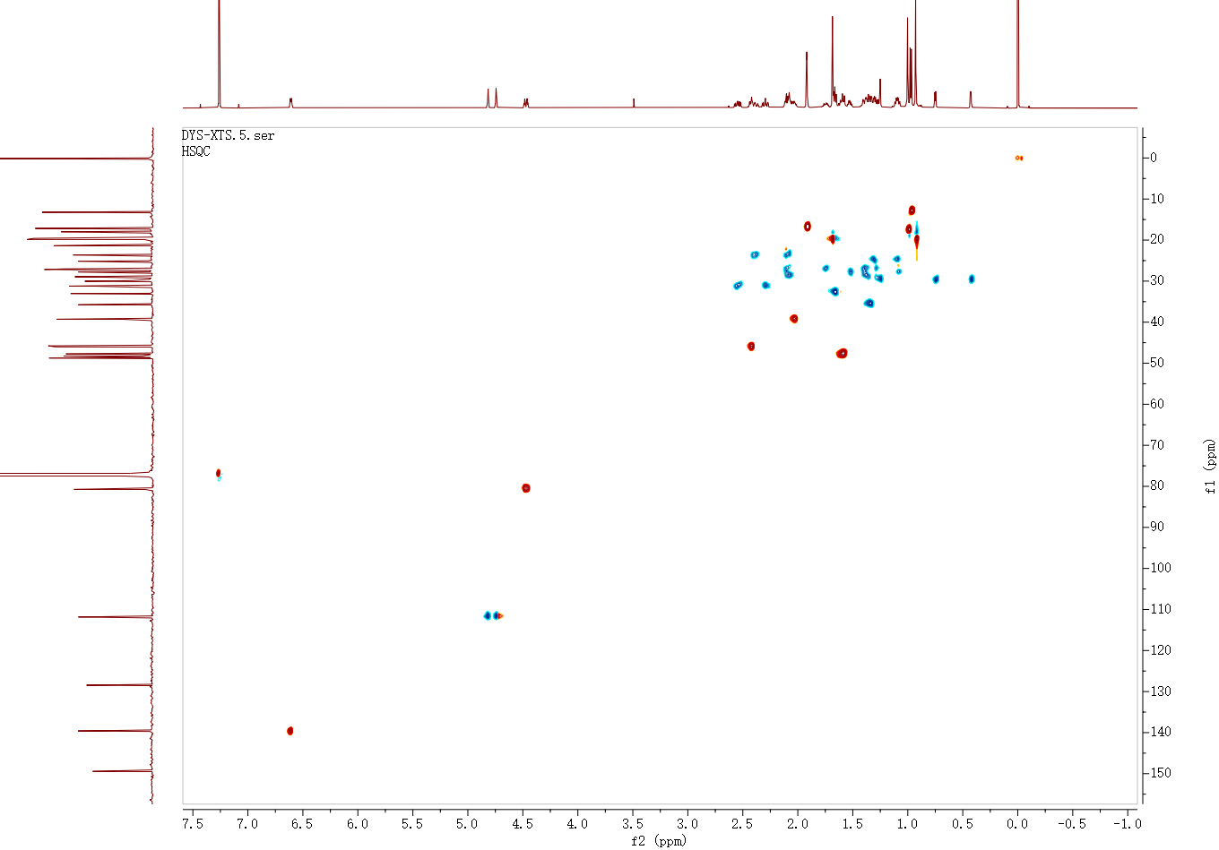
Fig. S5 HSQC NMR (600 MHz, CDCl₃) spectrum of 1

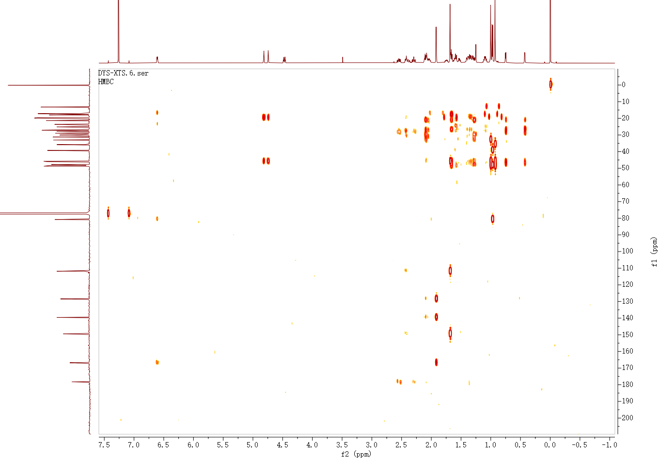
Fig. S6 HMBC NMR (600 MHz, CDCl₃) spectrum of 1

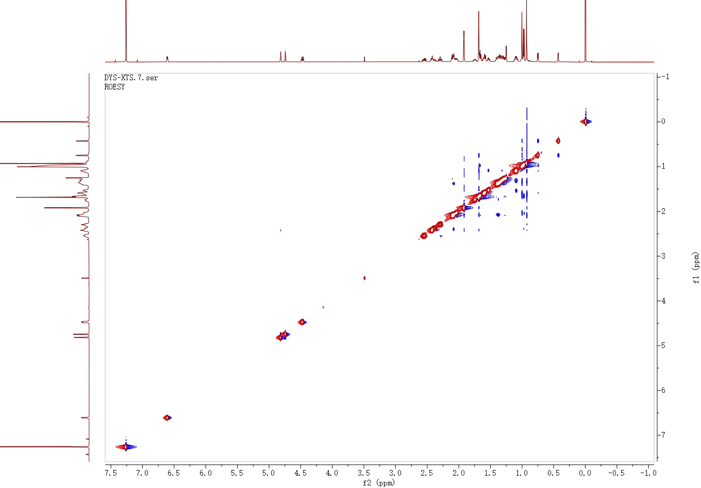
Fig. S7 ROESY NMR (600 MHz, CDCl₃) spectrum of 1

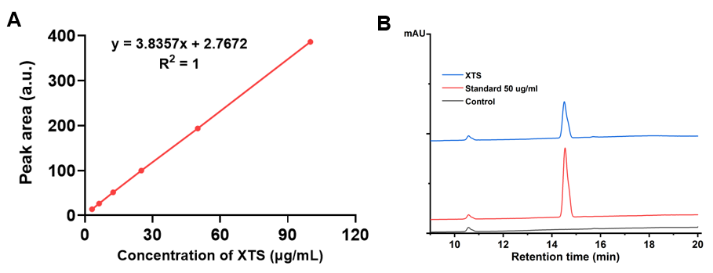

Fig. S8 Qualitative and quantitative analysis of SE
A, HPLC chromatograms of SE detected at 210 nm. B, Standard curve of SE

Fig. S9. Cytotoxicity of HFLS cells with various treatment.

Fig. S10. Cytotoxicity of RAW264.7 cells with various treatment.

Fig. S11. Cytotoxicity of NIH-3T3 cells with various treatment.

