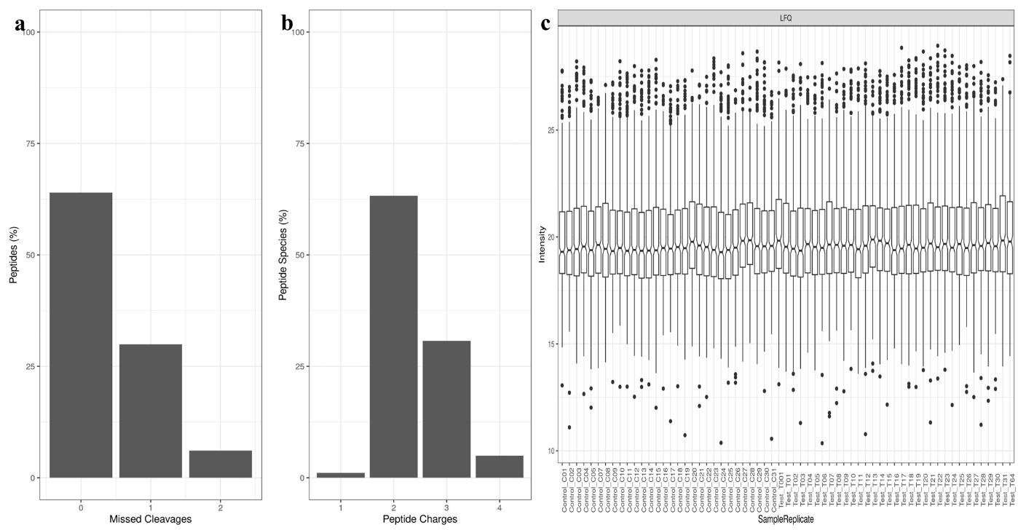
Supplementary Figure 1: Data Quality. a) Distribution of the number of missed cleavages per peptide shows good digestion efficiency b) Distribution of peptide charge states centers on 2 and 3+ species as expected c) Comparison of protein LFQ abundance distributions by sample shows comparable protein loading throughout the sample injections

