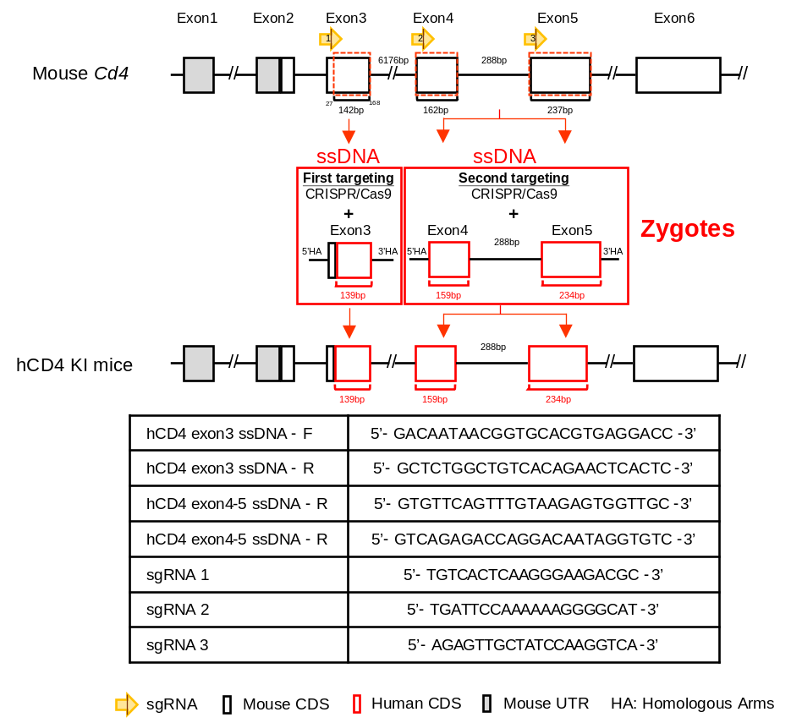
Supplementary Fig. 1 Schematic of a gene targeting strategy to create hCD4 KI mice. We employed CRISPR/Cas9 gene editing technology to replace the sequences encoding the extracellular domains (critical regions interacting with MHC class II molecules) D1 and D2 of mouse Cd4 with the corresponding human CD4 sequences, while keeping other regions unchanged. Therefore, we focused on replacing the region spanning from exon 3 to exon 5. Due to the length of the intron between exon 3 and exon 4 being 6176bp, we performed two rounds of gene targeting: the first targeting exon 3, followed by a focus on exons 4 and 5. The diagram illustrates the location and size of the targeted replacement region, along with the positioning and template usage of the target sgRNA and ssDNA.

Supplementary Fig. 2 Flow cytometry gating strategies for immunophenotyping of splenocytes (A) and PBMC (B). First, singlets were selected using the FSC-H and FSC-A plots. Live cells were then selected from the positively stained population using Near-IR vitality dye. The total live cell population was then separated into mCD3⁺mCD19⁻ and mCD3⁻mCD19⁺ populations to differentiate T and B cells, respectively. From the mCD3⁺ population, CD4⁺ and mCD8⁺ T cells were gated. For CD4⁺ T cells, gating was based on the specificity of corresponding antibodies to the CD4 domains, with T cells expressing CD4-D1 (including mCD4-D1⁺hCD4-D1⁻, mCD4-D1⁺hCD4-D1⁺, and mCD4-D1⁻hCD4⁻D1⁺ cells) and mCD4-D3 (mCD4-D3⁺mCD8⁻ cells) being gated. Finally, different subtypes of naïve (mCD44⁻mCD62L⁺), EM (mCD44⁺mCD62L⁻), and CM (mCD44⁺mCD62L⁺) T cells were defined from the mCD4-D3⁺ and mCD8⁺ T cell populations.

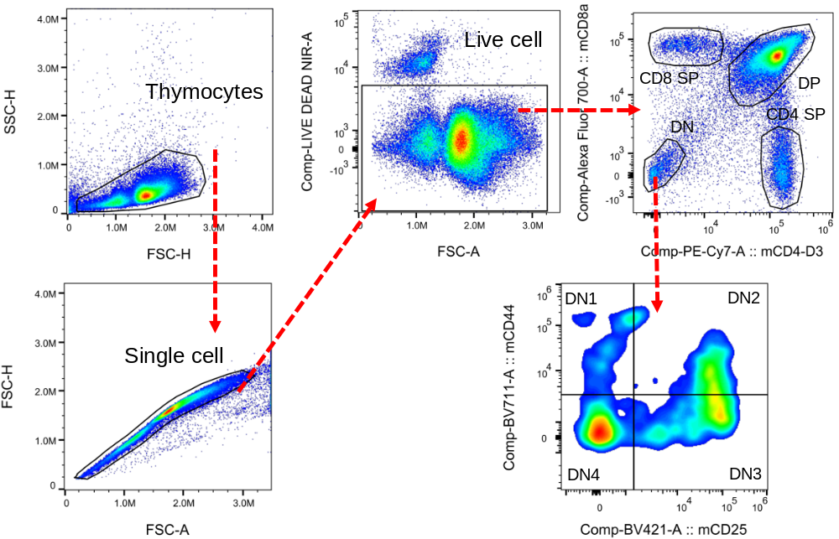
Supplementary Fig. 3 Flow cytometry gating strategies for immunophenotyping of thymocytes. Singlets were first selected using the FSC-H and FSC-A plots. Live cells were then selected from the positively stained population using the Near IR vitality dye. The total live cell population was separated into CD4 SP (mCD4-D3⁺mCD8⁻) cells, CD8 SP (mCD4-D3⁻mCD8⁺) cells, DN (mCD4-D3⁻mCD8⁻) cells, and DP (mCD4-D3⁺mCD8⁺) cells. Finally, from the DN population, DN1 (mCD44⁺mCD25⁻), DN2 (mCD44⁺mCD25⁺), DN3 (mCD44⁻mCD25⁺) and DN4 (mCD44⁻mCD25⁻) cells were defined.

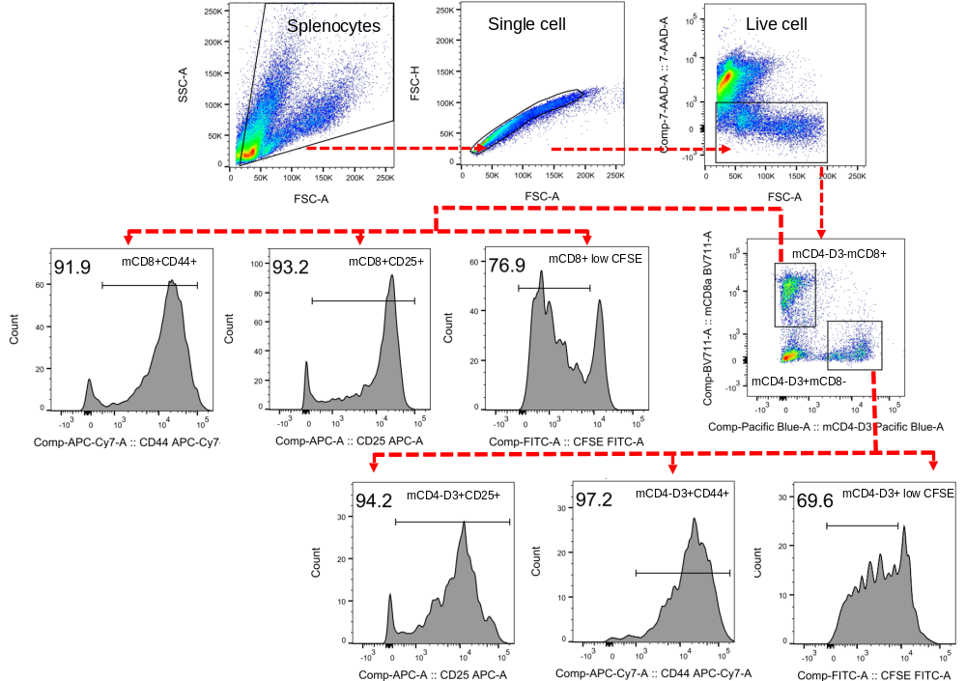
Supplementary Fig. 4 Flow cytometry gating strategies for anti-CD3/CD28-stimulated splenocytes. First, singlets were selected using the FSC-H and FSC-A plots. Live cells were then selected from the positively stained population using the 7-AAD vitality dye. The total live cell population was then separated into CD4 T (mCD4-D3⁺mCD8⁻) and CD8 T (mCD4-D3⁻mCD8⁺) cells, and their expression of CD44, CD25, and CFSE was analyzed.

Supplementary Table 1 Primer sequences for hCD4 KI mice genotyping
Gene | Species | Sequence (5’ → 3’) | Size (bp)
Cd4 (exon 3) | Mouse | F: ATCAGCAGAACTGCCCTGCG | 347
CD4 (exon 3) | Human | F: CAGGGCTCCTTCTTAACTAAA | 294
Cd4 (intron 3) | Mouse | R: ACATTAAGTTTGACAATGTCCA
Cd4 (intron 3) | Mouse | F: AGTTTGTAAGAGTGGTTGCTCC
Cd4 (exon 5) | Mouse | R: ACTGAGAGTGTCATGCCGAAC | 914
CD4 (exon 5) | Human | R: CTTGGACTCCTACATTGCACT-3 | 782

Supplementary Table 2 Primer sequences for RT-PCR and RT-qPCR
Gene | Species | Sequence (5’ → 3’) | Size (bp)
B2m (exon 1) | Mouse | F: CTCGGTGACCCTGGTCTTTC | 164
B2m (exon 2) | Mouse | R: GGATTTCAATGTGAGGCGGG
Cd4 (exon 2) | Mouse | F: CATCTCTCTTAGGCGCTTGCT | 233
Cd4 (exon 4) | Mouse | R: GATCAAACTGCGAAGGCGAAC
Cd4 (exon 2) | Mouse | F: CATCTCTCTTAGGCGCTTGCT | 351
CD4 (exon 4) | Human | R: AATTGCACCTCCTCCTTCTGG

Supplementary Table 3 Comparison of body weight between hCD4 KI mice and CD4^{m/m} mice at 4 to 12 weeks of age
Male body weight
 | CD4^{m/m} |  |  | CD4^{m/h} |  |  | CD4^{m/h} |  |  | P-value
Weeks | n | Mean ± SD (g) |  | n | Mean ± SD (g) |  | n | Mean ± SD (g) |  | m/m vs. m/h |  | m/m vs. h/h |  | m/h vs. h/h
4 | 38 | 14.97 ± 2.56 |  | 22 | 16.59 ± 2.84 |  | 15 | 16.33 ± 2.50 |  | 0.2008 |  | 0.8095 |  | >0.9999
5 | 47 | 19.72 ± 1.46 |  | 23 | 19.43 ± 2.61 |  | 23 | 18.61 ±1.80 |  | >0.9999 |  | 0.8407 |  | 0.9995
6 | 47 | 21.94 ± 1.90 |  | 26 | 21.12 ± 2.12 |  | 23 | 20.91 ± 1.90 |  | 0.9913 |  | 0.9193 |  | >0.9999
7 | 47 | 23.49 ± 1.27 |  | 32 | 22.97 ± 1.96 |  | 23 | 23.09 ± 1.68 |  | >0.9999 |  | >0.9999 |  | >0.9999
8 | 46 | 25.08 ± 1.94 |  | 44 | 24.08 ± 1.86 |  | 25 | 24.17 ± 1.43 |  | 0.7049 |  | 0.9730 |  | >0.9999
9 | 35 | 25.74 ± 1.44 |  | 35 | 24.89 ± 2.05 |  | 24 | 25.10 ± 1.47 |  | 0.9812 |  | >0.9999 |  | >0.9999
10 | 30 | 26.77 ± 1.41 |  | 28 | 26.18 ± 1.89 |  | 20 | 25.80 ± 1.58 |  | >0.9999 |  | 0.9911 |  | >0.9999
11 | 31 | 27.21 ± 1.80 |  | 24 | 26.64 ± 2.04 |  | 17 | 26.79 ± 1.62 |  | >0.9999 |  | >0.9999 |  | >0.9999
12 | 24 | 27.87 ± 1.22 |  | 22 | 27.18 ± 1.99 |  | 11 | 27.64 ± 1.50 |  | >0.9999 |  | >0.9999 |  | >0.9999
Female body weight
 | CD4^{m/m} |  |  | CD4^{m/h} |  |  | CD4^{m/h} |  |  | P-value
Weeks | n | Mean ± SD (g) |  | n | Mean ± SD (g) |  | n | Mean ± SD (g) |  | m/m vs. m/h | m/m vs. h/h | m/h vs. h/h
4 | 31 | 13.84 ± 1.21 |  | 24 | 14.42 ± 1.67 |  | 21 | 14.10 ± 1.30 |  | 0.9988 | >0.9999 | >0.9999
5 | 40 | 16.65 ± 1.23 |  | 28 | 16.36 ± 1.10 |  | 31 | 15.48 ± 1.52 |  | >0.9999 | 0.0710 | 0.7424
6 | 41 | 18.27 ± 1.79 |  | 32 | 17.50 ± 0.98 |  | 32 | 17.09 ± 1.33 |  | 0.7980 | 0.0543 | >0.9999
7 | 42 | 18.95 ± 1.19 |  | 34 | 18.62 ± 0.85 |  | 33 | 18.15 ± 1.18 |  | >0.9999 | 0.7079 | 0.9998
8 | 34 | 19.93 ± 1.45 |  | 39 | 19.45 ± 1.14 |  | 39 | 19.14 ± 1.44 |  | 0.9994 | 0.7468 | >0.9999
9 | 30 | 20.87 ± 1.78 |  | 34 | 20.24 ± 1.05 |  | 37 | 19.65 ± 1.46 |  | 0.9867 | 0.0594 | 0.9887
10 | 30 | 21.40 ± 1.81 |  | 33 | 20.82 ± 1.21 |  | 32 | 20.13 ± 1.18 |  | 0.9962 | 0.0550 | 0.9550
11 | 31 | 21.64 ± 1.82 |  | 26 | 21.14 ± 1.21 |  | 25 | 20.43 ± 1.06 |  | 0.9999 | 0.1629 | 0.9853
12 | 23 | 21.96 ± 1.36 |  | 23 | 21.70 ± 1.22 |  | 14 | 20.71 ± 1.54 |  | >0.9999 | 0.5628 | 0.9245
n: number of mice.
Statistical analysis using one-way ANOVA and Tukey's multiple comparisons test, showing that the body weight of both male and female mice of each genotype was similar during the 4 to 12-week age period. Statistical significance was considered when the P-value was less than 0.05.

Supplementary Table 4 Comparison of Complete Blood Count (CBC) between 9 to 10-week-old hCD4 KI mice and CD4^{m/m} mice
Complete blood count
 | CD4^{m/m} (n=8) |  | CD4^{m/h} (n=8) |  | CD4^{h/h} (n=8) |  | P-value
Parameter | Mean ± SD |  | Mean ± SD |  | Mean ± SD |  | m/m vs. m/h | m/m vs. h/h | m/h vs. h/h
RBC (M/uL) | 10.01 ± 0.48 |  | 10.00 ± 0.28 |  | 10.16 ± 0.47 |  | 0.9977 | 0.7588 | 0.7207
HGB (g/dL) | 15.03 ± 0.60 |  | 15.07 ± 0.50 |  | 15.40 ± 0.58 |  | 0.9904 | 0.4225 | 0.4973
HCT (%) | 51.42 ± 2.55 |  | 51.21 ± 1.92 |  | 52.72 ± 2.67 |  | 0.9830 | 0.5365 | 0.4344
MCV (fL) | 51.32 ± 0.80 |  | 51.20 ± 0.75 |  | 51.85 ± 0.82 |  | 0.9474 | 0.4019 | 0.2554
MCH (pg) | 15.02 ± 0.31 |  | 15.06 ± 0.19 |  | 15.15 ± 0.25 |  | 0.9557 | 0.6114 | 0.7833
MCHC (g/dL) | 29.26 ± 0.67 |  | 29.43 ± 0.36 |  | 29.23 ± 0.46 |  | 0.7800 | 0.9949 | 0.7238
RET (K/uL) | 377.7 ± 63.2 |  | 431.5 ± 105.8 |  | 374.0 ± 37.2 |  | 0.3356 | 0.9945 | 0.2898
RET (%) | 3.801 ± 0.82 |  | 4.327 ± 1.11 |  | 3.690 ± 0.45 |  | 0.4380 | 0.9623 | 0.3046
PLT (K/uL) | 659.6 ± 219.8 |  | 740.7 ± 95.8 |  | 786.0 ± 131.6 |  | 0.5684 | 0.2676 | 0.8358
WBC (K/uL) | 7.336 ± 0.47 |  | 6.940 ± 2.11 |  | 6.966 ± 1.39 |  | 0.9358 | 0.8554 | >0.9999
NEUT (K/uL) | 0.808 ± 0.24 |  | 0.708 ± 0.22 |  | 0.720 ± 0.25 |  | 0.6863 | 0.7425 | 0.9952
NEUT (%) | 11.11 ± 3.45 |  | 10.58 ± 2.96 |  | 10.71 ± 4.64 |  | 0.9579 | 0.9753 | 0.9976
LYMPH (K/uL) | 6.258 ± 0.55 |  | 5.911 ± 2.01 |  | 5.962 ± 1.34 |  | 0.9503 | 0.9149 | 0.9999
LYMPH (%) | 85.22 ± 3.85 |  | 84.42 ± 4.24 |  | 85.22 ± 4.69 |  | 0.9259 | >0.9999 | 0.9259
MONO (K/uL) | 0.150 ± 0.04 |  | 0.210 ± 0.21 |  | 0.163 ± 0.10 |  | 0.6702 | 0.9788 | 0.7868
MONO (%) | 2.037 ± 0.62 |  | 3.412 ± 4.02 |  | 2.312 ± 1.37 |  | 0.5203 | 0.9734 | 0.6550
EO (K/uL) | 0.108 ± 0.03 |  | 0.098 ± 0.04 |  | 0.111 ± 0.04 |  | 0.8939 | 0.9930 | 0.8398
EO (%) | 1.500 ± 0.56 |  | 1.388 ± 0.51 |  | 1.638 ± 0.75 |  | 0.9307 | 0.8984 | 0.7049
BASO (K/uL) | 0.010 ± 0.005 |  | 0.011 ± 0.006 |  | 0.008 ± 0.006 |  | 0.9113 | 0.9113 | 0.6932
BASO (%) | 0.125 ± 0.08 |  | 0.175 ± 0.12 |  | 0.111 ± 0.09 |  | 0.6230 | 0.9702 | 0.4821
n: number of mice, abbreviations: red blood cell (RBC), Hemoglobin (HGB), Hematocrit (HCT), Mean Corpuscular Volume (MCV), Mean Corpuscular Hemoglobin (MCH), Mean Corpuscular Hemoglobin Concentration (MCHC), Reticulocyte (RET), Platelet (PLT), White blood cell (WBC), Neutrophil (NEUT), Lymphocyte (LYMPH), Monocyte (MONO), Eosinophil (EO), Basophil (BASO).
Statistical analysis using one-way ANOVA and Tukey's multiple comparisons test, showing that each genotype exhibited similar CBC parameters. Statistical significance was considered when the P-value was less than 0.05.

Supplementary Table 5 Comparison of spleen, thymus length and relative weight at 8-week-old hCD4 KI mice and CD4^{m/m} mice
 | Thymus
 |  |  | Body / organ weight |  |  |  | Length
Genotype | Sex | n | Mean ± SD | P-value |  |  | Mean ± SD (cm) | P-value
CD4^{m/m} | M | 20 | 0.1781 ± 0.0301 | m/m vs. m/h | 0.9806 |  | 0.8900 ± 0.0940 | m/m vs. m/h | 0.9575
CD4^{m/h} | M | 20 | 0.1917 ± 0.0364 | m/m vs. h/h | 0.9819 |  | 0.9200 ± 0.0834 | m/m vs. h/h | 0.7290
CD4^{h/h} | M | 15 | 0.1925 ± 0.0407 | m/h vs. h/h | >0.9999 |  | 0.9433 ± 0.0594 | m/h vs. h/h | 0.9900
CD4^{m/m} | F | 20 | 0.3040 ± 0.0736 | m/m vs. m/h | 0.1232 |  | 0.9975 ± 0.1552 | m/m vs. m/h | 0.9203
CD4^{m/h} | F | 20 | 0.3524 ± 0.0986 | m/m vs. h/h | >0.9999 |  | 1.0325 ± 0.1280 | m/m vs. h/h | >0.9999
CD4^{h/h} | F | 20 | 0.3033 ± 0.0482 | m/h vs. h/h | 0.1131 |  | 1.0050 ± 0.1134 | m/h vs. h/h | 0.9707

 | Spleen
 |  |  | Body / organ weight |  |  |  | Length
Genotype | Sex | n | Mean ± SD | P-value |  |  | Mean ± SD (cm) | P-value
CD4^{m/m} | M | 20 | 0.2960 ± 0.0527 | m/m vs. m/h | >0.9999 |  | 1.3225 ± 0.0734 | m/m vs. m/h | 0.9429
CD4^{m/h} | M | 20 | 0.2963 ± 0.0638 | m/m vs. h/h | >0.9999 |  | 1.2875 ± 0.1512 | m/m vs. h/h | 0.5041
CD4^{h/h} | M | 15 | 0.2945 ± 0.0648 | m/h vs. h/h | >0.9999 |  | 1.2500 ± 0.1134 | m/h vs. h/h | 0.9448
CD4^{m/m} | F | 20 | 0.3411 ± 0.0657 | m/m vs. m/h | 0.9852 |  | 1.3075 ± 0.1104 | m/m vs. m/h | >0.9999
CD4^{m/h} | F | 20 | 0.3541 ± 0.0610 | m/m vs. h/h | >0.9999 |  | 1.3125 ± 0.1613 | m/m vs. h/h | 0.5401
CD4^{h/h} | F | 20 | 0.3369 ± 0.0613 | m/h vs. h/h | 0.9499 |  | 1.2425 ± 0.0936 | m/h vs. h/h | 0.4561
n: number of mice.
Statistical analysis using one-way ANOVA and Tukey's multiple comparisons test, showing that both spleen and thymus exhibited similar weight and length within each genotype. Statistical significance was considered when the P-value was less than 0.05.

