High diffuse bone marrow uptake in ¹⁸F-FDG PET/CT may reflect the diverse mutational characteristics of multiple myeloma

Running title: Mutational characteristics of multiple myeloma with high diffuse uptake

Hee Jeong Cho¹*, Donghyeon Lee^{2, 3}*, Chae Moon Hong⁴, Tan Minh Le^{2,3}, Hong Duc Thi Nguyen^{2,3}, Hyukjin Choi¹, Dong Won Baek¹, Ha-Jeong Kim⁵, Hyung Soo Han^{2,3}, Sang Kyun Sohn¹, Juhyung Kim¹, and Joon Ho Moon¹

¹Department of Hematology/Oncology, Kyungpook National University Hospital, School of Medicine, Kyungpook National University, Daegu, Republic of Korea, ²Department of Biomedical Science, Korea, ³BK21 Four Program, School of Medicine, Kyungpook National University, Daegu, Republic of Korea, ⁴Department of Nuclear Medicine, Kyungpook National University Hospital, School of Medicine, Kyungpook National University, Daegu, South Kore, ⁵Department of Physiology, Kyungpook National University Hospital, School of Medicine

* These Authors contributed equally to this study.

2. Supplementary tables
Table S1. Mutations relevant to multiple myeloma biology
ABCF1, ACTG1, ARID1A, ARID2, ATM, ATRX, BCL7A, BHLHE41, BRAF, BTG1, CCND1, CDKN1B, CDKN2C, CREBBP, CYLD, DIS3, DNMT3A, DTX1, DUSP2, EGR1, EP300, FAM46C, FGFR3, FUBP1, HIST1H1B, HIST1H1D, HIST1H1E, HIST1H2BK, HUWE1, IDH1, IDH2, IRF1, IRF4, KDM5C, KDM6A, KLHL6, KMT2B, KMT2C, KRAS, LCE1D, LTB, MAF, MAFB, MAML2, MAN2C1, MAX, NCOR1, NF1, NFKB2, NFKBIA, NRAS, PABPC1, PIK3CA, PIM1, POT1, PRDM1, PRKD2, PTPN11, RASA2, RB1, RFTN1, RPL10, RPL5, RPRD1B, RPS3A, SAMHD1, SETD2, SF3B1, SP140, TBC1D29, TCL1A, TET2, TGDS, TP53, TRAF2, TRAF3, UBR5, XBP1, ZFP36L1, ZNF292

3. Supplementary figures
Figure S1. Number of mutations per patient

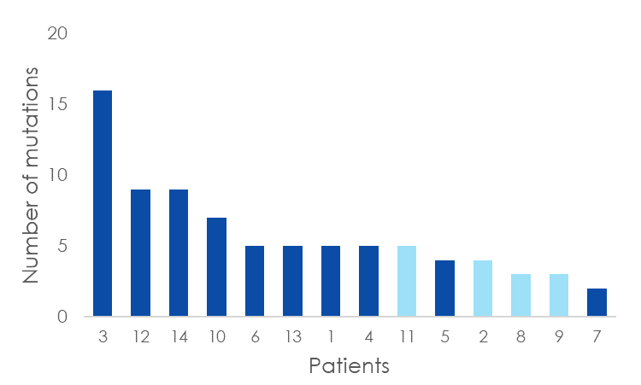
Abbreviations: DU, diffuse uptake.

Figure S2. Mutational characteristics relevant to the number of FL
(A) Box plot of the median number of mutations

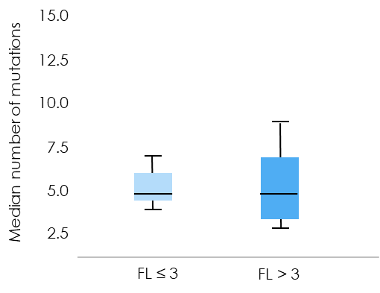
p = 0.948
(B) Frequency of each mutation
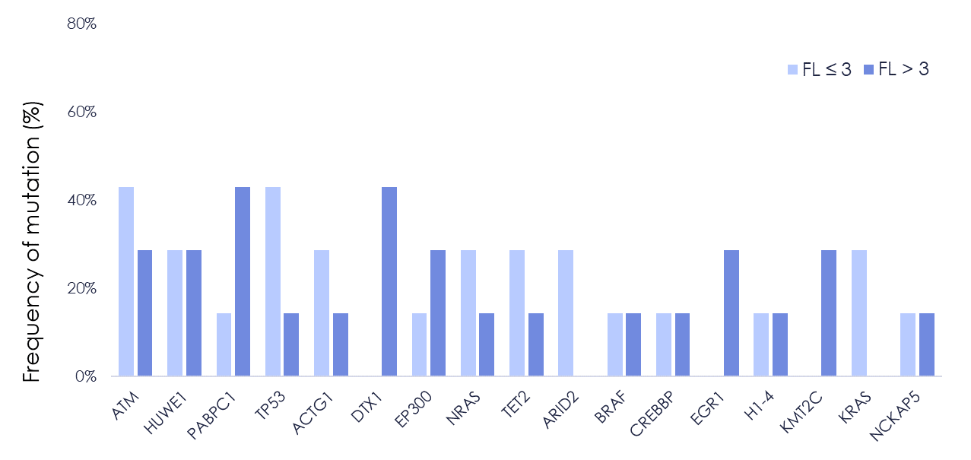

Abbreviations: FL, focal lesion.

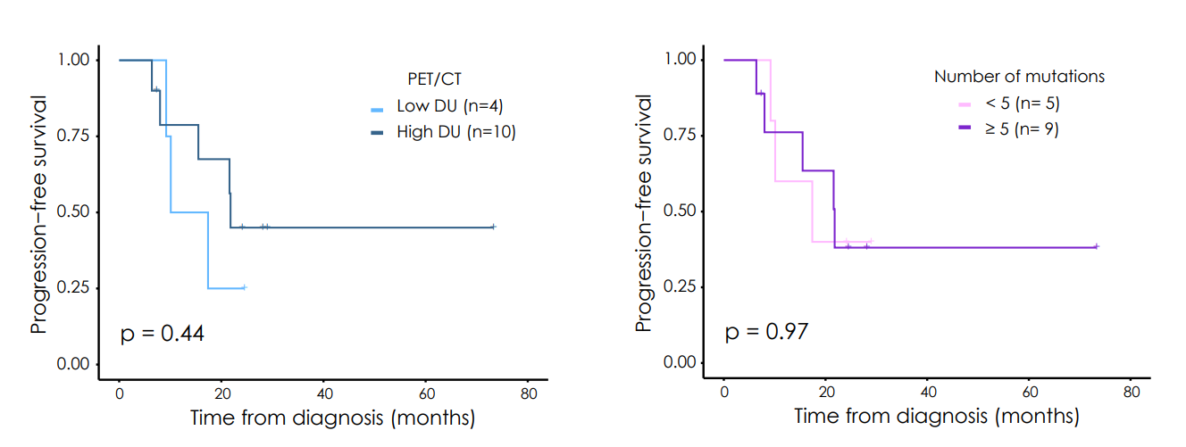
Figure S3. Progression-free survival analysis

Abbreviations: DU, diffuse uptake; FL, focal lesion.

Figure S4. Top 20 GO analysis terms regarding the biological processes in patients with high DU
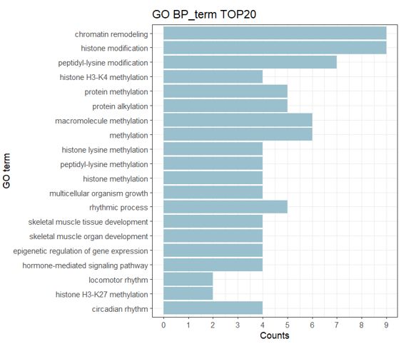

Abbreviations: DU, diffuse uptake; GO, gene ontology; BP, biological process.

