Supplement:
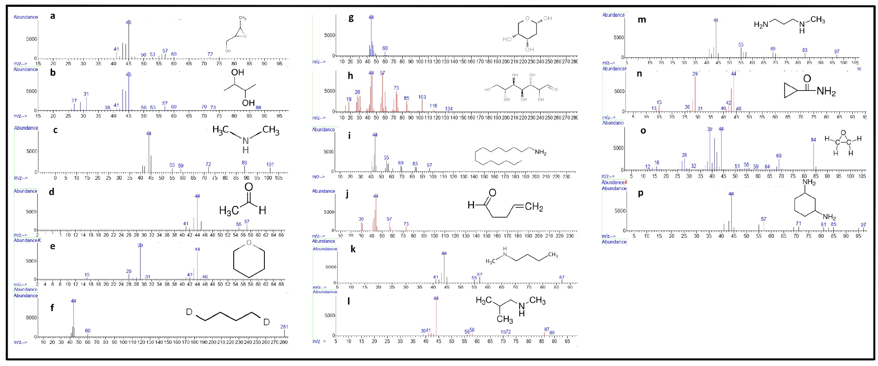
Figure S1: GC–MS chromatogram of the various compounds found in D. arborea aqueous extract. GC–MS chromatogram of: (a) (3-methyl-2-oxiranyl)methanol; (b) 2,3-butanediol; (c) n-methylmethanamine; (d) acetaldehyde; (e) oxane; (f) butane-1,4-d2; (g) 2-deoxy-alpha-d-ribopyranose; (h) d-Glycero-d-ido-heptose; (i) 1-pentadecanamine; (j) 4-pentenal; (k) 1-butanamine, n-methyl-; (l) 1-Propanamine, N,2-dimethyl-; (m) 1,3-Propanediamine, N-methyl-; (n) cyclopropanecarboxamide; (o) ethylene oxide; (p) 1,3-cyclohexane-1,3-d2-diamine, cis.
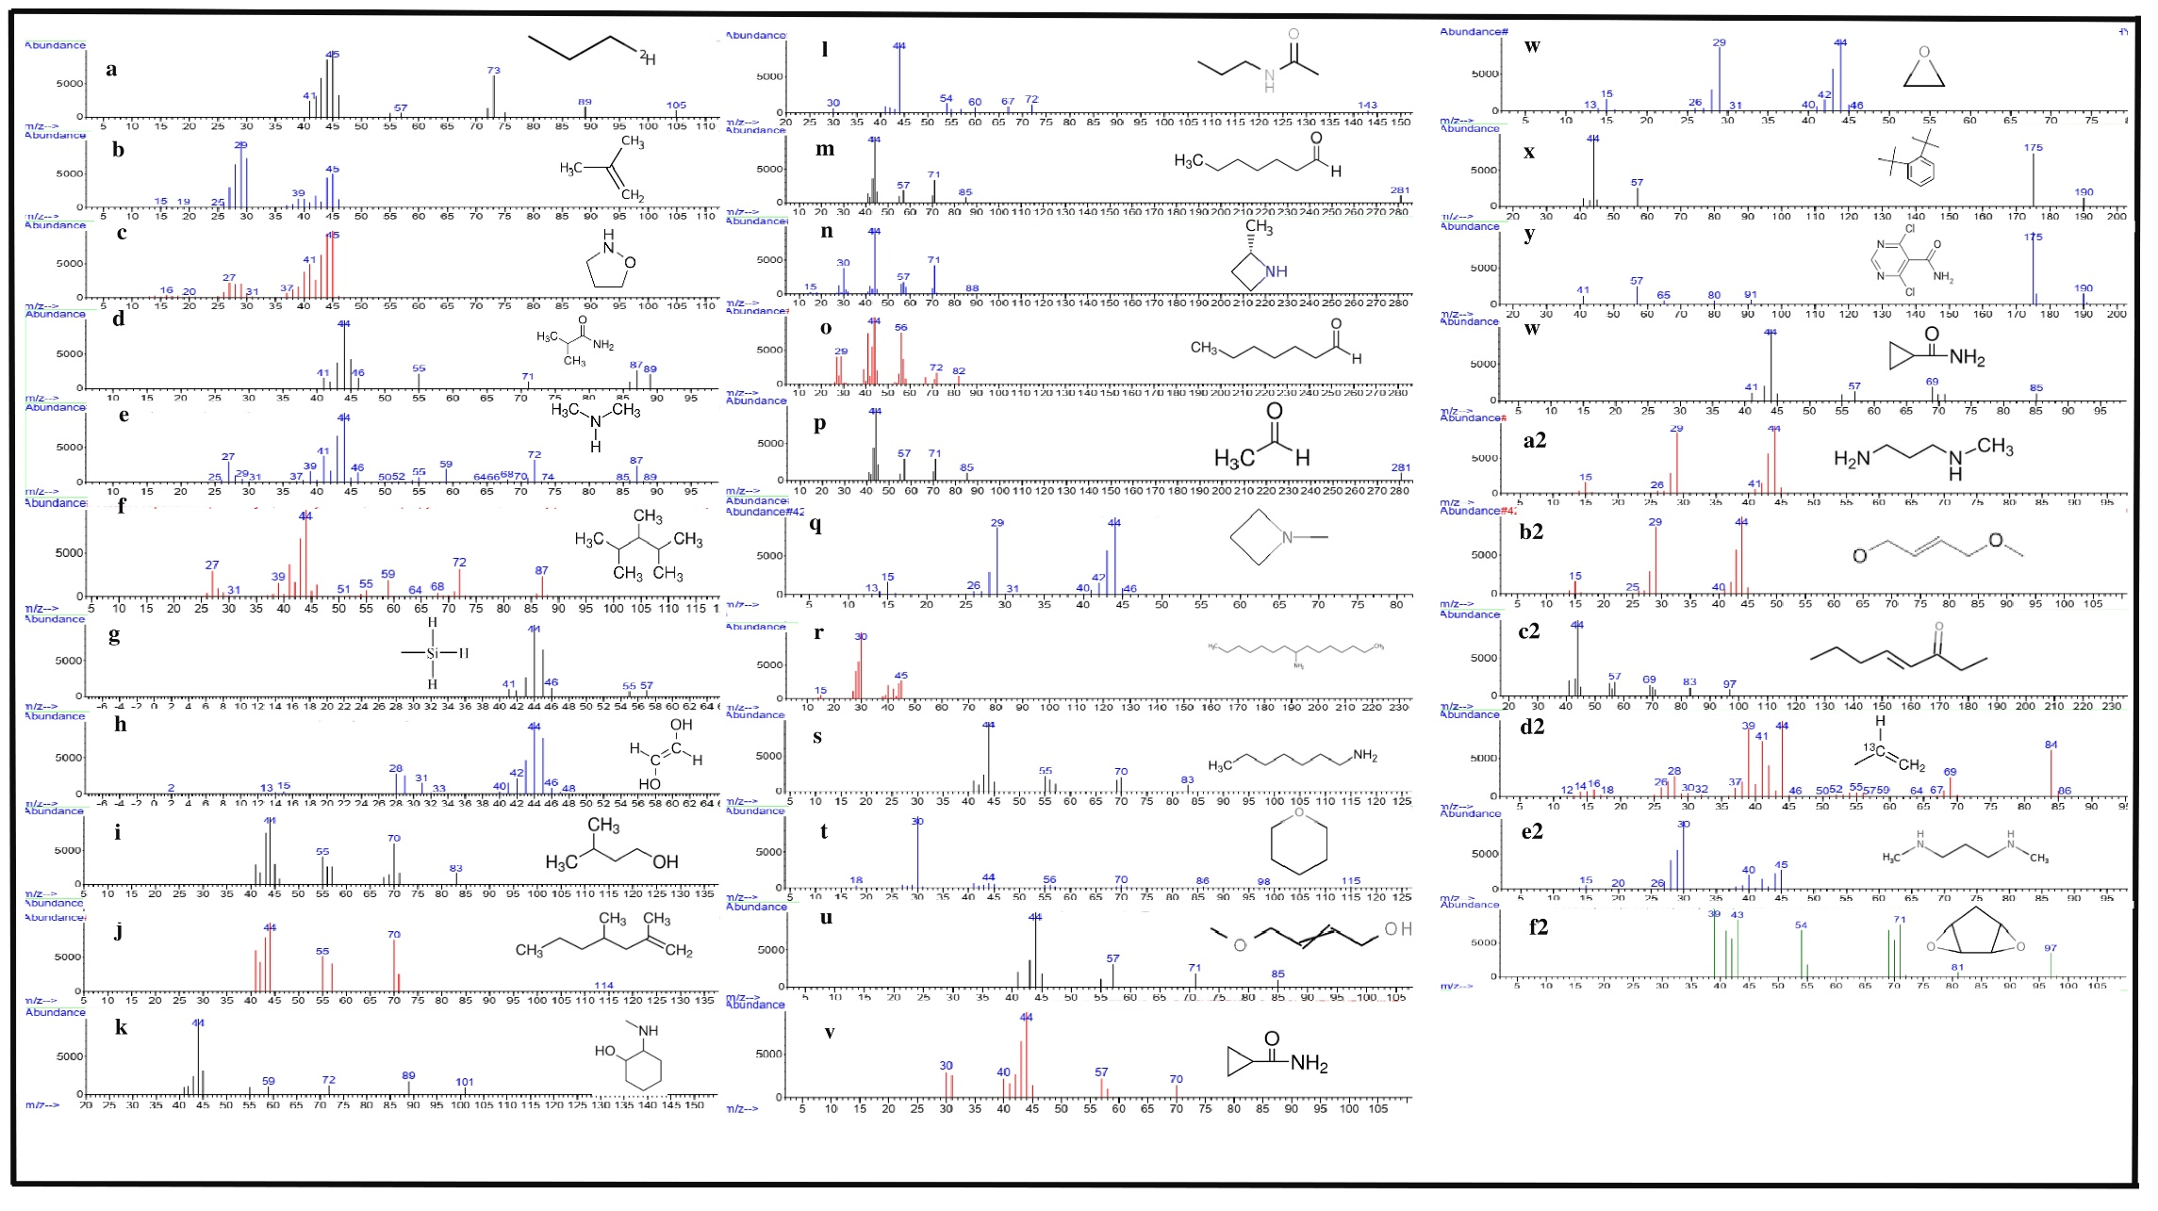Figure S2: GC–MS chromatogram of the various compounds identified in B. ferruginea aqueous extract. GC–MS chromatograms of: (a) propane-1-D1; (b) isobutylene; (c) isoxazolidine; (d) isobutyramide; (e) Dimethylamine; (f) 2,3,4-Trimethylpentane; (g) methylsilane; (h) ethen-1,2-diol; (i) 1-butanol, 3-methyl-; (j) 2,4-dimethyl-1-heptene; (k) 2-[(methylamino)methyl]cyclohexanol; (l) N-propylacetamide; (m) N-Methyl-1,3-propanediamine; (n) 2-Methylazetidine ; (o) heptanal; (p) acetaldehyde; (q) azetidine, 1-methyl; (r) 1-Aminopentadecane; (s) heptylamine; (t) oxane; (u) 4-methoxy-2-butyn-1-ol; (v) cyclopropanecarboxamide; (w) oxirane; (x) 1,2-di-tert-butylbenzene; (y) 5-fluoro-4-chloro-2-dimethylaminopyrimidine; (z) cyclopropanecarboxamide; (a2) 1,3-propanediamine, n-methyl-; (b2) 4-methoxy-2-butyn-1-ol; (c2) 4-octen-3-one; (d2) propane-2-13c; (e2) 1-methylamino-propylamine; (f2) cyclopentadiene dioxide.
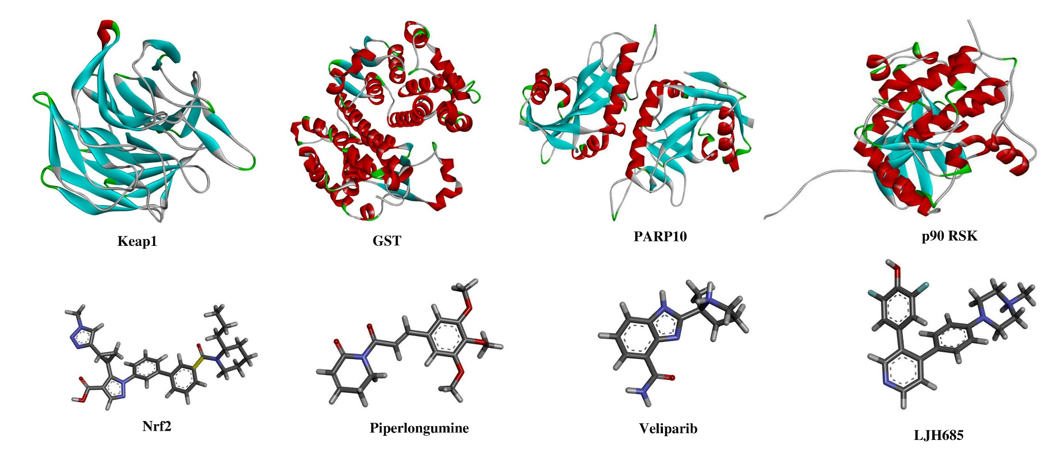
Figure S3: 3D structure of the target proteins and respective inhibitors. Nrf2, piperlongumine, veliparib and LJH685 were used as inhibitors of Keap1, GST, PARP10 and p90 RSK proteins, respectively, according to the literature.

Table S1: Metabolite profiling of D. arborea aqueous extract using gas chromatography/mass spectrometry (GC–MS) method.
Peak No. | Retention Time (minute) | Area % | Molecular Weight | Molecular Formula | Name of the compound | m/z
1 | 9.165 | 35.34 | 88.11 | C₄H₈O₂ | (3-methyl-2-oxiranyl)methanol | 41, 45, 50, 53, 57, 60, 72, 75
 |  |  | 90.12 | C₄H₁₀O₂ | 2,3-butanediol | 27, 31, 38, 41, 45, 50, 53, 57, 60, 70, 73, 88
2 | 11.461 | 3.46 | 43.07 | C₂H₅N | n-methylmethanamine | 44, 55, 59, 72, 89, 101
3 | 13.816 | 1.79 | 44.053 | CH₃CHO | acetaldehyde | 41, 44, 55, 57
 |  |  | 344.5 | C₂₀H₄₀O₄ | oxane | 44, 46
4 | 18.362 | 1.96 | 60.13 | C₄H₈D₂ | butane-1,4-d2 | 44, 60, 281
5 | 18.652 | 32.25 | 134.13 | C₅H₁₀O₄ | 2-deoxy-alpha-d-ribopyranose | 44, 60
 |  |  |  | C₇H₁₄O₇ | d-Glycero-d-ido-heptose | 18, 28, 44, 57, 73, 85, 103, 116, 134
6 | 28.004 | 9.01 | 227.4292 | C₁₅H₃₃N | 1-pentadecanamine | 44, 55, 69, 83, 97
 |  |  | 84.12 | C₅H₈O | 4-pentenal | 30, 44, 57, 73
7 | 35.804 | 2.23 | 87.1634 | C₅H₁₃N | 1-butanamine, n-methyl- | 41, 44, 55, 57, 87
 |  |  | 87.1634 | C₅H₁₃N | 1-Propanamine, N,2-dimethyl- | 39, 41, 44, 56, 58, 70, 72, 87, 89
8 | 36.933 | 4.64 | 88.15 | C₄H₁₂N₂ | 1,3-Propanediamine, N-methyl- | 44, 55, 69, 83, 97
9 | 37.275 | 2.09 | 85.10 | C₄H₇NO | cyclopropanecarboxamide | 13, 15, 26, 29, 31, 40, 42, 44, 46
10 | 45.216 | 3.93 | 44.05 | C₂H₄O | ethylene oxide | 12, 16, 28, 32, 39, 44, 51, 55, 59, 64, 69, 84
11 | 48.871 | 3.30 | 116.2 | C₆H₁₂D₂N₂ | 1,3-cyclohexane-1,3-d2-diamine, cis- | 44, 57, 71, 81, 85, 97

Table S2: Metabolite profiling of B. ferruginea aqueous extract using gas chromatography/mass spectrometry (GC–MS) method.
Peak No. | Retention Time (minute) | Area % | Molecular Weight | Molecular Formula | Name of the compound | m/z
1 | 5.629 | 6.97 | 45.10 | C₃H₈ | propane-1-D1 | 41, 45, 57, 73, 89, 105
 |  |  | 56.11 | C₄H₈ | isobutylene | 15, 19, 25, 29, 39, 45
 |  |  | 73.09 | C3H7NO | isoxazolidine | 16, 20, 27, 31, 37, 41, 45
2 | 8.274 | 4.85 | 73.09 | C₃H₇NO | isobutyramide | 41, 44, 46, 55, 71, 87, 89
 |  |  | 45.08 | C₂H₇N | Dimethylamine | 25, 27, 29, 31, 37, 39, 41, 44, 46, 50, 52, 55, 59, 64, 66, 68, 70, 72, 74, 78, 85, 87, 89
3 | 8.356 | 19.53 | 114.23 | C₈H₁₈ | 2,3,4-Trimethylpentane | 27, 31, 39, 44, 51, 55, 59, 64, 68, 72, 87
4 | 9.730 | 1.78 | 46.143 | CH₆Si | methylsilane | 41, 44, 46, 55, 57
 |  |  | 60.05 | C₂H₄O₂ | ethen-1,2-diol | 2, 13, 15, 28, 31, 33, 40, 42, 44, 46, 48
5 | 11.216 | 15.11 | 88.15 | C₅H₁₂O | 1-butanol, 3-methyl- | 44, 55, 70, 83
 |  |  | 126.24 | C₉H₁₈ | 2,4-dimethyl-1-heptene | 44, 55, 70
6 | 11.639 | 1.28 | 249.35 | C₁₅H₂₃NO₂ | 2-[(methylamino)methyl]cyclohexanol | 44, 59, 72, 89, 101
 |  |  | 101.15 | C₅H₁₁NO | N-propylacetamide | 30, 44, 54, 60, 67, 72
7 | 18.696 | 8.52 | 114.19 | C₇H₁₄O | heptanal | 29, 44, 56, 72, 82
8 | 19.157 | 2.77 | 88.15 | C₄H₁₂N₂ | N-Methyl-1,3-propanediamine | 44, 57, 71, 85
 |  |  | 71.12 | C₄H₉N | 2-Methylazetidine | 15, 30, 44, 57, 71, 88
9 | 19.380 | 6.47 | 44.05 | C₂H₄O | acetaldehyde | 44, 57, 71, 85, 281
10 | 22.656 | 2.07 | 71.12 | C₄H₉N | azetidine, 1-methyl | 13, 15, 26, 29, 31, 40, 42, 44, 46
11 | 22.871 | 3.27 | 227.43 | C₁₅H₃₃N | 1-Aminopentadecane | 15, 30, 45
12 | 28.034 | 6.16 | 115.22 | C₇H₁₇N | heptylamine | 44, 55, 70, 83
 |  |  | 86.13 | C₅H¹⁰O | oxane | 18, 30, 44, 56, 70, 86, 98, 115
13 | 28.413 | 2.55 | 100.12 | C₅H₈O₂ | 4-methoxy-2-butyn-1-ol | 44, 57, 71, 85
 |  |  | 85.1 | C₄H₇NO | cyclopropanecarboxamide | 30, 40, 44, 57, 70
14 | 30.500 | 1.02 |  | C₂H₄O | oxirane | 13, 15, 26, 29, 31, 40, 42, 44, 46
15 | 30.991 | 4.66 | 190.32 | C₁₄H₂₂ | 1,2-di-tert-butylbenzene | 44, 57, 175, 190
 |  |  |  |  | 5-fluoro-4-chloro-2-dimethylaminopyrimidine | 41, 57, 65, 80, 91, 175, 190
16 | 33.657 | 1.62 | 85.1 | C₄H₇NO | cyclopropanecarboxamide | 41, 44, 57, 69, 85
 |  |  | 88.15 | C₄H₁₂N₂ | 1,3-propanediamine, n-methyl- | 15, 26, 29, 41, 44
17 | 34.036 | 1.39 | 100.12 | C₅H₈O₂ | 4-methoxy-2-butyn-1-ol | 15, 25, 29, 40, 44
18 | 36.948 | 4.87 | 126.2 | C₈H₁₄O | 4-octen-3-one | 44, 57, 69, 83, 97
19 | 37.283 | 2.60 | 45.09 | C₃H₈ | propane-2-13c | 12, 14, 16, 18, 26, 28, 30, 32, 37, 39, 41, 44, 46, 50, 52, 55, 57, 59, 64, 67, 69, 84, 86
20 | 45.194 | 1.02 |  |  | 1-methylamino-propylamine | 15, 20, 26, 30, 40, 45
21 | 48.879 | 1.49 | 98.1 | C₅H₆O₂ | cyclopentadiene dioxide. | 39, 43, 54, 71, 81, 97

Table S3: Total phenolic and flavonoid contents in D. arborea and B. ferruginea.
Plant extract | Total phenolics  (mg of GAE/g DW) | Total flavonoids  (mg of QE/g DW)
D. arborea | 137.21±8.21 *** | 6.084±1.3
B. ferruginea | 295.25±15.25 *** | 10.42±1.25

***p<0.001: compared with B. ferruginea. Data represent mean ± standard error of the mean (SEM).

Table S4: Drug-Likeness and toxicity prediction of compounds identified from the aqueous extract of D. arborea using Lipinski’s rule
N˚ | Name of the compound | Molecular Weight | H-Bond  (Donor/ Acceptor) | GI absorption | Log P | Molar Refractivity | Rules satisfied
1 | (3-methyl-2-oxiranyl)methanol | 88.11 | 1/2 | High | -0.57 | 21.47 | 5/5
2 | 2,3-butanediol | 90.12 | 2/2 | High | -0.18 | 23.67 | 5/5
3 | n-methylmethanamine | 45.08 | 1/1 | Low | -0.23 | 14.53 | 5/5
4 | acetaldehyde | 44.053 | 0/1 | High | -0.37 | 11.93 | 5/5
5 | oxane | 86.13 | 0/1 | Low | 0.76 | 25.12 | 5/5
6 | butane-1,4-d2 | 60.13 | 0/0 | Low | 2.73 | 21.34 | 5/5
7 | 2-deoxy-alpha-d-ribopyranose | 134.13 | 3/4 | High | -1.49 | 28.61 | 5/5
8 | D-Glycero-D-ido-heptose | 210.18 | 6/7 | Low | -3.36 | 42.93 | 4/5
9 | 1-pentadecanamine | 227.43 | 1/1 | High | 4.20 | 76.93 | 4/5
10 | 4-pentenal | 84.12 | 0/1 | High | -0.52 | 10.70 | 5/5
11 | 1-butanamine, n-methyl- | 87.16 | 1/1 | High | 1.16 | 28.95 | 5/5
12 | 1-Propanamine, N,2-dimethyl- | 87.16 | 1/1 | Low | 1.16 | 28.95 | 5/5
13 | 1,3-Propanediamine, N-methyl- | 88.15 | 2/2 | High | -0.18 | 26.85 | 5/5
14 | cyclopropanecarboxamide | 85.10 | 1/1 | High | -0.31 | 22.14 | 5/5
15 | ethylene oxide | 44.05 | 0/1 | Low | -0.62 | 10.70 | 5/5
16 | 1,3-cyclohexane-1,3-d2-diamine, cis- | 116.2 | 2/2 | High | 0.21 | 34.26 | 5/5

Table S5: Drug-Likeness and toxicity prediction of compounds identified from the aqueous extract of B. ferruginea using Lipinski’s rule
N˚ | Name of the compound | Molecular Weight | H-Bond  (Donor/ Acceptor) | GI absorption | Log P | Molar Refractivity | Rules satisfied
1 | propane-1-D1 | 45.10 | 0/0 | Low | 2.28 | 16.54 | 5/5
2 | isobutylene | 56.11 | 0/0 | Low | 2.58 | 20.87 | 5/5
3 | isoxazolidine | 73.09 | 1/2 | Low | -0.21 | 22.22 | 5/5
4 | isobutyramide | 73.09 | 1/1 | High | 0.08 | 24.25 | 5/5
5 | Dimethylamine | 45.08 | 1/1 | Low | -0.23 | 14.53 | 5/5
6 | 2,3,4-Trimethylpentane | 114.23 | 0/0 | Low | 4.20 | 40.57 | 4/5
7 | methylsilane | 46.143 | 0/0 | Low | 0.20 | 15.80 | 5/5
8 | ethen-1,2-diol | 60.05 | 2/2 | High | -1.30 | 14.40 | 5/5
9 | 1-butanol, 3-methyl- | 88.15 | 1/1 | High | 1.16 | 27.31 | 5/5
10 | heptanal | 114.19 | 0/1 | High | 1.74 | 35.96 | 5/5
11 | 2,4-dimethyl-1-heptene | 126.24 | 0/0 | Low | 4.38 | 44.90 | 4/5
12 | 2-[(methylamino)methyl]cyclohexanol | 249.35 | 2/2 | High | 0.90 | 42.42 | 5/5
13 | N-propylacetamide | 101.15 | 1/1 | High | 0.49 | 29.15 | 5/5
14 | N-Methyl-1,3-propanediamine | 88.15 | 2/2 | High | -0.18 | 26.85 | 5/5
15 | 2-Methylazetidine | 71.12 | 1/1 | Low | 0.35 | 25.94 | 5/5
16 | acetaldehyde | 44.05 | 0/1 | Low | -0.37 | 11.93 | 5/5
17 | azetidine, 1-methyl | 71.12 | 0/1 | Low | 0.35 | 26.04 | 5/5
18 | propane-2-13c | 45.09 | 0/0 | Low | 2.28 | 16.54 | 5/5
19 | 1-Aminopentadecane | 227.43 | 1/1 | High | 4.20 | 76.93 | 4/5
20 | heptylamine | 115.22 | 1/1 | High | 1.89 | 38.47 | 5/5
21 | oxane | 86.13 | 0/1 | Low | 0.76 | 25.12 | 5/5
22 | 4-methoxy-2-butyn-1-ol | 100.12 | 1/2 | High | 0.08 | 26.56 | 5/5
23 | cyclopropanecarboxamide | 85.1 | 1/1 | High | -0.31 | 22.14 | 5/5
24 | oxirane | 44.05 | 0/1 | Low | -0.62 | 10.70 | 5/5
25 | 1,2-di-tert-butylbenzene | 190.32 | 0/0 | Low | 5.58 | 64.98 | 4/5
26 | 5-fluoro-4-chloro-2-dimethylaminopyrimidine | 162.55
27 | cyclopropanecarboxamide | 85.1 | 1/1 | High | -0.31 | 22.14 | 5/5
28 | 1,3-propanediamine, n-methyl- | 88.15 | 2/2 | High | -0.18 | 26.85 | 5/5
29 | 4-methoxy-2-butyn-1-ol | 100.12 | 1/2 | High | 0.08 | 26.56 | 5/5
30 | 4-octen-3-one | 126.2 | 0/1 | High | 1.97 | 40.30 | 5/5
31 | cyclopentadiene dioxide. | 98.1 | 0/1 | High | -0.16 | 21.98 | 5/5

Table S6: Molecular docking values of selected compounds from D. arborea against Keap1 (PDB ID: 2DYH) and glutathione S-transferase (PDBID: code 5J41).
 |  |  |  | Keap1 |  |  |  | GST
N˚ | Compound | Affinity (kcal/mol) | Number of H bonds | Alkyl/Pi-Alkyl interactions | Van-der Walls interactions | Affinity (kcal/mol) | Number of H bonds | Alkyl/Pi-Alkyl interactions | Van-der Walls interactions
1 | (3-methyl-2-oxiranyl)methanol | -5.72 | 2 (Arg-336) | Phe-335, Phe-577 | - | -5.98 | 2 (Thr-349, Arg-390) | Leu-391, Phe-350, Arg-394 | Lys-348, Ile-356
2 | 2,3-butanediol | -6.33 | 1 (Val-606) | Ile-559, Ala-366 | Ala-607, Leu-365, Gly-558, Gly-605, Val-604, Gly-417 | -6.95 | 1 (198) | Leu-160, Val-164, Ile-203, Ile-161 | Arg-11
4 | Acetaldehyde | -5.71 | 2 (Val-360, Gln-359) | - | Leu-358, Ala-376, Trp-403, Asp-394, Arg-362 | -5.64 | 0 | - | Tyr-215, Pro-261, Cys-222, Ile-276, Leu-225, Phe-263, Val-214, Thr-212
7 | 2-deoxypentose | -7.18 | 3 (Ile-559, Val-604, Val-463) | - | Val-606, Gly-367, Gly-605, Ala-366, Gly-558, Leu-365, Leu-557, Gly-511, Val-512, Gly-464, Val-465, Gly-417, Gly-509, Ile-416 | -6.63 | 2 (Cys-101, Asp-306) | - | Glu-97, Gln-64, Ser-65, Pro-53, Leu-52, Arg-13
8 | 2-deoxy-alpha-d-ribopyranose | -7.58 | 1 (Gly-367) | - | Val-604, Gly-558, Thr-560, Ala-607, Val-418, Gly-417, Cys-368, Leu-365, Ala-366, Gly-605 | -7.52 | 2 (Asp-98, Gln-272) | - | Gln-259, Tyr-257, Tyr-271, Ser-273, Pro-261, Leu-260, Arg-221
11 | 4-pentenal | -8.17 | 1 (Ala-522) | Tyr-520, Ile-566, Tyr-584, Trp-591, Val-534 | Val-547, Ala-521, Val-512, Gly-511, Ile-559, Val-568, Leu-515 | -7.65 | 0 | Leu-334, Leu-363, Phe-337, Leu-384, Leu-367 | Glu-338, Gln-333, Val-304, Leu-366, Leu-307, Leu-330, Leu-378
12 | 1-butanamine, n-methyl- | -5.90 | 2 (Ser-602) | Tyr-572, Phe-577 | Ala-556, Tyr-334, Gly-603, Ser-363, Asn-382 | -6.57 | 0 | Arg-18m Ala-15, Phe-192, Tyr-198 | Trp-28, Leu-201, Arg-11, Met-19, Cys-14
13 | 1-Propanamine, N,2-dimethyl- | -5.95 | 2 (Ser-602) | Tyr-572, Phe-577, Tyr-334 | Ala-556, Gly-603 | -6.57 | 0 | Arg-18, Ala-15, Phe-192, Tyr-198 | Trp-28, Leu-201, Arg-11, Met-19, Cys-14
14 | 1,3-Propanediamine, N-methyl- | -5.95 | 6 (Leu-557, Ala-510, Val-463, Ile-416) | - | Gly-558, Val-512, Ile-559, Gly-511, Ala-556, Gly-509, Gly-417, Gly-463, Gly-464 | -5.98 | 2 (Asn-204, Ile-203) | - | Gly-12, Arg-13, Phe-8, Gly-205, Ile-104, Tyr-108, Tyr-7, Val-10
15 | cyclopropanecarboxamide | -7.08 | 0 | Tyr-520, Ile-566, Val-534, Trp-591, Tyr-584 | Leu-515, Ile-559, Leu-557, Val-568, Gly-511, Ala-521 | -6.61 | 2 (Trp-38, Lys-44) | Phe-8, Leu-52 | Gln-51, Gly-50
17 | Cis-cyclohexane-1,3-diamine | -6.73 | 5 (Ile-559, Val-606, Val-604, Leu-365 | Ile-559 | Thr-560, Val-465, Gly-464, Val-521, Gly-511, Leu-557, Ala-510, Ala-366, Gly-605, Gly-558, Gly-367 | -7.33 | 5 (Gln-135, Leu-132, Ile-143) | Met-91, Leu-88 | Leu-256, Val-144, Val-92, Leu-133, Gly-145, Asn-136
Iinhibitors | Nrf2 /Piperlongumine | -11.82 | 2 (Asn-382, Arg-415) | Arg-483, Phe-577, Phe-335, Arg-336 | Gly-603, Ser-602, Ser-338, Ala-556, Ser-363, Gly-364, Arg-380, Arg-483, Tyr-334 | -8.85 | 3(Cys-101, Tyr-108) | Ile-104, Phe-8, Arg-13, Cys-101 | Gln-64, Gln-51, Ser-65, Pro-53, Leu-52, Val-10, Gly-12, Asn-204, Gly-205, Ser-105, Glu-97

Table S7: Molecular docking values of identified compounds from B. ferruginea against Keap1 (PDB ID: 2DYH) and glutathione S-transferase (PDBID: code 5J41).
 |  |  |  | Keap1 |  |  |  | GST
N˚ | Compound | Affinity (kcal/mol) | Number of H bonds | Alkyl/Pi-Alkyl interactions | Van-der Walls interactions | Affinity (kcal/mol) | Number of H bonds | Alkyl/Pi-Alkyl interactions | Van-der Walls interactions
4 | isobutyramide | -7.13 | 1 (Tyr-520) | Tyr-584, Val-534, Trp-591, Ile-566, Ile-559, Val-568, Ala-522 | -Val-521, Gly-511, Leu-557, Val-547 | -6.38 | 1 (Gly-413) | Val-243, Phe-216, Val-218, Tyr-215 | Asn-412, Pro-243, Phe-216, Val-218, Tyr-215
8 | ethen-1,2-diol | -5.95 | 2 (Val-512, Val-418) | - | Gly-511, Gly-464, Ala-466, Ala-366, Gly-417, Ule-559 | -5.80 | 1 (Gly-95) | - | Lys-102, Gln-125, Asp-98, Leu-99, Phe-129, Tyr-257, Pro-128
9 | 1-butanol, 3-methyl- | -8.56 | 0 | Tyr-584, Tyr-520, Val-534, Trp-591, Val-547, Ile-566 | Val-568, Leu-515, Ile-559, Cys-513, Gly-511, Ala-521, Ala-522, Val-512 | -7.32 | 1 (Val-300) | Leu-340, Val-352, Leu-296, Ile-351 | Gly-353, Asn-344, Val-297, Leu-48, Met-299
10 | heptanal | -9.00 | 0 | Trp-352, Tyr-345, Val-581, Leu-569, Ile-328 | Met-597, Thr-595, Val-594, Pro-347, His-562, Val-608, Thr-560, Val-606, Val-568 | -7.00 | 0 | Ala-329, Lys-310, Leu-330, His-370, Leu-330, Leu-307 | Leu-314, Asp-325, Gln-333, Val-327
12 | 2-[(methylamino)methyl]cyclohexanol | -8.00 | 1 (Arg-336) | - | Tyr-334, Phe-335, Phe-577, Tyr-572 | -8.66 | 1 (Arg-282) | Ala-294, Tyr-79, Arg-74, Ala-86, Tyr-287 | Arg-70, Arg-278, Gly-281, Leu-286, Gly-285, Gly-288, Asp-290, Gln-291, Lys-289
13 | N-propylacetamide | -7.20 | 1 (Ala-522) | Tyr-584, Tyr-520, Ile-566, Val-534, Trp-591 | Val-547, Leu-515, Val-568, Ala-521, Val-512, Cys-513. Ile-559 | -6.86 | 2 (Arg-221, Asn-412) | Ile-312, Ile-369, Tyr-311, Arg-308 | Gly-220, Arg-219, Tyr-215, Val-218, Tyr-316, Ile-411, Gly-413, Ile-315
14 | N-Methyl-1,3-propanediamine | -5.86 | 5 (Arg-536, Thr-543, Thr-545) | - | - | -5.99 | 2 (Ile-203, Asn-204) | - | Ile-104, Val-10, Tyr-108, Tyr-7, Gly-205, Gly-12, Arg-13, Phe-8
20 | heptylamine | -7.01 | 2 (Arg-336) | Phe-577, Phe-335 | Tyr-334 | -7.29 | 1 (Asp-315) | Leu-330, Leu-307, Lys-310, Tyr-326, Ala-329 | Gln-333, His-370, Lys-328
22 | 4-methoxy-2-butyn-1-ol | -6.54 | 1 (Arg-470) | - | Glu-493, Ile-421, Asp-422, His-424, Arg-442, Pro-492, Tyr-426 | -6.19 | 1 (Trp-38) | - | Val-35, Gln-39, Gly-50, Gln-51, Phe-8
27 | cyclopropanecarboxamide | -7.08 | 0 | Tyr-520, Ile-566, Val-534, Trp-591, Tyr-584 | Leu-515, Ile-559, Leu-557, Val-568, Gly-511, Ala-521 | -6.51 | 1 (Arg-11) | Phe-192, Arg-18, Tyr-198 | Glu-197, Glu-30, Trp-28, Leu-201, Ala-15
28 | 1,3-propanediamine, n-methyl- | -5.95 | 6 (Leu-557, Ala-510, Val-463, Ile-416 | - | Gly-558, Val-512, Ile-559, Gly-511, Ala-556, Gly-509, Gly-364, Gly-462, Gly-464 | -5.98 | 2 (Ile-203, Asn-204) | - | Gly-12, Arg-13, Phe-8, Gly-205, Ile-104, Tyr-108, Tyr-7, Val-10
30 | 4-octen-3-one | -7.84 | 1 (Arg-336) | Tyr-334, Phe-577, Phe-335 | His-575, Thr-576, Tyr-572 | -7.93 | 0 | Tyr-198, Ala-15, Arg-11, Leu-201, Val-32 | Phe-192, Arg-18, Glu-197, Trp-28, Glu-30, Pro-9
31 | cyclopentadiene dioxide | -5.89 | 0 | - | Leu-52, Val-10, Gly-12, Gly-511 | -5.62 | 2 (Arg-282, Arg-74) | - | Ala-86
Iinhibitors | Nrf2 /Piperlongumine | -11.82 | 2 (Asn-382, Arg-415) | Arg-483, Phe-577, Phe-335, Arg-336 | Gly-603, Ser-602, Ser-338, Ala-556, Ser-363, Gly-364, Arg-380, Arg-483, Tyr-334 | -8.85 | 3(Cys-101, Tyr-108) | Ile-104, Phe-8, Arg-13, Cys-101 | Gln-64, Gln-51, Ser-65, Pro-53, Leu-52, Val-10, Gly-12, Asn-204, Gly-205, Ser-105, Glu-97

Table S8: Molecular docking values of selected compounds from D. arborea against PARP10 (PDB ID: 5LX6) and p90 RSK (PDB ID: 4NUS)
 |  |  |  | PARP10 |  |  |  | p90 RSK
N˚ | Compound | Affinity (kcal/mol) | Number of H bonds | Alkyl/Pi-Alkyl interactions | Van-der Walls interactions | Affinity (kcal/mol) | Number of H bonds | Alkyl/Pi-Alkyl interactions | Van-der Walls interactions
1 | (3-methyl-2-oxiranyl)methanol | -6.16 | 2 (Ser-927, Gly-888) | Leu-926, Ala-921, Tyr-932 | Ile-987, Phe-920, Tyr-919, His-887, Tyr-886 | -5.99 | 2 (His-185) | Val-318, Ile-321 | Leu-311, Gly-317, Gln-247
2 | 2,3-butanediol | -6.75 | 3 (Gly-1077, His-1076) | Tyr-1121 | Phe-1109, Tyr-1075, Ala-1110, Ser-1116, Leu-1115 | -6.70 | 1 (Phe-303) | Phe-268, Leu-285, Met-287 | Leu-299, Arg-300, Trp-252, Ala-283, Lys-284
4 | Acetaldehyde | -5.75 | 2 (Gln-995, Ala-996) | - | Phe-920, Val-918, Phe-902, His-992, Asp-993, Thr-994, Ile-990 | -5.70 | 1 (Lys-142) | - | Tyr-144, Phe-83, Val-101, Leu-70, Met-99, Pro-65
7 | 2-deoxypentose | -6.95 | 4 (Arg-1146, Arg-1147, Gly-1145, Val-1102) | - | Tyr-1103 | -7.28 | 3 (Gly-244, Ser-227, Cys-229) | - | Arg-242, Glu-238, Lys-224, Arg-243, Phe-228, Met-235, Gly-230, His-245, Arg-192
8 | 2-deoxy-alpha-d-ribopyranose | -7.62 | 5 (Ala-962, Arg-957, Gly-959, Arg-961) | Leu-960 | Pro-963, Arg-974, Phe-1095 | -7.19 | 3 (Cys-229, Asp-220, Hi-245) | Val-239 | Arg-192, Phe-228, Ser-227, Arg-242, Gly-244, Lys-224
11 | 4-pentenal | -7.00 | 2 (Ala-1110, Ser-1116) | Ile-1176, Leu-1115, Tyr-1121 | Tyr-1108, Phe-1109, Gly-1077, His-1076, Tyr-1075 | -7.54 | 0 | Ile-199, Leu-155, Leu-257, Met-261 | Pro-196, Ile-207, Leu-177, Tyr-173, Leu-174
12 | 1-butanamine, n-methyl- | -6.49 | 2 (Tyr-919) | Leu-926, Tyr-932) | Ala-921, Ile-987, Tyr-886, Ser-927, Phe-920, Gly-888, His-887 | -6.39 | 1 (Tyr-144) | Phe-83, Leu-70, Met-99, Val-101 | Pro-65
13 | 1-Propanamine, N,2-dimethyl- | -6.58 | 1 (Tyr-1108) | Tyr-1121, Leu-1115, Ala-1110 | Tyr-1075, His-1076, Phe-1109, Ile-1176 | -6.20 | 0 | Ala-98, Leu-147, Val-82, Lys-100, Phe-212 | Leu-200, Thr-210, Val-131, Phe-79
14 | 1,3-Propanediamine, N-methyl- | -6.13 | 3 (Tyr-1075, Tyr-1108) | - | Phe-1109, Ala-1110, Leu-1115, Ser-1116, Gly-1077, Tyr-1121, His-1076, Val-1107 | -5.64 | 3 (Cys-229, Ser-227, Lys-224) | - | Met-235, Phe-228, His-245, Arg-192, Gly-244, Arg-243
15 | cyclopropanecarboxamide | -6.52 | 1 (Ser-927) | Leu-926, Ile-987 | Tyr-919, Phe-920, His-887, Ala-921, Tyr-886 | -6.96 | 1 (Lys-142) | Leu-70, Met-99, Val-101, Phe-83 | Tyr-144, Pro-65
17 | Cis-cyclohexane-1,3-diamine | -7.51 | 2 (Tyr-1108, Tyr-1075) | Leu-1115, Ala-1110 | Gly-1077, Phe-1109, His-1076, Ser-1116, Ile-1176 | -6.94 | 1 (Asp-148) | Phe-212, Leu-147, Val-131 | Phe-149, Leu-200, Leu-150, Ala-98, Val-82, Lys-100, Thr-210
Iinhibitors | Veliparib / LJH685 | -8.26 | 3 (Asn-1092, Phe-1095, Cys-1096) | Ile-1086, Ala-1082 | Thr-1079, Asp-1085, Phe-1091, Glu-1106, Arg-1093, Val-1107, Asn-1099, Tyr-1108, His-1076, Thr-1078 | -9.61 | 1 (Leu-71) | Lys-86, Lys-72 | Phe-149, Val-85, Arg-94, Leu-70

Table S9: Molecular docking values of identified compounds from B. ferruginea against PARP10 (PDB ID: 5LX6) and p90 RSK (PDB ID: 4NUS)
 |  |  |  | PARP10 |  |  |  | p90 RSK
N˚ | Compound | Affinity (kcal/mol) | Number of H bonds | Alkyl/Pi-Alkyl interactions | Van-der Walls interactions | Affinity (kcal/mol) | Number of H bonds | Alkyl/Pi-Alkyl interactions | Van-der Walls interactions
4 | isobutyramide | -6.65 | 3 (Ser-927, Ala-921, Tyr-019) | Tyr-932, Leu-926, Ile-987, Ala-921 | Gly-888, His-887, Tyr-886, Phe-920, Phe-988 | -6.78 | 1 (Lys-142) | Pro-65, Tyr-144, Val-101, Met-99, Leu-70, Phe-83 | Val-85
8 | ethen-1,2-diol | -5.88 | 0 | - | Glu-882, Pro-880, Val-881, Leu-873 | -6.12 | 1 (Cys-229) | - | Asp-111, Arg-110
9 | 1-butanol, 3-methyl- | -7.02 | 0 | Ala-921, Leu-926, Tyr-932, Ile-987 | Ser-927, Phe-920, Gly-888, Tyr-886, His-887 | -6.77 | 1 (Asp-211) | Leu-200, Phe-212, Leu-147, Val-82, Lys-100 | Asp-148, Leu-150, Val-131, Thr-210, Ala-98
10 | heptanal | -7.82 | 2 (Ser-1116, Gly-1077) | Leu-1115, Ala-1110, Tyr-1121, Ile-1176, Tyr-1108 | Tyr-1075, His-1076, Phe-1109, Tyr-1103 | -7.59 | 1 (Lys-171) | Pro-343m Phe-172, Ile-330, Ile-340, Leu-335 | Asp-169, Glu-168, Asp-331, Thy-329, His-341, Ala-175, Asp-331
12 | 2-[(methylamino)methyl]cyclohexanol | -9.80 | 2 (Tyr-919) | Ile-987, Tyr-932. Leu-926. Ala-921, Val-913 | His-887, Tyr-886, Ser-927, Phe-920, Phe-988, Thr-912 | -10.60 | 3 (Leu-285, Ala-283, Arg-300) | Met-287, Arg-305 | Leu-299, Lys-284, Ile-280, Phe-268, Pro-237, Lys-304
13 | N-propylacetamide | -6.60 | 2 (Ala-1110, Ser-1116) | Leu-1115, Tyr-1121, Ala-1110 | Ile-1176, Tyr-1108, His-1076, Gl-1077, Tyr-1075, Phe-1109 | -6.47 | 1 (Lys-142) | Tyr-144, Leu-70, Met-99, Pro-65 | Phe-83, Val-101, Val-85, Phe-137, Phe-68, Ser-66
14 | N-Methyl-1,3-propanediamine | -6.13 | 3 (Tyr-1075, Tyr-1108) | - | Leu-1115, Phe-1109, Ala-1110, Ser-1116, Gly-1077, Tyr-1121, Val-1107 | -5.64 | 3 (Cys-229, Ser-227, Lys-224) | - | Met-235, Phe-228, Val-239, Arg-192, His-245, Gly-244, Arg-243
20 | heptylamine | -8.22 | 2 (Tyr-1075, Tyr-1108) | Ile-1176, Ala-1110, Leu-1115, Tyr-1121 | Ser-1116, Gly-1077, Phe-1109, His-1076 | -7.53 | 0 | Ile-330, Leu-335, Ile-340, Pro-343, Phe-172 | Thr-329, Asp-331, Ala-175, His-341, Asp-169, Pro-342, Lys-171
22 | 4-methoxy-2-butyn-1-ol | -6.61 | 1 (His-1189) | - | Ala-1025, Phe-1026, Tyr-1075, Ile-1191, Thr-1188, Val-1134, Val-1073. Ala-1135. Arg-1136 | -6.45 | 1 (Val-101) | - | Leu-70, Tyr-144, Met-99, Pro-65, Lys-142, Phe-83, Lys-103, Leu-102, Gly-80, Lys-81
27 | cyclopropanecarboxamide | -6.71 | 2 (Ser-927, Tyr-919) | Ala-921, Ile-987, Tyr-932, Leu-926 | Tyr-886, Phe-920, Gly-888, His-887 | -6.87 | 1 (Lys-142) | Met-99, Val-101, Phe-83, Tyr-144, Leu-70 | Pro-65
28 | 1,3-propanediamine, n-methyl- | -6.13 | 3 (Tyr-1075, Tyr-1108) | - | Phe-1109, Ala-1110, Leu-1115, Ser-1116, Gly-1077, Tyr-1121, Val-1107 | -5.64 | 3 (Cys-229, Ser-227, Lys-224) | - | Met-235, Phe-228, Arg-192, His-245, Gly-244, Arg-243
30 | 4-octen-3-one | -8.19 | 2 (Ala-921, Ser-927) | Ile-987, Tyr-914, Tyr-919 | Val-913, Leu-926, Phe-920, Tyr-886, His-887, Gly-888 | -8.07 | 1 (Asp) | Val-82, Lys-100, Ala-98, Leu-147, Val-131, Leu-150, Leu-200 | Met-99, Phe-79, Phe-212, Thr-210, Lys-208, Asp-148
31 | cyclopentadiene dioxide | -5.62 | 2 (Gly-1077, His-1076) | Tyr-1121, Ala-1110) | Ser-1116, Leu-1115, Tyr-1075, Phe-1109 | -5.64 | 0 | - | Thy-329, Asp-169, Lys-171
Inhibitors | Veliparib / LJH685 | -8.26 | 3 (Asn-1092, Phe-1095, Cys-1096) | Ile-1086, Ala-1082 | Thr-1079, Asp-1085, Phe-1091, Glu-1106, Arg-1093, Val-1107, Asn-1099, Tyr-1108, His-1076, Thr-1078 | -9.61 | 1 (Leu-71) | Lys-86, Lys-72 | Phe-149, Val-85, Arg-94, Leu-70

