Supplementary Material

Omega 3 Sunflower and Flaxseed Oil Blends - Modelling Chemical Quality, Composition, Color and Sensory Acceptability

Running title
Omega 3 Oil Blends - Quality Attributes Modelling

Ranko Romanić¹*, Tanja Lužaić¹, Lato Pezo², Bojana Radić^{1,3}, Snežana Kravić¹

¹ Faculty of Technology Novi Sad, University of Novi Sad, Bulevar cara Lazara 1, Novi Sad, Serbia
² Institute of General and Physical Chemistry, University of Belgrade, Studentski trg 12-16, Belgrade, Serbia
³ Institute of Food Technology, University of Novi Sad, Bulevar cara Lazara 1, Novi Sad, Serbia

*Corresponding Author
Ranko Romanić
E-mail: rankor@uns.ac.rs
Faculty of Technology Novi Sad, University of Novi Sad, Bulevar cara Lazara 1, 21000 Novi Sad, Serbia
Telephone: +381214853700; Fax: +38121450413
Table S1. Elements of matrix W₁ and vector B₁ (presented in the bias column).
 | 1 | 2 | 3 | 4 | 5 | 6
S ratio | 1.864 | –0.014 | 1.925 | 3.889 | 1.837 | 0.479
F ratio | –2.966 | –1.314 | –3.266 | –5.991 | –2.786 | –0.555
Bias | –1.054 | –1.124 | –1.422 | –2.019 | –0.975 | –0.195

Table S2. Elements of matrix W₂ and vector B₂ (presented in the bias column).
Parameter | 1 | 2 | 3 | 4 | 5 | 6 | Bias
Color | –0.437 | –0.966 | 0.000 | –0.548 | 2.047 | –0.675 | 0.875
Odor | –0.431 | 1.025 | 0.296 | 0.589 | –1.786 | 0.634 | 0.380
Taste | 0.494 | –0.892 | –0.009 | –0.380 | 1.258 | –0.497 | 0.329
Average rating | –0.057 | –1.015 | 0.131 | –0.461 | 1.688 | –0.378 | 0.319
Total acceptability | 0.490 | -0.769 | –0.073 | –0.439 | 1.358 | –0.585 | 0.378
L* | 0.797 | 0.136 | 0.337 | 0.008 | –0.381 | –0.926 | 0.663
a* | –0.546 | 0.040 | 0.551 | 0.320 | –0.804 | –0.410 | 1.133
b* | –1.364 | 0.074 | 0.013 | –0.219 | 1.350 | 0.676 | 0.353
ΔE | –1.435 | 0.067 | –0.044 | –0.144 | 1.075 | 1.205 | 0.069
PV | 0.183 | 0.428 | –0.058 | –0.123 | 0.422 | 0.403 | –0.199
AnV | –0.407 | 0.771 | –0.094 | 0.024 | 0.240 | 1.237 | –0.556
TOTOX | –0.362 | 0.594 | 0.047 | –0.030 | 0.371 | 0.976 | –0.433
CD | –1.014 | 0.655 | –0.408 | –0.108 | 0.844 | 1.778 | –0.795
CT | –1.357 | 1.362 | –0.296 | 0.189 | –0.058 | 2.630 | –1.241
CD/CT | 0.954 | –2.264 | 0.472 | –0.323 | 0.744 | –2.972 | 2.336
AV | –0.056 | –0.997 | 0.401 | –0.087 | 0.312 | –1.495 | 1.614
C14:0 | 0.430 | 0.749 | 0.225 | 0.352 | –1.254 | 0.190 | –0.125
C16:0 | –0.918 | 0.455 | –0.091 | 0.072 | 0.357 | 1.942 | –0.909
C16:1 | –0.811 | 0.405 | –0.185 | 0.136 | –0.014 | 2.030 | –1.024
C18:0 | –0.585 | –0.350 | 0.279 | 0.086 | –0.037 | –0.496 | 1.169
C18:1c | –0.070 | 0.430 | 0.208 | –0.049 | 0.037 | 0.994 | –0.452
C18:2n6 | –0.357 | 0.747 | 0.056 | –0.049 | 0.352 | 1.063 | –0.465
C18:3n6 | –0.046 | 0.061 | 0.507 | 0.096 | –0.409 | –1.562 | 1.692
C18:3n3 | –0.505 | –0.197 | 0.639 | 0.035 | –0.006 | –1.144 | 1.480
C20:0 | –0.535 | 0.306 | –0.059 | 0.070 | 0.193 | 1.507 | –0.669
C20:1 | –0.363 | 0.415 | –0.227 | –0.007 | 0.243 | 1.174 | –0.601
C22:0 | 0.215 | 0.680 | –0.056 | –0.121 | 0.298 | 0.458 | –0.210
C24:0 | 0.443 | –1.415 | –0.043 | –0.414 | 1.425 | –0.773 | 0.694

Table S3. The „goodness of fit” tests for the developed ANN model.
Parameter | χ² | RMSE | MBE | MPE | r² | Skew | Kurt | Mean | StDev | Var
Color | –0.004 | 0.075 | 0.009 | 1.670 | 0.942 | –0.182 | –1.061 | 0.009 | 0.078 | 0.006
Odor | –0.008 | 0.113 | 0.016 | 2.268 | 0.668 | 0.713 | 0.204 | 0.016 | 0.118 | 0.014
Taste | –0.012 | 0.134 | –0.025 | 3.818 | 0.966 | –0.092 | –0.999 | –0.025 | 0.138 | 0.019
Average rating | –0.001 | 0.046 | –0.022 | 0.915 | 0.971 | –1.272 | 2.269 | –0.022 | 0.042 | 0.002
Total acceptability | –0.001 | 0.042 | –0.006 | 1.011 | 0.981 | –0.458 | –0.477 | –0.006 | 0.043 | 0.002
L* | –0.036 | 0.234 | –0.056 | 0.651 | 0.825 | –1.836 | 4.502 | –0.056 | 0.239 | 0.057
a* | –0.009 | 0.117 | 0.027 | 6.250 | 0.983 | 0.113 | 0.090 | 0.027 | 0.120 | 0.014
b* | –0.129 | 0.447 | –0.059 | 3.886 | 0.956 | 0.163 | –1.219 | –0.059 | 0.465 | 0.216
ΔE | –0.154 | 0.487 | –0.223 | 6.520 | 0.932 | –0.155 | –1.025 | –0.223 | 0.454 | 0.206
PV | –0.004 | 0.080 | 0.004 | 7.546 | 0.951 | 0.222 | –1.047 | 0.004 | 0.084 | 0.007
AnV | –0.484 | 0.864 | 0.262 | 8.972 | 0.965 | –0.150 | 0.433 | 0.262 | 0.864 | 0.747
TOTOX | –0.793 | 1.107 | 0.507 | 18.779 | 0.964 | –0.582 | –0.607 | 0.507 | 1.032 | 1.066
CD | –0.048 | 0.272 | 0.086 | 7.087 | 0.900 | 0.338 | 0.729 | 0.086 | 0.270 | 0.073
CT | –0.002 | 0.062 | 0.005 | 17.758 | 0.854 | 0.042 | –1.818 | 0.005 | 0.065 | 0.004
CD/CT | –2.204 | 1.846 | –0.003 | 16.306 | 0.688 | –1.032 | 1.658 | –0.003 | 1.936 | 3.747
AV | –0.008 | 0.114 | –0.007 | 14.282 | 0.838 | –0.432 | –0.523 | –0.007 | 0.119 | 0.014
C14:0 | 0.000 | 0.002 | 0.000 | 0.221 | 0.965 | 0.055 | 0.557 | 0.000 | 0.002 | 0.000
C16:0 | –0.009 | 0.116 | –0.001 | 1.586 | 0.896 | 1.311 | 0.661 | –0.001 | 0.122 | 0.015
C16:1 | 0.000 | 0.012 | 0.000 | 14.389 | 0.534 | 1.108 | 1.073 | 0.000 | 0.013 | 0.000
C18:0 | –0.005 | 0.092 | –0.003 | 1.966 | 0.960 | –0.451 | 0.330 | –0.003 | 0.096 | 0.009
C18:1c | –0.545 | 0.918 | 0.489 | 2.948 | 0.966 | 0.375 | 0.000 | 0.489 | 0.815 | 0.664
C18:2n6 | –2.239 | 1.860 | –1.141 | 5.137 | 0.989 | –0.544 | 0.268 | –1.141 | 1.541 | 2.376
C18:3n6 | 0.000 | 0.023 | –0.009 | 1.718 | 0.857 | –1.548 | 1.966 | –0.009 | 0.022 | 0.000
C18:3n3 | –2.527 | 1.976 | –0.217 | 207.782 | 0.989 | 1.133 | 1.262 | –0.217 | 2.060 | 4.244
C20:0 | 0.000 | 0.008 | –0.001 | 4.588 | 0.912 | 0.400 | –0.210 | –0.001 | 0.008 | 0.000
C20:1 | 0.000 | 0.008 | –0.001 | 5.299 | 0.598 | 1.774 | 4.356 | –0.001 | 0.008 | 0.000
C22:0 | –0.001 | 0.036 | 0.016 | 9.774 | 0.959 | 0.124 | –0.769 | 0.016 | 0.034 | 0.001
C24:0 | 0.000 | 0.015 | 0.005 | 7.596 | 0.856 | –0.656 | –0.661 | 0.005 | 0.015 | 0.000
χ² - reduced chi-square; RMSE - root mean square error; MBE - mean bias error; MPE - mean percentage error; r² - coefficient of determination; Skew - skeweness; Kurt - kurtosis; Mean - mean of residuals; StDev - standard deviation of residuals; Var - variation of residuals.
Table S4. Values of the control parameters used as limiting factors in the optimization.
 | Color | Odor | Taste | Average rating | Total acceptability
Score | ≥ 2.8 | ≥ 2.8 | ≥ 2.8 | ≥ 2.8 | ≥ 2.8

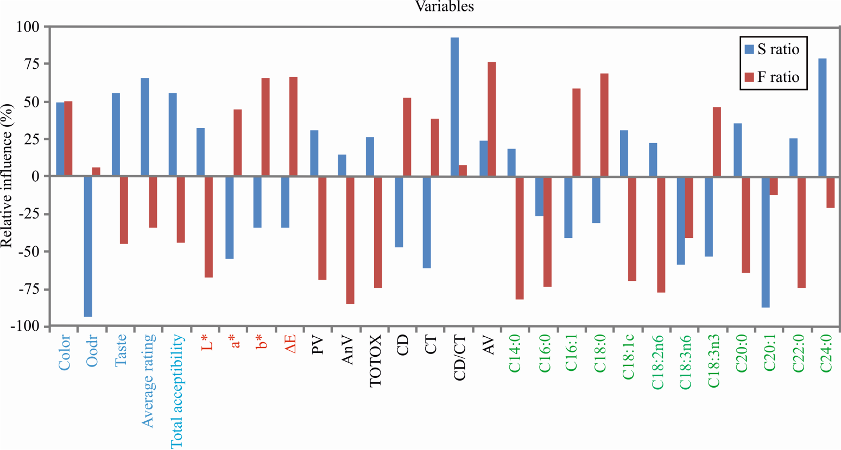
Fig. S1. The influence of S (sunflower oil) and F (flaxseed oil) ratio input variables, identified on quality of oil blend regarding sensory analysis parameters (color, odor, taste, average rating, total acceptability), fatty acids content, oil quality (acid value - AV, peroxide value - PV, anisidine value - AnV, total oxidation value - TOTOX, conjugated dienes content - CD, conjugated trienes content - CT, conjugated dienes conjugated trienes ratio - CD/CT) and color characteristics (lightness - L*, redness - a*, yellowness - b*, total color difference - ΔE).

