Visualizing Cancer Resistance via Nano-quenching and Recovery Detector of CD44
Jialin Zeng^{1†}, Lingke Zeng², Lihua Yang³, Chengyu Feng³, Yuepeng Yang⁴, Yingying Ye⁴, Wenxin Zhang³*, Jian He⁵*, Chao Zhang¹*
1Department of Oncology, Zhujiang Hospital, Southern Medical University, Guangzhou, Guangdong, 510282, China
2Department of Pathology, Zhujiang Hospital, Southern Medical University, Guangzhou, Guangdong, 510282, China
3Department of Pediatric Hematology, Zhujiang Hospital, Southern Medical University, Guangzhou, Guangdong, 510282, China
4The Second School of Clinical Medicine, Southern Medical University, Guangzhou, Guangdong, 510282, China
5Department of Nuclear Medicine, Nanjing Drum Tower Hospital, The Affiliated Hospital of Nanjing University Medical School, Nanjing, 210008, China
# Corresponding author. Email Address: czhangsinap@163.com (Chao Zhang); zwxsakura@gmail.com (Wenxin Zhang); hjxueren@126.com (Jian He).

Fig S1. The optimized ratio between CD44 aptamer and BPNSs was studied by gel retardation quantitative analysis: 1 represents free Apt (100 nM); 2, 3, 4, 5, 6 and 7 respectively represent different concentrations of Apt (110 nM, 90 nM, 70 nM, 50 nM, 30 nM, 0 nM) with the same concentrations of BPNSs.
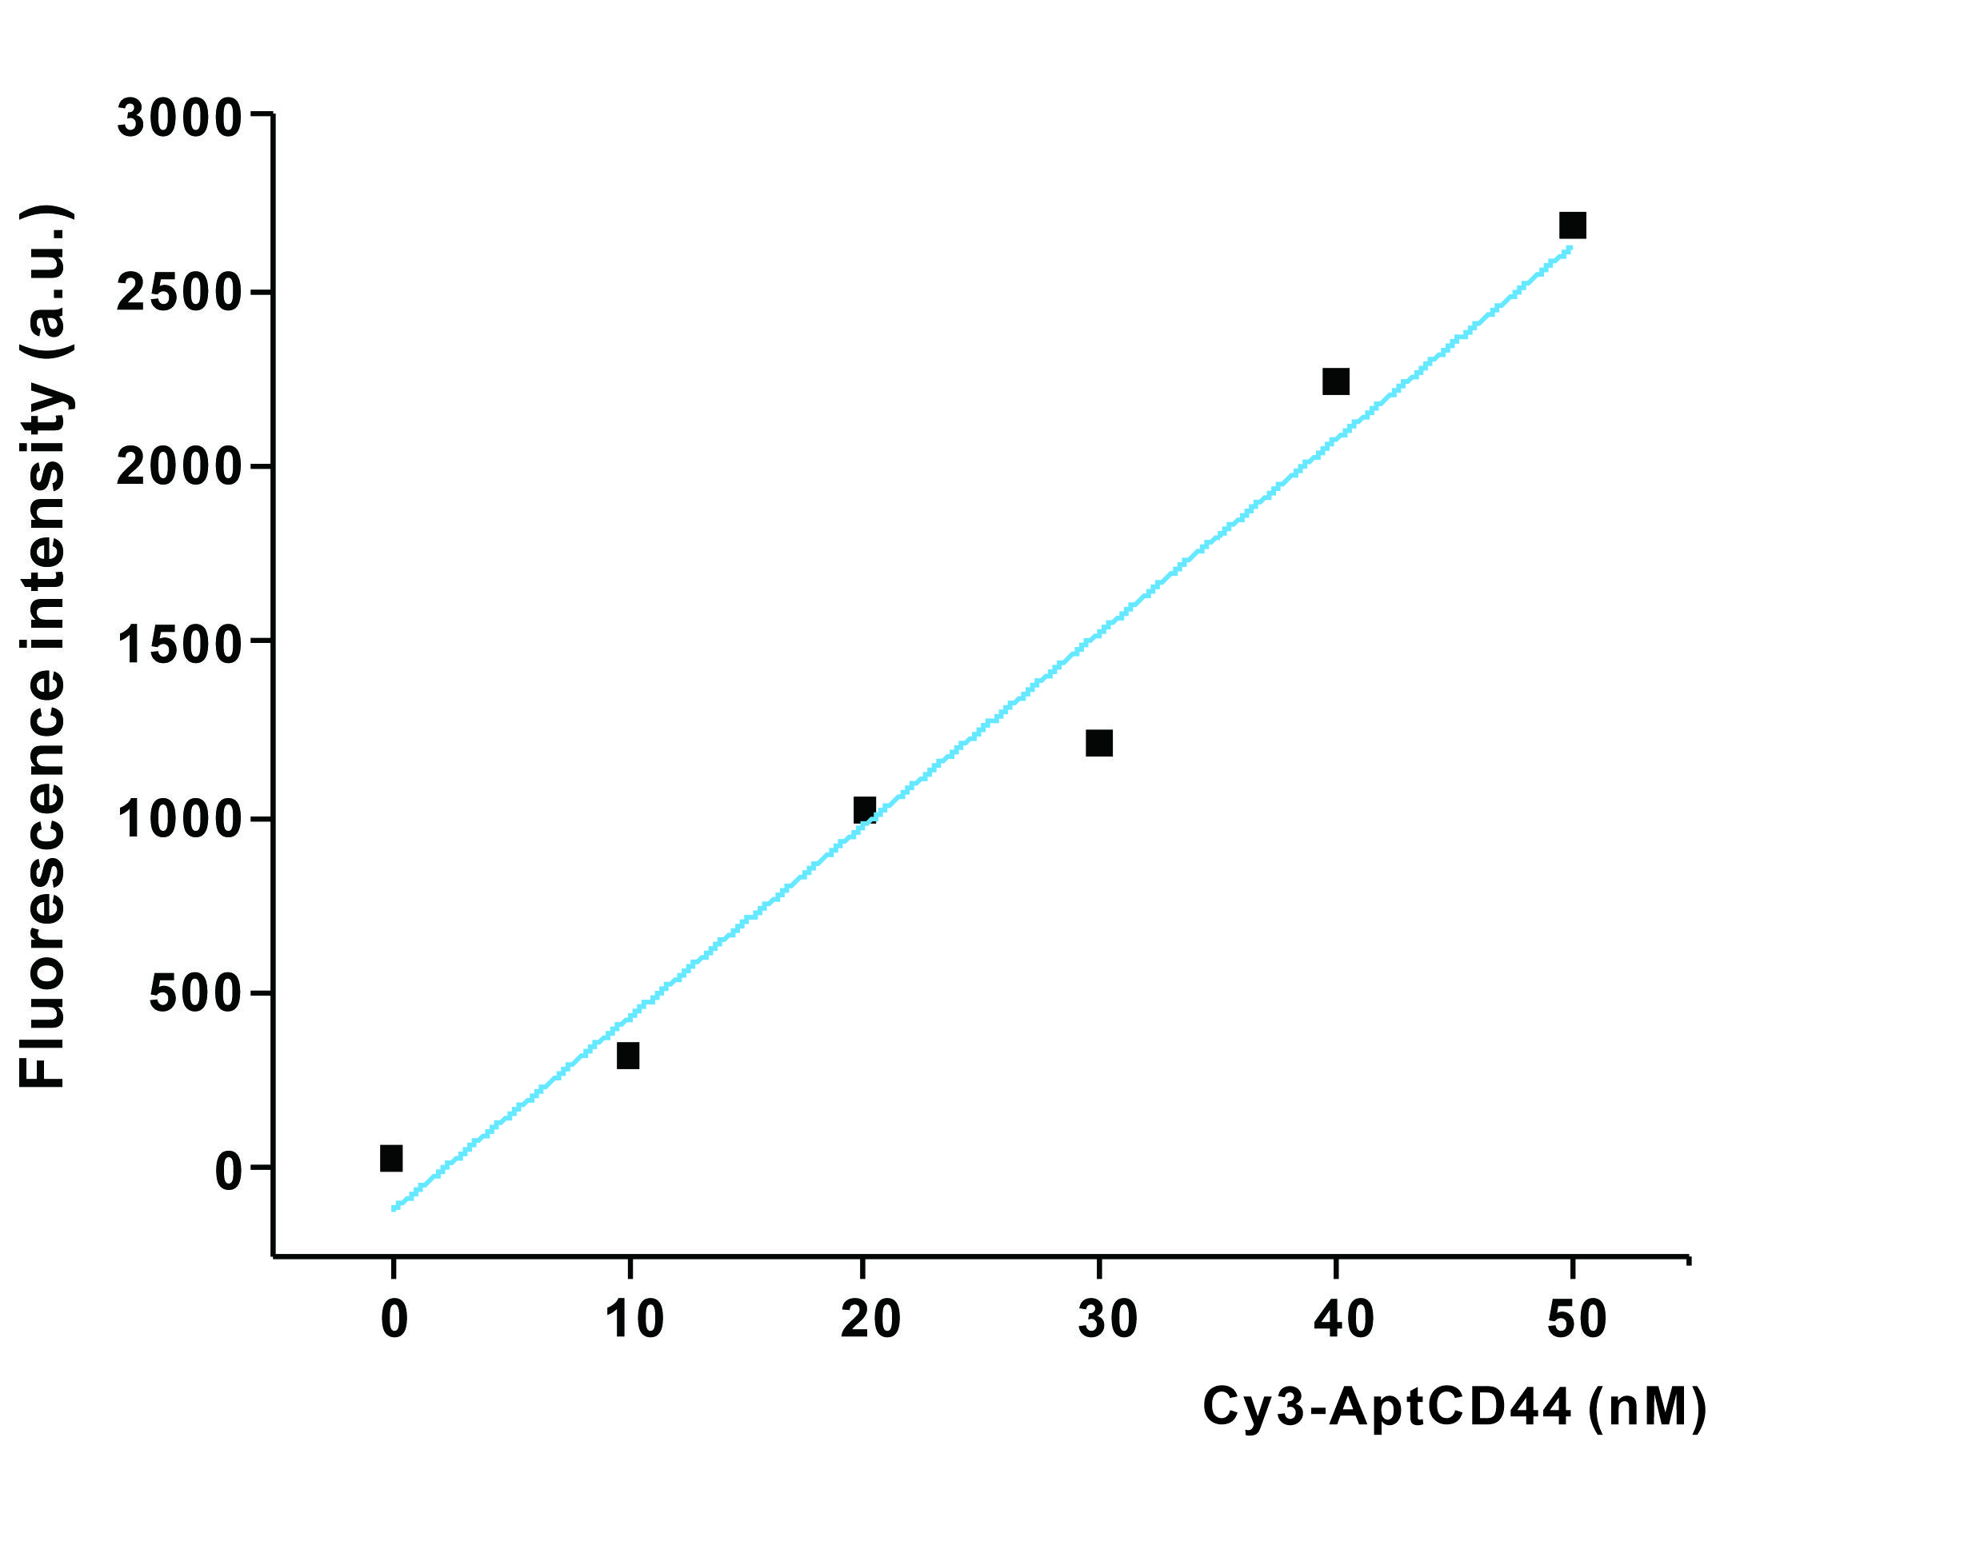
Fig S2. Loading Efficiency Line Chart.

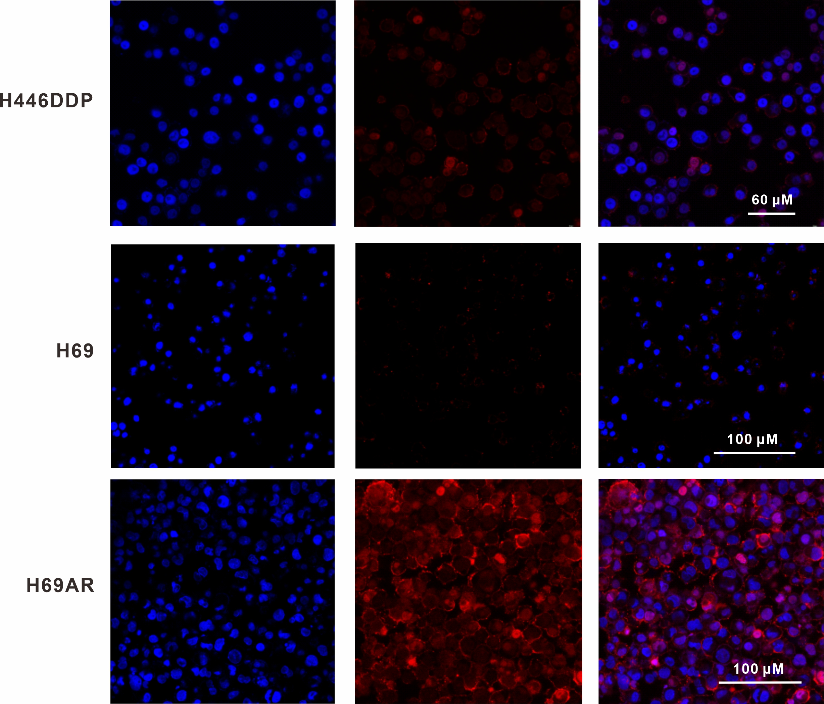Fig S3. Laser scanning confocal microscope (LSCM) images of H446DDP, H69, H69AR cells.
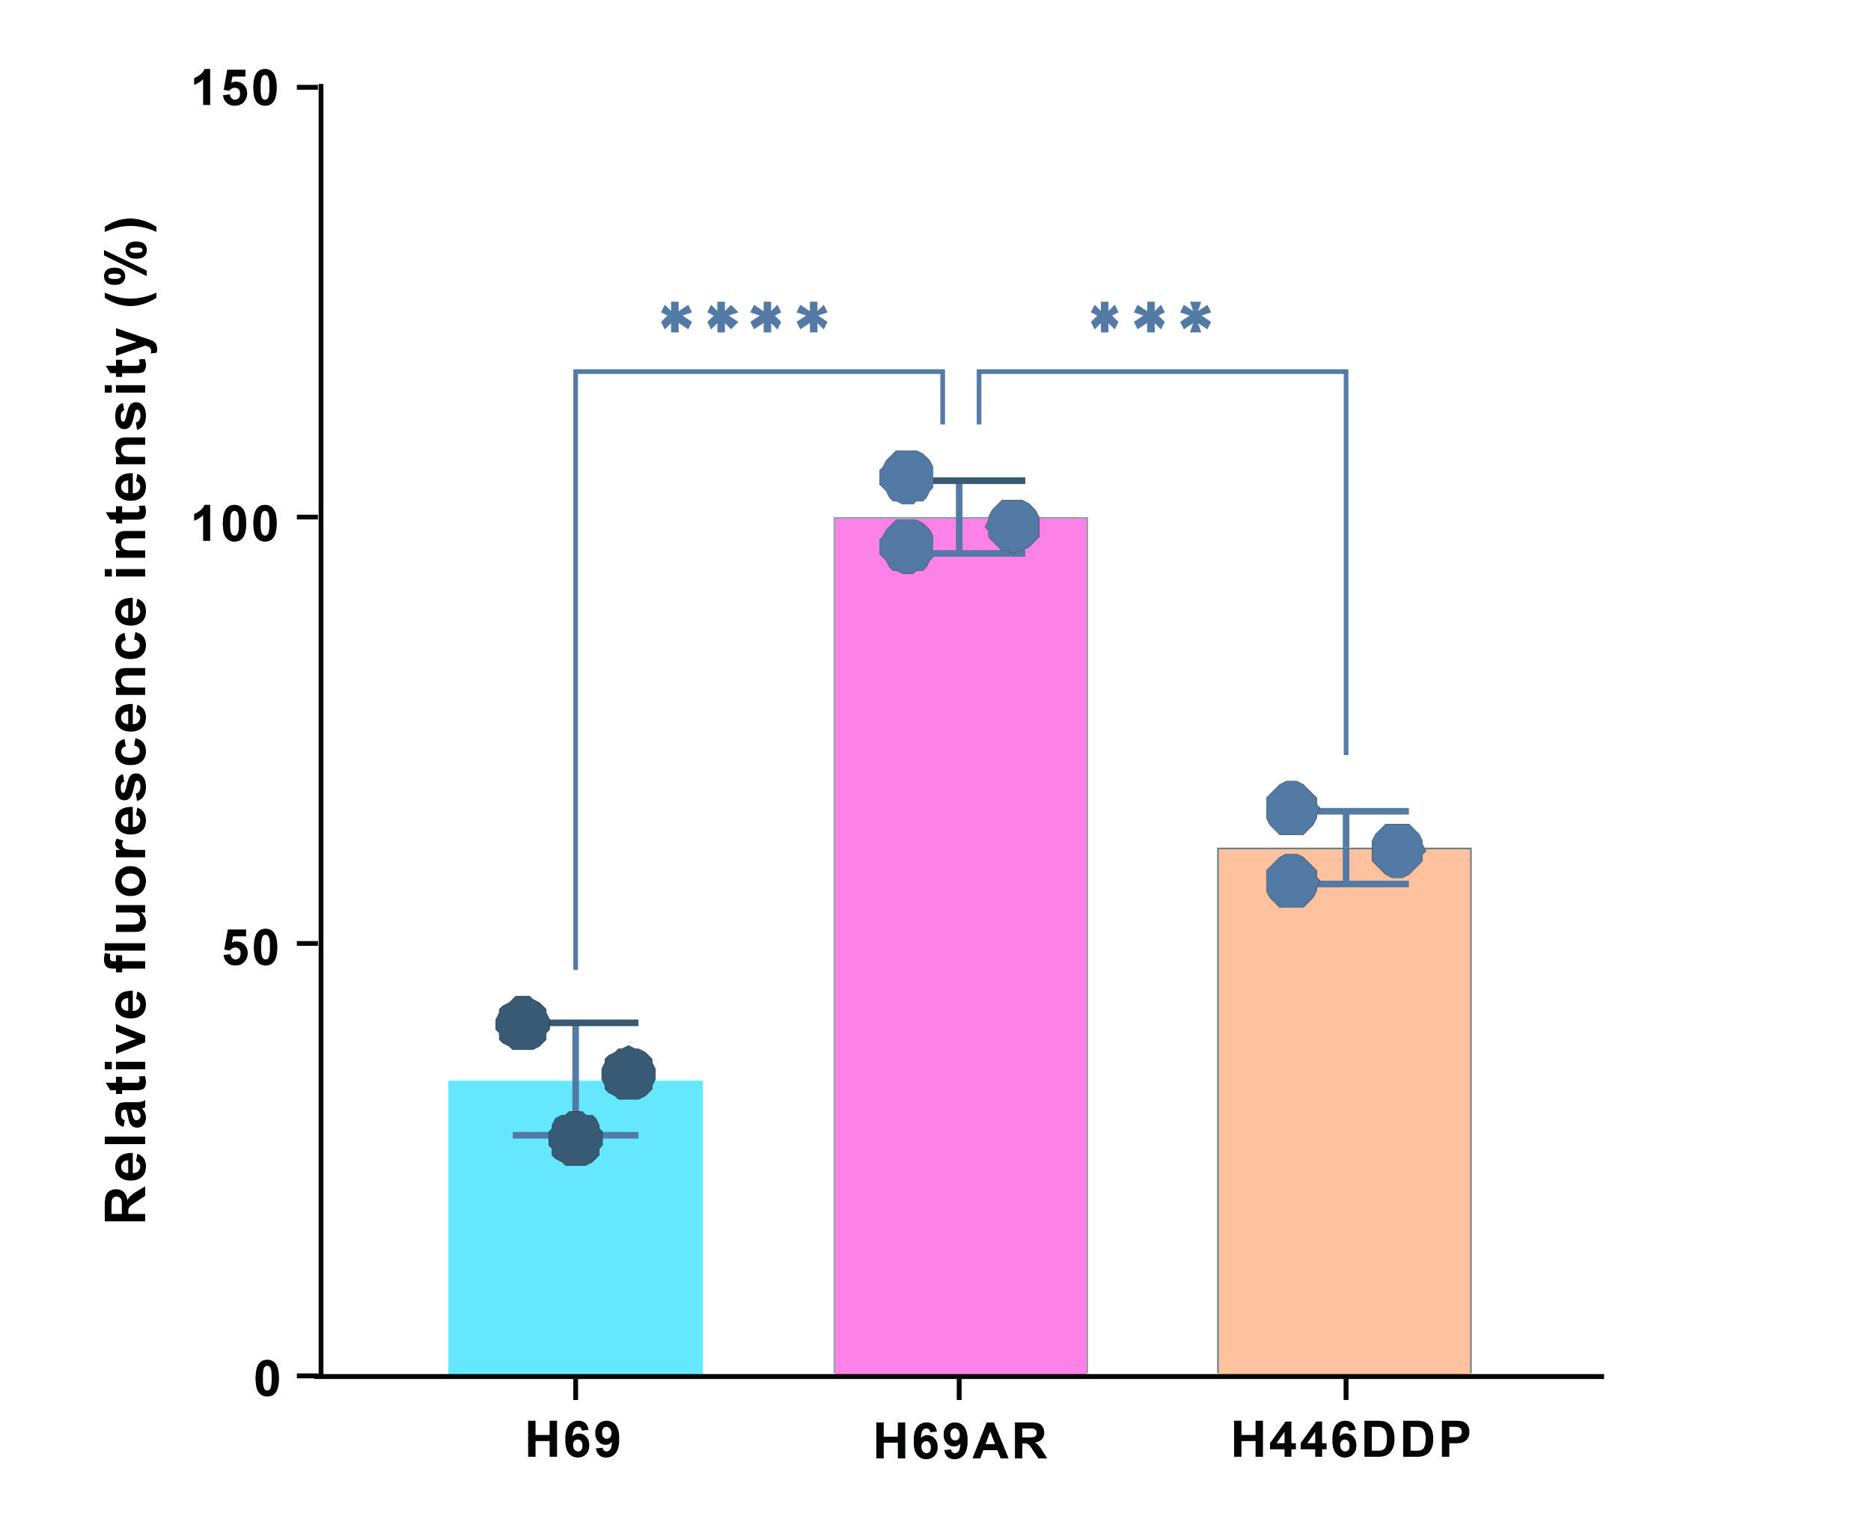
Fig S4. Data analysis of fluorescence intensity of different cell sublines. ***p < 0.001, ****p < 0.0001.

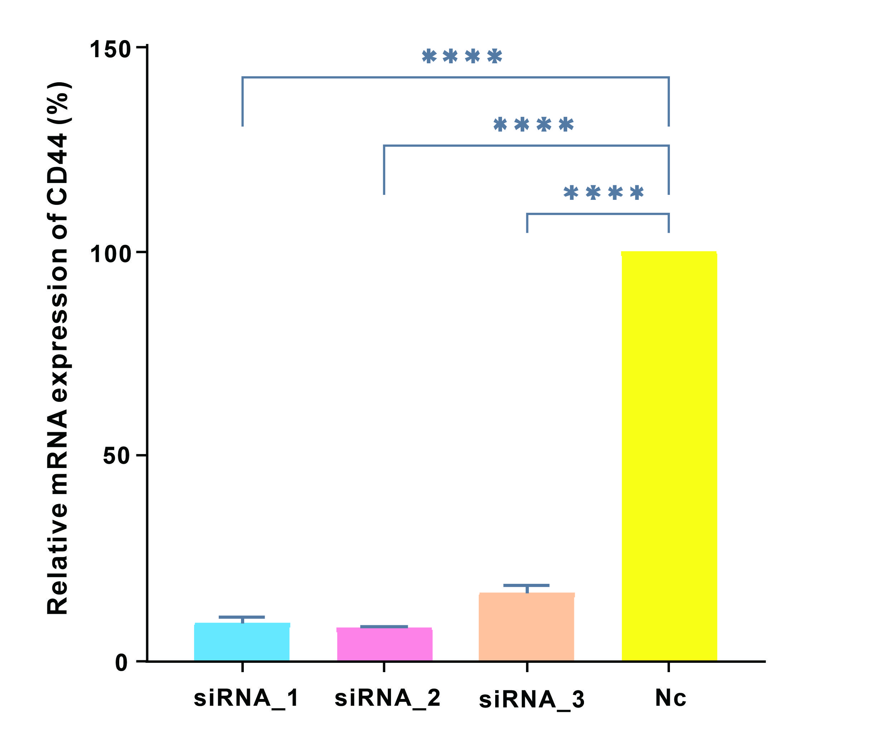Fig S5. CD44 mRNA expression levels were analyzed by qPCR in H69AR after downregulation. ****p < 0.0001.

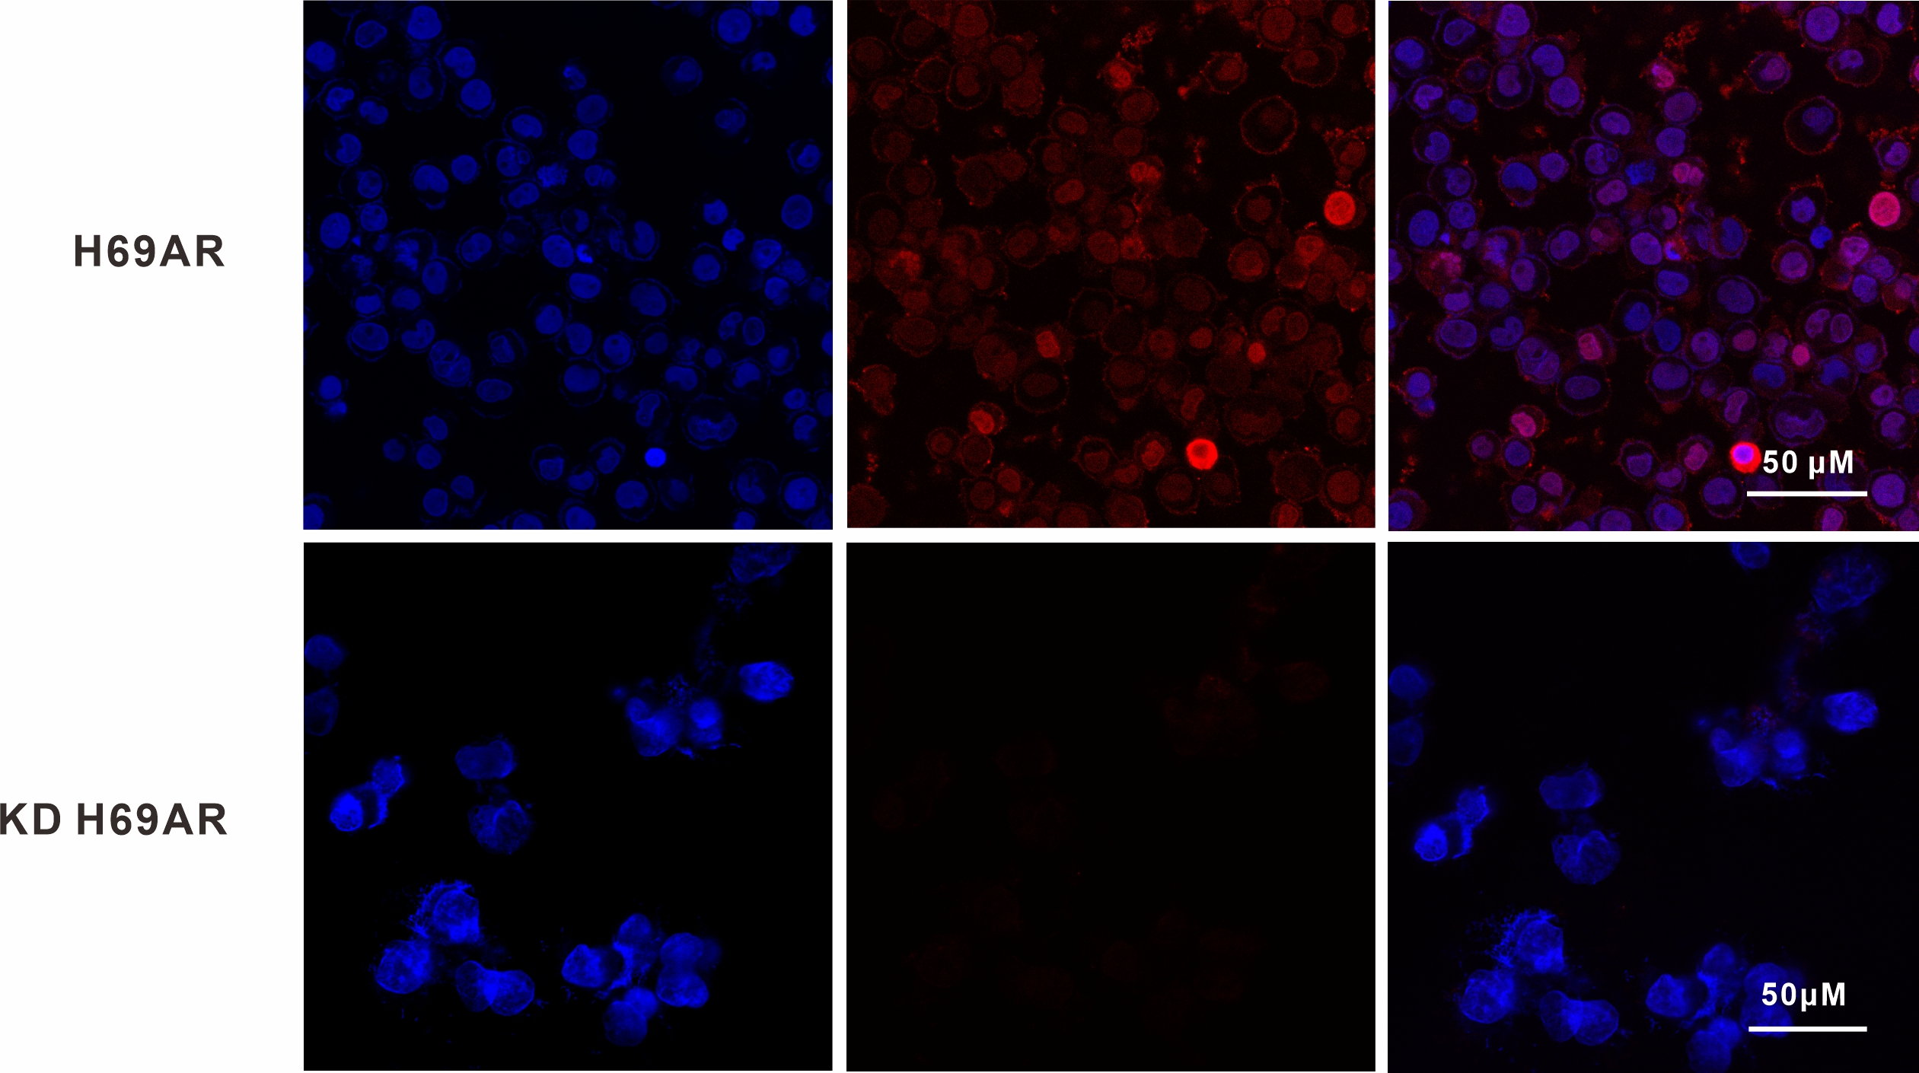
Fig S6. LSCM images of H69AR and KD H69AR cells.

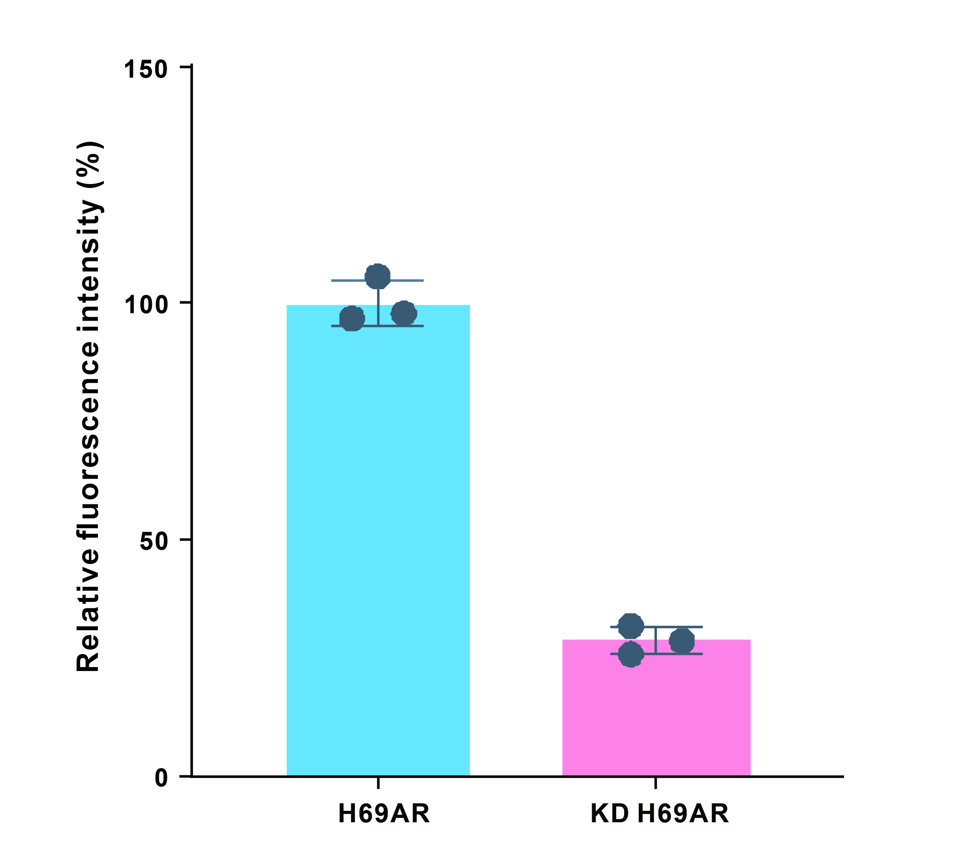
Fig S7. Analysis of fluorescence intensity in H69AR cell subline before and after the downregulation.

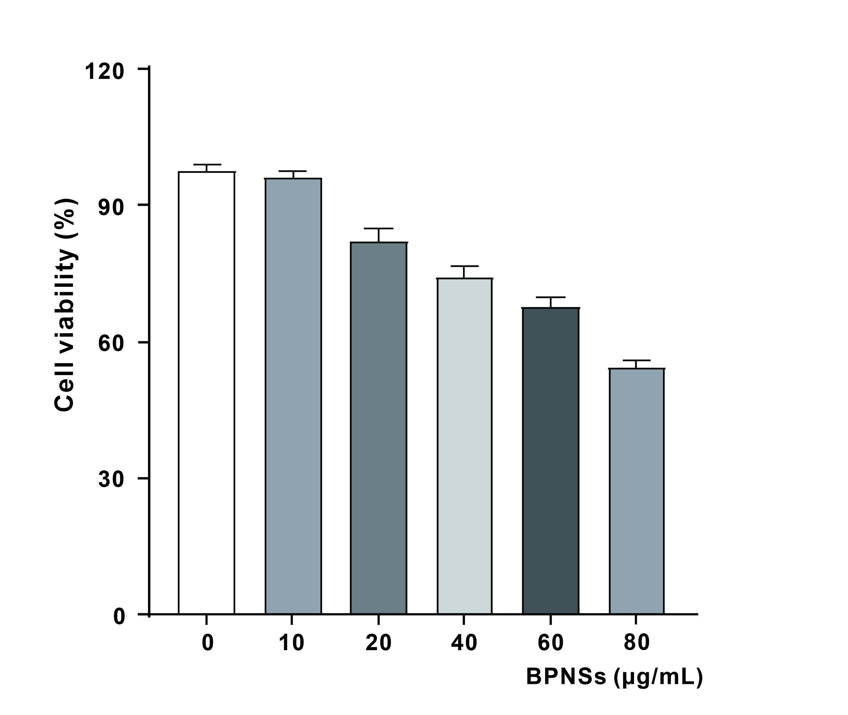
Fig S8. Analysis of cell viability with different concentrations of BPNSs.

Table S1. Cy3-AptCD44 and Cy3-Ran sequence information sequences
Type | Sequences (5’-3’)
Cy3-AptCD44 | C6 SH-GGGAUGGAUCCAAGCUUACUGGCAUCUGGAUUUGCGCGUGCCAGAAUAAAGAGUAUAACGUGUGAAUGGGAAGCUUCGAUAGGAAUUCGG-Cy3
Cy3-Ran | SH C6-AAAAAAAAAAAAAAAAAAAAAAAAAAAAAAAAAAAAAAAAAAAAA AAAAAAAAAAAAAAAAAAAAAAAAAAAAAAAAAAAAAAAAAAAAA-Cy3

Table S2. The RT-qPCR primer
Gene | Forward primer (5’-3’) | Reverse primer (5’-3’)
CD44 | CGGACACCATGGACAAGTTT | GCAAAGCGGCAGGTTATATT

