Supplementary Material

Activated carbon supported Ni-Co and Ni-Cu bimetallic catalysts for lignin depolymerization into short-chain phenolic substances with isopropanol as the H-donating solvent: Activity enhancement and products distribution studies
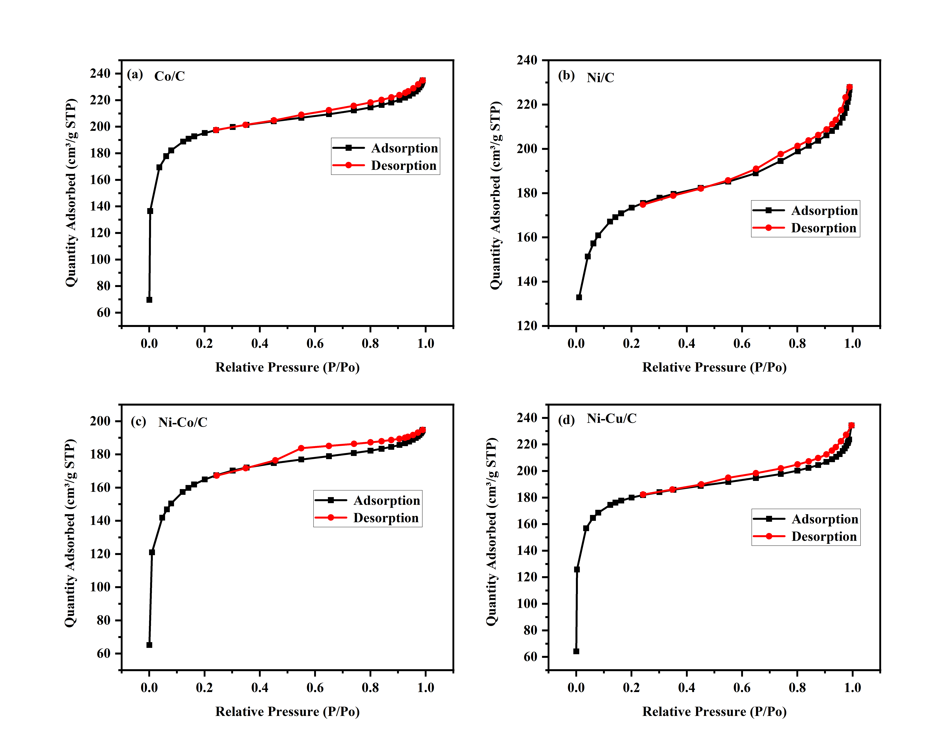

Fig. S1 N₂ adsorption-desorption isotherms of (a) Co/C, (b) Ni/C, (c) Ni-Co/C and (d) Ni-Cu/C catalysts.
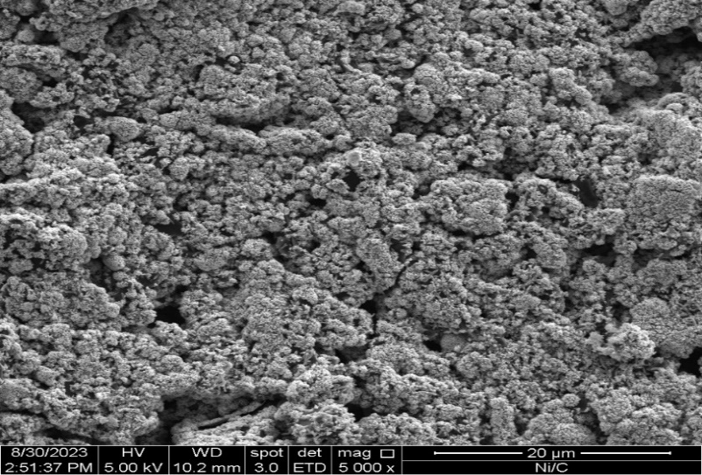

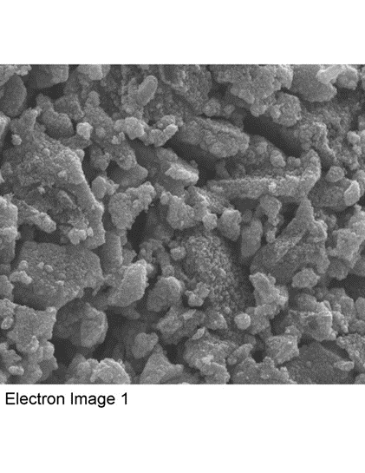
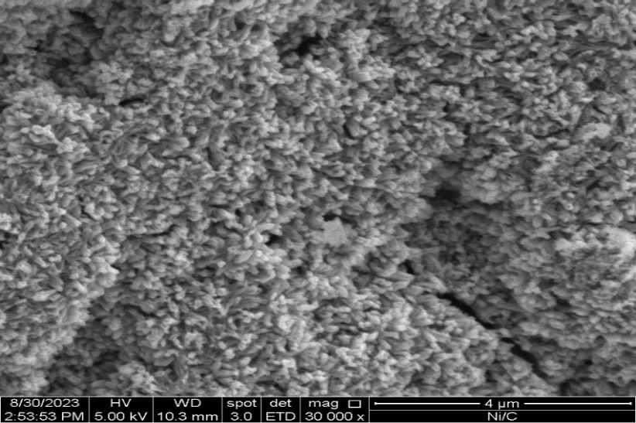
Fig. S2 SEM and EDX elemental mapping images of Ni/C. Mag.: 5 kX and 30 kX.

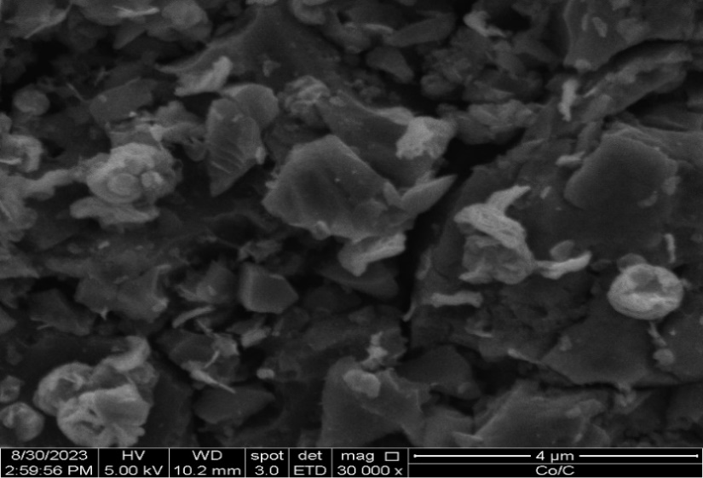

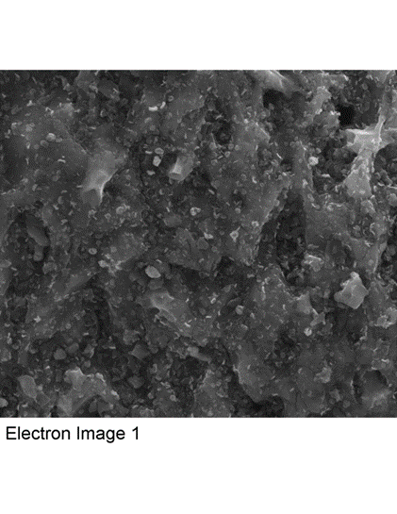
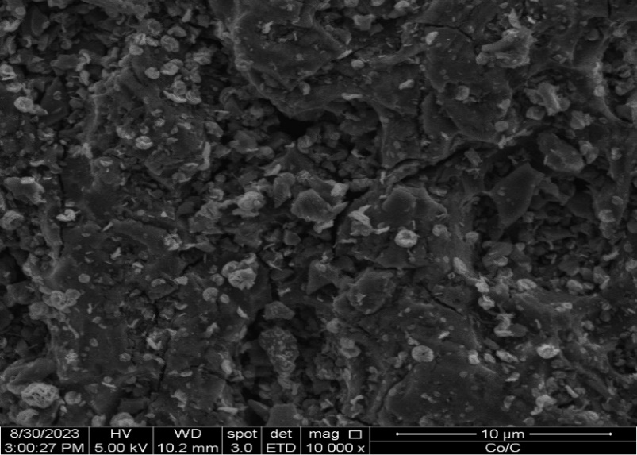
Fig. S3 SEM and EDX elemental mapping images of Co/C. Mag.: 10 kX and 30 kX.

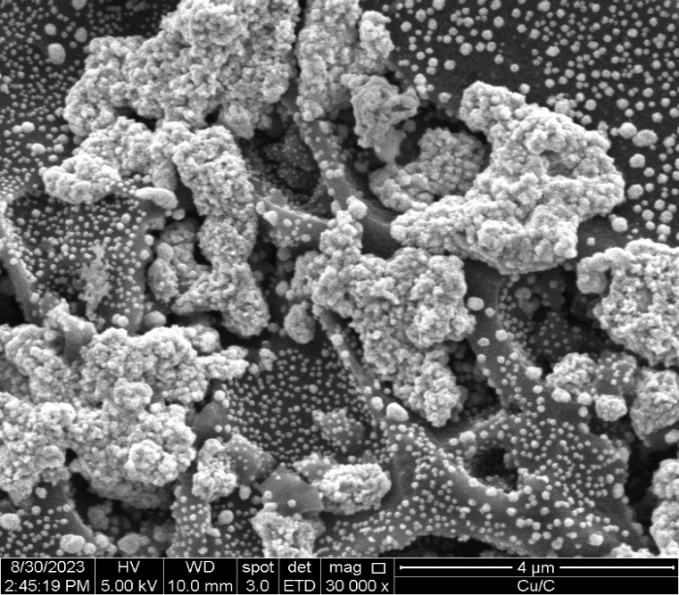
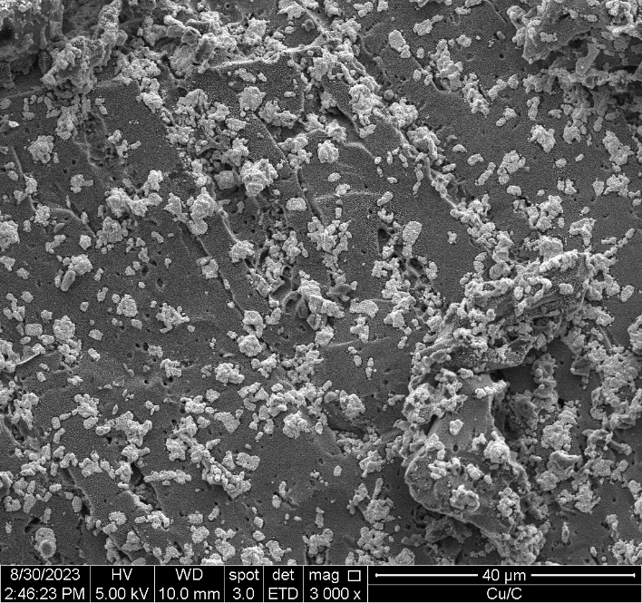

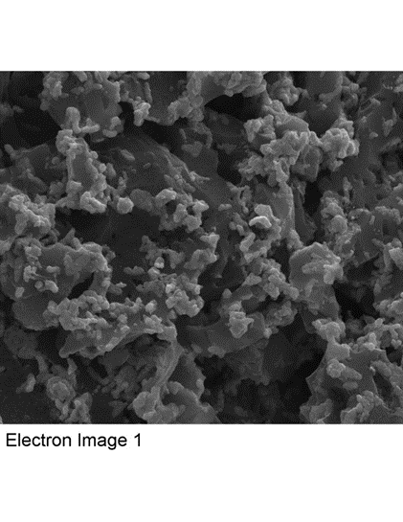
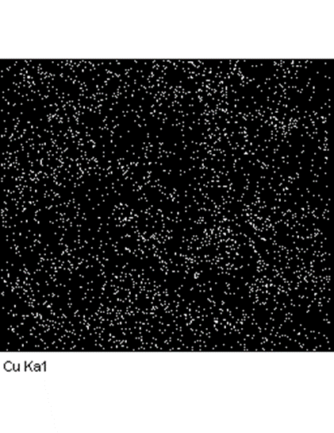
Fig. S4 SEM and EDX elemental mapping images of Cu/C. Mag.: 3 kX and 30 kX.

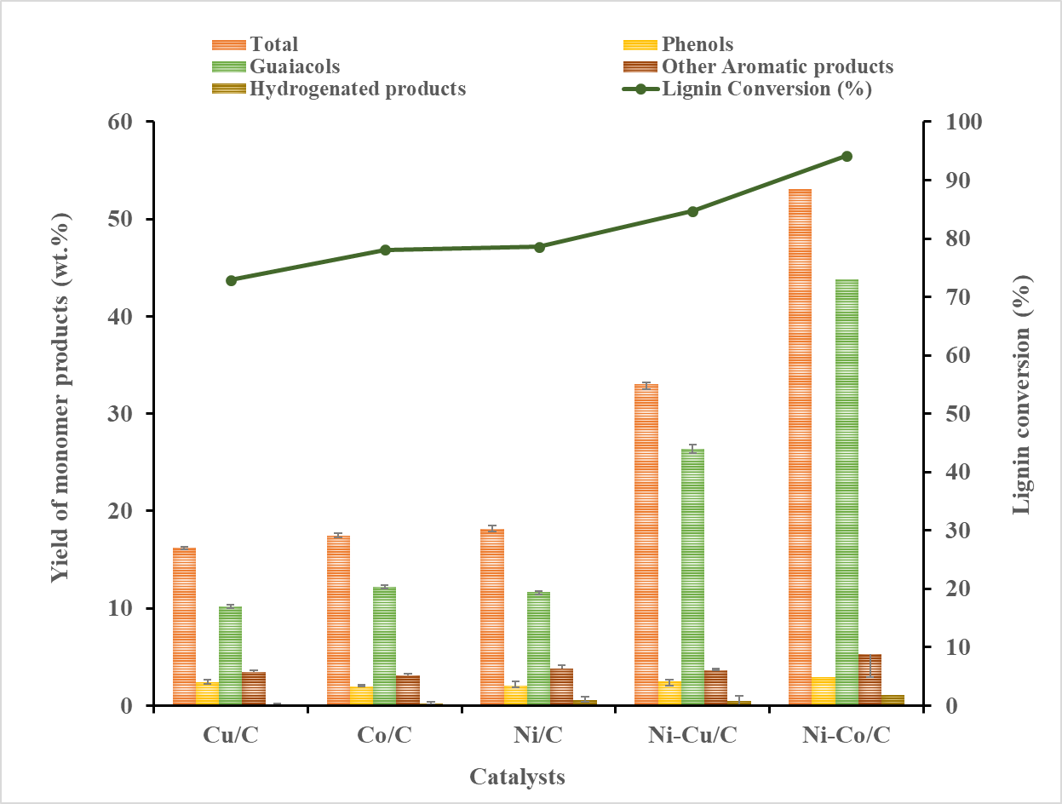
Fig. S5 The results of the catalysis experiments. (Reaction condition: lignin = 0.5 g, catalysts = 0.3 g, isopropanol = 16 mL, n-decane = 0.5 mL, 4 MPa N₂, 250$℃$, 4 h and 700 rpm).

Table S1
Summary of GC-MS analysis of the product distributions from lignin hydrogenolysis.
Retention  Time (Min) | Area  (counts) | Compound | Chemical  Structure | Molecular  Weight (g/mol)
9.74 | 278512 | Phenol | 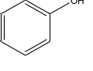 | 94.11
12.78 | 17688845 | Phenol, 2-methoxy | 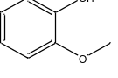 | 164.20
14.51 | 410551 | Benzene, 1,2-dimethoxy | 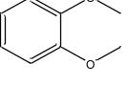 | 178.23
15.16 | 932608 | Phenol, 4-ethyl | 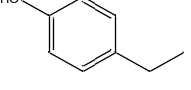 | 152.19
15.56 | 91066 | Phenol, 3-(1-methylethyl) | 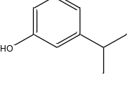 | 283.40
15.81 | 8893457 | Creosol | 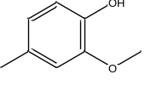 | 138.16
17.16 | 359472 | 3,4-Dimethoxytoluene | 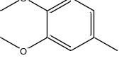 | 152.19
17.75 | 328228 | Phenol, 2-propyl | 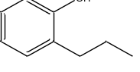 | 346.50
18.24 | 21890722 | Phenol, 4-ethyl-2-methoxy | 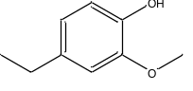 | 166.22
19.12 | 167691 | 2-Methoxy-4-vinylphenol | 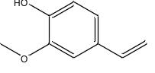 | 150.17
19.47 | 727304 | Benzene, 4-ethyl-1,2-dimethoxy | 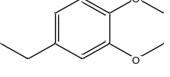 | 166.22
20.34 | 709333 | Eugenol | 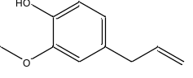 | 164.20
20.61 | 23554360 | Phenol, 2-methoxy-4-propyl- | 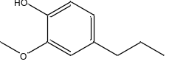 | 264.36
24.25 | 1008126 | Phenol, 2,5-bis(1,1-dimethylethyl | 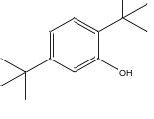 | 240.77
24.69 | 1116098 | Phenol, 3-(dimethylamino) | 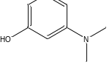 | 151.21
25.10 | 1214620 | Phenol, 4-(ethoxymethyl)-2-methoxy | 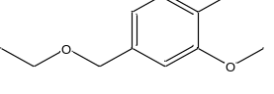 | 182.22
26.64 | 385246 | Benzoic acid, 3-(methylthio) | 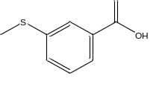 | 210.29
39.27 | 969005 | Benzeneacetic acid, 4-hydroxy | 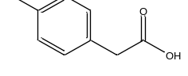 | 182.17
42.83 | 198635 | Benzene, 1,4-dimethoxy-2-methyl | 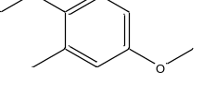 | 220.19
44.21 | 984385 | Benzaldehyde, 2,4-dihydroxy | 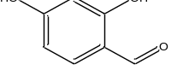 | 152.15
Reaction conditions: Lignin = 0.5g, catalyst = 0.3g, isopropanol = 16mL, 250 ℃, 4 h, 4 MPa. using GC-MS, where acetophenone was used as the internal standard chemical. The components listed were those with a GC-MS yield of more than 0.1 %.

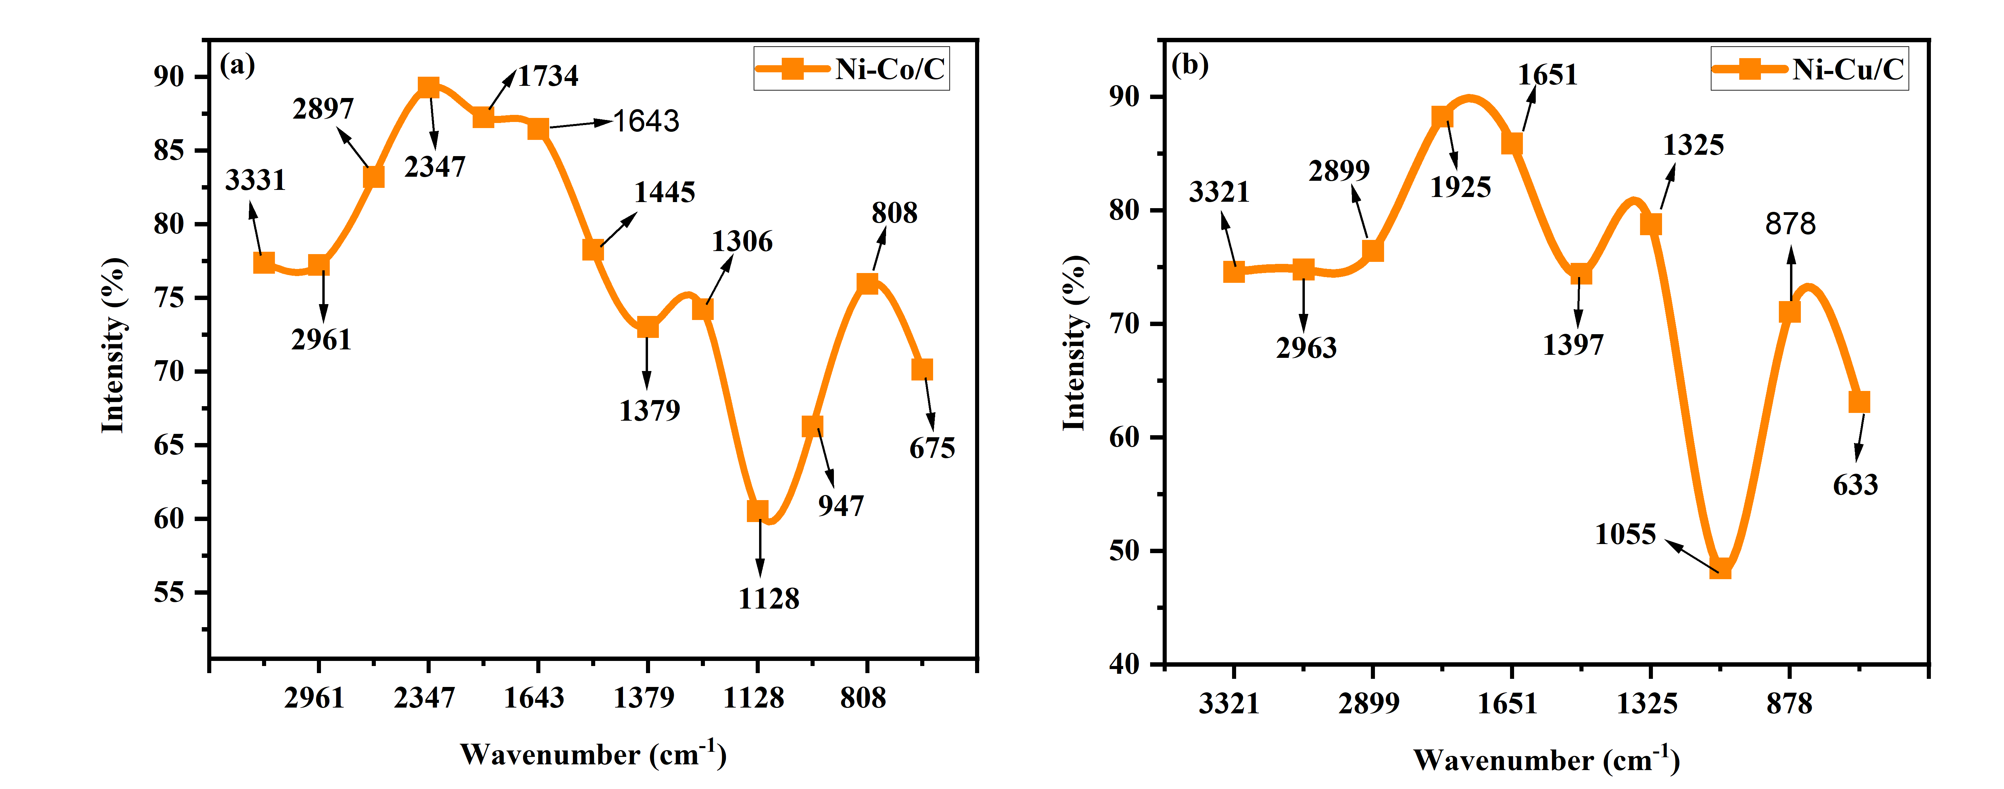
Fig. S6 FT-IR spectra of the nonvolatile products with the Ni-based bimetallic catalysts.

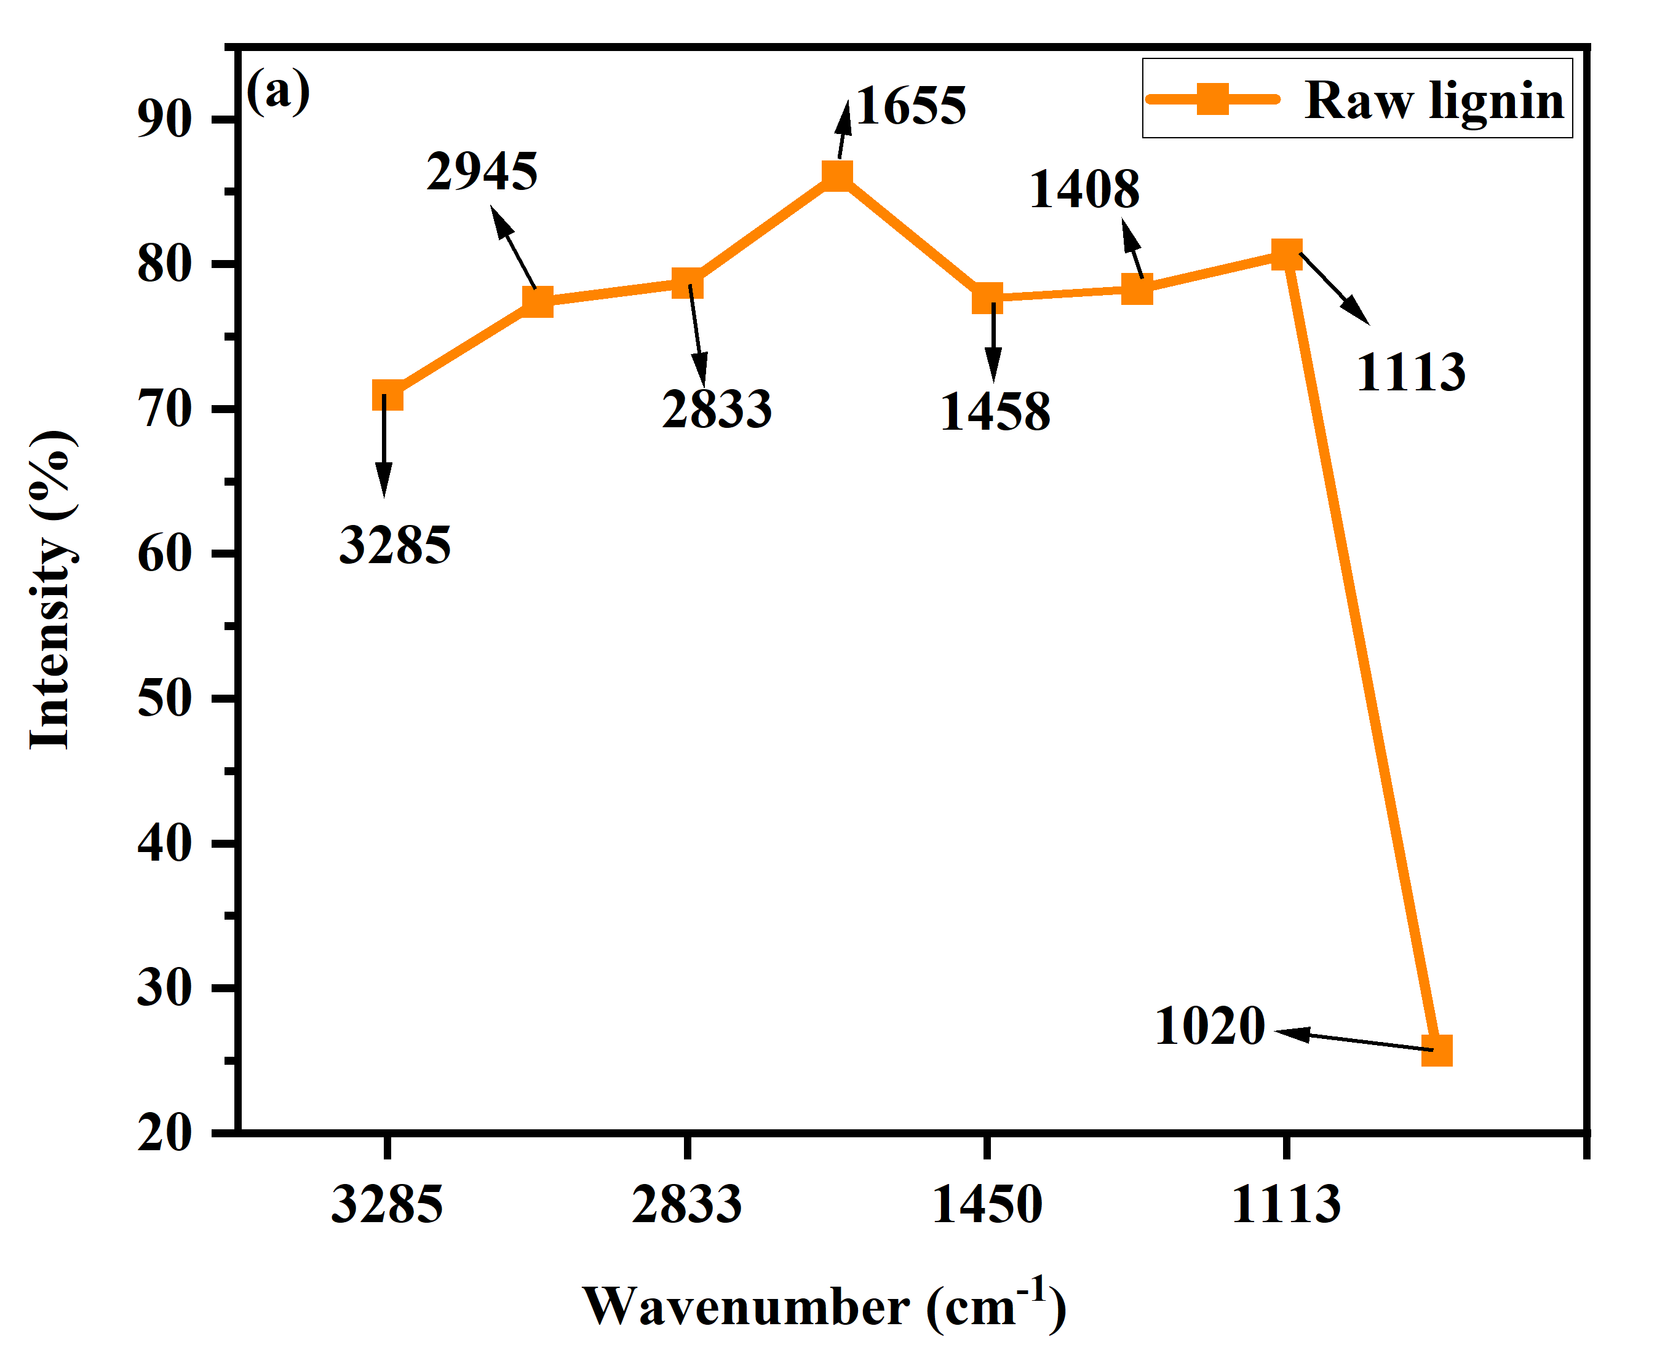
Fig. S7 FT-IR spectra of raw lignin.

