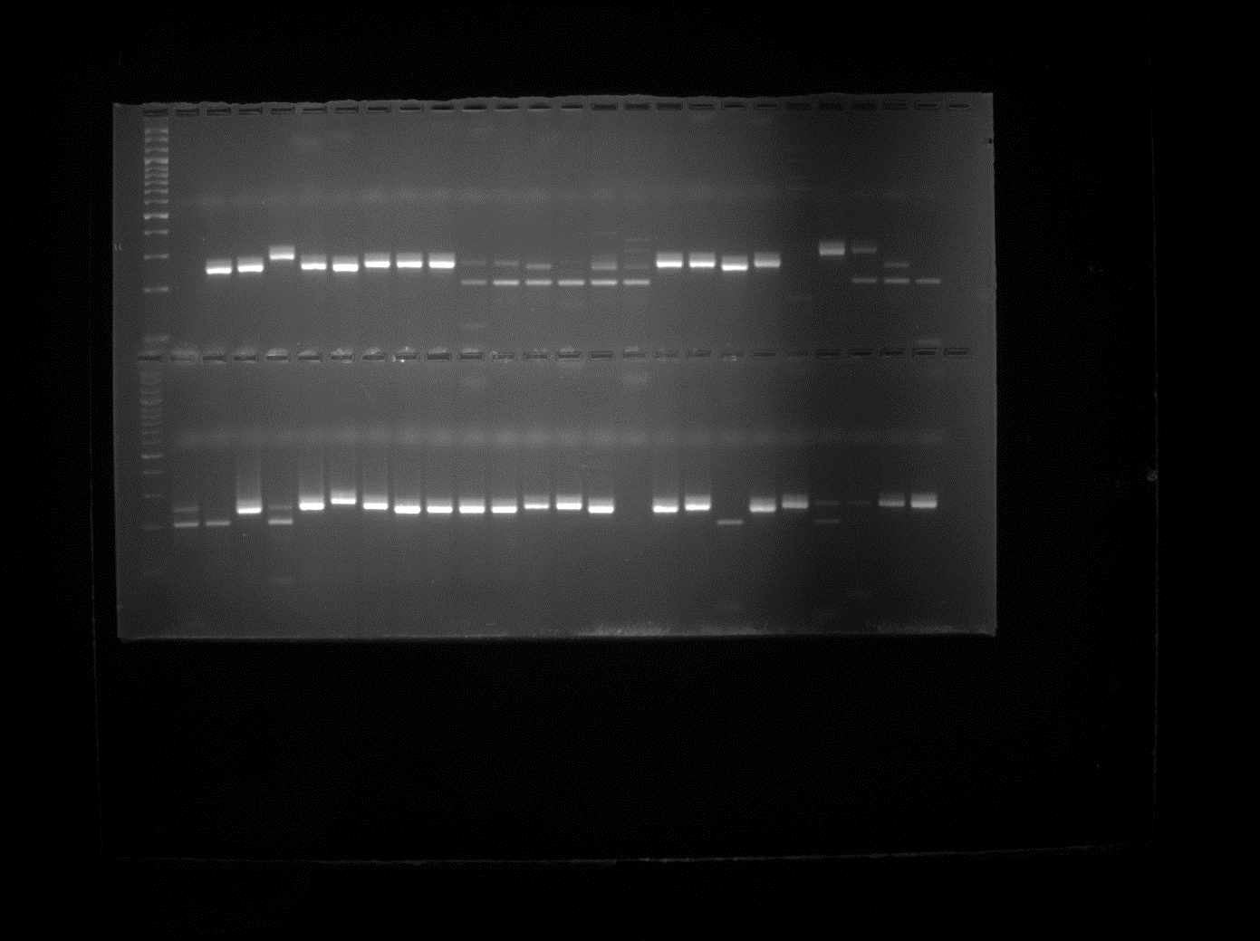
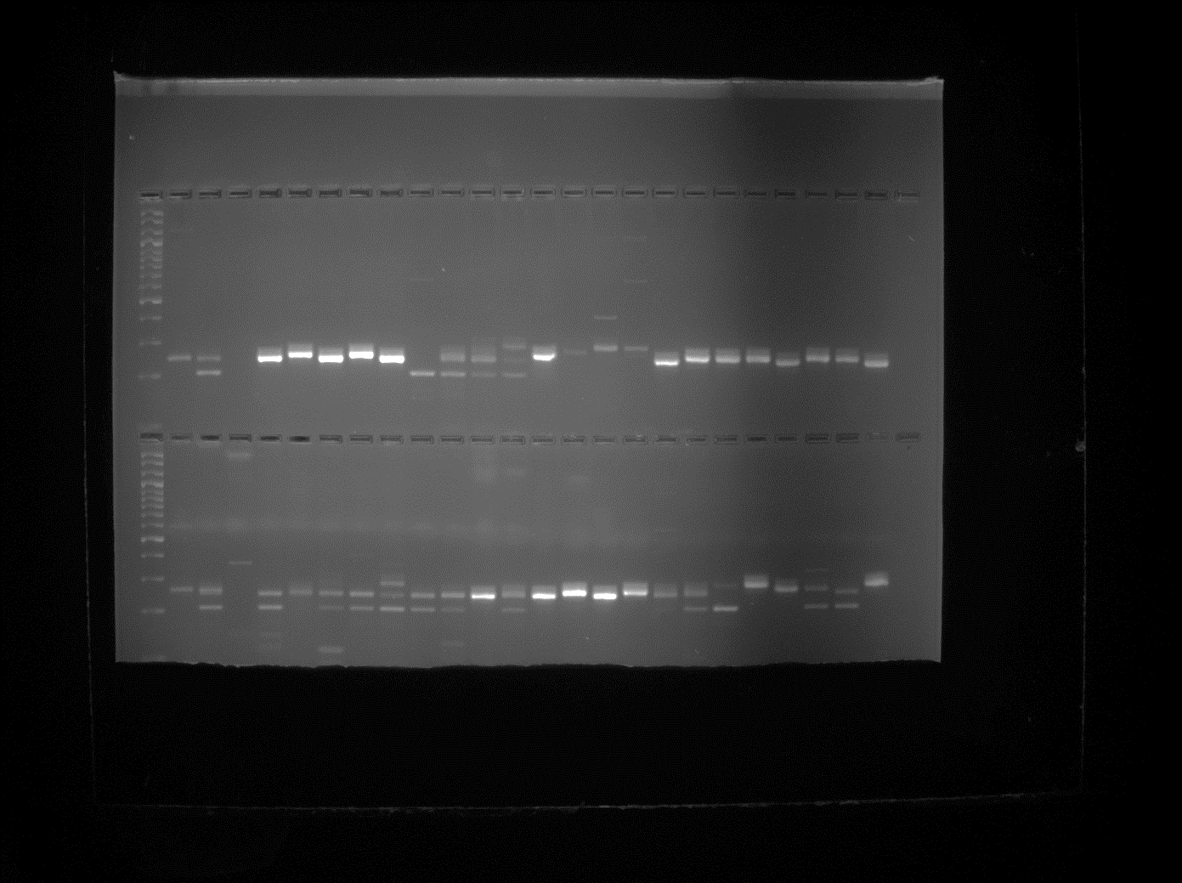
L 49 50 51 52 53 54 55 56 57 58 59 60 61 62 63 64 65 66 67 68 69 70 71 72
L 73 74 75 76 77 78 79 80 81 82 83 84 85 86 87 88 89 90 91 92 93 94 95 96
L 25 26 27 28 29 30 31 32 33 34 35 36 37 38 39 40 41 42 43 44 45 46 47 48
L 1 2 3 4 5 6 7 8 9 10 11 12 13 1415 16 17 18 19 20 21 22 23 24

Fig. 1 Gel electrophoresis profile of SSR marker Xwmc737 on 96 dicoccum accessions showing length polymorphism = 100 base pair ladder, (1-96 dicoccum accessions)

