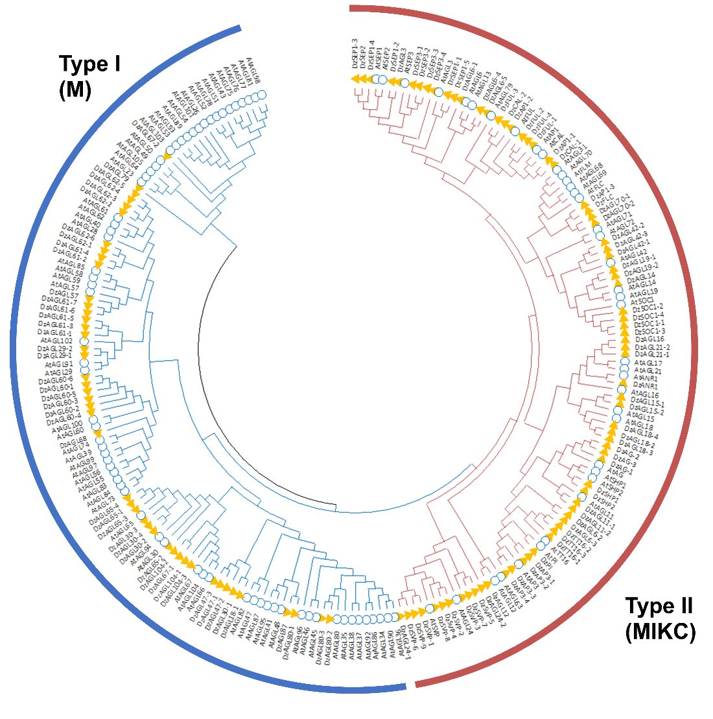
Supplementary Figure S1. Phylogenetic tree of MADS-box proteins from Durio zibethenus and Arabidopsis thaliana. ClustalW was used for multiple alignment. MEGA 11 was used for constructing the tree via Maximum Likelihood methods with the default parameter and 1,000 replicates (Tamura et al., 2021). MADS-box protein were divided into 2 types; type I and type II as indicated by different branch colors.

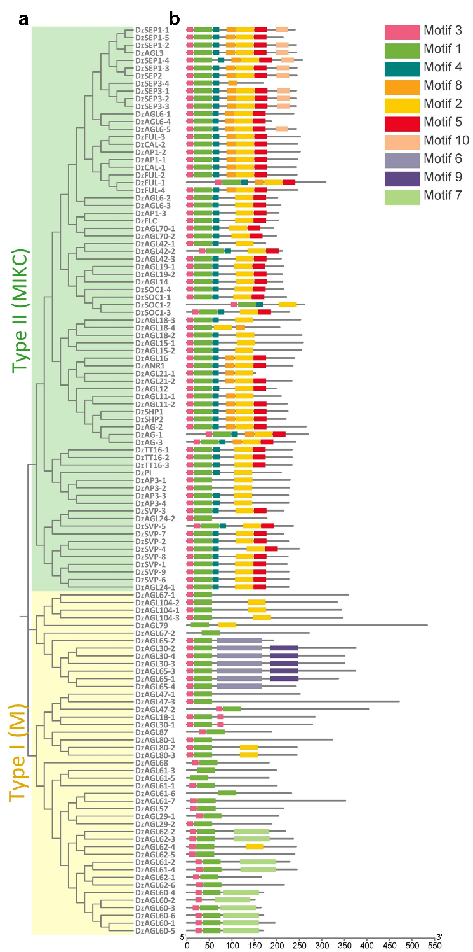
Supplementary Figure S2. (a) Phylogenetic tree and (b) conserved motif analysis of MADS proteins from Durio zibethenus. ClustalW was used for multiple alignment. MEGA 11 was used for constructing the tree via Maximum Likelihood methods with the default parameter and 1,000 replicates (Tamura et al., 2021) The conserved motifs were identified by MEME suit version 5.5.2 (https://meme-suite.org/meme/tools/meme) and visualized with TBtools (Chen et al., 2020).

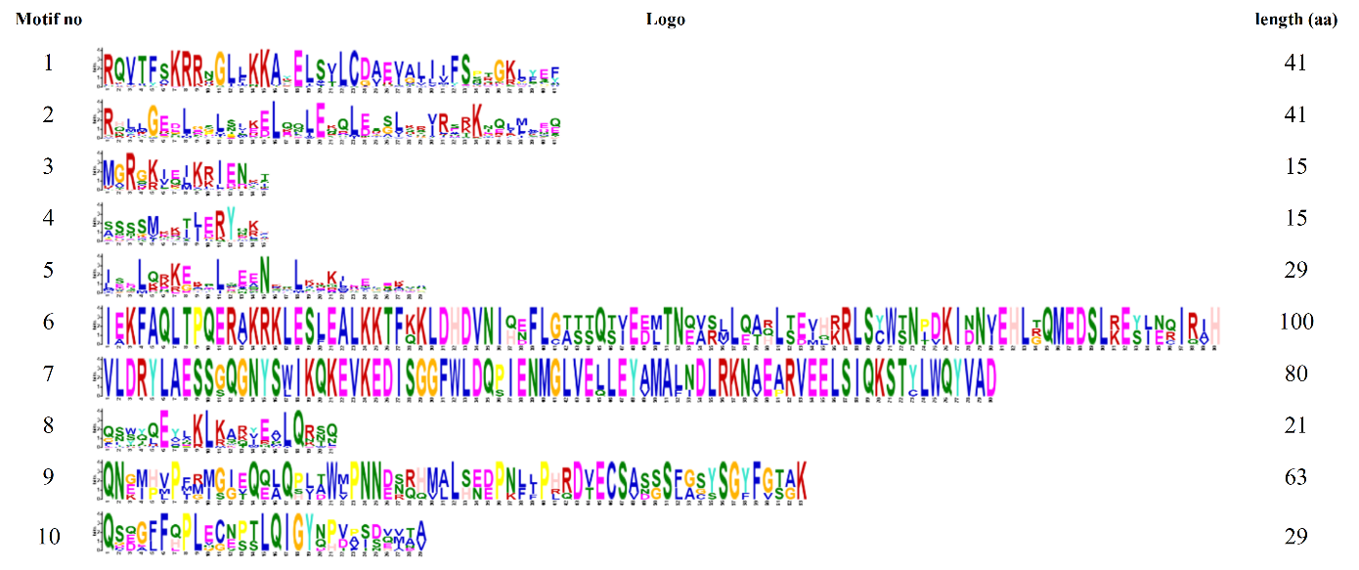
Supplementary Figure S3. Multilevel consensus sequences identified by MEME suit version 5.5.2 (https://meme-suite.org/meme/tools/meme). Protein sequences of durian MADS-box were used to identify conserved motifs. Ten conserved motifs were identified. The essential conserved domain for MADS-box present on motif 1 and 3.

Supplementary Figure S4. Relative expression of DzSEP3-1 and DzAGL6-1 at five different stages. The expression level was quantified using RT-qPCR. The expression levels were normalized against the transcript of DzEF-1α and DzACT; mean values ± SD are shown. Relative expression values were calculated using the 2^{-ΔCt} method. Different letters indicate a statistically significant difference between stages (p < 0.05, one-way ANOVA, Duncan”s multiple range test). IM1, IM2, M, MR, and R correspond to the stages of immature 1 at 85 days after anthesis (DAA), immature 2 at 95 DAA, mature/harvest at 105 DAA, midripe at 3 days after harvest (DAH), and ripe at 5 DAH, respectively. The study utilized three biological replicates for each stage. Abbreviation: EF-1α: elongation factor-1α; ACT: actin.

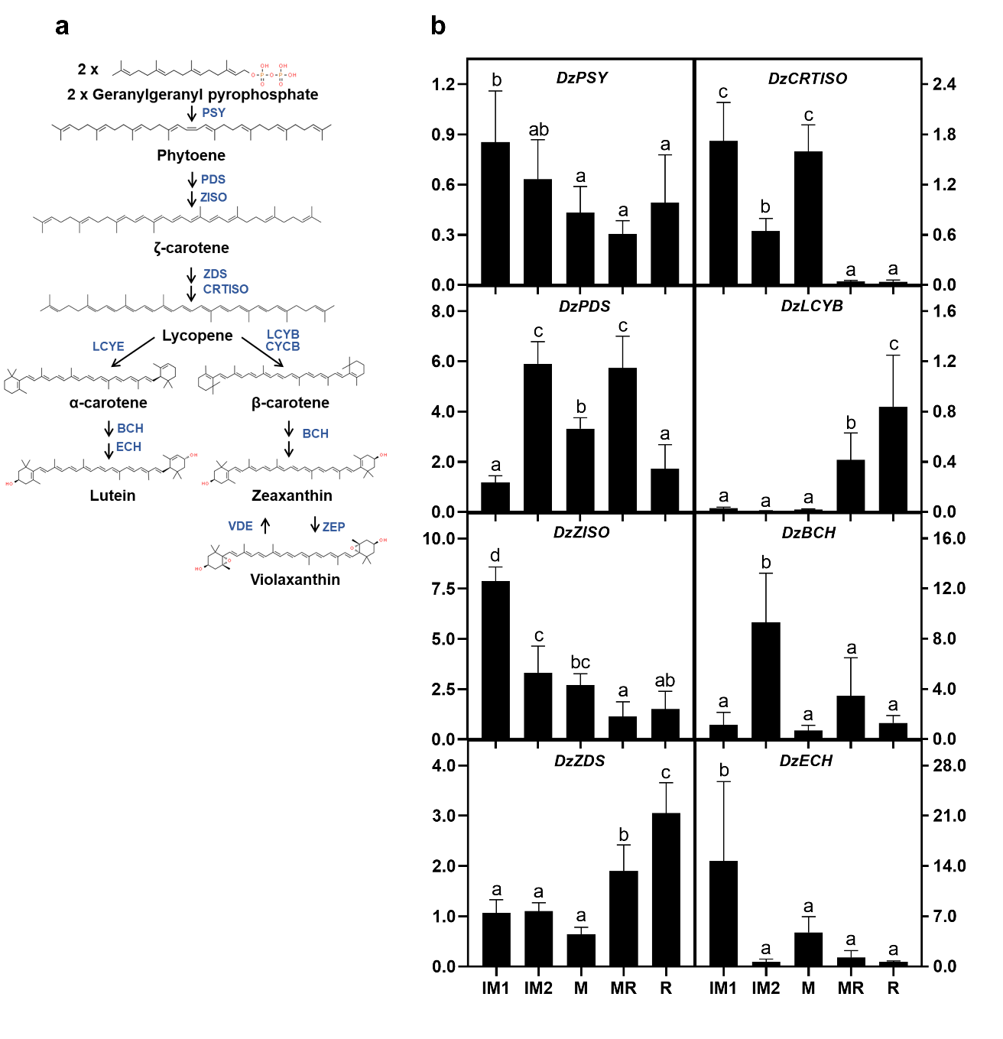
Supplementary Figure S5. (a) Carotenoid biosynthetic pathway. (b) Relative expression of carotenoid biosynthetic genes of durian at five different stages. The expression level was quantified using RT-qPCR. The expression levels were normalized against the transcript of DzEF-1α and DzACT; mean values ± SD are shown. Relative expression values were calculated using the 2^{-ΔCt} method. Different letters indicate a statistically significant difference between stages (p < 0.05, one-way ANOVA, Duncan”s multiple range test). IM1, IM2, M, MR, and R correspond to the stages of immature 1 at 85 days after anthesis (DAA), immature 2 at 95 DAA, mature/harvest at 105 DAA, midripe at 3 days after harvest (DAH), and ripe at 5 DAH, respectively. The study utilized three biological replicates for each stage. Abbreviation: PSY: phytoene synthase; PDS: phytoene desaturase; ZDS: ζ-carotene desaturase; ZISO: ζ-carotene isomerase; CRTISO: prolycopene isomerase; LCYE: lycopene ε-cyclase; LCYB: lycopene β-cyclase; CYCB: chromoplast specific lycopene β-cyclase; BCH: β-carotene hydroxylase; ECH: ε-carotene hydroxylase; ZEP: zeaxanthin epoxidase; VDE: violaxanthin de-epoxidase.; EF-1α: elongation factor-1α; ACT: actin.

