Appendix A
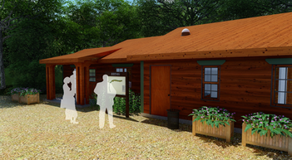  Zone I (a) | 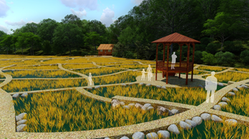Zone I (b) | 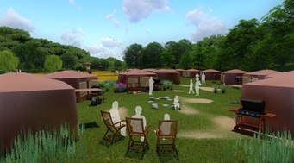  Zone I (c)
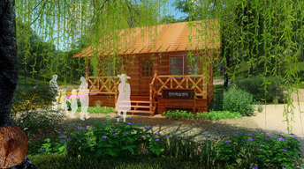 Zone II (a) | 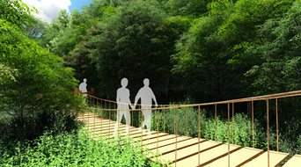 Zone II (b) | 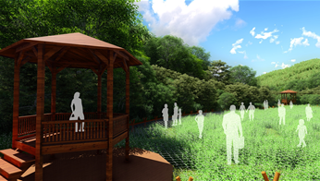  Zone II (c)
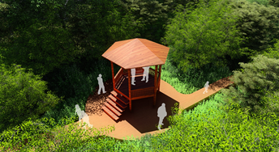  Zone III (a) | 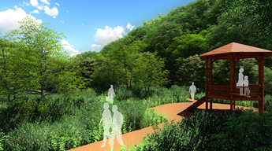  Zone III (b) | 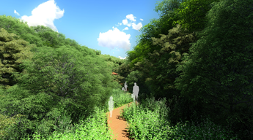  Zone III (c)
Fig A1: Suggested sketches of forest wetland master plan by each zone; zone I: rural developed; zone II: rural natural; zone III: semi-primitive. (Drawn by the authors)

