Rapid Explainable GNN-Derived Structure-Property Relationships in Interstitial-Alloy Materials: a Demonstrated Workflow Using Mo2C
Supporting Information

Eduardo Aguilar Bejarano,^{a,b,c} Luis Arrieta,^{d} Mauricio Gutierrez,^{e} Ender Özcan,^{c} Simon Woodward, ^{a,b} Grazziela Figueredo*^{f} and Ignacio Borge-Durán*^{g}

ª The GSK Carbon Neutral Laboratories for Sustainable Chemistry, The University of
Nottingham, Jubilee Campus, Nottingham, NG7 2TU, UK.
^{b} School of Chemistry, The University of Nottingham, University Park, Nottingham,
NG7 2RD, UK.
^{c} School of Computer Science, The University of Nottingham, Jubilee Campus, Nottingham, NG7 2TU, UK.
^{d} School of Chemical Engineering, Universidad de Costa Rica, San Pedro, San José, 11801, San José, Costa Rica.
^{e} School of Chemistry, Universidad de Costa Rica, San Pedro, San José, 11801, San José, Costa Rica.
^{f} School of Medicine, The University of Nottingham, University Park, Nottingham,
NG7 2RD, UK.
^{g} School of Chemistry, Bar-Ilan University, Ramat-Gan, 5290002, Israel.

*E-mail address:
borgedj@biu.ac.il
grazziela.figueredo@nottingham.ac.uk

Contents
Supporting Figures 3
Crystal Graph Explainer 7
Attribute score calculation using IPM 7

Supporting Figures

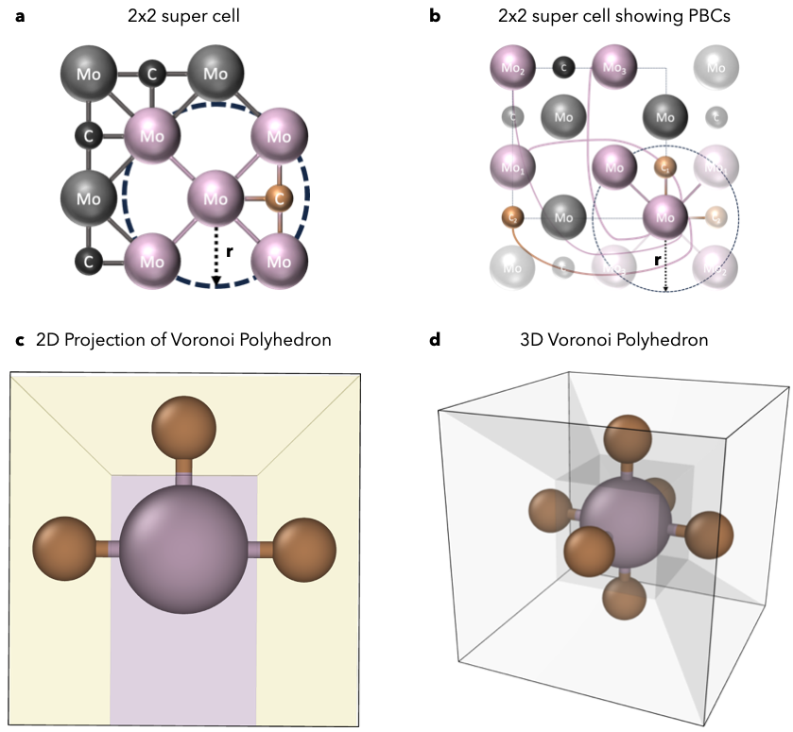
Figure S1. Scheme of graph representation used as input of the Crystal Graph Neural Network. a) Shows the radius threshold criteria used to determine whether or not two atoms share an edge, b) shows the radius threshold criteria applying periodic boundary conditions, c) shows the Voronoi polygons resulting from a Voronoi Tessellation algorithm applied to atoms that rely in 2D space, and d) shows the Voronoi polygons resulting from a Voronoi Tessellation algorithm applied to atoms that rely in 3D space.

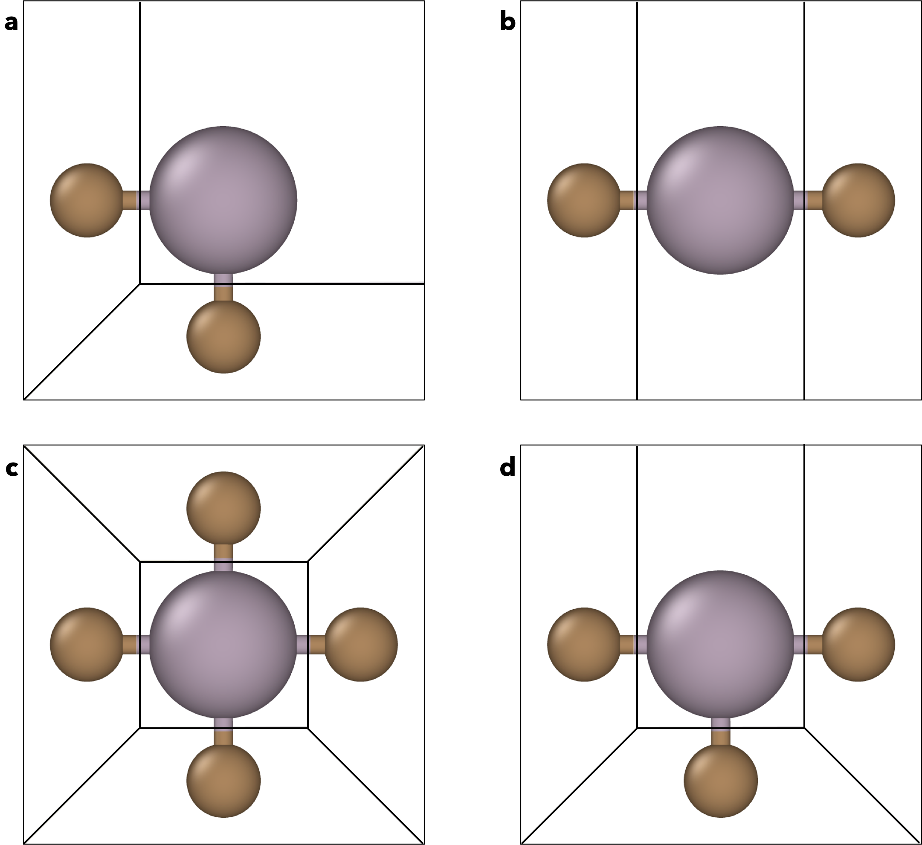
Fig. S2. Illustrative exemplars of Voronoi Polyhedrons for various atomic arrangements of carbide atoms around a molybdenum atom. The pictures show how the relative disposition of atoms makes the boundary of the central Mo polyhedron change.

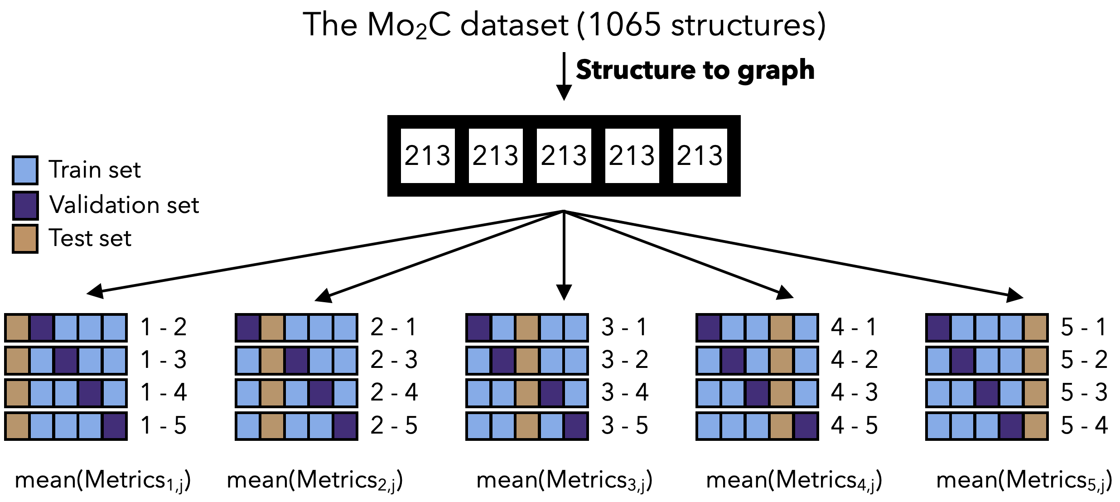
Fig. S3. Scheme of the inner cross validation approach for data splitting applied in this study.

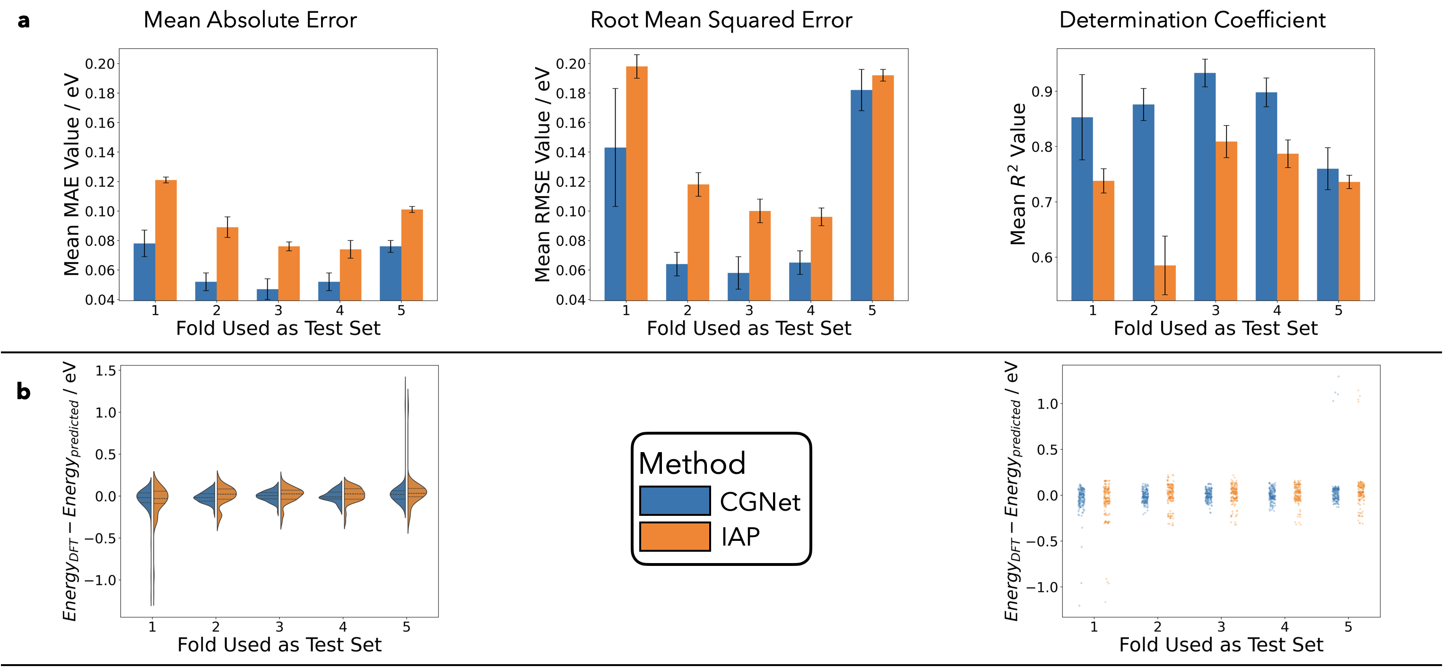
Fig. S4 Summary of results obtained by Crystal Graph Neural Network and Interatomic Potential approaches on the Ti₂C dataset. The reported values are shown for each test fold separately, using the mean of the metrics for the value in the bar and the standard deviation as error bars. a) Shows the mean metrics obtained for each test fold and standard deviation as error bars. b) Shows the error distribution of the test set obtained.

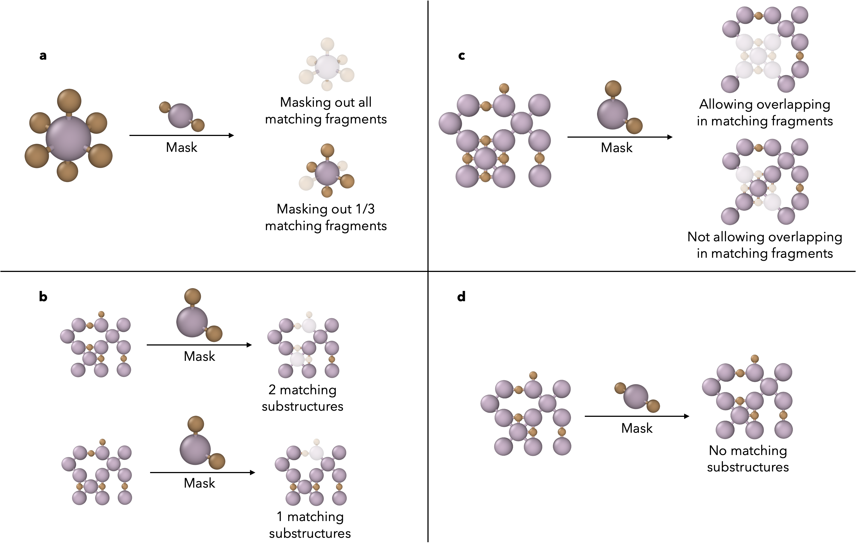
Fig. S5. Summary of possible problems that can arise when trying to mask out a fragment from a crystal graph structure. a) Shows a fragment that occurs multiple times in a single central atom, b) shows when a fragment to be masked can generate overlapping fragments, leading to bigger more complex masked structures, c) shows when a fragment frequency is variable in different cells, and d) shows when a fragment does not occur in a cell.

Crystal Graph Explainer
The Crystal Graph Explainer is a novel tool to explain the relation between ensembles of atoms in a crystal structure and their contribution to the prediction of the property of the material by a Graph Neural Network. The nature of this tool goes further from former strategies, as they assumed no defects in the crystal structure and quantified the impact of having a certain atom type in a certain position. For the Crystal Graph Explainer, such assumption is not done, and therefore allows the quantification of the impact of having certain atom types in given relative arrangements to the overall properties of the structure.
The crystal graph explainer works by masking atoms from the graph structure before the pooling operation occurs. As pooling operation is useful to summarize the information contained on all the nodes, then this operation must take more information from those nodes that the GNN found to correlate the most with the target property. If these nodes are masked (hidden), then pooling cannot take information from such nodes, which leads to a different graph-level representation. As the graph representation is different, the prediction must be different. We define the attribution of the masked graph as the difference between the prediction of the complete graph and the masked graph. This way, the fragments that destabilize the crystal structure will have bigger attributions.

Attribute score calculation using IPM
As the IPM consists of a summation over all the atoms of Molybdenum in the crystal structure, we defined as the attribution of each ensemble as the energy contribution of such fragment. This way, to calculate the contribution of each fragment, we used equation [1], where V_{i} is the total number of carbons around the molybdenum in the ensemble, C_{tot} is the total quantity of carbons around the molybdenum in the ensemble, N₁₈₀ is the total number of times the Molybdenum is surrounded by carbons forming a 180 angle in the ensemble, and α, β, and γ are the coefficients learnt from the multiple linear regression.

$$attr_{IPM}=α⋅\sqrt{\frac{{\left(V_{i}-6\right)}^{2}}{31}}+β⋅{\left(C_{tot}\right)}^{2}+γ⋅N_{180}$$

