Supplementary material for
Title: A Biomarker-Based Framework for the Prediction of Future Chronic Pain

Matt Fillingim^{1,2*}, Christophe Tanguay-Sabourin^{1,2,3}, Marc Parisien^{1,2,4}, Azin Zare^{1,4}, Gianluca V. Guglietti^{1,2,4}, Jax Norman^{1,4}, Bogdan Petre⁵, Andrey Bortsov⁶, Mark Ware⁷, Jordi Perez⁷, Mathieu Roy^{1,8}, Luda Diatchenko^{1,2,4}, & Etienne Vachon-Presseau^{1,2,4*}

¹ Alan Edwards Centre for Research on Pain, McGill University, Montreal, Quebec, Canada.
² Department of Anesthesia, Faculty of Medicine and Health Sciences, McGill University, Montreal, Quebec, Canada.
³ Faculty of Medicine, Université de Montréal, Montreal, Quebec, Canada.
⁴ Faculty of Dental Medicine and Oral Health Sciences, McGill University, Montreal, Quebec, Canada.
⁵ Dartmouth College Department of Psychological and Brain Sciences.
⁶ Center for Translational Pain Medicine, Duke University, Durham, North Carolina
⁷Alan Edwards Pain Management Unit, McGill University Health Center, Montréal, QC, Canada.
⁸ Psychology, McGill University, Montreal, Quebec, Canada.

* Corresponding authors: etienne.vachon-presseau@mcgill.ca; matthew.fillingim@mail.mcgill.ca

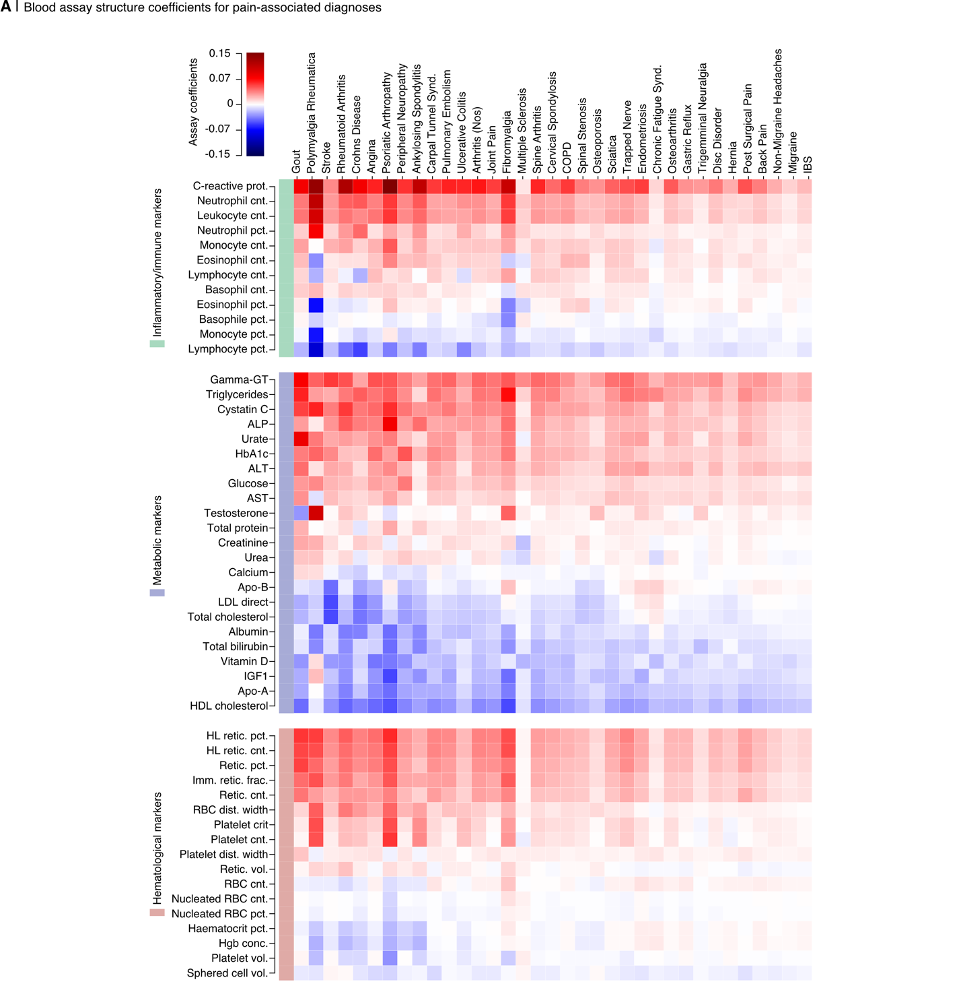
Supplementary Data Fig. 1: Blood assay structure coefficients for predictive models of diagnoses. Structure coefficients from logistic regression models, which were trained on blood assay data to predict pain-associated diagnoses, are displayed for each diagnosis. They are organized in descending order of their predictive accuracy (ROC-AUC) for each respective diagnosis and segmented into subcategories of inflammatory/immune markers, metabolic markers, or hematological markers. ALP, alkaline phosphatase; HbA1c, glycated hemoglobin, Glu, glucose; ALT, alanine aminotransferase; AST, aspartate aminotransferase; ApoB, apolipoprotein b; IGF1, insulin-like growth factor; LDL-C, low density lipoprotein cholesterol; HL, high light scatter; Retic, reticulocyte; Imm. retic. frac., immature reticulocyte fraction; PDW, platelet distribution width; RBC; red blood cell.

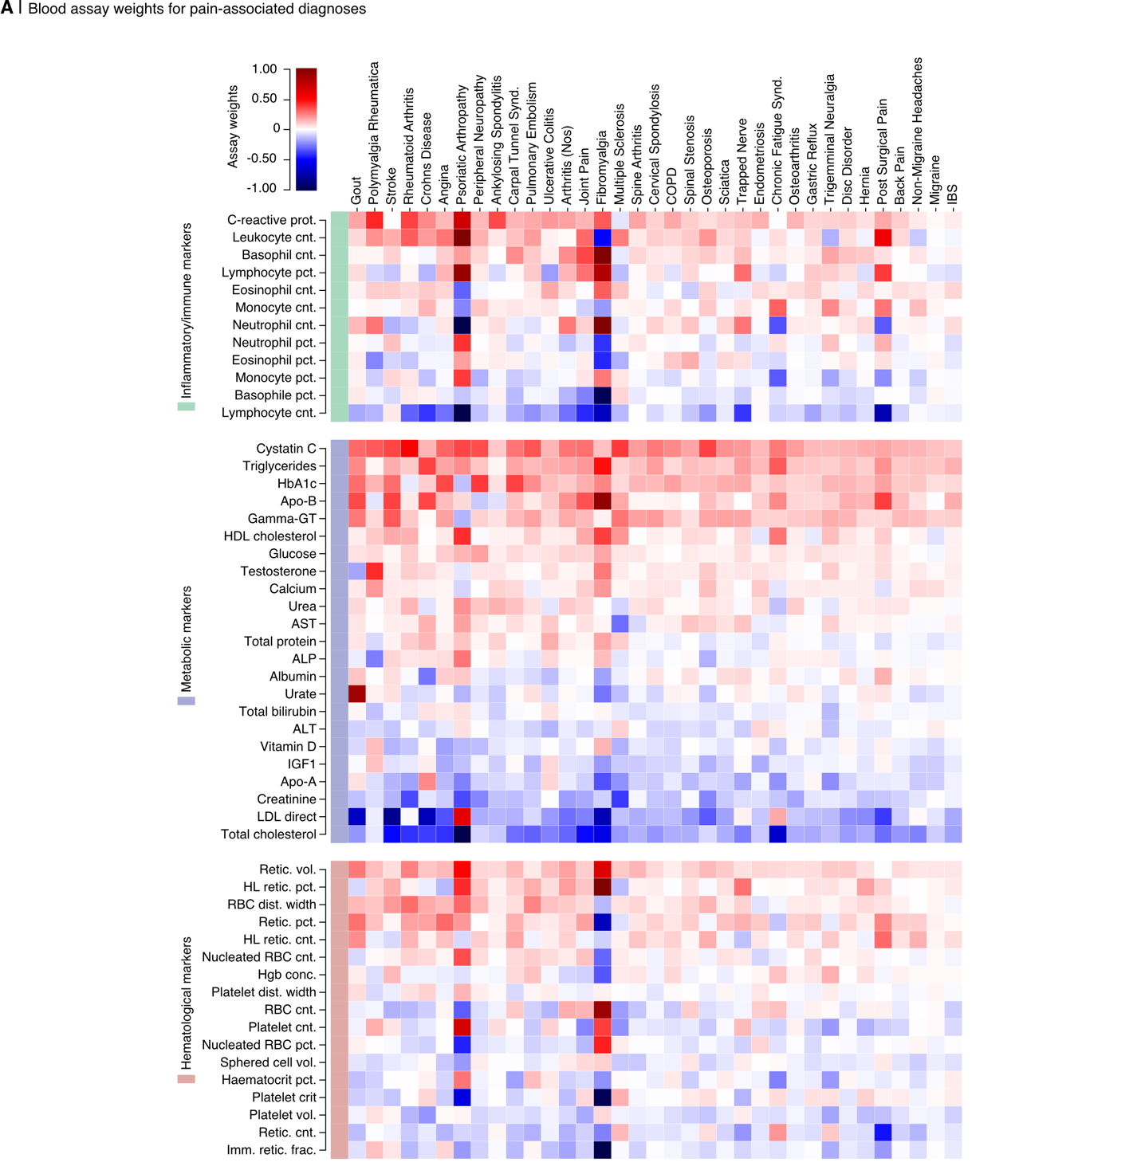

Supplementary Data Fig. 2: Blood assay weights for predictive models of diagnoses. Feature weights from logistic regression models, which were trained on blood assay data to predict pain-associated diagnoses, are displayed for each diagnosis. They are organized in descending order of their predictive accuracy (ROC-AUC) for each respective diagnosis and segmented into subcategories of inflammatory/immune markers, metabolic markers, or hematological markers. ALP, alkaline phosphatase; HbA1c, glycated hemoglobin, Glu, glucose; ALT, alanine aminotransferase; AST, aspartate aminotransferase; ApoB, apolipoprotein b; IGF1, insulin-like growth factor; LDL-C, low density lipoprotein cholesterol; HL, high light scatter; Retic, reticulocyte; Imm. retic. frac., immature reticulocyte fraction; PDW, platelet distribution width; RBC; red blood cell.
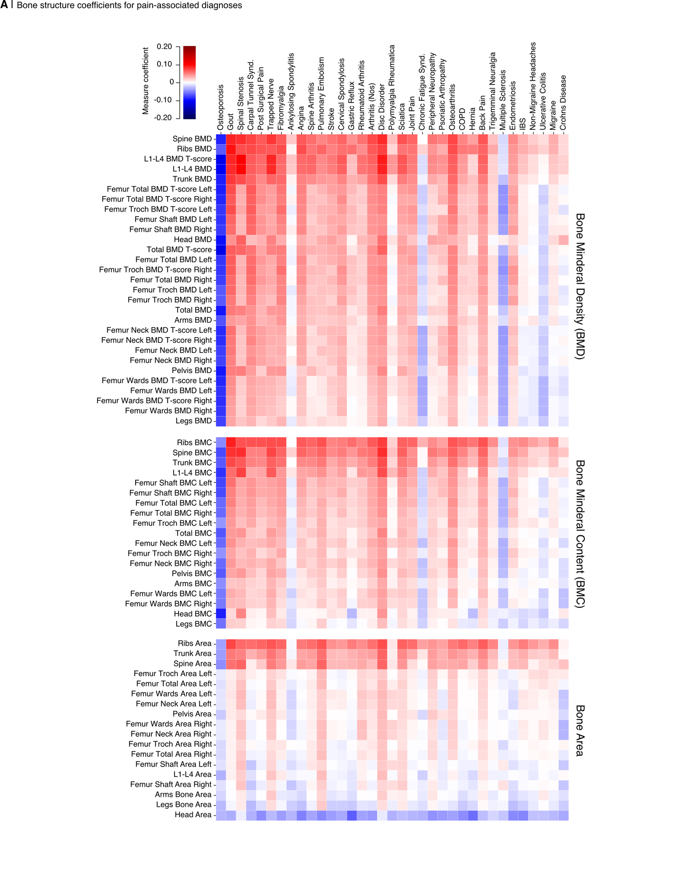

Supplementary Data Fig. 3: Structure coefficients of bone structure features for predictive models of diagnoses. Structure coefficients from logistic regression models, which were trained on Dual X-ray Absorptiometry (DXA) scan data to predict pain-associated diagnoses, are displayed. They are organized in descending order of their predictive accuracy (ROC-AUC) for each respective diagnosis.
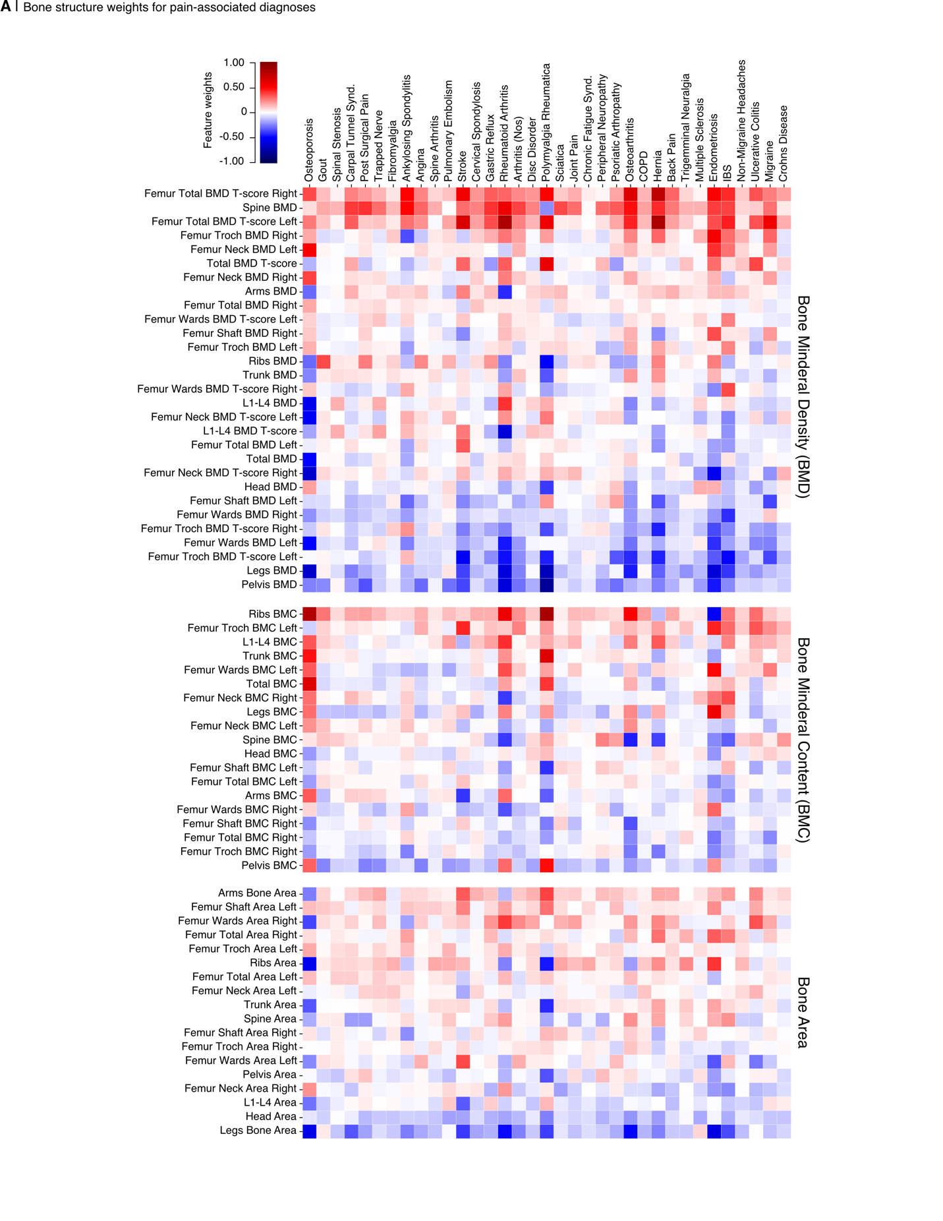

Supplementary Data Fig. 4: Bone structure weights for predictive models of diagnoses. Feature weights from logistic regression models, which were trained on Dual X-ray Absorptiometry (DXA) scan data to predict pain-associated diagnoses, are displayed. They are organized in descending order of their predictive accuracy (ROC-AUC) for each respective diagnosis.
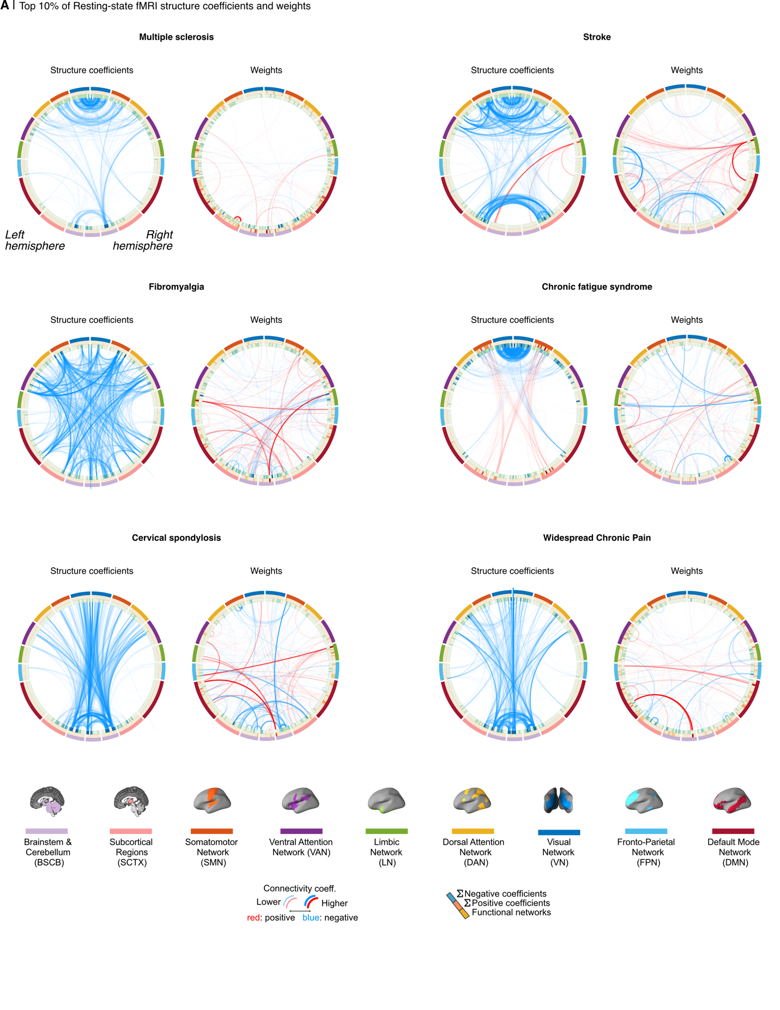 Supplementary Data Fig. 5: Resting-state fMRI structure coefficients and weights for top 5 predictive models of diagnoses and widespread chronic pain. Dynamic conditional correlation (DCC) functional connectivity structure coefficients and weights for brainnetome atlas parcels were derived from logistic regression models trained on resting-state fMRI features to classify pain-related diagnoses. The top five diagnoses with the highest ROC-AUC scores are highlighted, along with widespread chronic pain. In this context, coefficients indicate the unique impact of parcel-to-parcel connectivity on diagnostic predictions, while weights show the predictive strength and direction, adjusted for other model connections. Circos plots visualize the top 10% of influential connections as links between distinct parcels, categorized by resting-state network.
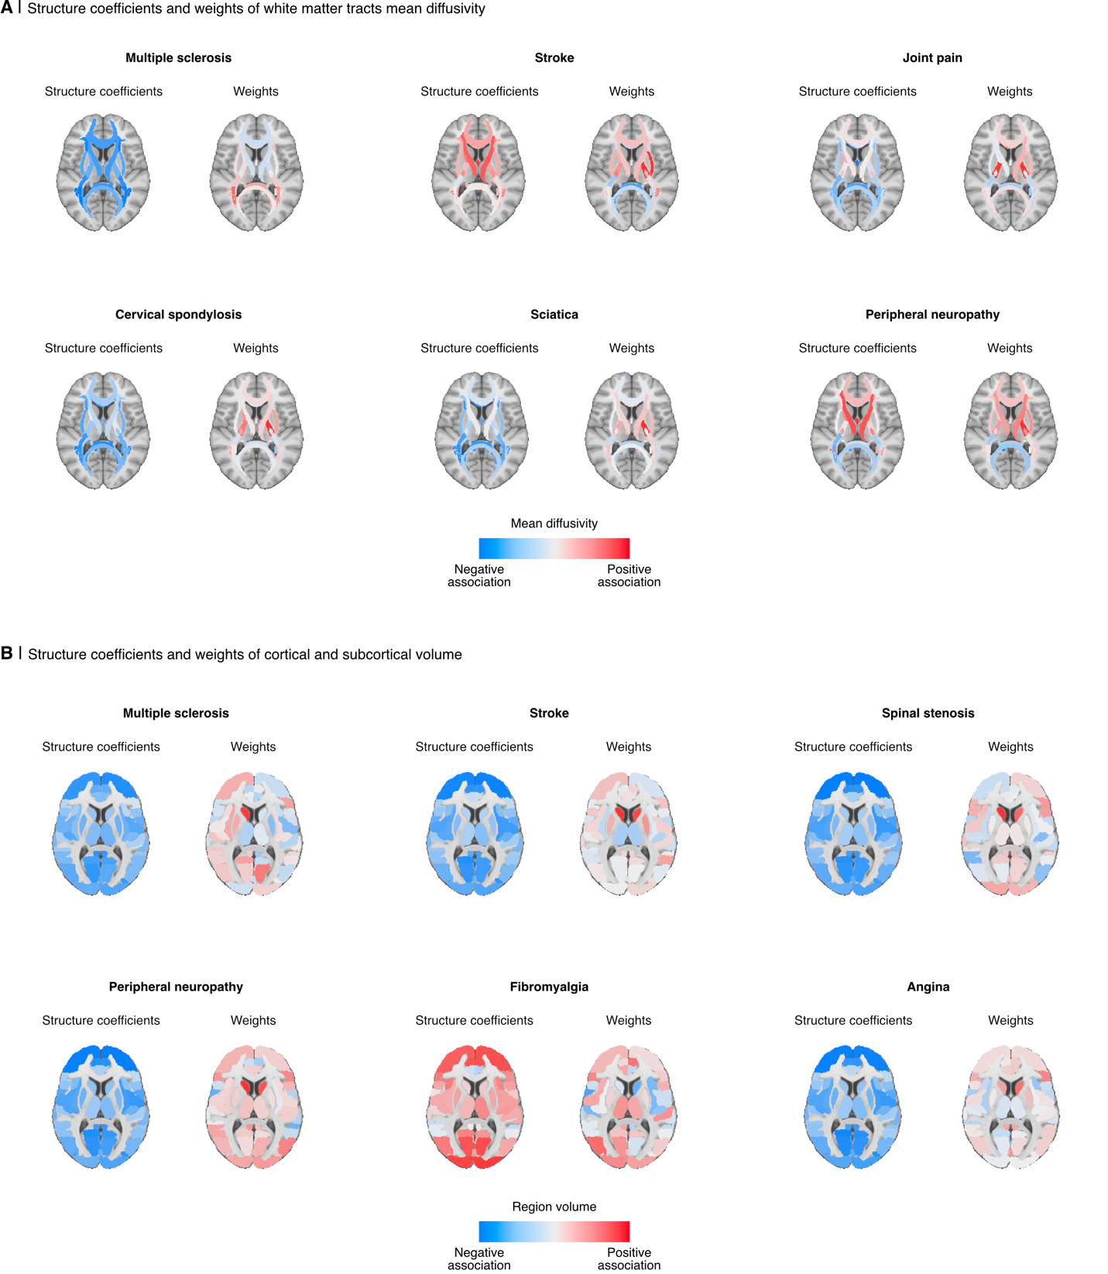 Supplementary Data Fig. 6: Diffusion and T1 imaging structure coefficients and weights for predictive models of diagnoses. A. Mean diffusivity structure coefficients and weights from white matter tracts were derived from logistic regression models using diffusion-weighted imaging features to classify pain-associated diagnoses. The six diagnoses yielding the highest ROC-AUC scores are presented, with their respective coefficient/weight values representing the impact of mean diffusivity within each tract on the predicted diagnosis. These values are mapped onto a white matter tract atlas superimposed on an MNI152 brain template. B. Similarly, structure coefficients and weights for cortical and subcortical volumes are displayed for the six diagnoses most accurately predicted using T1 structural brain imaging features. It is important to note that the features shown here represent a subset for clarity and do not encompass all the features utilized in the machine learning models. Specifically, mean diffusivity from diffusion weighted imaging and regional volumes from T1 imaging are highlighted for illustrative simplicity.
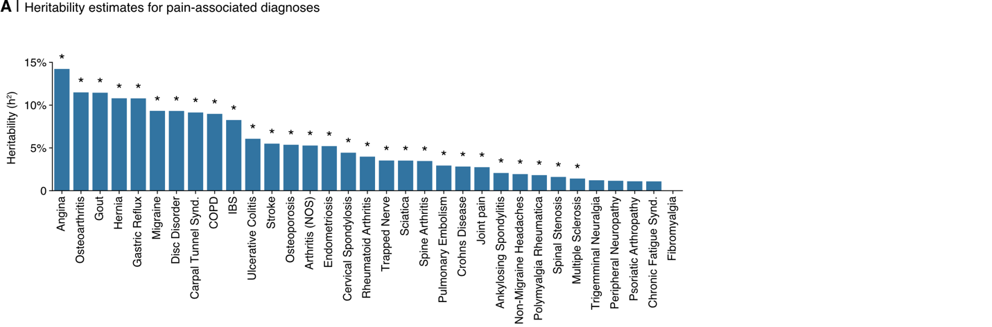 Supplementary Data Fig. 7: Heritability estimates from Genome-Wise Association Studies (GWAS) of pain-associated diagnoses. Narrow-sense heritability estimates obtained via LDSC (Linkage Disequilibrium Score Regression) from GWAS summary statistics are provided for each pain-associated diagnosis. Statistical significance is determined by P-FDR values less than 0.05.

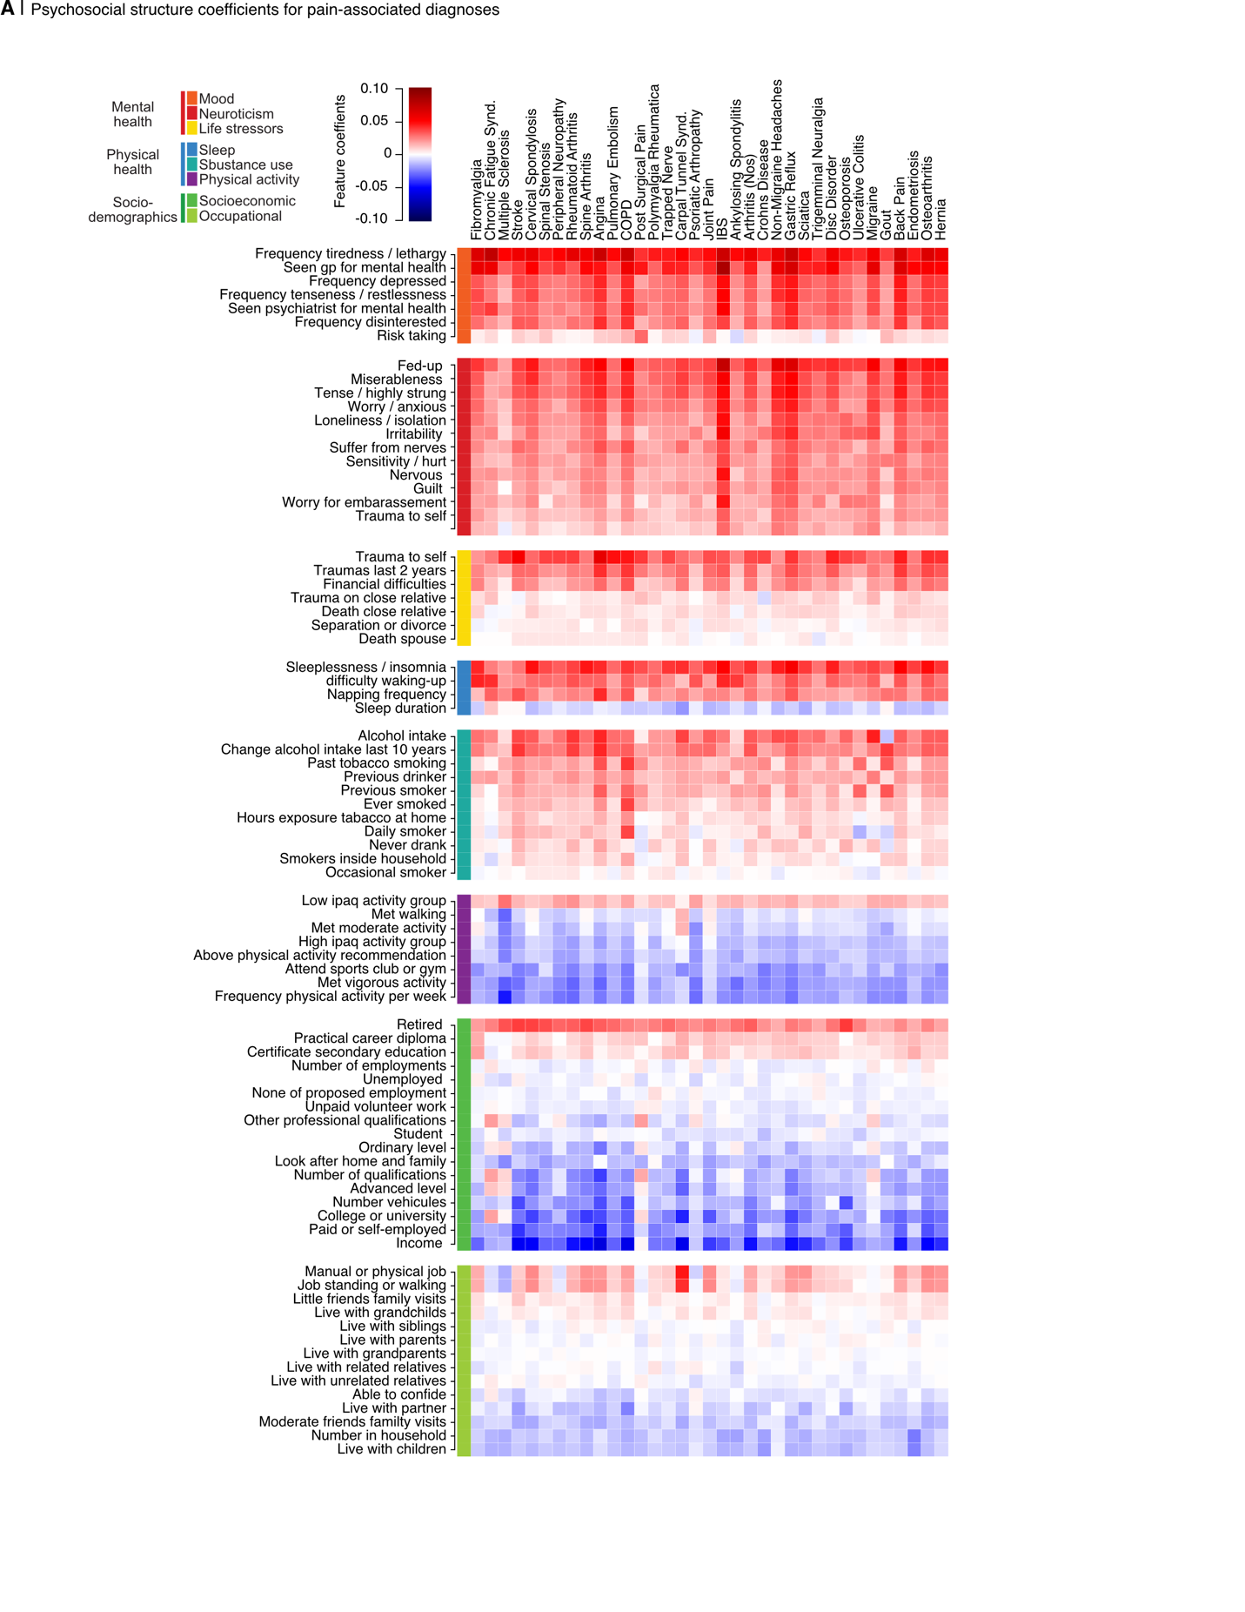
Supplementary Data Fig. 8: Psychosocial structure coefficients for predictive models of diagnoses. Feature weights from logistic regression models, which were trained on psychosocial variables to predict pain-associated diagnoses, are displayed for each diagnosis. They are organized in descending order of their predictive accuracy (ROC-AUC) for each respective diagnosis. IPAQ, International Physical Activity Questionnaire; MET, metabolic equivalent task.
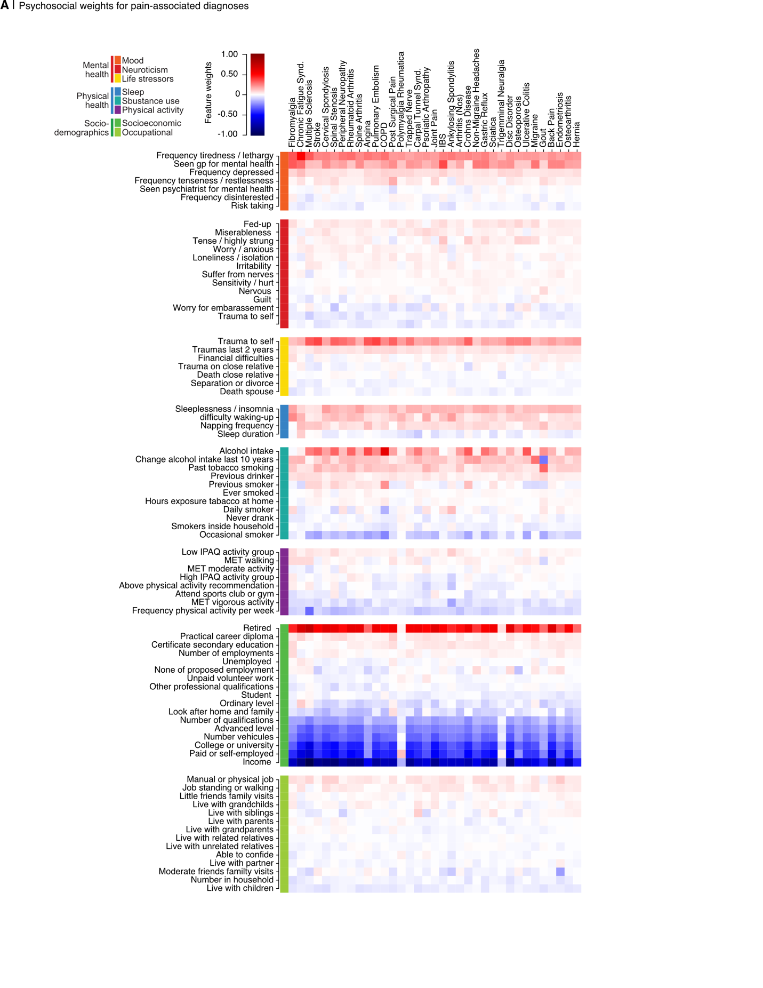
Supplementary Data Fig. 9: Psychosocial weights for predictive models of diagnoses. Feature weights from logistic regression models, which were trained on psychosocial variables to predict pain-associated diagnoses, are displayed for each diagnosis. They are organized in descending order of their predictive accuracy (ROC-AUC) for each respective diagnosis. IPAQ, International Physical Activity Questionnaire; MET, metabolic equivalent task.
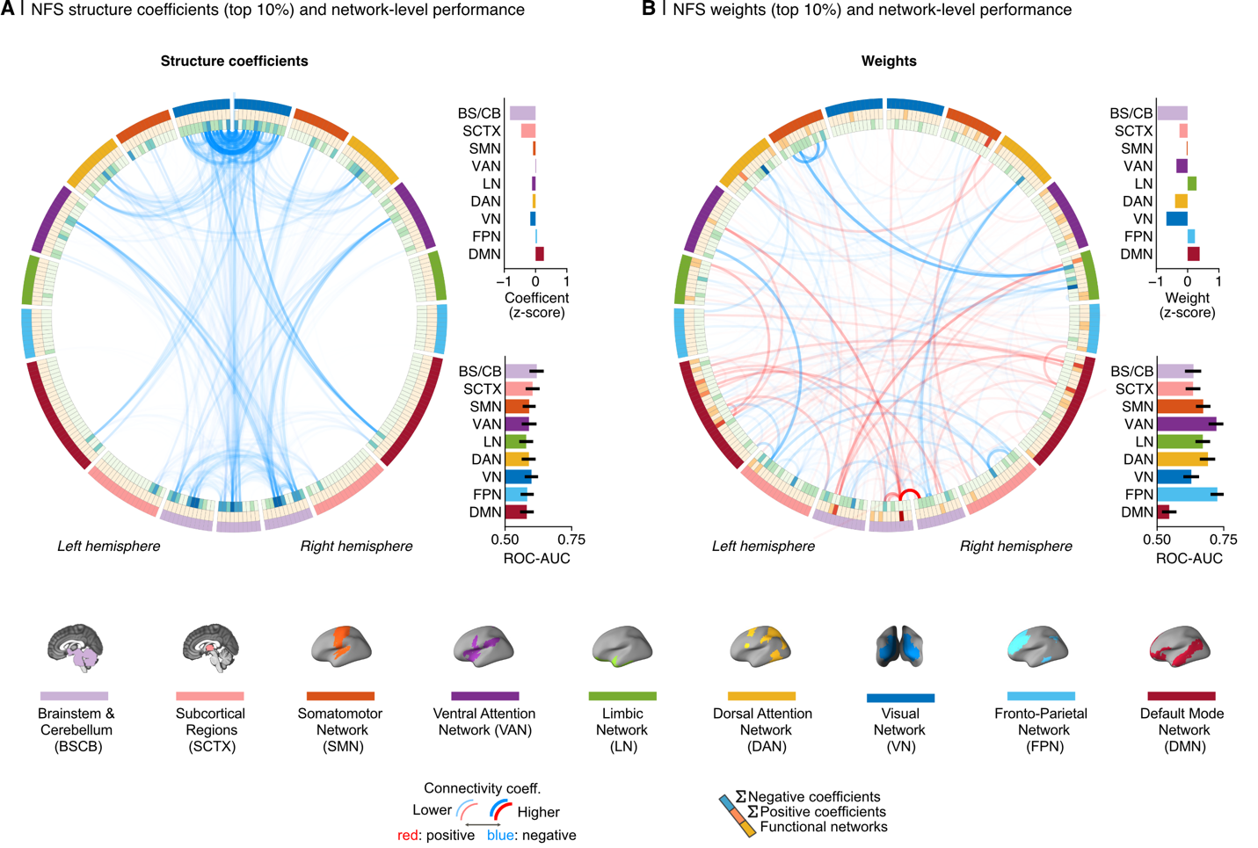
Supplementary Data Fig. 10: Functional connectivity structure coefficients and weights for the Nociplastic Functional Signature (NFS). A. Left: Circos plot illustrating the top 10% of connectivity links, as identified by structure coefficients from the NFS resting-state fMRI model, mapped across the canonical resting-state networks. Each cell represents a brain region of interest colored based on the density of positive (in red) and negative (in blue) edges. Top right: Average structure coefficient for edges within each resting state network, with values normalized across all edges. Bottom right: Classification performance of edges within each resting state network for distinguishing nociplastic conditions from diagnosis-free controls, based on coefficients from the full model. B. Same as A but using the logistic regression model weights instead of structure coefficients. Abbreviations: Brainstem and Cerebellum (BSCB); Somatosensory Network (SMN); Subcortex (SCTX); Ventral attention Network (VAN); Limbic Network (LN); Dorsal Attention Network (DAN); Visual Network (VN); Fronto-Parietal Network (FPN); Default Mode Network (DMN).

