Figure S1.

Figure S1. Cytotoxicity of CQ in HT-29 human colorectal cancer cell.
(A) And (B) Cytotoxicity of HT-29 human colorectal cancer cells treated with different concentrations of chloroquine (0µM, 10µM, 15µM, 20µM and 25µM) for 24 hour and 48 hour respectively. IC50 values for chloroquine (CQ) in HT-29 cancer cells was calculated using non-linear regression method in Graphpad prism software. *P ≤ 0.05, **P ≤ 0.01, ***P ≤ 0.001, and ****P ≤ 0.0001.

Figure S2.

Figure S2. CQ inhibits Proliferation of hypoxic HT-29 cells by targeting anaerobic glycolysis.
(A) And (B) Proliferation of HT-29 colorectal cancer cells under hypoxic conditions treated with 15µM of CQ for 24 hour and 48 hour respectively. (C) CQ induced changes in hypoxia mediated glucose consumption. (D) CQ induced reduction in extracellular lactate production by HT-29 cells during hypoxia. (E) Effect of CQ on Intracellular NAD+ level of HT-29 cancer cells during hypoxia. *P ≤ 0.05, **P ≤ 0.01, ***P ≤ 0.001, and ****P ≤ 0.0001.

Figure S3.
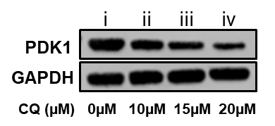
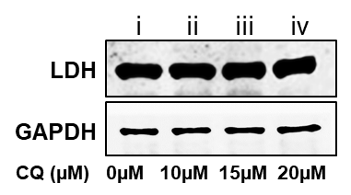
A)
B)

Figure S3. Effect of CQ on PDK1 in HT-29 cells and LDH of HCT-116 cells after CQ treatment.
- Western blot depicting reduction in PDK1 protein levels in HT-29 colorectal cancer cells after treatment with different concentrations of CQ for 24 hours.
- Western blot depicting reduction in LDH protein levels in HCT-116 colorectal cancer cells after treatment with different concentrations of CQ for 24 hours.

Figure S4.
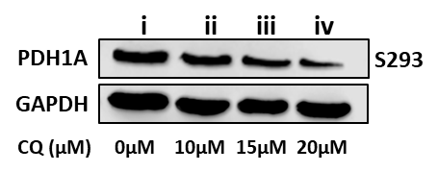

Figure S4. CQ mediated inhibition of PDK1 decrease phosphorylation of PDH1A in HCT-116 cells.
HCT-116 colorectal cancer cells were treated different concentration of CQ for 24 hours. Post 24 hours of treatment, phosphorylation at S293 residue of PDH1A was checked through western blotting with anti-PhosphoPDH1A(S293).

Figure S5.

Figure S5. Effect of CQ on purified PDK1 mobility in native-PAGE.
Purified recombinant human PDK1 was subjected to native-PAGE electrophoresis in absence or presence of 15µM and 20µM CQ.

Figure S6.

Figure S6.

Figure S6. Molecular Docking of CQ with LDH, PDK2, PDK3, and PDK4.
3D image of docked chloroquine, 2D map depicting interacting residues, nature of interactions and the binding energy of the complex.

