Supplementary Material
Morphological features
In this study, morphological features were extracted using PyRadiomics (version 3.1) (https://pyradiomics.readthedocs.io). V is the volume of the mesh in mm³, A is the surface area of the mesh in mm².
- Sphericity =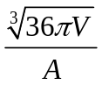. It is a measure of the roundness of the shape of the tumor region relative to a sphere. It is a dimensionless measure, independent of scale and orientation. The value range is 0<sphericity≤1, where a value of 1 indicates a perfect sphere (a sphere has the smallest possible surface area for a given volume, compared to other solids).
- Surface Area to Volume ratio =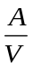. Here, a lower value indicates a more compact (sphere-like) shape. This feature is not dimensionless, and is therefore (partly) dependent on the volume of the ROI.
- Least Axis Length. This feature yield the smallest axis length of the ROI-enclosing ellipsoid and is calculated using the largest principal component . In case of a 2D segmentation, this value will be 0.
- Major Axis Length. This feature yield the largest axis length of the ROI-enclosing ellipsoid and is calculated using the largest principal component 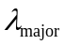. The principal component analysis is performed using the physical coordinates of the voxel centers defining the ROI. It therefore takes spacing into account, but does not make use of the shape mesh.
- Maximum 2D Diameter (Column). Maximum 2D diameter (Column) is defined as the largest pairwise Euclidean distance between tumor surface mesh vertices in the row-slice (usually the coronal) plane.
- Maximum 2D Diameter (Row). Maximum 2D diameter (Row) is defined as the largest pairwise Euclidean distance between tumor surface mesh vertices in the column-slice (usually the sagittal) plane.
- Maximum 2D Diameter (Slice). Maximum 2D diameter (Slice) is defined as the largest pairwise Euclidean distance between tumor surface mesh vertices in the row-column (generally the axial) plane.
- Maximum 3D diameter. Maximum 3D diameter is defined as the largest pairwise Euclidean distance between surface voxels in the ROI (Feret Diameter).
- Mesh Volume = 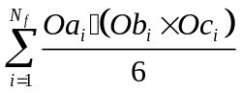. The volume of the ROI 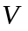 is calculated from the triangle mesh of the ROI. For each face i in the mesh, defined by points 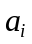, and , the (signed) volume 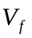of the tetrahedron defined by that face and the origin of the image (O) is calculated.
- Minor Axis Length. This feature yield the second-largest axis length of the ROI-enclosing ellipsoid and is calculated using the largest principal component 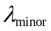. The principal component analysis is performed using the physical coordinates of the voxel centers defining the ROI. It therefore takes spacing into account, but does not make use of the shape mesh.
- Surface Area =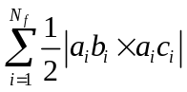. Surface Area is an approximation of the surface of the ROI in mm², calculated using a marching cubes algorithm, where N_{f} is the number of triangles forming the surface mesh of the volume (ROI), a_{i}b_{i} and a_{i}c_{i} are the edges of the i^{th} triangle formed by points a_{i}, b_{i} and c_{i.}
- Voxel Volume = 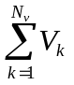. The volume of the ROI 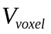 is approximated by multiplying the number of voxels in the ROI by the volume of a single voxel 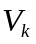.
- Elongation =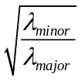. Here, λ_{major} and λ_{minor} are the lengths of the largest and second largest principal component axes. The values range between 1 (circle-like (non-elongated)) and 0 (single point or 1 dimensional line).
- Flatness = 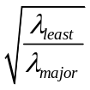. Here, λ_{major} and λ_{minor} are the lengths of the largest and smallest principal component axes. The values range between 1 (non-flat, sphere-like) and 0 (a flat object).

Table S1: TRIPOD Checklist: Prediction Model Development and Validation
Section/Topic | Item |  | Checklist Item | Page
Title and abstract
Title | 1 | D;V | Identify the study as developing and/or validating a multivariable prediction model, the target population, and the outcome to be predicted. | 1
Abstract | 2 | D;V | Provide a summary of objectives, study design, setting, participants, sample size, predictors, outcome, statistical analysis, results, and conclusions. | 2-3
Introduction
Background and objectives | 3a | D;V | Explain the medical context (including whether diagnostic or prognostic) and rationale for developing or validating the multivariable prediction model, including references to existing models. | 4
Background and objectives | 3b | D;V | Specify the objectives, including whether the study describes the development or validation of the model or both. | 4
Methods
Source of data | 4a | D;V | Describe the study design or source of data (e.g., randomized trial, cohort, or registry data), separately for the development and validation data sets, if applicable. | 5
Source of data | 4b | D;V | Specify the key study dates, including start of accrual; end of accrual; and, if applicable, end of follow-up. | 7-8
Participants | 5a | D;V | Specify key elements of the study setting (e.g., primary care, secondary care, general population) including number and location of centres. | 5
Participants | 5b | D;V | Describe eligibility criteria for participants. | 5-6
Participants | 5c | D;V | Give details of treatments received, if relevant. | 6
Outcome | 6a | D;V | Clearly define the outcome that is predicted by the prediction model, including how and when assessed. | 7-8
Outcome | 6b | D;V | Report any actions to blind assessment of the outcome to be predicted. | NA
Predictors | 7a | D;V | Clearly define all predictors used in developing or validating the multivariable prediction model, including how and when they were measured. | 11
Predictors | 7b | D;V | Report any actions to blind assessment of predictors for the outcome and other predictors. | NA
Sample size | 8 | D;V | Explain how the study size was arrived at. | 5
Missing data | 9 | D;V | Describe how missing data were handled (e.g., complete-case analysis, single imputation, multiple imputation) with details of any imputation method. | 6
Statistical analysis methods | 10a | D | Describe how predictors were handled in the analyses. | 8
Statistical analysis methods | 10b | D | Specify type of model, all model-building procedures (including any predictor selection), and method for internal validation. | 8-9
Statistical analysis methods | 10c | V | For validation, describe how the predictions were calculated. | 8
Statistical analysis methods | 10d | D;V | Specify all measures used to assess model performance and, if relevant, to compare multiple models. | 9
Statistical analysis methods | 10e | V | Describe any model updating (e.g., recalibration) arising from the validation, if done. | NA
Risk groups | 11 | D;V | Provide details on how risk groups were created, if done. | 9
Development vs. validation | 12 | V | For validation, identify any differences from the development data in setting, eligibility criteria, outcome, and predictors. | NA
Results
Participants | 13a | D;V | Describe the flow of participants through the study, including the number of participants with and without the outcome and, if applicable, a summary of the follow-up time. A diagram may be helpful. | 6
Participants | 13b | D;V | Describe the characteristics of the participants (basic demographics, clinical features, available predictors), including the number of participants with missing data for predictors and outcome. | 10,12-13
Participants | 13c | V | For validation, show a comparison with the development data of the distribution of important variables (demographics, predictors and outcome). | 10
Model development | 14a | D | Specify the number of participants and outcome events in each analysis. | 10
Model development | 14b | D | If done, report the unadjusted association between each candidate predictor and outcome. | NA
Model specification | 15a | D | Present the full prediction model to allow predictions for individuals (i.e., all regression coefficients, and model intercept or baseline survival at a given time point). | 9, 23
Model specification | 15b | D | Explain how to the use the prediction model. | 23
Model performance | 16 | D;V | Report performance measures (with CIs) for the prediction model. | 11-12
Model-updating | 17 | V | If done, report the results from any model updating (i.e., model specification, model performance). | NA
Discussion
Limitations | 18 | D;V | Discuss any limitations of the study (such as nonrepresentative sample, few events per predictor, missing data). | 15-16
Interpretation | 19a | V | For validation, discuss the results with reference to performance in the development data, and any other validation data. | 13-14
Interpretation | 19b | D;V | Give an overall interpretation of the results, considering objectives, limitations, results from similar studies, and other relevant evidence. | 13-14
Implications | 20 | D;V | Discuss the potential clinical use of the model and implications for future research. | 15
Other information
Supplementary information | 21 | D;V | Provide information about the availability of supplementary resources, such as study protocol, Web calculator, and data sets. | In supplementary material
Funding | 22 | D;V | Give the source of funding and the role of the funders for the present study. | In Cover letter

Table S2: MRI Acquisition Parameters of Four Centers
 | Center A | Center B | Center C | Center D
Scanner | Siemens 3.0 T (Prisma) | Siemens 1.5 T (Avanto) | Siemens 3.0 T (Spectra) | 1.5 or 3.0 T scanners
Sequence | CS-VIBE | VIBE | VIBE | Gradient echo
TR/TE (ms) | 4.5/1.6 | 4.65/1.74 | 5.4/1.1 | 4-10/Minimum
FOV (mm) | 360×292 | 340×340 | 360×360 | 260×360
Matrix | 384×384 | 307×384 | 300×300 | 384×512
Slice Thickness (mm) | 2.5 | 1.7 | 1.2 | ≤ 2.5 mm
Slice Gap (mm) | 0.3 | 0.34 | 0.3 | NA
Note.—The center D dataset is sourced from the ISPY-2 of The Cancer Imaging Archive (TCIA). FOV = field of view, TR = repetition time, TE = echo time, No. = number, ms = millisecond, mm = millimeter.

Table S3: Reproducibility of Fractal Analyses for Reader 1 at the First and Second Study
Fractal analyses | Fractal dimensions | Mean  difference* | Bland-Altman limits |  | Repeatability  coefficient  (95% CI) | Variance components |  | COV between readings (%) | COV between patients (%)
Fractal analyses | Fractal dimensions | Mean  difference* | Lower (95% CI) | Upper (95% CI) | Repeatability  coefficient  (95% CI) | Between readings | Between patients | COV between readings (%) | COV between patients (%)
2D | Max FD | 0.02 (0.31) | -0.17 (-0.23, -0.11) | 0.20 (0.14, 0.26) | 0.19 (0.14, 0.24) | 0.0007 | 0.0184 | 6.78 | 467.87
2D | Median FD | -0.01 (0.14) | -0.13 (-0.17, -0.09) | 0.10 (0.06, 0.14) | 0.11 (0.10, 0.13) | 0.0003 | 0.0169 | 3.21 | 427.42
2D | Min FD | 0.02 (0.16) | -0.11 (-0.15, -0.07) | 0.15 (0.10, 0.19) | 0.13 (0.09, 0.17) | 0.0009 | 0.0172 | 3.41 | 377.94
2D | Mean FD | 0.02 (0.12) | -0.12 (-0.16, -0.07) | 0.15 (0.11, 0.20) | 0.14 (0.11, 0.17) | 0.0019 | 0.0178 | 4.02 | 369.28
3D | Global FD | -0.02 (0.16) | -0.17 (-0.22, -0.12) | 0.13 (0.08, 0.18) | 0.16 (0.11, 0.20) | 0.0001 | 0.0195 | 2.65 | 486.94
Note. —CI = confidence interval, COV = coefficient of variation, FD = fractal dimension.
*Data in parentheses are P values (Wilcoxon test).

Table S4: Interobserver Agreement for Fractal Analyses for Readers 1 and 2
Fractal analyses | Fractal dimensions | Reader 1  (first study) | Reader 1  (second study) | Reader 2  (first study) | ICC (95% CI)
2D | Max FD | 1.44 ± 0.14 | 1.43 ± 0.12 | 1.43 ± 0.11 | 0.83 (0.76, 0.91)
2D | Median FD | 1.36 ± 0.14 | 1.37 ± 0.12 | 1.38 ± 0.15 | 0.82 (0.69, 0.88)
2D | Min FD | 1.10 ± 0.15 | 1.09 ± 0.16 | 1.09 ± 0.14 | 0.79 (0.61, 0.86)
2D | Mean FD | 1.33 ± 0.14 | 1.31 ± 0.11 | 1.31 ± 0.12 | 0.82 (0.73, 0.87)
3D | Global FD | 2.11 ± 0.15 | 2.13 ± 0.15 | 2.13 ± 0.14 | 0.89 (0.77, 0.93)
Note. —FD = fractal dimension, CI = confidence interval, ICC = intraclass correlation coefficient.

Table S5: Spearman Correlation Analysis Between FD and Clinical Characteristics
FD | Characteristics | Training cohort |  | External validation cohort 1 |  | External validation cohort 2
FD | Characteristics | Correlation coefficient | P Value | Correlation coefficient | P Value | Correlation coefficient | P Value
Max FD | Age | -0.081 | 0.090 | 0.100 | 0.062 | -0.043 | 0.445
Median FD | Age | -0.066 | 0.172 | 0.088 | 0.101 | -0.069 | 0.216
Min FD | Age | -0.055 | 0.255 | 0.051 | 0.336 | -0.099 | 0.074
Mean FD | Age | -0.075 | 0.120 | 0.093 | 0.083 | -0.079 | 0.158
Global FD | Age | -0.083 | 0.084 | 0.078 | 0.144 | -0.017 | 0.764
Max FD | Menopausal | -0.061 | 0.205 | 0.085 | 0.114 | -0.012 | 0.837
Median FD | Menopausal | -0.044 | 0.356 | 0.082 | 0.127 | -0.045 | 0.416
Min FD | Menopausal | -0.015 | 0.753 | -0.001 | 0.982 | -0.120 | 0.061
Mean FD | Menopausal | -0.041 | 0.397 | -0.078 | 0.147 | -0.063 | 0.257
Global FD | Menopausal | 0.014 | 0.771 | 0.096 | 0.072 | 0.004 | 0.937
Max FD | HR | 0.044 | 0.362 | 0.125 | 0.019 | 0.056 | 0.317
Median FD | HR | 0.025 | 0.607 | 0.156 | 0.003 | -0.055 | 0.328
Min FD | HR | 0.094 | 0.049 | 0.142 | 0.068 | 0.065 | 0.241
Mean FD | HR | 0.049 | 0.304 | 0.158 | 0.003 | 0.059 | 0.287
Global FD | HR | 0.140 | 0.003 | 0.049 | 0.364 | 0.017 | 0.760
Max FD | HER2 | -0.056 | 0.240 | -0.010 | 0.049 | -0.040 | 0.477
Median FD | HER2 | -0.046 | 0.334 | -0.072 | 0.180 | -0.015 | 0.788
Min FD | HER2 | -0.007 | 0.892 | 0.043 | 0.421 | 0.003 | 0.957
Mean FD | HER2 | -0.050 | 0.302 | -0.053 | 0.323 | -0.025 | 0.660
Global FD | HER2 | -0.115 | 0.016 | -0.013 | 0.041 | -0.090 | 0.041
Max FD | Ki67 | -0.074 | 0.124 | 0.143 | 0.007 | / | /
Median FD | Ki67 | -0.037 | 0.443 | 0.175 | 0.001 | / | /
Min FD | Ki67 | -0.026 | 0.584 | 0.048 | 0.367 | / | /
Mean FD | Ki67 | -0.055 | 0.254 | 0.150 | 0.005 | / | /
Global FD | Ki67 | -0.062 | 0.195 | 0.067 | 0.208 | / | /
Max FD | Clinical T stage | 0.335 | 0.000 | / | / | / | /
Median FD | Clinical T stage | 0.327 | 0.000 | / | / | / | /
Min FD | Clinical T stage | 0.222 | 0.000 | / | / | / | /
Mean FD | Clinical T stage | 0.333 | 0.000 | / | / | / | /
Global FD | Clinical T stage | 0.252 | 0.000 | / | / | / | /
Max FD | Clinical N stage | 0.017 | 0.725 | / | / | / | /
Median FD | Clinical N stage | 0.014 | 0.766 | / | / | / | /
Min FD | Clinical N stage | -0.004 | 0.934 | / | / | / | /
Mean FD | Clinical N stage | 0.010 | 0.836 | / | / | / | /
Global FD | Clinical N stage | 0.089 | 0.063 | / | / | / | /
Note.—FD = fractal dimension, HER2 = human epidermal growth factor receptor2, HR = hormone receptor.

Table S6: Spearman Correlation Analysis of Pairwise Comparisons in FD
FD | Characteristics | Training cohort |  | External validation cohort 1 |  | External validation cohort 2
FD | Characteristics | Correlation coefficient | P Value | Correlation coefficient | P Value | Correlation coefficient | P Value
Max FD | Median FD | 0.937 | < 0.001 | 0.938 | < 0.001 | 0.924 | < 0.001
Max FD | Min FD | 0.474 | < 0.001 | 0.614 | < 0.001 | 0.624 | < 0.001
Max FD | Mean FD | 0.928 | < 0.001 | 0.938 | < 0.001 | 0.921 | < 0.001
Max FD | Global FD | 0.756 | < 0.001 | 0.797 | < 0.001 | 0.710 | < 0.001
Median FD | Min FD | 0.591 | < 0.001 | 0.724 | < 0.001 | 0.725 | < 0.001
Median FD | Mean FD | 0.982 | < 0.001 | 0.986 | < 0.001 | 0.980 | < 0.001
Median FD | Global FD | 0.750 | < 0.001 | 0.806 | < 0.001 | 0.711 | < 0.001
Min FD | Mean FD | 0.682 | < 0.001 | 0.793 | < 0.001 | 0.808 | < 0.001
Min FD | Global FD | 0.407 | < 0.001 | 0.525 | < 0.001 | 0.414 | < 0.001
Mean FD | Global FD | 0.753 | < 0.001 | 0.794 | < 0.001 | 0.691 | < 0.001
Note.—FD = fractal dimension, HER2 = human epidermal growth factor receptor2, HR = hormone receptor.

Table S7: Univariable and Multivariable Logistic Regression Analysis of Clinicopathological and morphological Features Associated with pCR in the Training Cohort
Characteristics | Univariable | P Value |  | Multivariable | P Value
Characteristics | Odds Ratio (95% CI) | P Value |  | Odds Ratio (95% CI)
Age | 0.90 (0.73, 1.12) | .35
Menopausal
Premenopausal | Reference
Postmenopausal | 0.96 (0.62, 1.49) | .86
HR status
Negative | Reference |  |  | Reference
Positive | 0.20 (0.13, 0.31) | < .001 |  | 0.20 (0.12, 0.35) | < 0.001
HER2 status
Negative | Reference |  |  | Reference
Positive | 3.54 (2.27, 5.52) | < .001 |  | 3.95 (2.33, 6.69) | < 0.001
Ki-67 status
Low | Reference |  |  | Reference
High | 2.85 (1.37, 5.94) | .01 |  | 1.97 (0.83, 4.71) | .13
Clinical T stage
cT1 | Reference |  |  | Reference
cT2 | 1.57 (1.02, 2.41) | .04 |  | 1.53 (0.58, 4.03) | .39
cT3 | 0.81 (0.45, 1.46) | .05 |  | 1.11 (0.36, 3.46) | .86
cT4 | 0.59 (0.36, 0.98) | .04 |  | 1.03 (0.34, 3.06) | .96
Clinical N stage
cN0 | Reference
cN1 | 1.38 (0.89, 2.15) | .15
cN2 | 1.01 (0.65, 1.58) | .95
cN3 | 0.67 (0.36, 1.24) | .20
Morphological features
Sphericity | 1.26 (1.01, 1.58) | .02 |  | 4.03 (1.86, 8.71) | < .001
Surface Area to Volume ratio | 1.46 (1.01, 1.80) | .03 |  | 8.79 (0.8, 15.86) | .72
Least Axis Length | 0.72 (0.57, 0.91) | .0.01 |  | 0.96 (0.93, 1.23) | .46
Major Axis Length | 0.68 (0.54, 0.87) | .002 |  | 0.38 (0.25, 0.41) | 0.004
Maximum 2D Diameter (Column) | 0.64 (0.50, 0.81) | < 0.001 |  | 0.95 (0.88, 1.01) | .70
Maximum 2D Diameter (Row) | 0.78 (0.62, 0.99) | .02 |  | 0.40 (0.23, 0.68) | 0.001
Maximum 2D Diameter (Slice) | 0.69 (0.55, 0.88) | .002 |  | 1.00 (0.95, 1.06) | .61
Maximum 3D Diameter | 0.70 (0.56, 0.89) | .003 |  | 0.98 (0.91, 1.05) | .48
Mesh Volume | 0.73 (0.53, 0.99) | .04 |  | 1.00 (0.95, 1.12) | .38
Minor Axis Length | 0.66 (0.52, 0.85) | .001 |  | 0.99 (0.89, 1.89) | .76
Surface Area | 0.71 (0.53, 0.95) | .02 |  | 1.02 (0.78, 1.53) | .48
Voxel Volume | 0.73 (0.53, 0.98) | .06
Elongation | 0.92 (0.75, 1.14) | .47
Flatness | 1.00 (0.81, 1.24) | .99
Note.—Data in parentheses are 95% CIs. CI = confidence interval, HER2 = human epidermal growth factor receptor2, HR = hormone receptor, pCR = pathologic complete response.

Table S8: Comparison of Delong test for AUCs of Different Models
Cohorts | Models | △AUC | P Value
TC | Nomogram model-1 vs. Global FD | 0.08 | < 0.001
TC | Nomogram model -2 vs. Morphological model | 0.17 | < 0.001
TC | Global FD vs. Morphological model | 0.14 | < 0.001
TC | Nomogram model -1 vs. Nomogram model -2 | 0.05 | < 0.001
EVC-1 | Nomogram model-1 vs. Global FD | 0.07 | 0.01
EVC-1 | Nomogram model -2 vs. Morphological model | 0.13 | 0.001
EVC-1 | Global FD vs. Morphological model | 0.12 | < 0.001
EVC-1 | Nomogram model -1 vs. Nomogram model -2 | 0.06 | < 0.001
EVC-2 | Nomogram model-1 vs. Global FD | 0.06 | 0.02
EVC-2 | Nomogram model -2 vs. Morphological model | 0.14 | < 0.001
EVC-2 | Global FD vs. Morphological model | 0.13 | < 0.001
EVC-2 | Nomogram model -1 vs. Nomogram model -2 | 0.05 | < 0.001
Note. —Nomogram model-1 (combining hormone receptor, human epidermal growth factor receptor-2 and global FD), nomogram model-2 (combining hormone receptor, human epidermal growth factor receptor-2, sphericity, major axis length and maximum 2D diameter [row]). FD = fractal dimension, HER2 = human epidermal growth factor receptor2, HR = hormone receptor, ICC = intraclass correlation coefficient, TC = training cohort, EVC 1 = external validation cohort 1, EVC 2 = external validation cohort 2.

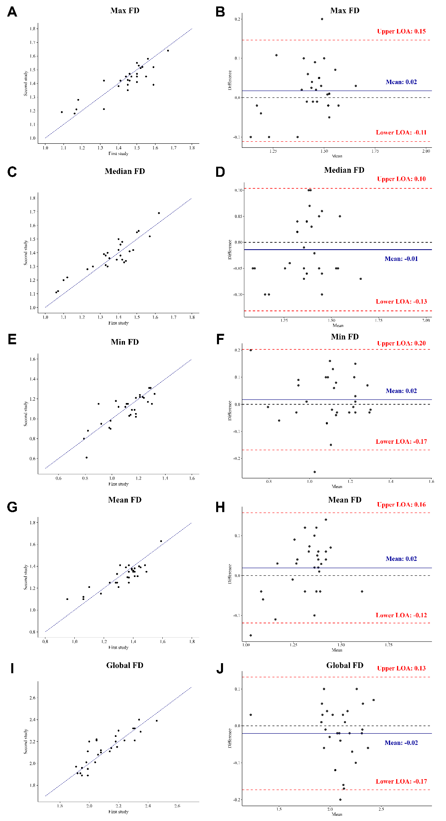
Figure S1: Reproducibility of fractal analyses for Reader 1 at two studies. Scatterplots of (A) max FD, (C) median FD, (E) min FD, (G) mean FD, (I) global FD. Bland-Altman plots of (B) max FD, (D) median FD, (F) min FD, (H) mean FD, (J) global FD. FD = fractal dimension, LOA = limits of agreement.

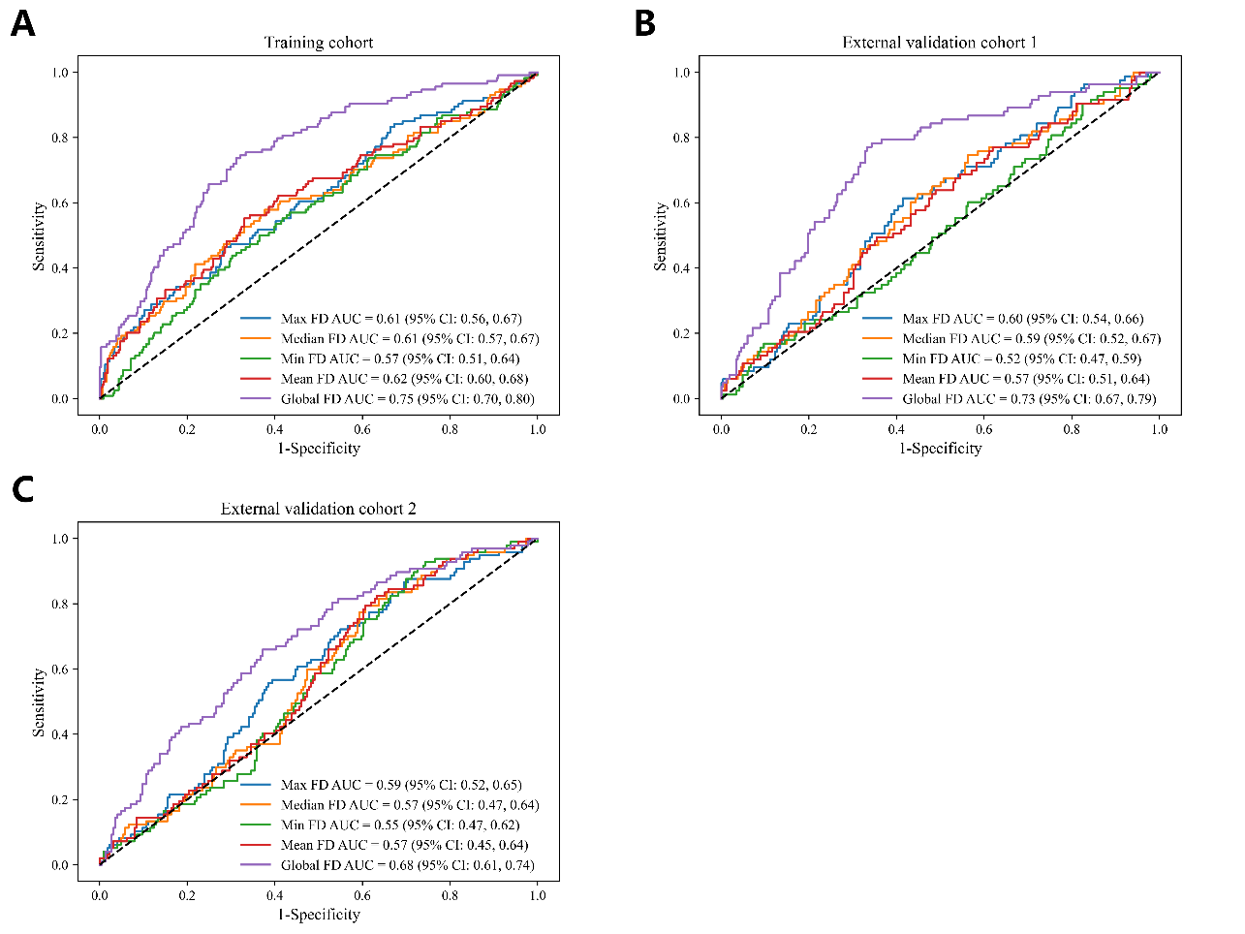
Figure S2: Predictive Performance of FDs in different cohorts. Receiver operating characteristic curves of the (A) training cohort, (B) External validation cohort 1, (C) External validation cohort 2. AUC = area under the receiver operating characteristic curve, CI = confidence interval, FD = fractal dimension.

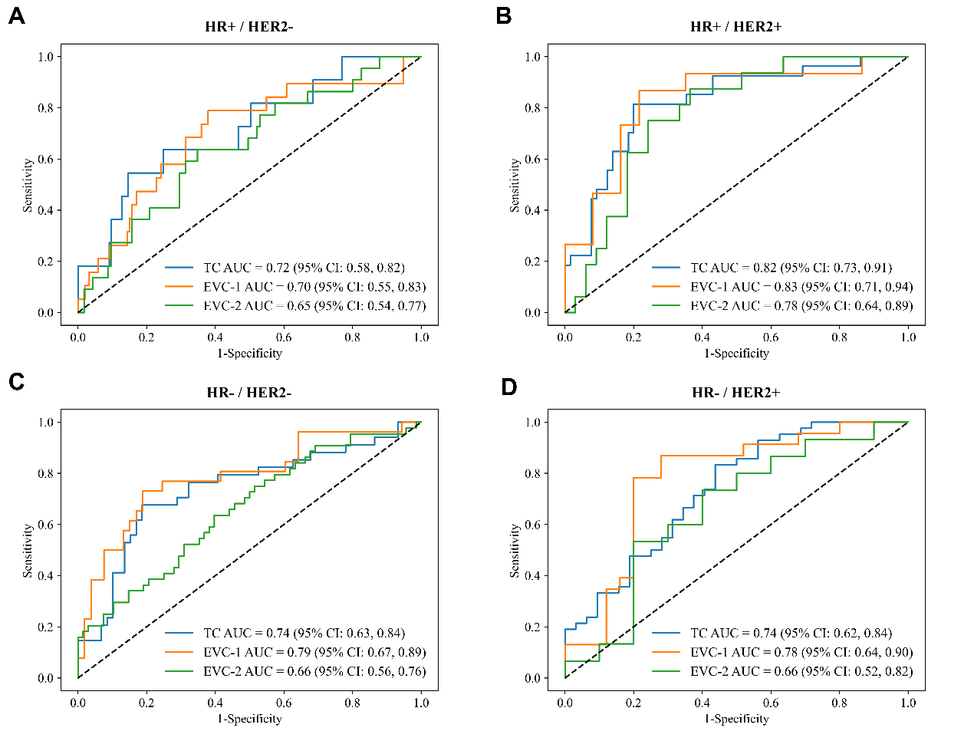
Figure S3: Performance of global FD in patient subgroups stratified according to molecular subtype. Receiver operating characteristic curves of global FD for (A) HR+/HER2-, (B) HR+/HER2+, (C) HR-/HER2-, (D) HR-/HER2+. AUC = area under the receiver operating characteristic curve, CI = confidence interval, EVC-1 = external validation cohort 1, EVC-2 = external validation cohort 2, HER2 = human epidermal growth factor receptor2, HR = hormone receptor. TC = training cohort.

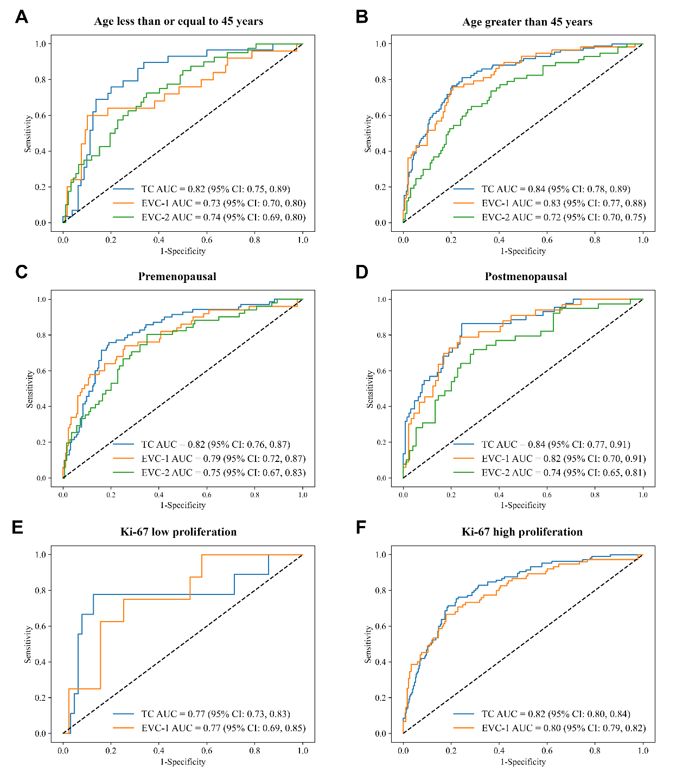
Figure S4: Performance of the models in patient subgroups in different cohorts. Receiver operating characteristic curves of nomogram model-1 (incorporates hormone receptor, human epidermal growth factor receptor-2 and global FD) for (A) age less than or equal to 45 years, (B) age greater than 45 years, (C) premenopausal status, (D) postmenopausal status, (E) Ki-67 low proliferation, (F) Ki-67 high proliferation. AUC = area under the receiver operating characteristic curve, CI = confidence interval, EVC-1 = external validation cohort 1, EVC-2 = external validation cohort 2, TC = training cohort.

