Extended Data Figures
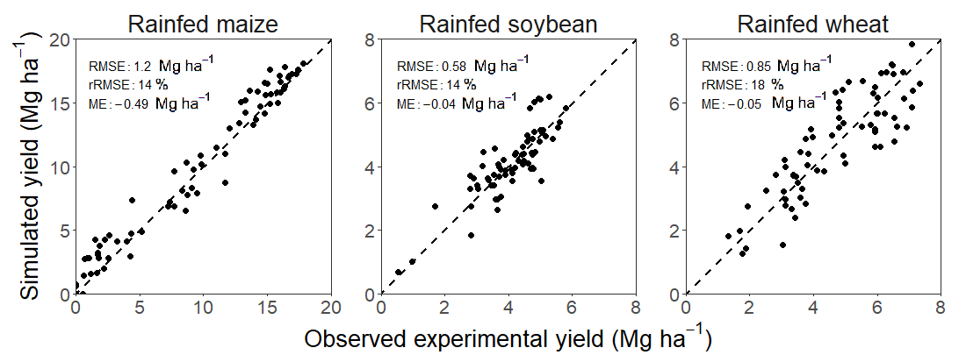
Extended data Figure 1. Evaluation of crop simulation models used in the present study. Simulated yield potential plotted against measured yields in well-managed experiments conducted across a wide range of environments. Details are provided elsewhere ^{33,54,59,60}. Root mean square error (RMSE), relative RMSE as percentage of the average measured yield (rRMSE, in %), and mean error (ME, Mg ha⁻¹) are indicated. Diagonal line indicates y = x.

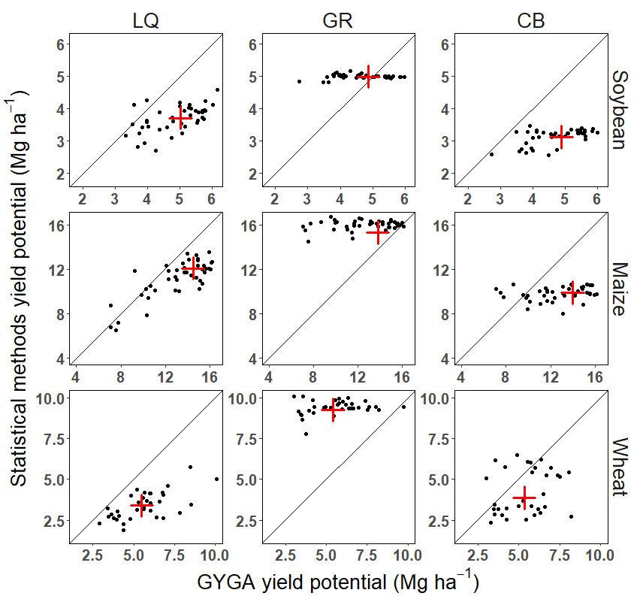
Extended Data Figure 2. Comparison of water-limited yield potential derived from the Global Yield Gap Atlas (GYGA) versus statistical approaches. Methods to estimate yield potential include bottom-up approach of GYGA based on well-validated crop models and high-quality weather and soil data, quantile regression based on local averaged farmer yield (LQ), Ya distribution across a large geographic region (GR), and Ya distribution within global climate bins (CB). Each datapoint represents the average yield potential estimated at each site following each method. Red crosses represent the weighted US average according to the crop area at each site. Diagonal line indicates y = x.

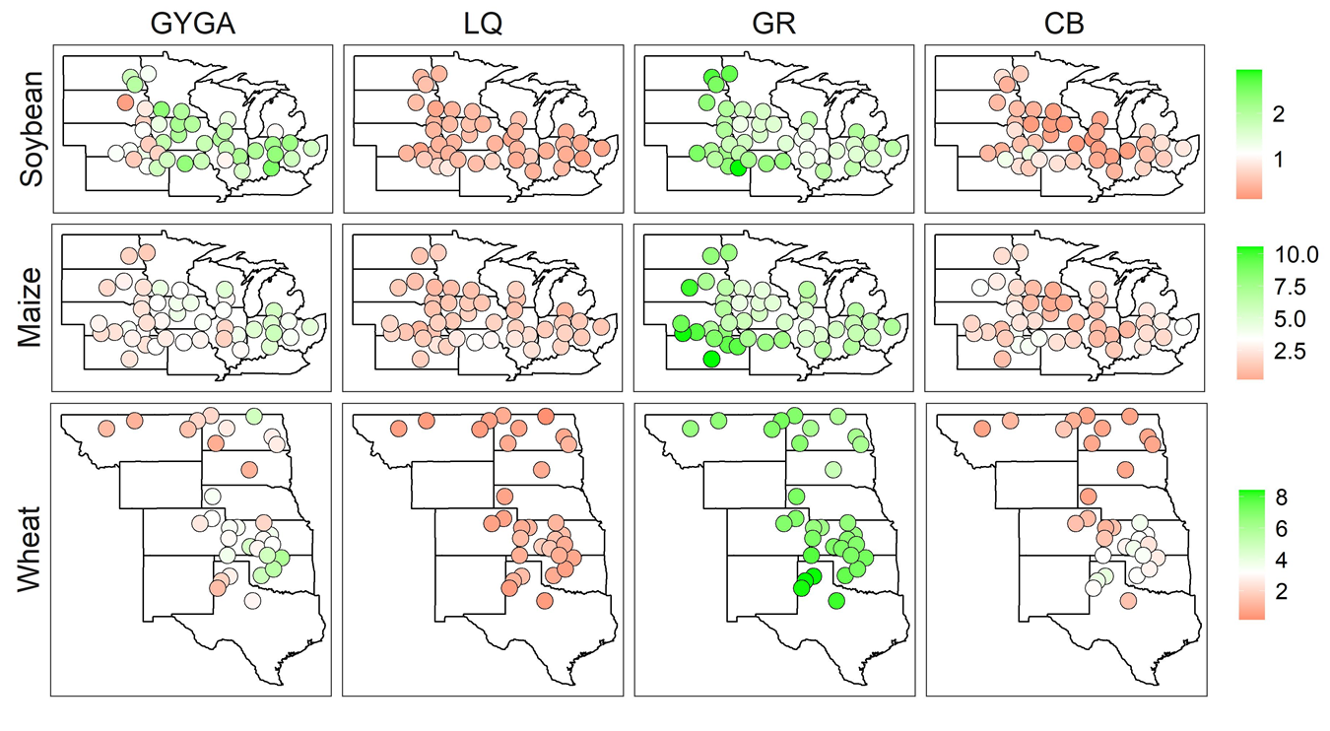
Extended Data Figure 3. Average yield gaps (Mg ha⁻¹) for rainfed soybean, maize and wheat as estimated using different methods. Methods to estimate yield potential include the bottom-up modeling approach of the Global Yield Gap Atlas (GYGA) based on well-validated crop models and high-quality weather and soil data, quantile regression based on local averaged farmer yield (LQ), Ya distribution across a large geographic region (GR), and Ya distribution within global climate bins (CB). The yield gap was estimated as the differences between average yield potential and average farmer yield. Each circle represents the average long-term yield gap at each site as estimated by each method.

Supplementary information

Supplementary Table S1. Summary of the data used to compare different approaches to estimate water-limited yield potential (Yw), average actual yield (Ya), and yield gaps (Yg) in the present study. Methods include: the bottom-up approach of the Global Yield Gap Atlas (GYGA), quantile regression based on long-term Ya (LQ), Ya distribution across a large geographic region (GR), and Ya distribution across a global climate bins (CB).
 | GYGA | LQ | GR | CB
Approach to estimate Yw | Well-calibrated process-based crop simulations coupled with measured weather data and local soil types and management practices. | County level quantile regression using 40 years (1979-2018) of actual yield. | 99.99% quantile from all US counties yield | 95% quantile within each global climate bin.
Source & time period for Yw | Retrieved from http://www.yieldgap.org/, with specific time period depending on statistical method being compared against | Retrieved from fitted quantile regression for the 2009-2018 time period | Yg over 2008-2017 from https://github.com/ramiadantsoa/Yield_trends and Yw recalculated by adding Ya over same time period | Retrieved from http://www.earthstat.org/yield-gaps-climate-bins-major-crops/ over the 1997-2003 period
Source & time period for Ya | USDA-NASS at county level, with specific time period depending on statistical method being compared against | USDA-NASS county yields over 2009-2018 years | USDA-NASS county yields over 2008-2017 | USDA-NASS county yields over 1997-2003 period
Source & time period for Yg | Retrieved from http://www.yieldgap.org/, with specific time period depending on statistical method being compared against | Calculated for the 2009-2018 period to be consistent with Yg available in GYGA | Retrieved from²³ for the 2008-2017 period | Retrieved from http://www.earthstat.org/yield-gaps-climate-bins-major-crops/ over the 1997-2003 period
References | http://www.yieldgap.org/  ^{5, 14, 15} | ^{20–22} | https://github.com/ramiadantsoa/Yield_trends , ²³ | http://www.earthstat.org/yield-gaps-climate-bins-major-crops/ , ²⁴

