Renal function changes in patients with chronic hepatitis B treated with pegylated interferon combined with nucleos(t)ide analogs

Jinhua Zhao1,2 #, Lili Wu1,2 #, Xiaoan Yang1,2, Zhiliang Gao1,2 *, Hong Deng1,2 *

1Department of Infectious Diseases, Third Affiliated Hospital of Sun Yat-sen University, Guangzhou, China
2Guangdong Provincial Key Laboratory of Liver Disease Research, Third Affiliated Hospital of Sun Yat-sen University, Guangzhou, China
Supplementary Materials
Supplementary figures
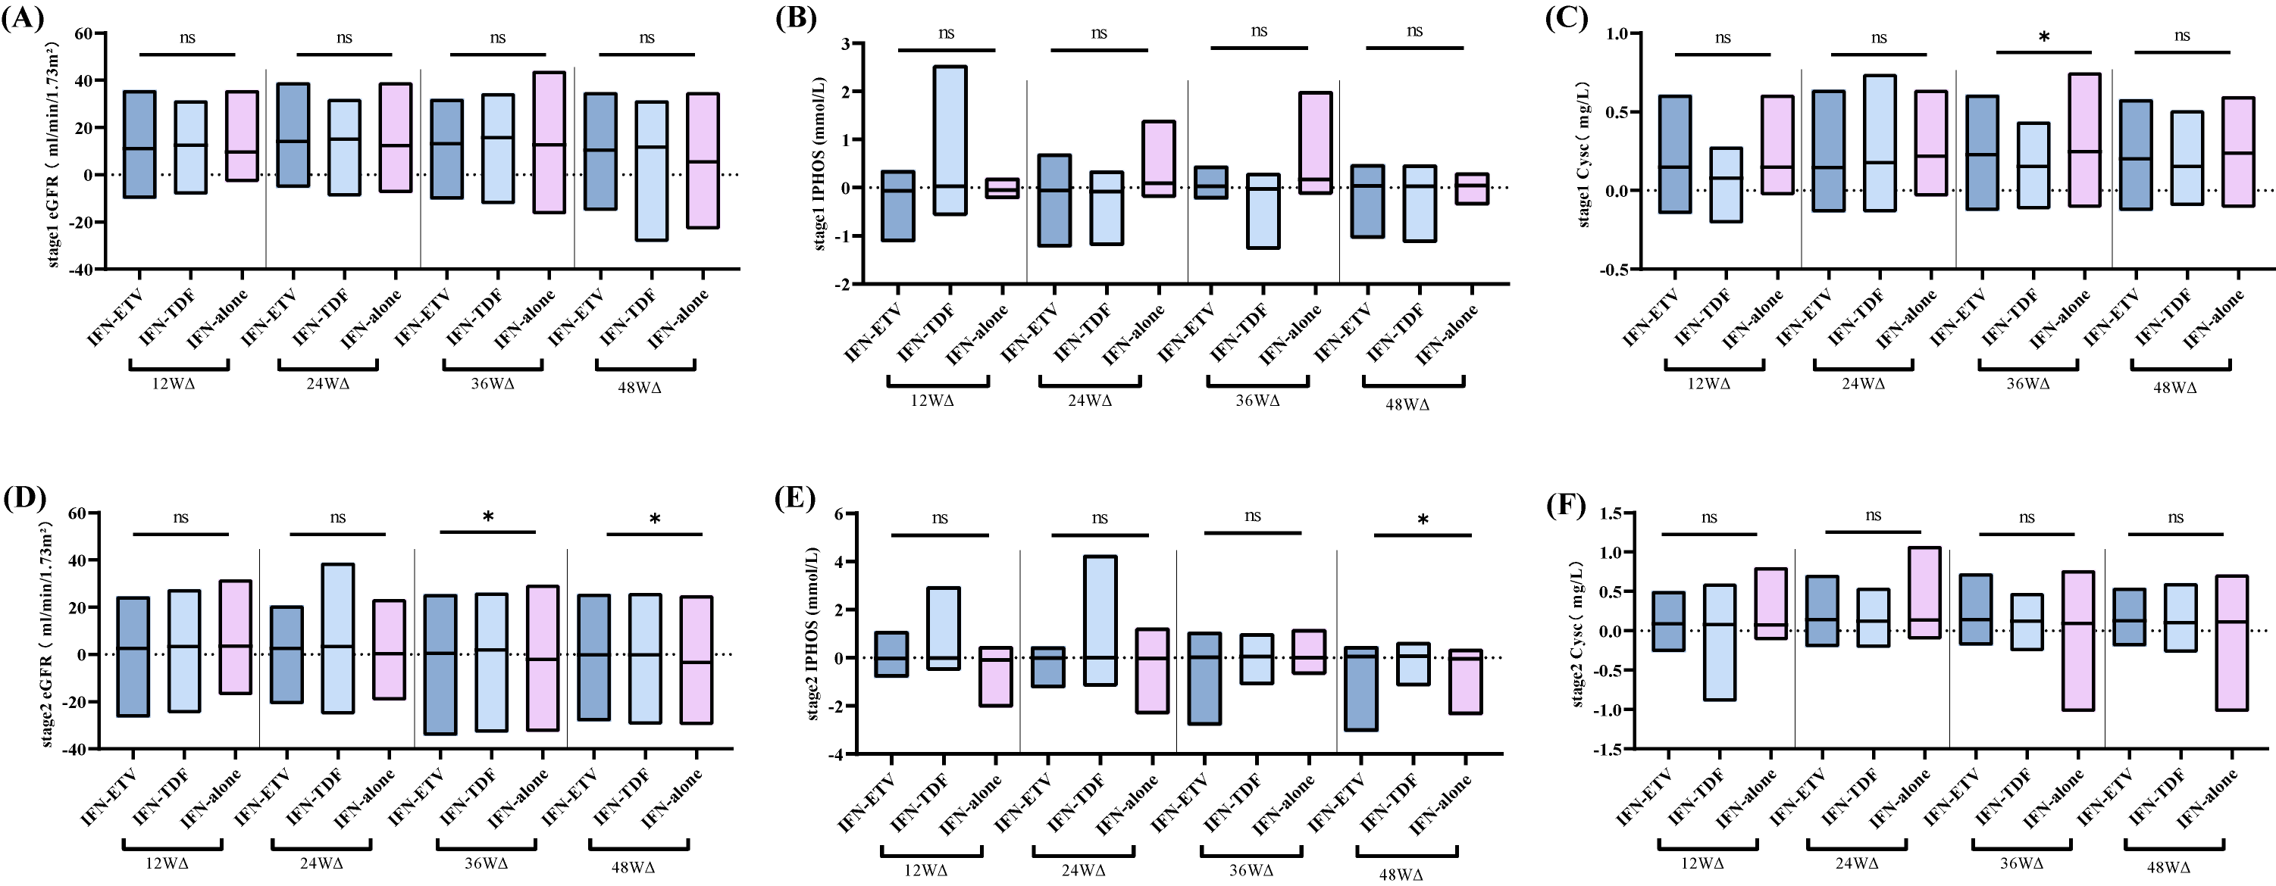

FigureS3.Variations at the different stages of renal function.
- . Variation in eGFR at stage 1. (B). Variation in IPHOS at stage 1. (C). Variation in Cysc at stage 1. (D). Variation in the eGFR at stage 2. (E). Variation in IPHOS at stage 2. (F). Variation in Cysc at stage 2.

