Renal function changes in patients with chronic hepatitis B treated with pegylated interferon combined with nucleos(t)ide analogs

Jinhua Zhao1,2 #, Lili Wu1,2 #, Xiaoan Yang1,2, Zhiliang Gao1,2 *, Hong Deng1,2 *

1Department of Infectious Diseases, Third Affiliated Hospital of Sun Yat-sen University, Guangzhou, China
2Guangdong Provincial Key Laboratory of Liver Disease Research, Third Affiliated Hospital of Sun Yat-sen University, Guangzhou, China
Supplementary Materials
Supplementary figures

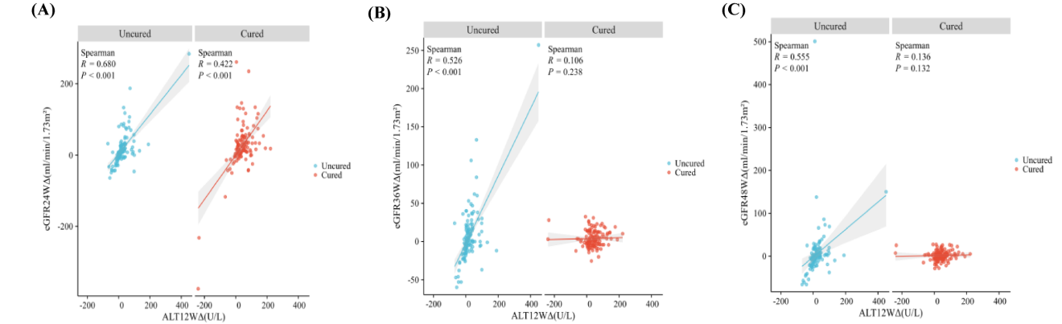
FigureS2.The correlation between ALT levels and eGFR. (A) ALT Δ at 12 weeks of treatment with eGFR Δ at 24 weeks. (B) The ALT Δ at 12 weeks of treatment and after 36 weeks. (C) ALT Δ at 12 weeks of treatment with eGFR Δ 48 weeks. Correlation analysis. ALT, alanine aminotransferase; Δ, delta; eGFR, estimated glomerular filtration rate.

