Renal function changes in patients with chronic hepatitis B treated with pegylated interferon combined with nucleos(t)ide analogs

Jinhua Zhao1,2 #, Lili Wu1,2 #, Xiaoan Yang1,2, Zhiliang Gao1,2 *, Hong Deng1,2 *

1Department of Infectious Diseases, Third Affiliated Hospital of Sun Yat-sen University, Guangzhou, China
2Guangdong Provincial Key Laboratory of Liver Disease Research, Third Affiliated Hospital of Sun Yat-sen University, Guangzhou, China
Supplementary Materials

Supplementary Figure
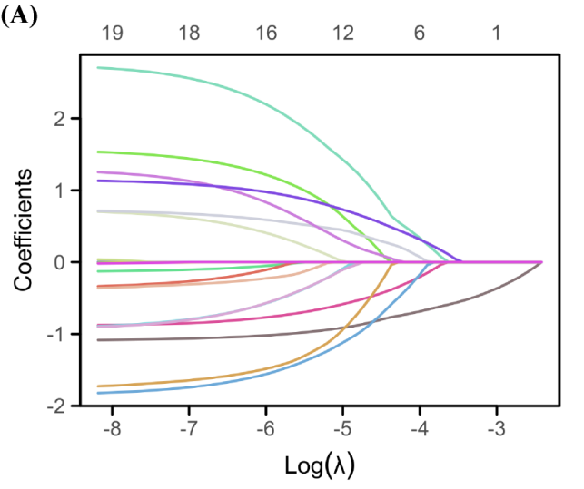
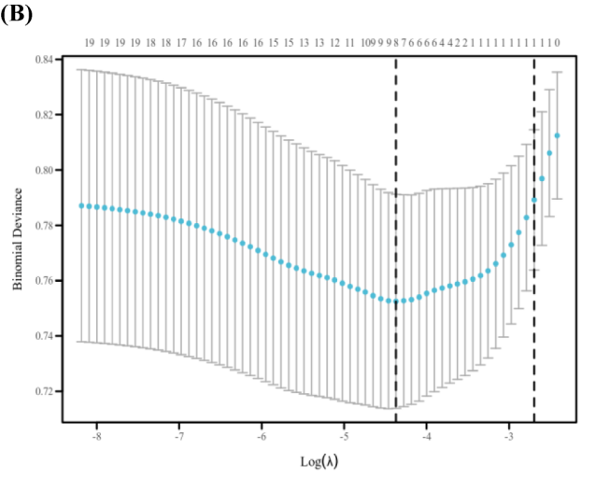
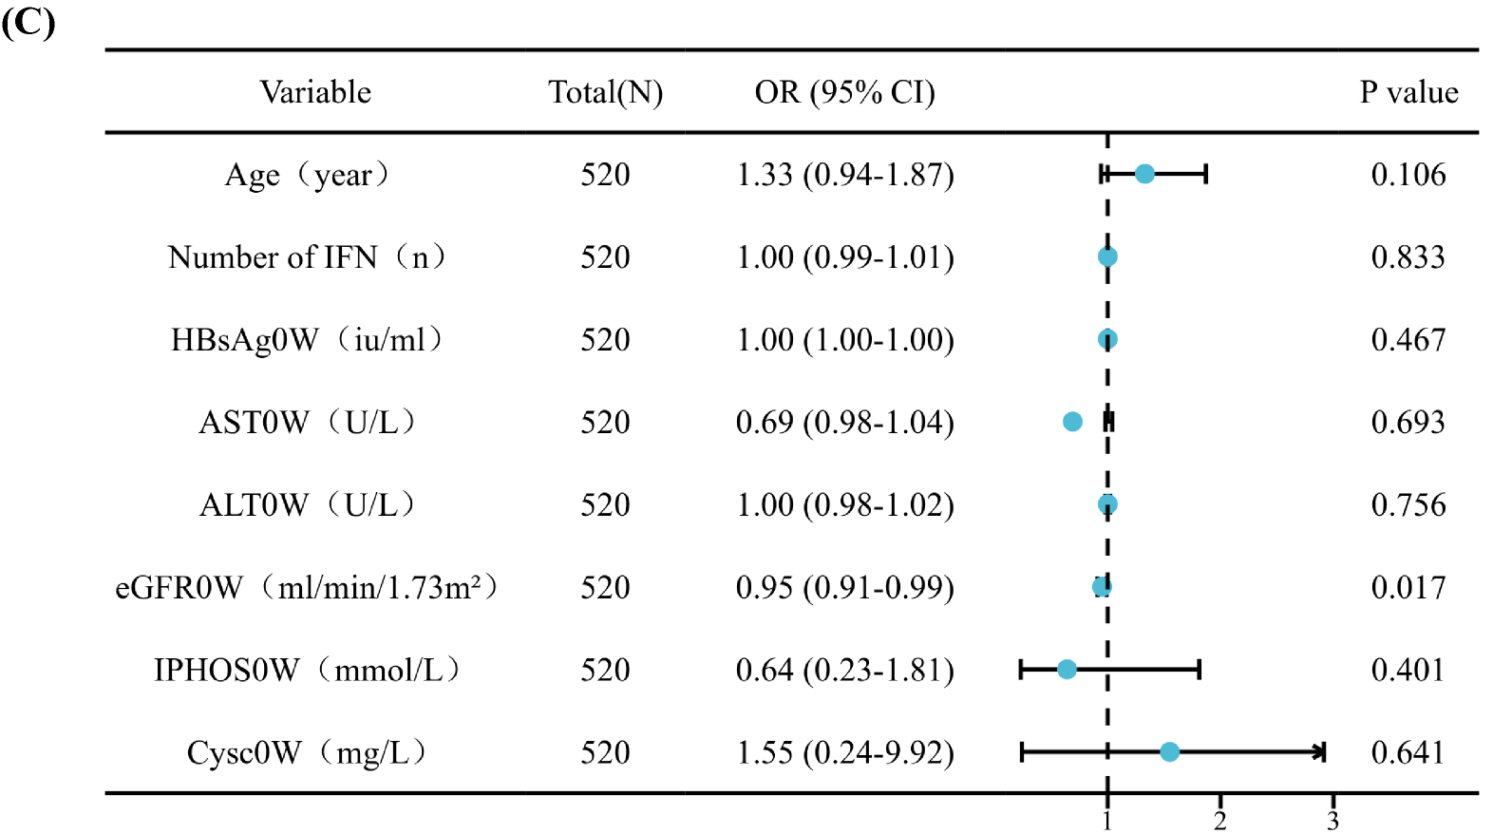
FigureS4 Analysis of factors predicting renal outcomes at 48 weeks.
- . Lasso coefficient path diagram. (B). LASSO regression analysis cross-validation. (C).Multivariate analysis forest plot of renal outcomes at 48 weeks.

