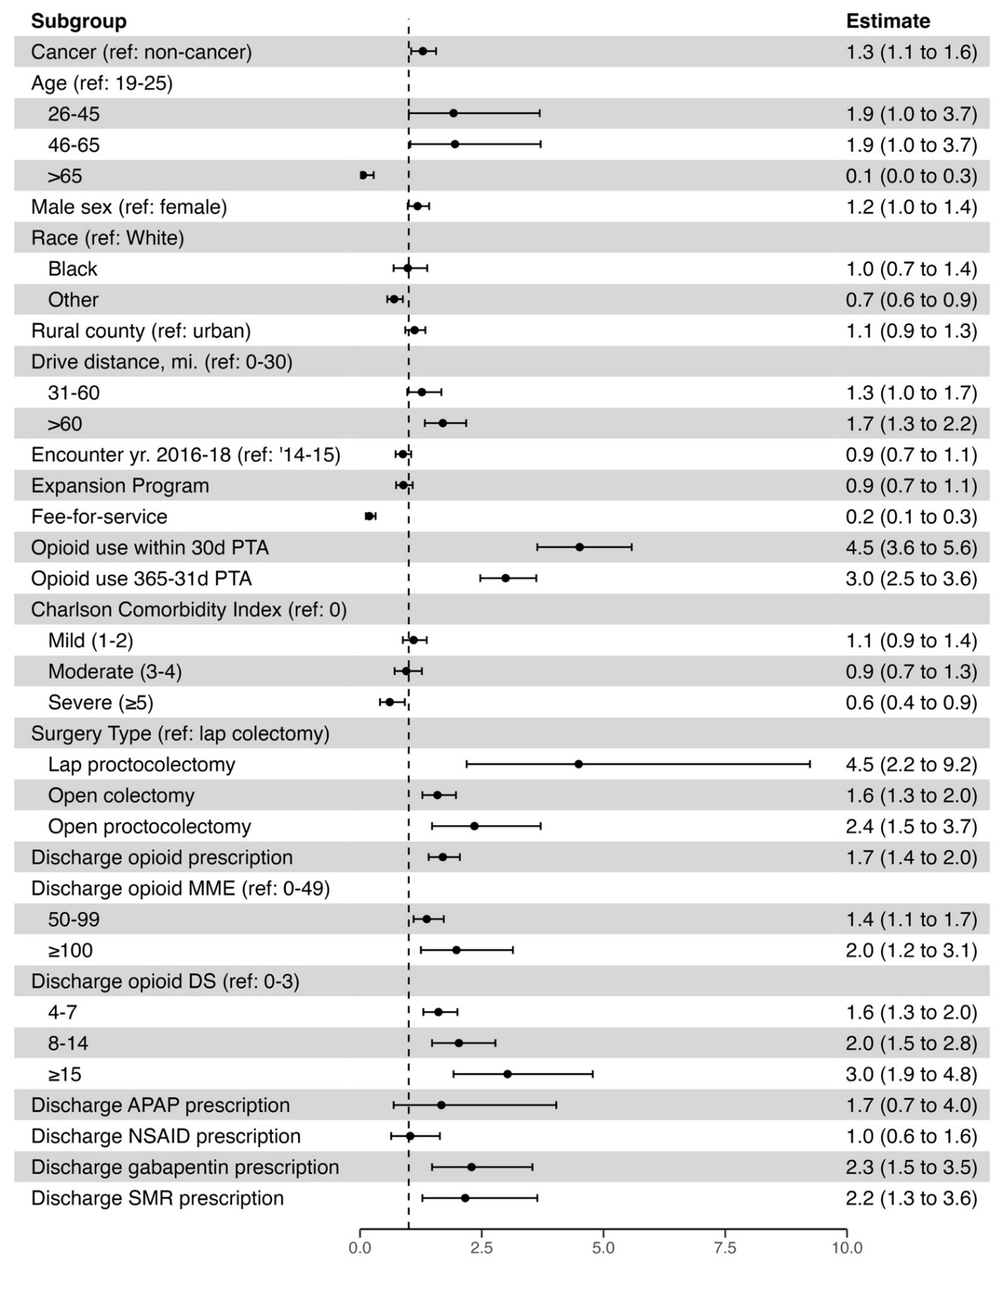
SUPPLEMENTAL FIGURE 1. Results from unadjusted logistic regression with a primary endpoint of persistent opioid use.
Notes: PTA, prior to admission; MME, morphine milligram equivalent; DS, days’ supply; APAP, acetaminophen; NSAID, nonsteroidal anti-inflammatory drug; SMR, skeletal muscle relaxant
SUPPLEMENTAL TABLE 1. Results from simple and multivariable logistic regression with a primary endpoint of persistent opioid use.
 | Simple Regression Model  OR (95% CI) | Multiple Regression Model  OR (95% CI)
Cancer (ref: non-cancer) | 1.29 (1.05-1.56) | 1.35 (1.08-1.69)
Age (ref: 19-25)
26-45 | 1.92 (1.00-3.69) | 1.67 (0.82-3.40)
46-65 | 1.95 (1.03-3.71) | 1.65 (0.79-3.44)
>65 | 0.06 (0.01-0.28) | 0.12 (0.02-0.64)
Male sex (ref: female) | 1.18 (0.98-1.42) | 1.25 (1.02-1.54)
Race (ref: White)
Black | 0.98 (0.69-1.38) | 1.17 (0.79-1.72)
Other | 0.70 (0.56-0.88) | 0.67 (0.51-0.87)
Rural county (ref: urban) | 1.12 (0.93-1.34) | 0.83 (0.66-1.04)
Drive distance, mi. (ref: 0-30)
31-60 | 1.27 (0.97-1.67) | 1.45 (1.06-2.00)
>60 | 1.70 (1.33-2.18) | 1.72 (1.26-2.32)
Encounter yr. 2016-18 (ref: ‘14-15) | 0.88 (0.73-1.05) | 0.77 (0.62-0.97)
Expansion Program | 0.89 (0.74-1.08) | 0.81 (0.65-1.02)
Fee-for-service | 0.19 (0.12-0.32) | 0.38 (0.22-0.67)
Opioid use within 30d PTA | 4.51 (3.64-5.58) | 3.00 (2.34-3.85)
Opioid use 365-31d PTA | 2.99 (2.47-3.62) | 1.71 (1.35-2.16)
Charlson Comorbidity Index (ref: 0)
Mild (1-2) | 1.10 (0.88-1.37) | 1.12 (0.83-1.51)
Moderate (3-4) | 0.95 (0.71-1.27) | 1.14 (0.77-1.67)
Severe (≥5) | 0.61 (0.41-0.92) | 1.22 (0.70-2.12)
Surgery Type (ref: lap colectomy)
Lap proctocolectomy | 4.49 (2.19-9.24) | 2.66 (1.19-5.91)
Open colectomy | 1.59 (1.28-1.97) | 1.75 (1.37-2.23)
Open proctocolectomy | 2.35 (1.48-3.71) | 1.43 (0.84-2.42)
Discharge opioid prescription | 1.70 (1.41-2.05) | 1.01 (0.65-1.57)
Discharge opioid MME (ref: 0-49)
50-99 | 1.37 (1.10-1.72) | 0.92 (0.68-1.24)
≥100 | 1.98 (1.25-3.14) | 1.25 (0.71-2.19)
Discharge opioid DS (ref: 0-3)
4-7 | 1.61 (1.30-2.00) | 1.45 (0.97-2.17)
8-14 | 2.03 (1.48-2.78) | 1.39 (0.86-2.26)
≥15 | 3.03 (1.92-4.78) | 1.58 (0.87-2.89)
Discharge APAP prescription | 1.67 (0.69-4.03) | 1.10 (0.39-3.13)
Discharge NSAID prescription | 1.03 (0.64-1.64) | 0.78 (0.45-1.35)
Discharge gabapentin prescription | 2.29 (1.48-3.54) | 1.48 (0.89-2.48)
Discharge SMR prescription | 2.16 (1.28-3.64) | 1.17 (0.63-2.16)
PTA, prior to admission; MME, morphine milligram equivalent; DS, days’ supply; APAP, acetaminophen; NSAID, nonsteroidal anti-inflammatory drug; SMR, skeletal muscle relaxant

Supplementary Appendix. CPT, DRG, and ICD Codes Used for Patient Inclusion and Classification

CPT Codes
44140, 44141, 44143, 44144, 44145, 44146, 44147, 44150, 44151, 44152, 44153, 44155, 44156, 44157, 44158, 44160, 44204, 44205, 44206, 44207, 44208, 44210, 44211, 44212, 45110, 45111, 45112, 45113, 45114, 45116, 45119, 45120, 45121, 45123, 45126, 45130, 45135, 45160, 45170, 45395, 45397, 45402, 45550

DRG Codes
0148, 0149, 0152, 0153, 0157, 0157, 0569, 0570

ICD-9 Codes
Cancer: 153, 1530, 1531, 1532, 1533, 1534, 1535, 1536, 1537, 1538, 1539, 154, 1540, 1541, 1542, 1543, 1548
Noncancer: 555, 5550, 5551, 5552, 5559, 556, 5560, 5561, 5562, 5563, 5564, 5565, 5566, 5568, 5569, 557, 5570, 5571, 5579, 562, 5620, 56200, 56201, 56202, 56203, 5621, 56210, 56211, 56212, 56213

ICD-10 Codes
Cancer: C180, C181, C182, C183, C184, C185, C186, C187, C188, C189, C19, C20, C210, C211, C212, C218, C260, C269
Noncancer: K5000, K50011, K50012, K50013, K50014, K50018, K50019, K5010, K50111, K50112, K50113, K50114, K50118, K50119, K5080, K50811, K50812, K50813, K50814, K50818, K50819, K5090, K50911, K50912, K50913, K50914, K50918, K50919, K5100, K51011, K51012, K51013, K51014, K51018, K51019, K5120, K51211, K51212, K51213, K51214, K51218, K51219, K5130, K51311, K51312, K51313, K51314, K51318, K51319, K5140, K51411, K51412, K51413, K51414, K51418, K51419, K5150, K51511, K51512, K51513, K51514, K51518, K51519, K5180, K51811, K51812, K51813, K51814, K51818, K51819, K5190, K51911, K51912, K51913, K51914, K51918, K51919, K5700, K5701, K5710, K5711, K5712, K5713, K5720, K5721, K5730, K5731, K5732, K5733, K5740, K5741, K5750, K5751, K5752, K5753, K5780, K5781, K5790, K5791, K5792, K5793

