Tables

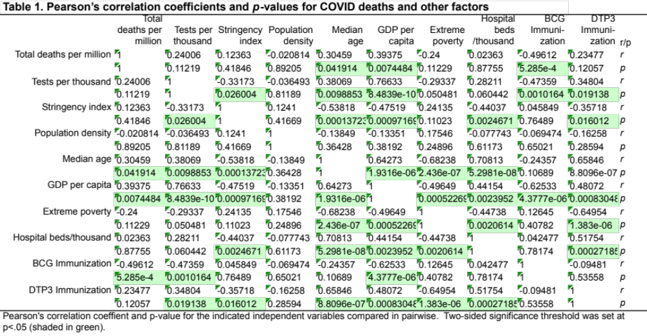

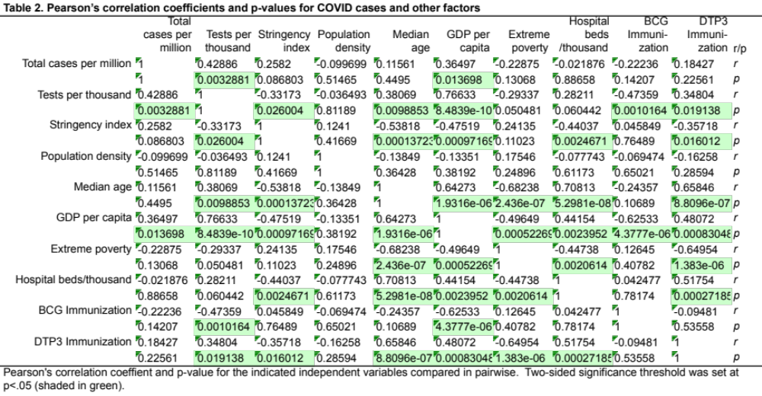

Table 3. Multivariate analysis of COVID deaths
Predictors | Estimate (b) | SE | t-Stat | p-Value
(Intercept) | 85.1258 | 30.0668 | 2.8312 | 0.0051
Tests per thousand | -0.2288 | 0.1477 | -1.5492 | 0.1229
Stringency index | 0.5202 | 0.3479 | 1.4952 | 0.1364
Population density | 0.0011 | 0.0073 | 0.1472 | 0.8831
Median age | -2.0553 | 1.1066 | -1.8574 | 0.0647
GDP per capita | 0.0018 | 0.0007 | 2.4233 | 0.0163
Extreme poverty | -1.0002 | 0.6836 | -1.4631 | 0.1450
Hospital beds/thousand | 1.2075 | 5.5085 | 0.2192 | 0.8267
BCG Immunization | -1.8233 | 0.3467 | -5.2596 | 3.70E-07
DTP3 Immunization | 1.8905 | 0.4680 | 4.0397 | 0.0001
Coefficient estimates (b) for a generalized linear regression of COVID deaths as responses on multiple predictors calculated using MATLAB glmfit function, with standard errors (SE), t statistics, and p-values.

Table 4. Multivariate analysis of COVID cases
Predictors | Estimate | SE | t-Stat | p-Value
(Intercept) | 2260.4548 | 795.8747 | 2.8402 | 0.0050
Tests per thousand | 10.2672 | 3.9101 | 2.6258 | 0.0093
Stringency index | 25.7003 | 9.2095 | 2.7906 | 0.0058
Population density | 0.0222 | 0.1920 | 0.1156 | 0.9081
Median age | -105.1955 | 29.2909 | -3.5914 | 0.0004
GDP per capita | 0.1074 | 0.0198 | 5.4144 | 1.75E-07
Extreme poverty | -39.1161 | 18.0948 | -2.1617 | 0.0318
Hospital beds/thousand | -186.4294 | 145.8114 | -1.2786 | 0.2025
BCG Immunization | 1.0827 | 9.1760 | 0.1180 | 0.9062
DTP3 Immunization | 15.1585 | 12.3878 | 1.2237 | 0.2225
Coefficient estimates (b) for a generalized linear regression of COVID cases as responses on multiple predictors calculated using MATLAB glmfit function, with standard errors (SE), t statistics, and p-values.

Table 5. Correlation coefficient in countries matched by median age
Group |  | "Young" | "Medium" | "Old"
N |  | 50 | 75 | 61
min Age |  | 15.1 | 23.1 | 36.2
Country |  | Niger | Gabon | Trinidad&Tobago
max Age |  | 22.9 | 35.7 | 48.2
Country |  | Guatemala | Armenia | Japan
BCG vs COVID cases | r | 0.095 | 0.065 | –0.299
 | p | 0.514 | 0.58 | 0.0192 | *
BCG vs COVID deaths | r | 0.082 | 0.12 | –0.424
 | p | 0.57 | 0.304 | 0.0007 | ***
BCG vs median Age | r | 0.201 | –0.128 | 0.116
 | p | 0.161 | 0.274 | 0.373
210 countries/regions were propensity score matched for median age into three groups. 24 countries were excluded due to lacking meidan age information. Pearson’s correlation coefficient (r) and p-value (p) are shown. *, *** indiate significant levels, p<0.5, p<0.001.

